Homework #1 Convert following Decimal numbers to IEEE.

5.75 and -11.5

-0.25 and 0.75

Hint: To normalize, you need to shift the number to left.

Show your work in the following order:
1. Straight forward translation from decimal to binary number
2. Normalization procedure
3. Formatting into IEEE representation

5.75 -> 101.11
Sign bit = 0
1.0111 * 22
2 + 127 = 129
129 -> 10000001
= 0 10000001 01110000000000000000000
= 0100 0000 1011 1000 0000 0000 0000 0000
= 40B80000

-11.5 -> -1011.1
Sign bit = 1
-1.0111 * 23
3 + 127 = 130
130 -> 10000010
= 1 10000010 01110000000000000000000
= 1100 0001 0011 1000 0000 0000 0000 0000
= C1380000

-0.25 -> -0.01
Sign bit = 1
-1.00 * 2-2
-2 + 127 = 125
125 -> 01111101
= 1 01111101 00000000000000000000000
= 1011 1110 1000 0000 0000 0000 0000 0000
= BE800000

0.75 -> 0.11
Sign bit = 0
1.1 * 2-1
-1 + 127 = 126
126 -> 01111110
= 0 01111110 10000000000000000000000
= 0011 1111 0100 0000 0000 0000 0000 0000
= 3F400000

-Homework #2 complete the 4:1 Mux Circuit so that it implements the Truth table below>

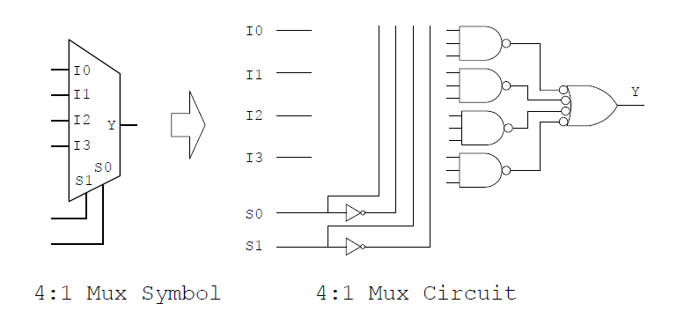

Truth table
s0 | s1 | Y
0 | 0 | I0
0 | 1 | I1
1 | 0 | I2
1 | 1 | I3

