* 1. Which of the Seven Layers in the OSI Model is the highest layer represented by the image below?  
     Data link layer: the two clients are only connected to each other via a switch and have no outside connectivity displayed.
  2. Which of the Seven Layers in the OSI Model would you identify with the image below?  
     Physical Layer: it is a network adapter.
  3. Which of the Seven Layers in the OSI Model would you identify with the image below?  
     Network Layer: shows all addresses of the host machine.
  4. Which of the Seven Layers in the OSI Model would you identify with the image below?  
     Session Layer

|  |  |  |
| --- | --- | --- |
| Layer | Name | Description |
| 7 | Application | Allows the user to operate and access network resources. |
| 6 | Presentation | Translates data in a form readable by the next layer. |
| 5 | Session | Responsible for keeping different applications data separate.  The session layer also coordinates connection and interaction between applications, establishes connections and manages data flow. |
| 4 | Transport | Ensures transport of data is successful with error-checking and sequencing. |
| 3 | Network | Provides logical addressing, which routers use for path determination. |
| 2 | Data Link | Establishes links and error correction |
| 1 | Physical | Moves bits between devices. Specifies voltage, wire speed, and pinout of cables. |

* 1. The OSI Model today is used as a reference model and is not implemented on the Internet today. What current model is used for the Internet in the 21st century?  
     The Internet protocol suite

Part 2

1. What is the IP Address for PC-1, PC-3, and PC-5?  
   192.168.0.10/24, 192.168.0.30/24, and 192.168.1.27/24
2. What is the gateway for PC-2?  
   0.0.0.0/0
3. Now that you know how to display network pieces of information for your PC’s, it’s time to check network connectivity from one PC to the next. Using the ping command, from PC-2, ping PC-1 and PC-3. Remember when pinging you needed to use the PC’s IP Address. Provide a screenshot of your results pinging PC-1 and PC-3.  
   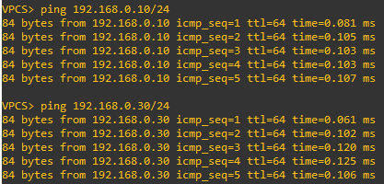
4. Now that you know how to ping command, use PC-2 to ping PC-1 and PC-5, and provide a screenshot of your results. Explain your screenshot results, and what you believe happened.  
   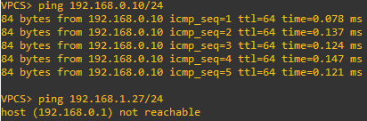  
   PC-5 is connected to a different switch than PC-1-3.

Part 3

1. Once you have successfully launched Wireshark to capture packets, use PC-2 to ping PC-1 and PC-3, and provide an explanation of what you are seeing in Wireshark.  
   Wireshark shows an initial broadcast packet asking for the owner of 192.168.0.10.  
   PC-1 replies with the MAC address, then packets are sent and received between the two devices.
2. List the protocols your PCs are using to transmit data over the network?  
   ARP and ICMP.
3. How many frames were transmitted over the wire?  
   For each PC, 5 sent and 5 received.
4. How many bytes were transmitted over the wire?  
   For each PC, 980 bytes.
5. Ping PC-6 from PC-2, and provide a screenshot of your packet capture and explain what happened.  
     
   There was no response on the network from a device matching that IP Address, so the request timed out.