**CSCD 434**

**Lab 2**

**Introduction to Physical Networks & TCP/IP**

# Section 1: IPv4 Addresses

To support the allocation of IP addresses, an organization called the Internet Assigned Numbers Authority (IANA) was formed to track and disperse IP addresses to those who need them. All end users are assigned IP Addresses from their respective ISPs IANA passes out IP Addresses in chunks called network blocks and every network IP Address typically falls into a class

The most common type of IP address (officially called IPv4 please keep in mind although IPv4 is widely used we are moving forward in the networking world to IPv6). IPv4 consists of a 32-bit value. The address space is 2^32 or 4,294,967,296 in total. IANA allocated the last IPv4 blocks to the RIR’s in February 2011. IPv4 is the standard network protocol on the Internet today.

Here is an example of an IPv4 address:

*Note: We get into greater detail and talk about IPv6 more in-depth at a later point in this course.

Example:

11000000.10101000.00000000.00000001 → 192.168.0.1

|  |  |  |  |
| --- | --- | --- | --- |
| 11000000 | 10101000 | 00000000 | 00000001 |
| 192 | 168 | 0 | 1 |

The table below is designed to help you understand IPv4 and binary count. Recall earlier that we said IPv4 consists of a 32-bit value.

|  |  |  |  |  |  |  |  |  |  |
| --- | --- | --- | --- | --- | --- | --- | --- | --- | --- |
| Power of 2 |  | 128 | 64 | 32 | 16 | 8 | 4 | 2 | 1 |
| Bit |  | 1 | 1 | 0 | 0 | 0 | 0 | 0 | 0 |
| Cumulative Amount | (128+64) 192 | 128 | 64 | 0 | 0 | 0 | 0 | 0 | 0 |

1. **Now, give it a try by converting the binary number 01010110 to decimal following the same steps as above. Explain how you got your answer and show your work.**

|  |  |  |  |  |  |  |  |  |  |
| --- | --- | --- | --- | --- | --- | --- | --- | --- | --- |
| Power of 2 | 128 | | 64 | 32 | 16 | 8 | 4 | 2 | 1 |
| Bit |  | 0 | 1 | 0 | 1 | 0 | 1 | 1 | 0 |
| Cumulative Amount | (64+16+4+2)  86 | 0 | 64 | 0 | 16 | 0 | 4 | 2 | 0 |

1. **Now give it a try by converting decimal number 155 to binary by filling in the box below.**

|  |  |  |  |  |  |  |  |  |  |
| --- | --- | --- | --- | --- | --- | --- | --- | --- | --- |
| Power of 2 | 128 | | 64 | 32 | 16 | 8 | 4 | 2 | 1 |
| Bit |  | 1 | 0 | 0 | 1 | 1 | 0 | 1 | 1 |
| Cumulative Amount | (128+16+8+2+1)  155 | 128 | 0 | 0 | 16 | 8 | 0 | 2 | 1 |

1. **Convert the following IP Address to binary: 192.172.34.11**

**192**

|  |  |  |  |  |  |  |  |  |  |
| --- | --- | --- | --- | --- | --- | --- | --- | --- | --- |
| Power of 2 | 128 | | 64 | 32 | 16 | 8 | 4 | 2 | 1 |
| Bit |  | 1 | 1 | 0 | 0 | 0 | 0 | 0 | 0 |
| Cumulative Amount | (128+64)  192 | 128 | 64 | 0 | 0 | 0 | 0 | 0 | 0 |

**172**

|  |  |  |  |  |  |  |  |  |  |
| --- | --- | --- | --- | --- | --- | --- | --- | --- | --- |
| Power of 2 | 128 | | 64 | 32 | 16 | 8 | 4 | 2 | 1 |
| Bit |  | 1 | 0 | 1 | 0 | 1 | 1 | 0 | 0 |
| Cumulative Amount | (128+32+8+4)  172 | 128 | 0 | 32 | 0 | 8 | 4 | 0 | 0 |

**34**

|  |  |  |  |  |  |  |  |  |  |
| --- | --- | --- | --- | --- | --- | --- | --- | --- | --- |
| Power of 2 | 128 | | 64 | 32 | 16 | 8 | 4 | 2 | 1 |
| Bit |  | 0 | 0 | 1 | 0 | 0 | 0 | 1 | 0 |
| Cumulative Amount | (32+2)  34 | 0 | 0 | 32 | 0 | 0 | 0 | 2 | 0 |

**11**

|  |  |  |  |  |  |  |  |  |  |
| --- | --- | --- | --- | --- | --- | --- | --- | --- | --- |
| Power of 2 | 128 | | 64 | 32 | 16 | 8 | 4 | 2 | 1 |
| Bit |  | 0 | 0 | 0 | 0 | 1 | 0 | 1 | 1 |
| Cumulative Amount | (8+2+1) | 0 | 0 | 0 | 0 | 8 | 0 | 2 | 1 |

1. **Convert the following binary to decimal quad-dotted notation: 11100000.00011000.00000001.00001111**

**11100000**

|  |  |  |  |  |  |  |  |  |  |
| --- | --- | --- | --- | --- | --- | --- | --- | --- | --- |
| Power of 2 | 128 | | 64 | 32 | 16 | 8 | 4 | 2 | 1 |
| Bit |  | 1 | 1 | 1 | 0 | 0 | 0 | 0 | 0 |
| Cumulative Amount | (128+64+32)  224 | 128 | 64 | 32 | 0 | 0 | 0 | 0 | 0 |

**00011000**

|  |  |  |  |  |  |  |  |  |  |
| --- | --- | --- | --- | --- | --- | --- | --- | --- | --- |
| Power of 2 | 128 | | 64 | 32 | 16 | 8 | 4 | 2 | 1 |
| Bit |  | 0 | 0 | 0 | 1 | 1 | 0 | 0 | 0 |
| Cumulative Amount | (16+8)  24 | 0 | 0 | 0 | 16 | 8 | 0 | 0 | 0 |

**00000001**

|  |  |  |  |  |  |  |  |  |  |
| --- | --- | --- | --- | --- | --- | --- | --- | --- | --- |
| Power of 2 | 128 | | 64 | 32 | 16 | 8 | 4 | 2 | 1 |
| Bit |  | 0 | 0 | 0 | 0 | 0 | 0 | 0 | 1 |
| Cumulative Amount | (1)  1 | 0 | 0 | 0 | 0 | 0 | 0 | 0 | 1 |

**00001111**

|  |  |  |  |  |  |  |  |  |  |
| --- | --- | --- | --- | --- | --- | --- | --- | --- | --- |
| Power of 2 | 128 | | 64 | 32 | 16 | 8 | 4 | 2 | 1 |
| Bit |  |  |  |  |  |  |  |  |  |
| Cumulative Amount |  |  |  |  |  |  |  |  |  |

# Section 2: Identifying IPv4 Classes & Calculating Host

One of the most important things you will need to understand in Network Security is how to identify Classful and Classless networks. You need to have a very good understanding of IP class blocks, and you should be able to identify what class an IPv4 Address falls into.

|  |  |  |  |  |  |
| --- | --- | --- | --- | --- | --- |
| IP Address Class | First & Last  Decimal Value | Addresses | Network (N) and  Host (H) parts of Address | Hosts per Network ID | Default Subnet mask (decimal and binary |
| Class A | 1 - 126 | 1.0.0.0 - 126.255.255.255 | 16,277,214 | N.H.H.H | 255.0.0.0 |
| Class B | 128 - 191 | 128.0.0.0 - 191.255.255.255 | 65,534 | N.N.H.H | 255.255.0.0 |
| Class C | 192 -223 | 192.0.0.0 - 223.255.255.255 | 254 | N.N.N.H | 255.255.255.0 |
| Class D | 224 - 239 | 224.0.0.0 - 239.255.255.255 | NA | Multicast |  |
| Class E | 240 -254 | 240.0.0.0 - 254.255.255.255 | NA | Experimental |  |

**Example:**

IPv4 Address → 1.1.1.1 → Class A

**Using the table above identify what class the following IPv4 addresses belong to and explain your answer.**

1. **What class does the following IP Address belong to 192.1.1.0?**C, between 192.0.0.0 and 223.255.255.255
2. **What class does the following IP Address belong to 10.255.255.0?**A, between 1.0.0.0 and 126.255.255.255
3. **What class does the following IP Address belong to 222.224.224.254?**   
   D, between 224.0.0.0 and 239.255.255.255
4. **What class does the following IP Address belong to 4.4.4.4?**A, between 1.0.0.0 and 126.255.255.255
5. **What class does the following IP Address belong to 2.2.2.1?**A, between 1.0.0.0 and 126.255.255.255

## Calculating Hosts in CIDR

Calculating the number of hosts available in a network is one of the most important things a Network & Systems Engineer needs to understand how to do. By knowing how to count the number of hosts in a network, an engineer can eliminate wasteful class blocks, and separate the network for greater security.

We know that IPv4 uses 32 bits and that every single bit has to be accounted for. Using Classless Inter-Domain Routing

(CIDR), e.g. in a /24 network, you have 24 network bits (the 1's), so the remaining 8 host bits (the 0's) can be the host ID

(Refer to page 190 of the text). Another way to calculate host is by using the following formula → *2^x - 2* where x represents the number of zeroes in the subnet mask.

For example, a /24 would have a subnet mask of:

1. 11111111.11111111.11111111.00000000 → 255.255.255.0

Applying the host formula to a /24 you would have 32 -24 network bits = 8 host bits, and *2^8-2* = [256 - 2] → 254 hosts, so in a /24 network we can have 254 possible hosts. Given this scenario, **determine the number of hosts for the subnets below**:

*Note: please be sure to show all of your work and explain your reasoning.

I used the general formula of 32 – subnet mask bits – for example 32 – 24 would be 8 bits for the number of hosts. I then used the formula 2𝑥 − 2 to determine the maximum number of hosts.

1. **What is the maximum number of hosts in a /22?**2(32-22) - 2 = 1,022 hosts
2. **What is the maximum number of hosts in a /16?** 2(32-16) - 2 = 65,534 hosts
3. **What is the maximum number of hosts in a /8?**2(32-8) – 2 = 16,777,214 hosts
4. **What is the maximum number of hosts in a /10?**2(32-10) – 2 = 4,194,302 hosts
5. **What is the maximum number of hosts in a /19?**2(32-19) – 2 = 4,294,967,275 hosts

# Calculating Simple Subnets

The best way to understand basic subnetting is work through a problem together. You have the IPv4 address of 138.101.114.250/25. You need to determine:

* Number of hosts
* The network address
* The broadcast address
* The host minimum address (AKA the first host address in the subnet)
* The host maximum address (AKA the last host address in the subnet)

## Step 1 – Convert to Binary

First take the IP address and convert the address into binary

|  |  |  |  |  |  |  |  |  |  |  |  |  |  |  |  |  |  |  |  |  |  |  |  |  |  |  |  |  |  |  |  |
| --- | --- | --- | --- | --- | --- | --- | --- | --- | --- | --- | --- | --- | --- | --- | --- | --- | --- | --- | --- | --- | --- | --- | --- | --- | --- | --- | --- | --- | --- | --- | --- |
| 138 | | | | | | | | 101 | | | | | | | |  | | | 114 | | | | |  |  |  | 250 | |  |  |  |
| 1 | 0 | 0 | 0 | 1 | 0 | 1 | 0 | 0 | 1 | 1 | 0 | 0 | 1 | 0 | 1 | 0 | 1 | 1 | 1 | 0 | 0 | 1 | 0 | 1 | 1 | 1 | 1 | 1 | 0 | 1 | 0 |
| Convert the subnet mask of 25 bits (255.255.255.128) into binary | | | | | | | | | | | | | | | | | | |  | | | | |  |  |  |  | |  |  |  |
| 255 | | | | | | | | 255 | | | | | | | |  | | | 255 | | | | |  |  |  | 128 | |  |  |  |
| 1 | 1 | 1 | 1 | 1 | 1 | 1 | 1 | 1 | 1 | 1 | 1 | 1 | 1 | 1 | 1 | 1 | 1 | 1 | 1 | 1 | 1 | 1 | 1 | 1 | 0 | 0 | 0 | 0 | 0 | 0 | 0 |

## Step 2 – Calculate the Subnet Address

Bitwise and the IP address with the subnet. Bitwise and rules are if both the binary IP address and the binary subnet mask are both a 1 then the result is a 1 (1 & 1 -> 1) If one either the binary IP address or the binary subnet mask is a 0 then the result is a 0 (1 & 0 -> 0) / (0 & 1 -> 0) / (0 & 0 -> 0)

|  |  |  |  |  |
| --- | --- | --- | --- | --- |
| IP Address (Decimal) | 138 | 101 | 114 | 250 |
| IP Address (Binary) | 10001010 | 01100101 | 01110010 | 11111010 |
| Subnet Mask (Binary) | 11111111 | 11111111 | 11111111 | 10000000 |
| Network Address (Binary) | 10001010 | 01100101 | 01110010 | 10000000 |
| Network Address (Symbols) | NNNNNNNN | NNNNNNNN | NNNNNNNN | NHHHHHHH |
| Network Address (Decimal) | 138 | 101 | 114 | 128 |

## Step 3 – Find the Host Range

|  |  |  |  |  |
| --- | --- | --- | --- | --- |
| IP Address (Decimal) | 138 | 101 | 114 | 250 |
| IP Address (Binary) | 10001010 | 01100101 | 01110010 | 11111010 |
| Subnet Mask (Binary) | 11111111 | 11111111 | 11111111 | 10000000 |
| Network Address (Binary) | 10001010 | 01100101 | 01110010 | 10000000 |

The host bits are denoted in red and are all 0s. The first host address is identified the host bits being all 0s and a 1.

|  |  |  |  |  |  |
| --- | --- | --- | --- | --- | --- |
| Host Min Address (Binary) | 10001010 | 01100101 | 01110010 |  | 1 0000001 |
| Host Min Address (Decimal) | 138 | 101 | 114 |  | 129 |
| The host bits are denoted in red. The last host address is | | identified by the host | bits being all 1s and a | 0 |  |
| Host Max Address (Binary) | 10001010 | 01100101 | 01110010 |  | 1 1111110 |
| Host Max Address (Decimal) | 138 | 101 | 114 |  | 254 |
| The broadcast address is the Host Maximum Address plus 1 | | |  |  |  |
| Broadcast Address (Binary) | 10001010 | 01100101 | 01110010 |  | 1 1111111 |
| Broadcast Address (Decimal) | 138 | 101 | 114 |  | 255 |

## Step 4 – Verify the Number of Hosts

Using the general formula of 32 – subnet mask bits yields the number of host bits. In the example (32 – 25 = 7), there are 7 host bits. Now using the formula 2𝑥 − 2 = 𝑛𝑢𝑚𝑏𝑒𝑟 𝑜𝑓 ℎ𝑜𝑠𝑡𝑠 where x is the number of host bits. In this example 27 = 128 − 2 = 126 ℎ𝑜𝑠𝑡𝑠. Verifying that value by subtracting the host minimum address from the broadcast address better yield the same results. In this example 138.101.114.255 – 138.101.114.129 yields 126.

**Determine:**

* **Number of hosts**
* **The network address**
* **The broadcast address**
* **The host minimum address (AKA the first host address in the subnet)**
* **The host maximum address (AKA the last host address in the subnet)**

for each of the following addresses. Show your work for full points.

1. **192.168.10.44/29**2(32-29) – 2 = 6 hosts

|  |  |  |  |  |
| --- | --- | --- | --- | --- |
| IP Address (Decimal) | 192 | 168 | 10 | 44 |
| IP Address (Binary) | 11000000 | 10101000 | 00001010 | 00101100 |
| Subnet Mask (Binary) | 11111111 | 11111111 | 11111111 | 11111000 |
| Network Address (Binary) | 11000000 | 10101000 | 00001010 | 00101000 |

Network Address = 192.168.10.40  
Host Min Address = 192.168.10.41 or 11000000.10101000.00001010.00101001  
Host Max Address = 192.168.10.46 or 11000000.10101000.00001010.00101110

Broadcast Address = 192.168.10.47 or 11000000.10101000.00001010.00101111

1. **10.10.5.20/18**2(32-18) – 2 = 16,382 hosts

|  |  |  |  |  |
| --- | --- | --- | --- | --- |
| IP Address (Decimal) | 10 | 10 | 5 | 20 |
| IP Address (Binary) | 00001010 | 00001010 | 00000101 | 00010100 |
| Subnet Mask (Binary) | 11111111 | 11111111 | 11000000 | 00000000 |
| Network Address (Binary) | 00001010 | 000001010 | 00000000 | 00000000 |

Network Address = 10.10.0.0  
Host Min Address = 10.10.0.1 or 00001010.00001010.00000000.00000001  
Host Max Address = 10.10.63.254 or 00001010.00001010.00111111.11111110  
Broadcast Address = 10.10.63.255 or 00001010.00001010.00111111.11111111

1. **146.187.130.81/23**2(32-23) – 2 = 510 hosts

|  |  |  |  |  |
| --- | --- | --- | --- | --- |
| IP Address (Decimal) | 146 | 187 | 130 | 81 |
| IP Address (Binary) | 10010010 | 10111011 | 10000010 | 01010001 |
| Subnet Mask (Binary) | 11111111 | 11111111 | 11111110 | 00000000 |
| Network Address (Binary) | 10010010 | 10111011 | 10000010 | 00000000 |

Network Address = 146.187.130.0  
Host Min Address = 146.187.130.1 or 10010010.10111011.10000010.00000001

Host Max Address = 146.187.131.254 or 10010010.10111011.100000011.11111110

Broadcast Address = 146.187.131.255 or 10010010.10111011.100000011.11111111

1. **145.16.25.18/21**2(32-21) – 2 = 2,046 hosts

|  |  |  |  |  |
| --- | --- | --- | --- | --- |
| IP Address (Decimal) | 145 | 16 | 25 | 18 |
| IP Address (Binary) | 10010001 | 00010000 | 00011001 | 00010010 |
| Subnet Mask (Binary) | 11111111 | 11111111 | 11111000 | 00000000 |
| Network Address (Binary) | 10010001 | 00010000 | 00011000 | 00000000 |

Network Address = 145.16.24.0

Host Min Address = 145.16.25.1 or 10010001.00010000.00011000.00000001

Host Max Address = 145.16.31.254 or 10010001.00010000.00011111.11111110

Broadcast Address = 145.16.31.255 or 10010001.00010000.00011111.11111111

# Calculating Complex Subnets

Now that we know how to determine the number of hosts a network can have based on its bit counts, we need to learn how to subnet a network ID. The rules for subnetting were developed for TCP/IP and we need to make sure we follow the rules very carefully in order to ensure that our subnets work well, and our hosts can interact inside and outside our network.

The key to subnetting is to simply remember the subnet mask you started with and extend it further. For example, suppose a financial firm currently has three departments that we want on three subnets, as follows:

1. Accounting → Network 1
2. Marketing → Network 2
3. Human Resources → Network 3

It’s very important that we create three networks because of the various security risks that having all branches of the business on the same network presents.

If the firm has a 192.168.4.0/24 network and it needs three subnets, we would extend the /24 to a /26 by using the formula

*2^y (where y is the number of bits you add to the subnet mask)* to determine how many network IDs would be created.

* Adding no additional bits results in a /24 (in other words, no change) and gives us 2^0 = 1 subnet, which we already have.
* One additional bit, resulting in a /25, would only give 2^1 = 2 subnets, but we are still short because we need three subnets.
* Two additional bits, resulting in a /26, would give us 2^2 = 4 subnets, which will satisfy the need for 3.

Given that we are using powers of two and the formula for subnets is *2^y*, the closest we can come to three subnets and satisfy the requirement is by adding two bits to the original /24 network, changing the network to a /26, which means we would be able to create 4 subnets even though the firm only needs 3.

Remember that subnets are created by powers of two, and powers of two have limitations when it comes to subnetting. Although the number we were looking for was 3, there was no way to extend the mask to obtain exactly 3 subnets using powers of two.

So, because we have to add two bits, we are effectively creating 4 network IDs although the firm only needs three. In order to see each of the network IDs, we would need to convert the original Network ID → 192.168.4.0 /24 to binary to construct four /26 network IDs, in other words, *four new network IDs with 26 bit subnet masks*. The two new bits can take on four values, 00, 01, 10, and 11, leading to four addresses, as shown in the example.

**The 00 case:**

Network ID → 192.168.4.0 /26 → Network 1

|  |  |  |  |  |  |
| --- | --- | --- | --- | --- | --- |
| 192 | 168 | 4 | 0 | | |
| 11000000 | 10101000 | 000000100 |  | **00** | 000000 |
| **The 01 case:**  Network ID → 192.168.4. | 64 /26 → Network 2 |  |  | | |
| 192 | 168 | 4 | 64 | | |
| 11000000 | 10101000 | 000000100 |  | **01** | 000000 |
| **The 10 case:**  Network ID → 192.168.4.128 /26 → Network 3 | |  |  | | |
| 192 | 168 | 4 | 128 | | |
| 11000000 | 10101000 | 000000100 |  | **10** | 000000 |
| **The 11 case:**  Network ID → 192.168.4.192 /26 → Network 4 | |  |  | | |
| 192 | 168 | 4 | 192 | | |
| 11000000 | 10101000 | 000000100 |  | **11** | 000000 |

|  |  |
| --- | --- |
| **\*Note: The formula for determining how many subnets you create is *2^y,* where y is the number of bits you add to** | |
| **the subnet** |  |

In the example above please recall that the '/' represents the starting subnet. In the case of 192.168.4.0/24, we know that we are using 24 bits for the first network which will leave us with 8 bits for the hosts.

However, remember that the firm needs three networks and we know we need to add two more bits to the original /24 network to create the three networks. As a result of the two additional bits, we now have a /26 network. We know that a /26 network gives us the ability to create 4 new networks.

|  |  |
| --- | --- |
| **\*Note: The formula for determining how many hosts in a network is *2^x- 2.* In the case of the network below we** | |
| **have 6 bits left for the host (*2^6- 2 = (64-2)*→ 62 possible host.** |  |

**\*Note: When subnetting, two addresses are reserved, Broadcast and Network, which is why we subtract 2 Address**

# Summary

The company original network was 192.168.4.0/24. The company needed to add 3 subnets for different departments. Since we are using power of two math we ended up creating 4 subnets. We went from a subnet mask of 255.255.255.0 to 255.255.255.192. The table below shows the host range, the network address and the broadcast address.

|  |  |  |  |  |  |
| --- | --- | --- | --- | --- | --- |
| N # |  | Network Address | Host Range | Subnet mask | Broadcast Address |
| 1 | /26 | 192.168.4.0 | 192.168.4.1 - 192.168.4.62 | 255.255.255.192 | 192.168.4.63 |
| 2 | /26 | 192.168.4.64 | 192.168.4.65 -192.168.4.126 | 255.255.255.192 | 192.168.4.127 |
| 3 | /26 | 192.168.4.128 | 192.168.4.129 -192.168.4.190 | 255.255.255.192 | 192.168.4.191 |
| 4 | /26 | 192.168.4.192 | 192.168.4.193 - 192.168.4.254 | 255.255.255.192 | 192.168.4.255 |

Using the examples above **please answer the following questions**. Recall that in the example above the financial firm needed only three networks. However, given the limitations of IPv4 we had to use two bits which created four networks. Using the example above, please answer the following questions:

1. **Jason Smith is opening a small coffee shop and he hopes to attract college students in the area to his shop. He knows one of the ways to get students into his coffee shop is to give them access to Wi-Fi. His IP has assigned him is 192.168.5.0 /24; however, he would like to keep his four department’s networks separate from the student network. Jason would like to have a total of five different networks for his business. What steps would you take to create five different networks for Jason Smith, and what would the network IDs be?**

**Create a chart similar to above to illustrate the networks. The four departments are accounting, human resources, marketing, and management. The student network will simply be students.**

|  |  |  |  |  |  |
| --- | --- | --- | --- | --- | --- |
| N # |  | Network Address | Host Range | Subnet mask | Broadcast Address |
| 1 Accounting | /27 | 192.168.5.0 | 192.168.5.1 - 192.168.5.30 | 255.255.255.224 | 162.168.5.31 |
| 2 Human Resources | /27 | 192.168.5.32 | 192.168.5.33 -192.168.5.62 | 255.255.255.224 | 162.168.5.63 |
| 3 Marketing | /27 | 192.168.5.64 | 192.168.5.65 – 192.165.5.94 | 255.255.255.224 | 192.168.5.95 |
| 4 Management | /27 | 192.168.5.96 | 192.168.5.97 – 192.168.5.126 | 255.255.255.224 | 192.168.5.127 |
| 5 Students | /27 | 192.168.5.128 | 192.168.5.129 – 192.168.5.158 | 255.255.255.224 | 192.168.5.159 |

1. **Which network would allow Jason to host the most students?**They all will allow for 29 hosts.
2. **Which network would allow Jason to host the fewest students?**
3. **How many subnets did you have to create to meet Jason's network needs?**5, but 8 are available.
4. **Create the network using GNS2. Create at least two machines for each department’s subnet and at least three machines for the student’s subnet. Each department will have its own switch and the switches will call connect together with a vyOS router. Similar to this image. Obviously, your IP addresses will be different.**

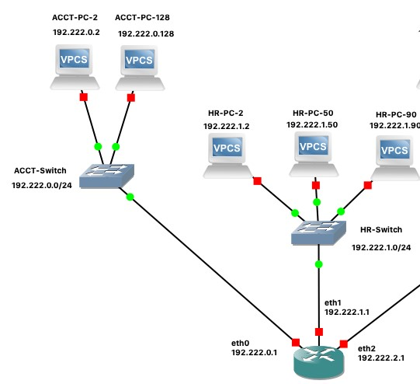

**Submit a screen capture of your GNS3 configuration and screen captures proving you can ping from one machine to all other machines in the subnet. You must ensure each machine has an IP address in the proper range and a gateway for that switch. Ensure you save your configuration for the machines because we will be revisiting this network in future labs.**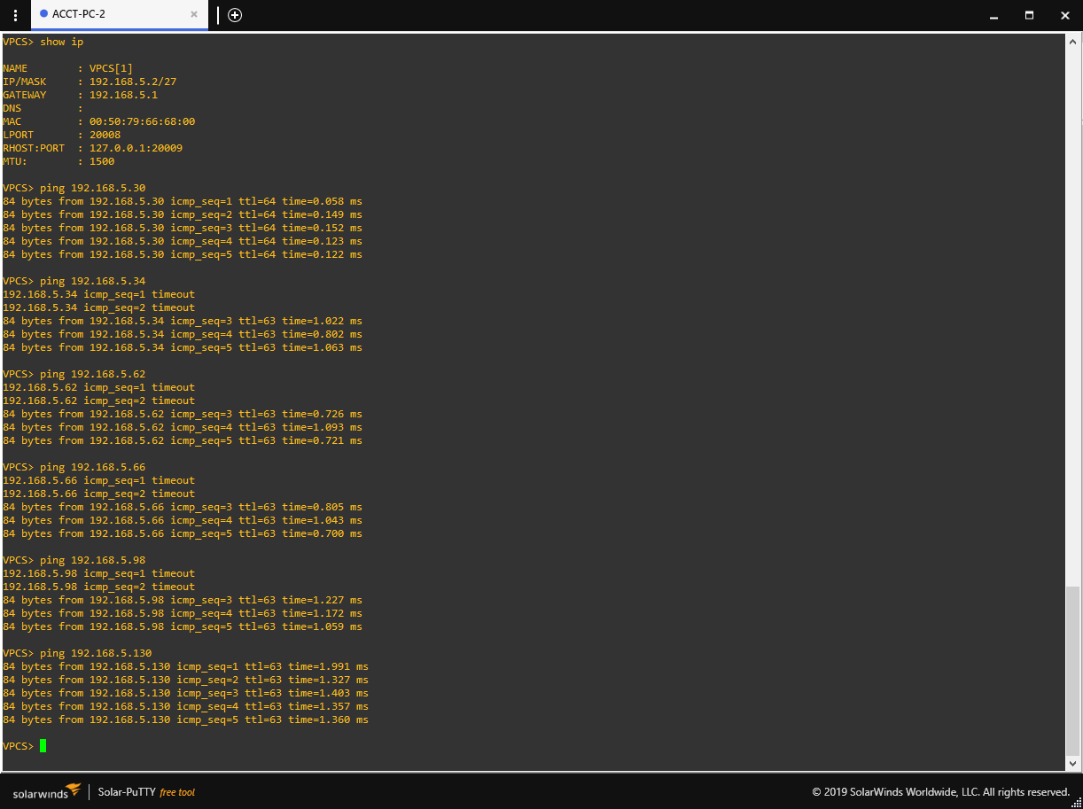

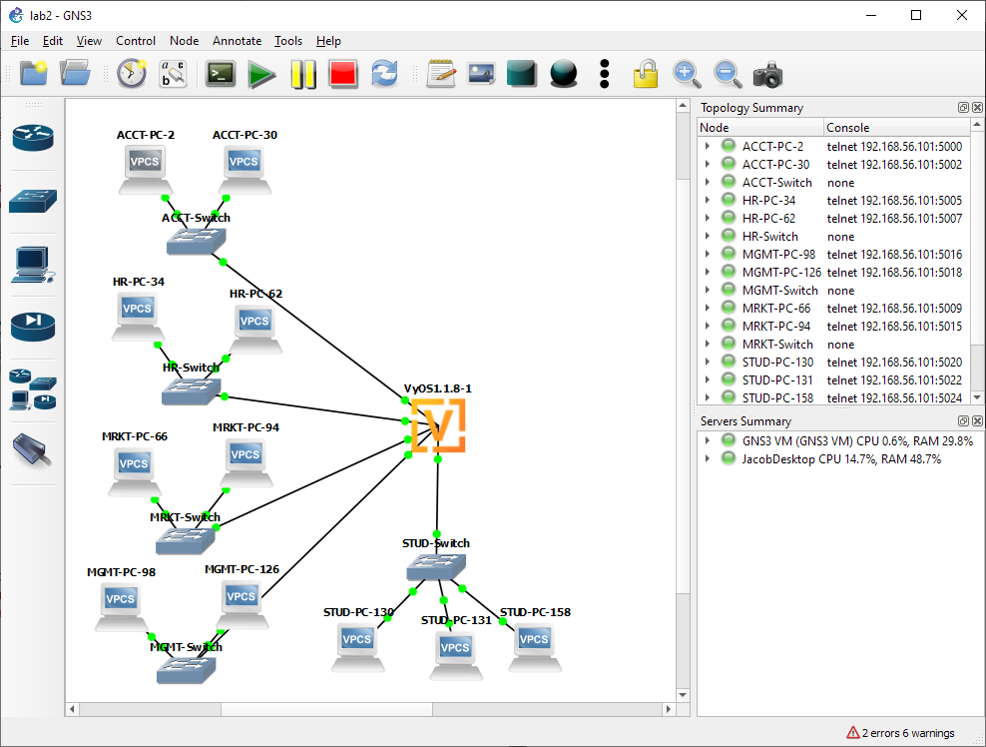

## Section 3: TCP/IP Protocol Suite

One of the most important things a Systems Network Engineer needs to understand is the TCP/IP protocol suite. In this section of the lab, we take a deep dive into the TCP/IP model.

1. **What is the difference between TCP and UDP?**  
   TCP relies on a handshake and is more secure, while UDP instead is connectionless and faster.
2. **What is ARP and what is ARP used for?**   
   Address Resolution Protocol, maps IP addresses to the MAC addresses of clients and is stored locally on each client.
3. **What is DHCP and what is used for?**   
   Dynamic Host Configuration Protocol, a server that assigns IP addresses to devices on a network.
4. **What is APIPA and what is it used for?**  
   Automatic Private IP Addressing, used as a fallback if a client fails to get an IP address.
5. **What is IP address 127.0.0.1 typically used for?**  
   Loopback, can be used for testing.

## Turn In

* Single PDF containing the question and your work.
* Name your pdf your last name first letter of your first name lab2.pdf (Example: steinerslab2.pdf)