1. MDNS, DHCPv6, ARP, SSDP, TLSv1.2, TCP, UDP, NBNS, DNS
2. 0.044907 seconds. Used the default time display setting and marked the GET message as the reference.  
   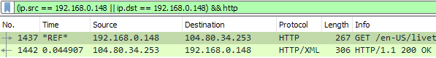
3. Their IP address is 104.80.34.253. My computer’s IP address is 192.168.0.148.  
   
4. Restarted WS, 133 total packets, all of them include my IP. *ip.addr==192.168.0.148*. Reversing the filter (*ip.addr!=192.168.0.148*) still results in 133 packets, but WS warns that != may have unexpected results. The proper filter should be something like *not ip.addr==192.168.0.148*. 131 packets do not contain my IP.
5. There were 4 DNS packets initially, TCP, but no HTTP requests. Looks like around 10600 packets in total. 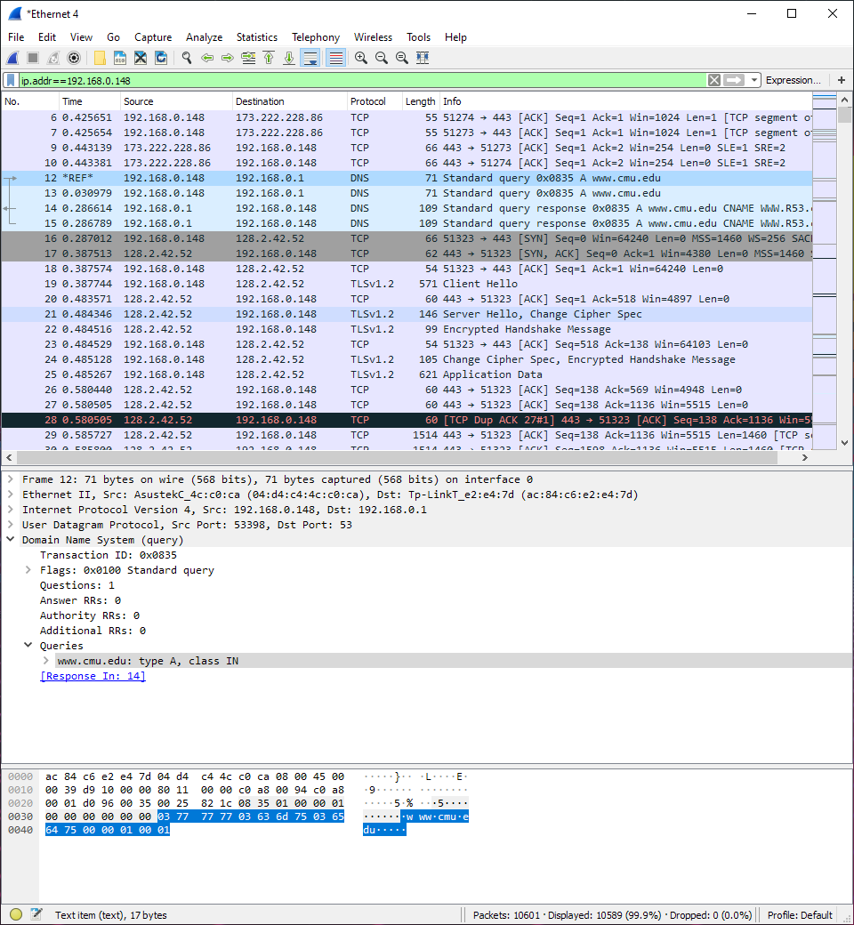  
   Towards the end of the capture, there are several FIN, ACK packets signaling the site finishing up loading? 