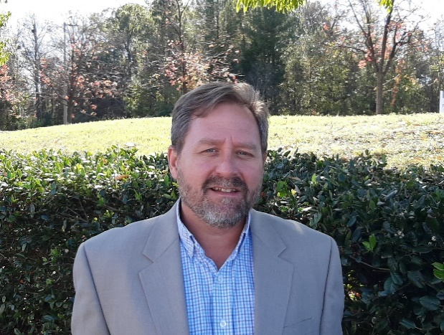Albert Glenn, pe

Education

B.S. - Civil Engineering, University of North Carolina at Charlotte, 1995

Professional Licenses

Professional Engineer, North Carolina

Professional Affiliations

Solid Waste Association of North America (SWANA), North Carolina Chapter

American Society of Civil Engineers

Professional Experience

Over the past 24 years, Albert Glenn has been assisting both public and private entities with solving and managing their environmental compliance and projects. His experience includes engineering and process design, project management, planning, regulatory liaison, federal and state permitting, construction quality assurance (CQA) and quality control. Examples of relevant project experience include:

Facility Environmental Services

**Re-Community Recycling, Charlotte, NC.** Assisted with maintaining compliance, employee training, and monitoring for the facility’s National Pollutant Discharge Elimination System (NPDES) stormwater permit for industrial activities, including preparing a Stormwater Pollution Prevention Plan (SWPPP) and Spill Prevention Control and Countermeasures (SPCC) Plan for the on-site petroleum aboveground storage.

**NDPES Permitting, Stormwater Pollution Prevention Plan (SWPPP), and Training.** Prepared both industrial and construction NDPES permitting and SWPPP for multiple facilities. These facilities include:

* Republic Services, Inc. transfer stations in North Carolina and South Carolina.
* Charlotte Motor Speedway Landfill, Concord, NC
* Lockhart Power, Wellford, SC
* Uwharrie Landfill, Troy, NC
* Anson County Landfill, Polkton, NC
* Electronics Recyclers, Inc., Badin, NC
* Peterman Bus Facilities, Ohio
* Union County Solid Waste Management Facility, Wingate, NC

**Spill Prevention Control and Countermeasures Plan (SPCC) and Training.** Prepared SPCC Plans and implemented the plans for multiple facilities. These facilities include:

* Republic Services, Inc. transfer stations in North Carolina and South Carolina.
* Charlotte Motor Speedway Landfill, Concord, NC
* Lockhart Power, Wellford, SC
* Uwharrie Landfill, Troy, NC
* Anson County Landfill, Polkton, NC
* Electronics Recyclers, Inc., Badin, NC
* Peterman Bus Facilities, Ohio
* Union County Solid Waste Management Facility, Wingate, NC

**Duke Energy, Ash Basin Third Party Engineering Review, Coal-Fired Stations, North Carolina.** Conducted site assessments and provided third-party engineering review for existing ash basins at three (3) coal-fired power plants in North Carolina. The site assessments and engineering review included extent and volume of in-place ash and geotechnical properties and static and seismic stability analysis for basins soil embankments.

**Landfill Gas Migration Remediation, Anson County, NC**. Project Manager. Prepared a remediation plan and system design for the prevention of methane gas migration from the County’s closed Lilesville Landfill property. Once the remediation plan and design was completed, SCS Field Services constructed the selected remedial action in 2014. Since then no methane has been detected outside the Landfill property.

**Waste Management, Great Oak Landfill, Randolph County, SC**. Regulatory permitting, engineering design, and construction documents for a 250,000-gallon aboveground wastewater (leachate) storage tank and secondary containment structure. Included design for the process hydraulics, foundation, tank and reinforced concrete secondary containment, piping, electrical, and process controls.

**New Hanover County Solid Waste Management Facility, Wilmington, NC.** Design modifications to a 20,000-gallon aboveground storage and pumping system for holding and transferring reject liquid from an on-site reverse osmosis wastewater treatment plant. Design included new electric centrifugal pumps, piping, electrical, and process controls.

**Wellford Solid Waste Management Facility, Spartanburg County, SC.** Design aboveground leachate storage tanks and conveyance structures and piping for Wellford Landfill. The project included a 500,000-gallon aboveground storage tank with the ability to put in two additional 500,000‑gallon storage tanks, two pump stations, gravity and pressure piping and connection to an existing pretreatment plant.

**Compliance with 29 CFR 1926.1101 - Asbestos in Construction Standard.** On an on-going basis, prepare written plans for disturbing solid waste that may contain asbestos-containing material and associated notifications to the North Carolina Department of Health and Human Services Health Hazards Control Unit for the following facilities:

* Foothills Landfill, Lenoir, NC
* East Carolina Landfill, Aulander, NC
* Upper Piedmont Landfill, Rougemont, NC
* Anson County Landfill, Polkton, NC