


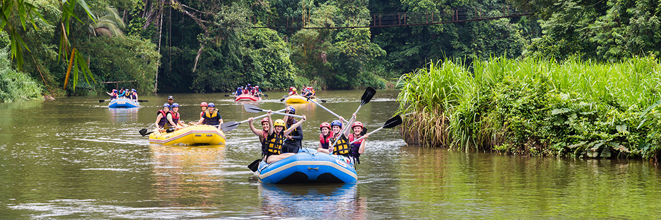
Was this Helpful?
Was this Helpful?
Is this a good trip for kids? What are the age ranges you allow?
Absolutely this is a good trip for children of all ages. We have found however that children over the age of 8 seem to enjoy it more overall (And parents especially enjoy it more if their children are all over 8). A common concern we get from parents is that their children will be bored stuck on a boat for hours at a time. Surprisingly we deal with very few bored children of any age. The areas we are rafting through are some of the most beautiful in the world, and you never know what you might see around any corner. Not to mention the rapids which keep things very interesting. Each boat also comes equipped with a guide. It has been proven that river guides are unable to go for very long at all without telling stories...some of which are even true!

Is whitewater rafting safe? I don't even know how to swim! Can I still come?
As with all adventure sports, there is an inherent and assumed element of risk. To help ensure your safety, our guides are all certified in Wilderness First aid and all start with at least 3 years of rafting experience. The most common injuries are sunburns and injuries that occur on land.
Everyone on commercial rafting trips wears coast guard approved life vest or personal flotation device (PFD). Many non-swimmers go on rafting trips and have a great time. Your guide will give you an in depth and engaging safety talk before your trip begins explaining what you should prepare for and do in the event that you fall out of the raft.

Frequently Asked Questions

