**Extinction and the ESA**—Jacob Malcom

The success of the Endangered Species Act (ESA) is often measured by comparing the number of species declared extinct (n = 10) to the number of listed species (n = 1,652), which indicates success on the order of 99%. But discussions of extinction in status reviews conducted by the U.S. Fish and Wildlife Service (FWS) and the National Marine Fisheries Service (NMFS) suggest many more species are thought extinct. I find that 85 (~5%) ESA-listed species are known or are likely to be extinct, concentrated in Hawaii and in a swath that extends from Mississippi to Virginia. This result has repercussions for how we work on and message threatened and endangered species protection.

* * *

The extinction crisis of the modern era was a key motivation for the ESA. Preventing extinction and recovering species so they are no longer threatened with extinction. One of the ways ESA success is measured is by comparing the number of listed species to the number that are extinct. As of this writing, ten species have been removed from the list of threatened and endangered species, and the list includes 1,652 species. Those numbers suggest 99.4% of species have been saved by the ESA, which is a great accomplishment. But there are a few problems with using the number of species “delisted due to extinction” as the metric of success. First, it ignores the key goal of species recovery and uses the lower bar of mere existence as success. We don’t really consider species on the edge of extinction, or known only to exist in captivity, as successes; success is wildlife out on the landscape. Second, we know that the ten delisted species are simply the ones formally accepted as extinct. But proving extinction is tough; we have too many examples where a species hadn’t been seen for many, many years–multiple decades and even over a century–only to be rediscovered. For such reasons, declarations of extinction are a rare occurrence. At the same time, we often have a very good idea that well-documented species are really-and-truly extinct.

Here I report on the species that experts with FWS and NMFS think are or may be extinct. Declaring extinction may not be warranted for most of these, but the professionals have indicated that extinction is likely to some greater or lesser degree. Getting a better handle on the number of species thought to be extinct rather than relying on the number delisted due to extinction is an important first step in understanding the effectiveness of the ESA.

For this analysis, I consider extinction at a level of experts’ statements that they think the species is or may be extinct, rather than a declaration of extinction. I computationally mined the text of all **~1,400 five-year status reviews, totaling >30,000 pages**, to discover phrases that indicate extinction. This search returned 387 matches from the documents; examples of matches include, “In November and December of 2006, a visual and acoustic survey failed to locate a single baiji leading to conclusions that the baiji is likely extinct”; “The Caribbean monk seal is extinct”; and, “This taxon has not been collected in more than 70 years and is likely extinct.” These matches included both true positives (i.e., the meaning of the matched sentence comports with the idea we have in mind) and false positives (e.g., local extinctions or species previously believed extinct but since re-discovered). To remove the false-positives, I manually checked every 5-year review with a phrase match. From the manually filtered data I found **85 species are likely extinct**, including:

* 44 species from 32 states or territories;
* 31 species of the genus Achatinella (see below); and
* the ten species already delisted due to extinction.

There are three general groupings of extinct species to discuss. First is the split based on geography. A significant number of species were found in a swath extending from Mississippi to Virginia, but most species formerly found in Hawaii (map on next page). The 16 extinct species from outside of Hawaii include—in descending order of frequency—mussels (some likely extinct before listing), birds, mammals, fish, and plants. And some of these are close to “home”: the Maryland darter, from near Baltimore, is likely extinct.

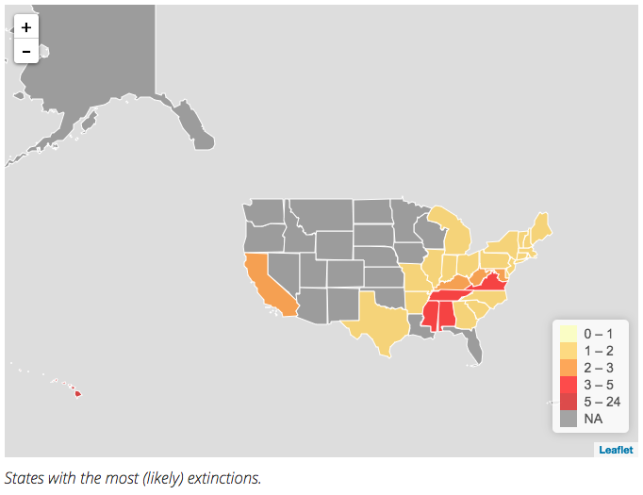

Figure . Extinct species are concentrated in Hawaii and a swath of the Southeastern US.

Most extinct Hawaiian species fall into one of two groups: the plants and the snails. A common theme of the plants in particular—found while I tracked down information on these species—is how few individuals were ever known. For example, the tree *Hibiscadelphus woodii* was only ever known from a tiny area on the side of a volcano; in 2009 a rockslide killed three of the four known plants and the last one was found dead in 2011.[1] The second group of species, the Oahu tree snail genus *Achatinella*, was listed as endangered in 1981. Even then, about 50% of species were thought extinct; today 31 of 43 species are thought extinct. These plants and snails have had to face not only natural threats, but also habitat destruction by humans and invasive species like feral hogs and “forests” of invasive plants. The snails also have to face an invasive predatory snail that was released as a biocontrol against a different invasive snail. The harsh reality is that extinct Hawaiian species happen to be the ones that succumbed to a host of threats faced by the nearly 500 listed species in Hawaii.

*Conclusion*

The phrase “The ESA is 99% effective” used by Defenders and the broader ESA community is almost certainly wrong. I propose we stop using it for three reasons. First, it hides one dire consequence of limited resources for conservation, which is less than 25% of estimated need for recovery. Even if the 85 extinct species cannot be saved with infinite funding, there are still over 1,500 species that need more resources. (This should also raise the critical issue of transparent prioritization.) Second, an opponent of the ESA could easily figure out what I’ve reported here. Not only would it look like we don’t know the species we care about, an opponent is likely to use the numbers as evidence of failure. Instead, I think it’s pretty remarkable that only 5% are likely extinct when so few resources and so little political will are available for conservation and recovery. Third, reliance on extinction as the measure of success ignores the main purpose of the ESA, recovering species. Preventing extinction is fundamental, but the goal is recovery, so we should raise the level of the discussion rather than aiming for the bare minimum.

1. Fortunately for many listed Hawaiian plants there is a dedicated group, the Plant Extinction Prevention (PEP) program, working to document and preserve species: they 20 species as extinct and 17 species extinct or extirpated in the wild, plus the 223 they maintain through cultivation. Unfortunately, [PEP is facing budget cuts](https://qz.com/1007400/the-botanists-last-stand-the-daring-work-of-saving-the-last-samples-of-dying-species/) that severely limit their conservation capabilities.