Part I:

Change the Matlab program to solve 2 dimensional trusses. Use the well-known stiffness matrix for truss elements and validate your program by comparing its answers to hand calculations or to the results of established programs. Please provide a thorough and professional report that documents your efforts.

Part II:

Modify the 2-D MatLab program (or a 3-D version) to conduct geometric nonlinear analysis of truss or frame structures. Your structure must have at least three elements and three active DOFs. You must validate your answer with an analytical solution or comparison to ABAQUS computations. Conduct a parametric study to investigate various solution methods of your choice.

To-Do:

**Introduction (Done)**

Simulation methods

1. Linear solutions
2. Wc
3. Ac
4. Nr
5. Geometric matrix

* write equations

Explain our code

Objects (structure, element, etc)

Interactive program

Numerical Verification and Examples

Arch

Bridge

Bridge

Antenna

Parametric Study

Arch

Bridge

Vary

1. Method
2. lambda increment
3. loading

**Introduction:**

A linear (static) analysis is an analysis where a linear relation holds between applied forces and displacements. Here, the model’s stiffness matrix is constant, and the solving process is short.

Contrarily, a nonlinear analysis is an analysis where a nonlinear relation holds between applied forces and displacements. Nonlinear effects can originate from varied geometrical nonlinearities (i.e. large deformations), material nonlinearities (i.e. elasto-plastic material), non-linear loading and constraints. These effects result in a stiffness matrix which is not constant during the load application and necessitates a different solver to solve such problems.

**(A) Geometric Nonlinearity:**

When there are changes in the geometry of the structure during the analyses, we observe the effects of geometric nonlinearity in the response of the structure.

E.g. **Large deflections of a cantilever beam.**

Consider a cantilever beam loaded vertically at the tip. If the tip deflection is small, the analysis can be considered as being approximately linear. However, if the tip deflections are large, the shape of the structure and, hence, its stiffness changes. In addition, if the load does not remain perpendicular to the beam, the action of the load on the structure changes significantly.

As the cantilever beam deflects, the load can be resolved into a component perpendicular to the beam and a component acting along the length of the beam. Both effects contribute to the nonlinear response of the cantilever beam (i.e., the changing of the beam's stiffness as the load it carries increases).

E.g. **Snap-through behavior of a large shallow panel.**

Here, there is a dramatic change in the stiffness of the panel as it deforms. As the panel “snaps through,” the stiffness becomes negative. Thus, although the magnitude of the displacements, relative to the panel's dimensions, is quite small, there is significant geometric nonlinearity in the simulation, which must be taken into consideration.

**(B) Material Nonlinearity:**

Material non-linearities occur in solid mechanics when the relationship between stress and strain, otherwise known as the constitutive relationship of the material, is no longer linear. The variation of the constitutive relationship also causes the stiffness of the structure or component consisting of the non-linear material to vary also. Thus, the stiffness of the structure or component may vary as a function of the combined or individual load level and load history.

Non-linear material models describe the macroscopic behaviour of the material; hence they are approximations to the real behaviour of the material as the real behaviour is also related to micro-mechanical effects within the material.

For example, the plastic behaviour of metals is related to dislocations and slip planes within the crystal lattice. These defects are assumed to be randomly distributed throughout the material such that a degree of homogeneity can be assumed by the model at a macroscopic level. This allows a uniform macroscopic approximation of the discrete microscopic behaviour of the material over a suitably large volume.

Nonlinear material behaviour in solid mechanics can be broadly divided into 2 buckets:   
rate-independent and rate-dependent.

**Rate-Independent Material Nonlinearity:**

The cases of material non-linearity described under this category are assumed to be independent of time. This is an immediate approximation as all materials are dependent to some degree upon the rate at which the load is applied. The rate dependence for some materials under specific loading conditions is such that it can be neglected, without reasonable loss of accuracy.

Important cases of Rate-Independent Nonlinear Elasticity include nonlinear elasticity and elasto-plasticity.

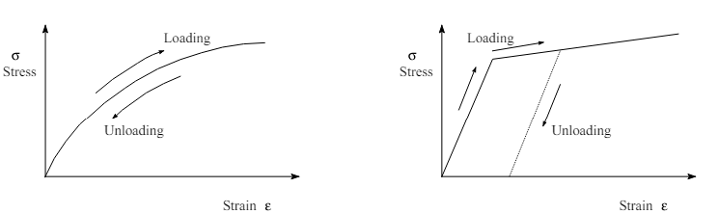

Nonlinear Elasticity Elasto-Plasticity

Elastic, perfectly Plastic Elastic, linear Work-Hardening.

**Rate-Dependent Material Non-linearity:**

Non-linearity described in this category is time dependent. This is true for many materials under specific conditions, where the rate dependency of the material can no longer be neglected.

Examples of such nonlinearity are found in materials displaying visco-plasticity, creep and stress relaxation.

Uniaxial Strain-Time Curve