Relay Oscillography Event Report

Station | Test Substation
Device / Relay ID | SEL-421-Relay
Location / Substation | North Substation 115kV
Relay / Device Type | SEL-421 Distance Relay
Recording Start | 2024-01-01 00:00:00.000
Trigger Time | 2024-01-01 00:00:00.050
Duration | 199.5 ms
Sample Rate | 1920 Hz (32 samples/cycle)
Channels | 7 analog / 4 digital
COMTRADE Revision | 1999
Data Format | ASCII

Event Operations Summary
Parameter | Measured / Detail | Status
Fault Type | Double Line-to-Ground (LLG) | Classified
Fault Inception | 50.52 ms (+0.5 ms from trigger) | Detected
Elements Operated | 51P, 50G, TRIP | Operated
Trip Time | 130.21 ms (+80.2 ms from trigger) [TRIP] | Tripped
Fault Clearing Time | 79.7 ms (inception → trip) | 80 ms
Relay Operate Time (Trip Delay) | 79.7 ms (IEEE time-delay grading reference: varies by coordination) | 80 ms

Peak Measured Quantities
Channel | Peak Magnitude | Units | Type
IA | 960.00 | A | Current
IB | 139.69 | A | Current
IC | 139.69 | A | Current
IN | 960.00 | A | Current
VAN | 6927.96 | V | Voltage
VBN | 7258.91 | V | Voltage
VCN | 7258.91 | V | Voltage

Waveform Record
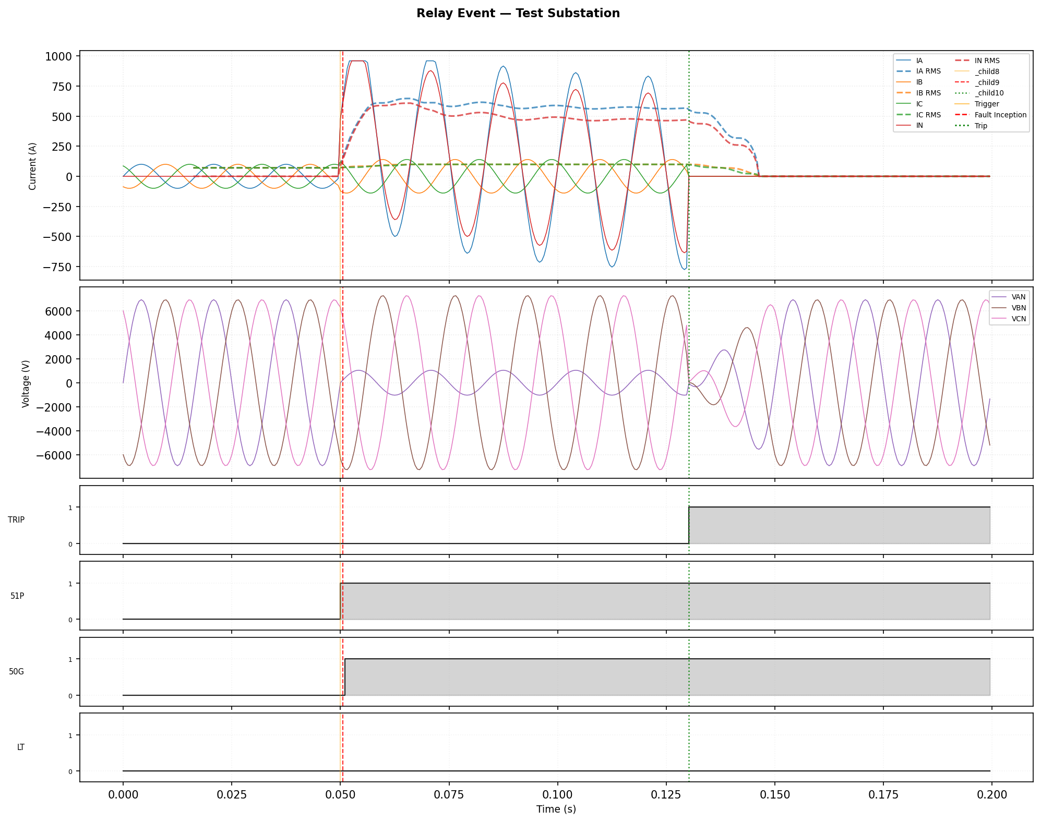
Figure: Three-phase currents, voltages, and digital status. Red dashed line = fault inception. Green dotted line = trip. Orange line = trigger.

Digital Operations Log
Channel | Event | Time (ms) | Rel. Trigger (ms)
51P | ASSERT (0→1) | 50.00 | -0.00
50G | ASSERT (0→1) | 51.04 | +1.04
TRIP | ASSERT (0→1) | 130.21 | +80.21

Analysis Notes
Fault classification: Double Line-to-Ground. Two phases faulted to ground. Often initiated by a single conductor contacting ground and subsequently involving an adjacent phase.

DC Offset:
IA: DC component ≈ 309.7 A | time constant τ ≈ 927.8 ms. DC offset is caused by the point-on-wave of fault inception relative to the voltage zero crossing. Full offset (50% of peak current added as DC) is worst-case for breaker interruption duty.
IN: DC component ≈ 338.8 A | time constant τ ≈ 745.0 ms. DC offset is caused by the point-on-wave of fault inception relative to the voltage zero crossing. Full offset (50% of peak current added as DC) is worst-case for breaker interruption duty.

Symmetrical Sequence Components (post-fault, one-cycle average):
I₁ (Positive) = 312.1 A | I₂ (Negative) = 184.9 A | I₀ (Zero) = 184.5 A
Negative-to-positive ratio: 59% (< 5% expected for balanced 3-phase faults; significant I₂ indicates phase-to-phase or ground fault involvement). Zero-to-positive ratio: 59% (significant I₀ confirms ground fault path).

Prepared by:

Jane Smith
Protection Engineer

