Relay Oscillography Event Report

Station | Maple Ave Feeder
Device / Relay ID | SEL-351R-Recloser
Location / Substation | Maple Ave Feeder — Bay 3
Relay / Device Type | SEL-351R Recloser Controller
Recording Start | 2026-06-01 14:22:15.000
Trigger Time | 2026-06-01 14:22:15.050
Duration | 3199.5 ms
Sample Rate | 1920 Hz (32 samples/cycle)
Channels | 7 analog / 6 digital
COMTRADE Revision | 1999
Data Format | ASCII

Event Operations Summary
Parameter | Measured / Detail | Status
Fault Type | Single Line-to-Ground (SLG) | Classified
Fault Inception | 50.52 ms (+0.5 ms from trigger) | Detected
Elements Operated | 50P, TRIP, 79, 52A, 51P, LOCK | Operated
Trip Time | 66.14 ms (+16.1 ms from trigger) [TRIP] | Tripped
Fault Clearing Time | 15.6 ms (inception → trip) | 16 ms
Relay Operate Time (Trip Delay) | 15.6 ms (IEEE time-delay grading reference: varies by coordination) | 16 ms

Peak Measured Quantities
Channel | Peak Magnitude | Units | Type
IA | 720.00 | A | Current
IB | 99.78 | A | Current
IC | 99.78 | A | Current
IN | 720.00 | A | Current
VAN | 10179.94 | V | Voltage
VBN | 10970.74 | V | Voltage
VCN | 10970.74 | V | Voltage

Waveform Record
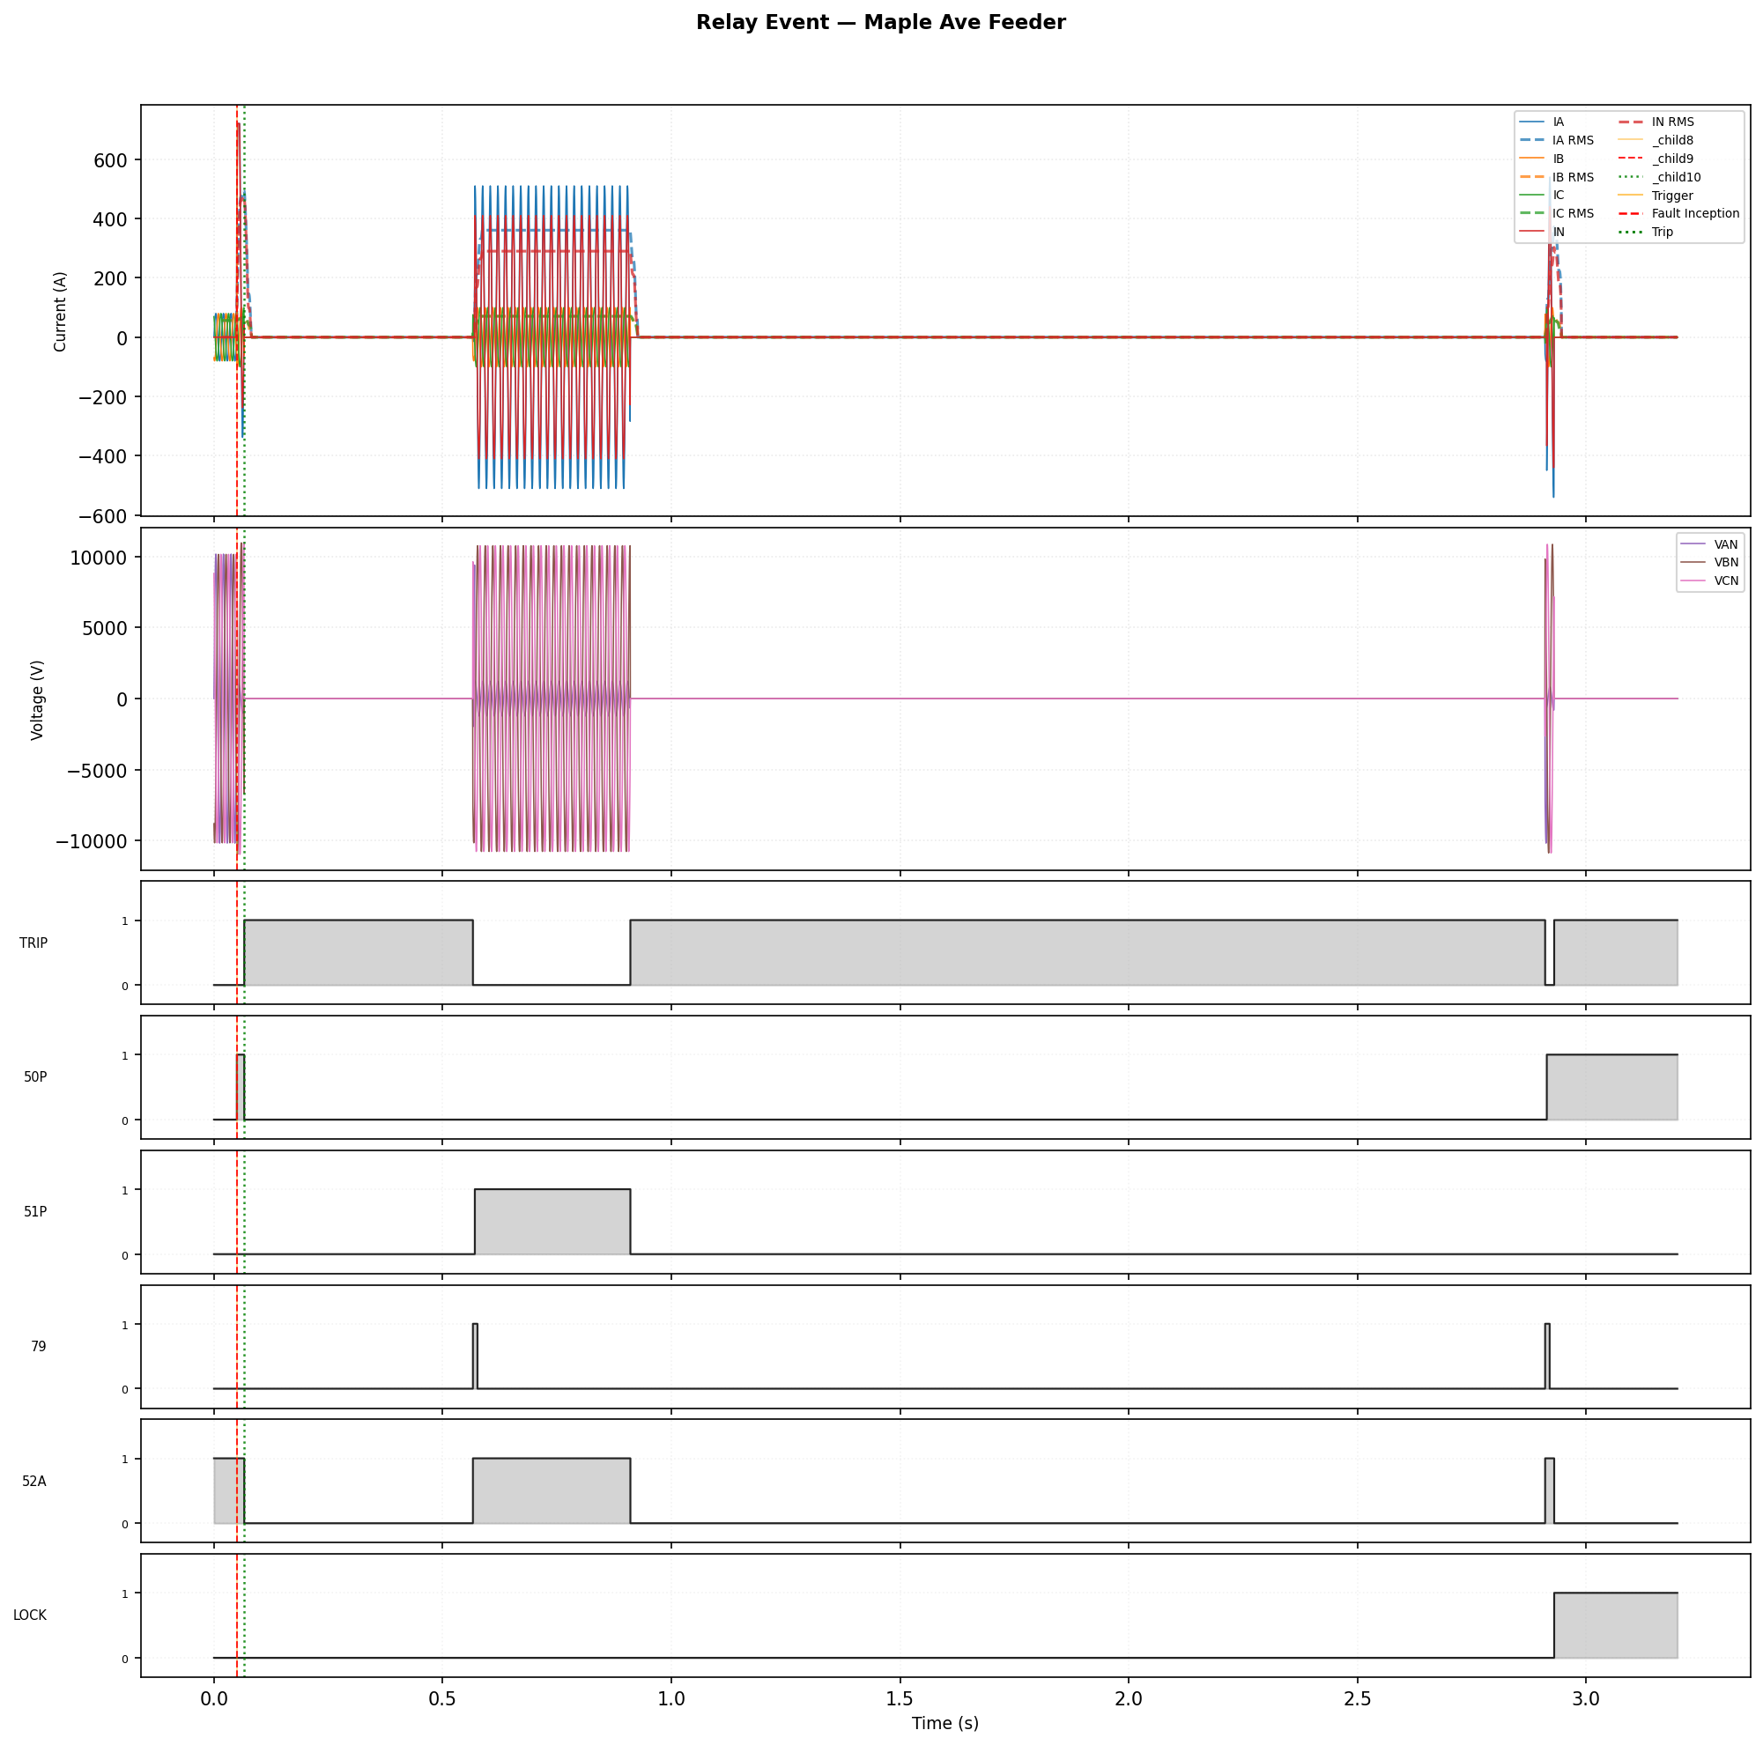
Figure: Three-phase currents, voltages, and digital status. Red dashed line = fault inception. Green dotted line = trip. Orange line = trigger.

Recloser / Feeder Relay Operations
Outcome: LOCKED OUT (permanent fault)
Fault is PERMANENT — device locked out. A line patrol or feeder sectionalizing is required to locate and clear the fault.

Operation Sequence
Shot | Element | Type | Operate Time (ms) | Dead Time (ms) | Outcome
1 | 50P | FAST | 16.1 | 500 | RECLOSED
2 | 51P | SLOW | 340.1 | 2000 | RECLOSED
3 | 50P | FAST | 16.1 | N/A | LOCKOUT

Fault Location Estimate
Faulted phase: A. Estimated distance: ~3.7 miles from the substation. Fault current: 487 A RMS. Apparent fault impedance: 1.48 Ω at 0.400 Ω/mile. Accuracy: ±20–30% without arc resistance / load compensation.

Voltage Recovery After Reclose
Shot 1: Voltage did NOT recover to 90% within the observation window (post-reclose level: 12%). Possible reclose into a still-present fault.
Shot 2: Voltage did NOT recover to 90% within the observation window (post-reclose level: 0%). Possible reclose into a still-present fault.

Digital Operations Log
Channel | Event | Time (ms) | Rel. Trigger (ms)
50P | ASSERT (0→1) | 50.00 | -0.00
TRIP | ASSERT (0→1) | 66.14 | +16.14
50P | RELEASE (1→0) | 66.14 | +16.14
52A | RELEASE (1→0) | 66.14 | +16.14
TRIP | RELEASE (1→0) | 566.14 | +516.14
79 | ASSERT (0→1) | 566.14 | +516.14
52A | ASSERT (0→1) | 566.14 | +516.14
51P | ASSERT (0→1) | 570.31 | +520.31
79 | RELEASE (1→0) | 576.04 | +526.04
TRIP | ASSERT (0→1) | 910.42 | +860.42
51P | RELEASE (1→0) | 910.42 | +860.42
52A | RELEASE (1→0) | 910.42 | +860.42
TRIP | RELEASE (1→0) | 2910.42 | +2860.42
79 | ASSERT (0→1) | 2910.42 | +2860.42
52A | ASSERT (0→1) | 2910.42 | +2860.42
50P | ASSERT (0→1) | 2914.06 | +2864.06
79 | RELEASE (1→0) | 2920.31 | +2870.31
TRIP | ASSERT (0→1) | 2930.21 | +2880.21
52A | RELEASE (1→0) | 2930.21 | +2880.21
LOCK | ASSERT (0→1) | 2930.21 | +2880.21

Analysis Notes
Fault classification: Single Line-to-Ground (A-phase to ground is the most common type, accounting for approximately 70–80% of all transmission faults).

DC Offset:
IA: DC component ≈ 251.6 A | time constant τ ≈ 759.3 ms. DC offset is caused by the point-on-wave of fault inception relative to the voltage zero crossing. Full offset (50% of peak current added as DC) is worst-case for breaker interruption duty.
IB: DC component ≈ 5.1 A | time constant τ ≈ 5788.2 ms. DC offset is caused by the point-on-wave of fault inception relative to the voltage zero crossing. Full offset (50% of peak current added as DC) is worst-case for breaker interruption duty.
IC: DC component ≈ -5.7 A | time constant τ ≈ 5108.7 ms. DC offset is caused by the point-on-wave of fault inception relative to the voltage zero crossing. Full offset (50% of peak current added as DC) is worst-case for breaker interruption duty.
IN: DC component ≈ 274.8 A | time constant τ ≈ 615.6 ms. DC offset is caused by the point-on-wave of fault inception relative to the voltage zero crossing. Full offset (50% of peak current added as DC) is worst-case for breaker interruption duty.

Symmetrical Sequence Components (post-fault, one-cycle average):
I₁ (Positive) = 149.9 A | I₂ (Negative) = 92.0 A | I₀ (Zero) = 87.5 A
Negative-to-positive ratio: 61% (< 5% expected for balanced 3-phase faults; significant I₂ indicates phase-to-phase or ground fault involvement). Zero-to-positive ratio: 58% (significant I₀ confirms ground fault path).

Prepared by:

Jane Smith
Protection Engineer

