**Web Dev Project**

**Prepared by: Jacob Coorey (Student#:5102810816)**

**Date: 2/20/2017**



Contents

Part A 2

Website Function 2

Business Rules and Solution 2

Use Case Interactions 3

Site Map 4

# Part A

## Website Function

The website shall act as a sharing platform for small video clips of games to share between fellow members. The site aims to act as a simple approach to sharing moments in your gaming history, and being able to follow, watch and share your favourite members content. A similar function to recently passed, vine but for game interactions and will allow for a more defined use with games.

## Business Rules and Solution

User will be able to register as a member  
Users as well as members may view categories/profiles/comments  
Members then may log in to access member privileges  
Members uploaded videos will be able to be viewed by other non-members and members  
Members may also return to previous post and edit content description  
Members may follow other members to be notified of when they upload  
Members may repost/share uploads of other members to their profile

## Use Case Interactions

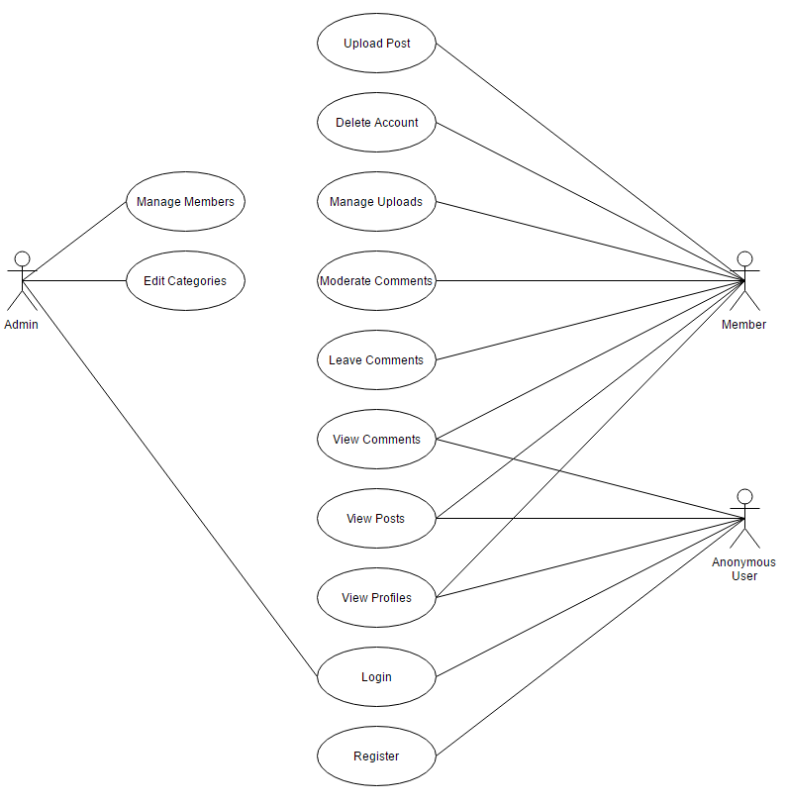

### Registration/Login

Non-member will be able to access a registration form allowing to register as a member/Non-member will be able to access a login form allowing to act as a member

### View Profiles

Members as well as non-members will be able to view profiles containing the member’s public information such as their username and description

### View Posts

Members as well as non-members will be able to view posts including the video, its description as well the comments contained within the post

### Interact with comments

Members will have access to commenting on other member’s videos as well as their own, the member will also be able to moderate the comments on their own post such as delete inappropriate comments

### Manage Uploads

Members will have access to manage their uploads, this will allow them to edit the description of their post or to delete their post entirely

### Account deletion

Members will also be given the option to delete their account through their profile, this will delete any information stored as well as any comments/post made through your account

## Site Map

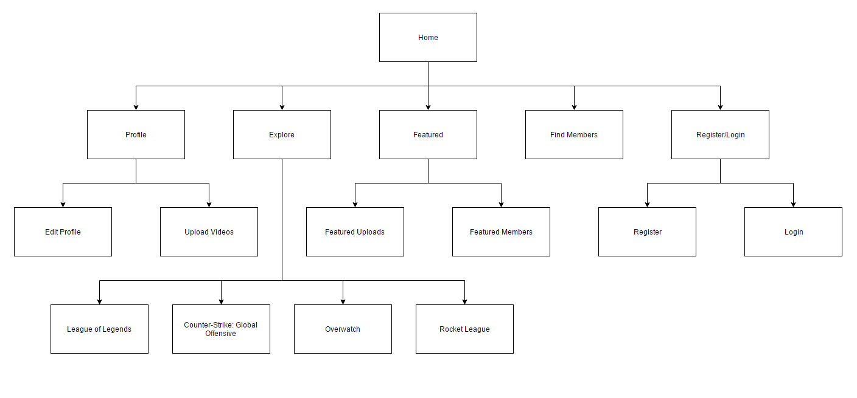

## Data Dictionary

