Building a Predictive Machine Learning Model to Identify Polycystic Ovary Syndrome Using Easily Measured Clinical or Physiological Parameters

Jacob and Hanwei

2023-02-27

## 1. Introduction and Background

### 1.1 Introduction

Our overarching goal for this project is to produce a machine learning (ML) model which can accurately predict polycystic ovary syndrome (PCOS) status (presence or absence of disease) using predictors which may be easily acquired from common clinical settings, for instance, information acquired from a standard blood test and routine clinical examination. PCOS is an endocrine (hormonal) disorder that affects females of a reproductive age1. Given the widespread nature of this condition among women of reproductive age and the troubling symptoms which accompany it, including infertility, it would be helpful for physicians to be able to predict, using inexpensive, minimally-invasive and readily available methods, individuals more likely to experience PCOS thereby enabling them to therapeutically intervene, support, advise or provide care in a timely manner, especially considering PCOS has been associated with other conditions such as endometriosis and endometrial cancer2,5.

### 1.2 Background

Polycystic ovarian syndrome (PCOS) is a common endocrine disorder affecting approximately 10-15% of reproductive-age women worldwide1. The condition is characterized by a complex set of symptoms, including hyperandrogenism, menstrual irregularities, and polycystic ovaries2. The diagnosis of PCOS is typically based on clinical and biochemical assessments, as well as ultrasound imaging of the ovaries1. However, the diagnosis of PCOS can be challenging due to the heterogeneous presentation of symptoms and the lack of a single diagnostic criterion.

Machine learning models have shown promise as a potential tool for the accurate prediction of PCOS. Compared to traditional diagnostic methods, machine learning models can utilize large amounts of data from various sources and provide more accurate predictions. This is particularly beneficial in the case of PCOS, as traditional diagnostic methods such as tissue biopsy or ultrasound imaging can be expensive and invasive. Furthermore, machine learning models can assist clinicians in identifying patients who may benefit from early intervention, which can improve long-term health outcomes1.

Our aim for the PCOS predictive model we are building would be to assist clinicians with identifying women between the ages of 21-47 at highest risk or likely to develop PCOS. Since current methods of PCOS diagnosis often require specialized equipment, we sought to develop a model that used a subset of easily measurable clinical and physiological parameters to predict PCOS, thus enabling early diagnoses to be made and enabling specialized resources to be used in fewer patients as a confirmatory test.

The appropriate ethical approval from Ethics Research Boards was obtained for this ML project. To help ensure privacy fo this ML project, we worked with de-identified anonymized data. In the event an individual was identified as being pregnant or may be at risk of a life-threatening condition, we followed-up immediately with the individual’s physician.

The rationale for developing this predictive model is based on the motivation to (1) provide a data-driven method of diagnosis that is cheaper and less invasive than current methods, (2) develop a method which may be applied without expensive diagnostic equipment (such as an ultrasound imaging device), (3) develop a method which may be used with just a blood test and the review of clinical symptoms and (4) construct a method which relies minimally on self-reported data (as this data can be highly variable and sometimes unreliable). As discussed in the background section of this report, current diagnosis of PCOS can be time-consuming and invasive, and replacing these methods with a model is advantageous for reasons related to clinical care, resource utilization and accessibility. This influenced our variable selection, as we did not consider the inclusion of predictors that cannot be measured in the above stated context in model development. We therefore, for example, exclude self-reported variables or variables which required ultrasound imaging (for example, endometrium thickness).

While accuracy was a key consideration for evaluating model performance, we also focused on optimizing the specificity of the model predictions. The rationale for optimizing specificity was based on the relatively high prevalence of PCOS7 as well as the relatively low mortality associated with the disease1,2,5. Since patients flagged for high risk of PCOS would receive a confirmatory ultrasound, we wanted to select a model that would be biased towards reducing false positives, as one of our goals was reducing the cost and burden of care.

Overall, the use of machine learning models to predict PCOS has the potential to improve the accuracy of diagnosis and reduce the cost and invasiveness of traditional diagnostic methods. We sought to evaluate the comparative accuracy of multiple machine learning classifiers to select the optimal model for predicting PCOS based on variables obtained via a blood test and routine clinical examination, given considerations surrounding false positives and the specificity of our predictive model.

### 1.3 Data

The dataset consists of physical and clinical parameters collected from 10 hospitals across Kerala, India, and from 541 women, to determine PCOS and infertility-related issues. The dataset contains information that can be used to analyze and understand the diagnosis and treatment of PCOS and infertility.

## 2. Objectives

Our objectives were twofold:

1: Develop a simple model that can predict PCOS status using data that can be acquired using a routine blood test and/or assessment by a general practitioner clinician.

2: Optimize the model for specificity, thus minimizing the risk of a false positive in model predictions.

Optimizing model specificity for the prediction of PCOS is important because PCOS is associated with several negative health outcomes, including infertility, insulin resistance, and metabolic disorders. Early diagnosis and treatment of PCOS can help prevent or manage these conditions, which can ultimately improve the overall health and quality of life of those affected. However, given that PCOS is not a life-threatening condition in and of itself, it is important to balance the trade-off between maximizing sensitivity and specificity in order to minimize the number of false positives and prevent unnecessary and potentially invasive follow-up testing. By optimizing model specificity, we can ensure that those who are diagnosed with PCOS are more likely to truly have the condition, while also reducing the risk of unnecessary medical interventions for those who do not have PCOS.

## 3. Methods

### 3.1 Splitting our dataset into training and testing datasets

To ensure data privacy, we worked with de-identified anonymized data. Following our Exploratory Data Analysis (EDA, please refer to Results section for EDA), to mitigate potential model overfitting we applied a 70 % versus 30 % partition of our dataset into the training set and the testing dataset, followed by building a simple model aimed at using our data to find factors that predict PCOS status (our outcome variable). We chose to partition our data into only two sets based on the relatively small overall sample size of our data and small effective sample size of our data. Further, to help determine generalizability, we believe it would be ideal for our predictive model to be validated on an external dataset derived from a different population than our training and test data. For example, an external validation could be performed on PCOS hospital data from different healthcare systems in other southern Indian states such as Tamil Nadu or Karnataka. For an even better gauge of model generalizability, the external validation could be performed on PCOS hospital data obtained from other countries.

### 3.2 Variable selection and building logistic regression models

The rationale for our variable selection and model building incorporated a mix of clinical and statistical perspectives. Within our constraints of using easily obtainable data that did not include self-reported measures, We chose initially to construct three models, one using physiological data only, one using clinical data only, and one using a mix of both. Variables for the models were identified as potentially relevant using a mix of exploratory data analysis and background knowledge. The resulting three models are described below:

* 1. Model 1 is the physiological model which includes six hormones and micronutrients of interest, namely hormone measurements of n=5 different types of hormones commonly included or easily measured/acquired as a part of a standard routine blood test, as well as vitamin D.
  2. Model 2 is the clinical model, including as variables clinical symptoms associated with PCOS, and specifically clinical symptoms which may be easily determined as a part of a routine examination by a physician. These are the variables included in the clinical model: weight gain, hair growth, skin darkening, hair loss, and acne.
  3. Model 3 includes both the physiological and clinical variables, that is the n=5 the hormone measurement levels, vitamin D, as well as the clinical symptoms that have been known to be associated with PCOS: weight gain, hair growth + skin darkening, hair loss and pimples (clinical symptoms which may be easily identified or tracked in a basic clinical setting).

To assess the relative fit and performance of these three models, we started with a simple logistic regression method. We fit the three models described above and compared the Akaike Information Criteria (AIC) as well as the Area Under the Receiving Operator Characteristic (AUC). Following this initial selection, we selected the two models with the best balance between both of these parameters, as well as clinical utility and applied various machine learning training methods to optimize model performance. We used the caret package to implement our various machine learning models.

We applied regularization methods, boosting methods, as well as random forest modelling using the variable combinations identified using the simple logistic regression approach.

This left us with a 6-way comparision: compared the performance of two different variable combinations (clinical only vs. clinical and physiologic) across three different machine learning methodologies (LASSO vs. Random Forest vs. XGBoost) to estimate the outcome of interest.

The rationale for testing both models with machine learning optimization was to assess if a simpler model with clinical parameters only could approximate the classification performance of a more complex model. The final model was selected based on a balance of accuracy, specificity, and clinical ease of use.

## 4. Results

### 4a. Exploratory Data Analysis (EDA)

This section contains the steps and output for the EDA performed on the PCOS dataset. The section proceeds sequentially with each step of EDA (please see Appendix for more details). The first steps in our EDA involved getting a high-level overview of our dataset and determining the dimension of our data: n=541 rows and n=45 columns. Further checking of the dataset reveals an additional column (column 45). This column does not contain any useful information and is not one of our 44 features, therefore the column was removed.

### 4a.1 Data Wrangling

The data was formatted to ensure the variables are the appropriate class type, this will enable us to perform our EDA. Specifically we converted binary variables (1 or 0) into the character class type.Next in our EDA we sought to identify missing values in our dataset. Figure A1 in Appendix A shows the missing values in our dataset. Our EDA identified some missing values for two variables: fast food and marriage status. The analysis indicates that only 0.18% of the rows for these variables are missing. Therefore, as this is below the generally used threshold of 5 %, missing values were simply removed for our subsequent analyses.

### Table 1: Clinical and sociodemographic characteristics of the study cohort (n=541, women from Kerala, India) stratified by PCOS status

|  | PCOS Negative (N=364) | PCOS Positive (N=177) | Overall (N=541) |
| --- | --- | --- | --- |
| Age |  |  |  |
| Mean (SD) | 32.1 (5.36) | 30.1 (5.29) | 31.4 (5.41) |
| Median [Min, Max] | 32.0 [20.0, 48.0] | 29.0 [21.0, 47.0] | 31.0 [20.0, 48.0] |
| BMI |  |  |  |
| Mean (SD) | 23.7 (3.76) | 25.5 (4.40) | 24.3 (4.06) |
| Median [Min, Max] | 23.6 [13.4, 38.3] | 25.1 [12.4, 38.9] | 24.2 [12.4, 38.9] |
| Pulse rate |  |  |  |
| Mean (SD) | 73.0 (5.03) | 73.8 (2.73) | 73.2 (4.43) |
| Median [Min, Max] | 72.0 [13.0, 82.0] | 72.0 [70.0, 82.0] | 72.0 [13.0, 82.0] |
| Respiratory rate |  |  |  |
| Mean (SD) | 19.2 (1.71) | 19.3 (1.65) | 19.2 (1.69) |
| Median [Min, Max] | 18.0 [16.0, 28.0] | 20.0 [16.0, 24.0] | 18.0 [16.0, 28.0] |
| Hemeglobin (g/dl) |  |  |  |
| Mean (SD) | 11.1 (0.880) | 11.3 (0.831) | 11.2 (0.867) |
| Median [Min, Max] | 11.0 [8.50, 14.8] | 11.0 [9.40, 14.0] | 11.0 [8.50, 14.8] |
| Pregnancy status |  |  |  |
| No | 222 (61.0%) | 113 (63.8%) | 335 (61.9%) |
| Yes | 142 (39.0%) | 64 (36.2%) | 206 (38.1%) |
| Human chorionic gonadotropin (IU/ml) |  |  |  |
| Mean (SD) | 729 (3540) | 532 (2920) | 665 (3350) |
| Median [Min, Max] | 13.7 [1.30, 32500] | 70.5 [1.92, 30000] | 20.0 [1.30, 32500] |
| Follicle stimulating hormone (IU/ml) |  |  |  |
| Mean (SD) | 19.2 (265) | 5.17 (5.74) | 14.6 (217) |
| Median [Min, Max] | 5.01 [0.210, 5050] | 4.48 [1.00, 65.4] | 4.85 [0.210, 5050] |
| Lutenizing hormone (IU/ml) |  |  |  |
| Mean (SD) | 2.61 (2.10) | 14.4 (151) | 6.47 (86.7) |
| Median [Min, Max] | 2.31 [0.0200, 14.7] | 2.22 [0.0320, 2020] | 2.30 [0.0200, 2020] |
| Thyroid stimulating hormone (IU/ml) |  |  |  |
| Mean (SD) | 3.01 (4.14) | 2.93 (2.82) | 2.98 (3.76) |
| Median [Min, Max] | 2.17 [0.0400, 65.0] | 2.31 [0.0500, 22.6] | 2.26 [0.0400, 65.0] |
| Anti-mullerian hormone (ng/ml) |  |  |  |
| Mean (SD) | 4.54 (4.29) | 7.84 (7.79) | 5.62 (5.88) |
| Median [Min, Max] | 3.20 [0.160, 26.8] | 5.90 [0.100, 66.0] | 3.70 [0.100, 66.0] |
| Missing | 1 (0.3%) | 0 (0%) | 1 (0.2%) |
| Prolactin (ng/ml) |  |  |  |
| Mean (SD) | 24.3 (15.5) | 24.4 (13.9) | 24.3 (15.0) |
| Median [Min, Max] | 21.2 [0.400, 128] | 22.9 [3.64, 112] | 21.9 [0.400, 128] |
| Vitamin D (ng/ml) |  |  |  |
| Mean (SD) | 29.3 (12.4) | 92.3 (604) | 49.9 (346) |
| Median [Min, Max] | 26.3 [9.01, 90.0] | 25.5 [0, 6010] | 25.9 [0, 6010] |
| Progesterone (ng/ml) |  |  |  |
| Mean (SD) | 0.727 (4.64) | 0.372 (0.174) | 0.611 (3.81) |
| Median [Min, Max] | 0.310 [0.110, 85.0] | 0.320 [0.0470, 1.10] | 0.320 [0.0470, 85.0] |
| Random blood sugar (mg/dl) |  |  |  |
| Mean (SD) | 99.2 (15.5) | 101 (23.6) | 99.8 (18.6) |
| Median [Min, Max] | 96.0 [60.0, 225] | 100 [70.0, 350] | 100 [60.0, 350] |
| Recent weight gain |  |  |  |
| No | 281 (77.2%) | 56 (31.6%) | 337 (62.3%) |
| Yes | 83 (22.8%) | 121 (68.4%) | 204 (37.7%) |
| Recent hair growth |  |  |  |
| No | 317 (87.1%) | 76 (42.9%) | 393 (72.6%) |
| Yes | 47 (12.9%) | 101 (57.1%) | 148 (27.4%) |
| Recent skin darkening |  |  |  |
| No | 308 (84.6%) | 67 (37.9%) | 375 (69.3%) |
| Yes | 56 (15.4%) | 110 (62.1%) | 166 (30.7%) |
| Recent hair loss |  |  |  |
| No | 221 (60.7%) | 75 (42.4%) | 296 (54.7%) |
| Yes | 143 (39.3%) | 102 (57.6%) | 245 (45.3%) |
| Recent onset acne |  |  |  |
| No | 222 (61.0%) | 54 (30.5%) | 276 (51.0%) |
| Yes | 142 (39.0%) | 123 (69.5%) | 265 (49.0%) |

For this table, we have included only the parameters we deemed eligible for the model. Thus, we have excluded self-report variables, expensive and/or invasive tests, and clinical variables not easily measured by a routine clinical examination or a blood test.

From table 1, we can observe some qualitative differences among women with and without PCOS in the following parameters: Clinical: cycle_r_i, cycle_length_days, weight_gain_y_n, hair_growth_y_n, skin_darkening_y_n, hair_loss_y_n, pimples_y_n, reg_exercise_y_n

Physiologic: i_beta_hcg_m_iu_m_l (Human chorionic gonadotropin), fsh_m_iu_m_l (Follicle Stimulating hormone), lh_m_iu_m_l (Lutenizing hormone), amh_ng_m_l (Anti-mullerian hormone), vit_d3_ng_m_l (Vitamin D), prg_ng_m_l (Progesterone).

### 4a.2 Bivariate associations

We visualized associations for selected categorical predictors and the outcome (PCOS) by constructing bivariate plots for the predictors stratified by PCOS status4.

#### Figure 1. Plotting categorical associations for clinical variables deemed eligible for modelling (clinical variables easily determined during a routine clinical examination)

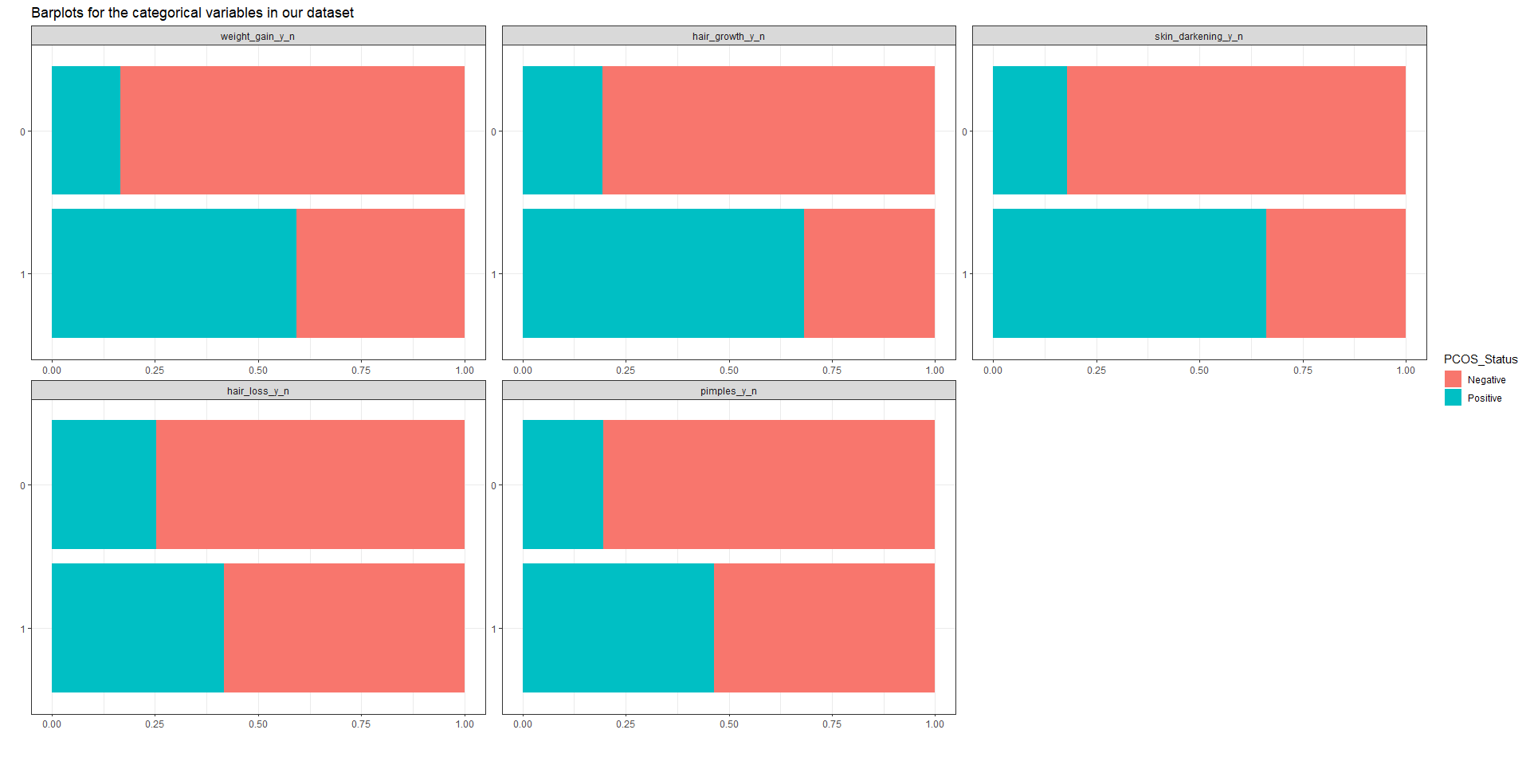

From the figure, we can see that the proportion of individuals with weight gain and a positive PCOS status is greater than the proportion of individuals with no weight gain and a positive PCOS status. We observe similar associations for hair growth and skin darkening. We also observe a similar but much weaker association for the categorical variables of hair loss and pimples. As these predictors appear to be visually associated with the outcome, as well as physiologically feasible to be associated with PCOS, they should be considered for inclusion in the predictive model.

While the etiology for PCOS is not known, our literature survey suggests PCOS is associated with abnormal hormone levels1. Thus, we compared measurements of hormone levels and PCOS status to get a sense of the relationships between these variables.

#### Figure 2. Boxplots looking at relationship of selected physiologic parameters and PCOS status (note log-scale on y-axis)

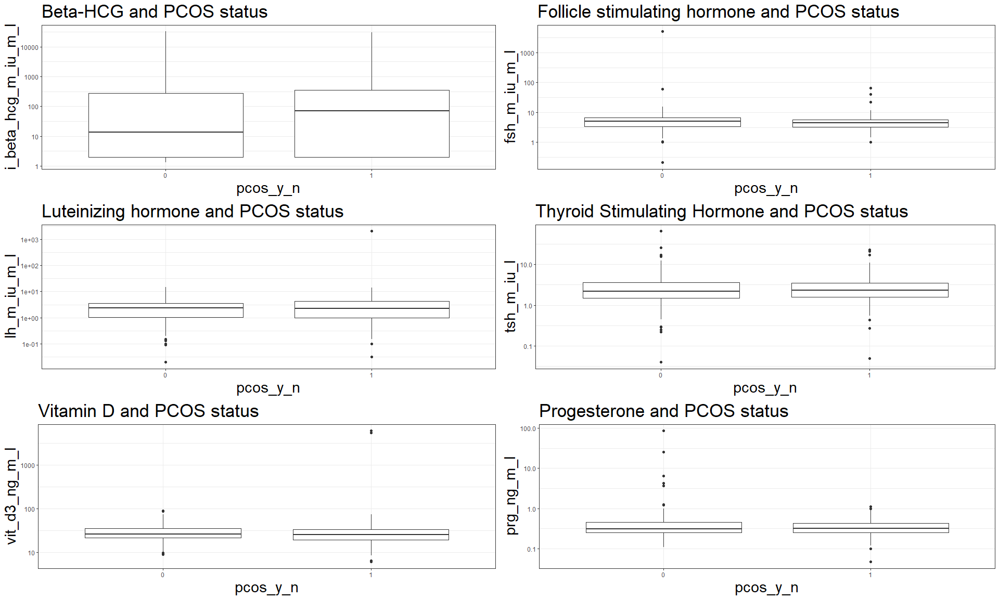

### Table 2. Assessing fit and accuracy for three different variable combinations

|  |  |  |
| --- | --- | --- |
| Model | AIC | ROC |
| Physiologic Model | 450.3339 | 0.6976283 |
| Clinical Model | 330.5912 | 0.8635065 |
| Physiologic and Clinical Model | 320.2643 | 0.8831598 |

### 4.1 Assessing model classification performance

Of our three logistic regression models, the clinical and physiological model had the lowest AIC score of 320, followed by the clincal model with an AIC score of 330. However, the predictive performance as assessed by AUC was higher for the clinical and physiological model (0.88) than the clinical model (0.86). The clinical and physiologic model also required more parameters for prediction that require blood testing.

Based on these results, we will compare the clinical model to the full clinical and physiological model. While the model including clinical predictors only is more simple both technically (as evidenced by the AIC) and practically (less inputs and no blood testing required), there is an approximate 10% drop in accuracy when excluding the physiological data. We will select these two models and compare performance in applying various machine learning methods below.

### 4.1.1 - Assessing penalized logistic regression with cross-validation for (RIDGE and LASSO), and Elastic Net (comparison of regularization methods)

### Table 3. Comparison of regularization methods across two models for predicting PCOS status

|  |  |  |
| --- | --- | --- |
| Model | Method | ROC |
| Clinical and Physiologic | ElasticNet | 0.8567290 |
| Clinical | ElasticNet | 0.8640776 |
| Clinical and Physiologic | LASSO | 0.4790018 |
| Clinical | LASSO | 0.8558824 |
| Clinical and Physiologic | Ridge | 0.4790018 |
| Clinical | Ridge | 0.8558824 |

ElasticNet appeared to outperform both LASSO and Ridge regression in terms of classification performance. We selected ElasticNet as the top performer among regularization methods and compared it with XGboost and tree-based methods on the test set.

### 4.2 Modelling our data using Trees and Forests

We next pursued a Random Forest approach for our selection of variables, using both the Clinical and Clinical + Physiological Parameters for our Random Forest Modelling. Random Forest modelling was also used to examine variable importance (Appendix plot 5).

### Table 4. Comparative performance of two models across three different modelling methodologies on the test data

|  |  |  |  |  |  |  |  |  |
| --- | --- | --- | --- | --- | --- | --- | --- | --- |
|  | Model | | Accuracy | | Sensitivity | | Specificity | |
| Clinical Parameters: Random Forest | | 0.881 | | 0.712 | | 0.963 | |
| Clinical and Physiologic Parameters: Random Forest | | 0.850 | | 0.615 | | 0.963 | |
| Clinical Parameters: XGBoost | | 0.844 | | 0.635 | | 0.944 | |
| Clinical and Physiologic Parameters: XGBoost | | 0.819 | | 0.481 | | 0.981 | |
| ElasticNet: Clinical Parameters | | 0.864 | | 0.934 | | 0.540 | |
| ElasticNet: Clinical and Physiological Parameters | | 0.857 | | 0.936 | | 0.522 | |

## 5. Discussion and Conclusion

### 5.1 Discussion

The tested modelling strategies produced a wide variability in accuracy, sensitivity, and specificity. While we observed higher sensitivity when using ElasticNet to fit the models, regardless of whether physiologic variables were included, XGBoost and Random Forest methods were better suited to optimizing specificity, and tended to have similar accuracy when compared to ElasticNet methods.The model that best balanced accuracy, specificity and clinical utility was the Random Forest model with clinical parameters (n=5 clinical symptoms: weight gain, hair growth + skin darkening, hair loss and pimples). This model performed with the highest accuracy, second highest specificity, and incorporated the simplest set of parameters to make predictions. This finding is supported by recent commentaries in the literature that indicate Random Forest models perform the most accurately on a wide variety of datasets6.

One of the drawbacks of the Random Forest is its black box nature, making it harder to determine and/or interpret how the model is making its predictions. This could pose a challenge to clinicians trying to troubleshoot or improve upon the model. However, this model is simple and requires few parameters, which may offset this inherent lack of interpretability. An additional advantage of our clinical model is the fact that we do not require the collection and storage of physiological parameters such as the hormones human chorionic gonadotropin (HCG) and anti-mullerian hormone (AMH), which may be used as indicators/proxies to determine pregnancy status and fertility respectively. This is sensitive data to patients and limiting the scope and invasiveness of data collection allows for better control of risk of harm to patients, as less data is vulnerable to access by predatory actors.

### 5.2 Conclusions

PCOS status can be predicted with a reasonably high level of accuracy (88.1% with our model) using a clinical parameters that are easily measurable in a general clinical practice setting. By optimizing for specificity, patients likely to be PCOS positive can be selected for more expensive and invasive testing, thus reducing the cost of care and improving patient experience for the population of at-risk individuals Implementation of model-based screening should be considered particularly in resource-limited settings, where access to advanced diagnostics is challenging due to cost or geography.

## References

1. Teede, H., Misso, M., Tassone, E. C., Dewailly, D., Ng, E. H., Azziz, R., … & Norman, R. J. (2018). Recommendations from the international evidence-based guideline for the assessment and management of polycystic ovary syndrome. Human Reproduction, 33(9), 1602-1618. <https://doi.org/10.1093/humrep/dey256>
2. Bozdag, G., Mumusoglu, S., Zengin, D., & Karabulut, E. (2016). The prevalence and phenotypic features of polycystic ovary syndrome: a systematic review and meta-analysis. Human Reproduction, 31(12), 2841–2855. <https://doi.org/10.1093/humrep/dew218>
3. R for Data Science by Hadley Wickham (<https://r4ds.had.co.nz>)
4. Ajmal N, Khan SZ, Shaikh R. Polycystic ovary syndrome (PCOS) and genetic predisposition: A review article. Eur J Obstet Gynecol Reprod Biol X. 2019 Jun 8;3:100060. doi: 10.1016/j.eurox.2019.100060. PMID: 31403134; PMCID: PMC6687436.
5. Hart R, Doherty DA. The potential implications of a PCOS diagnosis on a woman’s long-term health using data linkage. J Clin Endocrinol Metab. 2015 Mar;100(3):911-9. doi: 10.1210/jc.2014-3886. Epub 2014 Dec 22. Erratum in: J Clin Endocrinol Metab. 2015 Jun;100(6):2502. PMID: 25532045.
6. Fernández-Delgado, M., Cernadas E., Barro S., Amorim D. Do we need hundreds of classifiers to solve real world classification problems? The Journal of Machine Learning Research. Volume 15. Issue 1, pp 3133–3181.
7. Deswal R, Narwal V, Dang A, Pundir CS. The Prevalence of Polycystic Ovary Syndrome: A Brief Systematic Review. J Hum Reprod Sci. 2020 Oct-Dec;13(4):261-271. doi: 10.4103/jhrs.JHRS_95_18. Epub 2020 Dec 28. PMID: 33627974; PMCID: PMC7879843.

## Appendix

#### Appendix Plot 1, as part of EDA, showing missing values in our dataset

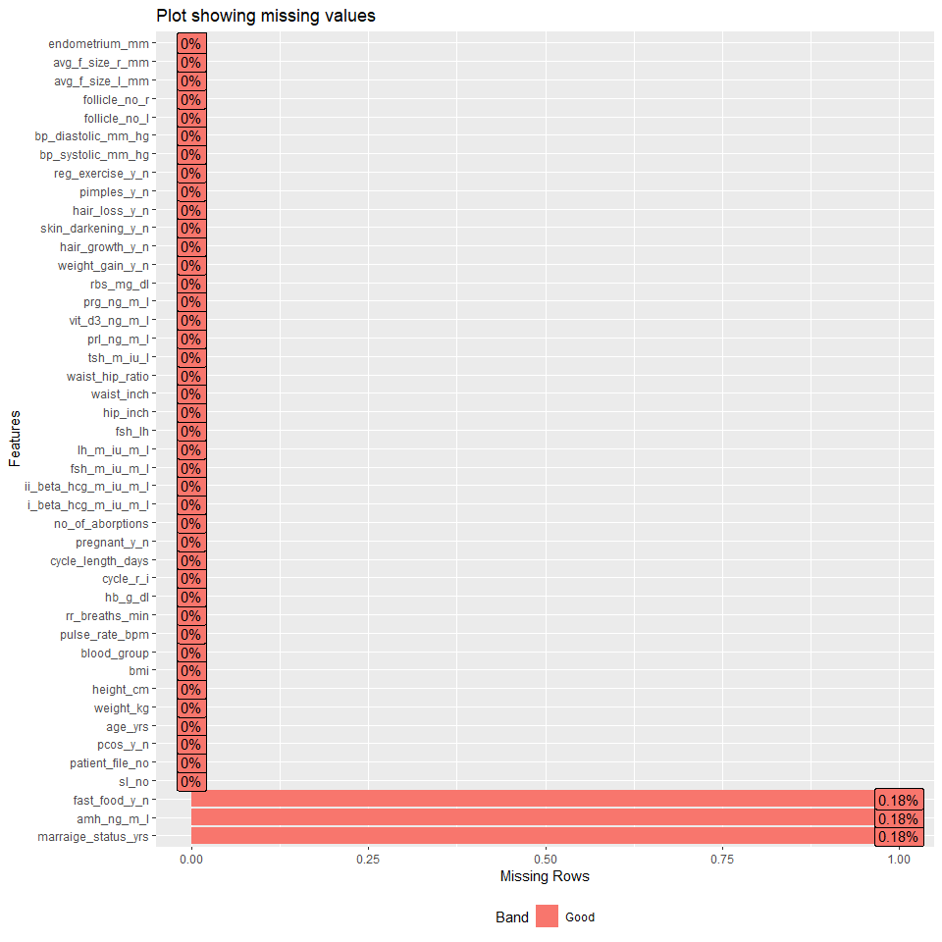

#### Appendix plot 2, as part of EDA, bivariate analysis examining correlations between continuous features

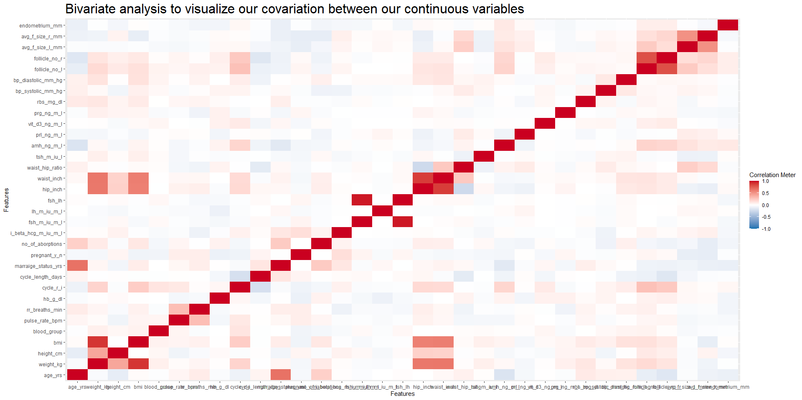

* From this correlation plot, we find that several continuous variables do co-vary with one another.
* Specifically, as we would expect, we find a positive correlation between the variables waist and hip (in inches) with weight. We find the same positive correlation for BMI.
* Another obvious correlation we observe is that between age (in years) and marriage (in years)
* Appendix Plot 3 showing boxplots generated to investigate potential associations between continuous variables and PCOS status.

### Appendix Plot 3 - Univariable distributions for continuous variables

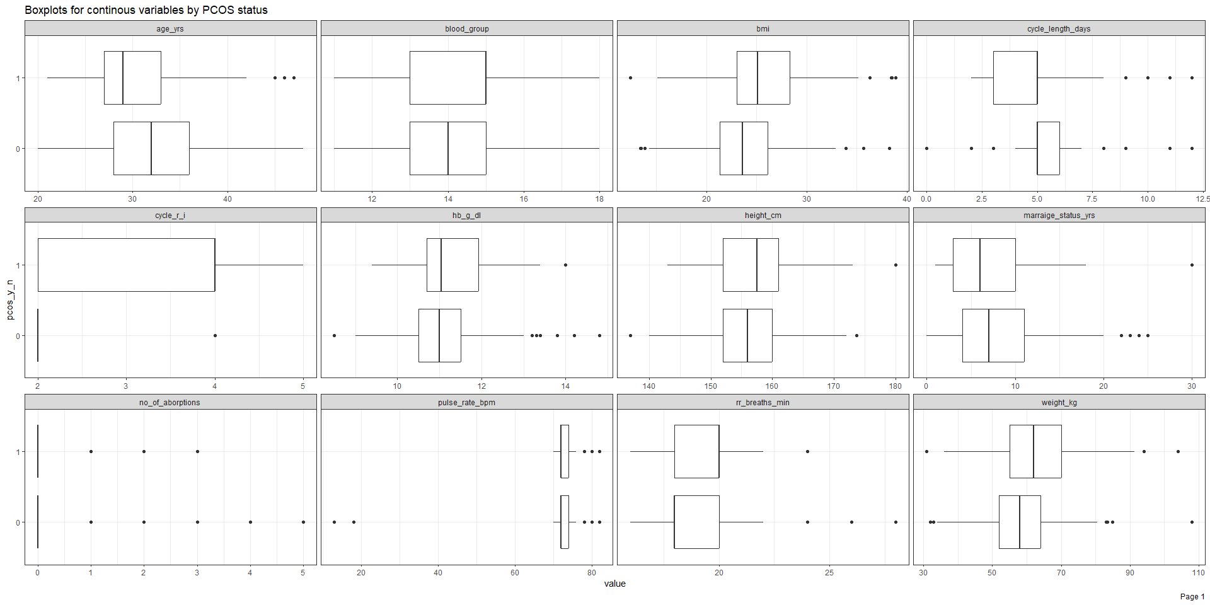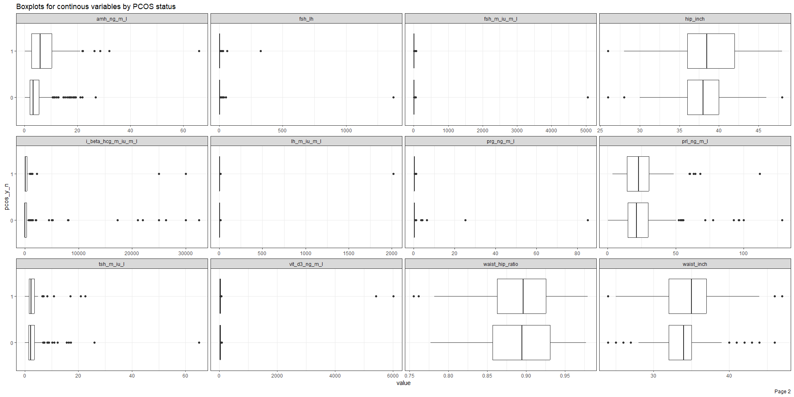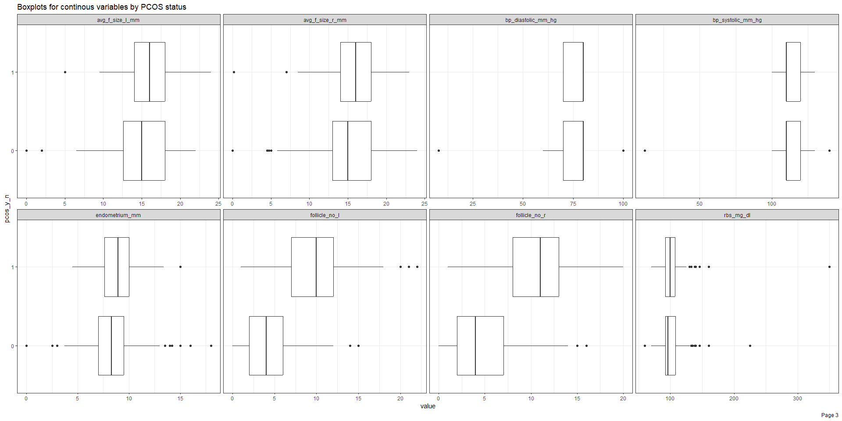 * Boxplots showing the distributions of continuous variables in our dataset, stratified by PCOS status.

#### Appendix Plot 4. ROC curves: physiological model (red) vs. clinical model (blue) vs. clinical and physiologic model (green)

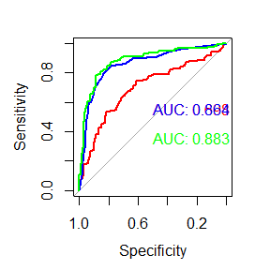

* ROC plot showing the ROC curves for our simple logistic regression modelling using three different variable selections (based on clinical variables only, physiological variables only, and both clinical and physiological variables).

### Appendix Plot 5 - Variable importance (based on Random Forest model)

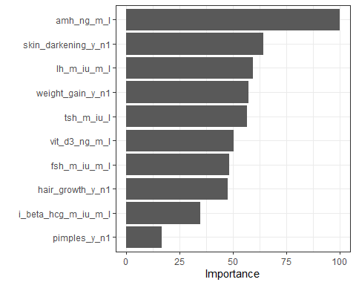

* Plot showing variable importance based on random forest modelling. We decided to adopt an approach of utilizing clinical and contextual knowledge for variable selection, and therefore, based on this we did not drop or remove any of the variables we deemed relevant for our modelling.