1. https://github.com/jacob7140/TestDrivenDevelopment_Lab3

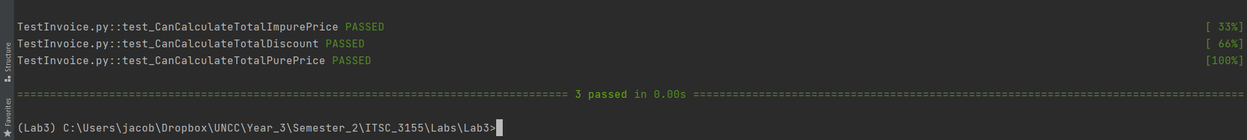

1. You design a test case by making sure the generated output matches an expected output
2. Text

   Description automatically generated