# Coupling a global climate scenario, general circulation models, and lake models to partition uncertainty in the projected thermal budget of a northern oligotrophic lake

## Abstract

Using the representative concentration pathway (RCP) 8.5 scenario coupled with four general circulation models (GCMs), an ensemble modelling approach using 5 general lake models will be applied to the northern oligotrophic Lake Sunapee. The output of the ensemble model will include temperature profiles and ice coverage from 1986 to 2099. Using these projections, insights regarding the thermal budget of Sunapee will be discussed such as stratification strength and depth, mixing, and water column temperature. Ice coverage projections will be presented and discussed as well. The outputs of the ensemble models will include sufficient information to carry out uncertainty propagation in relation to climate model uncertainty, parameter uncertainty, ecosystem model process uncertainty, and climate scenario uncertainty. The results of this study will be relevant to both stakeholders of Lake Sunapee as well as climate modelers and researchers.

## Introduction

Due to human activities, freshwater ecosystems around the globe are increasingly changing. Clear water, or oligotrophic, lakes provide critical ecosystem services such as drinking water yet are experiencing relatively abrupt and severe water quality problems attributed to climate change and land development. Because of this, new tools to predict future water quality are vital to improving the management of oligotrophic lakes and combat water quality degradation. In this project, the focus of this research will be Lake Sunapee, an oligotrophic lake in New Hampshire and important drinking water source. Lake Sunapee is an exemplary case study for understanding how currently high-water quality lakes are being rapidly degraded due to human activities.

Thermal stratification in lakes is a known regulator of physical, chemical and biological processes in lakes and reservoirs, contributing to primary production depth 1, quality of fisheries habitats 2, deep-water oxygen levels 34 and atmospheric gas exchange 56.7 The effects of climate change on stratification is less known, however the effects on temperate lakes appears to be a slow but steady regime shift from multiple mixing annually (polymictic and dimictic) to a single mixing event (monomictic). 8 This could be potentially devastating for the ecosystems residing within Lake Sunapee, which are acclimated to multiple mixing for a relatively static duration every year. Processes such as primary production, fish habitation and atmospheric gas exchange could shift dramatically from the status quo.

The study uses the representative concentration pathway (RCP) 8.5 scenario, which combines assumptions about multiple ecological and sociological factors, including high population, slow income growth, and modest technological change and energy intensity improvements. 9 Under these assumptions, the greenhouse gas emissions continually increase over time, leading to a radiative forcing of 8.5 W/m2 at the end of the century. 9 The RCP 8.5 scenario will be used in conference with four general circulation models (GCMs), all of which model Earth’s atmosphere using the radiative and thermodynamic properties of the atmosphere as well as the frictional dissipation and dynamics of kinetic energy on multiple scales. 10

The LakeEnsemblR R package is used to project lake temperature and ice cover in this study. The package includes the following lake models: FLake (Freshwater Lake model) which simulates lake systems using a two-layer parametric representation focusing on heat budget, GLM (General Lake Model) which applies a lagrangian structure to replicate mixing dynamics, GOTM (the General Ocean Turbulence Model) which is a vertical 1D hydrodynamic water column model, MyLake (Multi-year Lake simulation model) which simulates daily vertical profiles of water temperature, seasonal ice and snow cover as well as others, and Simstrat, which is a vertical 1D hydrodynamic model combining a buoyancy-extended k-epsilon model with seiche parameterization.11

Uncertainty partitioning is a novel aspect of this study. It is important in ecological forecasting for scientists to understand the “weak points” in the materials and methods. This allows researchers to focus resources on constraining the largest uncertainties in a study.12 For example, Raiho et al. found that process uncertainty greatly outweighed parameter uncertainty, even though parameter uncertainty has been the focus of the ecological modeling community.12 Gaining insight into the predictability of ecology makes ecology more relevant to policy, management and decision making. It also impacts the data collected, how models are structured, and the statistical tools linking models to data.13 The following study will require propagating the contributions of model parameters, ecosystem model processes and climate model projections.14

The following study is overall a novel approach to a climate change impact study, including four general circulation models coupled with a high intensity representative concentration pathway modeled by five lake models in LakeEnsemblR. Potential avenues of analysis in this study include:

Tracking the mean stratification duration by year up to 2099, with differences observed between models.

Determining the difference between surface and bottom temperature up to 2099 for each LER model, giving insight into the magnitude of stratification according to each LER model.

Comparing water temperature by meter, averaged yearly. This would give insight into the differences in that each LER model has when modeling complete water columns. Are some models stronger than other in different sections of the water column?

Studies of this nature that partition uncertainty are few and far between, and virtually nonexistent concerning individual lakes and their future projected outcomes. Because of this, a major goal of this study is to make the workflow usable to others so that they may do similar studies on one or more lakes of their choosing.

## Materials and Methods

In order to better understand the impacts of the future climate change scenario representative concentration pathway (RCP 8.5), four general circulation models (GCM) will be used to model lake temperature with the five lake models within LakeEnsemblR. Using a 30+ year historical dataset, parameters will be calibrated, and baselines will be created for each GCM. GCM climate data will then be forced through the calibrated LER and the anomalies between GCM’s will be compared using a 30-year intervals up to 2099. Metrics of interest from this LER output will include thermocline depth, length of stratification, thermocline strength, and ice coverage. An array of compiled outputs including parameter distributions, water column output, and anomaly values can subsequently be used to partition uncertainty across the climate models, parameters, lake models, total forecast and climate scenario.

*Study Site*

Lake Sunapee is an oligotrophic, clear-water lake located between Merrimack and Sullivan Counties in New Hampshire, USA. 15 The lake is dimictic, with ice cover ranging from December or January-March or April.16 The mean thermocline maximum depth is 6-8 m17 and the air temperature has been increasing at a rate of 0.42 C per decade from 1979 to present.15

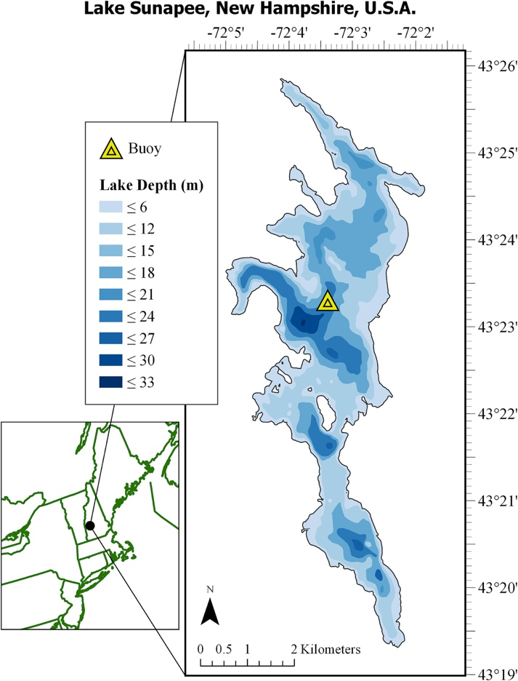

Figure 1: Location and Bathymetry of Lake Sunapee, New Hampshire, USA. Taken from Ward et al.

15

*Data*

The EWEMBI GCMs MIROC5, IPSL-CM5A-LR, GFDL-ESM2M, and HADGEM2-ES will be used under RCP 8.5 conditions for the purposes of future projections within Sunapee. These models have been chosen due to their relation to ISIMIP, which uses community agreed sets of scenarios with standardized climate variables and socioeconomic projections as inputs. 18 Historical observations for Lake Sunapee will be used, including inflow and outflow data, hypsography data, and water temperature data. EWEMBI meteorological forcing data will be used in place of locally collected meteorological data in order maintain consistency when using the GCMs in a post-calibrated LER setup.

*Calibration and Evaluation*

LakeEnsemblR will be calibrated using the time period 1 January 2005 to 31 December 2009 as these years cover a wide range in annual temperature and precipitation as well as contain an extensive amount of data according to Ward et al. 15 Calibration shall be carried out using a Latin Hypercube simulation (LHC) to first establish the priors of the parameters, and subsequently a Monte Carlo Markov Chain (MCMC) simulation to further establish the values of the parameters. Distributions of parameters will be utilized in the uncertainty analysis of the study. Once calibrated, models shall be evaluated using Root Mean Square Error (RMSE), with the hopes of roughly 2 degrees Celsius RMSE for each of the five LER models. In addition to this, evaluation will include visually ensuring that stratification is captured using a heatmap (Figure 1) that captures the thermal properties of the water column. Schmidt stability will be evaluated as well to ensure replication.

Figure 2: Thermal Profiles visualizing water column stratification in each LER model

*Model Analysis*

The historical anomaly for water temperature of the period 1986-2020 will be calculated within LER using calibrated parameter values. The historical anomaly will later be used as a comparative tool for the projected anomalies created by forcing the GCMS through LER. Once the historical anomaly is calculated, GCMs will be forced through LER and results up to 2099 will be used. The results from forcing the GCMs through LER will include water column temperature and ice coverage. These variables will be analyzed using 30-year intervals as this represents a climactic period, or a more complete and broad cycle that reduces climactic noise associated with using GCMs and the RCP scenarios. From these variables, multiple metrics of interest will be calculated including length of stratification, thermocline depth, and thermocline strength among others for each of the 5 LER models. Once these metrics of interest have been calculated for each model over 30-year intervals, a comparative analysis between all LER/GCM model combinations will be carried out including differences in the projections of stratification time, thermocline depth, water column temperature and others. In order to compare between models anomalies, the difference between the projected values given the RCP scenario and a historical scenario, must be used in order to procure accurate results and differences between the models.

*Uncertainty partitioning*

*Climate Model Uncertainty*

Climate model uncertainty will be estimated by generating projections using the 5 ISIMIP models under RCP 8.5 conditions. In order to isolate climate model uncertainty from other types of uncertainties, median parameter values are taken from the MCMC parameter calibration chains and process uncertainty is not propagated. Only one of 5 LER models will be used as well to avoid uncertainty between ecosystem models. Each climate model will be assumed to be equally likely, with the metric of uncertainty being defined as the width of the 95% quantile interval of percent change in total temperature between 2010 and 2099.14

*Ecosystem Model Uncertainty*

Ecosystem model uncertainty will be estimated by generating projections across all 5 LER models from 1 ISIMIP model under RCP 8.5 conditions. In order to isolate ecosystem uncertainty from other types of uncertainties, median parameter values are taken from MCMC parameter calibration chains and process uncertainty is not propagated. Only 1 of 5 ISIMIP models will be run in order to avoid uncertainty between climate models. Each ecosystem model will be assumed to be equally likely, with the metric of uncertainty being defined as the width of the 95% quantile interval of percent change in total temperature between 2010 and 2099.

*Parameter Uncertainty*

Parameter uncertainty will be estimated by sampling from the posterior distributions of the calibrated parameter sets. Using the sampled parameter sets, an ensemble will be constructed of 100 simulations from 2010-2099. To avoid interactions between parameter uncertainty and the other types of uncertainty, ensembles will be generated for each of the climate models and each of the ecosystem models. Parameter uncertainty will be calculated by taking the average uncertainty from each of these runs. Parameter uncertainty will be defined as the 95% quantile interval from the ensemble members averaged across the climate and ecosystem models.14

*Ecosystem Model Process Uncertainty*

Ecosystem model process uncertainty will be calculated by using a state-space data assimilation technique using sampled water temperature vales from a normal distribution at the end of a timestep and using the values to simulate the subsequent timestep. 100 ensemble models will then be calculated from 2010-2099 using median parameter values and generating all GCM/LER combinations. In this case, ecosystem model process uncertainty will be defined as the 95% quantile interval from the ensemble members averaged across GCM/LER combinations.

*Total Forecast Uncertainty:*

Total forecast uncertainty is calculated by simultaneously propagating uncertainty from the climate model uncertainty, ecosystem model uncertainty, parameter uncertainty and ecosystem model process uncertainty. Assuming that each model is equally likely, simulations from each model will be combined into a single distribution. The metric of uncertainty will be defined as the width of the 95% quantile interval from the projected output.

*Climate Scenario Uncertainty:*

Climate scenario uncertainty will be estimated by comparing a forecast from the RCP 8.5 scenario with a forecast from the RCP 4.5 scenario. In order to avoid propagating other types of uncertainty, median parameter values will be used and process uncertainty will not be propagated. The difference in percent change of water temperature between the RCP models will be calculated and the uncertainty will be defined as the mean difference across the GCM/LER combinations.

## Implications

This project will be multifaceted in its outcomes: first, the outputs of the LakeEnsemblR models will give insight into the future of Lake Sunapee given certain climate conditions. This will provide desired insights to managers and homeowners residing at Lake Sunapee, who are greatly interested in mitigating the impacts of climate change on their lake in order to maintain its community-wide and personal values. Second, this project will lead to novel insights revolving around the modelling itself. Because all models have inherent uncertainty, whether that be revolving around future temperature projections, global circulation methods, or water column properties, it is important for researchers to understand how much uncertainty is present and where that model uncertainty is coming from (e.g., model parameters, driver data). Because this project contains multiple models for both climate projections and lake water quality response, the ability to compare an ensemble of predictions is possible and extremely useful. These insights will be relevant to researchers and modelers carrying out similar climate change impact studies in order to mitigate future negative impacts on lake water quality.

## References

1. Leach, T. H. *et al.* Patterns and drivers of deep chlorophyll maxima structure in 100 lakes: The relative importance of light and thermal stratification. *Limnol. Oceanogr.* **63**, 628–646 (2018).

2. Hansen, G. J. A., Read, J. S., Hansen, J. F. & Winslow, L. A. Projected shifts in fish species dominance in Wisconsin lakes under climate change. *Glob. Chang. Biol.* **23**, 1463–1476 (2017).

3. Jankowski, T., Livingstone, D. M., Bührer, H., Forster, R. & Niederhauser, P. Consequences of the 2003 European heat wave for lake temperature profiles, thermal stability, and hypolimnetic oxygen depletion: Implications for a warmer world. *Limnol. Oceanogr.* **51**, 815–819 (2006).

4. Piccolroaz, S. & Toffolon, M. The fate of Lake Baikal: how climate change may alter deep ventilation in the largest lake on Earth. *Clim. Change* **150**, 181–194 (2018).

5. Tranvik, L. J. *et al.* Lakes and reservoirs as regulators of carbon cycling and climate. *Limnol. Oceanogr.* **54**, 2298–2314 (2009).

6. Read, J. S. *et al.* Lake-size dependency of wind shear and convection as controls on gas exchange. *Geophys. Res. Lett.* **39**, n/a-n/a (2012).

7. Stetler, J. T. *et al.* Atmospheric stilling and warming air temperatures drive long-term changes in lake stratification in a large oligotrophic lake. *Limnol. Ocean.* **9999**, 1–11 (2020).

8. Kirillin, G. *modeling the impact of global warming on water temperature and seasonal mixing regimes in small temperate lakes*. (2010).

9. Riahi, K. *et al.* RCP 8.5-A scenario of comparatively high greenhouse gas emissions. *Clim. Change* **109**, 33–57 (2011).

10. Phillips, N. A. The general circulation of the atmosphere: A numerical experiment. *Q. J. R. Meteorol. Soc.* **82**, 123–164 (1956).

11. LakeEnsemblR: An R package that facilitates ensemble modelling of lakes. Available at: https://eartharxiv.org/repository/view/1960/. (Accessed: 21st April 2021)

12. Raiho, A., Dietze, M., Dawson, A., Rollinson, C. R. & Tipton, J. *Determinants of Predictability in Multi-decadal Forest Community and Carbon Dynamics*. (2020).

13. Dietze, M. C. Prediction in ecology: a first-principles framework. *Ecol. Appl.* **27**, 2048–2060 (2017).

14. Thomas, R. Q., Jersild, A. L., Brooks, E. B., Thomas, V. A. & Wynne, R. H. A mid-century ecological forecast with partitioned uncertainty predicts increases in loblolly pine forest productivity. *Ecol. Appl.* **28**, 1503–1519 (2018).

15. Ward, N. K. *et al.* Differential Responses of Maximum Versus Median Chlorophyll‐ *a* to Air Temperature and Nutrient Loads in an Oligotrophic Lake Over 31 Years. *Water Resour. Res.* **56**, e2020WR027296 (2020).

16. Bruesewitz, D. A., Carey, C. C., Richardson, D. C. & Weathers, K. C. Under-ice thermal stratification dynamics of a large, deep lake revealed by high-frequency data. *Limnol. Oceanogr.* **60**, 347–359 (2015).

17. Carey, C. C. *et al.* Experimental blooms of the cyanobacterium Gloeotrichia echinulata increase phytoplankton biomass, richness and diversity in an oligotrophic lake. *J. Plankton Res.* **36**, 364–377 (2014).

18. Ruane, A. C. *et al.* To cite this article: Cynthia Rosenzweig et al. *Environ. Res. Lett* **12**, 10301 (2017).