**NOVA**

**Software Acceptance Test Plan**

**Version: 2.1**

**February 19, 2018**

**Mark Kirschenman  
Nathaniel Fleet  
John Hedman  
Jacob Gordon**

**Nova Acceptance Test Plan (ATP)**

**Table of Contents**

[1. Introduction . ………………………………………………………………………………….....](https://docs.google.com/document/d/1NlwWwy7S-YCazIhCP-wT-KVHnpCCqi5vlzFIcN1de8g/edit#heading=h.gjdgxs)2

1.1 Purpose of Acceptance Test ..[…………………………………………………….…](https://docs.google.com/document/d/1NlwWwy7S-YCazIhCP-wT-KVHnpCCqi5vlzFIcN1de8g/edit#heading=h.30j0zll)....2

1.2 Proposed System Overview or Configuration Chart………………………….……….2

1.3 Definitions, Acronyms, and Abbreviations[…………………………………………....](https://docs.google.com/document/d/1NlwWwy7S-YCazIhCP-wT-KVHnpCCqi5vlzFIcN1de8g/edit#heading=h.1fob9te) 2

1.4. Testing Principles Used[………………………………………………………………. 3](https://docs.google.com/document/d/1NlwWwy7S-YCazIhCP-wT-KVHnpCCqi5vlzFIcN1de8g/edit#heading=h.3znysh7)

1.5 Overview of Rest of ATP[…………………………………………………………......](https://docs.google.com/document/d/1NlwWwy7S-YCazIhCP-wT-KVHnpCCqi5vlzFIcN1de8g/edit#heading=h.2et92p0) 3

2. Hardware and Software Used for Testing………………………………………………………. [4](https://docs.google.com/document/d/1NlwWwy7S-YCazIhCP-wT-KVHnpCCqi5vlzFIcN1de8g/edit#heading=h.tyjcwt)

3[. Error Handling Policy…………………………………………………………………………...](https://docs.google.com/document/d/1NlwWwy7S-YCazIhCP-wT-KVHnpCCqi5vlzFIcN1de8g/edit#heading=h.3dy6vkm) 4

4. Test Schedule […………………………………………………………………………………... 5](https://docs.google.com/document/d/1NlwWwy7S-YCazIhCP-wT-KVHnpCCqi5vlzFIcN1de8g/edit#heading=h.1t3h5sf)

5. Test Sets (table) […………………………………………………………………………………](https://docs.google.com/document/d/1NlwWwy7S-YCazIhCP-wT-KVHnpCCqi5vlzFIcN1de8g/edit#heading=h.4d34og8)6

6. Individual Test Cases[…………………………………………………………………………....](https://docs.google.com/document/d/1NlwWwy7S-YCazIhCP-wT-KVHnpCCqi5vlzFIcN1de8g/edit#heading=h.2s8eyo1)8

7. Log of Meetings, Reviews, and Meetings[……………………………………………………... 25](https://docs.google.com/document/d/1NlwWwy7S-YCazIhCP-wT-KVHnpCCqi5vlzFIcN1de8g/edit#heading=h.17dp8vu)

8. Project Acceptance Signatures for Client and Developer […………………………………..…](https://docs.google.com/document/d/1NlwWwy7S-YCazIhCP-wT-KVHnpCCqi5vlzFIcN1de8g/edit#heading=h.3rdcrjn)26

**Introduction**

**Purpose of Acceptance Test**

The purpose of this document is to describe and demonstrate the functionality of the Bus Booker system. Tests will be executed using every possible input, allowing the user to see all possible outputs they could encounter while using the system. With this method, there should be no system output that is not accounted for, and no error that cannot be identified as a result of system use.

**Proposed System Overview**

The system is made up of three pieces based on the users of the system. The users are the managers, the drivers, and the customers. These pieces are made of multiple functions that each user needs in order to use the system. These functions would include: login, looking at schedules, or viewing or editing their profile. These pieces and functions are separated from each other in order to work on their own. This assures that the functions in the system are all independent. This allows for the testing team to easily diagnose problems that are found at any stage of testing. The system runs on Window, Mac OS, Linux, iOS, and Android to ensure that all personal devices are supported.

**Definitions, Acronyms, Abbreviations**

|  |  |
| --- | --- |
| **Term** | **Definition** |
| User | Any person (not on the development team) who interacts with the system. |
| Stakeholder/Client | Person involved with the project who is not on the development team. |
| Team Nova/NOVA | The entire development team. |
| Risk | Any event or action that poses a threat to the development process, that could result in loss of time and/or resources. |
| Manager | Special user of the system, with administrator access. |
| Deliverable | Any item that can be presented to the customer during or at the end of the development process. |
| Documentation | Any documents relating to the project generated by Team Nova. |
| PC | Personal Computer. |
| FWBS | Function Work Breakdown Structure. |
| Error | Bugs or problems in the system that could not be accounted for during testing phase. |

**Testing Principles Used**

The test that was used involves starting with the smallest parts of the code and testing if they are working properly. The smaller parts are then put together and tested to see if they work when put together. The processes is then repeated until we have tested all of the components of the system individually and the system as a whole.

|  |  |
| --- | --- |
| Unit Testing | This is the test of the individual functions of the project. These would include the individual functions that make up an actual component. |
| Component Testing | This is the testing of the actual component of the system. This would include testing a whole functionality such as Website Login, View Hours, or View Driver. |
| Integration Testing | This is putting the individual components together and testing the functionality of all of them. This would be testing the functionality of just the driver, manager, or customer and seeing if it works like expected. |
| System Testing | This is putting all of the integration categories that were tested and testing if they all work as a system. This would be the testing of the final product. |
| Documentation | The programmers have decided on a specific method of documentation. This method is used to have consistency among each team that is working on the project. This will lead to better readability for the testers and the programmers on different teams. |

**Overview of Rest of ATP**

Also in this document are the hardware specifications and software environments that Team Nova used to complete the testing are described, our testing deadline, Bus Booker’s error handling policy, as well as a table of test sets and the individual test cases. Lastly a log of meetings meetings is listed, and a final acceptance agreement to be signed by Team Nova and the client.

**Hardware and Software**

All tests will be done on a PC running Windows 10 Enterprise Edition Version 1607 with Google Chrome version 63.0.3239.132 (64-bit) as the web browser used to access the website.

**Error Handling Policy**

|  |  |  |
| --- | --- | --- |
| **Error Type** | **Error Maintenance Length** | **Description** |
| Error Type I | Less than an hour | Small errors that can be fixed by the developer in less than half an hour. Testing will resume an hour after the error was found |
| Error Type II | Less than 24 hours | Small error that takes time in order to fix. The developer and management will discuss the time needed in order to resume, 1-3 business days. |
| Error Type III | Less than 5 days | Medium error where developer needs opinions in order to come up with a exact estimate. Customer will be notified of when testing will resume in 1 business day, actual testing will resume after 1 business week. |
| Error Type IV | More than 2 working weeks | Large error found where the development team needs to change a large part of the system. Customer will be notified when the testing will be resumed within a business week. The testing will then be resumed after 2 business weeks or more. |

**Test Schedule**

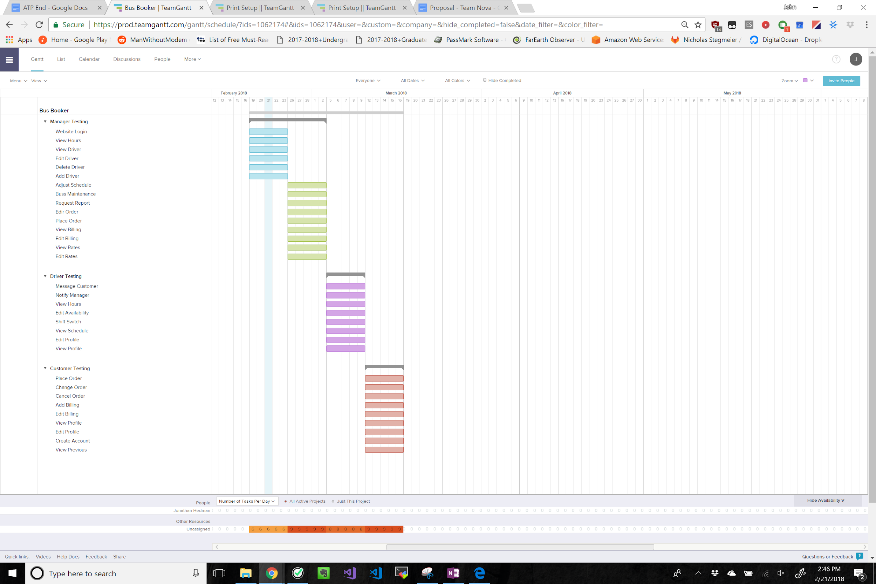

**Test Sets**

|  |  |  |  |  |  |
| --- | --- | --- | --- | --- | --- |
| **FWBS Ref** | **Tested Function** | **Test Method** | **Test Number** | **Who** | **Pass/Fail** |
| 1.0.1 | Website Login | Manual | 1.1 | Mark |  |
| 2.2.2 | View Hours | Manual | 2.1 | Jacob |  |
| 2.1.1 | View Driver | Manual | 3.1 | Jacob |  |
| 2.1.4 | Edit Driver | Manual | 4.1 | Jacob |  |
| 2.1.3 | Delete Driver | Manual | 5.1 | Jacob |  |
| 2.1.2 | Add Driver | Manual | 6.1 | Jacob |  |
| 2.5.1 | Adjust Schedule | Manual | 7.1 | Jonathan |  |
| 2.5.2 | Bus Maintenance | Manual | 8.1 | Jonathan |  |
| 2.5.3 | Request Report | Manual | 9.1 | Jonathan |  |
| 2.3.2 | Edit Order | Manual | 11.1 | Nate |  |
| 2.3.1 | Place Order | Manual | 12.1 | Nate |  |
| 2.4.1 | View Billing | Manual | 13.1 | Mark |  |
| 2.4.2 | Edit Billing | Manual | 14.1 | Mark |  |
| 2.2.1 | View Rates | Manual | 15.1 | Jonathan |  |
| 2.2.3 | Edit Rates | Manual | 16.1 | Jonathan |  |
| 3.1.1 | Message Customer | Manual | 17.1 | Jacob |  |
| 3.1.2 | Notify Manager | Manual | 18.1 | Jacob |  |
| 3.2.3 | View Hours | Manual | 19.1 | Mark |  |
| 3.2.2 | Edit Availability | Manual | 20.1 | Mark |  |
| 3.2.1 | Shift Switch | Manual | 21.1 | Mark |  |
| 3.4.1 | View Schedule | Manual | 22.1 | Jonathan |  |
| 3.3.2 | Edit Profile | Manual | 23.1 | Jonathan |  |
| 3.3.1 | View Profile | Manual | 24.1 | Jonathan |  |
| 4.1.1 | Place Order | Manual | 25.1 | Jacob |  |
| 4.1.2 | Change Order | Manual | 26.1 | Jacob |  |
| 4.1.3 | Cancel Order | Manual | 27.1 | Jacob |  |
| 4.2.2 | Add Billing | Manual | 28.1 | Nate |  |
| 4.2.3 | Edit Billing | Manual | 29.1 | Nate |  |
| 4.2.4 | View Profile | Manual | 30.1 | Nate |  |
| 4.2.5 | Edit Profile | Manual | 31.1 | Nate |  |
| 4.2.1 | Create Account | Manual | 32.1 | Nate |  |
| 4.2.6 | View Previous | Manual | 33.1 | Nate |  |

**Individual Test Cases**

**Test 1**

Purpose:

The purpose of this test is to verify the functionality of the login. If the login is successful, the user should be sent to either the driver, manager, or customer main page.

FWBs Number:1.0.1

Set Up:

Access the homepage of [www.teamnovaproject.us](http://www.teamnovaproject.us) in order to begin this test, shown by figure 1.0.

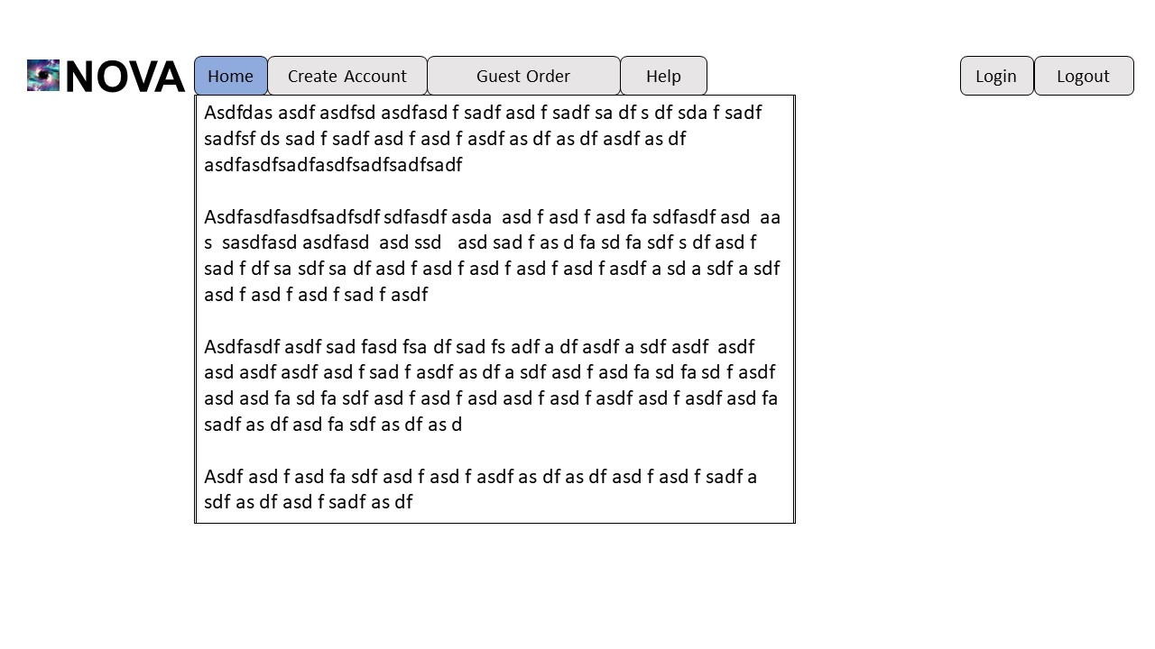

**Figure 1.0**

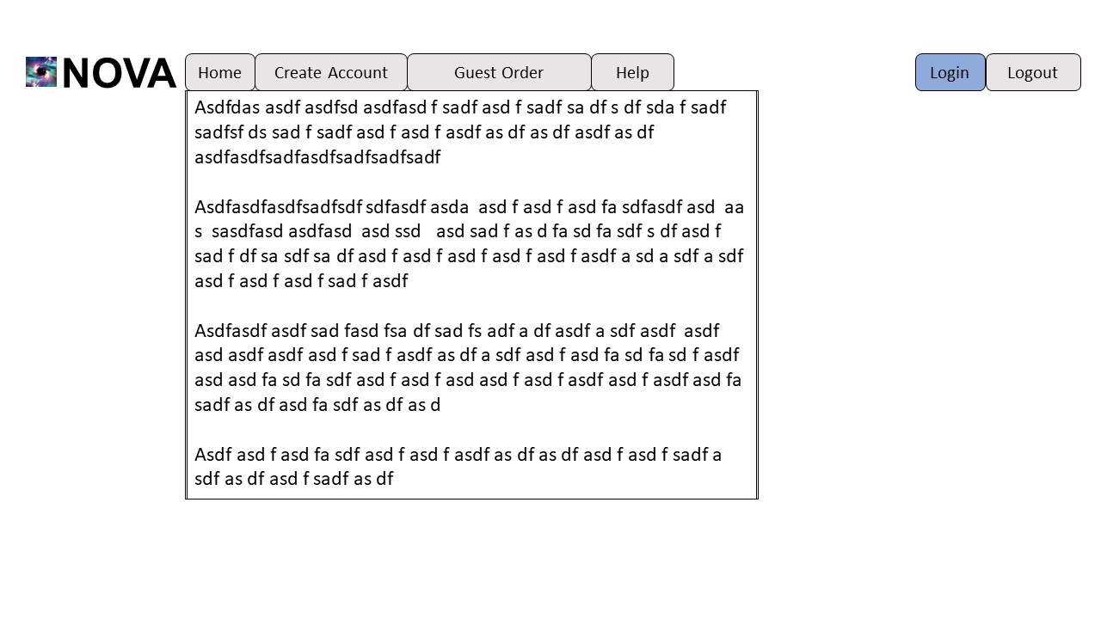**Figure 1.1**

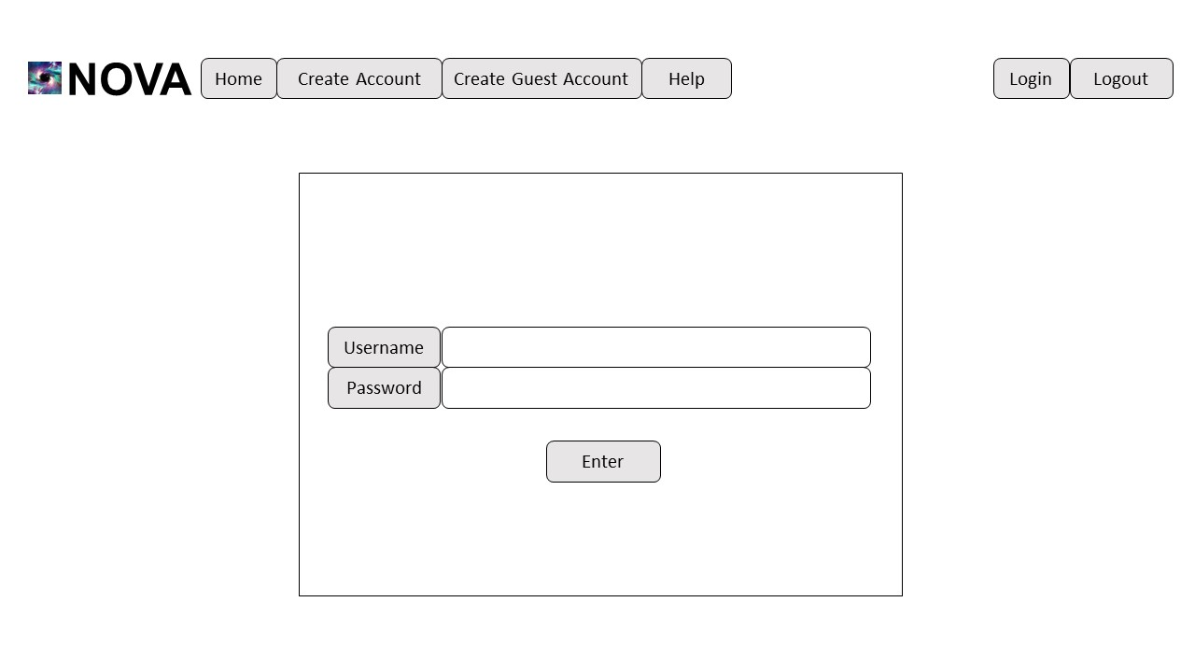

**Figure 1.2**

Input:

Click Login button, on figure 1.1.

Output:

Login screen username and password is displayed, on figure 1.2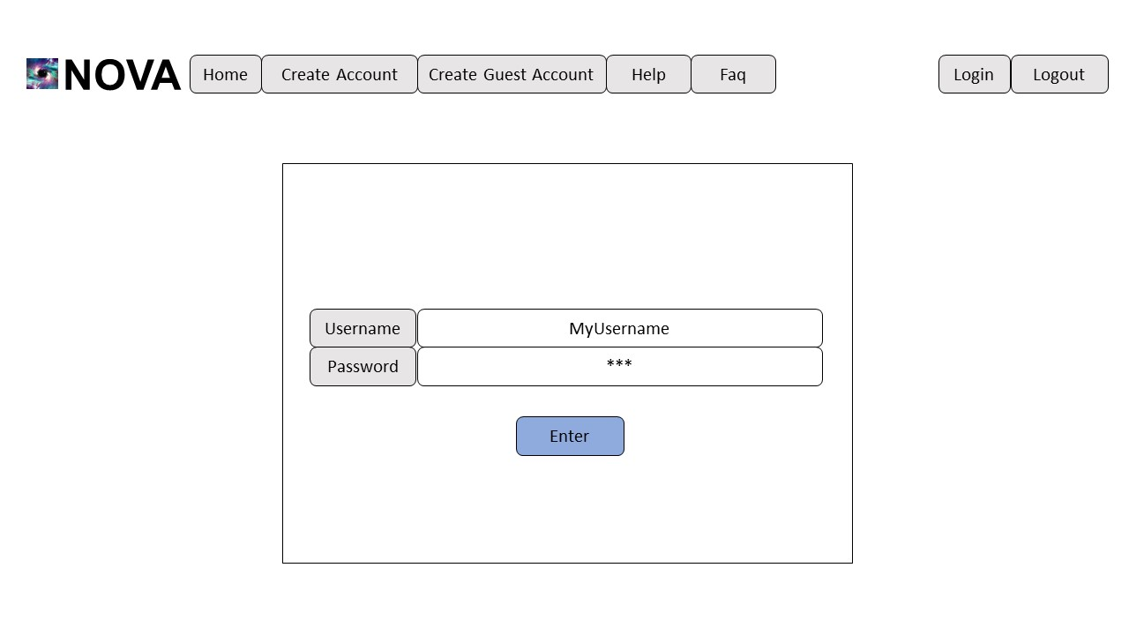

**Figure 1.3**

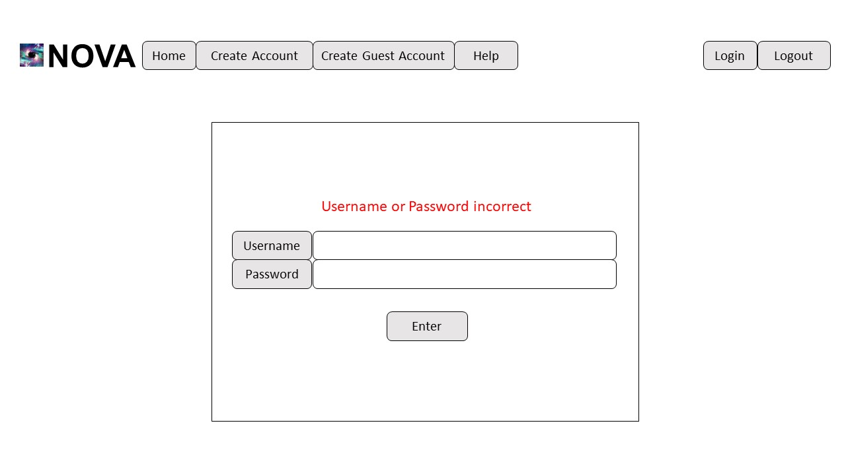

**Figure 1.4**

Input:

Enter a valid Username, on figure 1.3. Ex: MyUsername

Enter an invalid password, on figure 1.3. Ex 123

Click Enter button, on figure 1.3.

Output:

“Username or Password Incorrect,” on figure 1.4.

Stay at Login Screen, on figure 1.4.

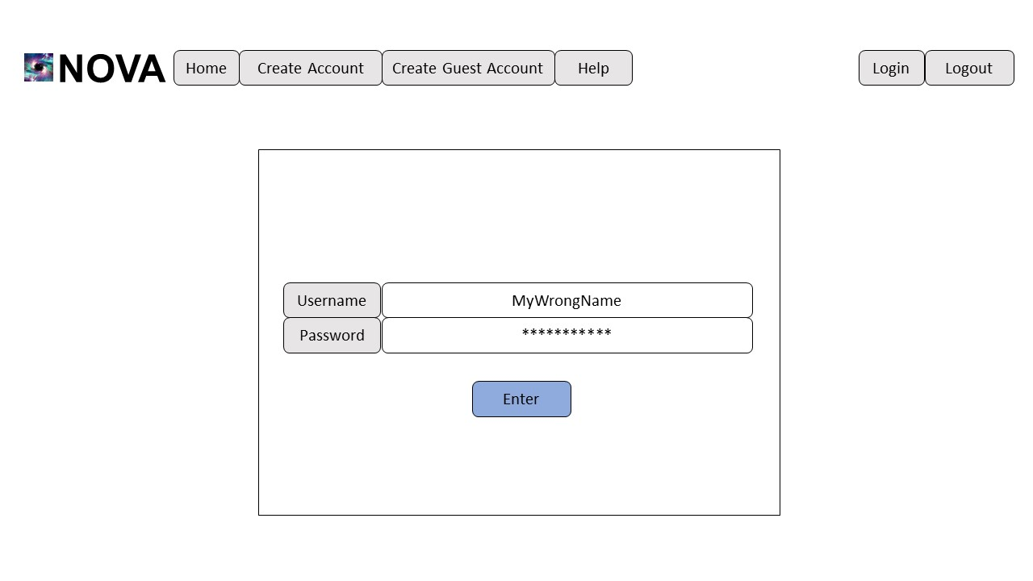

**Figure 1.5**



**Figure 1.6**

Input:

Enter an invalid Username, on figure 1.5. Ex: MyWrongname

Enter an valid password, on figure 1.5. Ex 123456seven

Click Enter button, on figure 1.5.

Output:

“Username or Password Incorrect,” on figure 1.6.

Stay at Login Screen, on figure 1.6.

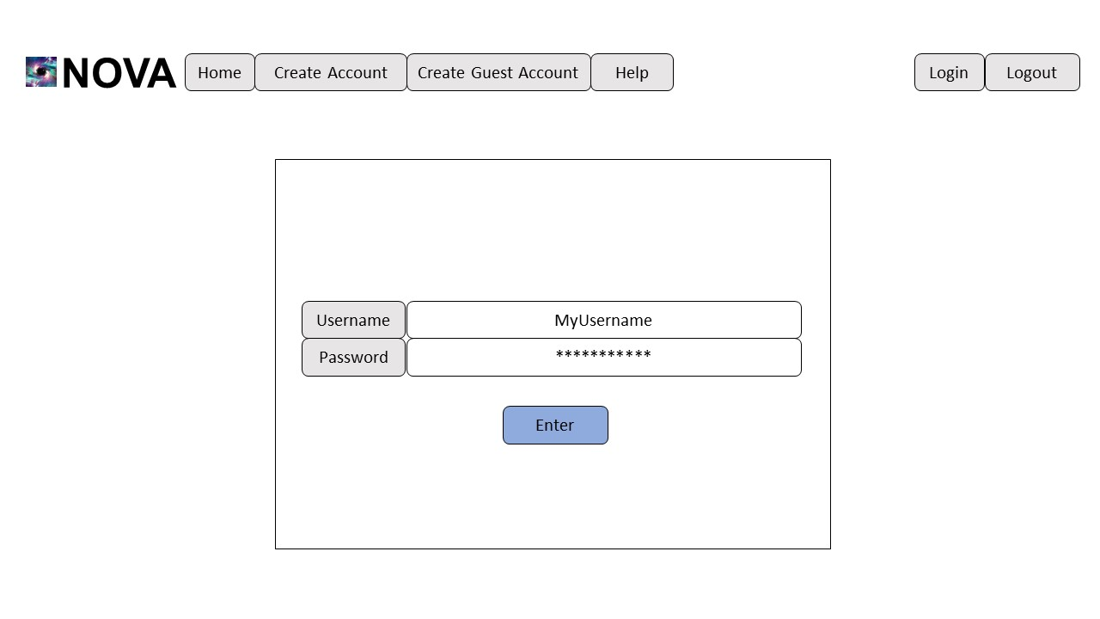**Figure 1.7**

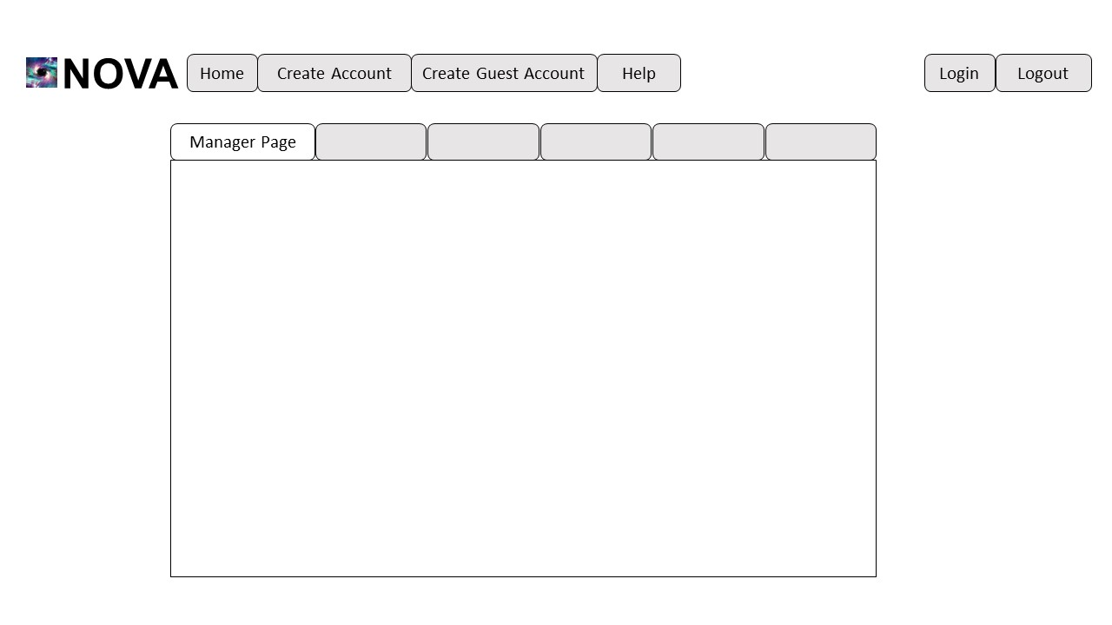

**Figure 1.8**

Input:

Enter an valid Username, on figure 1.7. Ex: MyUsername

Enter an valid password, on figure 1.7. Ex 123456seven

Click Enter button, on figure 1.7.

Output:

User sent to Manager, Driver, or Customer screen based on account status/type, on Figure 1.8.

**____________________________________________________________________________**

Test 1 Acceptance

Developer Signature:

_______________________________________________

Client Signature:

_______________________________________________

Date:

_________

Comments:

____________________________________________________________________________________________________________________________________________________________________________________________________________________________________________________________________________________________________________________________________________________________________________________________________________________________________

**____________________________________________________________________________**

**Test 2**

Purpose:

The purpose of this test is to verify the functionality of the create account. If successful the user will have created an account and reach the appropriate page. Later on the user will be able to use the login function to access their account at another time.

FWBs Number:4.2.1

Set Up:

Access the homepage of [www.teamnovaproject.us](http://www.teamnovaproject.us) in order to begin this test, shown by figure 2.0.

**Figure 2.0**

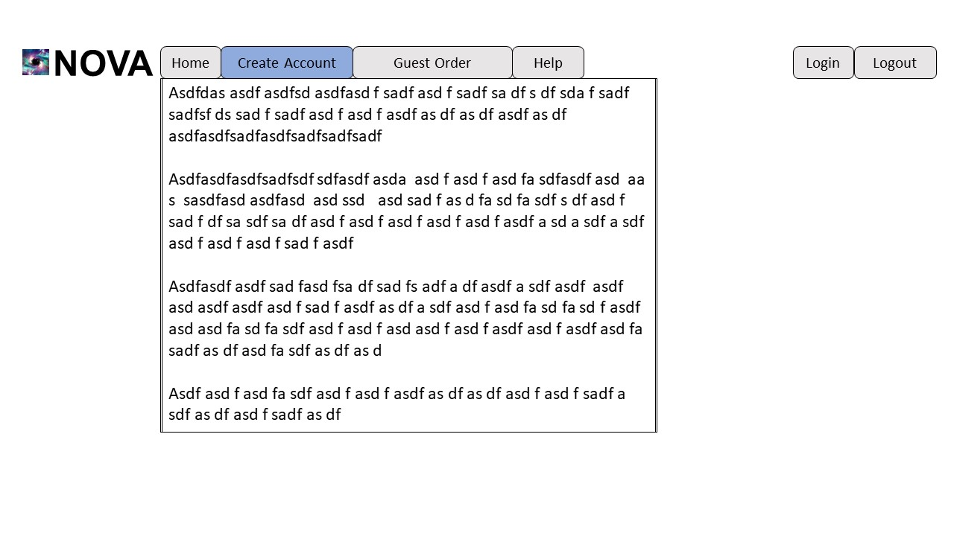**Figure 2.1**

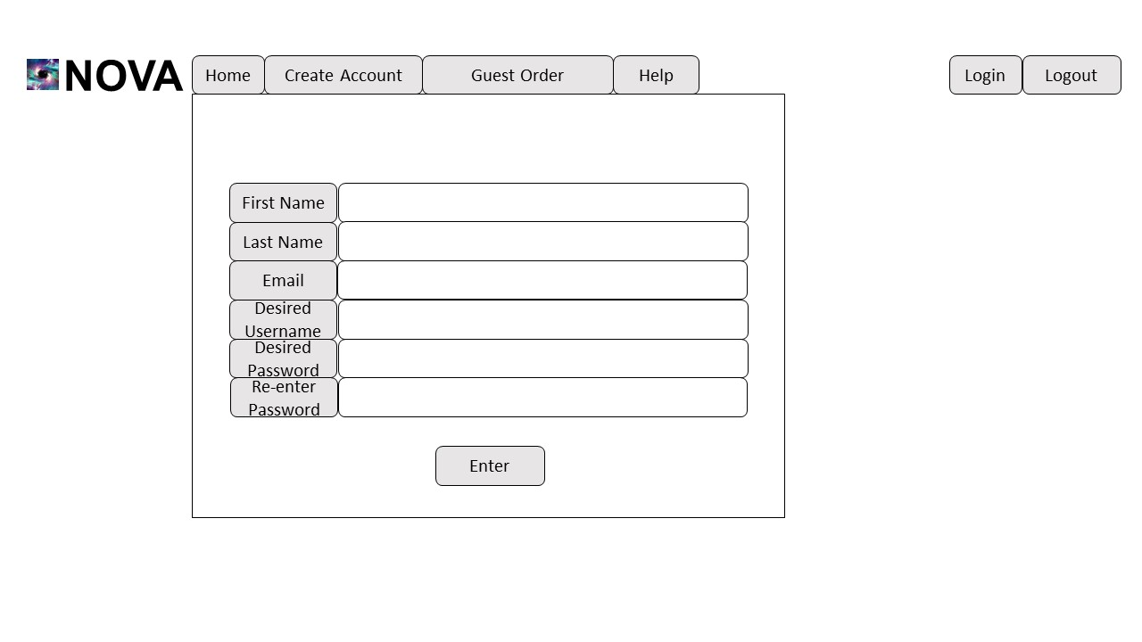

**Figure 2.2**

Input:

Click Create Account button, on figure 2.1.

Output:

Create Account Screen with screen is displayed, on figure 2.2

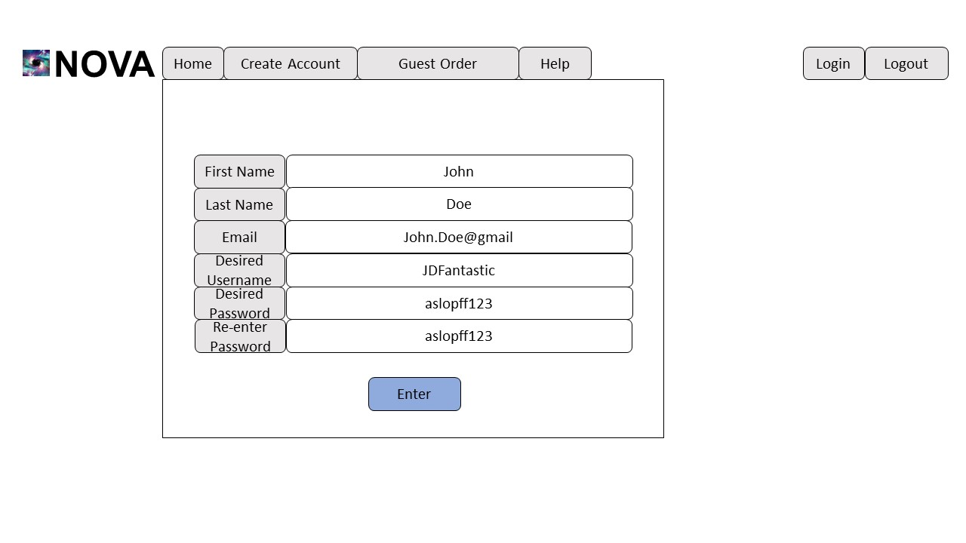

**Figure 2.3**

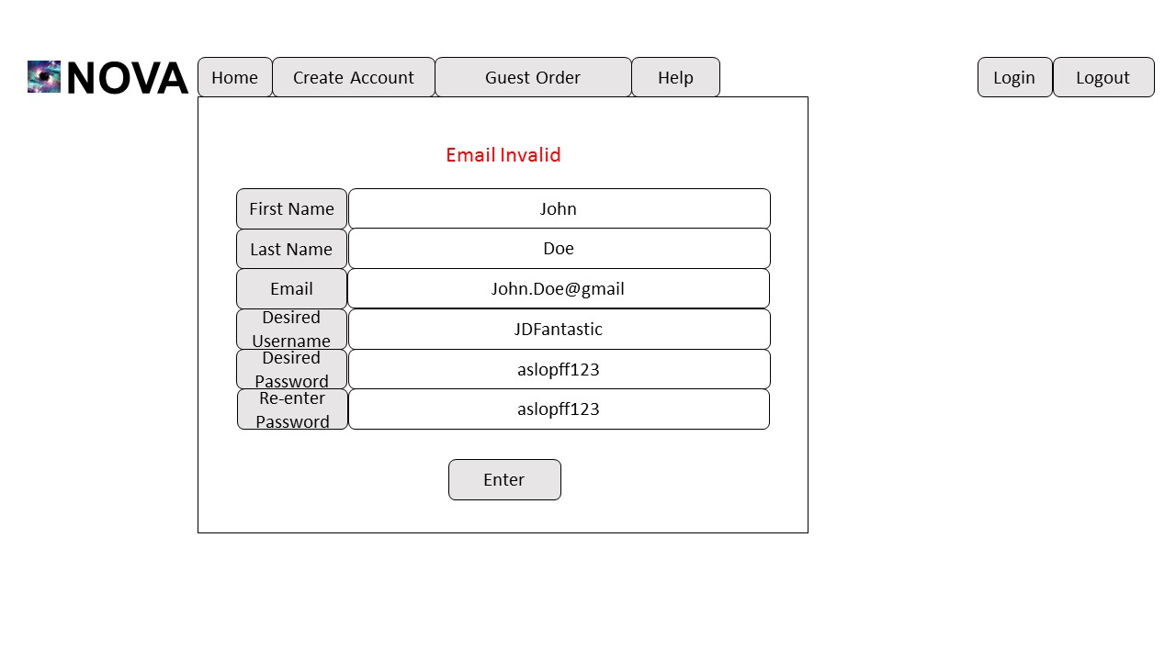

**Figure 2.4**

Input:

Enter a valid First Name, on figure 2.3. Ex John

Enter a valid Last Name, on figure 2.3. Ex Doe

Enter an invalid Email Address, on figure 2.3. Ex John.Does@gmail.com

Enter a valid Desired Username, on figure 2.3. Ex JDFantastic

Enter a valid Desired Password, on figure 2.3. Ex aslopff123

Re-Enter the same Password, on figure 2.3.Ex aslopff123

Click Enter button, on figure 2.3.

Output:

“Email invalid,” on figure 2.4.

Stay at Create Account screen, on figure 2.4.

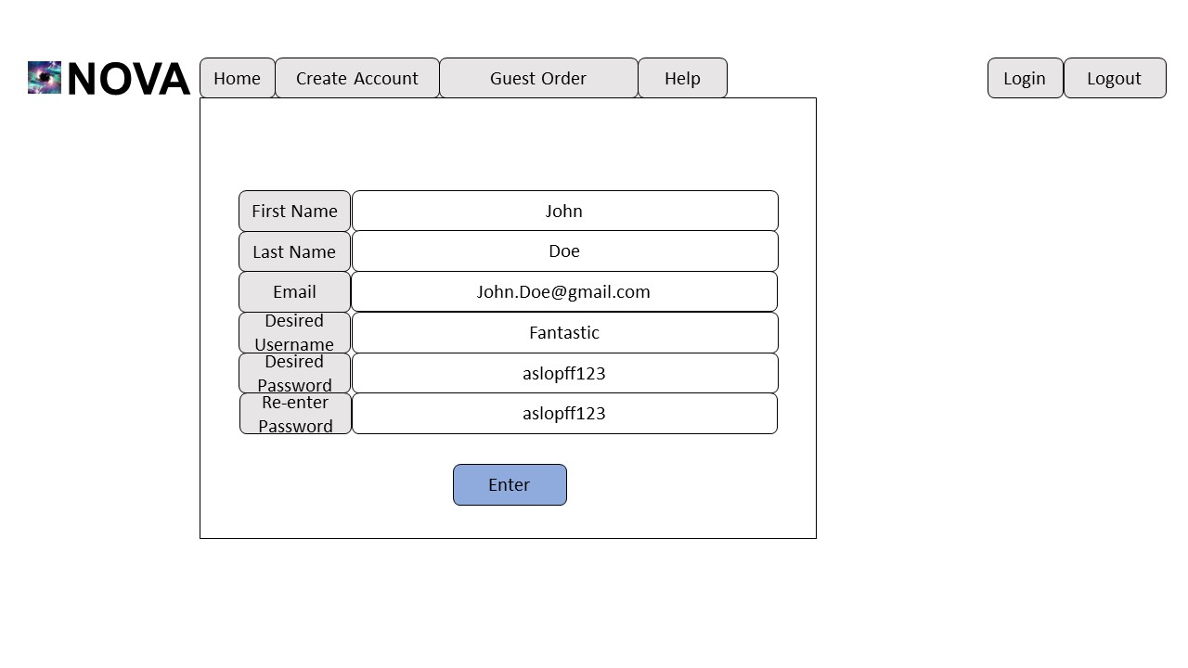

**Figure 2.5**

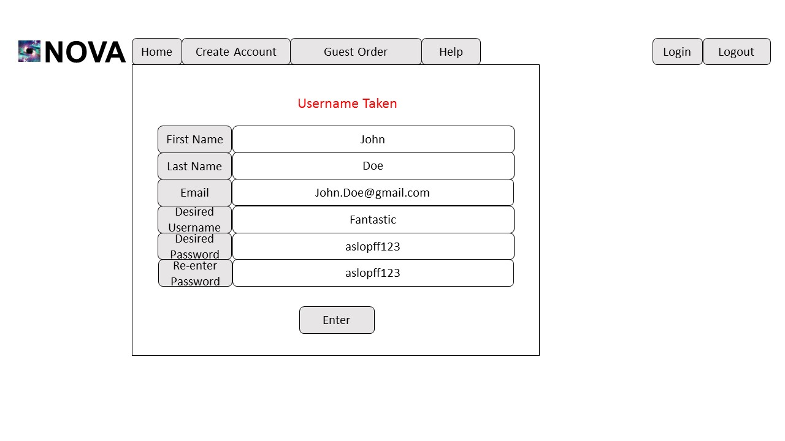

**Figure 2.6**

Input:

Enter a valid First Name, on figure 2.5. Ex John

Enter a valid Last Name, on figure 2.5.Ex Doe

Enter a valid Email Address, on figure 2.5. Ex John.Doe@gmail.com

Enter an invalid Desired Username, on figure 2.5. Ex Fantastic

Enter a valid Desired Password, on figure 2.5. Ex aslopff123

Re-Enter the same Password, on figure 2.5.Ex aslopff123

Click Enter button, on figure 2.5.

Output:

“Username Taken,” on figure 2.6.

Stay at Create Account screen, on figure 2.6.

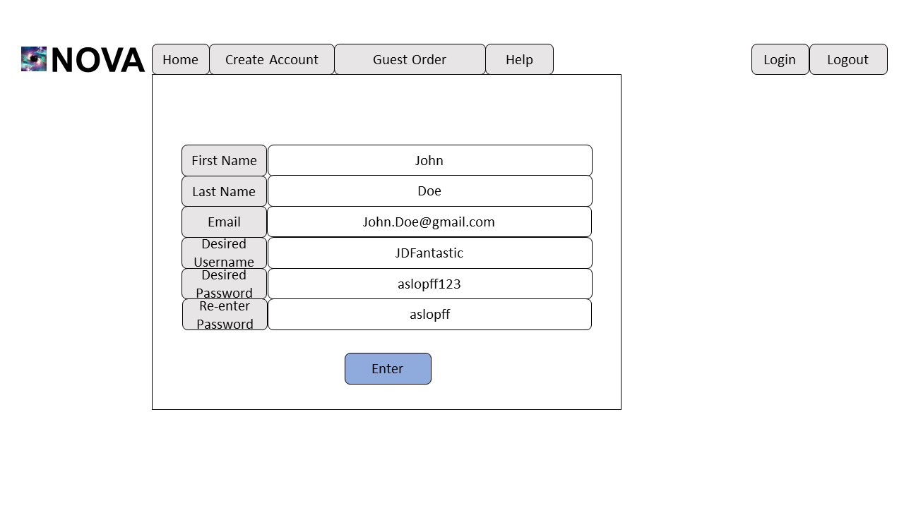

**Figure 2.7**

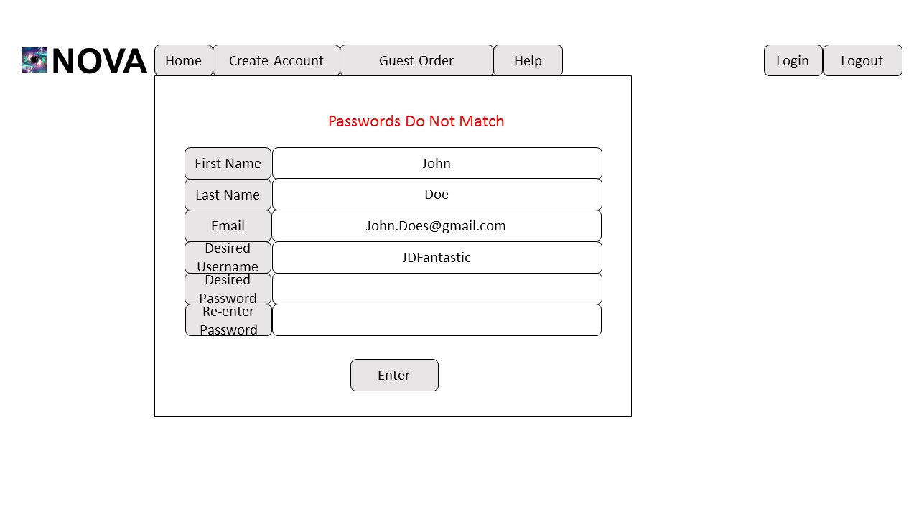

**Figure 2.8**

Input:

Enter a valid First Name, on figure 2.7. Ex John

Enter a valid Last Name, on figure 2.7. Ex Doe

Enter a valid Email Address, on figure 2.7. Ex John.Doe@gmail.com

Enter a valid Desired Username, on figure 2.7. Ex JDFantastic

Enter a valid Desired Password, on figure 2.7. Ex aslopff123

Re-Enter an invalid same Password, on figure 2.7. Ex aslopff

Click Enter button on figure 2.7.

Output:

“Passwords Do Not Match,” on figure 2.8.

Stay at Create Account screen, on figure 2.8.

Desired Username cleared, on figure 2.8.

Re-enter Password cleared, on figure 2.8.



**Figure 2.9**



**Figure 2.10**

Input:

Enter a valid First Name, on figure 2.9. Ex John

Enter a valid Last Name, on figure 2.9. Ex Doe

Enter a valid Email Address, on figure 2.9. Ex John.Doe@gmail.com

Enter a valid Desired Username, on figure 2.9. Ex JDFantastic

Enter a valid Desired Password, on figure 2.9. Ex aslopff123

Re-Enter the same Password, on figure 2.9. Ex aslopff

Click Enter button on figure 2.9.

Output:

User sent to Manager, Driver, or Customer screen based on status, on figure 2.10.

**____________________________________________________________________________**

Test 2 Acceptance

Developer Signature:

_______________________________________________

Client Signature:

_______________________________________________

Date:

_________

Comments:

____________________________________________________________________________________________________________________________________________________________________________________________________________________________________________________________________________________________________________________________________________________________________________________________________________________________________

**____________________________________________________________________________**

**Log of Meetings and Reviews**

Currently, we plan to meet with the client on the day of delivery to test all functionalities before signing final agreements. We will also meet on the day of delivery for the Acceptance Test Plan to discuss expected features, their functionalities, and sign agreements. Any other meetings or documentation reviews will be requested by the development or the client and scheduled appropriately.

**Project Acceptance Signatures for Client and Developer**

**____________________________________________________________________________**

These signatures signify that the Acceptance Test was approved by the client and developer. The client must deliver the payment of $127,415.60 to NOVA. If payment is not received by May 10, 2018, the client will be charged an additional late fee of 10,000 for each week (7 days) that payment is not delivered. If the client does not pay the initial charge ($127,415.60) plus any potential late fees by November 2, 2018. The product delivered must be returned to NOVA on November 3, 2018 and the client will still be responsible for the initial payment (127,415.60) and late fees. The client will be given until January 1, 2018 to deliver all late fees. Upon receiving the full payment for the product NOVA will re-deliver the product. By signing under client signature the client agrees to these terms and approves that the acceptance test is successful.

Developer Signature:

_______________________________________________

Client Signature:

_______________________________________________

Date:

_________

Comments:

____________________________________________________________________________________________________________________________________________________________________________________________________________________________________________________________________________________________________________________________________________________________________________________________________________________________________

**____________________________________________________________________________**