**NOVA**

To Brookings Area Transit Authority,

Thank you for the opportunity to propose our plan for the Bus Booker application! We are excited to have the chance to work with you and create this software for your bus system. Our company has been creating applications for 10 years and our members have experience in creating applications that integrate databases to solve problems. There are four members of our team: John Hedman, Mark Kirschenman, Nate Fleet and Jacob Gordon. Our plan proposed below explains how we intend to budget, schedule, and complete the project.

The product that we are proposing is a web-based application that serves as a management system for a bus transit company. Its primary function is to take orders from customers, and then create a pickup/drop-off schedule that the drivers will use. The system will utilize a database to store customer, manager, and driver information. The system, being web-based, will require an internet connection to function for all users. It also incorporates third-party GPS technology for customers to select departure points and destinations, as well as the creation of the driver’s pickup/dropoff schedule. All users will create an account that will be stored on the database, with the exception of “Guest” users. Information associated with an account includes name, phone number, address, and billing information will be stored on the database. Nova Bus Booker also provides useful managerial tools, such as logging employee hours, editing driver records, managing bus maintenance, and financial report generation. Additionally, manager functions will include the ability to manually edit the schedule provided by the system, and input orders taken from phone calls.

We believe that we will be able to complete this project efficiently. We have estimated that the cost of developing this product will cost $127,415.60. The estimate calculation was done by using prior project experiences to calculate what the budget will be for this project. We have also broken down the timeframe of the job and expect that the project will be completed by May.

Once again, thank you for this opportunity. We are very excited to work with you to create a great product. We hope that you will choose us as the right candidate for this product. Do not hesitate to contact us with any further questions.

Thank you,

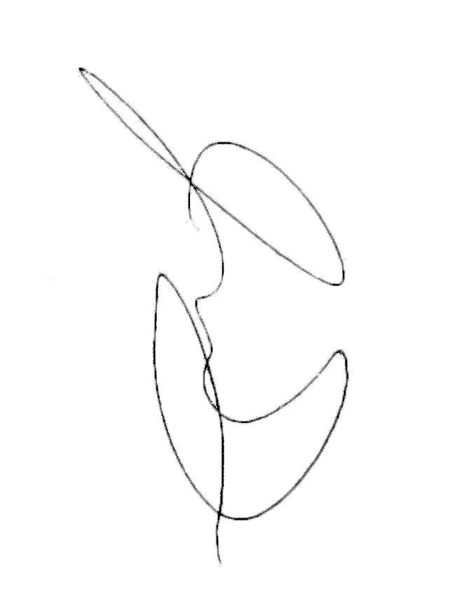

Jacob Gordon,

Manager-Nova

**NOVA**

**Software Proposal**

**Version: 2.1**

**February 8, 2018**

**Mark Kirschenman  
Nathaniel Fleet  
John Hedman  
Jacob Gordon**

**Table of Contents**

[1.](https://docs.google.com/document/d/1NlwWwy7S-YCazIhCP-wT-KVHnpCCqi5vlzFIcN1de8g/edit#heading=h.gjdgxs) Scope……………………………………………………………………………………………..3

2. Team Members Hierarchy………………………...…………………………………...………....3

3. Functional Work Breakdown Structure ……………………………………………….…..….....4

4. Milestones…………………………………………………………………………………….….6

5[.](https://docs.google.com/document/d/1NlwWwy7S-YCazIhCP-wT-KVHnpCCqi5vlzFIcN1de8g/edit#heading=h.3dy6vkm) Activity Graph/Critical Path[……………………………………………………………………..](https://docs.google.com/document/d/1NlwWwy7S-YCazIhCP-wT-KVHnpCCqi5vlzFIcN1de8g/edit#heading=h.3dy6vkm) 7

6. Project Schedule [………………………………………………………………………………..](https://docs.google.com/document/d/1NlwWwy7S-YCazIhCP-wT-KVHnpCCqi5vlzFIcN1de8g/edit#heading=h.1t3h5sf) 11

7. Project Team Organization and List of Responsibilities[……………..……………….………](https://docs.google.com/document/d/1NlwWwy7S-YCazIhCP-wT-KVHnpCCqi5vlzFIcN1de8g/edit#heading=h.4d34og8) ..12

8. Log of Meetings, Reviews, and Meetings[………………………………………………………](https://docs.google.com/document/d/1NlwWwy7S-YCazIhCP-wT-KVHnpCCqi5vlzFIcN1de8g/edit#heading=h.17dp8vu) 13

9. Risk Management[…………………………………..…](https://docs.google.com/document/d/1NlwWwy7S-YCazIhCP-wT-KVHnpCCqi5vlzFIcN1de8g/edit#heading=h.3rdcrjn)………………………………………...14

10. Security……………………………………………………………………………..………….16

11. Backup. .…………………………………………………… … …………………..………….17

12. Deliverables.. ………………………………………………………………..……….………..18

13. Cost Estimates.…...…………….…………………………………………....…………….. .…21

14. Alternatives…………………………………………………………………………………….26

15. Training and Maintenance Plan………………………………………………………………..27

16. Terms of Acceptance………………………………………………………………………..... 28

17. Warranty ………………………………………………………………………..……………...31

18. Terminology …………………………………………………………………………………...32

**1. Scope**

The product we are proposing is a web-based application that serves as a management system for a bus transit company. The system’s primary function is to take orders from customers and to create pickup/drop-off schedules for the drivers to use. The schedules are created by the system automatically using the pickup and dropoff location and times specified by the customers.

The system will utilize a MySQL database to store customer, manager, and driver information. The system, will require the users to have an internet connection in order to connect to the web application. The system also incorporates third-party GPS technology in addition to the database. All users will create an account that will be stored on the database, with the exception of “Guest” users. Information associated with an account includes name, phone number, address, and billing information will also be stored on the database. All of the data stored inside of the database will be backed up and passwords and credit cards from users will be hashed and salted before being stored.

Nova Bus Booker also provides useful managerial tools, such as logging employee hours, editing driver records, managing bus maintenance, and report generation. Additionally, manager functions will include the ability to manually edit the schedule provided by the system, and input orders taken from phone calls.

**2. Team Members Hierarchy**

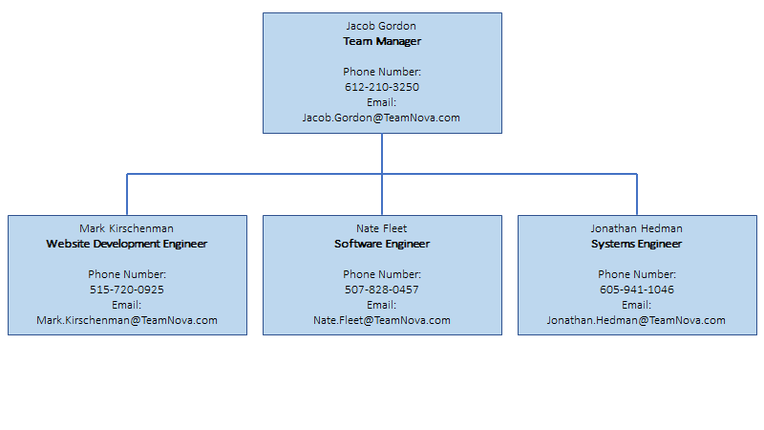

**3. Function Work Breakdown Structure**

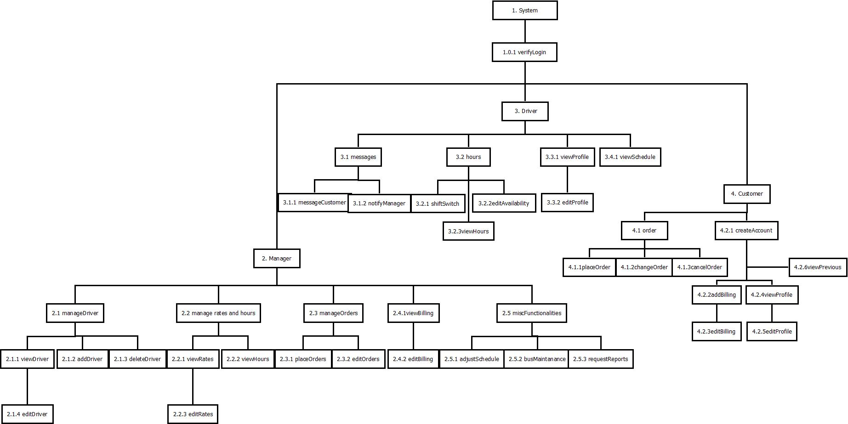

**Function Work Breakdown Structure Table**

|  |  |  |  |  |  |
| --- | --- | --- | --- | --- | --- |
| **Feature** | **Use case no.** | **Subsystem no.** | **Component no.** | **Activity no. in WBS** | **Estimated Time (Hours)** |
| **verifyLogin(Manager)** | **1.0.1** | **2** | **2.1** | **1.7.4** | **45** |
| **viewHours** | **2.2.2** | **2** | **2.2** | **1.7.1** | **23** |
| **viewDriver** | **2.1.1** | **2** | **2.2** | **1.7.1** | **22** |
| **editDriver** | **2.1.4** | **2** | **2.2** | **1.7.1** | **13** |
| **deleteDriver** | **2.1.3** | **2** | **2.2** | **1.7.1** | **10** |
| **addDriver** | **2.1.2** | **2** | **2.2** | **1.7.1** | **11** |
| **adjustSchedule** | **2.5.1** | **2** | **2.3** | **1.7.1** | **45** |
| **busMaintenance** | **2.5.2** | **2** | **2.4** | **1.7.1** | **23** |
| **requestReports** | **2.5.3** | **2** | **2.5** | **1.7.1** | **21** |
| **editOrder** | **2.3.2** | **2** | **2.6** | **1.7.1** | **24** |
| **placeOrder** | **2.3.1** | **2** | **2.6** | **1.7.1** | **22** |
| **viewBilling** | **2.4.1** | **2** | **2.6** | **1.7.1** | **11** |
| **editBilling** | **2.4.2** | **2** | **2.6** | **1.7.1** | **11** |
| **viewRates** | **2.2.1** | **2** | **2.7** | **1.7.1** | **23** |
| **editRates** | **2.2.3** | **2** | **2.7** | **1.7.1** | **23** |
| **messageCustomer** | **3.1.1** | **3** | **3.1** | **1.7.2** | **45** |
| **notifyManager** | **3.1.2** | **3** | **3.1** | **1.7.2** | **23** |
| **viewHours** | **3.2.3** | **3** | **3.2** | **1.7.2** | **11** |
| **editAvailability** | **3.2.2** | **3** | **3.2** | **1.7.2** | **22** |
| **shiftSwitch** | **3.2.1** | **3** | **3.2** | **1.7.2** | **22** |
| **viewSchedule** | **3.4.1** | **3** | **3.3** | **1.7.2** | **10** |
| **editProfile** | **3.3.2** | **3** | **3.4** | **1.7.2** | **24** |
| **viewProfile** | **3.3.1** | **3** | **3.4** | **1.7.2** | **23** |
| **verifyLogin(Driver)** | **1.0.1** | **3** | **3.5** | **1.7.4** | **45** |
| **placeOrder** | **4.1.1** | **4** | **4.1** | **1.7.3** | **24** |
| **changeOrder** | **4.1.2** | **4** | **4.1** | **1.7.3** | **22** |
| **cancelOrder** | **4.1.3** | **4** | **4.1** | **1.7.3** | **22** |
| **addBilling** | **4.2.2** | **4** | **4.2** | **1.7.3** | **25** |
| **editBilling** | **4.2.3** | **4** | **4.2** | **1.7.3** | **21** |
| **viewProfile** | **4.2.4** | **4** | **4.2** | **1.7.3** | **12** |
| **editProfile** | **4.2.5** | **4** | **4.2** | **1.7.3** | **13** |
| **createAccount** | **4.2.1** | **4** | **4.2** | **1.7.3** | **45** |
| **viewPrevious** | **4.2.6** | **4** | **4.2** | **1.7.3** | **70** |
| **verifyLogin(Customer)** | **1.0.1** | **4** | **4.3** | **1.7.4** | **24** |

**4. Milestones**

1. Completing System Functions
2. Designing algorithms to control user interaction with database
3. Implementing the database
4. Testing the software and database implementation
5. Completing the Structure of the website
6. Integrating the database and system functions into the Website
7. Testing the integration of website with database

**5. Activity Graph/Critical Path**

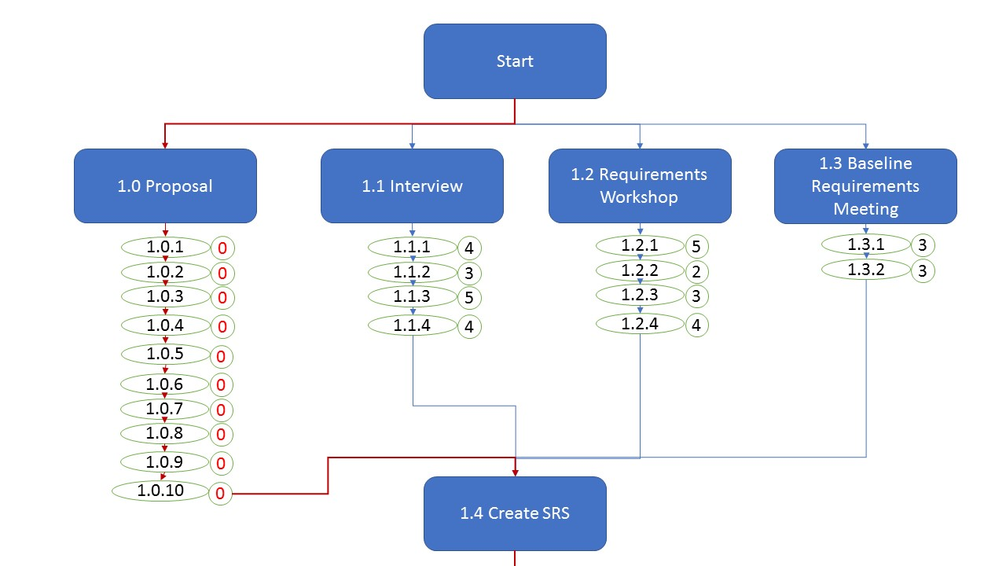

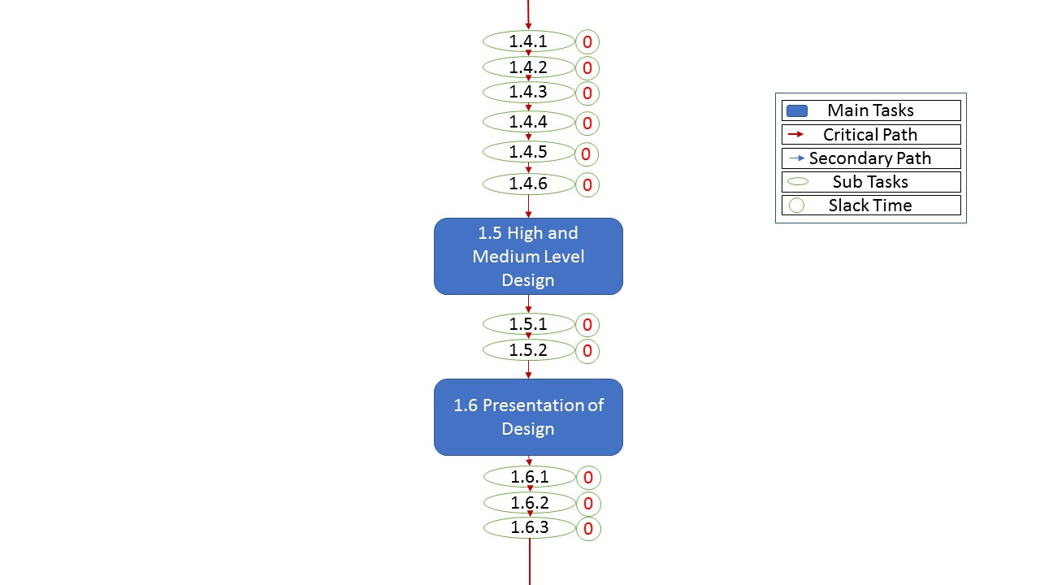

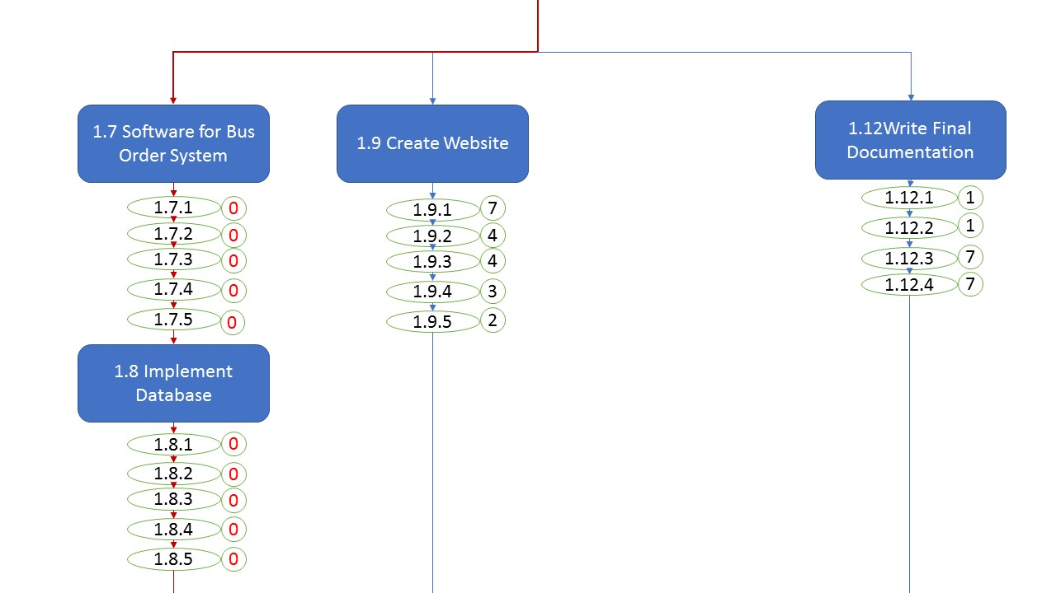

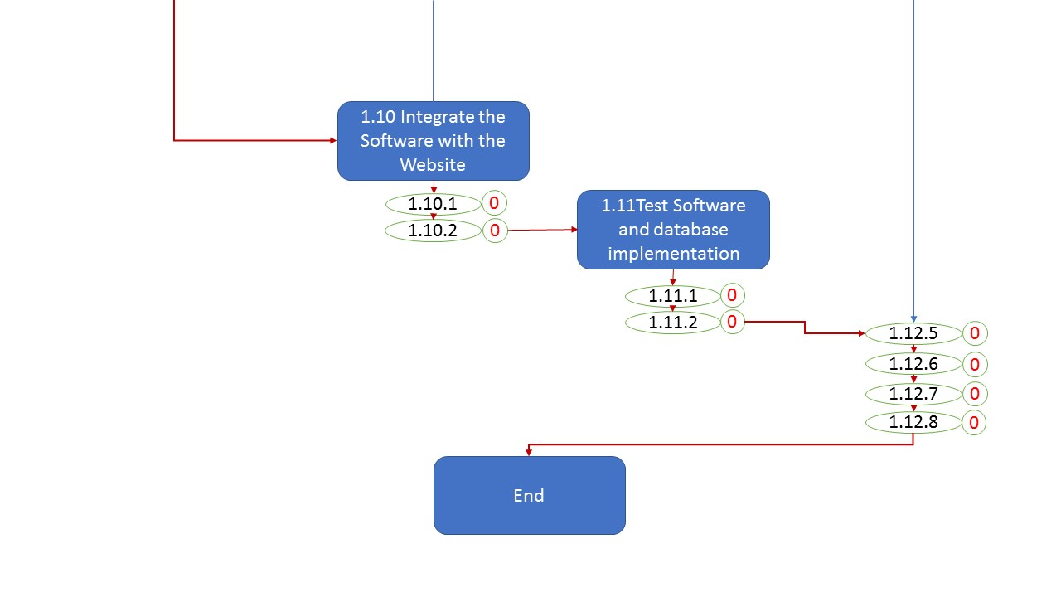

**Activity Graph Number Key**

1.0 Proposal

1.0.1 Letter of Proposal

1.0.2 Scope

1.0.3 Plan

1.0.4 Estimates

1.0.5 Alternatives

1.0.6 Training and Maintenance Plan

1.0.7 Terms of Acceptance

1.0.8 Warranty

1.0.9 Terminology

1.0.10 Log of Meetings and Review Processes

1.1 Interview

1.1.1 Schedule an interview

1.1.2 Create questions

1.1.3 Send questions to client

1.1.4 Have Interview

1.2 Requirements Workshop

1.2.1 Schedule meeting with client

1.2.2 Brainstorm Ideas

1.2.3 Idea Reduction

1.2.4 Prioritization

1.3 Baseline Requirements Meeting

1.3.1 Evaluate Risk and Effort

1.3.2 Create Baseline Requirements

1.4 Create SRS

1.4.1 Introduction

1.4.2 Overall Description

1.4.3 Specific Requirements

1.4.4 Use case diagrams

1.4.5 Sequence diagrams

1.5 High and Medium level Design

1.5.1 Create High level of Design

1.5.2 Create Medium Level of Design

1.6 Presentation of Design

1.6.1 Schedule a time for Presentation of Design

1.6.2 Create presentation

1.6.3 Presentation of Design

1. 7 Software for Bus Order System

1.7.1 Code function implementation

1.7.2 Code Manager functions

1.7.3 Code Driver functions

1.7.4 Code Customer functions

1.7.5 Code System functions

1.8 Implement Database

1.8.1 Design database tables

1.8.2 Code database

1.8.3 Link database to main code

1.9 Create Website

1.9.1 Create the homepage

1.9.2 Create multiple login

1.9.3 Create customer page

1.9.4 Create driver page

1.9.5 Create manager page

1.10 Integrate Software with the Website

1.10.1 Create appropriate buttons on each page

1.10.2 Allow buttons to call functions

1.11 Test Software and database implementation

1.11.1 Test software codes and functions

1.11.2 Test database and code link implementation

1.12 Write Final Documentation

1.12.1 Weekly progress report

1.12.2 Acceptance test plan

1.12.3 Unit and integration test plan

1.12.4 Final Codes

1.12.5 Integrated Documentation

1.12.6 Write help file

1.12.7 Complete final documentation

**6. Project Schedule**

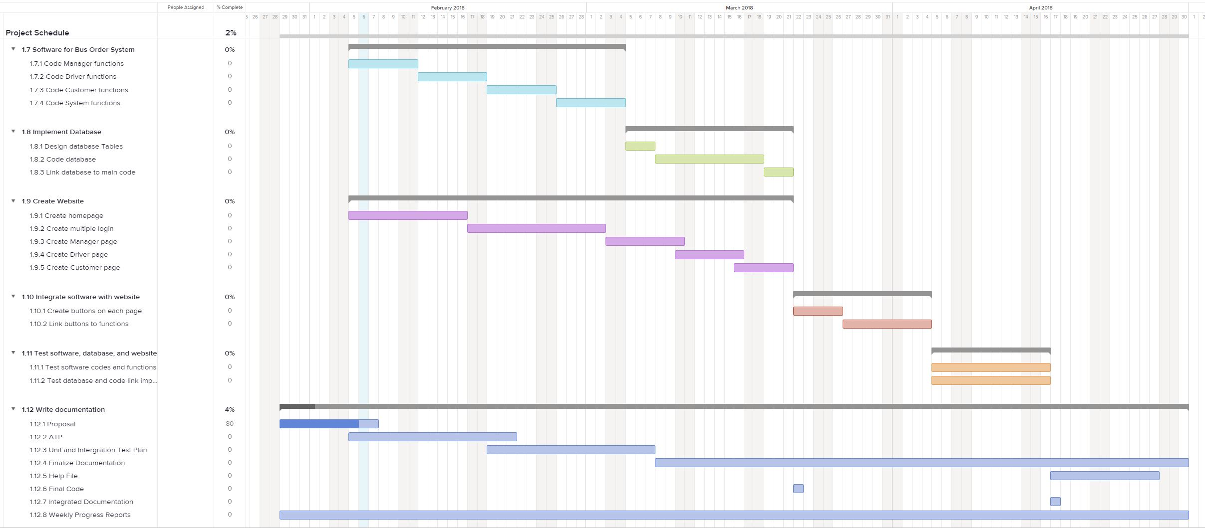



**7. Project Team Organization and List of Responsibilities**

**Jacob Gordon**

* **Team Manager**
* Programming Languages: C++, C, and Python
* Contact Information:
  + Phone: 612-310-3250, Email: Jacob.Gordon@jacks.sdstate.edu
* Responsibilities:
  + Oversee all team activities
  + Create weekly report for customer
  + Create/edit project documentation
  + Programmer

**John Hedman**

* **Team Member**
* Programming Languages: C++, C, and Python
* Contact Information:
  + Phone: 605-941-1046, Email: Jonathan.Hedman@jacks.sdstate.edu
* Responsibilities:
  + Set up server access
  + Create/edit project documentation
  + Programmer

**Nate Fleet**

* **Team Member**
* Programming Languages: C++, C, Javascript, and Python
* Contact Information:
  + Phone: 507-828-0457, Email: Nate.Fleet@jacks.sdstate.edu
* Responsibilities:
  + Create/edit project documentation
  + Programmer

**Mark Kirschenman**

* **Team Member**
* Programming Languages: C++, C, HTML, Javascript, and Python
* Contact Information:
  + Phone:515-720-0925, Email: Mark.Kirschenman@jacks.sdstate.edu
* Responsibilities:
  + Create/edit project documentation
  + Programmer

**8. Log of Meetings and Review Processes**

Team Nova will meet at least twice a week to discuss the current status of the project. At each meeting, a weekly plan will be created to ensure that we are on schedule. Meetings will take place on Tuesdays at 3:00 pm and Sundays at 1:00 pm. These meetings will be a minimum of two hours each. If necessary, a meeting may be extended up to five hours. These meetings will help reinforce what each team member needs to do so that the project can continue on-schedule. Any additional team-decided meetings during the week will be documented and added to the log.

**9. Risk Management**

Below we have included a risk management table which displays problems we believe may occur during the development of the product. To mitigate these risks during production, we have also included a contingency table that represents the estimated cost of the risk, and the actions we should take to mitigate the effect or entirely prevent the risk.

|  |  |  |  |  |
| --- | --- | --- | --- | --- |
| **Risk Table** | | | | |
| **Item No** | **Risk Item** | **Probability**  **(1-10)** | **Impact**  **(1-10)** | **Priority**  **(PxI)** |
| **1** | **Requirements miscommunication** | **7** | **9** | **63** |
| **2** | **Loss of code files** | **4** | **8** | **32** |
| **3** | **Loss of employee** | **4** | **9** | **36** |
| **4** | **Server failure** | **1** | **10** | **10** |
| **5** | **Changing requirements** | **6** | **3** | **18** |
| **6** | **Theft of equipment** | **1** | **9** | **9** |
| **7** | **Loss of funding** | **3** | **10** | **30** |
| **8** | **Bugs in released code** | **7** | **5** | **35** |
| **9** | **Difficult/incomplete algorithms** | **7** | **2** | **14** |
| **10** | **Natural Disaster** | **2** | **10** | **20** |

|  |  |  |  |  |
| --- | --- | --- | --- | --- |
| **Contingency Table** | | | | |
| **Item No** | **Risk Item** | **Action** | **Who** | **Cost** |
| **1** | **Requirements miscommunication** | **Regular mtg. with customer** | **All** | **$100K** |
| **2** | **Loss of code files** | **Back-up on secondary storage** | **Programmers** | **$20K** |
| **3** | **Loss of employee** | **Adjust for group to cover workload** | **Programmers** | **$40K** |
| **4** | **Server failure** | **Backup server** | **All** | **$60K** |
| **5** | **Changing requirements** | **Update customer, keep plan flexible** | **Programmers** | **>$10K** |
| **6** | **Theft of equipment** | **Have critical files on multiple machines** | **Programmers** | **$11K** |
| **7** | **Loss of funding** | **Lawsuit** | **All** | **$100K+** |
| **8** | **Bugs in released code** | **Appropriate testing before release** | **Programmers** | **$30K** |
| **9** | **Difficult/incomplete algorithms** | **Thorough evaluation of algorithms** | **Programmers** | **>$8K** |
| **10** | **Natural Disaster** | **Have critical files on multiple machines** | **All** | **$7-10K** |

**10. Security**

The system will securely store the user's account information and password in the database through end-to-end encryption. User passwords and credit card information will be securely stored in a hash table using the SHA-3 hashing algorithm and a 128 bit Salt.

Security Features:

* System will be alerted to more than 5 unsuccessful login attempts, prohibiting more than 7 attempts.
* Security questions for logins from unrecognized devices for customers. Managers will always have to answer questions on login, regardless of device.
* Managers will have to re-enter their password to perform system backup functions, or edit financial information.
* User activity will be logged and secured. The system will be alerted if a customer places more than 8 orders in a day, and user account will be marked as a potential spam account. Users will not be able to place more than 10 orders in a day.
  + Orders placed from accounts marked as potential spam that the customer does not fulfil will result in the account being marked as definite spam.
* System modules will only be able to interact with other appropriate connected modules. No module, at any time, can interact with another module incorrectly, prohibiting data corruption.

**11. Backup**

To keep the system running and protected at all times, a backup system will be put into place. In the case of damage or other events that result in the primary server being compromised, the backup server will be able to assume the workload in a maximum of 15 minute downtime. Backing up the server information will also result in a downtime of a maximum of 15 minutes to complete file transfer.

Automatic Backup:

Who: System

When: Weekly on Tuesday at 4:00 AM (CST) - 4:15 AM (CST)

Where: Hard drive located at BATA Headquarters

Hardware: WD Gold 12TB Enterprise Class Hard Disk Drive

Model #: WD121KRYZ

Optional Manual Backup:

Who: BATA System Administrator

When: Anytime. **!!WARNING!!** Requires system shutdown for 15 minutes

Where: Hard drive located on BATA System Administrator’s computer

Hardware: WD Gold 12TB Enterprise Class Hard Disk Drive

Model #: WD121KRYZ

During the weekly automated backup, all information on the server will be saved onto the WD Gold hard drive. This information includes:

Customers: name, address, phone number, email, account password, credit card number, credit card expiry date, CVV number, billing address, previous trips, currently scheduled trips, messages.

Driver: name, address, phone number, email, account password, scheduled trips, hours, pay rate, messages.

System: current schedule, cost rates, bus numbers, bus status, manager password.

**12. Deliverables**

During the duration of this project we will create documentation that will show our process throughout the project. This will help to alleviate any concerns about the progress on the project and will also aid to manage any changes to the project plan. The deliverables that we intent to present are listed below. Upon delivery of a deliverable both the delivering Nova manager and customer must sign to confirm that the deliverable was delivered.

* **Proposal**

**2/8/17**

**Delivered By: Jacob Gordon**

**Customer Signature**

**_________________________________________**

**Nova Manager Signature**

**__________________________________________**

* **Weekly progress report**

**Sunday’s 1/14/18 - 4/29/18**

**Delivered By: Jacob Gordon**

**Customer Signature**

**_________________________________________**

**Nova Manager Signature**

**__________________________________________**

* **Acceptance Test Plan**

**2/14/18**

**Delivered By: Jacob Gordon**

**Customer Signature**

**_________________________________________**

**Nova Manager Signature**

**__________________________________________**

* **Unit and Integration Test Plan**

**3/12/18**

**Delivered By: Jacob Gordon**

**Customer Signature**

**_________________________________________**

**Nova Manager Signature**

**__________________________________________**

* **Final Codes**

**4/9/18**

**Delivered By: Jacob Gordon**

**Customer Signature**

**_________________________________________**

**Nova Manager Signature**

**__________________________________________**

* **Integrated Documentation**

**4/29/18**

**Delivered By: Jacob Gordon**

**Customer Signature**

**_________________________________________**

**Nova Manager Signature**

**__________________________________________**

**13. Cost Estimates**

This project is expected to take 9 months to complete, beginning in August of 2017, and completing in May of 2018. During this time, a staff consisting of the four members of Team Nova will be the primary personnel in charge of completing all activities for the project. The exact breakdown of the project time-frame can be seen in the Activity Graph and Gantt Chart earlier in the document.

We have produced our cost estimate using the Cocomo I Model. This model was used to generate an accurate cost-estimate of the software development project. The method itself is well-used by many software development companies, and therefore can be relied on for our cost estimation. Each step in the calculations will be explained and how the results were produced.

**Expert Cost**

Our experts have calculated that the project will take a total of 916 man hours to complete this project based on past projects. Our expert estimate comes from the following equation, where H is the total amount of hours multiplied by our hourly rate of $130:

|  |  |  |  |  |  |  |
| --- | --- | --- | --- | --- | --- | --- |
| **Activity Graph Label** | **Feature** | **Estimated Design Time (Hours)** | **Estimated Programming Time (Hours)** | **Estimated Debugging Time (Hours)** | **Estimated Total Time (Hours)** | **Estimated Cost ($)** |
| **1.1.1** | **Schedule an Interview** | **-** | **-** | **-** | **0.5** | **$65.00** |
| **1.1.2** | **Create Questions** | **-** | **-** | **-** | **1** | **$130.00** |
| **1.1.3** | **Send Questions to Client** | **-** | **-** | **-** | **0.5** | **$65.00** |
| **1.1.4** | **Have Interview** | **-** | **-** | **-** | **4** | **$520.00** |
| **1.2.1** | **Schedule Meeting with Client** | **-** | **-** | **-** | **0.5** | **$65.00** |
| **1.2.2** | **Brainstorm Ideas** | **-** | **-** | **-** | **2** | **$260.00** |
| **1.2.3** | **Idea Reduction** | **-** | **-** | **-** | **1** | **$130.00** |
| **1.2.4** | **Prioritization** | **-** | **-** | **-** | **1** | **$130.00** |
| **1.3.1** | **Evaluate Risk and Effort** | **-** | **-** | **-** | **1** | **$130.00** |
| **1.3.2** | **Create Baseline Requirements** | **-** | **-** | **-** | **1** | **$130.00** |
| **1.4.1** | **Introduction** | **-** | **-** | **-** | **2** | **$260.00** |
| **1.4.2** | **Overall Description** | **-** | **-** | **-** | **2** | **$260.00** |
| **1.4.3** | **Specific Requirements** | **-** | **-** | **-** | **2** | **$260.00** |
| **1.4.4** | **Use Case Diagrams** | **-** | **-** | **-** | **4** | **$520.00** |
| **1.4.5** | **Sequence Diagrams** | **-** | **-** | **-** | **3** | **$390.00** |
| **1.5.1** | **Create High Level of Design** | **-** | **-** | **-** | **2** | **$260.00** |
| **1.5.2** | **Create Medium Level of Design** | **-** | **-** | **-** | **2** | **$260.00** |
| **1.6.1** | **Schedule a time for Presentation of Design** | **-** | **-** | **-** | **0.5** | **$65.00** |
| **1.6.2** | **Create Presentation** | **-** | **-** | **-** | **4** | **$520.00** |
| **1.6.3** | **Presentation of Design** | **-** | **-** | **-** | **1** | **$130.00** |
| **Pre-Implementation Cost** | | | | | | **$4,550.00** |
| **1.0.1** | **verifyLogin(Manager)** | **16** | **18** | **11** | **45** | **$5,850.00** |
| **2.2.2** | **viewHours** | **8** | **9** | **6** | **23** | **$2,990.00** |
| **2.1.1** | **viewDriver** | **8** | **9** | **5** | **22** | **$2,860.00** |
| **2.1.4** | **editDriver** | **5** | **5** | **3** | **13** | **$1,690.00** |
| **2.1.3** | **deleteDriver** | **3** | **4** | **3** | **10** | **$1,300.00** |
| **2.1.2** | **addDriver** | **4** | **4** | **3** | **11** | **$1,430.00** |
| **2.5.1** | **adjustSchedule** | **16** | **18** | **11** | **45** | **$5,850.00** |
| **2.3.2** | **busMaintenance** | **8** | **9** | **6** | **23** | **$2,990.00** |
| **2.3.1** | **requestReports** | **7** | **8** | **6** | **21** | **$2,730.00** |
| **2.4.1** | **editOrder** | **8** | **10** | **6** | **24** | **$3,120.00** |
| **2.3.1** | **placeOrder** | **8** | **9** | **5** | **22** | **$2,860.00** |
| **2.4.1** | **viewBilling** | **4** | **4** | **3** | **11** | **$1,430.00** |
| **2.4.2** | **editBilling** | **4** | **4** | **3** | **11** | **$1,430.00** |
| **2.2.1** | **viewRates** | **8** | **9** | **6** | **23** | **$2,990.00** |
| **2.2.3** | **editRates** | **8** | **9** | **6** | **23** | **$2,990.00** |
| **3.1.1** | **messageCustomer** | **16** | **18** | **11** | **45** | **$5,850.00** |
| **3.1.2** | **notifyManager** | **8** | **9** | **6** | **23** | **$2,990.00** |
| **3.2.3** | **viewHours** | **4** | **4** | **3** | **11** | **$1,430.00** |
| **3.2.2** | **editAvailability** | **8** | **9** | **5** | **22** | **$2,860.00** |
| **3.2.1** | **shiftSwitch** | **8** | **9** | **5** | **22** | **$2,860.00** |
| **3.4.1** | **viewSchedule** | **3** | **4** | **3** | **10** | **$1,300.00** |
| **3.3.2** | **editProfile** | **8** | **10** | **6** | **24** | **$3,120.00** |
| **3.3.1** | **viewProfile** | **8** | **9** | **6** | **23** | **$2,990.00** |
| **1.0.1** | **verifyLogin(Driver)** | **16** | **18** | **11** | **45** | **$5,850.00** |
| **4.1.1** | **placeOrder** | **8** | **10** | **6** | **24** | **$3,120.00** |
| **4.1.2** | **changeOrder** | **8** | **9** | **5** | **22** | **$2,860.00** |
| **4.1.3** | **cancelOrder** | **8** | **9** | **5** | **22** | **$2,860.00** |
| **4.2.2** | **addBilling** | **9** | **10** | **6** | **25** | **$3,250.00** |
| **4.2.3** | **editBilling** | **7** | **8** | **6** | **21** | **$2,730.00** |
| **4.2.4** | **viewProfile** | **4** | **5** | **3** | **12** | **$1,560.00** |
| **4.2.5** | **editProfile** | **5** | **5** | **3** | **13** | **$1,690.00** |
| **4.2.1** | **createAccount** | **16** | **18** | **11** | **45** | **$5,850.00** |
| **4.2.6** | **viewPrevious** | **24** | **28** | **18** | **70** | **$9,100.00** |
| **1.0.1** | **verifyLogin(Customer)** | **8** | **10** | **6** | **24** | **$3,120.00** |
| **Implementation Cost** | | | | | | **$107,000.00** |
| **1.12.1** | **Weekly Progress Report** | **-** | **-** | **-** | **4** | **$520.00** |
| **1.12.2** | **Acceptance Test Plan** | **-** | **-** | **-** | **15** | **$1,950.00** |
| **1.12.3** | **Unit & Integration Test Plan** | **-** | **-** | **-** | **15** | **$1,950.00** |
| **1.12.4** | **Final Codes** | **-** | **-** | **-** | **1** | **$130.00** |
| **1.12.5** | **Integrated Documentation** | **-** | **-** | **-** | **10** | **$1,300.00** |
| **1.12.6** | **Write Help File** | **-** | **-** | **-** | **1** | **$130.00** |
| **1.12.7** | **Complete Final Documentation** | **-** | **-** | **-** | **5** | **$650.00** |
| **Documentation** | | | | | | **$6,630.00** |
| **Subtotal** | | | | | | **$119,080.00** |
| **Tax** | | | | | | **$8,335.60** |
| **Total** | | | | | | **$127,415.60** |

Using the model estimate as a guideline to our expert estimate, we believe $127,415.60 will be a fair price to deliver the software project.

**Model Cost**

The equation that was used to find the model cost was the following:

This is a model that we have developed and updated over the 10 years and it is designed to give a us a comfortable beginning estimate for the cost of multiple software projects. The S in the equation is the total estimated lines of code for the project. The a and b in the equation are parameters that we have found to fit well in the equation when developing different sizes of projects. Lastly, the m(x) is a multiple of attributes that would affect the overall time and cost of the hole project and it follows the following equation:

The following is the parameters that we used in the equation:

Estimated Lines of code (S): 14,600 Lines of code

a :3.2

b: 1.05

m(x): 1.947

The model came up with an estimated cost of $147,000. The parameters are described more in the following pages.

Here is the table that we use to find the a and b parameters:

|  |  |  |  |  |
| --- | --- | --- | --- | --- |
| Mode | Basic a | Basic b | Intermediate a | Intermediate b |
| Organic | 2.4 | 1.05 | 3.2 | 1.05 |
| Semidetached | 3.0 | 1.12 | 3.0 | 1.12 |
| Embedded | 3.6 | 1.20 | 2.8 | 1.20 |

These are the cost drivers that we use when calculating m(x):

|  |  |  |  |  |  |
| --- | --- | --- | --- | --- | --- |
| Attribute | Very Low | Low | Medium | High | Very High |
| Required Software Reliability | 0.75 | 0.9 | 1.0 | 1.1 | 1.25 |
| Availability | 0.75 | 0.9 | 1.0 | 1.1 | 1.25 |
| Data Security | 0.80 | 0.95 | 1.0 | 1.15 | 1.3 |
| Maintainability | 0.75 | 0.9 | 1.0 | 1.1 | 1.25 |
| Portability | 0.75 | 0.9 | 1.0 | 1.1 | 1.25 |
| Storage Constraints | 0.75 | 0.9 | 1.0 | 1.1 | 1.25 |
| Applications Experience | 1.25 | 1.1 | 1.0 | 0.9 | 0.75 |
| Size of Database | 0.70 | 0.85 | 1.0 | 1.05 | 1.20 |
| Complexity | 0.75 | 0.9 | 1.0 | 1.1 | 1.25 |
| New Subjects to learn | 0.75 | 0.9 | 1.0 | 1.1 | 1.25 |

Values for the cost drivers for this project:

|  |  |  |
| --- | --- | --- |
| Attribute | Value | Multiplication |
| Reliability | High | 1.1 |
| Availability | Very High | 1.25 |
| Data Security | Very High | 1.3 |
| Maintainability | Medium | 1.0 |
| Portability | Medium | 1.0 |
| Storage Constraints | Low | 0.9 |
| Capability of Programmers | Medium | 1.0 |
| Size of Database | Medium | 1.0 |
| Complexity | High | 1.1 |
| New Subjects to learn | High | 1.1 |
| M(x)(Total): |  | 1.947 |

**14. Alternatives**

At this point we do not have any alternative plans for this project.

**15. Training and Maintenance Plan**

Training for managers and drivers will occur at a negotiated date approximately one week after the final product has been delivered. Both drivers and managers will receive a separate training session. Each of these training sessions will be two and a half hours long. The Managers will be given training in small groups of about 10 people. The first hour will be dedicated to giving a lecture and explaining how the managers will use the system. The second half hour will be dedicated for questions regarding the system. The third hour will be dedicated to managers individually going through a “quiz of the system.” Here, the managers will be asked to complete specific tasks using the system. This will test their understanding of the system. The managers will also be encouraged to help one another as they complete the training tasks. A similar structured training session will be given to the drivers one hour after manager training. This training will also have one hour of lecture, half an hour of questions, and one hour of a quiz. Upon the hiring of more employees or if training is missed by the client company, It will be the responsibility of the client company to train their employees. Future training will be done by client company, but we recommend that a similar training method be used.

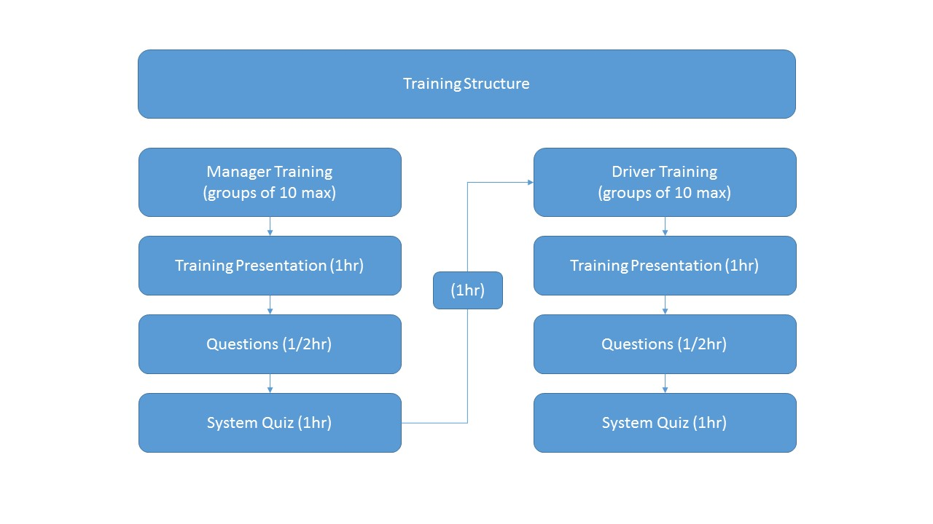

**16. Terms of Acceptance**

**SOFTWARE DEVELOPMENT AND SUPPORT SERVICES TERMS & CONDITIONS OF BUSINESS**

This agreement is between Team Nova Pty Ltd (we/our/us) and the Client (you/your) engaging Team Nova to provide software development and software support services. You accept this agreement by signing below, clicking a box indicating your acceptance or executing an order form that references this agreement or by payment of a deposit authorizing work on your quoted project to begin. If you are accepting these terms and conditions on behalf of an entity, you represent that you have the authority to bind such entity and its affiliates to these terms and conditions.

These terms were last updated on January 28, 2018 and are effective between You and Us as of the date of you accepting them.

**OUR RESPONSIBILITIES**

**Provision of Purchased Services.**​We will (a) make the Services available to You pursuant to this Agreement and the applicable Order Forms, (b) provide Our standard support for the Purchased Services to You at no additional charge, and/or upgraded support if purchased, and (c) use commercially reasonable efforts to make the Purchased Services hosted by us available 24 hours a day, 7 days a week, except for: (i) planned downtime (of which We shall give at least 8 hours electronic notice and which We shall schedule to the extent practicable during the weekend hours between 6:00 p.m. Friday and 3:00 a.m. Monday Pacific time), and (ii) any unavailability caused by circumstances beyond Our reasonable control, including, for example, an act of God, act of government, flood, fire, earthquake, civil unrest, act of terror, strike or other labor problem (other than one involving Our employees), Internet service provider failure or delay, non­-Team Nova Application malfunction, or denial of service attack.

**Protection of Your Data**.​We will maintain administrative, physical, and technical safeguards for protection of the security, confidentiality and integrity of Your Data. Those safeguards will include, but will not be limited to, measures for preventing access, use, modification or disclosure of Your Data by Our personnel except (a) to provide the Purchased Services and prevent or address service or technical problems, (b) as compelled by law, or (c) as You expressly permit in writing.

**Conflicts of Interest​.** We will have in place and maintain processes for the early detection and mitigation of conflict of interest risks. These will include but not be limited to the following safeguards:

(1) *Declaration* ­- We will declare the potential conflict of interest to the client as soon as we

become aware of it as well as explain to both clients the safeguards put in place to mitigate the potential conflict of interest risk.

(2) *Screens* ­ - Software Engineers working on one project are prohibited from certain kinds of communication with Software Engineers working on a project for a competing client; for instance prohibiting discussion of technical requirements and coding outside of closed, project specific electronic discussion boards. Where necessary, for example on projects that require verbal group discussions, these prohibitions will be augmented by placing the Software Engineers in separate locations (on different floors or in different buildings) and putting controls on e­mail and file access.

(3) *Project Management* ­ - Technical Project Managers are prohibited from working on two or more projects that have been identified during the business development or requirements definition stage to pose a conflict of interest risk for clients (e.g same product in the same industry)

(4) *Code of Ethics* ­ - we require all of our Software Engineers to pass accreditation and maintain membership with the Australian Computer Society (ACS). As part of this, our Software Engineers subscribe the ACS’ Code of Ethics which stipulates and enforces honesty and protection of client interests standards.

**Confidentiality**.​“Confidential Information” means all information disclosed by a party (“Disclosing Party”) to the other party (“Receiving Party”), whether orally or in writing, that is designated as confidential or that reasonably should be understood to be confidential given the nature of the information and the circumstances of disclosure. Your Confidential Information includes Your Data; Our Confidential Information includes the Services and Content; and Confidential Information of each party includes the terms and conditions of this Agreement and all Order Forms (including pricing), as well as business and marketing plans, technology and technical information, product plans and designs, and business processes disclosed by such party. However, Confidential Information does not include any information that (i) is or becomes generally known to the public without breach of any obligation owed to the Disclosing Party, (ii) was known to the Receiving Party prior to its disclosure by the Disclosing Party without breach of any obligation owed to the Disclosing Party, (iii) is received from a third party without breach of any obligation owed to the Disclosing Party, or (iv) was independently developed by the Receiving Party. The Receiving Party will use the same degree of care that it uses to protect the confidentiality of its own confidential information of like kind (but not less than reasonable care) (i) not to use any Confidential Information of the Disclosing Party for any purpose outside the scope of this Agreement, and (ii) except as otherwise authorized by the Disclosing Party in writing, to limit access to Confidential Information of the Disclosing Party to those of its and its Affiliates’ employees and contractors who need that access for purposes consistent with this Agreement and who have signed confidentiality agreements with the Receiving Party containing protections no less stringent than those herein. Neither party will disclose the terms of this Agreement or any Order Form to any third party other than its Affiliates, legal counsel and accountants without the other party’s prior written consent.

**Quality Assurance.**​ We provide quality assurance through 4 steps: (1) We undertake automated and manual testing of the developed application for internal signoff of its proper functioning (2) You undertake manual testing of the developed application and sign off on its proper functioning (3) We run an automated test once the application goes live (4) We give you 14 days after the application goes live to identify any final issues. Thus we demonstrate the application’s functionality materially complies with the relevant Specifications to the Customer. The Customer is responsible for conducting any additional testing of the deliverables subject to any applicable Acceptance Criteria agreed on by the parties before the tests take place. If the Customer reasonably determines a submitted deliverable does not materially comply with the Acceptance Criteria, it must provide its reasons to Team Nova in writing within 14 Business Days of the software being made available for client testing. Team Nova will then use commercially reasonable efforts to promptly resolve any deficiencies raised by the Customer and submit the deliverable for re­testing. Unless otherwise agreed by Team Nova, the Customer agrees not to use the Software before its acceptance except to complete the tests. If the Customer uses the Software in live commercial use, acceptance of the tests will be deemed to have occurred.

**Our Personnel**.​ We will be responsible for the performance of Our personnel (including Our employees and contractors) and their compliance with Our obligations under this Agreement, except as otherwise specified herein.

**YOUR RESPONSIBILITIES**

**Communication​.**The customer must let Team Nova know of any defect in the operation of the Software in writing as soon as it becomes aware of the defect and agrees that Team Nova may resolve the defect remotely.

**IT Environment:** ​The client is responsible for ensuring that the IT environment in which the application is installed is in good working order and that it has sole responsibility for the availability and integrity of the that environment. The client is responsible for taking all reasonable precautions to safeguard its business and specifically its IT Environment, the Software and all software and data to minimise potential loss or disruption, including (as applicable) implementing effective audit control, working methods, firewalls, virus checking controls and data security measures including appropriate data and software back­ups.

**Milestone Review Process**

The client will have the opportunity to review project progress at the end of each identified project stage. Team Nova will provide the client with a 7 day window in which the client can request a face to face or phone based meeting to review progress. This 7 day period will begin from the date Team Nova issues notice via email that the particular stage is ready for review. If the Client does not review progress within this period the particular stage milestone will be deemed to be signed off on by the client and the next payment installment will become due.

**Final Testing**. ​The client is responsible for final testing of the application to ensure it complies with their requirements before going live. ​Team Nova has a 4 step quality assurance process that requires us to test automatically and manually that the software meets requirements specifications prior to going live and after going live. Part of this quality assurance process requires the customer to test the software before it goes live and after it goes live. After carrying out this process, Team Nova does not accept responsibility for losses or damage arising from errors within any application. Team Nova also does not accept responsibility for errors, damages, losses or additional costs that relate to third party products.

**Permissions & Copyright.​**The client will obtain all necessary permissions and authorities with respect to the use of all copy, graphics, logos, names and trademarks and any other material supplied by the client to Team Nova. Supply of said material by the client to Team Nova shall be regarded as a guarantee from the client that all such permissions and authorities have been sought and obtained for said material. No responsibility will be accepted by Team Nova for damages or losses incurred by the client from the use of material for which permission or authority has not been obtained.

**Timely Payment.**​The client is responsible for paying invoices by the due date specified on the invoice in line with Team Nova’s terms of payment. Team Nova incurs expenses for Software Engineering wages, software development platforms, purchase of copyright items (e.g. customer specific images, modules etc.). We incur these expenses prior to invoicing the client. Any late payments usually create cash flow challenges for us. As a result, we will postpone work on any project as soon as soon as an invoice related to that project becomes overdue. The project due date will be extended in line with the postponement time. Invoices that become overdue by more than 21 days may be referred onto a debt collection agency and all fees incurred to recover the owed amounts are payable by the client.

**Cancellation​.** Should you wish to cancel after having authorized us to begin development, Team Nova will invoice you for any work completed to date, as a percentage of the total work involved. You must advise Team Nova in writing of the request not to proceed with work.

**FEES & PAYMENT FOR PURCHASED SERVICES**

**Invoicing and Payment.** ​We will invoice you as per the agreed payment schedule. Unless otherwise stated, invoiced charges are due net 14 days from the invoice date. You are responsible for providing complete and accurate billing and contact information to Us and notifying Us of any changes to such information.

**Overdue Charges**. ​If any invoiced amount is not received by Us by the due date, then without limiting Our rights or remedies, (a) those charges may accrue late interest at the rate of 10% of the outstanding balance per month, or the maximum rate permitted by law, whichever is lower, and/or (b) We may condition future any future work on prepayment basis.

**Suspension of Service and Acceleration.** ​If any amount owing by You under this or any other agreement for Our services is 14 or more days overdue, We may, without limiting Our other rights and remedies, accelerate Your unpaid fee obligations under such agreements so that all such obligations become immediately due and payable, and suspend Our services to You until such amounts are paid in full. We will give You at least 10 days’ prior notice that Your account is overdue, before suspending services to You.

**Payment Disputes.**​ We will not exercise Our rights under the section “Overdue Charges” or “Suspension of Service and Acceleration” above if You are disputing the applicable charges reasonably and in good faith and are cooperating diligently to resolve the dispute.

**MUTUAL INDEMNIFICATION**

**Indemnification by Us**. ​We will defend You against any claim, demand, suit or proceeding made or brought against You by a third party alleging that the use of a Purchased Service in accordance with this Agreement infringes or misappropriates such third party’s intellectual property rights (a “Claim Against You”), and will indemnify You from any damages, attorney fees costs finally awarded against You as a result of, or for amounts paid by You under a court­ approved settlement of, a Claim Against You, provided You (a) promptly give Us written notice of the Claim Against You, (b) give Us sole control of the defense and settlement of the Claim Against You (except that We may not settle any Claim Against You unless it unconditionally releases You of all liability), and (c) give Us all reasonable assistance, at Our expense. If We receive information about an infringement or misappropriation claim related to a Service, We may in Our discretion and at no cost to You (i) modify the Service so that it no longer infringes or misappropriates (ii) obtain a license for Your continued use of that Service in accordance with this Agreement. The above defense and indemnification obligations do not apply to the extent a Claim Against You arises from Content, a Non-­Team Nova Application or Your breach of this Agreement.

**Indemnification by You**.​ You will defend Us against any claim, demand, suit or proceeding made or brought against Us by a third party alleging that Your Data, or Your use of any Service or Content in breach of this Agreement, infringes or misappropriates such third party’s intellectual property rights or violates applicable law (a “Claim Against Us”), and will indemnify Us from any damages, attorney fees and costs finally awarded against Us as a result of, or for any amounts paid by Us under a court­ approved settlement of, a Claim Against Us, provided We (a) promptly give You written notice of the Claim Against Us, (b) give You sole control of the defense and settlement of the Claim Against Us (except that You may not settle any Claim Against Us unless it unconditionally releases Us of all liability), and (c) give You all reasonable assistance, at Your expense.

**INTELLECTUAL PROPERTY**

All intellectual property created by Team Nova is absolutely retained by Team Nova. Fees paid by the customer under these terms do not constitute consideration for ownership of created IP by the customer. Team Nova may separately negotiate custom licensing or intellectual property assignment arrangements in relation to the created IP. Such an agreement must be recorded in writing as special terms overriding the provisions of this agreement in relation to intellectual property.

Subject to the customer’s compliance with all the above terms, Team Nova grants the customer a non­exclusive, irrevocable, perpetual and fee free license to use the software for the purpose which it was intended. This grant is also subject to the customer warranting that it will not, nor will it allow any third party to, separate out the created IP and use it for any other project or purpose, including transplanting that IP into other code, documentation or artefacts. The customer grants Team Nova a non­exclusive, irrevocable, perpetual, fee free license to use the customer IP, in its minimum usable form and without such customer IP being deemed to be confidential information, insofar as it is inextricable from the created IP, for the purposes of exploiting the created IP.

“SOFTWARE DEVELOPMENT AND SUPPORT SERVICES TERMS & CONDITIONS OF BUSINESS.” *Codium*, Codium, 30 Jan. 2014, [www.codium.com.au/wp-content/uploads/2015/04/Codium-Terms-and-Conditions-of-Business.pdf](http://www.codium.com.au/wp-content/uploads/2015/04/Codium-Terms-and-Conditions-of-Business.pdf).**S**

**Customer Signature**

**_________________________________________**

**17. Warranty**

**Limited Warranty**. Team Nova warrants that for a period of ninety days from the beginning of the applicable warranty period (as described below), or for the designated warranty period if a different warranty period is designated as the warranty period for the Software in the current version of an instrument operating manual or catalog or in a specific written warranty including with and covering the Software, the Software will function substantially in accordance with the functions and features described in the Documentation delivered with the Software when properly installed, and that for a period of ninety days from the beginning of the applicable warranty period (as described below) the tapes, CDs, diskettes or other media bearing the Software will be free of defects in materials and workmanship under normal use. The above warranties do **not** apply to defects resulting from misuse, neglect, or accident, including without limitation: operation outside of the environmental or use specifications, or not in conformance with the instructions for any instrument system, software, or accessories; improper or inadequate maintenance by the user; installation of software or interfacing, or use in combination with software or products not supplied or authorized by Team Nova; and modification or repair of the products not authorized by Team Nova. Team Nova accepts no responsibility for defects or issues caused by third-party software incorporated in this software.

TEAM NOVA MAKES NO OTHER WARRANTIES OF ANY KIND WHATSOEVER, EXPRESS OR IMPLIED, WITH RESPECT TO THE SOFTWARE OR DOCUMENTATION, INCLUDING BUT NOT LIMITED TO WARRANTIES OF FITNESS FOR A PARTICULAR PURPOSE OR MERCHANTABILITY OR THAT THE SOFTWARE OR DOCUMENTATION IS NON-INFRINGING. ALL OTHER WARRANTIES ARE EXPRESSLY DISCLAIMED. WITHOUT LIMITING THE GENERALITY OF THE FOREGOING, TEAM NOVA MAKES NO WARRANTIES THAT THE SOFTWARE WILL MEET YOUR REQUIREMENTS, THAT OPERATION OF THE LICENSED SOFTWARE WILL BE UNINTERRUPTED OR ERROR FREE OR WILL CONFORM EXACTLY TO THE DOCUMENTATION, OR THAT TEAM NOVA WILL CORRECT ALL PROGRAM ERRORS. TEAM NOVA’ SOLE LIABILITY AND RESPONSIBILITY FOR BREACH OF WARRANTY RELATING TO THE SOFTWARE OR DOCUMENTATION SHALL BE LIMITED, AT TEAM NOVA’S SOLE OPTION, TO (1) CORRECTION OF ANY ERROR IDENTIFIED TO TEAM NOVA IN A WRITING FROM YOU IN A SUBSEQUENT RELEASE OF THE SOFTWARE, WHICH SHALL BE SUPPLIED TO YOU FREE OF CHARGE, (2) ACCEPTING A RETURN OF THE PRODUCT, AND REFUNDING THE PURCHASE PRICE UPON RETURN OF THE PRODUCT AND REMOVAL OF ALL COPIES OF THE SOFTWARE FROM YOUR COMPUTERS AND STORAGE DEVICES, (3) REPLACEMENT OF THE DEFECTIVE SOFTWARE WITH A FUNCTIONALLY EQUIVALENT PROGRAM AT NO CHARGE TO YOU, OR (4) PROVIDING A REASONABLE WORK AROUND WITHIN A REASONABLE TIME. TEAM NOVA’S SOLE LIABILITY AND RESPONSIBILITY UNDER THIS AGREEMENT FOR BREACH OF WARRANTY RELATING TO MEDIA IS THE REPLACEMENT OF DEFECTIVE MEDIA RETURNED WITHIN 90 DAYS OF THE DELIVERY DATE. THESE ARE YOUR SOLE AND EXCLUSIVE REMEDIES FOR ANY BREACH OF WARRANTY. WARRANTY CLAIMS MUST BE MADE WITHIN THE APPLICABLE WARRANTY PERIOD.

Applied Biosystems. “SOFTWARE LICENSE and LIMITED PRODUCT WARRANTY.” *Thermofisher*, 28 May 2003, tools.thermofisher.com/downloads/end-user-license-so-sop-software.pdf

**Customer Signature**

**_________________________________________**

**18. Terminology**

Below is a table of useful terms that may be referred to in order to understand project terminology used in this document and future deliverables and documentation.

|  |  |
| --- | --- |
| **Term** | **Definition** |
| User | Any person (not on the development team) who interacts with the system |
| MySQL | The database management system used in the project |
| DBMS | Database management system |
| Stakeholder | Person involved with the project who is not on the development team |
| Customer | Person involved with the project who is not on the development |
| Team Nova | The entire development team |
| Risk | Any event or action that poses a threat to the development process, that could result in loss of time and/or resources. |
| Manager | Special user of the system, with administrator access. |
| Deliverable | Any item that can be presented to the customer during or at the end of the development process |
| Contingency | Action that can be taken to mitigate a risk |
| Cocomo I | The cost estimation model used for this project |
| SRS | Software requirement specification |
| Documentation | Any documents relating to the project generated by Team Nova |