**NOVA**

**System Test Plan**

**Version: 1.0**

**April 16, 2018**

**Mark Kirschenman  
Nathaniel Fleet  
John Hedman  
Jacob Gordon**

**Table of Contents**

[1 Purpose of Document . …………………………………………………………………………... 3](https://docs.google.com/document/d/1NlwWwy7S-YCazIhCP-wT-KVHnpCCqi5vlzFIcN1de8g/edit#heading=h.gjdgxs)

2. Scope of Product[…………………………………………………………………………………](https://docs.google.com/document/d/1NlwWwy7S-YCazIhCP-wT-KVHnpCCqi5vlzFIcN1de8g/edit#heading=h.30j0zll)5

3. Definitions Acronyms and Abreviations………………………...

4. Overview of Document[………………………………………... 3](https://docs.google.com/document/d/1NlwWwy7S-YCazIhCP-wT-KVHnpCCqi5vlzFIcN1de8g/edit#heading=h.1fob9te)

5. Software Testing Team[……………………………………………… 3](https://docs.google.com/document/d/1NlwWwy7S-YCazIhCP-wT-KVHnpCCqi5vlzFIcN1de8g/edit#heading=h.3znysh7)

6. Software Testing Process […………………………………………………………………….... 4](https://docs.google.com/document/d/1NlwWwy7S-YCazIhCP-wT-KVHnpCCqi5vlzFIcN1de8g/edit#heading=h.2et92p0)

7. Hardware and Software Requirements [4](https://docs.google.com/document/d/1NlwWwy7S-YCazIhCP-wT-KVHnpCCqi5vlzFIcN1de8g/edit#heading=h.tyjcwt)

8[. Transaction Flow Testing………………………………………………………... 5](https://docs.google.com/document/d/1NlwWwy7S-YCazIhCP-wT-KVHnpCCqi5vlzFIcN1de8g/edit#heading=h.3dy6vkm)

9. Compatibility Test [……………………………………………... 5](https://docs.google.com/document/d/1NlwWwy7S-YCazIhCP-wT-KVHnpCCqi5vlzFIcN1de8g/edit#heading=h.1t3h5sf)

10. Regression Test Policy [………………………………………………………………….. 5](https://docs.google.com/document/d/1NlwWwy7S-YCazIhCP-wT-KVHnpCCqi5vlzFIcN1de8g/edit#heading=h.4d34og8)

11. Stress and Performance Test[……………………………………………………………….. 5](https://docs.google.com/document/d/1NlwWwy7S-YCazIhCP-wT-KVHnpCCqi5vlzFIcN1de8g/edit#heading=h.2s8eyo1)

12. Backup and Recovery Test […………………………………….. 5](https://docs.google.com/document/d/1NlwWwy7S-YCazIhCP-wT-KVHnpCCqi5vlzFIcN1de8g/edit#heading=h.17dp8vu)

13. Security Test[………………………………………………………………... 5](https://docs.google.com/document/d/1NlwWwy7S-YCazIhCP-wT-KVHnpCCqi5vlzFIcN1de8g/edit#heading=h.3rdcrjn)

14. Unit Test 1[………………………………………………………... 6](https://docs.google.com/document/d/1NlwWwy7S-YCazIhCP-wT-KVHnpCCqi5vlzFIcN1de8g/edit#heading=h.26in1rg)

15. Unit Test 2[……………………………………………………………………………………...6](https://docs.google.com/document/d/1NlwWwy7S-YCazIhCP-wT-KVHnpCCqi5vlzFIcN1de8g/edit#heading=h.lnxbz9)

16. Integration Test[…………………………………………………………………………. 6](https://docs.google.com/document/d/1NlwWwy7S-YCazIhCP-wT-KVHnpCCqi5vlzFIcN1de8g/edit#heading=h.35nkun2)

17. Testing Schedule[…………………………………………………….. 6](https://docs.google.com/document/d/1NlwWwy7S-YCazIhCP-wT-KVHnpCCqi5vlzFIcN1de8g/edit#heading=h.1ksv4uv)

**Introduction**

**Purpose of Document**

The purpose of this System Test Plan (STP) is to lay out a schedule and plan to fully test every functionality, implicit and explicit. Every feature will be tested using inputs and comparing the outputs they create to the expected outputs. This will demonstrate the functionality of all the features and requirements from the customer for the software. This document will demonstrate the agreements laid out in the Acceptance Test Plan.

**Scope of Product**

The scope of this product covers all the user requirements contained in System Requirements Specification. The features for drivers, customers, and managers are contained within the tests below. Features for each of these users is listed below.

*Manager Features:*

Manage Drivers, Rates, Hours, and Orders. They can also view and edit billing information, adjust schedule, edit buses, request reports, send and receive messages.

*Customer Features:*

Place an order, change order, cancel an order, view billing, add billing, edit billing, view profile, edit profile, view trips, send messages and receive messages.

*Driver Features:*

Send messages, receive messages, shift switch, edit availability, view hours, view profile, edit profile, and view routes.

**Definitions, Acronyms, and Abbreviations**

|  |  |
| --- | --- |
| **Term** | **Definition** |
| STP | System Test Plan, this document |
| Environment | Specific set of hardware and software |
| Whitebox test | Tests run by the development team |
| Blackbox test | Test run by the testing team |
| Alpha test | Tests in developer environment |
| Beta test | Tests run in user environment |

**Overview of Document**

The rest of this document will explain the breakdown of the STP in greater detail. It includes the requirements that will and will not be tested, our testing approach, details on the testing team and processes used. It will also describe the environments (hardware and software) used to test the system. It will then describe in detail all the different tests executed such as transaction flows, compatibility, regression tests, and others. Finally, it will present the results of the tests in a report, broken down into component tests and unit tests.

**Approach**

**Software Testing Team**

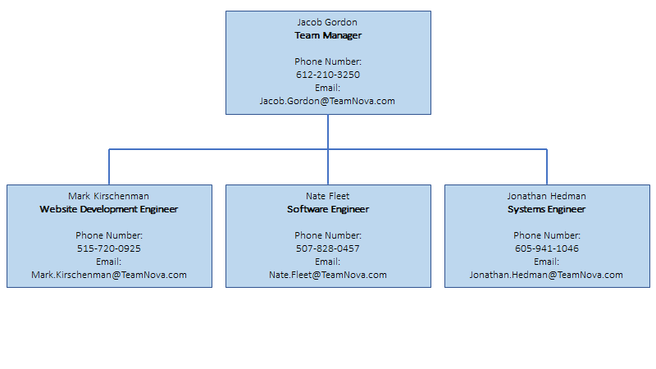

**Software Testing Process**

Tests will be distributed to a testing team, and each team will complete their required tests and mark the results of each test. After completing the tests they will be given back to project manager. Results will be compared to expected results and any changed needing to be done to the system will be analysed.

**Hardware and Software Requirements**

Hardware:

CPU: Intel Core i7-7500U

Memory: 8.00 GB DDR3

HDD: >1 GB

Software:

Operating System: Windows 10 64bit

Web Browser: Google Chrome

|  |  |  |  |  |
| --- | --- | --- | --- | --- |
| **Features to be Tested** | | | | |
| **Test Number** | **Feature** | **FWBS Number** | **Description** | **Completed** |
| STR-1 | Customer Login | 1.0.1 | This feature will allow customers to login to the Nova Bus Booker. |  |
| STR-2 | Driver Login | 1.0.1 | This feature will allow drivers to login to the Nova Bus Booker. |  |
| STR-3 | Manager Login | 1.0.1 | This feature will allow managers to login to the Nova Bus Booker. |  |
| STR-4 | Manager - Edit Driver | 2.1.4 | This feature will allow a manager to edit driver information such as username, first name, middle name, last name, and payrate. |  |
| STR-5 | Manager - Add Driver | 2.1.2 | This feature will allow a manager to add a driver. |  |
| STR-6 | Manager - Delete Driver | 2.1.3 | This feature will allow a manager to delete a driver given .a driver username. |  |
| STR-7 | Manager - Edit Rates | 2.2.3 | This feature will allow a manager to edits the current rates of trips, such as the normal trip, nightly, group, and discounts. |  |
| STR-8 | Manager - Place Orders | 2.3.1 | This feature will allow a manager place an order for a customer or a guest. |  |
| STR-9 | Manager - Edit Orders | 2.3.2 | This feature will allow a manager place an order for a customer or a guest. |  |
| STR-10 | Manager - Edit Billing | 2.4.2 | This feature will allow the manager to edit the billing information of a customer when they are placing an order and they have not added billing information. This feature is a sub feature of place orders. |  |
| STR-11 | Manager - Adjust Schedule | 2.5.1 | This feature allow a manager to adjust the weekly schedule of a given driver based on drier ID number |  |
| STR-12 | Manager - Bus Edit | 2.5.2 | This feature will allow a manager to edit a selected bus information |  |
| STR-13 | Driver - Send Message | 3.1 | This feature will allow a driver to send a message to any other user, such as a manager or customer. |  |
| STR-14 | Driver - Edit Availability | 3.2.2 | This feature will allow a driver to edit their profile. |  |
| STR-15 | Customer - Create Account | 4.2.1 | This feature will allow a new user to register a customer account |  |
| STR-16 | Customer - Place Order | 4.1.1 | This feature will allow a customer to place an order given the date, starting time, starting address, and ending address. |  |
| STR-17 | Customer - Add/Edit Billing | 4.2.2  4.2.3 | This feature will allow a customer to add/edit their billing information to their account |  |

|  |  |  |  |  |
| --- | --- | --- | --- | --- |
| **Features not to be Tested** | | | | |
| **Test Number** | **Feature** | **FWBS Number** | **Description** | **Completed** |
| STNR-1 | Manager - View Driver | 2.1.1 | This feature allows a manager to view a driver’s profile information |  |
| STNR-2 | Manager - View Rates | 2.2.1 | This feature allows a manager to update the price rates of the booking system |  |
| STNR-3 | Manager - View Billing | 2.4.1 | This feature allows a manager to view all the billing information of all the customers. |  |
| STNR-4 | Manager - View Messages | 2.5 | This feature will allow the manager to view any messages sent by a driver or customer. |  |
| STNR-5 | Driver - View Profile | 3.3.1 | This feature will allow a driver to view their own profile information |  |
| STNR-6 | Customer - View Previous | 4.2.6 | This feature will allow a customer to view their previously booked trips |  |
| STNR-7 | Customer - View Profile | 4.2.4 | This feature allows a customer to view their own profile information |  |
| STNR-8 | Manager - View Hours | 2.2.2 | This feature will allow the manager to view all the hours /weekly schedule of all employees. |  |
| STNR-9 | Customer - Change Order | 4.1.2 | This feature will allow a customer to alter an order that has been placed |  |
| STNR-10 | Customer - Cancel Order | 4.1.3 | This feature will allow a customer to cancel an order that they have placed |  |
| STNR-11 | Driver - Edit Profile | 3.3.2 | This feature will allow a driver to edit their personal profile information |  |
| STNR-12 | Driver - View Schedule | 3.4.1 | This feature will allow a driver to view his or her daily route and their bus. |  |
| STNR-13 | Driver - View Hours | 3.2.3 | This feature will allow a driver to view the hours he or she is scheduled to work during a week. |  |

**STR-1 Customer Login**

***Setup*: Navigate to** [**http://teamnovaproject.us/**](http://teamnovaproject.us/) **and click Login Button (Shown in Screenshot 1.1).**

***Techniques 1*: Positive and Negative Testing**

**Enter Username input into entry field labeled Username and Password input into entry field labeled Password (Both Shown in Screenshot 1.2)**

***Positive Test Cases***

|  |  |  |  |
| --- | --- | --- | --- |
| **Test Case Number** | **Input** | **Current State** | **Expected Output** |
| **STR-1.1** | **Username:**  **SamB**  **Password:**  **Password**    **Click Enter** | **Not Logged in (Screenshot 1.2)** | **Log user in(Screenshot 1.3)** |
| **STR-1.2** | **Username:**  **NotRealUser**    **Password:**  **Password**    **Click Enter** | **Not Logged in (Screenshot 1.2)** | **Not Logged in with error message (Screenshot 1.4)** |
| **STR-1.3** | **Username:**  **samB**    **Password:**  **Wrong password**    **Click Enter** | **Not Logged in (Screenshot 1.2)** | **Not Logged in with error message (Screenshot 1.4)** |
| **STR-1.4** | **Username:**  **NotRealUser**    **Password:**  **Wrong password**    **Click Enter** | **Not Logged in (Screenshot 1.2)** | **Not Logged in with error message (Screenshot 1.4)** |
| **STR-1.5** | **Username:**  **Sam B Henry**    **Password:**  **password**    **Click Enter** | **Not Logged in (Screenshot 1.2)** | **Not Logged in with error message (Screenshot 1.4)** |

***Negative Test Cases***

|  |  |  |  |
| --- | --- | --- | --- |
| **Test Case Number** | **Input** | **Current State** | **Expected Output** |
| **STR-1.6** | **Pour Coffee on keyboard** | **Not Logged in (Screenshot 1.2)** | **Not Logged in**  **(Screenshot 1.2)** |

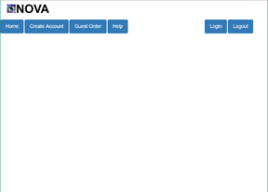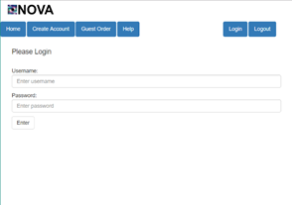

***Screenshot 1.1 Screenshot 1.2***

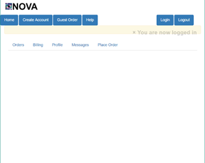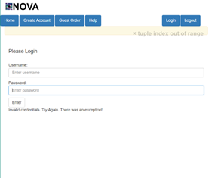

***Screenshot 1.3 Screenshot 1.4***

***Techniques 2*: Cause-Effect Graph and Decision Table**

|  |  |
| --- | --- |
| **Causes:** | **Effects:** |
| **1: Valid Password** | **101: Valid Login** |
| **2: Valid Username** | **102: Error** |

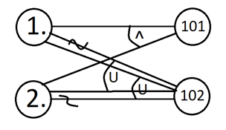

|  |  |  |  |
| --- | --- | --- | --- |
| **1** | **1** | **0** |  |
| **2** | **1** |  | **0** |
| **101** | **1** | **0** | **0** |
| **102** | **0** | **1** | **1** |

|  |  |  |  |
| --- | --- | --- | --- |
| **Test Case Number** | **Input** | **Current State** | **Expected Output** |
| **STR-1.6** | **Username:**  **SamB**    **Password:**  **password:**    **Click Enter** | **Not Logged in (Screenshot 1.5)** | **Log user in(Screenshot 1.6)** |
| **STR-1.7** | **Username:**  **SamB**    **Password:**  **Wrong password**    **Click Enter** | **Not Logged in (Screenshot 1.5)** | **Not Logged in with error message (Screenshot 1.7)** |
| **STR-1.8** | **Username:**  **SamB**    **Password:**  **Wrong password**    **Click Enter** | **Not Logged in (Screenshot 1.5)** | **Not Logged in with error message (Screenshot 1.7)** |



**Screenshot 1.5: Screenshot 1.6:**



**Screenshot 1.7:**

***Final Merged Test Cases:***

|  |  |  |  |
| --- | --- | --- | --- |
| **Test Case Number** | **Input** | **Current State** | **Expected Output** |
| **STR-1.1** | **Username:**  **SamB**    **Password:**  **password**    **Click Enter** | **Not Logged in (Screenshot 1.2)** | **Log user in(Screenshot 1.3)** |
| **STR-1.2** | **Username:**  **NotRealUser**  **Password:**  **password**    **Click Enter** | **Not Logged in (Screenshot 1.2)** | **Not Logged in with error message (Screenshot 1.4)** |
| **STR-1.3** | **Username:**  **SamB**  **Password:**  **Wrongpassword**    **Click Enter** | **Not Logged in (Screenshot 1.2)** | **Not Logged in with error message (Screenshot 1.4)** |
| **STR-1.4** | **Username:**  **NotRealUser**  **Password:**  **Wrongpassword**    **Click Enter** | **Not Logged in (Screenshot 1.2)** | **Not Logged in with error message (Screenshot 1.4)** |
| **STR-1.5** | **Username:**  **Sam B Henry**  **Password:**  **password**    **Click Enter** | **Not Logged in (Screenshot 1.2)** | **Not Logged in with error message (Screenshot 1.4)** |

**_____________________________________________________________________**

**STR-2 Driver Login**

***Setup*: Navigate to** [**http://teamnovaproject.us/**](http://teamnovaproject.us/) **and click Login Button (Shown in Screenshot 2.1).**

***Techniques 1*: Positive and Negative Testing**

**Enter Username input into entry field labeled Username and Password input into entry field labeled Password (Both Shown in Screenshot 2.2)**

***Positive Test Cases***

|  |  |  |  |
| --- | --- | --- | --- |
| **Test Case Number** | **Input** | **Current State** | **Expected Output** |
| **STR-2.1** | **Username:**  **driver**  **Password:**  **password**    **Click Enter** | **Not Logged in (Screenshot 2.2)** | **Log user in(Screenshot 2.3)** |
| **STR-2.2** | **Username:**  **NotRealDriver**  **Password:**  **password**    **Click Enter** | **Not Logged in (Screenshot 2.2)** | **Not Logged in with error message (Screenshot 2.4)** |
| **STR-2.3** | **Username:**  **driver**  **Password:**  **wrongpassword**    **Click Enter** | **Not Logged in (Screenshot 2.2)** | **Not Logged in with error message (Screenshot 2.4)** |
| **STR-2.4** | **Username:**  **NotRealDriver**  **Password:**  **Wrongpassword**    **Click Enter** | **Not Logged in (Screenshot 2.2)** | **Not Logged in with error message (Screenshot 2.4)** |
| **STR-2.5** | **Username:**  **Driver Henry**  **Password:**  **password**    **Click Enter** | **Not Logged in (Screenshot 2.2)** | **Not Logged in with error message (Screenshot 2.4)** |

***Negative Test Cases***

|  |  |  |  |
| --- | --- | --- | --- |
| **Test Case Number** | **Input** | **Current State** | **Expected Output** |
| **STR-2.6** | **Pour Coffee on keyboard** | **Not Logged in (Screenshot 2.2)** | **Not Logged in**  **(Screenshot 2.2)** |



***Screenshot 2.1 Screenshot 2.2***

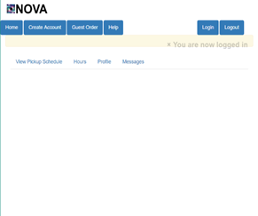

***Screenshot 2.3 Screenshot 2.4***

***Techniques 2*: Cause-Effect Graph and Decision Table**

|  |  |
| --- | --- |
| **Causes:** | **Effects:** |
| **1: Valid Password** | **101: Valid Login** |
| **2: Valid Username** | **102: Error** |



|  |  |  |  |
| --- | --- | --- | --- |
| **1** | **1** | **0** |  |
| **2** | **1** |  | **0** |
| **101** | **1** | **0** | **0** |
| **102** | **0** | **1** | **1** |

|  |  |  |  |
| --- | --- | --- | --- |
| **Test Case Number** | **Input** | **Current State** | **Expected Output** |
| **STR-2.6** | **Username:**  **driver**  **Password:**  **password**    **Click Enter** | **Not Logged in (Screenshot 2.5)** | **Log user in(Screenshot 2.6)** |
| **STR-2.7** | **Username:**  **NotRealDriver**  **Password:**  **password**    **Click Enter** | **Not Logged in (Screenshot 2.5)** | **Not Logged in with error message (Screenshot 2.7)** |
| **STR-2.8** | **Username:**  **driver**  **Password:**  **Wrongpassword**    **Click Enter** | **Not Logged in (Screenshot 2.5)** | **Not Logged in with error message (Screenshot 2.7)** |

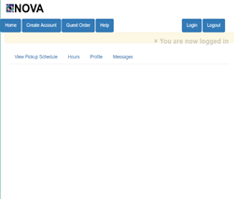

**Screenshot 2.5: Screenshot 2.6:**



**Screenshot 2.7:**

***Final Merged Test Cases:***

|  |  |  |  |
| --- | --- | --- | --- |
| **Test Case Number** | **Input** | **Current State** | **Expected Output** |
| **STR-2.1** | **Username:**  **driver**  **Password:**  **password**    **Click Enter** | **Not Logged in (Screenshot 2.2)** | **Log user in(Screenshot 2.3)** |
| **STR-2.2** | **Username:**  **NotRealDriver**  **Password:**  **password**    **Click Enter** | **Not Logged in (Screenshot 2.2)** | **Not Logged in with error message (Screenshot 2.4)** |
| **STR-2.3** | **Username:**  **driver**  **Password:**  **wrongpassword**    **Click Enter** | **Not Logged in (Screenshot 2.2)** | **Not Logged in with error message (Screenshot 2.4)** |
| **STR-2.4** | **Username:**  **NotRealDriver**  **Password:**  **wrongpassword**    **Click Enter** | **Not Logged in (Screenshot 2.2)** | **Not Logged in with error message (Screenshot 2.4)** |
| **STR-2.5** | **Username:**  **Henry**  **Password:**  **password**    **Click Enter** | **Not Logged in (Screenshot 2.2)** | **Not Logged in with error message (Screenshot 2.4)** |

**_____________________________________________________________________**

**STR-3 Manager Login**

***Setup*: Navigate to** [**http://teamnovaproject.us/**](http://teamnovaproject.us/) **and click Login Button (Shown in Screenshot 3.1).**

***Techniques 1*: Positive and Negative Testing**

**Enter Username input into entry field labeled Username and Password input into entry field labeled Password (Both Shown in Screenshot 3.2)**

***Positive Test Cases***

|  |  |  |  |
| --- | --- | --- | --- |
| **Test Case Number** | **Input** | **Current State** | **Expected Output** |
| **STR-3.1** | **Username:**  **manager**  **Password:**  **password**    **Click Enter** | **Not Logged in (Screenshot 3.2)** | **Log user in(Screenshot 3.3)** |
| **STR-3.2** | **Username:**  **NotRealManager**  **Password:**  **password**    **Click Enter** | **Not Logged in (Screenshot 3.2)** | **Not Logged in with error message (Screenshot 3.4)** |
| **STR-3.3** | **Username:**  **manager**  **Password:**  **wrongpassword**    **Click Enter** | **Not Logged in (Screenshot 3.2)** | **Not Logged in with error message (Screenshot 3.4)** |
| **STR-3.4** | **Username:**  **NotRealManager**  **Password:**  **wrongpassword**    **Click Enter** | **Not Logged in (Screenshot 3.2)** | **Not Logged in with error message (Screenshot 3.4)** |
| **STR-3.5** | **Username:**  **Manager Henry**  **Password:**  **password**    **Click Enter** | **Not Logged in (Screenshot 3.2)** | **Not Logged in with error message (Screenshot 3.4)** |

***Negative Test Cases***

|  |  |  |  |
| --- | --- | --- | --- |
| **Test Case Number** | **Input** | **Current State** | **Expected Output** |
| **STR-3.6** | **Pour Coffee on keyboard** | **Not Logged in (Screenshot 3.2)** | **Not Logged in**  **(Screenshot 3.2)** |



***Screenshot 3.1 Screenshot 3.2***

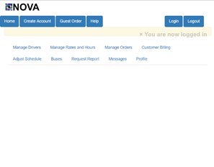

***Screenshot 3.3 Screenshot 3.4***

***Techniques 2*: Cause-Effect Graph and Decision Table**

|  |  |
| --- | --- |
| **Causes:** | **Effects:** |
| **1: Valid Password** | **101: Valid Login** |
| **2: Valid Username** | **102: Error** |



|  |  |  |  |
| --- | --- | --- | --- |
| **1** | **1** | **0** |  |
| **2** | **1** |  | **0** |
| **101** | **1** | **0** | **0** |
| **102** | **0** | **1** | **1** |

|  |  |  |  |
| --- | --- | --- | --- |
| **Test Case Number** | **Password Input** | **Current State** | **Expected Output** |
| **STR-3.6** | **Username:**  **manager**  **Password:**  **password**    **Click Enter** | **Not Logged in (Screenshot 3.5)** | **Log user in(Screenshot 3.6)** |
| **STR-3.7** | **Username:**  **NotRealManager**  **Password:**  **password**    **Click Enter** | **Not Logged in (Screenshot 3.5)** | **Not Logged in with error message (Screenshot 3.7)** |
| **STR-3.8** | **Username:**  **manager**  **Password:**  **wrongpassword**    **Click Enter** | **Not Logged in (Screenshot 3.5)** | **Not Logged in with error message (Screenshot 3.7)** |

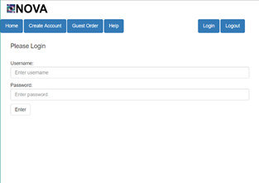

**Screenshot 3.5: Screenshot 3.6:**



**Screenshot 3.7:**

***Final Merged Test Cases:***

|  |  |  |  |
| --- | --- | --- | --- |
| **Test Case Number** | **Input** | **Current State** | **Expected Output** |
| **STR-3.1** | **Username:**  **manager**  **Password:**  **password**    **Click Enter** | **Not Logged in (Screenshot 3.2)** | **Log user in(Screenshot 3.3)** |
| **STR-3.2** | **Username:**  **NotRealManager**  **Password:**  **password**    **Click Enter** | **Not Logged in (Screenshot 3.2)** | **Not Logged in with error message (Screenshot 3.4)** |
| **STR-3.3** | **Username:**  **manager**  **Password:**  **wrongpassword**    **Click Enter** | **Not Logged in (Screenshot 3.2)** | **Not Logged in with error message (Screenshot 3.4)** |
| **STR-3.4** | **Username:**  **NotRealManager**  **Password:**  **wrongpassword**    **Click Enter** | **Not Logged in (Screenshot 3.2)** | **Not Logged in with error message (Screenshot 3.4)** |
| **STR-3.5** | **Username:**  **Manager Henry**  **Password:**  **password**    **Click Enter** | **Not Logged in (Screenshot 3.2)** | **Not Logged in with error message (Screenshot 3.4)** |

**_____________________________________________________________________**

**STR-4 Manager - Edit Driver**

***Setup*: Navigate to** [**http://teamnovaproject.us/managerpage**](http://teamnovaproject.us/managerpage) **and click Manage Drivers, then Edit Driver button(Shown in Screenshot 4.1).**

***Techniques 1*: State Based Test**

**State Diagram**

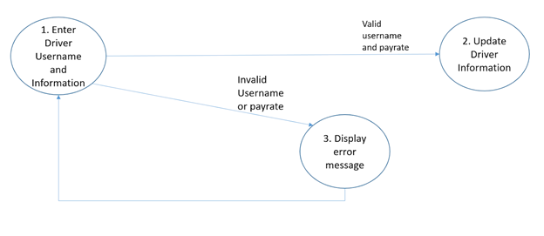

**State Table**

|  |  |  |
| --- | --- | --- |
| **State** | **Input** | **Next State** |
| **1** | **Valid username**  **Updated name**  **Valid payrate** | **2** |
| **1** | **Invalid username**  **Updated information**  **Valid payrate** | **3** |
| **1** | **Valid username**  **Updated name**  **Invalid payrate** | **3** |
| **1** | **Invalid username**  **Updated name**  **Invalid payrate** | **3** |
| **3** | **None** | **1** |

***Test Cases***

|  |  |  |  |
| --- | --- | --- | --- |
| **Test Case Number** | **Input** | **Current State** | **Expected Output** |
| **STR-4.1** | **Driver Username:**  **driver**  **First name:**  **John**  **Middle name:**  **Smith**  **Last name:**  **Henry**  **Payrate:**  **17.00**  **Click Enter** | **Not updated**  **(Screenshot 4.2)** | **Updated information with success message**  **(Screenshot 4.3)** |
| **STR-4.2** | **Driver Username:**  **notDriver**  **First name:**  **John**  **Middle name:**  **Smith**  **Last name:**  **Henry**  **Payrate:**  **17.00**  **Click Enter** | **Not updated**  **(Screenshot 4.2)** | **Not updated with error**  **(Screenshot 4.4)** |
| **STR-4.3** | **Driver Username:**  **driver**  **First name:**  **John**  **Middle name:**  **Smith**  **Last name:**  **Henry**  **Payrate:**  **A17.00**  **Click Enter** | **Not updated**  **(Screenshot 4.2)** | **Not updated with error**  **(Screenshot 4.5)** |
| **STR-4.4** | **Driver Username:**  **notDriver**  **First name:**  **John**  **Middle name: Smith**  **Last name:**  **Henry**  **Payrate:**  **A17.00**  **Click Enter** | **Not updated**  **(Screenshot 4.2)** | **Not updated with error**  **(Screenshot 4.6)** |

**Techniques 1 screenshots:**

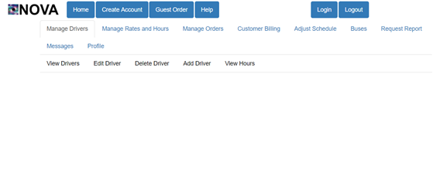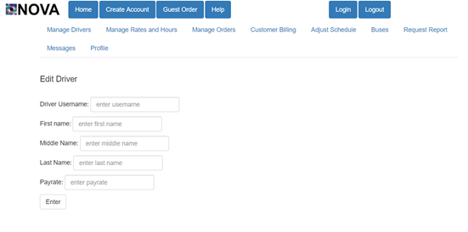

**Screenshot 4.1 Screenshot 4.2**

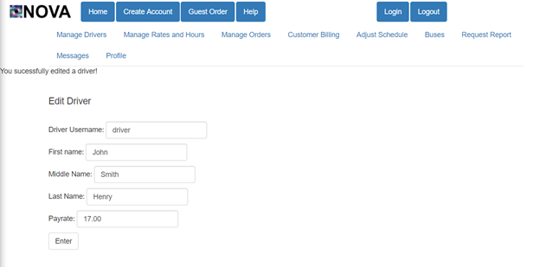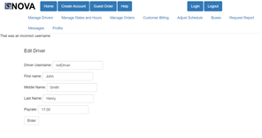

**Screenshot 4.3 Screenshot 4.4**

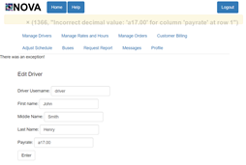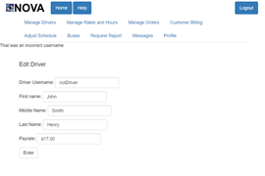

**Screenshot 4.5 Screenshot 4.6**

***Techniques 2*: Positive and Negative Tests**

**Positive Tests:**

|  |  |  |  |
| --- | --- | --- | --- |
| **Test Case Number** | **Input Data** | **Current State** | **Expected Output** |
| **STR-4.5** | **Driver Username:**  **driver**  **First name:**  **John**  **Middle name: Smith**  **Last name:**  **Henry**  **Payrate:**  **17.00**  **Click Enter** | **Not updated**  **(Screenshot 4.2)** | **Updated information with success message**  **(Screenshot 4.3)** |
| **STR-4.6** | **Driver Username:**  **notDriver**  **First name:**  **John**  **Middle name: Smith**  **Last name:**  **Henry**  **Payrate:**  **17.00**  **Click Enter** | **Not updated**  **(Screenshot 4.2)** | **Not updated with error**  **(Screenshot 4.4)** |
| **STR-4.7** | **Driver Username:**  **driver**  **First name:**  **John**  **Middle name: Smith**  **Last name:**  **Henry**  **Payrate:**  **A17.00**  **Click Enter** | **Not updated**  **(Screenshot 4.2)** | **Not updated with error**  **(Screenshot 4.5)** |
| **STR-4.8** | **Driver Username:**  **notDriver**  **First name:**  **John**  **Middle name: Smith**  **Last name:**  **Henry**  **Payrate:**  **A17.00**  **Click Enter** | **Not updated**  **(Screenshot 4.2)** | **Not updated with error**  **(Screenshot 4.6)** |

**Negative Tests:**

|  |  |  |  |
| --- | --- | --- | --- |
| **Test Case Number** | **Input Data** | **Current State** | **Expected Output** |
| **STR-4.9** | **Computer is thrown out the window** | **Not updated**  **(Screenshot 4.2)** | **Not updated**  **(Screenshot 4.2)** |

**Techniques 2 screenshots:**

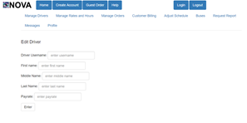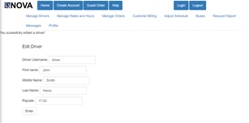

**Screenshot 4.2 Screenshot 4.3**

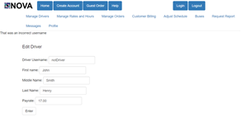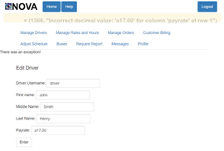

**Screenshot 4.4 Screenshot 4.5**

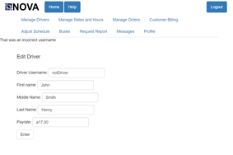

**Screenshot 4.6**

***Final Merged Test Cases:***

|  |  |  |  |
| --- | --- | --- | --- |
| **Test Case Number** | **Input** | **Current State** | **Expected Output** |
| **STR-4.1** | **Driver Username:**  **driver**  **First name:**  **John**  **Middle name:**  **Smith**  **Last name:**  **Henry**  **Payrate:**  **17.00**  **Click Enter** | **Not updated**  **(Screenshot 4.2)** | **Updated information with success message**  **(Screenshot 4.3)** |
| **STR-4.2** | **Driver Username:**  **notDriver**  **First name:**  **John**  **Middle name:**  **Smith**  **Last name:**  **Henry**  **Payrate:**  **17.00**  **Click Enter** | **Not updated**  **(Screenshot 4.2)** | **Not updated with error**  **(Screenshot 4.4)** |
| **STR-4.3** | **Driver Username:**  **driver**  **First name:**  **John**  **Middle name: Smith**  **Last name:**  **Henry**  **Payrate:**  **A17.00**  **Click Enter** | **Not updated**  **(Screenshot 4.2)** | **Not updated with error**  **(Screenshot 4.5)** |
| **STR-4.4** | **Driver Username:**  **notDriver**  **First name:**  **John**  **Middle name: Smith**  **Last name:**  **Henry**  **Payrate:**  **A17.00**  **Click Enter** | **Not updated**  **(Screenshot 4.2)** | **Not updated with error**  **(Screenshot 4.6)** |
| **STR-4.9** | **Driver Username:**  **No input**  **First name:**  **John**  **Middle name:**  **Smith**  **Last name:**  **Henry**  **Payrate:**  **17.00**  **Click Enter** | **Not updated**  **(Screenshot 4.2)** | **Not updated with error**  **(Screenshot 4.4)** |

**_____________________________________________________________________**

**STR-5 Manager - Add Driver**

***Setup*: Navigate to** [**http://teamnovaproject.us/managerpage**](http://teamnovaproject.us/managerpage) **and click Manage Drivers, and then Add Driver button(Shown in Screenshot 5.1).**

***Techniques 1*: State Diagram**

**State Table**

|  |  |  |
| --- | --- | --- |
| **State** | **Input** | **Next State** |
| **1** | **Enter Username**  **Enter Password**  **Confirm Password**  **Enter First Name**  **Enter Middle Name**  **Enter Last Name**  **Enter Payrate** | **2** |
| **2** | **none** | **3** |
| **2** | **none** | **6** |
| **3** | **none** | **4** |
| **3** | **none** | **6** |
| **4** | **none** | **5** |
| **4** | **none** | **6** |
| **5** | **none** | **6** |
| **5** | **none** | **7** |
| **6** | **none** | **1** |

***Test Cases***

|  |  |  |  |
| --- | --- | --- | --- |
| **Test Case Number** | **Input** | **Current State** | **Expected Output** |
| **STR-5.1** | **Username:**  **newguy**  **Password:**  **password**  **Confirm Password:**  **password**  **First Name:**  **carl**  **Middle Name:**  **dave**  **Last Name:**  **davids**  **Payrate:**  **12.00**    **Click Enter** | **Not updated**  **(Screenshot 5.2)** | **(Screenshot 5.3)** |
| **STR-5.2** | **Username:**  **driver**  **Password:**  **password**  **Confirm Password:**  **password**  **First Name:**  **carl**  **Middle Name:**  **dave**  **Last Name:**  **davids**  **Payrate:**  **12.00**    **Click Enter** | **Not updated**  **(Screenshot 5.2)** | **(Screenshot 5.4)** |
| **STR-5.3** | **Username:**  **newguy**  **Password:**  **password**  **Confirm Password:**  **Password**  **First Name:**  **carl**  **Middle Name:**  **dave**  **Last Name:**  **davids**  **Payrate:**  **12.00**    **Click Enter** | **Not updated**  **(Screenshot 5.0)** | **(Screenshot 5.5)** |
| **STR-5.4** | **Username:**  **newguy**  **Password:**  **password**  **Confirm Password:**  **Password**  **First Name:**  **carl**  **Middle Name:**  **dave**  **Last Name:**  **davids**  **Payrate:**  **nothing**    **Click Enter** | **Not updated**  **(Screenshot 5.0)** | **Not updated**  **(Screenshot 5.7)** |

**Techniques 1 screenshots:**

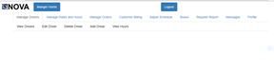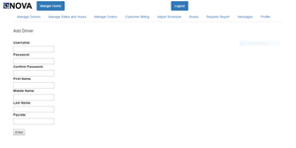

**Screenshot 5.1 Screenshot 5.2**

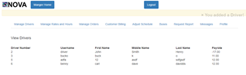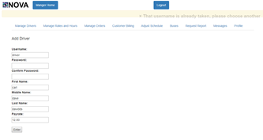

**Screenshot 5.3 Screenshot 5.4**

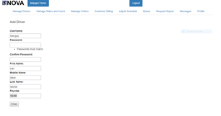

**Screenshot 5.5**

***Techniques 2*: Boundary Value Analysis**

**Boundaries to be tested exist on different pay rates entered. The rate for a driver should be between [8, 35] . The light yellow sections in the chart below indicate the boundaries. The numbers represent the values around the boundaries we will test.**

|  |  |  |  |  |
| --- | --- | --- | --- | --- |
| **7.5** | **8** | **8.5 34.5** | **35** | **35.5** |

***Test Cases***

|  |  |  |  |
| --- | --- | --- | --- |
| **Test Case Number** | **Input** | **Current State** | **Expected Output** |
| **STR-5.5** | **Username:**  **mynewdriver**  **Password:**  **password**  **Confirm Password:**  **password**  **First Name:**  **ben**  **Middle Name:**  **dave**  **Last Name:**  **mickey**  **Payrate:**  **7.50**    **Click Enter** | **Not updated**  **(Screenshot 5.2)** | **(Screenshot 5.6)** |
| **STR-5.6** | **Username:**  **mynewdriver**  **Password:**  **password**  **Confirm Password:**  **password**  **First Name:**  **ben**  **Middle Name:**  **dave**  **Last Name:**  **mickey**  **Payrate:**  **35.50**    **Click Enter** | **Not updated**  **(Screenshot 5.2)** | **(Screenshot 5.6)** |
| **STR-5.7** | **Username:**  **mynewdriver**  **Password:**  **password**  **Confirm Password:**  **password**  **First Name:**  **ben**  **Middle Name:**  **dave**  **Last Name:**  **mickey**  **Payrate:**  **35**    **Click Enter** | **Not updated**  **(Screenshot 5.2)** | **(Screenshot 5.7)** |
| **STR-5.8** | **Username:**  **thenewdriver**  **Password:**  **password**  **Confirm Password:**  **password**  **First Name:**  **ben**  **Middle Name:**  **dave**  **Last Name:**  **mickey**  **Payrate:**  **8.00**    **Click Enter** | **Not updated**  **(Screenshot 5.2)** | **(Screenshot 5.7)** |
| **STR-5.9** | **Username:**  **newemployess**  **Password:**  **password**  **Confirm Password:**  **password**  **First Name:**  **ben**  **Middle Name:**  **dave**  **Last Name:**  **mickey**  **Payrate:**  **8.50**    **Click Enter** | **Not updated**  **(Screenshot 5.2)** | **(Screenshot 5.7)** |
| **STR-5.10** | **Username:**  **anothernew**  **Password:**  **password**  **Confirm Password:**  **password**  **First Name:**  **ben**  **Middle Name:**  **dave**  **Last Name:**  **mickey**  **Payrate:**  **34.50**    **Click Enter** | **Not updated**  **(Screenshot 5.2)** | **(Screenshot 5.7)** |

**Techniques 2 screenshots:**

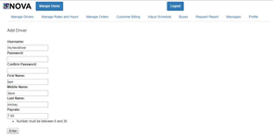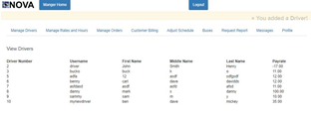

**Screenshot 5.6 Screenshot 5.7**

***Final Merged Test Cases:***

|  |  |  |  |
| --- | --- | --- | --- |
| **Test Case Number** | **Input** | **Current State** | **Expected Output** |
| **STR-5.2** | **Username:**  **driver**  **Password:**  **password**  **Confirm Password:**  **password**  **First Name:**  **carl**  **Middle Name:**  **dave**  **Last Name:**  **davids**  **Payrate:**  **12.00**    **Click Enter** | **Not updated**  **(Screenshot 5.2)** | **(Screenshot 5.4)** |
| **STR-5.3** | **Username:**  **newguy**  **Password:**  **password**  **Confirm Password:**  **Password**  **First Name:**  **carl**  **Middle Name:**  **dave**  **Last Name:**  **davids**  **Payrate:**  **12.00**    **Click Enter** | **Not updated**  **(Screenshot 5.0)** | **(Screenshot 5.5)** |
| **STR-5.4** | **Username:**  **newguy**  **Password:**  **password**  **Confirm Password:**  **Password**  **First Name:**  **carl**  **Middle Name:**  **dave**  **Last Name:**  **davids**  **Payrate:**  **nothing**    **Click Enter** | **Not updated**  **(Screenshot 5.2)** | **Not updated**  **(Screenshot 5.7)** |
| **STR-5.5** | **Username:**  **mynewdriver**  **Password:**  **password**  **Confirm Password:**  **password**  **First Name:**  **ben**  **Middle Name:**  **dave**  **Last Name:**  **mickey**  **Payrate:**  **7.50**    **Click Enter** | **Not updated**  **(Screenshot 5.2)** | **(Screenshot 5.6)** |
| **STR-5.6** | **Username:**  **mynewdriver**  **Password:**  **password**  **Confirm Password:**  **password**  **First Name:**  **ben**  **Middle Name:**  **dave**  **Last Name:**  **mickey**  **Payrate:**  **35.50**    **Click Enter** | **Not updated**  **(Screenshot 5.2)** | **(Screenshot 5.6)** |
| **STR-5.7** | **Username:**  **mynewdriver**  **Password:**  **password**  **Confirm Password:**  **password**  **First Name:**  **ben**  **Middle Name:**  **dave**  **Last Name:**  **mickey**  **Payrate:**  **35**    **Click Enter** | **Not updated**  **(Screenshot 5.2)** | **(Screenshot 5.7)** |
| **STR-5.8** | **Username:**  **thenewdriver**  **Password:**  **password**  **Confirm Password:**  **password**  **First Name:**  **ben**  **Middle Name:**  **dave**  **Last Name:**  **mickey**  **Payrate:**  **8.00**    **Click Enter** | **Not updated**  **(Screenshot 5.2)** | **(Screenshot 5.7)** |
| **STR-5.9** | **Username:**  **newemployess**  **Password:**  **password**  **Confirm Password:**  **password**  **First Name:**  **ben**  **Middle Name:**  **dave**  **Last Name:**  **mickey**  **Payrate:**  **8.50**    **Click Enter** | **Not updated**  **(Screenshot 5.2)** | **(Screenshot 5.7)** |
| **STR-5.10** | **Username:**  **anothernew**  **Password:**  **password**  **Confirm Password:**  **password**  **First Name:**  **ben**  **Middle Name:**  **dave**  **Last Name:**  **mickey**  **Payrate:**  **34.50**    **Click Enter** | **Not updated**  **(Screenshot 5.2)** | **(Screenshot 5.7)** |

**______________________________________________________________________**

**STR-6 Manager - Delete Driver**

*Setup*: Navigate to<http://teamnovaproject.us/> and click Login button(Shown in Screenshot 6.1).

*Techniques 1*: Requirements Based Testing

Requirement 3.3.20 from Software Requirements Specification. The requirement listed in the SRS is described in figure 6.1 below.

|  |
| --- |
| **3.3.20 Use Case 20: Terminate Drivers**  **3.3.20.1 Use case description**  Name: Terminate Drivers  Initiator: Manager  Goal: Remove a driver from the database    Main Success Scenario  1. Include Verify Manager Information/Login  2. Manager selects Terminate Driver  3. Manager enters desired drivers username  4. System finds the entered driver’s information in the database  5. System removes information from the main database |

*figure 6.1*

For this scenario to occur we must go through all these steps to verify that this can be done, we must follow the current version of the user interface to guarantee that this process can be followed. We must follow these tests step by step if any are skipped or fail this entire functionality is a failure. Also an implied requirement is that the system will reply with an error message if a driver does not exist or a successful message if the driver has been deleted.

Traceability Matrix

|  |  |  |
| --- | --- | --- |
| **Requirement Identifier** | **Description** | **Priority** |
| 1 | A manager should be able to log into the system using their username and password. | H |
| 2 | A manager should be can able to navigate to the location to delete a driver | H |
| 3 | If a manager enters desired driver’s username and clicks enter, that driver is deleted | H |
| 4 | If a manager enters desired driver’s username but the driver does not exist and clicks enter, that driver is not deleted | M |
| 5 | Only managers logged in should be able to access this function | H |

*Test Cases*

|  |  |  |  |
| --- | --- | --- | --- |
| **Test Case Number** | **Input** | **Current State** | **Expected Output** |
| STR-6.1 | Username:  Manager  Password:  Password    Click Enter | Not Logged in (Screenshot 6.1) | Log user in(Screenshot6.2) |
| STR-6.2 | Click on Manage Drivers Tab and then on Delete Driver Tab | (Screenshot 6.2) | (Screenshot6.3) |
| STR-6.3 | Enter a Driver Username to Delete:  driver    Click Delete | (Screenshot6.2) | (Screenshot6.4) |
| STR-6.4 | Enter a Driver Username to Delete:  Sadfasdf778    Click Delete | (Screenshot 6.2) | (Screenshot6.5) |
| STR-6.5 | Enter a Driver Username to Delete:    Click Delete | (Screenshot 6.2) | (Screenshot6.5) |
| STR-6.6 | Enter this url into a web Brower without logging in  http://teamnovaproject.us/managerpage/deletedriver/ | Not Logged in (Screenshot 6.2) | Sent to this url  http://teamnovaproject.us/home/ |

Techniques 1 screenshots:

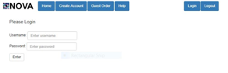

*Screenshot 6.1 Screenshot 6.2*

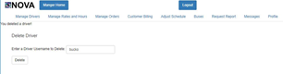

*Screenshot 6.3 Screenshot 6.4*

**

*Screenshot 6.5*

*Techniques 2*:

Positive Tests

|  |  |  |  |
| --- | --- | --- | --- |
| **Test Case Number** | **Input** | **Current State** | **Expected Output** |
| STR-6.7 | Enter a Driver Username to Delete:  driver    Click Delete | (Screenshot6.6) | (Screenshot6.7) |
| STR-6.8 | Enter a Driver Username to Delete:  Sadfasdf778    Click Delete | (Screenshot 6.6) | (Screenshot6.8) |
| STR-6.9 | Enter a Driver Username to Delete:    Click Delete | (Screenshot 6.6) | (Screenshot6.8) |
| STR-6.10 | Enter a Driver Username to Delete:    Click Delete | (Screenshot 6.6) | (Screenshot6.8) |

Negative Tests

|  |  |  |  |
| --- | --- | --- | --- |
| **Test Case Number** | **Input** | **Current State** | **Expected Output** |
| **STR-6.11** | **Pour Coffee on keyboard** | **Not Logged in (Screenshot 6.2)** | **Not Logged in**  **(Screenshot 6.2)** |

Techniques 2 screenshots: Same as screenshots for 1 check above

**

*Screenshot 6.6 Screenshot 6.4 6.7*

**

*Screenshot 6.8*

*Final Merged Test Cases:*

|  |  |  |  |
| --- | --- | --- | --- |
| **Test Case Number** | **Input** | **Current State** | **Expected Output** |
| STR-6.1 | Username:  Manager  Password:  Password    Click Enter | Not Logged in (Screenshot 6.1) | Log user in(Screenshot6.2) |
| STR-6.2 | Click on Manage Drivers Tab and then on Delete Driver Tab | (Screenshot 6.2) | (Screenshot6.3) |
| STR-6.3 | Enter a Driver Username to Delete:  driver    Click Delete | (Screenshot6.3) | (Screenshot6.4) |
| STR-6.4 | Enter a Driver Username to Delete:  Sadfasdf778    Click Delete | (Screenshot 6.3) | (Screenshot6.5) |
| STR-6.5 | Enter a Driver Username to Delete:    Click Delete | (Screenshot 6.3) | (Screenshot6.5) |
| STR-6.6 | Enter this url into a web Brower without logging in  http://teamnovaproject.us/managerpage/deletedriver/ | Not Logged in (Screenshot 6.1) | Sent to this url  http://teamnovaproject.us/home/ |
| STR-6.7 | Enter a Driver Username to Delete:  driver    Click Delete | (Screenshot6.6) | (Screenshot6.7) |
| STR-6.8 | Enter a Driver Username to Delete:  Sadfasdf778    Click Delete | (Screenshot 6.6) | (Screenshot6.8) |
| STR-6.9 | Enter a Driver Username to Delete:    Click Delete | (Screenshot 6.6) | (Screenshot6.8) |
| STR-6.10 | Enter a Driver Username to Delete:    Click Delete | (Screenshot 6.6) | (Screenshot6.8) |

**_____________________________________________________________________**

**STR-7 Manager - Edit Rates**

*Setup*: Navigate to <http://teamnovaproject.us/managerpage> and click Manage Rates and Hours, and then Edit Rates button(Shown in Screenshot 7.1).

*Techniques 1*: Equivalence Partitioning

Trip: Input condition, range: specified value >= 0.0

Night: Input condition, range: specified value >= 0.0

Discount: Input condition, range: specified value >=0.0

Group: Input condition, range: specified value >=0.0

*Test Cases*

|  |  |  |  |
| --- | --- | --- | --- |
| **Test Case Number** | **Input** | **Current State** | **Expected Output** |
| STR-7.1 | Trip: -1.0  Night:  Discount:  Group: | Edit rates page (Screenshot 7.2) | Edit rates page with exception fail (Screenshot 7.3) |
| STR-7.2 | Trip: 1.0  Night:  Discount:  Group: | Edit rates page (Screenshot 7.2) | View rates page (Screenshot 7.4) |
| STR-7.3 | Trip:  Night: -1.0  Discount:  Group: | Edit rates page (Screenshot 7.2) | Edit rates page with exception fail (Screenshot 7.3) |
| STR-7.4 | Trip:  Night: 1.0  Discount:  Group: | Edit rates page (Screenshot 7.2) | View rates page (Screenshot 7.4) |
| STR-7.5 | Trip:  Night:  Discount: -1.0  Group: | Edit rates page (Screenshot 7.2) | Edit rates page with exception fail (Screenshot 7.3) |
| STR-7.6 | Trip:  Night:  Discount: 1.0  Group: | Edit rates page (Screenshot 7.2) | View rates page (Screenshot 7.4) |
| STR-7.7 | Trip:  Night:  Discount:  Group: -1.0 | Edit rates page (Screenshot 7.2) | Edit rates page with exception fail (Screenshot 7.3) |
| STR-7.8 | Trip:  Night:  Discount:  Group: 1.0 | Edit rates page (Screenshot 7.2) | View rates page (Screenshot 7.4) |

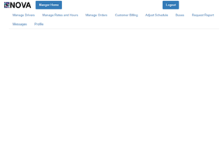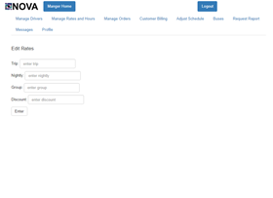

Screenshot 7.1 Screenshot 7.2

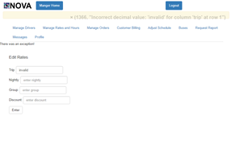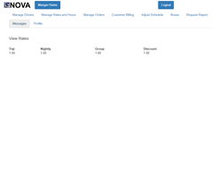

Screenshot 7.3 Screenshot 7.4

*Techniques 2*: Boundary Value Analysis (BVA)

Intervals for Trip:

(negative infinite, 0], (0, infinite)

Intervals for Night:

(negative infinite, 0], (0, infinite)

Intervals for Discount:

(negative infinite, 0], (0, infinite)

Intervals for Group:

(negative infinite, 0], (0, infinite)

|  |  |  |  |
| --- | --- | --- | --- |
| **Test Case Number** | **Input** | **Current State** | **Expected Output** |
| STR-7.9 | Trip: -1.0  Night:  Discount:  Group: | Edit rates page (Screenshot 7.5) | Edit rates page with exception fail (Screenshot 7.6) |
| STR-7.10 | Trip: 0.0  Night:  Discount:  Group: | Edit rates page (Screenshot 7.5) | View rates page (Screenshot 7.7) |
| STR-7.11 | Trip: 1.0  Night:  Discount:  Group: | Edit rates page (Screenshot 7.5) | View rates page (Screenshot 7.7) |
| STR-7.12 | Trip:  Night: -1.0  Discount:  Group: | Edit rates page (Screenshot 7.5) | Edit rates page with exception fail (Screenshot 7.6) |
| STR-7.13 | Trip:  Night: 0.0  Discount:  Group: | Edit rates page (Screenshot 7.5) | View rates page (Screenshot 7.7) |
| STR-7.14 | Trip:  Night: 1.0  Discount:  Group: | Edit rates page (Screenshot 7.5) | View rates page (Screenshot 7.7) |
| STR-7.15 | Trip:  Night:  Discount: -1.0  Group: | Edit rates page (Screenshot 7.5) | Edit rates page with exception fail (Screenshot 7.6) |
| STR-7.16 | Trip:  Night:  Discount: 0.0  Group: | Edit rates page (Screenshot 7.5) | View rates page (Screenshot 7.7) |
| STR-7.17 | Trip:  Night:  Discount: 1.0  Group: | Edit rates page (Screenshot 7.5) | View rates page (Screenshot 7.7) |
| STR-7.18 | Trip:  Night:  Discount:  Group: -1.0 | Edit rates page (Screenshot 7.5) | Edit rates page with exception fail (Screenshot 7.6) |
| STR-7.19 | Trip:  Night:  Discount:  Group: 0.0 | Edit rates page (Screenshot 7.5) | View rates page (Screenshot 7.7) |
| STR-7.20 | Trip:  Night:  Discount:  Group: 1.0 | Edit rates page (Screenshot 7.5) | View rates page (Screenshot 7.7) |



Screenshot 7.5 Screenshot 7.6



Screenshot 7.7

*Final Merged Test Cases:*

|  |  |  |  |
| --- | --- | --- | --- |
| **Test Case Number** | **Input** | **Current State** | **Expected Output** |
| STR-7.9 | Trip: -1.0  Night:  Discount:  Group: | Edit rates page (Screenshot 7.5) | Edit rates page with exception fail (Screenshot 7.6) |
| STR-7.10 | Trip: 0.0  Night:  Discount:  Group: | Edit rates page (Screenshot 7.5) | View rates page (Screenshot 7.7) |
| STR-7.11 | Trip: 1.0  Night:  Discount:  Group: | Edit rates page (Screenshot 7.5) | View rates page (Screenshot 7.7) |
| STR-7.12 | Trip:  Night: -1.0  Discount:  Group: | Edit rates page (Screenshot 7.5) | Edit rates page with exception fail (Screenshot 7.6) |
| STR-7.13 | Trip:  Night: 0.0  Discount:  Group: | Edit rates page (Screenshot 7.5) | View rates page (Screenshot 7.7) |
| STR-7.14 | Trip:  Night: 1.0  Discount:  Group: | Edit rates page (Screenshot 7.5) | View rates page (Screenshot 7.7) |
| STR-7.15 | Trip:  Night:  Discount: -1.0  Group: | Edit rates page (Screenshot 7.5) | Edit rates page with exception fail (Screenshot 7.6) |
| STR-7.16 | Trip:  Night:  Discount: 0.0  Group: | Edit rates page (Screenshot 7.5) | View rates page (Screenshot 7.7) |
| STR-7.17 | Trip:  Night:  Discount: 1.0  Group: | Edit rates page (Screenshot 7.5) | View rates page (Screenshot 7.7) |
| STR-7.18 | Trip:  Night:  Discount:  Group: -1.0 | Edit rates page (Screenshot 7.5) | Edit rates page with exception fail (Screenshot 7.6) |
| STR-7.19 | Trip:  Night:  Discount:  Group: 0.0 | Edit rates page (Screenshot 7.5) | View rates page (Screenshot 7.7) |
| STR-7.20 | Trip:  Night:  Discount:  Group: 1.0 | Edit rates page (Screenshot 7.5) | View rates page (Screenshot 7.7) |

**_____________________________________________________________________**

**STR-8 Manager - Place Order**

***Setup*: Navigate to****http://teamnovaproject.us/managerpage/placecustomerorder/ (Shown in Screenshot (8.1)).**

***Technique 1: Cause-Effect Graph and Decision Table***

|  |  |
| --- | --- |
| **Causes:** | **Effects:** |
| **1. Customer Username = Valid** | **101. Valid Order, Order is submitted** |
| **2. Time of Order > current time + 1 hour** | **102. Error, Invalid Customer Username** |
| **3. Start Address = Valid** | **103. Error, Invalid Time** |
| **4. Destination Address = Valid** | **104. Error, Invalid Address** |
|  |  |

|  |  |  |  |  |
| --- | --- | --- | --- | --- |
|  | **P1** | **P2** | **P3** | **P4** |
| **1** | **1** |  |  |  |
| **2** | **1** | **1** |  |  |
| **3** | **1** |  | **1** |  |
| **4** | **1** |  |  | **1** |
| **101** | **1** |  |  |  |
| **102** | **0** | **1** |  |  |
| **103** | **0** |  | **1** |  |
| **104** | **0** |  |  | **1** |

|  |  |  |  |
| --- | --- | --- | --- |
| **Test Case Number** | **Input** | **Current State** | **Expected Output** |
| **STR-8.1** | **Customer Username:**  **Customer**  **Date of Order:**  **04/26/2019**  **Starting Time of Order:**  **5:25 PM**  **Starting Address:**  **W Hwy 14, Brookings, SD**  **Ending Address:**  **417-499 9th Ave, Brookings, SD** | **Logged in as manager on place Order Page (Screenshot 8.2)** | **Logged in as manager on place order page with confirmation that the order was completed (Screenshot 8.3)** |
| **STR-8.2** | **Customer Username:**  **NotRealCustomer**  **Date of Order:**  **04/26/20189**  **Starting Time of Order:**  **5:35 PM**  **Starting Address:**  **W Hwy 14, Brookings, SD**  **Ending Address:**  **417-499 9th Ave, Brookings, SD** | **Logged in as a manager on place order page (Screenshot 8.2)** | **Logged in as manager on place order page with an error indicating “ Customer Does Not Exist” (Screenshot 8.4)** |
| **STR-8.3** | **Customer Username:**  **customer**  **Date of Order:**  **04/20/2018**  **Starting Time of Order:**  **5:25 PM**  **Starting Address:**  **W Hwy 14, Brookings, SD**  **Ending Address:**  **417-499 9th Ave, Brookings, SD** | **Logged in as a manager on place order page (Screenshot 8.2)** | **Logged in as manager on place order page with an error indicating “Invalid Date or Time” (Screenshot 8.5)** |
| **STR-8.4** | **Customer Username:**  **Customer**  **Date of Order:**  **04/26/20189**  **Starting Time of Order:**  **5:35 PM**  **Starting Address:**  **324 Street**  **Ending Address:**  **417-499 9th Ave, Brookings, SD** | **Logged in as a manager on place order page (Screenshot 8.2)** | **Logged in as manager on place order page with an error indicating “Invalid Starting or Ending Address” (Screenshot 8.6)** |

**_____________________________________________________________________**

**STR-8 Manager - Edit Order**

***Setup*: Navigate to**[**http://teamnovaproject.us/managerpage/editcustomerorder/**](http://teamnovaproject.us/managerpage/editcustomerorder/)

**(Shown in Screenshot (9.1)).**

***Technique 1: Cause-Effect Graph and Decision Table***

|  |  |
| --- | --- |
| ***Causes*** | ***Effects*** |
| ***1. Customer Username = Valid*** | ***101. Valid Order, Order is submitted*** |
| ***2. Time of Order > current time + 1 hour*** | ***102. Error, Invalid Order Number*** |
| ***3. Start Address = Valid*** | ***103. Error, Invalid Time*** |
| ***4. Destination Address = Valid*** | ***104. Error, Invalid Address*** |

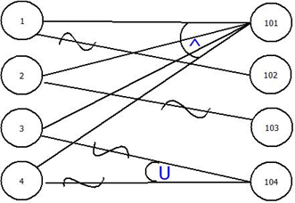

|  |  |  |  |  |
| --- | --- | --- | --- | --- |
|  | ***P1*** | ***P2*** | ***P3*** | ***P4*** |
| ***1*** | ***1*** |  |  |  |
| ***2*** | ***1*** | ***1*** |  |  |
| ***3*** | ***1*** |  | ***1*** |  |
| ***4*** | ***1*** |  |  | ***1*** |
| ***101*** | ***1*** |  |  |  |
| ***102*** | ***0*** | ***1*** |  |  |
| ***103*** | ***0*** |  | ***1*** |  |
| ***104*** | ***0*** |  |  | ***1*** |

|  |  |  |  |
| --- | --- | --- | --- |
| **Test Case Number** | **Input** | **Current State** | **Expected Output** |
| **STR-9.1** | **Order Number:**  **15**  **Date of Order:**  **04/26/2019**  **Starting Time of Order:**  **5:25 PM**  **Starting Address:**  **W Hwy 14, Brookings, SD**  **Ending Address:**  **417-499 9th Ave, Brookings, SD** | **Logged in as manager on edit Order Page (Screenshot 9.2)** | **Logged in as manager on edit order page with confirmation that the order was edited (Screenshot 9.3)** |
| **STR-9.2** | **Order Number:**  **-5656715**  **Date of Order:**  **04/26/20189**  **Starting Time of Order:**  **5:35 PM**  **Starting Address:**  **W Hwy 14, Brookings, SD**  **Ending Address:**  **417-499 9th Ave, Brookings, SD** | **Logged in as a manager on edit order page (Screenshot 9.2)** | **Logged in as manager on edit order page with an error indicating “Order Number Does Not Exist” (Screenshot 9.4)** |
| **STR-9.3** | **Order Number:**  **15**  **Date of Order:**  **04/20/2018**  **Starting Time of Order:**  **5:25 PM**  **Starting Address:**  **W Hwy 14, Brookings, SD**  **Ending Address:**  **417-499 9th Ave, Brookings, SD** | **Logged in as a manager on edit order page (Screenshot 9.2)** | **Logged in as manager on edit order page with an error indicating “Invalid Date or Time” (Screenshot 9.5)** |
| **STR-9.4** | **Order Number:**  **15**  **Date of Order:**  **04/26/20189**  **Starting Time of Order:**  **5:35 PM**  **Starting Address:**  **324 Street**  **Ending Address:**  **417-499 9th Ave, Brookings, SD** | **Logged in as a manager on edit order page (Screenshot 9.2)** | **Logged in as manager on edit order page with an error indicating “Invalid Starting or Ending Address” (Screenshot 9.6)** |

**_____________________________________________________________________**

**STR-10 Manager - Edit Billing**

***Setup*: Navigate to** [**http://teamnovaproject.us/managerpage/placecustomerorderbilling**](http://teamnovaproject.us/managerpage/placecustomerorderbilling) **(Shown in Screenshot (10.1)).**

***Techniques 1*: State-based Test**

**State Diagram:**

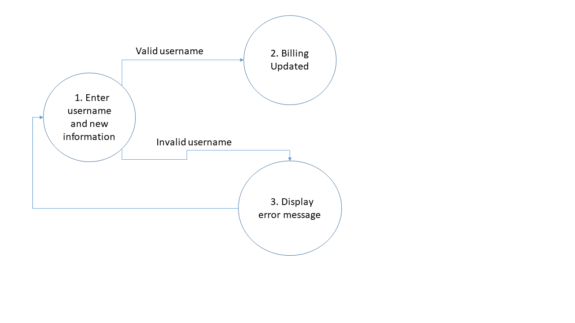

**State Table**

|  |  |  |
| --- | --- | --- |
| **State** | **Input** | **Next State** |
| **1** | **Valid username**  **Billing info** | **2** |
| **1** | **Invalid username**  **Billing info** | **3** |
| **3** | **None** | **1** |

***Test Cases***

|  |  |  |  |
| --- | --- | --- | --- |
| **Test Case Number** | **Input** | **Current State** | **Expected Output** |
| **STR-10.1** | **Username:**  **tester2**  **Credit Card Number:**  **0123456789101112**  **CVV Number:**  **123**  **Address:**  **405 south street**  **City:**  **Brookings**  **State:**  **SD**  **Zipcode:**  **57006**  **Bill Home:**  **yes**  **Click Enter** | **No billing info**  **(Screenshot 10.1)** | **Billing info added,**  **reroute to place**  **order page:**  **<http://teamnovaproject.us/managerpage/placecustomerorder/>**  **(Screenshot 10.2)** |
| **STR-10.2** | **Username:**  **notTester2**  **Credit Card Number:**  **0123456789101112**  **CVV Number:**  **123**  **Address:**  **405 south street**  **City:**  **Brookings**  **State:**  **SD**  **Zipcode:**  **57006**  **Bill Home:**  **yes**  **Click Enter** | **No billing info**  **(Screenshot 10.1)** | **No billing info, with error message**  **(Screenshot 10.3)** |

**Techniques 1 screenshots:**

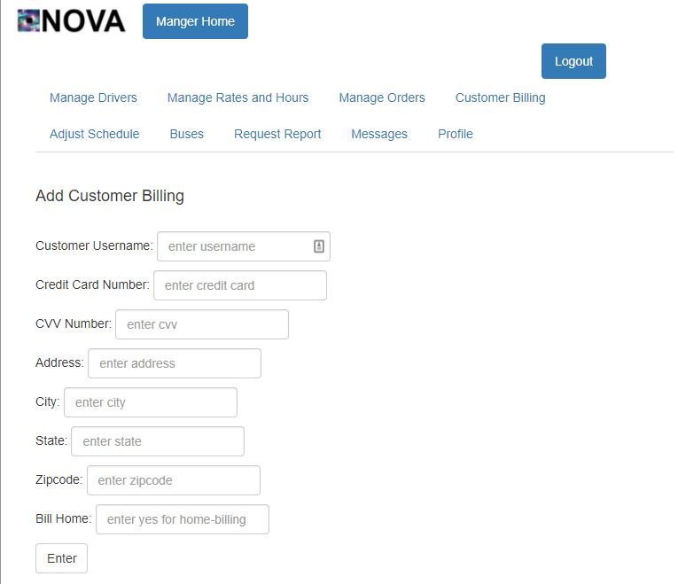

**Screenshot 10.1**

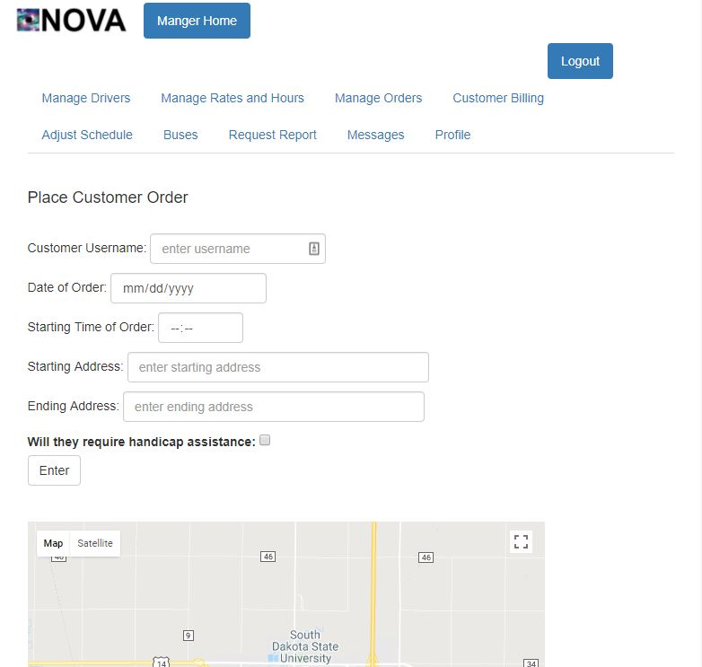

**Screenshot 10.2**

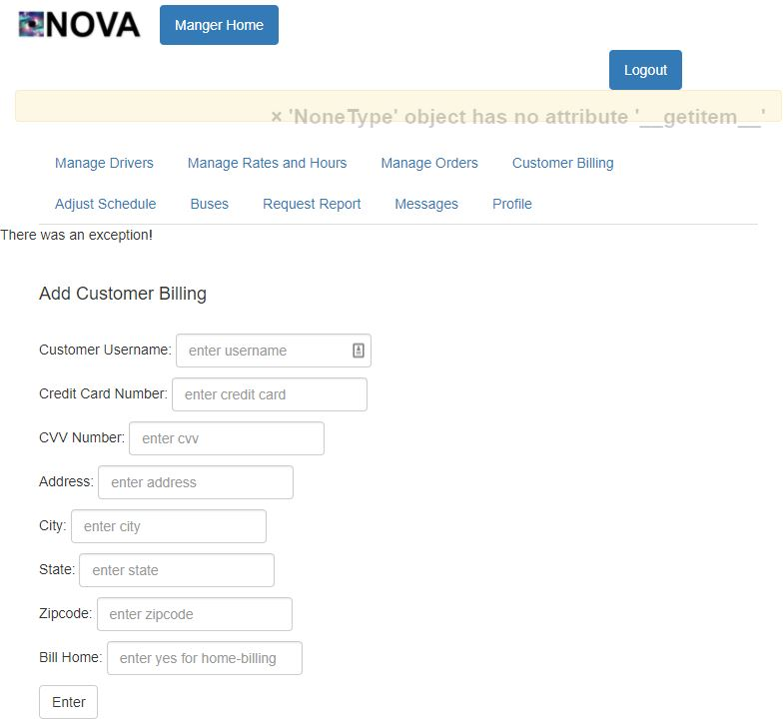

**Screenshot 10.3**

***Techniques 2*: Positive and Negative Test**

**Positive Test:**

|  |  |  |  |
| --- | --- | --- | --- |
| **Test Case Number** | **Input** | **Current State** | **Expected Output** |
| **STR-10.3** | **Username:**  **tester2**  **Credit Card Number:**  **0123456789101112**  **CVV Number:**  **123**  **Address:**  **405 south street**  **City:**  **Brookings**  **State:**  **SD**  **Zipcode:**  **57006**  **Bill Home:**  **yes**  **Click Enter** | **No billing info**  **(Screenshot 10.1)** | **Billing info added,**  **reroute to place**  **order page:**  **<http://teamnovaproject.us/managerpage/placecustomerorder/>**  **(Screenshot 10.2)** |
| **STR-10.4** | **Username:**  **notTester2**  **Credit Card Number:**  **0123456789101112**  **CVV Number:**  **123**  **Address:**  **405 south street**  **City:**  **Brookings**  **State:**  **SD**  **Zipcode:**  **57006**  **Bill Home:**  **yes**  **Click Enter** | **No billing info**  **(Screenshot 10.1)** | **No billing info, with error message**  **(Screenshot 10.3)** |

**Negative Test:**

|  |  |  |  |
| --- | --- | --- | --- |
| **Test Case Number** | **Input** | **Current State** | **Expected Output** |
| **STR-10.5** | **Punch the monitor** | **Bus not updated**  **(Screenshot 12.1)** | **Bus not updated**  **(Screenshot 12.1)** |

**Techniques 2 screenshots:**



**Screenshot 10.1**



**Screenshot 10.2**



**Screenshot 10.3**

***Final Merged Test Cases:***

|  |  |  |  |
| --- | --- | --- | --- |
| **Test Case Number** | **Input** | **Current State** | **Expected Output** |
| **STR-10.1** | **Username:**  **tester2**  **Credit Card Number:**  **0123456789101112**  **CVV Number:**  **123**  **Address:**  **405 south street**  **City:**  **Brookings**  **State:**  **SD**  **Zipcode:**  **57006**  **Bill Home:**  **yes**  **Click Enter** | **No billing info**  **(Screenshot 10.1)** | **Billing info added,**  **reroute to place**  **order page:**  **<http://teamnovaproject.us/managerpage/placecustomerorder/>**  **(Screenshot 10.2)** |
| **STR-10.2** | **Username:**  **notTester2**  **Credit Card Number:**  **0123456789101112**  **CVV Number:**  **123**  **Address:**  **405 south street**  **City:**  **Brookings**  **State:**  **SD**  **Zipcode:**  **57006**  **Bill Home:**  **yes**  **Click Enter** | **No billing info**  **(Screenshot 10.1)** | **No billing info, with error message**  **(Screenshot 10.3)** |

**_____________________________________________________________________**

**STR-11 Manager - Adjust Schedule**

***Setup*: Navigate to** [**http://teamnovaproject.us/managerpage**](http://teamnovaproject.us/managerpage) **and click Adjust Schedule, (Shown in Screenshot (11.1)).**

***Techniques 1*: State Diagram**

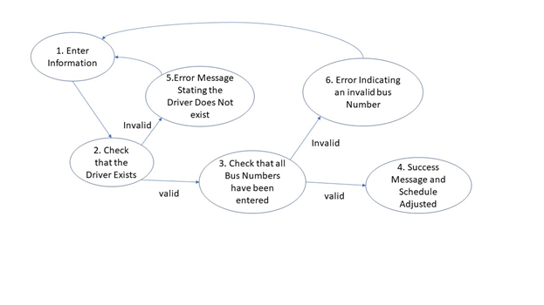

**State Table**

|  |  |  |
| --- | --- | --- |
| **State** | **Input** | **Next State** |
| **1** | **Enter Driver Number**  **Enter Monday- Start, End, Bus Number**  **Enter Tuesday - Start, End, Bus Number**  **Enter Wednesday- Start, End, Bus Number**  **Enter Thursday- Start, End, Bus Number**  **Enter Friday- Start, End, Bus Number**  **Enter Saturday- Start, End, Bus Number**  **Enter Sunday- Start, End, Bus Number** | **2** |
| **2** | **none** | **3** |
| **2** | **none** | **5** |
| **3** | **none** | **4** |
| **3** | **none** | **6** |
| **5** | **none** | **1** |
| **6** | **none** | **1** |

***Test Cases***

|  |  |  |  |
| --- | --- | --- | --- |
| **Test Case Number** | **Input** | **Current State** | **Expected Output** |
| **STR-11.1** | **Driver Number:**  **2**  **Enter Monday- Start, End, Bus Number:**  **07:00, 09:00, 1**  **Enter Tuesday- Start, End, Bus Number:**  **07:00, 09:00, 1**  **Enter Wednesday- Start, End, Bus Number:**  **07:00, 09:00, 1**  **Enter Thursday-Start, End, Bus Number:**  **07:00, 09:00, 1**  **Enter Friday-Start, End, Bus Number:**  **07:00, 09:00, 1**  **Enter Saturday- Start, End, Bus Number:**  **07:00, 09:00, 1**  **Enter Sunday- Start, End, Bus Number:**  **07:00, 09:00, 1**    **Click Adjust Schedule** | **Not updated**  **(Screenshot 11.2)** | **(Screenshot 11.3)** |
| **STR-11.2** | **Driver Number:**  **10000**  **Enter Monday- Start, End, Bus Number:**  **07:00, 09:00, 1**  **Enter Tuesday- Start, End, Bus Number:**  **07:00, 09:00, 1**  **Enter Wednesday- Start, End, Bus Number:**  **07:00, 09:00, 1**  **Enter Thursday-Start, End, Bus Number:**  **07:00, 09:00, 1**  **Enter Friday-Start, End, Bus Number:**  **07:00, 09:00, 1**  **Enter Saturday- Start, End, Bus Number:**  **07:00, 09:00, 1**  **Enter Sunday- Start, End, Bus Number:**  **07:00, 09:00, 1**    **Click Adjust Schedule** | **Not updated**  **(Screenshot 11.2)** | **(Screenshot 11.4)** |
| **STR-11.3** | **Driver Number:**  **2**  **Enter Monday- Start, End, Bus Number:**  **07:00, 09:00, 10000**  **Enter Tuesday- Start, End, Bus Number:**  **07:00, 09:00, 1**  **Enter Wednesday- Start, End, Bus Number:**  **07:00, 09:00, 1**  **Enter Thursday-Start, End, Bus Number:**  **07:00, 09:00, 1**  **Enter Friday-Start, End, Bus Number:**  **07:00, 09:00, 1**  **Enter Saturday- Start, End, Bus Number:**  **07:00, 09:00, 1**  **Enter Sunday- Start, End, Bus Number:**  **07:00, 09:00, 1**    **Click Adjust Schedule** | **Not updated**  **(Screenshot 11.2)** | **(Screenshot 11.5)** |

**Techniques 1 screenshots:**

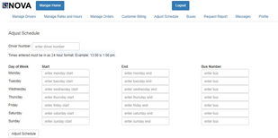

**Screenshot 11.1 Screenshot 11.2**

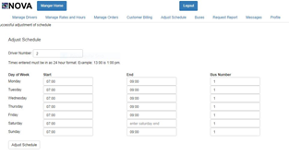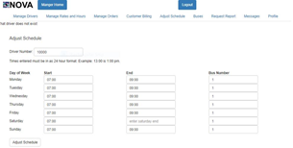

**Screenshot 11.3 Screenshot 11.4**

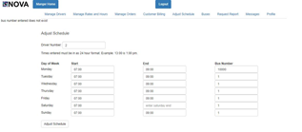

**Screenshot 11.5**

***Techniques 2*: Boundary Value Analysis**

**Boundaries to be tested exist on different times entered. The times should be between [00:00,24:00]. The light yellow sections in the chart below indicate the boundaries. The numbers represent the values around the boundaries we will test.**

|  |  |  |  |  |
| --- | --- | --- | --- | --- |
| **-00:01** | **00:00** | **00:01 23:59** | **24:00** | **24:01** |

|  |  |  |  |
| --- | --- | --- | --- |
| **Test Case Number** | **Input** | **Current State** | **Expected Output** |
| **STR-11.4** | **Driver Number:**  **2**  **Enter Monday- Start, End, Bus Number:**  **00:00, 00:00, 1**  **Enter Tuesday- Start, End, Bus Number:**  **00:00, 00:00, 1**  **Enter Wednesday- Start, End, Bus Number:**  **00:00, 00:00, 1**  **Enter Thursday-Start, End, Bus Number:**  **00:00, 00:00, 1**  **Enter Friday-Start, End, Bus Number:**  **00:00, 00:00, 1**  **Enter Saturday- Start, End, Bus Number:**  **00:00, 00:00, 1**  **Enter Sunday- Start, End, Bus Number:**  **00:00, 00:00, 1**    **Click Adjust Schedule** | **Not updated**  **(Screenshot 11.2)** | **(Screenshot 11.3)** |
| **STR-11.5** | **Driver Number:**  **2**  **Enter Monday- Start, End, Bus Number:**  **24:00, 24:00, 1**  **Enter Tuesday- Start, End, Bus Number:**  **24:00, 24:00, 1**  **Enter Wednesday- Start, End, Bus Number:**  **24:00, 24:00, 1**  **Enter Thursday-Start, End, Bus Number:**  **24:00, 24:00, 1**  **Enter Friday-Start, End, Bus Number:**  **24:00, 24:00, 1**  **Enter Saturday- Start, End, Bus Number:**  **24:00, 24:00, 1**  **Enter Sunday- Start, End, Bus Number:**  **24:00, 24:00, 1**    **Click Adjust Schedule** | **Not updated**  **(Screenshot 11.2)** | **(Screenshot 11.3)** |
| **STR-11.6** | **Driver Number:**  **2**  **Enter Monday- Start, End, Bus Number:**  **23:59, 23:59, 1**  **Enter Tuesday- Start, End, Bus Number:**  **23:59, 23:59, 1**    **Enter Wednesday- Start, End, Bus Number:**  **23:59, 23:59, 1**  **Enter Thursday-Start, End, Bus Number:**  **23:59, 23:59, 1**  **Enter Friday-Start, End, Bus Number:**  **23:59, 23:59, 1**  **Enter Saturday- Start, End, Bus Number:**  **23:59, 23:59, 1**  **Enter Sunday- Start, End, Bus Number:**  **23:59, 23:59, 1**    **Click Adjust Schedule** | **Not updated**  **(Screenshot 11.2)** | **(Screenshot 11.3)** |
| **STR-11.7** | **Driver Number:**  **2**  **Enter Monday- Start, End, Bus Number:**  **00:01, 00:01, 1**  **Enter Tuesday- Start, End, Bus Number:**  **00:01, 00:01, 1**  **Enter Wednesday- Start, End, Bus Number:**  **00:01, 00:01, 1**  **Enter Thursday-Start, End, Bus Number:**  **00:01, 00:01, 1**  **Enter Friday-Start, End, Bus Number:**  **00:01, 00:01, 1**  **Enter Saturday- Start, End, Bus Number:**  **00:01, 00:01, 1**  **Enter Sunday- Start, End, Bus Number:**  **00:01, 00:01, 1**    **Click Adjust Schedule** | **Not updated**  **(Screenshot 11.2)** | **(Screenshot 11.3)** |
| **STR-11.8** | **Driver Number:**  **2**  **Enter Monday- Start, End, Bus Number:**  **-00:01, -00:01, 1**  **Enter Tuesday- Start, End, Bus Number:**  **-00:01, -00:01, 1**  **Enter Wednesday- Start, End, Bus Number:**  **-00:01, -00:01, 1**  **Enter Thursday-Start, End, Bus Number:**  **-00:01, -00:01, 1**  **Enter Friday-Start, End, Bus Number:**  **-00:01, -00:01, 1**  **Enter Saturday- Start, End, Bus Number:**  **-00:01, -00:01, 1**  **Enter Sunday- Start, End, Bus Number:**  **-00:01, -00:01, 1**    **Click Adjust Schedule** | **Not updated**  **(Screenshot 11.2)** | **(Screenshot 11.2)**  **With Error Message: Invalid Time entered** |
| **STR-11.9** | **Driver Number:**  **2**  **Enter Monday- Start, End, Bus Number:**  **24:01, 24:01, 1**  **Enter Tuesday- Start, End, Bus Number:**  **24:01, 24:01, 1**  **Enter Wednesday- Start, End, Bus Number:**  **24:01, 24:01, 1**  **Enter Thursday-Start, End, Bus Number:**  **24:01, 24:01, 1**  **Enter Friday-Start, End, Bus Number:**  **24:01, 24:01, 1**  **Enter Saturday- Start, End, Bus Number:**  **24:01, 24:01, 1**    **Enter Sunday- Start, End, Bus Number:**  **24:01, 24:01, 1**    **Click Adjust Schedule** | **Not updated**  **(Screenshot 11.2)** | **(Screenshot 11.2)**  **With Error Message: Invalid Time entered** |

**Techniques 2 screenshots:**



**Screenshot 10.1 Screenshot 10.2**



**Screenshot 10.3 Screenshot 10.4**



**Screenshot 10.5**

***Final Merged Test Cases:***

|  |  |  |  |
| --- | --- | --- | --- |
| **Test Case Number** | **Input** | **Current State** | **Expected Output** |
| **STR-11.1** | **Driver Number:**  **2**  **Enter Monday- Start, End, Bus Number:**  **07:00, 09:00, 1**  **Enter Tuesday- Start, End, Bus Number:**  **07:00, 09:00, 1**  **Enter Wednesday- Start, End, Bus Number:**  **07:00, 09:00, 1**  **Enter Thursday-Start, End, Bus Number:**  **07:00, 09:00, 1**  **Enter Friday-Start, End, Bus Number:**  **07:00, 09:00, 1**  **Enter Saturday- Start, End, Bus Number:**  **07:00, 09:00, 1**  **Enter Sunday- Start, End, Bus Number:**  **07:00, 09:00, 1**    **Click Adjust Schedule** | **Not updated**  **(Screenshot 11.2)** | **(Screenshot 11.3)** |
| **STR-11.2** | **Driver Number:**  **10000**  **Enter Monday- Start, End, Bus Number:**  **07:00, 09:00, 1**  **Enter Tuesday- Start, End, Bus Number:**  **07:00, 09:00, 1**  **Enter Wednesday- Start, End, Bus Number:**  **07:00, 09:00, 1**  **Enter Thursday-Start, End, Bus Number:**  **07:00, 09:00, 1**  **Enter Friday-Start, End, Bus Number:**  **07:00, 09:00, 1**  **Enter Saturday- Start, End, Bus Number:**  **07:00, 09:00, 1**  **Enter Sunday- Start, End, Bus Number:**  **07:00, 09:00, 1**    **Click Adjust Schedule** | **Not updated**  **(Screenshot 11.2)** | **(Screenshot 11.4)** |
| **STR-11.3** | **Driver Number:**  **2**  **Enter Monday- Start, End, Bus Number:**  **07:00, 09:00, 10000**  **Enter Tuesday- Start, End, Bus Number:**  **07:00, 09:00, 1**  **Enter Wednesday- Start, End, Bus Number:**  **07:00, 09:00, 1**  **Enter Thursday-Start, End, Bus Number:**  **07:00, 09:00, 1**  **Enter Friday-Start, End, Bus Number:**  **07:00, 09:00, 1**  **Enter Saturday- Start, End, Bus Number:**  **07:00, 09:00, 1**  **Enter Sunday- Start, End, Bus Number:**  **07:00, 09:00, 1**    **Click Adjust Schedule** | **Not updated**  **(Screenshot 11.2)** | **(Screenshot 11.5)** |
| **STR-11.4** | **Driver Number:**  **2**  **Enter Monday- Start, End, Bus Number:**  **00:00, 00:00, 1**  **Enter Tuesday- Start, End, Bus Number:**  **00:00, 00:00, 1**  **Enter Wednesday- Start, End, Bus Number:**  **00:00, 00:00, 1**  **Enter Thursday-Start, End, Bus Number:**  **00:00, 00:00, 1**  **Enter Friday-Start, End, Bus Number:**  **00:00, 00:00, 1**  **Enter Saturday- Start, End, Bus Number:**  **00:00, 00:00, 1**  **Enter Sunday- Start, End, Bus Number:**  **00:00, 00:00, 1**    **Click Adjust Schedule** | **Not updated**  **(Screenshot 11.2)** | **(Screenshot 11.3)** |
| **STR-11.5** | **Driver Number:**  **2**  **Enter Monday- Start, End, Bus Number:**  **24:00, 24:00, 1**  **Enter Tuesday- Start, End, Bus Number:**  **24:00, 24:00, 1**  **Enter Wednesday- Start, End, Bus Number:**  **24:00, 24:00, 1**  **Enter Thursday-Start, End, Bus Number:**  **24:00, 24:00, 1**  **Enter Friday-Start, End, Bus Number:**  **24:00, 24:00, 1**  **Enter Saturday- Start, End, Bus Number:**  **24:00, 24:00, 1**  **Enter Sunday- Start, End, Bus Number:**  **24:00, 24:00, 1**    **Click Adjust Schedule** | **Not updated**  **(Screenshot 11.2)** | **(Screenshot 11.3)** |
| **STR-11.6** | **Driver Number:**  **2**  **Enter Monday- Start, End, Bus Number:**  **23:59, 23:59, 1**  **Enter Tuesday- Start, End, Bus Number:**  **23:59, 23:59, 1**    **Enter Wednesday- Start, End, Bus Number:**  **23:59, 23:59, 1**  **Enter Thursday-Start, End, Bus Number:**  **23:59, 23:59, 1**  **Enter Friday-Start, End, Bus Number:**  **23:59, 23:59, 1**  **Enter Saturday- Start, End, Bus Number:**  **23:59, 23:59, 1**  **Enter Sunday- Start, End, Bus Number:**  **23:59, 23:59, 1**    **Click Adjust Schedule** | **Not updated**  **(Screenshot 11.2)** | **(Screenshot 11.3)** |
| **STR-11.7** | **Driver Number:**  **2**  **Enter Monday- Start, End, Bus Number:**  **00:01, 00:01, 1**  **Enter Tuesday- Start, End, Bus Number:**  **00:01, 00:01, 1**  **Enter Wednesday- Start, End, Bus Number:**  **00:01, 00:01, 1**  **Enter Thursday-Start, End, Bus Number:**  **00:01, 00:01, 1**  **Enter Friday-Start, End, Bus Number:**  **00:01, 00:01, 1**  **Enter Saturday- Start, End, Bus Number:**  **00:01, 00:01, 1**  **Enter Sunday- Start, End, Bus Number:**  **00:01, 00:01, 1**    **Click Adjust Schedule** | **Not updated**  **(Screenshot 11.2)** | **(Screenshot 11.3)** |
| **STR-11.8** | **Driver Number:**  **2**  **Enter Monday- Start, End, Bus Number:**  **-00:01, -00:01, 1**  **Enter Tuesday- Start, End, Bus Number:**  **-00:01, -00:01, 1**  **Enter Wednesday- Start, End, Bus Number:**  **-00:01, -00:01, 1**  **Enter Thursday-Start, End, Bus Number:**  **-00:01, -00:01, 1**  **Enter Friday-Start, End, Bus Number:**  **-00:01, -00:01, 1**  **Enter Saturday- Start, End, Bus Number:**  **-00:01, -00:01, 1**  **Enter Sunday- Start, End, Bus Number:**  **-00:01, -00:01, 1**    **Click Adjust Schedule** | **Not updated**  **(Screenshot 11.2)** | **(Screenshot 11.2)**  **With Error Message: Invalid Time entered** |
| **STR-11.9** | **Driver Number:**  **2**  **Enter Monday- Start, End, Bus Number:**  **24:01, 24:01, 1**  **Enter Tuesday- Start, End, Bus Number:**  **24:01, 24:01, 1**  **Enter Wednesday- Start, End, Bus Number:**  **24:01, 24:01, 1**  **Enter Thursday-Start, End, Bus Number:**  **24:01, 24:01, 1**  **Enter Friday-Start, End, Bus Number:**  **24:01, 24:01, 1**  **Enter Saturday- Start, End, Bus Number:**  **24:01, 24:01, 1**    **Enter Sunday- Start, End, Bus Number:**  **24:01, 24:01, 1**    **Click Adjust Schedule** | **Not updated**  **(Screenshot 11.2)** | **(Screenshot 11.2)**  **With Error Message: Invalid Time entered** |

**STR-12 Manager - Bus Edit**

***Setup*: Navigate to** [**http://teamnovaproject.us/managerpage**](http://teamnovaproject.us/managerpage) **and click Buses, and then Edit Bus button (Shown in Screenshot 12.1).**

***Techniques 1*: State-based Test**

**State Diagram:**

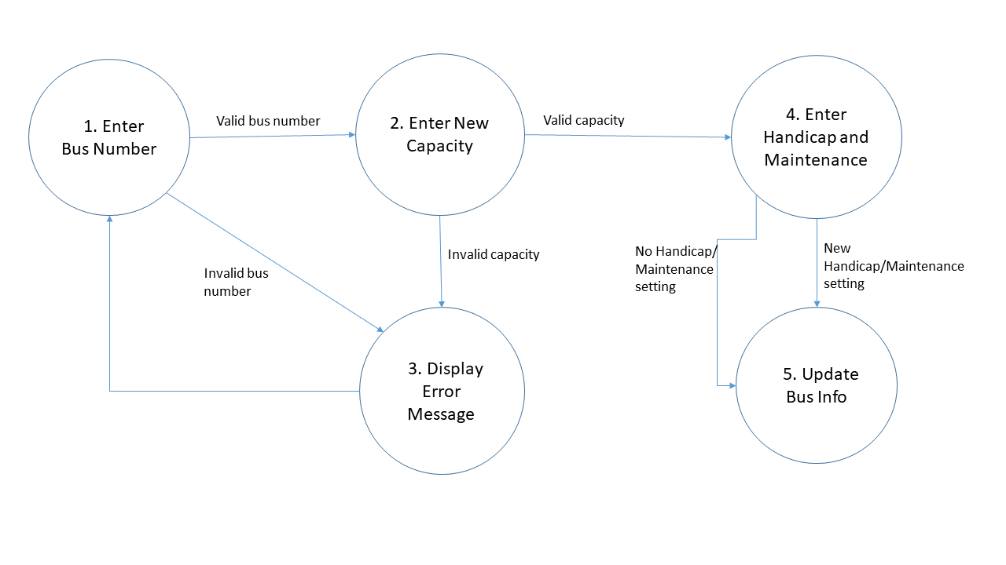

**State Table**

|  |  |  |
| --- | --- | --- |
| **State** | **Input** | **Next State** |
| **1** | **Valid bus number** | **2** |
| **1** | **Invalid bus number** | **3** |
| **2** | **Valid capacity** | **4** |
| **2** | **Invalid capacity** | **3** |
| **3** | **No input** | **1** |
| **4** | **New handicap and maintenance setting** | **5** |
| **4** | **New handicap setting**  **No maintenance setting** | **5** |
| **4** | **No handicap setting**  **New maintenance setting** | **5** |
| **4** | **No handicap/maintenance setting** | **5** |

***Test Cases***

|  |  |  |  |
| --- | --- | --- | --- |
| **Test Case Number** | **Input** | **Current State** | **Expected Output** |
| **STR-12.1** | **Bus Number:**  **1**  **Capacity:**  **100**  **Handicap:**  **yes**  **Maintenance:**  **yes**  **Click Enter** | **Bus not updated**  **(Screenshot 12.1)** | **Bus updated, reroute**  **to bus list page**  **(Screenshot 12.2)**  **<http://teamnovaproject.us/managerpage/viewbuses/>** |
| **STR-12.2** | **Bus Number:**  **A1132e**  **Capacity:**  **100**  **Handicap:**  **yes**  **Maintenance:**  **yes**  **Click Enter** | **Bus not updated**  **(Screenshot 12.1)** | **Bus not updated, with error message**  **(Screenshot 12.4)** |
| **STR-12.3** | **Bus Number:**  **1**  **Capacity:**  **abcdef**  **Handicap:**  **yes**  **Maintenance:**  **yes**  **Click Enter** | **Bus not updated**  **(Screenshot 12.1)** | **Bus not updated, with error message**  **(Screenshot 12.3)** |
| **STR-12.4** | **Bus Number:**  **A113**  **Capacity:**  **abcdef**  **Handicap:**  **yes**  **Maintenance:**  **yes**  **Click Enter** | **Bus not updated**  **(Screenshot 12.1)** | **Bus not updated, with error message**  **(Screenshot 12.4)** |
| **STR-12.5** | **Bus Number:**  **1**  **Capacity:**  **100**  **Handicap:**  **\*blank\***  **Maintenance:**  **\*blank\***  **Click Enter** | **Bus not updated**  **(Screenshot 12.1)** | **Bus updated, reroute**  **to bus list page**  **(Screenshot 12.2)**  **<http://teamnovaproject.us/managerpage/viewbuses/>** |
| **STR-12.6** | **Bus Number:**  **1**  **Capacity:**  **100**  **Handicap:**  **yes**  **Maintenance:**  **\*blank\***  **Click Enter** | **Bus not updated**  **(Screenshot 12.1)** | **Bus updated, reroute**  **to bus list page**  **(Screenshot 12.2)**  **<http://teamnovaproject.us/managerpage/viewbuses/>** |
| **STR-12.7** | **Bus Number:**  **1**  **Capacity:**  **100**  **Handicap:**  **\*blank\***  **Maintenance:**  **yes**  **Click Enter** | **Bus not updated**  **(Screenshot 12.1)** | **Bus updated, reroute**  **to bus list page**  **(Screenshot 12.2)**  **<http://teamnovaproject.us/managerpage/viewbuses/>** |

**[Techniques 1 screenshots:](http://teamnovaproject.us/managerpage/viewbuses/)**

**[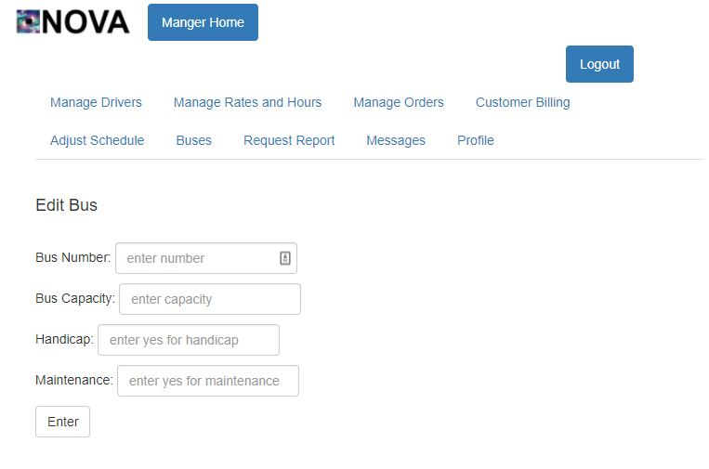](http://teamnovaproject.us/managerpage/viewbuses/)**

**[Screenshot 12.1](http://teamnovaproject.us/managerpage/viewbuses/)**

**[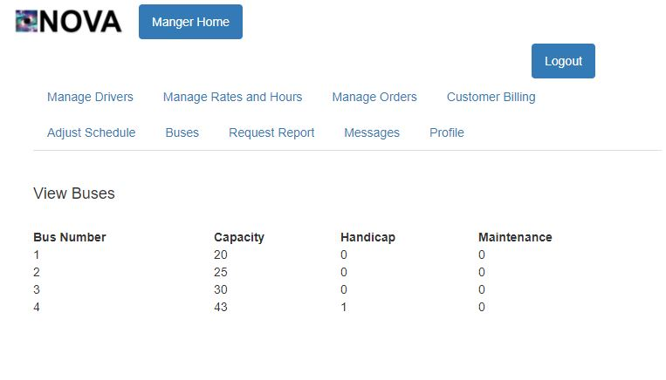](http://teamnovaproject.us/managerpage/viewbuses/)**

**[Screenshot 12.2](http://teamnovaproject.us/managerpage/viewbuses/)**

**[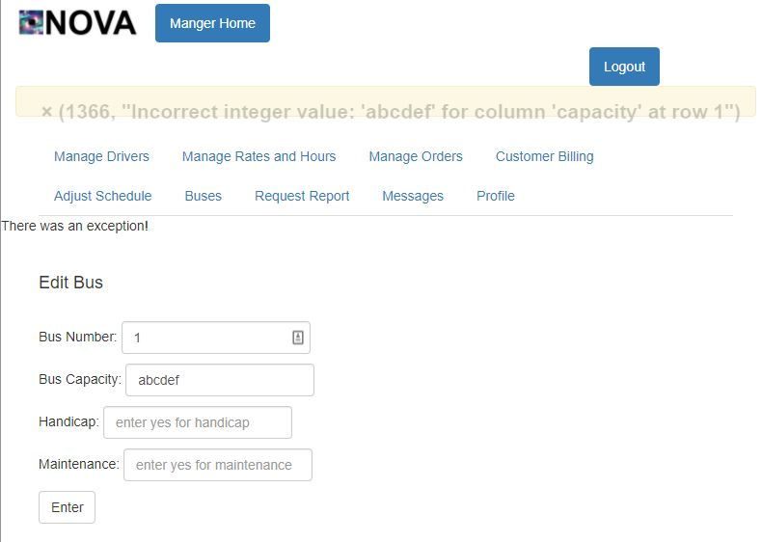](http://teamnovaproject.us/managerpage/viewbuses/)**

**[Screenshot 12.3](http://teamnovaproject.us/managerpage/viewbuses/)**

**[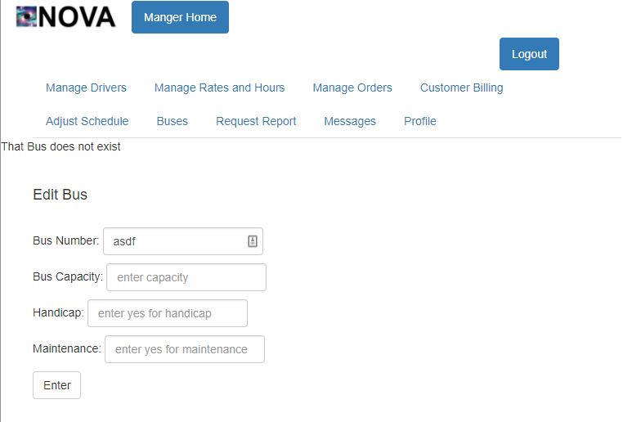](http://teamnovaproject.us/managerpage/viewbuses/)**

**[Screenshot 12.4](http://teamnovaproject.us/managerpage/viewbuses/)**

***[Techniques 2](http://teamnovaproject.us/managerpage/viewbuses/)*[: Positive and Negative Tests](http://teamnovaproject.us/managerpage/viewbuses/)**

**[Positive Tests:](http://teamnovaproject.us/managerpage/viewbuses/)**

|  |  |  |  |
| --- | --- | --- | --- |
| **[Test Case Number](http://teamnovaproject.us/managerpage/viewbuses/)** | **[Input](http://teamnovaproject.us/managerpage/viewbuses/)** | **[Current State](http://teamnovaproject.us/managerpage/viewbuses/)** | **[Expected Output](http://teamnovaproject.us/managerpage/viewbuses/)** |
| **[STR-12.8](http://teamnovaproject.us/managerpage/viewbuses/)** | **[Bus Number:](http://teamnovaproject.us/managerpage/viewbuses/)**  **[1](http://teamnovaproject.us/managerpage/viewbuses/)**  **[Capacity:](http://teamnovaproject.us/managerpage/viewbuses/)**  **[100](http://teamnovaproject.us/managerpage/viewbuses/)**  **[Handicap:](http://teamnovaproject.us/managerpage/viewbuses/)**  **[yes](http://teamnovaproject.us/managerpage/viewbuses/)**  **[Maintenance:](http://teamnovaproject.us/managerpage/viewbuses/)**  **[yes](http://teamnovaproject.us/managerpage/viewbuses/)**  **[Click Enter](http://teamnovaproject.us/managerpage/viewbuses/)** | **[Bus not updated](http://teamnovaproject.us/managerpage/viewbuses/)**  **[(Screenshot 12.1)](http://teamnovaproject.us/managerpage/viewbuses/)** | **[Bus updated, reroute](http://teamnovaproject.us/managerpage/viewbuses/)**  **[to bus list page](http://teamnovaproject.us/managerpage/viewbuses/)**  **[(Screenshot 12.2)](http://teamnovaproject.us/managerpage/viewbuses/)**  **<http://teamnovaproject.us/managerpage/viewbuses/>** |
| **[STR-12.9](http://teamnovaproject.us/managerpage/viewbuses/)** | **[Bus Number:](http://teamnovaproject.us/managerpage/viewbuses/)**  **[A1132e](http://teamnovaproject.us/managerpage/viewbuses/)**  **[Capacity:](http://teamnovaproject.us/managerpage/viewbuses/)**  **[100](http://teamnovaproject.us/managerpage/viewbuses/)**  **[Handicap:](http://teamnovaproject.us/managerpage/viewbuses/)**  **[yes](http://teamnovaproject.us/managerpage/viewbuses/)**  **[Maintenance:](http://teamnovaproject.us/managerpage/viewbuses/)**  **[yes](http://teamnovaproject.us/managerpage/viewbuses/)**  **[Click Enter](http://teamnovaproject.us/managerpage/viewbuses/)** | **[Bus not updated](http://teamnovaproject.us/managerpage/viewbuses/)**  **[(Screenshot 12.1)](http://teamnovaproject.us/managerpage/viewbuses/)** | **[Bus not updated, with error message](http://teamnovaproject.us/managerpage/viewbuses/)**  **[(Screenshot 12.4)](http://teamnovaproject.us/managerpage/viewbuses/)** |
| **[STR-12.10](http://teamnovaproject.us/managerpage/viewbuses/)** | **[Bus Number:](http://teamnovaproject.us/managerpage/viewbuses/)**  **[1](http://teamnovaproject.us/managerpage/viewbuses/)**  **[Capacity:](http://teamnovaproject.us/managerpage/viewbuses/)**  **[abcdef](http://teamnovaproject.us/managerpage/viewbuses/)**  **[Handicap:](http://teamnovaproject.us/managerpage/viewbuses/)**  **[yes](http://teamnovaproject.us/managerpage/viewbuses/)**  **[Maintenance:](http://teamnovaproject.us/managerpage/viewbuses/)**  **[yes](http://teamnovaproject.us/managerpage/viewbuses/)**  **[Click Enter](http://teamnovaproject.us/managerpage/viewbuses/)** | **[Bus not updated](http://teamnovaproject.us/managerpage/viewbuses/)**  **[(Screenshot 12.1)](http://teamnovaproject.us/managerpage/viewbuses/)** | **[Bus not updated, with error message](http://teamnovaproject.us/managerpage/viewbuses/)**  **[(Screenshot 12.3)](http://teamnovaproject.us/managerpage/viewbuses/)** |
| **[STR-12.11](http://teamnovaproject.us/managerpage/viewbuses/)** | **[Bus Number:](http://teamnovaproject.us/managerpage/viewbuses/)**  **[A113](http://teamnovaproject.us/managerpage/viewbuses/)**  **[Capacity:](http://teamnovaproject.us/managerpage/viewbuses/)**  **[abcdef](http://teamnovaproject.us/managerpage/viewbuses/)**  **[Handicap:](http://teamnovaproject.us/managerpage/viewbuses/)**  **[yes](http://teamnovaproject.us/managerpage/viewbuses/)**  **[Maintenance:](http://teamnovaproject.us/managerpage/viewbuses/)**  **[yes](http://teamnovaproject.us/managerpage/viewbuses/)**  **[Click Enter](http://teamnovaproject.us/managerpage/viewbuses/)** | **[Bus not updated](http://teamnovaproject.us/managerpage/viewbuses/)**  **[(Screenshot 12.1)](http://teamnovaproject.us/managerpage/viewbuses/)** | **[Bus not updated, with error message](http://teamnovaproject.us/managerpage/viewbuses/)**  **[(Screenshot 12.4)](http://teamnovaproject.us/managerpage/viewbuses/)** |
| **[STR-12.12](http://teamnovaproject.us/managerpage/viewbuses/)** | **[Bus Number:](http://teamnovaproject.us/managerpage/viewbuses/)**  **[1](http://teamnovaproject.us/managerpage/viewbuses/)**  **[Capacity:](http://teamnovaproject.us/managerpage/viewbuses/)**  **[100](http://teamnovaproject.us/managerpage/viewbuses/)**  **[Handicap:](http://teamnovaproject.us/managerpage/viewbuses/)**  **[*blank*](http://teamnovaproject.us/managerpage/viewbuses/)**  **[Maintenance:](http://teamnovaproject.us/managerpage/viewbuses/)**  **[*blank*](http://teamnovaproject.us/managerpage/viewbuses/)**  **[Click Enter](http://teamnovaproject.us/managerpage/viewbuses/)** | **[Bus not updated](http://teamnovaproject.us/managerpage/viewbuses/)**  **[(Screenshot 12.1)](http://teamnovaproject.us/managerpage/viewbuses/)** | **[Bus updated, reroute](http://teamnovaproject.us/managerpage/viewbuses/)**  **[to bus list page](http://teamnovaproject.us/managerpage/viewbuses/)**  **[(Screenshot 12.2)](http://teamnovaproject.us/managerpage/viewbuses/)**  **<http://teamnovaproject.us/managerpage/viewbuses/>** |
| **[STR-12.13](http://teamnovaproject.us/managerpage/viewbuses/)** | **[Bus Number:](http://teamnovaproject.us/managerpage/viewbuses/)**  **[1](http://teamnovaproject.us/managerpage/viewbuses/)**  **[Capacity:](http://teamnovaproject.us/managerpage/viewbuses/)**  **[100](http://teamnovaproject.us/managerpage/viewbuses/)**  **[Handicap:](http://teamnovaproject.us/managerpage/viewbuses/)**  **[yes](http://teamnovaproject.us/managerpage/viewbuses/)**  **[Maintenance:](http://teamnovaproject.us/managerpage/viewbuses/)**  **[*blank*](http://teamnovaproject.us/managerpage/viewbuses/)**  **[Click Enter](http://teamnovaproject.us/managerpage/viewbuses/)** | **[Bus not updated](http://teamnovaproject.us/managerpage/viewbuses/)**  **[(Screenshot 12.1)](http://teamnovaproject.us/managerpage/viewbuses/)** | **[Bus updated, reroute](http://teamnovaproject.us/managerpage/viewbuses/)**  **[to bus list page](http://teamnovaproject.us/managerpage/viewbuses/)**  **[(Screenshot 12.2)](http://teamnovaproject.us/managerpage/viewbuses/)**  **<http://teamnovaproject.us/managerpage/viewbuses/>** |
| **[STR-12.14](http://teamnovaproject.us/managerpage/viewbuses/)** | **[Bus Number:](http://teamnovaproject.us/managerpage/viewbuses/)**  **[1](http://teamnovaproject.us/managerpage/viewbuses/)**  **[Capacity:](http://teamnovaproject.us/managerpage/viewbuses/)**  **[100](http://teamnovaproject.us/managerpage/viewbuses/)**  **[Handicap:](http://teamnovaproject.us/managerpage/viewbuses/)**  **[*blank*](http://teamnovaproject.us/managerpage/viewbuses/)**  **[Maintenance:](http://teamnovaproject.us/managerpage/viewbuses/)**  **[yes](http://teamnovaproject.us/managerpage/viewbuses/)**  **[Click Enter](http://teamnovaproject.us/managerpage/viewbuses/)** | **[Bus not updated](http://teamnovaproject.us/managerpage/viewbuses/)**  **[(Screenshot 12.1)](http://teamnovaproject.us/managerpage/viewbuses/)** | **[Bus updated, reroute](http://teamnovaproject.us/managerpage/viewbuses/)**  **[to bus list page](http://teamnovaproject.us/managerpage/viewbuses/)**  **[(Screenshot 12.2)](http://teamnovaproject.us/managerpage/viewbuses/)**  **<http://teamnovaproject.us/managerpage/viewbuses/>** |

**[Negative tests:](http://teamnovaproject.us/managerpage/viewbuses/)**

|  |  |  |  |
| --- | --- | --- | --- |
| **[Test Case Number](http://teamnovaproject.us/managerpage/viewbuses/)** | **[Input](http://teamnovaproject.us/managerpage/viewbuses/)** | **[Current State](http://teamnovaproject.us/managerpage/viewbuses/)** | **[Expected Output](http://teamnovaproject.us/managerpage/viewbuses/)** |
| **[STR-12.15](http://teamnovaproject.us/managerpage/viewbuses/)** | **[Punch the monitor](http://teamnovaproject.us/managerpage/viewbuses/)** | **[Bus not updated](http://teamnovaproject.us/managerpage/viewbuses/)**  **[(Screenshot 12.1)](http://teamnovaproject.us/managerpage/viewbuses/)** | **[Bus not updated](http://teamnovaproject.us/managerpage/viewbuses/)**  **[(Screenshot 12.1)](http://teamnovaproject.us/managerpage/viewbuses/)** |

**[Techniques 2 screenshots:](http://teamnovaproject.us/managerpage/viewbuses/)**

**[](http://teamnovaproject.us/managerpage/viewbuses/)**

**[Screenshot 12.1](http://teamnovaproject.us/managerpage/viewbuses/)**

**[](http://teamnovaproject.us/managerpage/viewbuses/)**

**[Screenshot 12.2](http://teamnovaproject.us/managerpage/viewbuses/)**

**[](http://teamnovaproject.us/managerpage/viewbuses/)**

**[Screenshot 12.3](http://teamnovaproject.us/managerpage/viewbuses/)**

**[](http://teamnovaproject.us/managerpage/viewbuses/)**

**[Screenshot 12.4](http://teamnovaproject.us/managerpage/viewbuses/)**

***[Final Merged Test Cases:](http://teamnovaproject.us/managerpage/viewbuses/)***

|  |  |  |  |
| --- | --- | --- | --- |
| **[Test Case Number](http://teamnovaproject.us/managerpage/viewbuses/)** | **[Input](http://teamnovaproject.us/managerpage/viewbuses/)** | **[Current State](http://teamnovaproject.us/managerpage/viewbuses/)** | **[Expected Output](http://teamnovaproject.us/managerpage/viewbuses/)** |
| **[STR-12.1](http://teamnovaproject.us/managerpage/viewbuses/)** | **[Bus Number:](http://teamnovaproject.us/managerpage/viewbuses/)**  **[1](http://teamnovaproject.us/managerpage/viewbuses/)**  **[Capacity:](http://teamnovaproject.us/managerpage/viewbuses/)**  **[100](http://teamnovaproject.us/managerpage/viewbuses/)**  **[Handicap:](http://teamnovaproject.us/managerpage/viewbuses/)**  **[yes](http://teamnovaproject.us/managerpage/viewbuses/)**  **[Maintenance:](http://teamnovaproject.us/managerpage/viewbuses/)**  **[yes](http://teamnovaproject.us/managerpage/viewbuses/)**  **[Click Enter](http://teamnovaproject.us/managerpage/viewbuses/)** | **[Bus not updated](http://teamnovaproject.us/managerpage/viewbuses/)**  **[(Screenshot 12.1)](http://teamnovaproject.us/managerpage/viewbuses/)** | **[Bus updated, reroute](http://teamnovaproject.us/managerpage/viewbuses/)**  **[to bus list page](http://teamnovaproject.us/managerpage/viewbuses/)**  **[(Screenshot 12.2)](http://teamnovaproject.us/managerpage/viewbuses/)**  **<http://teamnovaproject.us/managerpage/viewbuses/>** |
| **[STR-12.2](http://teamnovaproject.us/managerpage/viewbuses/)** | **[Bus Number:](http://teamnovaproject.us/managerpage/viewbuses/)**  **[A1132e](http://teamnovaproject.us/managerpage/viewbuses/)**  **[Capacity:](http://teamnovaproject.us/managerpage/viewbuses/)**  **[100](http://teamnovaproject.us/managerpage/viewbuses/)**  **[Handicap:](http://teamnovaproject.us/managerpage/viewbuses/)**  **[yes](http://teamnovaproject.us/managerpage/viewbuses/)**  **[Maintenance:](http://teamnovaproject.us/managerpage/viewbuses/)**  **[yes](http://teamnovaproject.us/managerpage/viewbuses/)**  **[Click Enter](http://teamnovaproject.us/managerpage/viewbuses/)** | **[Bus not updated](http://teamnovaproject.us/managerpage/viewbuses/)**  **[(Screenshot 12.1)](http://teamnovaproject.us/managerpage/viewbuses/)** | **[Bus not updated, with error message](http://teamnovaproject.us/managerpage/viewbuses/)**  **[(Screenshot 12.4)](http://teamnovaproject.us/managerpage/viewbuses/)** |
| **[STR-12.3](http://teamnovaproject.us/managerpage/viewbuses/)** | **[Bus Number:](http://teamnovaproject.us/managerpage/viewbuses/)**  **[1](http://teamnovaproject.us/managerpage/viewbuses/)**  **[Capacity:](http://teamnovaproject.us/managerpage/viewbuses/)**  **[abcdef](http://teamnovaproject.us/managerpage/viewbuses/)**  **[Handicap:](http://teamnovaproject.us/managerpage/viewbuses/)**  **[yes](http://teamnovaproject.us/managerpage/viewbuses/)**  **[Maintenance:](http://teamnovaproject.us/managerpage/viewbuses/)**  **[yes](http://teamnovaproject.us/managerpage/viewbuses/)**  **[Click Enter](http://teamnovaproject.us/managerpage/viewbuses/)** | **[Bus not updated](http://teamnovaproject.us/managerpage/viewbuses/)**  **[(Screenshot 12.1)](http://teamnovaproject.us/managerpage/viewbuses/)** | **[Bus not updated, with error message](http://teamnovaproject.us/managerpage/viewbuses/)**  **[(Screenshot 12.3)](http://teamnovaproject.us/managerpage/viewbuses/)** |
| **[STR-12.4](http://teamnovaproject.us/managerpage/viewbuses/)** | **[Bus Number:](http://teamnovaproject.us/managerpage/viewbuses/)**  **[A113](http://teamnovaproject.us/managerpage/viewbuses/)**  **[Capacity:](http://teamnovaproject.us/managerpage/viewbuses/)**  **[abcdef](http://teamnovaproject.us/managerpage/viewbuses/)**  **[Handicap:](http://teamnovaproject.us/managerpage/viewbuses/)**  **[yes](http://teamnovaproject.us/managerpage/viewbuses/)**  **[Maintenance:](http://teamnovaproject.us/managerpage/viewbuses/)**  **[yes](http://teamnovaproject.us/managerpage/viewbuses/)**  **[Click Enter](http://teamnovaproject.us/managerpage/viewbuses/)** | **[Bus not updated](http://teamnovaproject.us/managerpage/viewbuses/)**  **[(Screenshot 12.1)](http://teamnovaproject.us/managerpage/viewbuses/)** | **[Bus not updated, with error message](http://teamnovaproject.us/managerpage/viewbuses/)**  **[(Screenshot 12.4)](http://teamnovaproject.us/managerpage/viewbuses/)** |
| **[STR-12.5](http://teamnovaproject.us/managerpage/viewbuses/)** | **[Bus Number:](http://teamnovaproject.us/managerpage/viewbuses/)**  **[1](http://teamnovaproject.us/managerpage/viewbuses/)**  **[Capacity:](http://teamnovaproject.us/managerpage/viewbuses/)**  **[100](http://teamnovaproject.us/managerpage/viewbuses/)**  **[Handicap:](http://teamnovaproject.us/managerpage/viewbuses/)**  **[*blank*](http://teamnovaproject.us/managerpage/viewbuses/)**  **[Maintenance:](http://teamnovaproject.us/managerpage/viewbuses/)**  **[*blank*](http://teamnovaproject.us/managerpage/viewbuses/)**  **[Click Enter](http://teamnovaproject.us/managerpage/viewbuses/)** | **[Bus not updated](http://teamnovaproject.us/managerpage/viewbuses/)**  **[(Screenshot 12.1)](http://teamnovaproject.us/managerpage/viewbuses/)** | **[Bus updated, reroute](http://teamnovaproject.us/managerpage/viewbuses/)**  **[to bus list page](http://teamnovaproject.us/managerpage/viewbuses/)**  **[(Screenshot 12.2)](http://teamnovaproject.us/managerpage/viewbuses/)**  **<http://teamnovaproject.us/managerpage/viewbuses/>** |
| **[STR-12.6](http://teamnovaproject.us/managerpage/viewbuses/)** | **[Bus Number:](http://teamnovaproject.us/managerpage/viewbuses/)**  **[1](http://teamnovaproject.us/managerpage/viewbuses/)**  **[Capacity:](http://teamnovaproject.us/managerpage/viewbuses/)**  **[100](http://teamnovaproject.us/managerpage/viewbuses/)**  **[Handicap:](http://teamnovaproject.us/managerpage/viewbuses/)**  **[yes](http://teamnovaproject.us/managerpage/viewbuses/)**  **[Maintenance:](http://teamnovaproject.us/managerpage/viewbuses/)**  **[*blank*](http://teamnovaproject.us/managerpage/viewbuses/)**  **[Click Enter](http://teamnovaproject.us/managerpage/viewbuses/)** | **[Bus not updated](http://teamnovaproject.us/managerpage/viewbuses/)**  **[(Screenshot 12.1)](http://teamnovaproject.us/managerpage/viewbuses/)** | **[Bus updated, reroute](http://teamnovaproject.us/managerpage/viewbuses/)**  **[to bus list page](http://teamnovaproject.us/managerpage/viewbuses/)**  **[(Screenshot 12.2)](http://teamnovaproject.us/managerpage/viewbuses/)**  **<http://teamnovaproject.us/managerpage/viewbuses/>** |
| **[STR-12.7](http://teamnovaproject.us/managerpage/viewbuses/)** | **[Bus Number:](http://teamnovaproject.us/managerpage/viewbuses/)**  **[1](http://teamnovaproject.us/managerpage/viewbuses/)**  **[Capacity:](http://teamnovaproject.us/managerpage/viewbuses/)**  **[100](http://teamnovaproject.us/managerpage/viewbuses/)**  **[Handicap:](http://teamnovaproject.us/managerpage/viewbuses/)**  **[*blank*](http://teamnovaproject.us/managerpage/viewbuses/)**  **[Maintenance:](http://teamnovaproject.us/managerpage/viewbuses/)**  **[yes](http://teamnovaproject.us/managerpage/viewbuses/)**  **[Click Enter](http://teamnovaproject.us/managerpage/viewbuses/)** | **[Bus not updated](http://teamnovaproject.us/managerpage/viewbuses/)**  **[(Screenshot 12.1)](http://teamnovaproject.us/managerpage/viewbuses/)** | **[Bus updated, reroute](http://teamnovaproject.us/managerpage/viewbuses/)**  **[to bus list page](http://teamnovaproject.us/managerpage/viewbuses/)**  **[(Screenshot 12.2)](http://teamnovaproject.us/managerpage/viewbuses/)**  **<http://teamnovaproject.us/managerpage/viewbuses/>** |
| **[STR-12.15](http://teamnovaproject.us/managerpage/viewbuses/)** | **[Punch the monitor](http://teamnovaproject.us/managerpage/viewbuses/)** | **[Bus not updated](http://teamnovaproject.us/managerpage/viewbuses/)**  **[(Screenshot 12.1)](http://teamnovaproject.us/managerpage/viewbuses/)** | **[Bus not updated](http://teamnovaproject.us/managerpage/viewbuses/)**  **[(Screenshot 12.1)](http://teamnovaproject.us/managerpage/viewbuses/)** |

**[_____________________________________________________________________](http://teamnovaproject.us/managerpage/viewbuses/)**

**[STR-13 Driver - Send Message](http://teamnovaproject.us/managerpage/viewbuses/)**

***[Setup](http://teamnovaproject.us/managerpage/viewbuses/)*[: Navigate to](http://teamnovaproject.us/managerpage/viewbuses/)** [**[http://teamnovaproject.us/driverpage](http://teamnovaproject.us/managerpage/viewbuses/)**](http://teamnovaproject.us/driverpage) **[and click Messages, and then Send Message Button(Shown in Screenshot 13.1).](http://teamnovaproject.us/managerpage/viewbuses/)**

***[Techniques 1](http://teamnovaproject.us/managerpage/viewbuses/)*[: Positive and Negative Testing](http://teamnovaproject.us/managerpage/viewbuses/)**

**[Enter Username and Message into fields Username and Message.](http://teamnovaproject.us/managerpage/viewbuses/)**

***[Test Cases](http://teamnovaproject.us/managerpage/viewbuses/)***

***[Positive Test Cases](http://teamnovaproject.us/managerpage/viewbuses/)***

|  |  |  |  |
| --- | --- | --- | --- |
| **[Test Case Number](http://teamnovaproject.us/managerpage/viewbuses/)** | **[Input](http://teamnovaproject.us/managerpage/viewbuses/)** | **[Current State](http://teamnovaproject.us/managerpage/viewbuses/)** | **[Expected Output](http://teamnovaproject.us/managerpage/viewbuses/)** |
| **[STR-13.1](http://teamnovaproject.us/managerpage/viewbuses/)** | **[Username of recipient:](http://teamnovaproject.us/managerpage/viewbuses/)**  **[manager](http://teamnovaproject.us/managerpage/viewbuses/)**  **[Message:](http://teamnovaproject.us/managerpage/viewbuses/)**  **[hello](http://teamnovaproject.us/managerpage/viewbuses/)**  **[Click Enter](http://teamnovaproject.us/managerpage/viewbuses/)** | **[No message Sent](http://teamnovaproject.us/managerpage/viewbuses/)**  **[(Screenshot 13.2)](http://teamnovaproject.us/managerpage/viewbuses/)** | **[(Screenshot 13.3)](http://teamnovaproject.us/managerpage/viewbuses/)** |
| **[STR-13.2](http://teamnovaproject.us/managerpage/viewbuses/)** | **[Username of recipient:](http://teamnovaproject.us/managerpage/viewbuses/)**  **[manager](http://teamnovaproject.us/managerpage/viewbuses/)**  **[Message:](http://teamnovaproject.us/managerpage/viewbuses/)**  **[Click Enter](http://teamnovaproject.us/managerpage/viewbuses/)** | **[No message Sent](http://teamnovaproject.us/managerpage/viewbuses/)**  **[(Screenshot 13.2)](http://teamnovaproject.us/managerpage/viewbuses/)** | **[(Screenshot 13.4)](http://teamnovaproject.us/managerpage/viewbuses/)** |
| **[STR-13.3](http://teamnovaproject.us/managerpage/viewbuses/)** | **[Username of recipient:](http://teamnovaproject.us/managerpage/viewbuses/)**  **[customer](http://teamnovaproject.us/managerpage/viewbuses/)**  **[Message:](http://teamnovaproject.us/managerpage/viewbuses/)**  **[hello](http://teamnovaproject.us/managerpage/viewbuses/)**  **[Click Enter](http://teamnovaproject.us/managerpage/viewbuses/)** | **[No message Sent](http://teamnovaproject.us/managerpage/viewbuses/)**  **[(Screenshot 13.2)](http://teamnovaproject.us/managerpage/viewbuses/)** | **[(Screenshot 13.5)](http://teamnovaproject.us/managerpage/viewbuses/)** |
| **[STR-13.4](http://teamnovaproject.us/managerpage/viewbuses/)** | **[Username of recipient:](http://teamnovaproject.us/managerpage/viewbuses/)**  **[customer](http://teamnovaproject.us/managerpage/viewbuses/)**  **[Message:](http://teamnovaproject.us/managerpage/viewbuses/)**    **[Click Enter](http://teamnovaproject.us/managerpage/viewbuses/)** | **[No message Sent](http://teamnovaproject.us/managerpage/viewbuses/)**  **[(Screenshot 13.2)](http://teamnovaproject.us/managerpage/viewbuses/)** | **[(Screenshot 13.6)](http://teamnovaproject.us/managerpage/viewbuses/)** |
| **[STR-13.5](http://teamnovaproject.us/managerpage/viewbuses/)** | **[Username of recipient:](http://teamnovaproject.us/managerpage/viewbuses/)**  **[1234214](http://teamnovaproject.us/managerpage/viewbuses/)**  **[Message:](http://teamnovaproject.us/managerpage/viewbuses/)**  **[hello](http://teamnovaproject.us/managerpage/viewbuses/)**    **[Click Enter](http://teamnovaproject.us/managerpage/viewbuses/)** | **[No message Sent](http://teamnovaproject.us/managerpage/viewbuses/)**  **[(Screenshot 13.2)](http://teamnovaproject.us/managerpage/viewbuses/)** | **[(Screenshot 13.2)](http://teamnovaproject.us/managerpage/viewbuses/)** |
| **[STR-13.6](http://teamnovaproject.us/managerpage/viewbuses/)** | **[Username of recipient:](http://teamnovaproject.us/managerpage/viewbuses/)**  **[Message:](http://teamnovaproject.us/managerpage/viewbuses/)**    **[Click Enter](http://teamnovaproject.us/managerpage/viewbuses/)** | **[No message Sent](http://teamnovaproject.us/managerpage/viewbuses/)**  **[(Screenshot 13.2)](http://teamnovaproject.us/managerpage/viewbuses/)** | **[(Screenshot 13.2)](http://teamnovaproject.us/managerpage/viewbuses/)** |

***[Negative Test Cases](http://teamnovaproject.us/managerpage/viewbuses/)***

|  |  |  |  |
| --- | --- | --- | --- |
| **[Test Case Number](http://teamnovaproject.us/managerpage/viewbuses/)** | **[Input](http://teamnovaproject.us/managerpage/viewbuses/)** | **[Current State](http://teamnovaproject.us/managerpage/viewbuses/)** | **[Expected Output](http://teamnovaproject.us/managerpage/viewbuses/)** |
| **[STR-13.7](http://teamnovaproject.us/managerpage/viewbuses/)** | **[Pour Coffee on Keyboard](http://teamnovaproject.us/managerpage/viewbuses/)** | **[(Screenshot 13.2)](http://teamnovaproject.us/managerpage/viewbuses/)** | **[(Screenshot 13.2)](http://teamnovaproject.us/managerpage/viewbuses/)** |

**[Techniques 1 screenshots:](http://teamnovaproject.us/managerpage/viewbuses/)**

***[](http://teamnovaproject.us/managerpage/viewbuses/)*[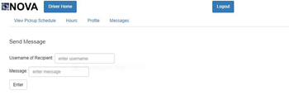](http://teamnovaproject.us/managerpage/viewbuses/)**

***[Screenshot 13.1](http://teamnovaproject.us/managerpage/viewbuses/)* [Screenshot 13.1](http://teamnovaproject.us/managerpage/viewbuses/)**

**[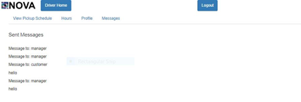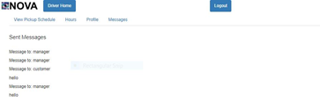](http://teamnovaproject.us/managerpage/viewbuses/)**

**[Screenshot 13.2 Screenshot 13.3](http://teamnovaproject.us/managerpage/viewbuses/)**

**[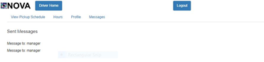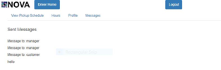](http://teamnovaproject.us/managerpage/viewbuses/)**

**[Screenshot 13.4 Screenshot 13.5](http://teamnovaproject.us/managerpage/viewbuses/)**

***[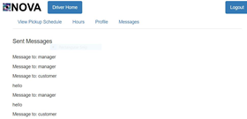](http://teamnovaproject.us/managerpage/viewbuses/)***

**[Screenshot 13.6](http://teamnovaproject.us/managerpage/viewbuses/)**

***[Techniques 2](http://teamnovaproject.us/managerpage/viewbuses/)*[: Cause-Effect Graph and Decision Table](http://teamnovaproject.us/managerpage/viewbuses/)**

**[Causes:](http://teamnovaproject.us/managerpage/viewbuses/)**

**[1. Username of Recipient](http://teamnovaproject.us/managerpage/viewbuses/)**

**[2. Message](http://teamnovaproject.us/managerpage/viewbuses/)**

**[Effects:](http://teamnovaproject.us/managerpage/viewbuses/)**

**[101: Message Sent](http://teamnovaproject.us/managerpage/viewbuses/)**

**[102: Message Not Sent](http://teamnovaproject.us/managerpage/viewbuses/)**

**[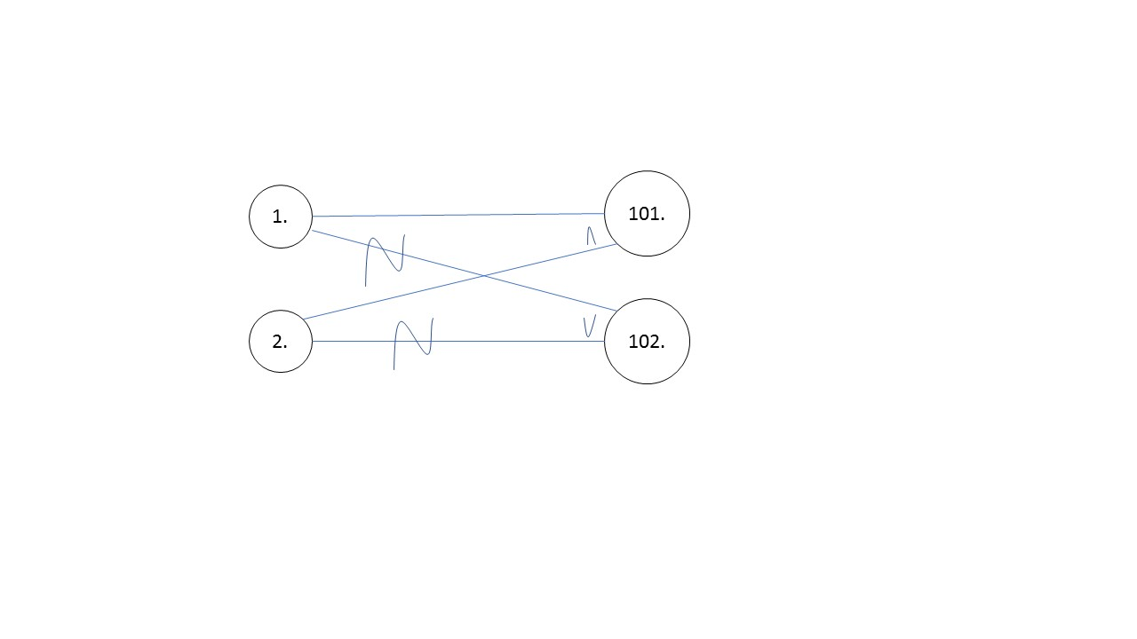](http://teamnovaproject.us/managerpage/viewbuses/)**

**[1= Valid](http://teamnovaproject.us/managerpage/viewbuses/)**

**[0= Invalid](http://teamnovaproject.us/managerpage/viewbuses/)**

**[Graph](http://teamnovaproject.us/managerpage/viewbuses/)**

|  |  |  |  |
| --- | --- | --- | --- |
| **[1](http://teamnovaproject.us/managerpage/viewbuses/)** | **[2](http://teamnovaproject.us/managerpage/viewbuses/)** | **[101](http://teamnovaproject.us/managerpage/viewbuses/)** | **[102](http://teamnovaproject.us/managerpage/viewbuses/)** |
| **[1](http://teamnovaproject.us/managerpage/viewbuses/)** | **[1](http://teamnovaproject.us/managerpage/viewbuses/)** | **[1](http://teamnovaproject.us/managerpage/viewbuses/)** | **[0](http://teamnovaproject.us/managerpage/viewbuses/)** |
| **[1](http://teamnovaproject.us/managerpage/viewbuses/)** | **[0](http://teamnovaproject.us/managerpage/viewbuses/)** | **[0](http://teamnovaproject.us/managerpage/viewbuses/)** | **[1](http://teamnovaproject.us/managerpage/viewbuses/)** |
| **[0](http://teamnovaproject.us/managerpage/viewbuses/)** | **[1](http://teamnovaproject.us/managerpage/viewbuses/)** | **[0](http://teamnovaproject.us/managerpage/viewbuses/)** | **[1](http://teamnovaproject.us/managerpage/viewbuses/)** |
| **[0](http://teamnovaproject.us/managerpage/viewbuses/)** | **[0](http://teamnovaproject.us/managerpage/viewbuses/)** | **[0](http://teamnovaproject.us/managerpage/viewbuses/)** | **[1](http://teamnovaproject.us/managerpage/viewbuses/)** |

|  |  |  |  |
| --- | --- | --- | --- |
| **[Test Case Number](http://teamnovaproject.us/managerpage/viewbuses/)** | **[Input](http://teamnovaproject.us/managerpage/viewbuses/)** | **[Current State](http://teamnovaproject.us/managerpage/viewbuses/)** | **[Expected Output](http://teamnovaproject.us/managerpage/viewbuses/)** |
| **[STR-13.7](http://teamnovaproject.us/managerpage/viewbuses/)** | **[Username of recipient:](http://teamnovaproject.us/managerpage/viewbuses/)**  **[manager](http://teamnovaproject.us/managerpage/viewbuses/)**  **[Message:](http://teamnovaproject.us/managerpage/viewbuses/)**  **[hello](http://teamnovaproject.us/managerpage/viewbuses/)**    **[Click Enter](http://teamnovaproject.us/managerpage/viewbuses/)** | **[No message Sent](http://teamnovaproject.us/managerpage/viewbuses/)**  **[(Screenshot 13.2)](http://teamnovaproject.us/managerpage/viewbuses/)** | **[(Screenshot 13.3)](http://teamnovaproject.us/managerpage/viewbuses/)** |
| **[STR-13.8](http://teamnovaproject.us/managerpage/viewbuses/)** | **[Username of recipient:](http://teamnovaproject.us/managerpage/viewbuses/)**  **[1234214](http://teamnovaproject.us/managerpage/viewbuses/)**  **[Message:](http://teamnovaproject.us/managerpage/viewbuses/)**  **[hello](http://teamnovaproject.us/managerpage/viewbuses/)**    **[Click Enter](http://teamnovaproject.us/managerpage/viewbuses/)** | **[No message Sent](http://teamnovaproject.us/managerpage/viewbuses/)**  **[(Screenshot 13.2)](http://teamnovaproject.us/managerpage/viewbuses/)** | **[(Screenshot 13.2)](http://teamnovaproject.us/managerpage/viewbuses/)** |

**[Techniques 2 screenshots:](http://teamnovaproject.us/managerpage/viewbuses/)**

***[](http://teamnovaproject.us/managerpage/viewbuses/)*[](http://teamnovaproject.us/managerpage/viewbuses/)**

***[Screenshot 13.1](http://teamnovaproject.us/managerpage/viewbuses/)* [Screenshot 13.1](http://teamnovaproject.us/managerpage/viewbuses/)**

**[](http://teamnovaproject.us/managerpage/viewbuses/)**

**[Screenshot 13.2 Screenshot 13.3](http://teamnovaproject.us/managerpage/viewbuses/)**

**[](http://teamnovaproject.us/managerpage/viewbuses/)**

**[Screenshot 13.4 Screenshot 13.5](http://teamnovaproject.us/managerpage/viewbuses/)**

***[](http://teamnovaproject.us/managerpage/viewbuses/)***

**[Screenshot 13.6](http://teamnovaproject.us/managerpage/viewbuses/)**

***[Final Merged Test Cases:](http://teamnovaproject.us/managerpage/viewbuses/)***

|  |  |  |  |
| --- | --- | --- | --- |
| **[Test Case Number](http://teamnovaproject.us/managerpage/viewbuses/)** | **[Input](http://teamnovaproject.us/managerpage/viewbuses/)** | **[Current State](http://teamnovaproject.us/managerpage/viewbuses/)** | **[Expected Output](http://teamnovaproject.us/managerpage/viewbuses/)** |
| **[STR-13.1](http://teamnovaproject.us/managerpage/viewbuses/)** | **[Username of recipient:](http://teamnovaproject.us/managerpage/viewbuses/)**  **[manager](http://teamnovaproject.us/managerpage/viewbuses/)**  **[Message:](http://teamnovaproject.us/managerpage/viewbuses/)**  **[hello](http://teamnovaproject.us/managerpage/viewbuses/)**    **[Click Enter](http://teamnovaproject.us/managerpage/viewbuses/)** | **[No message Sent](http://teamnovaproject.us/managerpage/viewbuses/)**  **[(Screenshot 13.2)](http://teamnovaproject.us/managerpage/viewbuses/)** | **[(Screenshot 13.3)](http://teamnovaproject.us/managerpage/viewbuses/)** |
| **[STR-13.2](http://teamnovaproject.us/managerpage/viewbuses/)** | **[Username of recipient:](http://teamnovaproject.us/managerpage/viewbuses/)**  **[manager](http://teamnovaproject.us/managerpage/viewbuses/)**  **[Message:](http://teamnovaproject.us/managerpage/viewbuses/)**    **[Click Enter](http://teamnovaproject.us/managerpage/viewbuses/)** | **[No message Sent](http://teamnovaproject.us/managerpage/viewbuses/)**  **[(Screenshot 13.2)](http://teamnovaproject.us/managerpage/viewbuses/)** | **[(Screenshot 13.4)](http://teamnovaproject.us/managerpage/viewbuses/)** |
| **[STR-13.3](http://teamnovaproject.us/managerpage/viewbuses/)** | **[Username of recipient:](http://teamnovaproject.us/managerpage/viewbuses/)**  **[customer](http://teamnovaproject.us/managerpage/viewbuses/)**  **[Message:](http://teamnovaproject.us/managerpage/viewbuses/)**  **[hello](http://teamnovaproject.us/managerpage/viewbuses/)**    **[Click Enter](http://teamnovaproject.us/managerpage/viewbuses/)** | **[No message Sent](http://teamnovaproject.us/managerpage/viewbuses/)**  **[(Screenshot 13.2)](http://teamnovaproject.us/managerpage/viewbuses/)** | **[(Screenshot 13.5)](http://teamnovaproject.us/managerpage/viewbuses/)** |
| **[STR-13.4](http://teamnovaproject.us/managerpage/viewbuses/)** | **[Username of recipient:](http://teamnovaproject.us/managerpage/viewbuses/)**  **[customer](http://teamnovaproject.us/managerpage/viewbuses/)**  **[Message:](http://teamnovaproject.us/managerpage/viewbuses/)**    **[Click Enter](http://teamnovaproject.us/managerpage/viewbuses/)** | **[No message Sent](http://teamnovaproject.us/managerpage/viewbuses/)**  **[(Screenshot 13.2)](http://teamnovaproject.us/managerpage/viewbuses/)** | **[(Screenshot 13.6)](http://teamnovaproject.us/managerpage/viewbuses/)** |
| **[STR-13.5](http://teamnovaproject.us/managerpage/viewbuses/)** | **[Username of recipient:](http://teamnovaproject.us/managerpage/viewbuses/)**  **[1234214](http://teamnovaproject.us/managerpage/viewbuses/)**  **[Message:](http://teamnovaproject.us/managerpage/viewbuses/)**  **[hello](http://teamnovaproject.us/managerpage/viewbuses/)**    **[Click Enter](http://teamnovaproject.us/managerpage/viewbuses/)** | **[No message Sent](http://teamnovaproject.us/managerpage/viewbuses/)**  **[(Screenshot 13.2)](http://teamnovaproject.us/managerpage/viewbuses/)** | **[(Screenshot 13.2)](http://teamnovaproject.us/managerpage/viewbuses/)** |
| **[STR13.6](http://teamnovaproject.us/managerpage/viewbuses/)** | **[Username of recipient:](http://teamnovaproject.us/managerpage/viewbuses/)**  **[Message:](http://teamnovaproject.us/managerpage/viewbuses/)**    **[Click Enter](http://teamnovaproject.us/managerpage/viewbuses/)** | **[No message Sent](http://teamnovaproject.us/managerpage/viewbuses/)**  **[(Screenshot 13.2)](http://teamnovaproject.us/managerpage/viewbuses/)** | **[(Screenshot 13.2)](http://teamnovaproject.us/managerpage/viewbuses/)** |

**[_____________________________________________________________________](http://teamnovaproject.us/managerpage/viewbuses/)**

**[STR-14 Driver - Edit Availability](http://teamnovaproject.us/managerpage/viewbuses/)**

*[Setup](http://teamnovaproject.us/managerpage/viewbuses/)*[: Navigate to](http://teamnovaproject.us/managerpage/viewbuses/) [[http://teamnovaproject.us/driverpage](http://teamnovaproject.us/managerpage/viewbuses/)](http://teamnovaproject.us/driverpage) [and click Hours, and then Edit Availability(Shown in Screenshot 14.1).](http://teamnovaproject.us/managerpage/viewbuses/)

*[Techniques 1](http://teamnovaproject.us/managerpage/viewbuses/)*[: User Documentation](http://teamnovaproject.us/managerpage/viewbuses/)

[Documentations Tested:](http://teamnovaproject.us/managerpage/viewbuses/)

[Monday Start:](http://teamnovaproject.us/managerpage/viewbuses/) *[example HH:MM:SS](http://teamnovaproject.us/managerpage/viewbuses/)*

*[Test Cases](http://teamnovaproject.us/managerpage/viewbuses/)*

|  |  |  |  |
| --- | --- | --- | --- |
| **[Test Case Number](http://teamnovaproject.us/managerpage/viewbuses/)** | **[Input](http://teamnovaproject.us/managerpage/viewbuses/)** | **[Current State](http://teamnovaproject.us/managerpage/viewbuses/)** | **[Expected Output](http://teamnovaproject.us/managerpage/viewbuses/)** |
| [STR-14.1](http://teamnovaproject.us/managerpage/viewbuses/) | [Monday Start: 00:00:00](http://teamnovaproject.us/managerpage/viewbuses/)  [All other fields:](http://teamnovaproject.us/managerpage/viewbuses/) | [Edit Availability page (Screenshot 14.2)](http://teamnovaproject.us/managerpage/viewbuses/) | [Availability Successfully Changed (Screenshot 14.3)](http://teamnovaproject.us/managerpage/viewbuses/) |
| [STR-14.2](http://teamnovaproject.us/managerpage/viewbuses/) | [Monday Start: 12:12:12](http://teamnovaproject.us/managerpage/viewbuses/)  [All other fields:](http://teamnovaproject.us/managerpage/viewbuses/) | [Edit Availability page (Screenshot 14.2)](http://teamnovaproject.us/managerpage/viewbuses/) | [Availability Successfully Changed (Screenshot 14.3)](http://teamnovaproject.us/managerpage/viewbuses/) |
| [STR-14.3](http://teamnovaproject.us/managerpage/viewbuses/) | [Monday Start: 25:01:01](http://teamnovaproject.us/managerpage/viewbuses/)  [All other fields:](http://teamnovaproject.us/managerpage/viewbuses/) | [Edit Availability page (Screenshot 14.2)](http://teamnovaproject.us/managerpage/viewbuses/) | [Edit Availability page with exception fail (Screenshot 14.4)](http://teamnovaproject.us/managerpage/viewbuses/) |
| [STR-14.4](http://teamnovaproject.us/managerpage/viewbuses/) | [Monday Start: Ten thirty](http://teamnovaproject.us/managerpage/viewbuses/)  [All other fields:](http://teamnovaproject.us/managerpage/viewbuses/) | [Edit Availability page (Screenshot 14.2)](http://teamnovaproject.us/managerpage/viewbuses/) | [Edit Availability page with exception fail (Screenshot 14.4)](http://teamnovaproject.us/managerpage/viewbuses/) |

***[](http://teamnovaproject.us/managerpage/viewbuses/)***[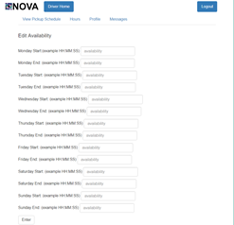](http://teamnovaproject.us/managerpage/viewbuses/)

[Screenshot 14.1 Screenshot 14.2](http://teamnovaproject.us/managerpage/viewbuses/)

[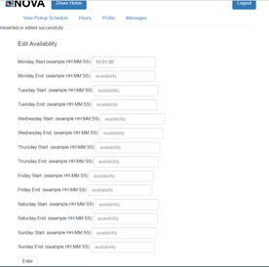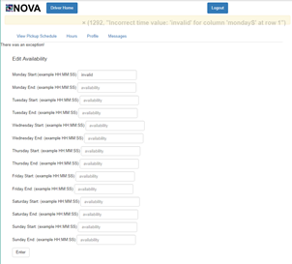](http://teamnovaproject.us/managerpage/viewbuses/)

[Screenshot 14.3 Screenshot 14.4](http://teamnovaproject.us/managerpage/viewbuses/)

*[Techniques 2](http://teamnovaproject.us/managerpage/viewbuses/)*[: Boundary Value Analysis (BVA)](http://teamnovaproject.us/managerpage/viewbuses/)

[Intervals for Monday Start:](http://teamnovaproject.us/managerpage/viewbuses/)

[(negative infinite, 00:00:00), [00:00:00, 23:59:59], [24:00:00, infinite)](http://teamnovaproject.us/managerpage/viewbuses/)

|  |  |  |  |
| --- | --- | --- | --- |
| **[Test Case Number](http://teamnovaproject.us/managerpage/viewbuses/)** | **[Input](http://teamnovaproject.us/managerpage/viewbuses/)** | **[Current State](http://teamnovaproject.us/managerpage/viewbuses/)** | **[Expected Output](http://teamnovaproject.us/managerpage/viewbuses/)** |
| [STR-14.5](http://teamnovaproject.us/managerpage/viewbuses/) | [Monday Start: -10:00:00](http://teamnovaproject.us/managerpage/viewbuses/)  [All other fields:](http://teamnovaproject.us/managerpage/viewbuses/) | [Edit Availability page (Screenshot 14.5)](http://teamnovaproject.us/managerpage/viewbuses/) | [Edit Availability page with exception fail (Screenshot 14.6)](http://teamnovaproject.us/managerpage/viewbuses/) |
| [STR-14.6](http://teamnovaproject.us/managerpage/viewbuses/) | [Monday Start: 00:00:00](http://teamnovaproject.us/managerpage/viewbuses/)  [All other fields:](http://teamnovaproject.us/managerpage/viewbuses/) | [Edit Availability page (Screenshot 14.5)](http://teamnovaproject.us/managerpage/viewbuses/) | [Availability Successfully Changed (Screenshot 14.7)](http://teamnovaproject.us/managerpage/viewbuses/) |
| [STR-14.7](http://teamnovaproject.us/managerpage/viewbuses/) | [Monday Start: 12:12:12](http://teamnovaproject.us/managerpage/viewbuses/)  [All other fields:](http://teamnovaproject.us/managerpage/viewbuses/) | [Edit Availability page (Screenshot 14.5)](http://teamnovaproject.us/managerpage/viewbuses/) | [Availability Successfully Changed (Screenshot 14.7)](http://teamnovaproject.us/managerpage/viewbuses/) |
| [STR-14.8](http://teamnovaproject.us/managerpage/viewbuses/) | [Monday Start: 23:59:59](http://teamnovaproject.us/managerpage/viewbuses/)  [All other fields:](http://teamnovaproject.us/managerpage/viewbuses/) | [Edit Availability page (Screenshot 14.5)](http://teamnovaproject.us/managerpage/viewbuses/) | [Availability Successfully Changed (Screenshot 14.7)](http://teamnovaproject.us/managerpage/viewbuses/) |
| [STR-14.9](http://teamnovaproject.us/managerpage/viewbuses/) | [Monday Start: 24:00:00](http://teamnovaproject.us/managerpage/viewbuses/)  [All other fields:](http://teamnovaproject.us/managerpage/viewbuses/) | [Edit Availability page (Screenshot 14.5)](http://teamnovaproject.us/managerpage/viewbuses/) | [Edit Availability page with exception fail (Screenshot 14.6)](http://teamnovaproject.us/managerpage/viewbuses/) |
| [STR-14.10](http://teamnovaproject.us/managerpage/viewbuses/) | [Monday Start: 28:00:00](http://teamnovaproject.us/managerpage/viewbuses/)  [All other fields:](http://teamnovaproject.us/managerpage/viewbuses/) | [Edit Availability page (Screenshot 14.5)](http://teamnovaproject.us/managerpage/viewbuses/) | [Edit Availability page with exception fail (Screenshot 14.6)](http://teamnovaproject.us/managerpage/viewbuses/) |

[](http://teamnovaproject.us/managerpage/viewbuses/)

[Screenshot 14.5 Screenshot 14.6](http://teamnovaproject.us/managerpage/viewbuses/)

[](http://teamnovaproject.us/managerpage/viewbuses/)

[Screenshot 14.7](http://teamnovaproject.us/managerpage/viewbuses/)

*[Final Merged Test Cases:](http://teamnovaproject.us/managerpage/viewbuses/)*

|  |  |  |  |
| --- | --- | --- | --- |
| **[Test Case Number](http://teamnovaproject.us/managerpage/viewbuses/)** | **[Input](http://teamnovaproject.us/managerpage/viewbuses/)** | **[Current State](http://teamnovaproject.us/managerpage/viewbuses/)** | **[Expected Output](http://teamnovaproject.us/managerpage/viewbuses/)** |
| [STR-14.4](http://teamnovaproject.us/managerpage/viewbuses/) | [Monday Start: Ten thirty](http://teamnovaproject.us/managerpage/viewbuses/)  [All other fields:](http://teamnovaproject.us/managerpage/viewbuses/) | [Edit Availability page (Screenshot 14.2)](http://teamnovaproject.us/managerpage/viewbuses/) | [Edit Availability page with exception fail (Screenshot 14.4)](http://teamnovaproject.us/managerpage/viewbuses/) |
| [STR-14.5](http://teamnovaproject.us/managerpage/viewbuses/) | [Monday Start: -10:00:00](http://teamnovaproject.us/managerpage/viewbuses/)  [All other fields:](http://teamnovaproject.us/managerpage/viewbuses/) | [Edit Availability page (Screenshot 14.5)](http://teamnovaproject.us/managerpage/viewbuses/) | [Edit Availability page with exception fail (Screenshot 14.6)](http://teamnovaproject.us/managerpage/viewbuses/) |
| [STR-14.6](http://teamnovaproject.us/managerpage/viewbuses/) | [Monday Start: 00:00:00](http://teamnovaproject.us/managerpage/viewbuses/)  [All other fields:](http://teamnovaproject.us/managerpage/viewbuses/) | [Edit Availability page (Screenshot 14.5)](http://teamnovaproject.us/managerpage/viewbuses/) | [Availability Successfully Changed (Screenshot 14.7)](http://teamnovaproject.us/managerpage/viewbuses/) |
| [STR-14.7](http://teamnovaproject.us/managerpage/viewbuses/) | [Monday Start: 12:12:12](http://teamnovaproject.us/managerpage/viewbuses/)  [All other fields:](http://teamnovaproject.us/managerpage/viewbuses/) | [Edit Availability page (Screenshot 14.5)](http://teamnovaproject.us/managerpage/viewbuses/) | [Availability Successfully Changed (Screenshot 14.7)](http://teamnovaproject.us/managerpage/viewbuses/) |
| [STR-14.8](http://teamnovaproject.us/managerpage/viewbuses/) | [Monday Start: 23:59:59](http://teamnovaproject.us/managerpage/viewbuses/)  [All other fields:](http://teamnovaproject.us/managerpage/viewbuses/) | [Edit Availability page (Screenshot 14.5)](http://teamnovaproject.us/managerpage/viewbuses/) | [Availability Successfully Changed (Screenshot 14.7)](http://teamnovaproject.us/managerpage/viewbuses/) |
| [STR-14.9](http://teamnovaproject.us/managerpage/viewbuses/) | [Monday Start: 24:00:00](http://teamnovaproject.us/managerpage/viewbuses/)  [All other fields:](http://teamnovaproject.us/managerpage/viewbuses/) | [Edit Availability page (Screenshot 14.5)](http://teamnovaproject.us/managerpage/viewbuses/) | [Edit Availability page with exception fail (Screenshot 14.6)](http://teamnovaproject.us/managerpage/viewbuses/) |
| [STR-14.10](http://teamnovaproject.us/managerpage/viewbuses/) | [Monday Start: 28:00:00](http://teamnovaproject.us/managerpage/viewbuses/)  [All other fields:](http://teamnovaproject.us/managerpage/viewbuses/) | [Edit Availability page (Screenshot 14.5)](http://teamnovaproject.us/managerpage/viewbuses/) | [Edit Availability page with exception fail (Screenshot 14.6)](http://teamnovaproject.us/managerpage/viewbuses/) |

**[_____________________________________________________________________](http://teamnovaproject.us/managerpage/viewbuses/)**

**[STR-15 Customer - Create Account](http://teamnovaproject.us/managerpage/viewbuses/)**

*[Setup](http://teamnovaproject.us/managerpage/viewbuses/)*[: Navigate to](http://teamnovaproject.us/managerpage/viewbuses/) [[http://teamnovaproject.us](http://teamnovaproject.us/managerpage/viewbuses/)](http://teamnovaproject.us/customerpage) [and click Create Account Button(Shown in Screenshot 15.1).](http://teamnovaproject.us/managerpage/viewbuses/)

*[Techniques 1](http://teamnovaproject.us/managerpage/viewbuses/)*[: User Documentation](http://teamnovaproject.us/managerpage/viewbuses/)

[Documentations tested:](http://teamnovaproject.us/managerpage/viewbuses/)

[Username:](http://teamnovaproject.us/managerpage/viewbuses/) *[Field must be between 4 and 20 characters long.](http://teamnovaproject.us/managerpage/viewbuses/)*

[Email:](http://teamnovaproject.us/managerpage/viewbuses/) *[Field must be between 6 and 50 characters long.](http://teamnovaproject.us/managerpage/viewbuses/)*

[Phone Number:](http://teamnovaproject.us/managerpage/viewbuses/) *[Field must be between 6 and 15 characters long.](http://teamnovaproject.us/managerpage/viewbuses/)*

*[Test Cases](http://teamnovaproject.us/managerpage/viewbuses/)*

|  |  |  |  |
| --- | --- | --- | --- |
| **[Test Case Number](http://teamnovaproject.us/managerpage/viewbuses/)** | **[Input](http://teamnovaproject.us/managerpage/viewbuses/)** | **[Current State](http://teamnovaproject.us/managerpage/viewbuses/)** | **[Expected Output](http://teamnovaproject.us/managerpage/viewbuses/)** |
| [STR-15.1](http://teamnovaproject.us/managerpage/viewbuses/) | [Username: a](http://teamnovaproject.us/managerpage/viewbuses/)  [Password: Password](http://teamnovaproject.us/managerpage/viewbuses/)  [Confirm Password: Password](http://teamnovaproject.us/managerpage/viewbuses/)  [First Name: a](http://teamnovaproject.us/managerpage/viewbuses/)  [Last Name: a](http://teamnovaproject.us/managerpage/viewbuses/)  [Email:](http://teamnovaproject.us/managerpage/viewbuses/) [[email@web.com](http://teamnovaproject.us/managerpage/viewbuses/)](mailto:email@web.com)  [Phone Number: 9875554321](http://teamnovaproject.us/managerpage/viewbuses/)  [Terms of Service: Agree](http://teamnovaproject.us/managerpage/viewbuses/) | [Create account page](http://teamnovaproject.us/managerpage/viewbuses/)  [(Screenshot 15.2)](http://teamnovaproject.us/managerpage/viewbuses/) | [Account not created (Screenshot 15.3)](http://teamnovaproject.us/managerpage/viewbuses/) |
| [STR-15.2](http://teamnovaproject.us/managerpage/viewbuses/) | [Username: aaaaa](http://teamnovaproject.us/managerpage/viewbuses/)  [Password: Password](http://teamnovaproject.us/managerpage/viewbuses/)  [Confirm Password: Password](http://teamnovaproject.us/managerpage/viewbuses/)  [First Name: a](http://teamnovaproject.us/managerpage/viewbuses/)  [Last Name: a](http://teamnovaproject.us/managerpage/viewbuses/)  [Email:](http://teamnovaproject.us/managerpage/viewbuses/) [[email@web.com](http://teamnovaproject.us/managerpage/viewbuses/)](mailto:email@web.com)  [Phone Number: 9875554321](http://teamnovaproject.us/managerpage/viewbuses/)  [Terms of Service: Agree](http://teamnovaproject.us/managerpage/viewbuses/) | [Create account page](http://teamnovaproject.us/managerpage/viewbuses/)  [(Screenshot 15.2)](http://teamnovaproject.us/managerpage/viewbuses/) | [Account created (Screenshot 15.4)](http://teamnovaproject.us/managerpage/viewbuses/) |
| [STR-15.3](http://teamnovaproject.us/managerpage/viewbuses/) | [Username: aaaaaaaaaaaaaaaaaaaaa](http://teamnovaproject.us/managerpage/viewbuses/)  [Password: Password](http://teamnovaproject.us/managerpage/viewbuses/)  [Confirm Password: Password](http://teamnovaproject.us/managerpage/viewbuses/)  [First Name: a](http://teamnovaproject.us/managerpage/viewbuses/)  [Last Name: a](http://teamnovaproject.us/managerpage/viewbuses/)  [Email:](http://teamnovaproject.us/managerpage/viewbuses/) [[email@web.com](http://teamnovaproject.us/managerpage/viewbuses/)](mailto:email@web.com)  [Phone Number: 9875554321](http://teamnovaproject.us/managerpage/viewbuses/)  [Terms of Service: Agree](http://teamnovaproject.us/managerpage/viewbuses/) | [Create account page](http://teamnovaproject.us/managerpage/viewbuses/)  [(Screenshot 15.2)](http://teamnovaproject.us/managerpage/viewbuses/) | [Account not created (Screenshot 15.3)](http://teamnovaproject.us/managerpage/viewbuses/) |
| [STR-15.4](http://teamnovaproject.us/managerpage/viewbuses/) | [Username: abcde](http://teamnovaproject.us/managerpage/viewbuses/)  [Password: Password](http://teamnovaproject.us/managerpage/viewbuses/)  [Confirm Password: Password](http://teamnovaproject.us/managerpage/viewbuses/)  [First Name: a](http://teamnovaproject.us/managerpage/viewbuses/)  [Last Name: a](http://teamnovaproject.us/managerpage/viewbuses/)  [Email: @w.cm](http://teamnovaproject.us/managerpage/viewbuses/)  [Phone Number: 9875554321](http://teamnovaproject.us/managerpage/viewbuses/)  [Terms of Service: Agree](http://teamnovaproject.us/managerpage/viewbuses/) | [Create account page](http://teamnovaproject.us/managerpage/viewbuses/)  [(Screenshot 15.2)](http://teamnovaproject.us/managerpage/viewbuses/) | [Account not created (Screenshot 15.3)](http://teamnovaproject.us/managerpage/viewbuses/) |
| [STR-15.5](http://teamnovaproject.us/managerpage/viewbuses/) | [Username: abcde](http://teamnovaproject.us/managerpage/viewbuses/)  [Password: Password](http://teamnovaproject.us/managerpage/viewbuses/)  [Confirm Password: Password](http://teamnovaproject.us/managerpage/viewbuses/)  [First Name: a](http://teamnovaproject.us/managerpage/viewbuses/)  [Last Name: a](http://teamnovaproject.us/managerpage/viewbuses/)  [Email: email@website.com](http://teamnovaproject.us/managerpage/viewbuses/)  [Phone Number: 9875554321](http://teamnovaproject.us/managerpage/viewbuses/)  [Terms of Service: Agree](http://teamnovaproject.us/managerpage/viewbuses/) | [Create account page](http://teamnovaproject.us/managerpage/viewbuses/)  [(Screenshot 15.2)](http://teamnovaproject.us/managerpage/viewbuses/) | [Account created (Screenshot 15.4)](http://teamnovaproject.us/managerpage/viewbuses/) |
| [STR-15.6](http://teamnovaproject.us/managerpage/viewbuses/) | [Username: abcde](http://teamnovaproject.us/managerpage/viewbuses/)  [Password: Password](http://teamnovaproject.us/managerpage/viewbuses/)  [Confirm Password: Password](http://teamnovaproject.us/managerpage/viewbuses/)  [First Name: a](http://teamnovaproject.us/managerpage/viewbuses/)  [Last Name: a](http://teamnovaproject.us/managerpage/viewbuses/)  [Email: way.way.way.way.too.long.of.email](http://teamnovaproject.us/managerpage/viewbuses/)  [@toolongofwebsite.com](http://teamnovaproject.us/managerpage/viewbuses/)  [Phone Number: 9875554321](http://teamnovaproject.us/managerpage/viewbuses/)  [Terms of Service: Agree](http://teamnovaproject.us/managerpage/viewbuses/) | [Create account page](http://teamnovaproject.us/managerpage/viewbuses/)  [(Screenshot 15.2)](http://teamnovaproject.us/managerpage/viewbuses/) | [Account not created (Screenshot 15.3)](http://teamnovaproject.us/managerpage/viewbuses/) |
| [STR-15.7](http://teamnovaproject.us/managerpage/viewbuses/) | [Username: abcdef](http://teamnovaproject.us/managerpage/viewbuses/)  [Password: Password](http://teamnovaproject.us/managerpage/viewbuses/)  [Confirm Password: Password](http://teamnovaproject.us/managerpage/viewbuses/)  [First Name: a](http://teamnovaproject.us/managerpage/viewbuses/)  [Last Name: a](http://teamnovaproject.us/managerpage/viewbuses/)  [Email: email@website.com](http://teamnovaproject.us/managerpage/viewbuses/)  [Phone Number: 98752](http://teamnovaproject.us/managerpage/viewbuses/)  [Terms of Service: Agree](http://teamnovaproject.us/managerpage/viewbuses/) | [Create account page](http://teamnovaproject.us/managerpage/viewbuses/)  [(Screenshot 15.2)](http://teamnovaproject.us/managerpage/viewbuses/) | [Account not created (Screenshot 15.3)](http://teamnovaproject.us/managerpage/viewbuses/) |
| [STR-15.8](http://teamnovaproject.us/managerpage/viewbuses/) | [Username: abcdef](http://teamnovaproject.us/managerpage/viewbuses/)  [Password: Password](http://teamnovaproject.us/managerpage/viewbuses/)  [Confirm Password: Password](http://teamnovaproject.us/managerpage/viewbuses/)  [First Name: a](http://teamnovaproject.us/managerpage/viewbuses/)  [Last Name: a](http://teamnovaproject.us/managerpage/viewbuses/)  [Email: email@website.com](http://teamnovaproject.us/managerpage/viewbuses/)  [Phone Number: 9876543210](http://teamnovaproject.us/managerpage/viewbuses/)  [Terms of Service: Agree](http://teamnovaproject.us/managerpage/viewbuses/) | [Create account page](http://teamnovaproject.us/managerpage/viewbuses/)  [(Screenshot 15.2)](http://teamnovaproject.us/managerpage/viewbuses/) | [Account created (Screenshot 15.4)](http://teamnovaproject.us/managerpage/viewbuses/) |
| [STR-15.9](http://teamnovaproject.us/managerpage/viewbuses/) | [Username: abcdef](http://teamnovaproject.us/managerpage/viewbuses/)  [Password: Password](http://teamnovaproject.us/managerpage/viewbuses/)  [Confirm Password: Password](http://teamnovaproject.us/managerpage/viewbuses/)  [First Name: a](http://teamnovaproject.us/managerpage/viewbuses/)  [Last Name: a](http://teamnovaproject.us/managerpage/viewbuses/)  [Email: email@website.com](http://teamnovaproject.us/managerpage/viewbuses/)  [Phone Number: 9876543210123456](http://teamnovaproject.us/managerpage/viewbuses/)  [Terms of Service: Agree](http://teamnovaproject.us/managerpage/viewbuses/) | [Create account page](http://teamnovaproject.us/managerpage/viewbuses/)  [(Screenshot 15.2)](http://teamnovaproject.us/managerpage/viewbuses/) | [Account not created (Screenshot 15.3)](http://teamnovaproject.us/managerpage/viewbuses/) |

***[](http://teamnovaproject.us/managerpage/viewbuses/)***[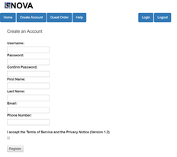](http://teamnovaproject.us/managerpage/viewbuses/)

[Screenshot 15.1 Screenshot 15.2](http://teamnovaproject.us/managerpage/viewbuses/)

[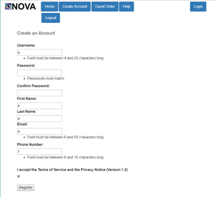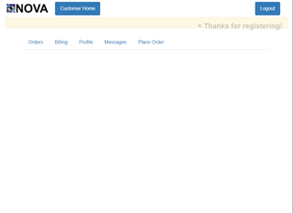](http://teamnovaproject.us/managerpage/viewbuses/)

[Screenshot 15.3 Screenshot 15.4](http://teamnovaproject.us/managerpage/viewbuses/)

*[Techniques 2](http://teamnovaproject.us/managerpage/viewbuses/)*[: Positive and Negative Test](http://teamnovaproject.us/managerpage/viewbuses/)

[Positive Test Cases:](http://teamnovaproject.us/managerpage/viewbuses/)

|  |  |  |  |
| --- | --- | --- | --- |
| **[Test Case Number](http://teamnovaproject.us/managerpage/viewbuses/)** | **[Input](http://teamnovaproject.us/managerpage/viewbuses/)** | **[Current State](http://teamnovaproject.us/managerpage/viewbuses/)** | **[Expected Output](http://teamnovaproject.us/managerpage/viewbuses/)** |
| [STR-15.10](http://teamnovaproject.us/managerpage/viewbuses/) | [Username: ValidUser](http://teamnovaproject.us/managerpage/viewbuses/)  [Password: Password](http://teamnovaproject.us/managerpage/viewbuses/)  [Confirm Password: Password](http://teamnovaproject.us/managerpage/viewbuses/)  [First Name: a](http://teamnovaproject.us/managerpage/viewbuses/)  [Last Name: a](http://teamnovaproject.us/managerpage/viewbuses/)  [Email: email@website.com](http://teamnovaproject.us/managerpage/viewbuses/)  [Phone Number: 1234567890](http://teamnovaproject.us/managerpage/viewbuses/)  [Terms of Service: Agree](http://teamnovaproject.us/managerpage/viewbuses/) | [Create account page](http://teamnovaproject.us/managerpage/viewbuses/)  [(Screenshot 15.5)](http://teamnovaproject.us/managerpage/viewbuses/) | [Account created (Screenshot 15.6)](http://teamnovaproject.us/managerpage/viewbuses/) |
| [STR-15.11](http://teamnovaproject.us/managerpage/viewbuses/) | [Username: a](http://teamnovaproject.us/managerpage/viewbuses/)  [Password: Password](http://teamnovaproject.us/managerpage/viewbuses/)  [Confirm Password: Password](http://teamnovaproject.us/managerpage/viewbuses/)  [First Name: a](http://teamnovaproject.us/managerpage/viewbuses/)  [Last Name: a](http://teamnovaproject.us/managerpage/viewbuses/)  [Email: email@website.com](http://teamnovaproject.us/managerpage/viewbuses/)  [Phone Number: 1234567890](http://teamnovaproject.us/managerpage/viewbuses/)  [Terms of Service: Agree](http://teamnovaproject.us/managerpage/viewbuses/) | [Create account page](http://teamnovaproject.us/managerpage/viewbuses/)  [(Screenshot 15.5)](http://teamnovaproject.us/managerpage/viewbuses/) | [Account not created (Screenshot 15.7)](http://teamnovaproject.us/managerpage/viewbuses/) |
| [STR-15.12](http://teamnovaproject.us/managerpage/viewbuses/) | [Username: ValidUser](http://teamnovaproject.us/managerpage/viewbuses/)  [Password: Pass](http://teamnovaproject.us/managerpage/viewbuses/)  [Confirm Password: Password](http://teamnovaproject.us/managerpage/viewbuses/)  [First Name: a](http://teamnovaproject.us/managerpage/viewbuses/)  [Last Name: a](http://teamnovaproject.us/managerpage/viewbuses/)  [Email: email@website.com](http://teamnovaproject.us/managerpage/viewbuses/)  [Phone Number: 1234567890](http://teamnovaproject.us/managerpage/viewbuses/)  [Terms of Service: Agree](http://teamnovaproject.us/managerpage/viewbuses/) | [Create account page](http://teamnovaproject.us/managerpage/viewbuses/)  [(Screenshot 15.5)](http://teamnovaproject.us/managerpage/viewbuses/) | [Account not created (Screenshot 15.7)](http://teamnovaproject.us/managerpage/viewbuses/) |
| [STR-15.13](http://teamnovaproject.us/managerpage/viewbuses/) | [Username: ValidUser](http://teamnovaproject.us/managerpage/viewbuses/)  [Password: Password](http://teamnovaproject.us/managerpage/viewbuses/)  [Confirm Password: Pass](http://teamnovaproject.us/managerpage/viewbuses/)  [First Name: a](http://teamnovaproject.us/managerpage/viewbuses/)  [Last Name: a](http://teamnovaproject.us/managerpage/viewbuses/)  [Email: email@website.com](http://teamnovaproject.us/managerpage/viewbuses/)  [Phone Number: 1234567890](http://teamnovaproject.us/managerpage/viewbuses/)  [Terms of Service: Agree](http://teamnovaproject.us/managerpage/viewbuses/) | [Create account page](http://teamnovaproject.us/managerpage/viewbuses/)  [(Screenshot 15.5)](http://teamnovaproject.us/managerpage/viewbuses/) | [Account not created (Screenshot 15.7)](http://teamnovaproject.us/managerpage/viewbuses/) |
| [STR-15.14](http://teamnovaproject.us/managerpage/viewbuses/) | [Username: ValidUser](http://teamnovaproject.us/managerpage/viewbuses/)  [Password: Password](http://teamnovaproject.us/managerpage/viewbuses/)  [Confirm Password: Password](http://teamnovaproject.us/managerpage/viewbuses/)  [First Name: a](http://teamnovaproject.us/managerpage/viewbuses/)  [Last Name: a](http://teamnovaproject.us/managerpage/viewbuses/)  [Email: a](http://teamnovaproject.us/managerpage/viewbuses/)  [Phone Number: 1234567890](http://teamnovaproject.us/managerpage/viewbuses/)  [Terms of Service: Agree](http://teamnovaproject.us/managerpage/viewbuses/) | [Create account page](http://teamnovaproject.us/managerpage/viewbuses/)  [(Screenshot 15.5)](http://teamnovaproject.us/managerpage/viewbuses/) | [Account not created (Screenshot 15.7)](http://teamnovaproject.us/managerpage/viewbuses/) |
| [STR-15.15](http://teamnovaproject.us/managerpage/viewbuses/) | [Username: ValidUser](http://teamnovaproject.us/managerpage/viewbuses/)  [Password: Password](http://teamnovaproject.us/managerpage/viewbuses/)  [Confirm Password: Password](http://teamnovaproject.us/managerpage/viewbuses/)  [First Name: a](http://teamnovaproject.us/managerpage/viewbuses/)  [Last Name: a](http://teamnovaproject.us/managerpage/viewbuses/)  [Email: email@website.com](http://teamnovaproject.us/managerpage/viewbuses/)  [Phone Number: 1234](http://teamnovaproject.us/managerpage/viewbuses/)  [Terms of Service: Agree](http://teamnovaproject.us/managerpage/viewbuses/) | [Create account page](http://teamnovaproject.us/managerpage/viewbuses/)  [(Screenshot 15.5)](http://teamnovaproject.us/managerpage/viewbuses/) | [Account not created (Screenshot 15.7)](http://teamnovaproject.us/managerpage/viewbuses/) |
| [STR-15.16](http://teamnovaproject.us/managerpage/viewbuses/) | [Username: ValidUser](http://teamnovaproject.us/managerpage/viewbuses/)  [Password: Password](http://teamnovaproject.us/managerpage/viewbuses/)  [Confirm Password: Password](http://teamnovaproject.us/managerpage/viewbuses/)  [First Name: a](http://teamnovaproject.us/managerpage/viewbuses/)  [Last Name: a](http://teamnovaproject.us/managerpage/viewbuses/)  [Email: email@website.com](http://teamnovaproject.us/managerpage/viewbuses/)  [Phone Number: 1234567890](http://teamnovaproject.us/managerpage/viewbuses/)  [Terms of Service: Decline](http://teamnovaproject.us/managerpage/viewbuses/) | [Create account page](http://teamnovaproject.us/managerpage/viewbuses/)  [(Screenshot 15.5)](http://teamnovaproject.us/managerpage/viewbuses/) | [Account not created (Screenshot 15.7)](http://teamnovaproject.us/managerpage/viewbuses/) |

[Negative Test Cases:](http://teamnovaproject.us/managerpage/viewbuses/)

|  |  |  |  |
| --- | --- | --- | --- |
| **[Test Case Number](http://teamnovaproject.us/managerpage/viewbuses/)** | **[Input](http://teamnovaproject.us/managerpage/viewbuses/)** | **[Current State](http://teamnovaproject.us/managerpage/viewbuses/)** | **[Expected Output](http://teamnovaproject.us/managerpage/viewbuses/)** |
| [STR-15.17](http://teamnovaproject.us/managerpage/viewbuses/) | [Punch computer monitor](http://teamnovaproject.us/managerpage/viewbuses/) | [Create account page](http://teamnovaproject.us/managerpage/viewbuses/)  [(Screenshot 15.5)](http://teamnovaproject.us/managerpage/viewbuses/) | [Create account page](http://teamnovaproject.us/managerpage/viewbuses/)  [(Screenshot 15.5)](http://teamnovaproject.us/managerpage/viewbuses/) |
| [STR-15.18](http://teamnovaproject.us/managerpage/viewbuses/) | [Pour coffee on keyboard](http://teamnovaproject.us/managerpage/viewbuses/) | [Create account page](http://teamnovaproject.us/managerpage/viewbuses/)  [(Screenshot 15.5)](http://teamnovaproject.us/managerpage/viewbuses/) | [Create account page](http://teamnovaproject.us/managerpage/viewbuses/)  [(Screenshot 15.5)](http://teamnovaproject.us/managerpage/viewbuses/) |

[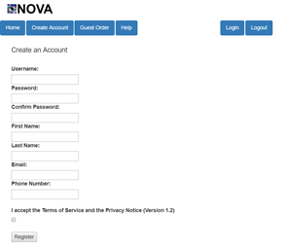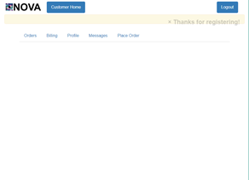](http://teamnovaproject.us/managerpage/viewbuses/)

[Screenshot 15.5 Screenshot 15.6](http://teamnovaproject.us/managerpage/viewbuses/)

[](http://teamnovaproject.us/managerpage/viewbuses/)

[Screenshot 15.7](http://teamnovaproject.us/managerpage/viewbuses/)

*[Final Merged Test Cases:](http://teamnovaproject.us/managerpage/viewbuses/)*

|  |  |  |  |
| --- | --- | --- | --- |
| **[Test Case Number](http://teamnovaproject.us/managerpage/viewbuses/)** | **[Input](http://teamnovaproject.us/managerpage/viewbuses/)** | **[Current State](http://teamnovaproject.us/managerpage/viewbuses/)** | **[Expected Output](http://teamnovaproject.us/managerpage/viewbuses/)** |
| [STR-15.1](http://teamnovaproject.us/managerpage/viewbuses/) | [Username: a](http://teamnovaproject.us/managerpage/viewbuses/)  [Password: Password](http://teamnovaproject.us/managerpage/viewbuses/)  [Confirm Password: Password](http://teamnovaproject.us/managerpage/viewbuses/)  [First Name: a](http://teamnovaproject.us/managerpage/viewbuses/)  [Last Name: a](http://teamnovaproject.us/managerpage/viewbuses/)  [Email:](http://teamnovaproject.us/managerpage/viewbuses/) [[email@web.com](http://teamnovaproject.us/managerpage/viewbuses/)](mailto:email@web.com)  [Phone Number: 9875554321](http://teamnovaproject.us/managerpage/viewbuses/)  [Terms of Service: Agree](http://teamnovaproject.us/managerpage/viewbuses/) | [Create account page](http://teamnovaproject.us/managerpage/viewbuses/)  [(Screenshot 15.2)](http://teamnovaproject.us/managerpage/viewbuses/) | [Account not created (Screenshot 15.3)](http://teamnovaproject.us/managerpage/viewbuses/) |
| [STR-15.2](http://teamnovaproject.us/managerpage/viewbuses/) | [Username: aaaaa](http://teamnovaproject.us/managerpage/viewbuses/)  [Password: Password](http://teamnovaproject.us/managerpage/viewbuses/)  [Confirm Password: Password](http://teamnovaproject.us/managerpage/viewbuses/)  [First Name: a](http://teamnovaproject.us/managerpage/viewbuses/)  [Last Name: a](http://teamnovaproject.us/managerpage/viewbuses/)  [Email:](http://teamnovaproject.us/managerpage/viewbuses/) [[email@web.com](http://teamnovaproject.us/managerpage/viewbuses/)](mailto:email@web.com)  [Phone Number: 9875554321](http://teamnovaproject.us/managerpage/viewbuses/)  [Terms of Service: Agree](http://teamnovaproject.us/managerpage/viewbuses/) | [Create account page](http://teamnovaproject.us/managerpage/viewbuses/)  [(Screenshot 15.2)](http://teamnovaproject.us/managerpage/viewbuses/) | [Account created (Screenshot 15.4)](http://teamnovaproject.us/managerpage/viewbuses/) |
| [STR-15.3](http://teamnovaproject.us/managerpage/viewbuses/) | [Username: aaaaaaaaaaaaaaaaaaaaa](http://teamnovaproject.us/managerpage/viewbuses/)  [Password: Password](http://teamnovaproject.us/managerpage/viewbuses/)  [Confirm Password: Password](http://teamnovaproject.us/managerpage/viewbuses/)  [First Name: a](http://teamnovaproject.us/managerpage/viewbuses/)  [Last Name: a](http://teamnovaproject.us/managerpage/viewbuses/)  [Email:](http://teamnovaproject.us/managerpage/viewbuses/) [[email@web.com](http://teamnovaproject.us/managerpage/viewbuses/)](mailto:email@web.com)  [Phone Number: 9875554321](http://teamnovaproject.us/managerpage/viewbuses/)  [Terms of Service: Agree](http://teamnovaproject.us/managerpage/viewbuses/) | [Create account page](http://teamnovaproject.us/managerpage/viewbuses/)  [(Screenshot 15.2)](http://teamnovaproject.us/managerpage/viewbuses/) | [Account not created (Screenshot 15.3)](http://teamnovaproject.us/managerpage/viewbuses/) |
| [STR-15.4](http://teamnovaproject.us/managerpage/viewbuses/) | [Username: abcde](http://teamnovaproject.us/managerpage/viewbuses/)  [Password: Password](http://teamnovaproject.us/managerpage/viewbuses/)  [Confirm Password: Password](http://teamnovaproject.us/managerpage/viewbuses/)  [First Name: a](http://teamnovaproject.us/managerpage/viewbuses/)  [Last Name: a](http://teamnovaproject.us/managerpage/viewbuses/)  [Email: @w.cm](http://teamnovaproject.us/managerpage/viewbuses/)  [Phone Number: 9875554321](http://teamnovaproject.us/managerpage/viewbuses/)  [Terms of Service: Agree](http://teamnovaproject.us/managerpage/viewbuses/) | [Create account page](http://teamnovaproject.us/managerpage/viewbuses/)  [(Screenshot 15.2)](http://teamnovaproject.us/managerpage/viewbuses/) | [Account not created (Screenshot 15.3)](http://teamnovaproject.us/managerpage/viewbuses/) |
| [STR-15.5](http://teamnovaproject.us/managerpage/viewbuses/) | [Username: abcde](http://teamnovaproject.us/managerpage/viewbuses/)  [Password: Password](http://teamnovaproject.us/managerpage/viewbuses/)  [Confirm Password: Password](http://teamnovaproject.us/managerpage/viewbuses/)  [First Name: a](http://teamnovaproject.us/managerpage/viewbuses/)  [Last Name: a](http://teamnovaproject.us/managerpage/viewbuses/)  [Email: email@website.com](http://teamnovaproject.us/managerpage/viewbuses/)  [Phone Number: 9875554321](http://teamnovaproject.us/managerpage/viewbuses/)  [Terms of Service: Agree](http://teamnovaproject.us/managerpage/viewbuses/) | [Create account page](http://teamnovaproject.us/managerpage/viewbuses/)  [(Screenshot 15.2)](http://teamnovaproject.us/managerpage/viewbuses/) | [Account created (Screenshot 15.4)](http://teamnovaproject.us/managerpage/viewbuses/) |
| [STR-15.6](http://teamnovaproject.us/managerpage/viewbuses/) | [Username: abcde](http://teamnovaproject.us/managerpage/viewbuses/)  [Password: Password](http://teamnovaproject.us/managerpage/viewbuses/)  [Confirm Password: Password](http://teamnovaproject.us/managerpage/viewbuses/)  [First Name: a](http://teamnovaproject.us/managerpage/viewbuses/)  [Last Name: a](http://teamnovaproject.us/managerpage/viewbuses/)  [Email: way.way.way.way.too.long.of.email](http://teamnovaproject.us/managerpage/viewbuses/)  [@toolongofwebsite.com](http://teamnovaproject.us/managerpage/viewbuses/)  [Phone Number: 9875554321](http://teamnovaproject.us/managerpage/viewbuses/)  [Terms of Service: Agree](http://teamnovaproject.us/managerpage/viewbuses/) | [Create account page](http://teamnovaproject.us/managerpage/viewbuses/)  [(Screenshot 15.2)](http://teamnovaproject.us/managerpage/viewbuses/) | [Account not created (Screenshot 15.3)](http://teamnovaproject.us/managerpage/viewbuses/) |
| [STR-15.7](http://teamnovaproject.us/managerpage/viewbuses/) | [Username: abcdef](http://teamnovaproject.us/managerpage/viewbuses/)  [Password: Password](http://teamnovaproject.us/managerpage/viewbuses/)  [Confirm Password: Password](http://teamnovaproject.us/managerpage/viewbuses/)  [First Name: a](http://teamnovaproject.us/managerpage/viewbuses/)  [Last Name: a](http://teamnovaproject.us/managerpage/viewbuses/)  [Email: email@website.com](http://teamnovaproject.us/managerpage/viewbuses/)  [Phone Number: 98752](http://teamnovaproject.us/managerpage/viewbuses/)  [Terms of Service: Agree](http://teamnovaproject.us/managerpage/viewbuses/) | [Create account page](http://teamnovaproject.us/managerpage/viewbuses/)  [(Screenshot 15.2)](http://teamnovaproject.us/managerpage/viewbuses/) | [Account not created (Screenshot 15.3)](http://teamnovaproject.us/managerpage/viewbuses/) |
| [STR-15.8](http://teamnovaproject.us/managerpage/viewbuses/) | [Username: abcdef](http://teamnovaproject.us/managerpage/viewbuses/)  [Password: Password](http://teamnovaproject.us/managerpage/viewbuses/)  [Confirm Password: Password](http://teamnovaproject.us/managerpage/viewbuses/)  [First Name: a](http://teamnovaproject.us/managerpage/viewbuses/)  [Last Name: a](http://teamnovaproject.us/managerpage/viewbuses/)  [Email: email@website.com](http://teamnovaproject.us/managerpage/viewbuses/)  [Phone Number: 9876543210](http://teamnovaproject.us/managerpage/viewbuses/)  [Terms of Service: Agree](http://teamnovaproject.us/managerpage/viewbuses/) | [Create account page](http://teamnovaproject.us/managerpage/viewbuses/)  [(Screenshot 15.2)](http://teamnovaproject.us/managerpage/viewbuses/) | [Account created (Screenshot 15.4)](http://teamnovaproject.us/managerpage/viewbuses/) |
| [STR-15.9](http://teamnovaproject.us/managerpage/viewbuses/) | [Username: abcdef](http://teamnovaproject.us/managerpage/viewbuses/)  [Password: Password](http://teamnovaproject.us/managerpage/viewbuses/)  [Confirm Password: Password](http://teamnovaproject.us/managerpage/viewbuses/)  [First Name: a](http://teamnovaproject.us/managerpage/viewbuses/)  [Last Name: a](http://teamnovaproject.us/managerpage/viewbuses/)  [Email: email@website.com](http://teamnovaproject.us/managerpage/viewbuses/)  [Phone Number: 9876543210123456](http://teamnovaproject.us/managerpage/viewbuses/)  [Terms of Service: Agree](http://teamnovaproject.us/managerpage/viewbuses/) | [Create account page](http://teamnovaproject.us/managerpage/viewbuses/)  [(Screenshot 15.2)](http://teamnovaproject.us/managerpage/viewbuses/) | [Account not created (Screenshot 15.3)](http://teamnovaproject.us/managerpage/viewbuses/) |
| [STR-15.12](http://teamnovaproject.us/managerpage/viewbuses/) | [Username: ValidUser](http://teamnovaproject.us/managerpage/viewbuses/)  [Password: Pass](http://teamnovaproject.us/managerpage/viewbuses/)  [Confirm Password: Password](http://teamnovaproject.us/managerpage/viewbuses/)  [First Name: a](http://teamnovaproject.us/managerpage/viewbuses/)  [Last Name: a](http://teamnovaproject.us/managerpage/viewbuses/)  [Email: email@website.com](http://teamnovaproject.us/managerpage/viewbuses/)  [Phone Number: 1234567890](http://teamnovaproject.us/managerpage/viewbuses/)  [Terms of Service: Agree](http://teamnovaproject.us/managerpage/viewbuses/) | [Create account page](http://teamnovaproject.us/managerpage/viewbuses/)  [(Screenshot 15.5)](http://teamnovaproject.us/managerpage/viewbuses/) | [Account not created (Screenshot 15.7)](http://teamnovaproject.us/managerpage/viewbuses/) |
| [STR-15.13](http://teamnovaproject.us/managerpage/viewbuses/) | [Username: ValidUser](http://teamnovaproject.us/managerpage/viewbuses/)  [Password: Password](http://teamnovaproject.us/managerpage/viewbuses/)  [Confirm Password: Pass](http://teamnovaproject.us/managerpage/viewbuses/)  [First Name: a](http://teamnovaproject.us/managerpage/viewbuses/)  [Last Name: a](http://teamnovaproject.us/managerpage/viewbuses/)  [Email: email@website.com](http://teamnovaproject.us/managerpage/viewbuses/)  [Phone Number: 1234567890](http://teamnovaproject.us/managerpage/viewbuses/)  [Terms of Service: Agree](http://teamnovaproject.us/managerpage/viewbuses/) | [Create account page](http://teamnovaproject.us/managerpage/viewbuses/)  [(Screenshot 15.5)](http://teamnovaproject.us/managerpage/viewbuses/) | [Account not created (Screenshot 15.7)](http://teamnovaproject.us/managerpage/viewbuses/) |
| [STR-15.16](http://teamnovaproject.us/managerpage/viewbuses/) | [Username: ValidUser](http://teamnovaproject.us/managerpage/viewbuses/)  [Password: Password](http://teamnovaproject.us/managerpage/viewbuses/)  [Confirm Password: Password](http://teamnovaproject.us/managerpage/viewbuses/)  [First Name: a](http://teamnovaproject.us/managerpage/viewbuses/)  [Last Name: a](http://teamnovaproject.us/managerpage/viewbuses/)  [Email: email@website.com](http://teamnovaproject.us/managerpage/viewbuses/)  [Phone Number: 1234567890](http://teamnovaproject.us/managerpage/viewbuses/)  [Terms of Service: Decline](http://teamnovaproject.us/managerpage/viewbuses/) | [Create account page](http://teamnovaproject.us/managerpage/viewbuses/)  [(Screenshot 15.5)](http://teamnovaproject.us/managerpage/viewbuses/) | [Account not created (Screenshot 15.7)](http://teamnovaproject.us/managerpage/viewbuses/) |

**[_____________________________________________________________________](http://teamnovaproject.us/managerpage/viewbuses/)**

**[STR-16 Customer - Place Order](http://teamnovaproject.us/managerpage/viewbuses/)**

***[Setup](http://teamnovaproject.us/managerpage/viewbuses/)*[: Navigate to](http://teamnovaproject.us/managerpage/viewbuses/)****[http://teamnovaproject.us/customerpage/placeorder/](http://teamnovaproject.us/managerpage/viewbuses/)**

**[(Shown in Screenshot (16.1)).](http://teamnovaproject.us/managerpage/viewbuses/)**

***[Technique 1: Cause-Effect Graph and Decision Table](http://teamnovaproject.us/managerpage/viewbuses/)***

|  |  |
| --- | --- |
| **[Causes](http://teamnovaproject.us/managerpage/viewbuses/)** | **[Effects](http://teamnovaproject.us/managerpage/viewbuses/)** |
| **[1. Time of Order > current time + 1 hour](http://teamnovaproject.us/managerpage/viewbuses/)** | **[101. Valid Order, Order is submitted](http://teamnovaproject.us/managerpage/viewbuses/)** |
| **[2. Start Address = Valid](http://teamnovaproject.us/managerpage/viewbuses/)** | **[102. Error, Invalid Time](http://teamnovaproject.us/managerpage/viewbuses/)** |
| **[3. Destination Address = Valid](http://teamnovaproject.us/managerpage/viewbuses/)** | **[103. Error, Invalid Address](http://teamnovaproject.us/managerpage/viewbuses/)** |

***[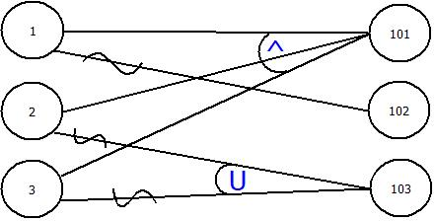](http://teamnovaproject.us/managerpage/viewbuses/)***

|  |  |  |  |
| --- | --- | --- | --- |
|  | **[P1](http://teamnovaproject.us/managerpage/viewbuses/)** | **[P2](http://teamnovaproject.us/managerpage/viewbuses/)** | **[P3](http://teamnovaproject.us/managerpage/viewbuses/)** |
| **[1](http://teamnovaproject.us/managerpage/viewbuses/)** | **[1](http://teamnovaproject.us/managerpage/viewbuses/)** | **[1](http://teamnovaproject.us/managerpage/viewbuses/)** |  |
| **[2](http://teamnovaproject.us/managerpage/viewbuses/)** | **[1](http://teamnovaproject.us/managerpage/viewbuses/)** |  | **[1](http://teamnovaproject.us/managerpage/viewbuses/)** |
| **[3](http://teamnovaproject.us/managerpage/viewbuses/)** | **[1](http://teamnovaproject.us/managerpage/viewbuses/)** |  |  |
| **[101](http://teamnovaproject.us/managerpage/viewbuses/)** | **[1](http://teamnovaproject.us/managerpage/viewbuses/)** |  |  |
| **[102](http://teamnovaproject.us/managerpage/viewbuses/)** | **[0](http://teamnovaproject.us/managerpage/viewbuses/)** | **[1](http://teamnovaproject.us/managerpage/viewbuses/)** |  |
| **[103](http://teamnovaproject.us/managerpage/viewbuses/)** | **[0](http://teamnovaproject.us/managerpage/viewbuses/)** |  | **[1](http://teamnovaproject.us/managerpage/viewbuses/)** |

|  |  |  |  |
| --- | --- | --- | --- |
| **[Test Cast Number](http://teamnovaproject.us/managerpage/viewbuses/)** | **[Input](http://teamnovaproject.us/managerpage/viewbuses/)** | **[Current State](http://teamnovaproject.us/managerpage/viewbuses/)** | **[Expected Output](http://teamnovaproject.us/managerpage/viewbuses/)** |
| **[STR-16.1](http://teamnovaproject.us/managerpage/viewbuses/)** | **[Date of Order:](http://teamnovaproject.us/managerpage/viewbuses/)**  **[04/26/2019](http://teamnovaproject.us/managerpage/viewbuses/)**    **[Starting Time of Order:](http://teamnovaproject.us/managerpage/viewbuses/)**  **[5:25 PM](http://teamnovaproject.us/managerpage/viewbuses/)**    **[Starting Address:](http://teamnovaproject.us/managerpage/viewbuses/)**  **[W Hwy 14, Brookings, SD](http://teamnovaproject.us/managerpage/viewbuses/)**    **[Ending Address:](http://teamnovaproject.us/managerpage/viewbuses/)**  **[417-499 9th Ave, Brookings, SD](http://teamnovaproject.us/managerpage/viewbuses/)** | **[Logged in as a customer of the place order page (Screenshot 16.2)](http://teamnovaproject.us/managerpage/viewbuses/)** | **[Logged in as customer on place order page with confirmation that the order was completed (Screenshot 8.3)](http://teamnovaproject.us/managerpage/viewbuses/)** |
| **[STR-16.2](http://teamnovaproject.us/managerpage/viewbuses/)** | **[Date of Order:](http://teamnovaproject.us/managerpage/viewbuses/)**  **[04/20/2018](http://teamnovaproject.us/managerpage/viewbuses/)**    **[Starting Time of Order:](http://teamnovaproject.us/managerpage/viewbuses/)**  **[5:25 PM](http://teamnovaproject.us/managerpage/viewbuses/)**    **[Starting Address:](http://teamnovaproject.us/managerpage/viewbuses/)**  **[W Hwy 14, Brookings, SD](http://teamnovaproject.us/managerpage/viewbuses/)**    **[Ending Address:](http://teamnovaproject.us/managerpage/viewbuses/)**  **[417-499 9th Ave, Brookings, SD](http://teamnovaproject.us/managerpage/viewbuses/)** | **[Logged in as a customer of the place order page (Screenshot 16.2)](http://teamnovaproject.us/managerpage/viewbuses/)** | **[Logged in as customer on place order page with an error indicating “Invalid Date or Time”](http://teamnovaproject.us/managerpage/viewbuses/)**  **[(Screenshot 8.4)](http://teamnovaproject.us/managerpage/viewbuses/)** |
| **[STR-16.3](http://teamnovaproject.us/managerpage/viewbuses/)** | **[Date of Order:](http://teamnovaproject.us/managerpage/viewbuses/)**  **[04/26/2019](http://teamnovaproject.us/managerpage/viewbuses/)**    **[Starting Time of Order:](http://teamnovaproject.us/managerpage/viewbuses/)**  **[5:25 PM](http://teamnovaproject.us/managerpage/viewbuses/)**    **[Starting Address:](http://teamnovaproject.us/managerpage/viewbuses/)**  **[324 Street](http://teamnovaproject.us/managerpage/viewbuses/)**    **[Ending Address:](http://teamnovaproject.us/managerpage/viewbuses/)**  **[417-499 9th Ave, Brookings, SD](http://teamnovaproject.us/managerpage/viewbuses/)** | **[Logged in as a customer of the place order page (Screenshot 16.2)](http://teamnovaproject.us/managerpage/viewbuses/)** | **[Logged in as customer on place order page with an error indicating “Invalid Starting or Ending Address”](http://teamnovaproject.us/managerpage/viewbuses/)**  **[(Screenshot 8.5)](http://teamnovaproject.us/managerpage/viewbuses/)** |

**[_____________________________________________________________________](http://teamnovaproject.us/managerpage/viewbuses/)**

**[STR-17 Customer - Add/Edit Billing](http://teamnovaproject.us/managerpage/viewbuses/)**

***[Setup](http://teamnovaproject.us/managerpage/viewbuses/)*[: Navigate to](http://teamnovaproject.us/managerpage/viewbuses/)** [**[http://teamnovaproject.us/customerpage](http://teamnovaproject.us/managerpage/viewbuses/)**](http://teamnovaproject.us/customerpage) **[and click Billing, and then Edit Billing(Shown in Screenshot 17.1).](http://teamnovaproject.us/managerpage/viewbuses/)**

***[Techniques 1](http://teamnovaproject.us/managerpage/viewbuses/)*[: State Diagram](http://teamnovaproject.us/managerpage/viewbuses/)**

**[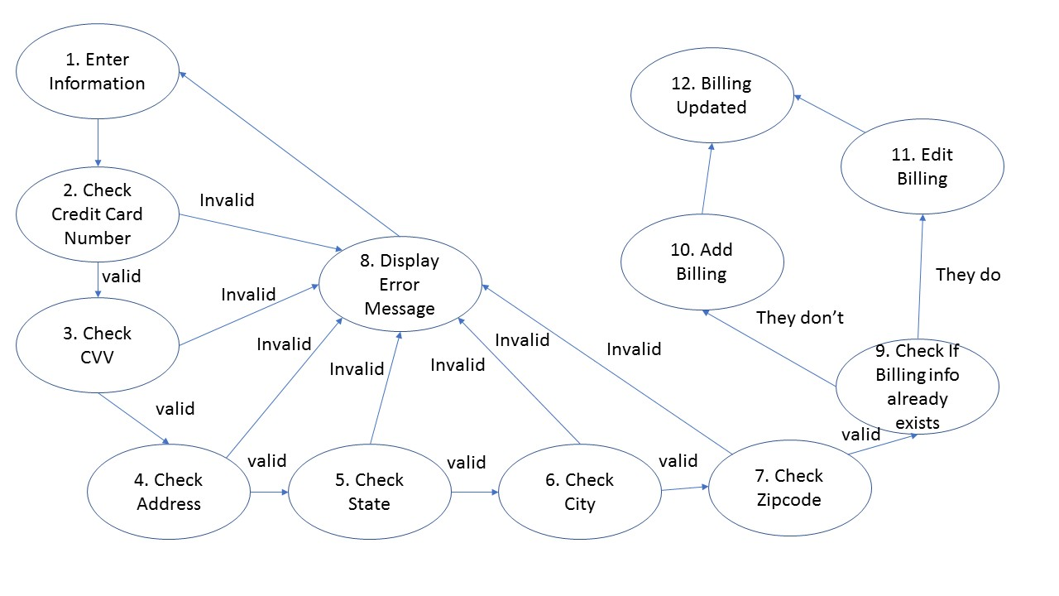](http://teamnovaproject.us/managerpage/viewbuses/)**

**[State Table](http://teamnovaproject.us/managerpage/viewbuses/)**

|  |  |  |
| --- | --- | --- |
| **[State](http://teamnovaproject.us/managerpage/viewbuses/)** | **[Input](http://teamnovaproject.us/managerpage/viewbuses/)** | **[Next State](http://teamnovaproject.us/managerpage/viewbuses/)** |
| **[1](http://teamnovaproject.us/managerpage/viewbuses/)** | **[Enter Credit Card Number](http://teamnovaproject.us/managerpage/viewbuses/)**  **[Enter CVV Number](http://teamnovaproject.us/managerpage/viewbuses/)**  **[Enter Address](http://teamnovaproject.us/managerpage/viewbuses/)**  **[Enter City](http://teamnovaproject.us/managerpage/viewbuses/)**  **[Enter State](http://teamnovaproject.us/managerpage/viewbuses/)**  **[Enter Zipcode](http://teamnovaproject.us/managerpage/viewbuses/)**  **[Enter Bill Home](http://teamnovaproject.us/managerpage/viewbuses/)** | **[2](http://teamnovaproject.us/managerpage/viewbuses/)** |
| **[2](http://teamnovaproject.us/managerpage/viewbuses/)** | **[none](http://teamnovaproject.us/managerpage/viewbuses/)** | **[3](http://teamnovaproject.us/managerpage/viewbuses/)** |
| **[2](http://teamnovaproject.us/managerpage/viewbuses/)** | **[none](http://teamnovaproject.us/managerpage/viewbuses/)** | **[8](http://teamnovaproject.us/managerpage/viewbuses/)** |
| **[3](http://teamnovaproject.us/managerpage/viewbuses/)** | **[none](http://teamnovaproject.us/managerpage/viewbuses/)** | **[4](http://teamnovaproject.us/managerpage/viewbuses/)** |
| **[3](http://teamnovaproject.us/managerpage/viewbuses/)** | **[none](http://teamnovaproject.us/managerpage/viewbuses/)** | **[8](http://teamnovaproject.us/managerpage/viewbuses/)** |
| **[4](http://teamnovaproject.us/managerpage/viewbuses/)** | **[none](http://teamnovaproject.us/managerpage/viewbuses/)** | **[5](http://teamnovaproject.us/managerpage/viewbuses/)** |
| **[4](http://teamnovaproject.us/managerpage/viewbuses/)** | **[none](http://teamnovaproject.us/managerpage/viewbuses/)** | **[8](http://teamnovaproject.us/managerpage/viewbuses/)** |
| **[5](http://teamnovaproject.us/managerpage/viewbuses/)** | **[none](http://teamnovaproject.us/managerpage/viewbuses/)** | **[6](http://teamnovaproject.us/managerpage/viewbuses/)** |
| **[5](http://teamnovaproject.us/managerpage/viewbuses/)** | **[none](http://teamnovaproject.us/managerpage/viewbuses/)** | **[8](http://teamnovaproject.us/managerpage/viewbuses/)** |
| **[6](http://teamnovaproject.us/managerpage/viewbuses/)** | **[none](http://teamnovaproject.us/managerpage/viewbuses/)** | **[7](http://teamnovaproject.us/managerpage/viewbuses/)** |
| **[6](http://teamnovaproject.us/managerpage/viewbuses/)** | **[none](http://teamnovaproject.us/managerpage/viewbuses/)** | **[8](http://teamnovaproject.us/managerpage/viewbuses/)** |
| **[7](http://teamnovaproject.us/managerpage/viewbuses/)** | **[none](http://teamnovaproject.us/managerpage/viewbuses/)** | **[9](http://teamnovaproject.us/managerpage/viewbuses/)** |
| **[7](http://teamnovaproject.us/managerpage/viewbuses/)** | **[none](http://teamnovaproject.us/managerpage/viewbuses/)** | **[8](http://teamnovaproject.us/managerpage/viewbuses/)** |
| **[8](http://teamnovaproject.us/managerpage/viewbuses/)** | **[none](http://teamnovaproject.us/managerpage/viewbuses/)** | **[1](http://teamnovaproject.us/managerpage/viewbuses/)** |
| **[9](http://teamnovaproject.us/managerpage/viewbuses/)** | **[none](http://teamnovaproject.us/managerpage/viewbuses/)** | **[10](http://teamnovaproject.us/managerpage/viewbuses/)** |
| **[9](http://teamnovaproject.us/managerpage/viewbuses/)** | **[none](http://teamnovaproject.us/managerpage/viewbuses/)** | **[11](http://teamnovaproject.us/managerpage/viewbuses/)** |
| **[10](http://teamnovaproject.us/managerpage/viewbuses/)** | **[none](http://teamnovaproject.us/managerpage/viewbuses/)** | **[12](http://teamnovaproject.us/managerpage/viewbuses/)** |
| **[11](http://teamnovaproject.us/managerpage/viewbuses/)** | **[none](http://teamnovaproject.us/managerpage/viewbuses/)** | **[12](http://teamnovaproject.us/managerpage/viewbuses/)** |

***[Test Cases](http://teamnovaproject.us/managerpage/viewbuses/)***

|  |  |  |  |
| --- | --- | --- | --- |
| **[Test Case Number](http://teamnovaproject.us/managerpage/viewbuses/)** | **[Input](http://teamnovaproject.us/managerpage/viewbuses/)** | **[Current State](http://teamnovaproject.us/managerpage/viewbuses/)** | **[Expected Output](http://teamnovaproject.us/managerpage/viewbuses/)** |
| **[STR-17.1](http://teamnovaproject.us/managerpage/viewbuses/)** | **[Credit Card Number:](http://teamnovaproject.us/managerpage/viewbuses/)**  **[1128923212567845](http://teamnovaproject.us/managerpage/viewbuses/)**  **[CVV Number:](http://teamnovaproject.us/managerpage/viewbuses/)**  **[123](http://teamnovaproject.us/managerpage/viewbuses/)**  **[Address:](http://teamnovaproject.us/managerpage/viewbuses/)**  **[206 South Street](http://teamnovaproject.us/managerpage/viewbuses/)**  **[City:](http://teamnovaproject.us/managerpage/viewbuses/)**  **[Brookings](http://teamnovaproject.us/managerpage/viewbuses/)**  **[State:](http://teamnovaproject.us/managerpage/viewbuses/)**  **[SD](http://teamnovaproject.us/managerpage/viewbuses/)**  **[Zipcode:](http://teamnovaproject.us/managerpage/viewbuses/)**  **[57006](http://teamnovaproject.us/managerpage/viewbuses/)**  **[Bill Home:](http://teamnovaproject.us/managerpage/viewbuses/)**  **[yes](http://teamnovaproject.us/managerpage/viewbuses/)**  **[Click Enter](http://teamnovaproject.us/managerpage/viewbuses/)** | **[Not updated](http://teamnovaproject.us/managerpage/viewbuses/)**  **[(Screenshot 17.2)](http://teamnovaproject.us/managerpage/viewbuses/)** | **[(Screenshot 17.3)](http://teamnovaproject.us/managerpage/viewbuses/)** |
| **[STR-17.2](http://teamnovaproject.us/managerpage/viewbuses/)** | **[Credit Card Number:](http://teamnovaproject.us/managerpage/viewbuses/)**    **[CVV Number:](http://teamnovaproject.us/managerpage/viewbuses/)**  **[123](http://teamnovaproject.us/managerpage/viewbuses/)**  **[Address:](http://teamnovaproject.us/managerpage/viewbuses/)**  **[206 South Street](http://teamnovaproject.us/managerpage/viewbuses/)**  **[City:](http://teamnovaproject.us/managerpage/viewbuses/)**  **[Brookings](http://teamnovaproject.us/managerpage/viewbuses/)**  **[State:](http://teamnovaproject.us/managerpage/viewbuses/)**  **[SD](http://teamnovaproject.us/managerpage/viewbuses/)**  **[Zipcode:](http://teamnovaproject.us/managerpage/viewbuses/)**  **[57006](http://teamnovaproject.us/managerpage/viewbuses/)**  **[Bill Home:](http://teamnovaproject.us/managerpage/viewbuses/)**  **[yes](http://teamnovaproject.us/managerpage/viewbuses/)**  **[Click Enter](http://teamnovaproject.us/managerpage/viewbuses/)** | **[Not updated](http://teamnovaproject.us/managerpage/viewbuses/)**  **[(Screenshot 17.2)](http://teamnovaproject.us/managerpage/viewbuses/)** | **[(Screenshot 17.2)](http://teamnovaproject.us/managerpage/viewbuses/)** |
| **[STR-17.3](http://teamnovaproject.us/managerpage/viewbuses/)** | **[Credit Card Number:](http://teamnovaproject.us/managerpage/viewbuses/)**  **[1128923212567845](http://teamnovaproject.us/managerpage/viewbuses/)**  **[CVV Number:](http://teamnovaproject.us/managerpage/viewbuses/)**    **[Address:](http://teamnovaproject.us/managerpage/viewbuses/)**  **[206 South Street](http://teamnovaproject.us/managerpage/viewbuses/)**  **[City:](http://teamnovaproject.us/managerpage/viewbuses/)**  **[Brookings](http://teamnovaproject.us/managerpage/viewbuses/)**  **[State:](http://teamnovaproject.us/managerpage/viewbuses/)**  **[SD](http://teamnovaproject.us/managerpage/viewbuses/)**  **[Zipcode:](http://teamnovaproject.us/managerpage/viewbuses/)**  **[57006](http://teamnovaproject.us/managerpage/viewbuses/)**  **[Bill Home:](http://teamnovaproject.us/managerpage/viewbuses/)**  **[yes](http://teamnovaproject.us/managerpage/viewbuses/)**  **[Click Enter](http://teamnovaproject.us/managerpage/viewbuses/)** | **[Not updated](http://teamnovaproject.us/managerpage/viewbuses/)**  **[(Screenshot 17.2)](http://teamnovaproject.us/managerpage/viewbuses/)** | **[(Screenshot 17.2)](http://teamnovaproject.us/managerpage/viewbuses/)** |
| **[STR-17.4](http://teamnovaproject.us/managerpage/viewbuses/)** | **[Credit Card Number:](http://teamnovaproject.us/managerpage/viewbuses/)**  **[1128923212567845](http://teamnovaproject.us/managerpage/viewbuses/)**  **[CVV Number:](http://teamnovaproject.us/managerpage/viewbuses/)**  **[123](http://teamnovaproject.us/managerpage/viewbuses/)**  **[Address:](http://teamnovaproject.us/managerpage/viewbuses/)**    **[City:](http://teamnovaproject.us/managerpage/viewbuses/)**  **[Brookings](http://teamnovaproject.us/managerpage/viewbuses/)**  **[State:](http://teamnovaproject.us/managerpage/viewbuses/)**  **[SD](http://teamnovaproject.us/managerpage/viewbuses/)**  **[Zipcode:](http://teamnovaproject.us/managerpage/viewbuses/)**  **[57006](http://teamnovaproject.us/managerpage/viewbuses/)**  **[Bill Home:](http://teamnovaproject.us/managerpage/viewbuses/)**  **[yes](http://teamnovaproject.us/managerpage/viewbuses/)**  **[Click Enter](http://teamnovaproject.us/managerpage/viewbuses/)** | **[Not updated](http://teamnovaproject.us/managerpage/viewbuses/)**  **[(Screenshot 17.2)](http://teamnovaproject.us/managerpage/viewbuses/)** | **[(Screenshot 17.2)](http://teamnovaproject.us/managerpage/viewbuses/)** |
| **[STR-17.5](http://teamnovaproject.us/managerpage/viewbuses/)** | **[Credit Card Number:](http://teamnovaproject.us/managerpage/viewbuses/)**  **[1128923212567845](http://teamnovaproject.us/managerpage/viewbuses/)**  **[CVV Number:](http://teamnovaproject.us/managerpage/viewbuses/)**  **[123](http://teamnovaproject.us/managerpage/viewbuses/)**  **[Address:](http://teamnovaproject.us/managerpage/viewbuses/)**  **[206 South Street](http://teamnovaproject.us/managerpage/viewbuses/)**  **[City:](http://teamnovaproject.us/managerpage/viewbuses/)**    **[State:](http://teamnovaproject.us/managerpage/viewbuses/)**  **[SD](http://teamnovaproject.us/managerpage/viewbuses/)**  **[Zipcode:](http://teamnovaproject.us/managerpage/viewbuses/)**  **[57006](http://teamnovaproject.us/managerpage/viewbuses/)**  **[Bill Home:](http://teamnovaproject.us/managerpage/viewbuses/)**  **[yes](http://teamnovaproject.us/managerpage/viewbuses/)**  **[Click Enter](http://teamnovaproject.us/managerpage/viewbuses/)** | **[Not updated](http://teamnovaproject.us/managerpage/viewbuses/)**  **[(Screenshot 17.2)](http://teamnovaproject.us/managerpage/viewbuses/)** | **[(Screenshot 17.2)](http://teamnovaproject.us/managerpage/viewbuses/)** |
| **[STR-17.6](http://teamnovaproject.us/managerpage/viewbuses/)** | **[Credit Card Number:](http://teamnovaproject.us/managerpage/viewbuses/)**  **[1128923212567845](http://teamnovaproject.us/managerpage/viewbuses/)**  **[CVV Number:](http://teamnovaproject.us/managerpage/viewbuses/)**  **[123](http://teamnovaproject.us/managerpage/viewbuses/)**  **[Address:](http://teamnovaproject.us/managerpage/viewbuses/)**  **[206 South Street](http://teamnovaproject.us/managerpage/viewbuses/)**  **[City:](http://teamnovaproject.us/managerpage/viewbuses/)**  **[Brookings](http://teamnovaproject.us/managerpage/viewbuses/)**  **[State:](http://teamnovaproject.us/managerpage/viewbuses/)**    **[Zipcode:](http://teamnovaproject.us/managerpage/viewbuses/)**  **[57006](http://teamnovaproject.us/managerpage/viewbuses/)**  **[Bill Home:](http://teamnovaproject.us/managerpage/viewbuses/)**  **[yes](http://teamnovaproject.us/managerpage/viewbuses/)**  **[Click Enter](http://teamnovaproject.us/managerpage/viewbuses/)** | **[Not updated](http://teamnovaproject.us/managerpage/viewbuses/)**  **[(Screenshot 17.2)](http://teamnovaproject.us/managerpage/viewbuses/)** | **[(Screenshot 17.2)](http://teamnovaproject.us/managerpage/viewbuses/)** |
| **[STR-17.7](http://teamnovaproject.us/managerpage/viewbuses/)** | **[Credit Card Number:](http://teamnovaproject.us/managerpage/viewbuses/)**  **[1128923212567845](http://teamnovaproject.us/managerpage/viewbuses/)**  **[CVV Number:](http://teamnovaproject.us/managerpage/viewbuses/)**  **[123](http://teamnovaproject.us/managerpage/viewbuses/)**  **[Address:](http://teamnovaproject.us/managerpage/viewbuses/)**  **[206 South Street](http://teamnovaproject.us/managerpage/viewbuses/)**  **[City:](http://teamnovaproject.us/managerpage/viewbuses/)**  **[Brookings](http://teamnovaproject.us/managerpage/viewbuses/)**  **[State:](http://teamnovaproject.us/managerpage/viewbuses/)**  **[SD](http://teamnovaproject.us/managerpage/viewbuses/)**  **[Zipcode:](http://teamnovaproject.us/managerpage/viewbuses/)**    **[Bill Home:](http://teamnovaproject.us/managerpage/viewbuses/)**  **[yes](http://teamnovaproject.us/managerpage/viewbuses/)**  **[Click Enter](http://teamnovaproject.us/managerpage/viewbuses/)** | **[Not updated](http://teamnovaproject.us/managerpage/viewbuses/)**  **[(Screenshot 17.2)](http://teamnovaproject.us/managerpage/viewbuses/)** | **[(Screenshot 17.2)](http://teamnovaproject.us/managerpage/viewbuses/)** |

**[Techniques 1 screenshots:](http://teamnovaproject.us/managerpage/viewbuses/)**

**[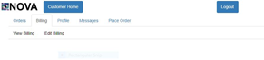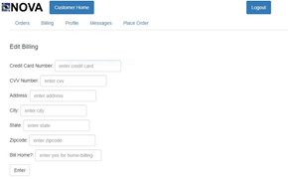](http://teamnovaproject.us/managerpage/viewbuses/)**

**[Screenshot 17.1 Screenshot 17.2](http://teamnovaproject.us/managerpage/viewbuses/)**

**[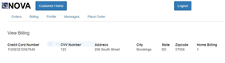](http://teamnovaproject.us/managerpage/viewbuses/)**

**[Screenshot 17.3](http://teamnovaproject.us/managerpage/viewbuses/)**

***[Techniques 2](http://teamnovaproject.us/managerpage/viewbuses/)*[: Domain Testing](http://teamnovaproject.us/managerpage/viewbuses/)**

**[Steps for successful functionality](http://teamnovaproject.us/managerpage/viewbuses/)**

**[1. Enter correct Credit Card Number](http://teamnovaproject.us/managerpage/viewbuses/)**

**[2, Enter Correct CVV](http://teamnovaproject.us/managerpage/viewbuses/)**

**[3, Enter Correct Address](http://teamnovaproject.us/managerpage/viewbuses/)**

**[4. Enter Correct City](http://teamnovaproject.us/managerpage/viewbuses/)**

**[5. Enter Correct State](http://teamnovaproject.us/managerpage/viewbuses/)**

**[6. Enter Correct Zipcode](http://teamnovaproject.us/managerpage/viewbuses/)**

**[7. Enter yes or anything else in bill home](http://teamnovaproject.us/managerpage/viewbuses/)**

**[8. Click the Enter button](http://teamnovaproject.us/managerpage/viewbuses/)**

**[9. View the Updated billing Information](http://teamnovaproject.us/managerpage/viewbuses/)**

|  |  |  |  |
| --- | --- | --- | --- |
| **[Test Case Number](http://teamnovaproject.us/managerpage/viewbuses/)** | **[Input](http://teamnovaproject.us/managerpage/viewbuses/)** | **[Current State](http://teamnovaproject.us/managerpage/viewbuses/)** | **[Expected Output](http://teamnovaproject.us/managerpage/viewbuses/)** |
| **[STR-17.8](http://teamnovaproject.us/managerpage/viewbuses/)** | **[Credit Card Number:](http://teamnovaproject.us/managerpage/viewbuses/)**  **[1128923212567845](http://teamnovaproject.us/managerpage/viewbuses/)**  **[CVV Number:](http://teamnovaproject.us/managerpage/viewbuses/)**  **[123](http://teamnovaproject.us/managerpage/viewbuses/)**  **[Address:](http://teamnovaproject.us/managerpage/viewbuses/)**  **[206 South Street](http://teamnovaproject.us/managerpage/viewbuses/)**  **[City:](http://teamnovaproject.us/managerpage/viewbuses/)**  **[Brookings](http://teamnovaproject.us/managerpage/viewbuses/)**  **[State:](http://teamnovaproject.us/managerpage/viewbuses/)**  **[SD](http://teamnovaproject.us/managerpage/viewbuses/)**  **[Zipcode:](http://teamnovaproject.us/managerpage/viewbuses/)**  **[57006](http://teamnovaproject.us/managerpage/viewbuses/)**  **[Bill Home:](http://teamnovaproject.us/managerpage/viewbuses/)**  **[yes](http://teamnovaproject.us/managerpage/viewbuses/)**  **[Click Enter](http://teamnovaproject.us/managerpage/viewbuses/)** | **[Not updated](http://teamnovaproject.us/managerpage/viewbuses/)**  **[(Screenshot 17.2)](http://teamnovaproject.us/managerpage/viewbuses/)** | **[(Screenshot 17.3)](http://teamnovaproject.us/managerpage/viewbuses/)** |
| **[STR-17.9](http://teamnovaproject.us/managerpage/viewbuses/)** | **[Credit Card Number:](http://teamnovaproject.us/managerpage/viewbuses/)**    **[CVV Number:](http://teamnovaproject.us/managerpage/viewbuses/)**  **[123](http://teamnovaproject.us/managerpage/viewbuses/)**  **[Address:](http://teamnovaproject.us/managerpage/viewbuses/)**  **[206 South Street](http://teamnovaproject.us/managerpage/viewbuses/)**  **[PCity:](http://teamnovaproject.us/managerpage/viewbuses/)**  **[Brookings](http://teamnovaproject.us/managerpage/viewbuses/)**  **[State:](http://teamnovaproject.us/managerpage/viewbuses/)**  **[SD](http://teamnovaproject.us/managerpage/viewbuses/)**  **[Zipcode:](http://teamnovaproject.us/managerpage/viewbuses/)**  **[57006](http://teamnovaproject.us/managerpage/viewbuses/)**  **[Bill Home:](http://teamnovaproject.us/managerpage/viewbuses/)**  **[yes](http://teamnovaproject.us/managerpage/viewbuses/)**  **[Click Enter](http://teamnovaproject.us/managerpage/viewbuses/)** | **[Not updated](http://teamnovaproject.us/managerpage/viewbuses/)**  **[(Screenshot 17.2)](http://teamnovaproject.us/managerpage/viewbuses/)** | **[(Screenshot 17.2)](http://teamnovaproject.us/managerpage/viewbuses/)** |
| **[STR-17.10](http://teamnovaproject.us/managerpage/viewbuses/)** | **[Credit Card Number:](http://teamnovaproject.us/managerpage/viewbuses/)**  **[1128923212567845](http://teamnovaproject.us/managerpage/viewbuses/)**  **[CVV Number:](http://teamnovaproject.us/managerpage/viewbuses/)**    **[Address:](http://teamnovaproject.us/managerpage/viewbuses/)**  **[206 South Street](http://teamnovaproject.us/managerpage/viewbuses/)**  **[City:](http://teamnovaproject.us/managerpage/viewbuses/)**  **[Brookings](http://teamnovaproject.us/managerpage/viewbuses/)**  **[State:](http://teamnovaproject.us/managerpage/viewbuses/)**  **[SD](http://teamnovaproject.us/managerpage/viewbuses/)**  **[Zipcode:](http://teamnovaproject.us/managerpage/viewbuses/)**  **[57006](http://teamnovaproject.us/managerpage/viewbuses/)**  **[Bill Home:](http://teamnovaproject.us/managerpage/viewbuses/)**  **[yes](http://teamnovaproject.us/managerpage/viewbuses/)**  **[Click Enter](http://teamnovaproject.us/managerpage/viewbuses/)** | **[Not updated](http://teamnovaproject.us/managerpage/viewbuses/)**  **[(Screenshot 17.2)](http://teamnovaproject.us/managerpage/viewbuses/)** | **[(Screenshot 17.2)](http://teamnovaproject.us/managerpage/viewbuses/)** |
| **[STR-17.11](http://teamnovaproject.us/managerpage/viewbuses/)** | **[Credit Card Number:](http://teamnovaproject.us/managerpage/viewbuses/)**  **[1128923212567845](http://teamnovaproject.us/managerpage/viewbuses/)**  **[CVV Number:](http://teamnovaproject.us/managerpage/viewbuses/)**  **[123](http://teamnovaproject.us/managerpage/viewbuses/)**  **[Address:](http://teamnovaproject.us/managerpage/viewbuses/)**    **[City:](http://teamnovaproject.us/managerpage/viewbuses/)**  **[Brookings](http://teamnovaproject.us/managerpage/viewbuses/)**  **[State:](http://teamnovaproject.us/managerpage/viewbuses/)**  **[SD](http://teamnovaproject.us/managerpage/viewbuses/)**  **[Zipcode:](http://teamnovaproject.us/managerpage/viewbuses/)**  **[57006](http://teamnovaproject.us/managerpage/viewbuses/)**  **[Bill Home:](http://teamnovaproject.us/managerpage/viewbuses/)**  **[yes](http://teamnovaproject.us/managerpage/viewbuses/)**  **[Click Enter](http://teamnovaproject.us/managerpage/viewbuses/)** | **[Not updated](http://teamnovaproject.us/managerpage/viewbuses/)**  **[(Screenshot 17.2)](http://teamnovaproject.us/managerpage/viewbuses/)** | **[(Screenshot 17.2)](http://teamnovaproject.us/managerpage/viewbuses/)** |
| **[STR-17.12](http://teamnovaproject.us/managerpage/viewbuses/)** | **[Credit Card Number:](http://teamnovaproject.us/managerpage/viewbuses/)**  **[1128923212567845](http://teamnovaproject.us/managerpage/viewbuses/)**  **[CVV Number:](http://teamnovaproject.us/managerpage/viewbuses/)**  **[123](http://teamnovaproject.us/managerpage/viewbuses/)**  **[Address:](http://teamnovaproject.us/managerpage/viewbuses/)**  **[206 South Street](http://teamnovaproject.us/managerpage/viewbuses/)**  **[City:](http://teamnovaproject.us/managerpage/viewbuses/)**    **[State:](http://teamnovaproject.us/managerpage/viewbuses/)**  **[SD](http://teamnovaproject.us/managerpage/viewbuses/)**  **[Zipcode:](http://teamnovaproject.us/managerpage/viewbuses/)**  **[57006](http://teamnovaproject.us/managerpage/viewbuses/)**  **[Bill Home:](http://teamnovaproject.us/managerpage/viewbuses/)**  **[yes](http://teamnovaproject.us/managerpage/viewbuses/)**  **[Click Enter](http://teamnovaproject.us/managerpage/viewbuses/)** | **[Not updated](http://teamnovaproject.us/managerpage/viewbuses/)**  **[(Screenshot 17.2)](http://teamnovaproject.us/managerpage/viewbuses/)** | **[(Screenshot 17.2)](http://teamnovaproject.us/managerpage/viewbuses/)** |
| **[STR-17.13](http://teamnovaproject.us/managerpage/viewbuses/)** | **[Credit Card Number:](http://teamnovaproject.us/managerpage/viewbuses/)**  **[1128923212567845](http://teamnovaproject.us/managerpage/viewbuses/)**  **[CVV Number:](http://teamnovaproject.us/managerpage/viewbuses/)**  **[123](http://teamnovaproject.us/managerpage/viewbuses/)**  **[Address:](http://teamnovaproject.us/managerpage/viewbuses/)**  **[206 South Street](http://teamnovaproject.us/managerpage/viewbuses/)**  **[City:](http://teamnovaproject.us/managerpage/viewbuses/)**  **[Brookings](http://teamnovaproject.us/managerpage/viewbuses/)**  **[State:](http://teamnovaproject.us/managerpage/viewbuses/)**    **[Zipcode:](http://teamnovaproject.us/managerpage/viewbuses/)**  **[57006](http://teamnovaproject.us/managerpage/viewbuses/)**  **[Bill Home:](http://teamnovaproject.us/managerpage/viewbuses/)**  **[yes](http://teamnovaproject.us/managerpage/viewbuses/)**  **[Click Enter](http://teamnovaproject.us/managerpage/viewbuses/)** | **[Not updated](http://teamnovaproject.us/managerpage/viewbuses/)**  **[(Screenshot 17.2)](http://teamnovaproject.us/managerpage/viewbuses/)** | **[(Screenshot 17.2)](http://teamnovaproject.us/managerpage/viewbuses/)** |
| **[STR-17.14](http://teamnovaproject.us/managerpage/viewbuses/)** | **[Credit Card Number:](http://teamnovaproject.us/managerpage/viewbuses/)**  **[1128923212567845](http://teamnovaproject.us/managerpage/viewbuses/)**  **[CVV Number:](http://teamnovaproject.us/managerpage/viewbuses/)**  **[123](http://teamnovaproject.us/managerpage/viewbuses/)**  **[Address:](http://teamnovaproject.us/managerpage/viewbuses/)**  **[206 South Street](http://teamnovaproject.us/managerpage/viewbuses/)**  **[City:](http://teamnovaproject.us/managerpage/viewbuses/)**  **[Brookings](http://teamnovaproject.us/managerpage/viewbuses/)**  **[State:](http://teamnovaproject.us/managerpage/viewbuses/)**  **[SD](http://teamnovaproject.us/managerpage/viewbuses/)**  **[Zipcode:](http://teamnovaproject.us/managerpage/viewbuses/)**    **[Bill Home:](http://teamnovaproject.us/managerpage/viewbuses/)**  **[yes](http://teamnovaproject.us/managerpage/viewbuses/)**  **[Click Enter](http://teamnovaproject.us/managerpage/viewbuses/)** | **[Not updated](http://teamnovaproject.us/managerpage/viewbuses/)**  **[(Screenshot 17.2)](http://teamnovaproject.us/managerpage/viewbuses/)** | **[(Screenshot 17.2)](http://teamnovaproject.us/managerpage/viewbuses/)** |

**[Techniques 2 screenshots:](http://teamnovaproject.us/managerpage/viewbuses/)**

**[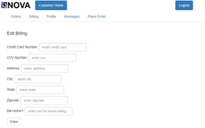](http://teamnovaproject.us/managerpage/viewbuses/)**

**[Screenshot 18.1 Screenshot 18.2](http://teamnovaproject.us/managerpage/viewbuses/)**

**[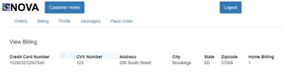](http://teamnovaproject.us/managerpage/viewbuses/)**

**[Screenshot 18.3](http://teamnovaproject.us/managerpage/viewbuses/)**

***[Final Merged Test Cases:](http://teamnovaproject.us/managerpage/viewbuses/)***

|  |  |  |  |
| --- | --- | --- | --- |
| **[Test Case Number](http://teamnovaproject.us/managerpage/viewbuses/)** | **[Input](http://teamnovaproject.us/managerpage/viewbuses/)** | **[Current State](http://teamnovaproject.us/managerpage/viewbuses/)** | **[Expected Output](http://teamnovaproject.us/managerpage/viewbuses/)** |
| **[STR-17.1](http://teamnovaproject.us/managerpage/viewbuses/)** | **[Credit Card Number:](http://teamnovaproject.us/managerpage/viewbuses/)**  **[1128923212567845](http://teamnovaproject.us/managerpage/viewbuses/)**  **[CVV Number:](http://teamnovaproject.us/managerpage/viewbuses/)**  **[123](http://teamnovaproject.us/managerpage/viewbuses/)**  **[Address:](http://teamnovaproject.us/managerpage/viewbuses/)**  **[206 South Street](http://teamnovaproject.us/managerpage/viewbuses/)**  **[City:](http://teamnovaproject.us/managerpage/viewbuses/)**  **[Brookings](http://teamnovaproject.us/managerpage/viewbuses/)**  **[State:](http://teamnovaproject.us/managerpage/viewbuses/)**  **[SD](http://teamnovaproject.us/managerpage/viewbuses/)**  **[Zipcode:](http://teamnovaproject.us/managerpage/viewbuses/)**  **[57006](http://teamnovaproject.us/managerpage/viewbuses/)**  **[Bill Home:](http://teamnovaproject.us/managerpage/viewbuses/)**  **[yes](http://teamnovaproject.us/managerpage/viewbuses/)**  **[Click Enter](http://teamnovaproject.us/managerpage/viewbuses/)** | **[Not updated](http://teamnovaproject.us/managerpage/viewbuses/)**  **[(Screenshot 17.2)](http://teamnovaproject.us/managerpage/viewbuses/)** | **[(Screenshot 17.3)](http://teamnovaproject.us/managerpage/viewbuses/)** |
| **[STR-17.2](http://teamnovaproject.us/managerpage/viewbuses/)** | **[Credit Card Number:](http://teamnovaproject.us/managerpage/viewbuses/)**    **[CVV Number:](http://teamnovaproject.us/managerpage/viewbuses/)**  **[123](http://teamnovaproject.us/managerpage/viewbuses/)**  **[Address:](http://teamnovaproject.us/managerpage/viewbuses/)**  **[206 South Street](http://teamnovaproject.us/managerpage/viewbuses/)**  **[City:](http://teamnovaproject.us/managerpage/viewbuses/)**  **[Brookings](http://teamnovaproject.us/managerpage/viewbuses/)**  **[State:](http://teamnovaproject.us/managerpage/viewbuses/)**  **[SD](http://teamnovaproject.us/managerpage/viewbuses/)**  **[Zipcode:](http://teamnovaproject.us/managerpage/viewbuses/)**  **[57006](http://teamnovaproject.us/managerpage/viewbuses/)**  **[Bill Home:](http://teamnovaproject.us/managerpage/viewbuses/)**  **[yes](http://teamnovaproject.us/managerpage/viewbuses/)**  **[Click Enter](http://teamnovaproject.us/managerpage/viewbuses/)** | **[Not updated](http://teamnovaproject.us/managerpage/viewbuses/)**  **[(Screenshot 17.2)](http://teamnovaproject.us/managerpage/viewbuses/)** | **[(Screenshot 17.2)](http://teamnovaproject.us/managerpage/viewbuses/)** |
| **[STR-17.3](http://teamnovaproject.us/managerpage/viewbuses/)** | **[Credit Card Number:](http://teamnovaproject.us/managerpage/viewbuses/)**  **[1128923212567845](http://teamnovaproject.us/managerpage/viewbuses/)**  **[CVV Number:](http://teamnovaproject.us/managerpage/viewbuses/)**    **[Address:](http://teamnovaproject.us/managerpage/viewbuses/)**  **[206 South Street](http://teamnovaproject.us/managerpage/viewbuses/)**  **[City:](http://teamnovaproject.us/managerpage/viewbuses/)**  **[Brookings](http://teamnovaproject.us/managerpage/viewbuses/)**  **[State:](http://teamnovaproject.us/managerpage/viewbuses/)**  **[SD](http://teamnovaproject.us/managerpage/viewbuses/)**  **[Zipcode:](http://teamnovaproject.us/managerpage/viewbuses/)**  **[57006](http://teamnovaproject.us/managerpage/viewbuses/)**  **[Bill Home:](http://teamnovaproject.us/managerpage/viewbuses/)**  **[yes](http://teamnovaproject.us/managerpage/viewbuses/)**  **[Click Enter](http://teamnovaproject.us/managerpage/viewbuses/)** | **[Not updated](http://teamnovaproject.us/managerpage/viewbuses/)**  **[(Screenshot 17.2)](http://teamnovaproject.us/managerpage/viewbuses/)** | **[(Screenshot 17.2)](http://teamnovaproject.us/managerpage/viewbuses/)** |
| **[STR-17.4](http://teamnovaproject.us/managerpage/viewbuses/)** | **[Credit Card Number:](http://teamnovaproject.us/managerpage/viewbuses/)**  **[1128923212567845](http://teamnovaproject.us/managerpage/viewbuses/)**  **[CVV Number:](http://teamnovaproject.us/managerpage/viewbuses/)**  **[123](http://teamnovaproject.us/managerpage/viewbuses/)**  **[Address:](http://teamnovaproject.us/managerpage/viewbuses/)**    **[City:](http://teamnovaproject.us/managerpage/viewbuses/)**  **[Brookings](http://teamnovaproject.us/managerpage/viewbuses/)**  **[State:](http://teamnovaproject.us/managerpage/viewbuses/)**  **[SD](http://teamnovaproject.us/managerpage/viewbuses/)**  **[Zipcode:](http://teamnovaproject.us/managerpage/viewbuses/)**  **[57006](http://teamnovaproject.us/managerpage/viewbuses/)**  **[Bill Home:](http://teamnovaproject.us/managerpage/viewbuses/)**  **[yes](http://teamnovaproject.us/managerpage/viewbuses/)**  **[Click Enter](http://teamnovaproject.us/managerpage/viewbuses/)** | **[Not updated](http://teamnovaproject.us/managerpage/viewbuses/)**  **[(Screenshot 17.2)](http://teamnovaproject.us/managerpage/viewbuses/)** | **[(Screenshot 17.2)](http://teamnovaproject.us/managerpage/viewbuses/)** |
| **[STR-17.5](http://teamnovaproject.us/managerpage/viewbuses/)** | **[Credit Card Number:](http://teamnovaproject.us/managerpage/viewbuses/)**  **[1128923212567845](http://teamnovaproject.us/managerpage/viewbuses/)**  **[CVV Number:](http://teamnovaproject.us/managerpage/viewbuses/)**  **[123](http://teamnovaproject.us/managerpage/viewbuses/)**  **[Address:](http://teamnovaproject.us/managerpage/viewbuses/)**  **[206 South Street](http://teamnovaproject.us/managerpage/viewbuses/)**  **[City:](http://teamnovaproject.us/managerpage/viewbuses/)**    **[State:](http://teamnovaproject.us/managerpage/viewbuses/)**  **[SD](http://teamnovaproject.us/managerpage/viewbuses/)**  **[Zipcode:](http://teamnovaproject.us/managerpage/viewbuses/)**  **[57006](http://teamnovaproject.us/managerpage/viewbuses/)**  **[Bill Home:](http://teamnovaproject.us/managerpage/viewbuses/)**  **[yes](http://teamnovaproject.us/managerpage/viewbuses/)**  **[Click Enter](http://teamnovaproject.us/managerpage/viewbuses/)** | **[Not updated](http://teamnovaproject.us/managerpage/viewbuses/)**  **[(Screenshot 17.2)](http://teamnovaproject.us/managerpage/viewbuses/)** | **[(Screenshot 17.2)](http://teamnovaproject.us/managerpage/viewbuses/)** |
| **[STR-17.6](http://teamnovaproject.us/managerpage/viewbuses/)** | **[Credit Card Number:](http://teamnovaproject.us/managerpage/viewbuses/)**  **[1128923212567845](http://teamnovaproject.us/managerpage/viewbuses/)**  **[CVV Number:](http://teamnovaproject.us/managerpage/viewbuses/)**  **[123](http://teamnovaproject.us/managerpage/viewbuses/)**  **[Address:](http://teamnovaproject.us/managerpage/viewbuses/)**  **[206 South Street](http://teamnovaproject.us/managerpage/viewbuses/)**  **[City:](http://teamnovaproject.us/managerpage/viewbuses/)**  **[Brookings](http://teamnovaproject.us/managerpage/viewbuses/)**  **[State:](http://teamnovaproject.us/managerpage/viewbuses/)**    **[Zipcode:](http://teamnovaproject.us/managerpage/viewbuses/)**  **[57006](http://teamnovaproject.us/managerpage/viewbuses/)**  **[Bill Home:](http://teamnovaproject.us/managerpage/viewbuses/)**  **[yes](http://teamnovaproject.us/managerpage/viewbuses/)**  **[Click Enter](http://teamnovaproject.us/managerpage/viewbuses/)** | **[Not updated](http://teamnovaproject.us/managerpage/viewbuses/)**  **[(Screenshot 17.2)](http://teamnovaproject.us/managerpage/viewbuses/)** | **[(Screenshot 17.2)](http://teamnovaproject.us/managerpage/viewbuses/)** |
| **[STR-17.7](http://teamnovaproject.us/managerpage/viewbuses/)** | **[Credit Card Number:](http://teamnovaproject.us/managerpage/viewbuses/)**  **[1128923212567845](http://teamnovaproject.us/managerpage/viewbuses/)**  **[CVV Number:](http://teamnovaproject.us/managerpage/viewbuses/)**  **[123](http://teamnovaproject.us/managerpage/viewbuses/)**  **[Address:](http://teamnovaproject.us/managerpage/viewbuses/)**  **[206 South Street](http://teamnovaproject.us/managerpage/viewbuses/)**  **[City:](http://teamnovaproject.us/managerpage/viewbuses/)**  **[Brookings](http://teamnovaproject.us/managerpage/viewbuses/)**  **[State:](http://teamnovaproject.us/managerpage/viewbuses/)**  **[SD](http://teamnovaproject.us/managerpage/viewbuses/)**  **[Zipcode:](http://teamnovaproject.us/managerpage/viewbuses/)**    **[Bill Home:](http://teamnovaproject.us/managerpage/viewbuses/)**  **[yes](http://teamnovaproject.us/managerpage/viewbuses/)**  **[Click Enter](http://teamnovaproject.us/managerpage/viewbuses/)** | **[Not updated](http://teamnovaproject.us/managerpage/viewbuses/)**  **[(Screenshot 17.2)](http://teamnovaproject.us/managerpage/viewbuses/)** | **[(Screenshot 17.2)](http://teamnovaproject.us/managerpage/viewbuses/)** |

**[Compatibility Test](http://teamnovaproject.us/managerpage/viewbuses/)**

|  |  |  |  |
| --- | --- | --- | --- |
| **[Test Case Number](http://teamnovaproject.us/managerpage/viewbuses/)** | **[Test Environment](http://teamnovaproject.us/managerpage/viewbuses/)** | **[Test Browser](http://teamnovaproject.us/managerpage/viewbuses/)** | **[Test Procedure](http://teamnovaproject.us/managerpage/viewbuses/)** |
| [CT-1](http://teamnovaproject.us/managerpage/viewbuses/) | [Windows 10 Home Ver. 1709](http://teamnovaproject.us/managerpage/viewbuses/) | [Google Chrome Desktop v.65.0.3325](http://teamnovaproject.us/managerpage/viewbuses/) | [Run Test cases 1.1 to 1.3, 2.1 to 2.3, 3.1 to 3.3, and 4.1 to 4.3. Verify test data for correctness with expected output.](http://teamnovaproject.us/managerpage/viewbuses/) |
| [CT-2](http://teamnovaproject.us/managerpage/viewbuses/) | [Microsoft Edge Desktop v.41.16299.15.0](http://teamnovaproject.us/managerpage/viewbuses/) |
| [CT-3](http://teamnovaproject.us/managerpage/viewbuses/) | [Firefox Desktop v.59.0.2](http://teamnovaproject.us/managerpage/viewbuses/) |
| [CT-4](http://teamnovaproject.us/managerpage/viewbuses/) | [Safari Desktop v.11.1](http://teamnovaproject.us/managerpage/viewbuses/) |
| [CT-5](http://teamnovaproject.us/managerpage/viewbuses/) | [Mac OS X](http://teamnovaproject.us/managerpage/viewbuses/) | [Google Chrome Desktop v.65.0.3325](http://teamnovaproject.us/managerpage/viewbuses/) |
| [CT-6](http://teamnovaproject.us/managerpage/viewbuses/) | [Microsoft Edge Desktop v.41.16299.15.0](http://teamnovaproject.us/managerpage/viewbuses/) |
| [CT-7](http://teamnovaproject.us/managerpage/viewbuses/) | [Firefox Desktop v.59.0.2](http://teamnovaproject.us/managerpage/viewbuses/) |
| [CT-8](http://teamnovaproject.us/managerpage/viewbuses/) | [Safari Desktop v.11.1](http://teamnovaproject.us/managerpage/viewbuses/) |
| [CT-9](http://teamnovaproject.us/managerpage/viewbuses/) | [Ubuntu 16.04](http://teamnovaproject.us/managerpage/viewbuses/) | [Google Chrome Desktop v.65.0.3325](http://teamnovaproject.us/managerpage/viewbuses/) |
| [CT-10](http://teamnovaproject.us/managerpage/viewbuses/) | [Microsoft Edge Desktop v.41.16299.15.0](http://teamnovaproject.us/managerpage/viewbuses/) |
| [CT-11](http://teamnovaproject.us/managerpage/viewbuses/) | [Firefox Desktop v.59.0.2](http://teamnovaproject.us/managerpage/viewbuses/) |
| [CT-12](http://teamnovaproject.us/managerpage/viewbuses/) | [Safari Desktop v.11.1](http://teamnovaproject.us/managerpage/viewbuses/) |
| [CT-13](http://teamnovaproject.us/managerpage/viewbuses/) | [iPhone iOS 11.3](http://teamnovaproject.us/managerpage/viewbuses/) | [Google Chrome Mobile v.65.0.3325.109](http://teamnovaproject.us/managerpage/viewbuses/) |
| [CT-14](http://teamnovaproject.us/managerpage/viewbuses/) | [Microsoft Edge Mobile v.40.15254.248.0](http://teamnovaproject.us/managerpage/viewbuses/) |
| [CT-15](http://teamnovaproject.us/managerpage/viewbuses/) | [Firefox Mobile v.59.0.2](http://teamnovaproject.us/managerpage/viewbuses/) |
| [CT-16](http://teamnovaproject.us/managerpage/viewbuses/) | [Safari Mobile v11.3](http://teamnovaproject.us/managerpage/viewbuses/) |
| [CT-17](http://teamnovaproject.us/managerpage/viewbuses/) | [Android Orea 8.1](http://teamnovaproject.us/managerpage/viewbuses/) | [Google Chrome Mobile v.65.0.3325.109](http://teamnovaproject.us/managerpage/viewbuses/) |
| [CT-18](http://teamnovaproject.us/managerpage/viewbuses/) | [Microsoft Edge Mobile v.40.15254.248.0](http://teamnovaproject.us/managerpage/viewbuses/) |
| [CT-19](http://teamnovaproject.us/managerpage/viewbuses/) | [Firefox Mobile v.59.0.2](http://teamnovaproject.us/managerpage/viewbuses/) |

**[Regression Test Policy](http://teamnovaproject.us/managerpage/viewbuses/)**

[The following policies are formulated to ensure that the regression system is used effectively to identify all code regressions immediately on getting diagnosed and that the timely removal of regression defects is properly facilitated.  
  
Policy - 1: The Regression system must be configured so that it provides detailed information on result  
  
The regression software testing system should be configured to provide adequate information to the developer for reviewing the regression report and be able to investigate the problem without the need to execute any more tests. For example, for unit test regressions the results should indicate the type of problem that occurred (unexpected outcome, uncaught runtime exception, etc.), the inputs responsible for uncovering the problem, the unit, & the stack trace. The stack trace is especially useful to identify defects causing abnormal program termination, as the exact instruction that caused the failure is displayed.  
In all cases, the regression software testing system results must provide more informative detail than the data tracked by the other components of the infrastructure, and the amount of information should be sufficient to identify the location and the cause of the regression.  
  
Policy - 2: Regression Tests must be executed automatically after every build  
  
The earlier that regression problems are detected, the faster, easier, and less costly it is to fix them. Therefore, the regression test execution should be integrated with the automated build system and executed immediately after each build. As a result of this approach, regression defects will be uncovered soon after they are introduced, and they can be fixed before they propagate to other parts of the code.  
  
Policy - 3: Regression test results must be reviewed at the start of every working day and the test suite should be updated as required  
  
Every failure in the regression test should be examined to find out whether the reported problem indicates a defect in the test suite or in the code itself. If the failure is due to some problem in the code, the developers must fix the code instantly, before taking up another work on some new functionality.  
  
If the failure indicates a problem with a regression test, for example, as uncovered by a false positive result, the developers must fix the test within one week to ensure that false positive results are not reported in future, which in the longer run may lead to desensitization of the entire team for all defects that get reported. For example, let us say that a test case happened to fail due to an intentional change in functionality of the code, and the expected outcome of the test case also must have been modified. The concerned developers responsible for the particular test case must revise the test case with the revised outcome expected out of it.  
  
This review process must take place at the start of every day of software testing activity. Otherwise, the team members lose valuable opportunities to learn from their own mistakes. If the team is not able to identify the problem & the developers and testers do not take immediate actions to prevent its recurrence, it is quite possible that developers will repeat the similar mistake in successive developments. This is due to the fact that had not been aware of the problem & / or due to the reason that the process has not been improved so far to prevent this type of mistake.  
  
Policy - 4: Regression tests results must be used to assess the deployment readiness of the system   
  
When the project comes close to release, the project manager & the architect must find out the ratio of regression test passes to the total number of regression tests executed that must be targeted to be achieved before the product can be considered ready for deployment.  
  
For example, this ratio would be 95% if the architect has developed a good understating of the product and the test status, and estimates that approximately 5% of failures are due to false positive results reported out of the software testing effort.](http://teamnovaproject.us/managerpage/viewbuses/)

[Reference: http://www.softwaretestinggenius.com/four-best-policies-for-regression-testing-as-suggested-by-software-testing-experts](http://teamnovaproject.us/managerpage/viewbuses/)

**[Stress and Performance Test](http://teamnovaproject.us/managerpage/viewbuses/)**

|  |  |  |  |
| --- | --- | --- | --- |
| **[Test Case Number](http://teamnovaproject.us/managerpage/viewbuses/)** | **[Test Environment](http://teamnovaproject.us/managerpage/viewbuses/)** | **[Test Browser](http://teamnovaproject.us/managerpage/viewbuses/)** | **[Test Procedure](http://teamnovaproject.us/managerpage/viewbuses/)** |
| [SP-1](http://teamnovaproject.us/managerpage/viewbuses/) | [Windows 10 Home Ver. 1709](http://teamnovaproject.us/managerpage/viewbuses/) | [Google Chrome Desktop v.65.0.3325](http://teamnovaproject.us/managerpage/viewbuses/) | [Run Test cases 1.1 to 1.3, 2.1 to 2.3, 3.1 to 3.3, and 4.1 to 4.3 each 20 times. Verify test data for correctness with expected output and that response times between entries does not exceed 4 seconds.](http://teamnovaproject.us/managerpage/viewbuses/) |
| [SP-2](http://teamnovaproject.us/managerpage/viewbuses/) | [Microsoft Edge Desktop v.41.16299.15.0](http://teamnovaproject.us/managerpage/viewbuses/) |
| [SP-3](http://teamnovaproject.us/managerpage/viewbuses/) | [Firefox Desktop v.59.0.2](http://teamnovaproject.us/managerpage/viewbuses/) |
| [SP-4](http://teamnovaproject.us/managerpage/viewbuses/) | [Safari Desktop v.11.1](http://teamnovaproject.us/managerpage/viewbuses/) |

**[Backup and Recovery Test](http://teamnovaproject.us/managerpage/viewbuses/)**

|  |  |  |  |  |
| --- | --- | --- | --- | --- |
| **[Test Case Number](http://teamnovaproject.us/managerpage/viewbuses/)** | **[Test Case](http://teamnovaproject.us/managerpage/viewbuses/)** | **[Description](http://teamnovaproject.us/managerpage/viewbuses/)** | **[Input](http://teamnovaproject.us/managerpage/viewbuses/)** | **[Output](http://teamnovaproject.us/managerpage/viewbuses/)** |
| [BU-1.1](http://teamnovaproject.us/managerpage/viewbuses/) | [Backup Data](http://teamnovaproject.us/managerpage/viewbuses/) | [Test to make sure that the backup data is saved successfully.](http://teamnovaproject.us/managerpage/viewbuses/) | [User information, order information, schedule, report information.](http://teamnovaproject.us/managerpage/viewbuses/) | *[backupNum](http://teamnovaproject.us/managerpage/viewbuses/)*[.bak file](http://teamnovaproject.us/managerpage/viewbuses/) |
| [BU-2.1](http://teamnovaproject.us/managerpage/viewbuses/) | [Virus or Malware](http://teamnovaproject.us/managerpage/viewbuses/) | [Usual behavior meaning possible virus/malware.](http://teamnovaproject.us/managerpage/viewbuses/) | [Halt system and reload most recent backup file.](http://teamnovaproject.us/managerpage/viewbuses/) | [Previous state of system before infection.](http://teamnovaproject.us/managerpage/viewbuses/) |
| [BU-3.1](http://teamnovaproject.us/managerpage/viewbuses/) | [Data Breach](http://teamnovaproject.us/managerpage/viewbuses/) | [Lost or stolen information from the database by external source.](http://teamnovaproject.us/managerpage/viewbuses/) | [Notify users of breach.](http://teamnovaproject.us/managerpage/viewbuses/) | [Damage control.](http://teamnovaproject.us/managerpage/viewbuses/) |

**[Security Test](http://teamnovaproject.us/managerpage/viewbuses/)**

|  |  |  |  |  |
| --- | --- | --- | --- | --- |
| **[Test Case Number](http://teamnovaproject.us/managerpage/viewbuses/)** | **[Test Case](http://teamnovaproject.us/managerpage/viewbuses/)** | **[Description](http://teamnovaproject.us/managerpage/viewbuses/)** | **[Input](http://teamnovaproject.us/managerpage/viewbuses/)** | **[Output](http://teamnovaproject.us/managerpage/viewbuses/)** |
| [ST-1.1](http://teamnovaproject.us/managerpage/viewbuses/) | [Root Login](http://teamnovaproject.us/managerpage/viewbuses/) | [Tests the security of the root login.](http://teamnovaproject.us/managerpage/viewbuses/) | [Enter:](http://teamnovaproject.us/managerpage/viewbuses/)  [Any invalid root username, and an invalid password.](http://teamnovaproject.us/managerpage/viewbuses/) | [Declined access to the root page.](http://teamnovaproject.us/managerpage/viewbuses/) |
| [ST-1.2](http://teamnovaproject.us/managerpage/viewbuses/) | [Customer Login](http://teamnovaproject.us/managerpage/viewbuses/) | [Tests the security of the customer login.](http://teamnovaproject.us/managerpage/viewbuses/) | [Enter:](http://teamnovaproject.us/managerpage/viewbuses/)  [Any invalid root username, and an invalid password.](http://teamnovaproject.us/managerpage/viewbuses/) | [Declined access to the root customer page.](http://teamnovaproject.us/managerpage/viewbuses/) |
| [ST-1.3](http://teamnovaproject.us/managerpage/viewbuses/) | [Driver Login](http://teamnovaproject.us/managerpage/viewbuses/) | [Tests the security of the driver login.](http://teamnovaproject.us/managerpage/viewbuses/) | [Enter:](http://teamnovaproject.us/managerpage/viewbuses/)  [Any invalid root username, and an invalid password.](http://teamnovaproject.us/managerpage/viewbuses/) | [Declined access to the driver page.](http://teamnovaproject.us/managerpage/viewbuses/) |
| [ST-1.4](http://teamnovaproject.us/managerpage/viewbuses/) | [Manager Login](http://teamnovaproject.us/managerpage/viewbuses/) | [Tests the security of the manager login.](http://teamnovaproject.us/managerpage/viewbuses/) | [Enter:](http://teamnovaproject.us/managerpage/viewbuses/)  [Any invalid root username, and an invalid password.](http://teamnovaproject.us/managerpage/viewbuses/) | [Declined access to the manager page.](http://teamnovaproject.us/managerpage/viewbuses/) |
| [ST-2.1](http://teamnovaproject.us/managerpage/viewbuses/) | [Enter URL Customer Page](http://teamnovaproject.us/managerpage/viewbuses/) | [Tests the security of the customer page not logging in.](http://teamnovaproject.us/managerpage/viewbuses/) | [Enter:](http://teamnovaproject.us/managerpage/viewbuses/)  [[http://teamnovaproject.us/customerpage/](http://teamnovaproject.us/managerpage/viewbuses/)](http://teamnovaproject.us/customerpage/)  [Into browser](http://teamnovaproject.us/managerpage/viewbuses/) | [Declined access to this url.](http://teamnovaproject.us/managerpage/viewbuses/) |
| [ST-2.2](http://teamnovaproject.us/managerpage/viewbuses/) | [Enter URL Driver Page](http://teamnovaproject.us/managerpage/viewbuses/) | [Tests the security of the driver page not logging in.](http://teamnovaproject.us/managerpage/viewbuses/) | [Enter:](http://teamnovaproject.us/managerpage/viewbuses/)  [[http://teamnovaproject.us/driverpage/](http://teamnovaproject.us/managerpage/viewbuses/)](http://teamnovaproject.us/driverpage/)  [Into browser](http://teamnovaproject.us/managerpage/viewbuses/) | [Declined access to this url.](http://teamnovaproject.us/managerpage/viewbuses/) |
| [ST-2.3](http://teamnovaproject.us/managerpage/viewbuses/) | [Enter URL Manager Page](http://teamnovaproject.us/managerpage/viewbuses/) | [Tests the security of the manager page not logging in.](http://teamnovaproject.us/managerpage/viewbuses/) | [Enter:](http://teamnovaproject.us/managerpage/viewbuses/) [[http://teamnovaproject.us/managerpage/](http://teamnovaproject.us/managerpage/viewbuses/)](http://teamnovaproject.us/managerpage/)  [Into browser](http://teamnovaproject.us/managerpage/viewbuses/) | [Declined access to this url.](http://teamnovaproject.us/managerpage/viewbuses/) |
| [ST-3.1](http://teamnovaproject.us/managerpage/viewbuses/) | [Check for Billing information when Placing Order - Manager](http://teamnovaproject.us/managerpage/viewbuses/) | [Tests the security of placing an order without billing information by a manager for a customer.](http://teamnovaproject.us/managerpage/viewbuses/) | [Start at:](http://teamnovaproject.us/managerpage/viewbuses/)  [[http://teamnovaproject.us/managerpage/placecustomerorder/](http://teamnovaproject.us/managerpage/viewbuses/)](http://teamnovaproject.us/managerpage/placecustomerorder/)  [Enter all the details for a customer that exists but does not have billing information](http://teamnovaproject.us/managerpage/viewbuses/) | [Sent to:](http://teamnovaproject.us/managerpage/viewbuses/)  [[http://teamnovaproject.us/managerpage/placecustomerorderbilling/](http://teamnovaproject.us/managerpage/viewbuses/)](http://teamnovaproject.us/managerpage/placecustomerorderbilling/) |
| [ST-3.2](http://teamnovaproject.us/managerpage/viewbuses/) | [Check for Billing information when Placing Order - Customer](http://teamnovaproject.us/managerpage/viewbuses/) | [Tests the security of placing an order without billing information by a manager for a customer.](http://teamnovaproject.us/managerpage/viewbuses/) | [Start at:](http://teamnovaproject.us/managerpage/viewbuses/)  [http://teamnovaproject.us/customerpage/placeorder/](http://teamnovaproject.us/managerpage/viewbuses/)  [Enter all the details for a customer that exists but does not have billing information](http://teamnovaproject.us/managerpage/viewbuses/) | [Sent to:](http://teamnovaproject.us/managerpage/viewbuses/)  [[http://teamnovaproject.us/customerpage/editbilling/](http://teamnovaproject.us/managerpage/viewbuses/)](http://teamnovaproject.us/customerpage/editbilling/) |

**[Unit Test 1](http://teamnovaproject.us/managerpage/viewbuses/)**

**[1.1](http://teamnovaproject.us/managerpage/viewbuses/)**

[FWBS Number and Name: 2.3.1 placeOrders](http://teamnovaproject.us/managerpage/viewbuses/)

[Date: 4/12/2018](http://teamnovaproject.us/managerpage/viewbuses/)

[Name: Jacob Gordon](http://teamnovaproject.us/managerpage/viewbuses/)

[Propose(Objective): Test the manager’s functionality to place an order for a customer.](http://teamnovaproject.us/managerpage/viewbuses/)

[Coverage Measurement (%)](http://teamnovaproject.us/managerpage/viewbuses/)

* [McCabe’s 100%](http://teamnovaproject.us/managerpage/viewbuses/)
* [Principal Paths 80%](http://teamnovaproject.us/managerpage/viewbuses/)
* [Branch Coverage 90%](http://teamnovaproject.us/managerpage/viewbuses/)

[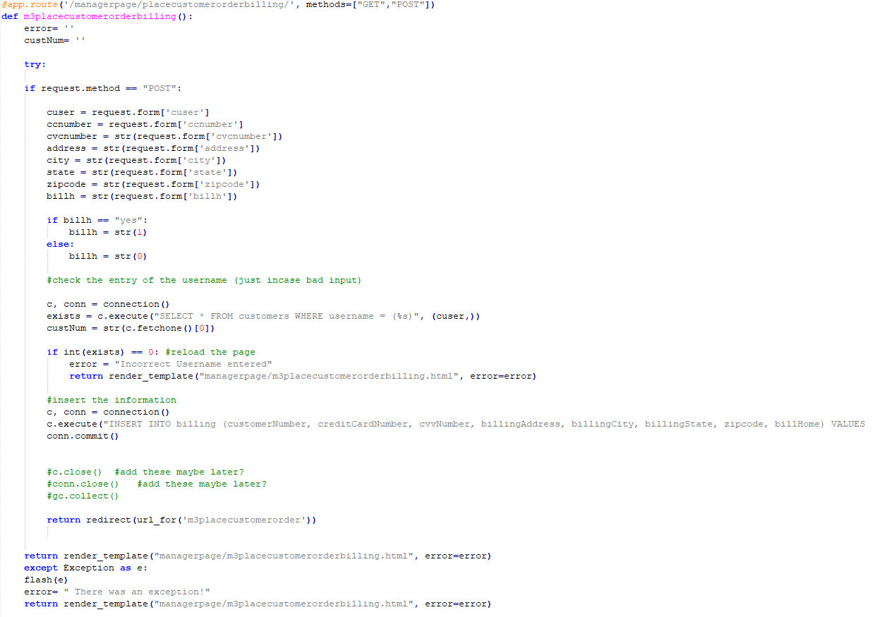](http://teamnovaproject.us/managerpage/viewbuses/)

[Individual Test Cases](http://teamnovaproject.us/managerpage/viewbuses/)

* [McCabe’s Path Testing Technique:](http://teamnovaproject.us/managerpage/viewbuses/)

[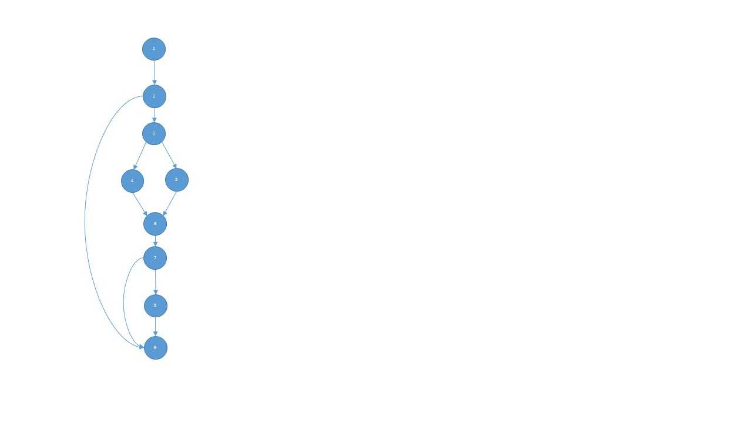](http://teamnovaproject.us/managerpage/viewbuses/)

[Nodes = 9](http://teamnovaproject.us/managerpage/viewbuses/)

[Edges = 11](http://teamnovaproject.us/managerpage/viewbuses/)

[Predicates = 3](http://teamnovaproject.us/managerpage/viewbuses/)

[V(G): 11-9+2=4](http://teamnovaproject.us/managerpage/viewbuses/)

[V(G): 3+1=4](http://teamnovaproject.us/managerpage/viewbuses/)

[Independent Paths](http://teamnovaproject.us/managerpage/viewbuses/)

**[1)](http://teamnovaproject.us/managerpage/viewbuses/)**[1-2-3-4-6-7-9](http://teamnovaproject.us/managerpage/viewbuses/)

**[2)](http://teamnovaproject.us/managerpage/viewbuses/)**[1-2-9](http://teamnovaproject.us/managerpage/viewbuses/)

**[3)](http://teamnovaproject.us/managerpage/viewbuses/)**[1-2-3-5-6-7-9](http://teamnovaproject.us/managerpage/viewbuses/)

**[4)](http://teamnovaproject.us/managerpage/viewbuses/)**[1-2-3-4-6-7-8-9](http://teamnovaproject.us/managerpage/viewbuses/)

**[5)](http://teamnovaproject.us/managerpage/viewbuses/)**[1-2-3-5-6-7-8-9](http://teamnovaproject.us/managerpage/viewbuses/)

|  |  |  |  |  |
| --- | --- | --- | --- | --- |
| **[Test Cases for McCabe](http://teamnovaproject.us/managerpage/viewbuses/)** | | | | |
| **[Test Case](http://teamnovaproject.us/managerpage/viewbuses/)** | **[Description](http://teamnovaproject.us/managerpage/viewbuses/)** | **[Start at](http://teamnovaproject.us/managerpage/viewbuses/)** | **[Input](http://teamnovaproject.us/managerpage/viewbuses/)** | **[Output](http://teamnovaproject.us/managerpage/viewbuses/)** |
| [UT.1.1.1](http://teamnovaproject.us/managerpage/viewbuses/) | [Test of path 1. Invalid Username.](http://teamnovaproject.us/managerpage/viewbuses/) | [[http://teamnovaproject.us/managerpage/placecustomerorderbilling/](http://teamnovaproject.us/managerpage/viewbuses/)](http://teamnovaproject.us/managerpage/placecustomerorderbilling/) | **[Username:](http://teamnovaproject.us/managerpage/viewbuses/)**  [Invalidcustomer](http://teamnovaproject.us/managerpage/viewbuses/)  **[Credit Card Number:](http://teamnovaproject.us/managerpage/viewbuses/)**  [1234567891011121](http://teamnovaproject.us/managerpage/viewbuses/)  **[CVV Number:](http://teamnovaproject.us/managerpage/viewbuses/)**  [123](http://teamnovaproject.us/managerpage/viewbuses/)  **[Address:](http://teamnovaproject.us/managerpage/viewbuses/)**  [123 Something Rd.](http://teamnovaproject.us/managerpage/viewbuses/)  **[City:](http://teamnovaproject.us/managerpage/viewbuses/)**  [Brookings](http://teamnovaproject.us/managerpage/viewbuses/)  **[State:](http://teamnovaproject.us/managerpage/viewbuses/)**  [SD](http://teamnovaproject.us/managerpage/viewbuses/)  **[Zipcode:](http://teamnovaproject.us/managerpage/viewbuses/)**  [57006](http://teamnovaproject.us/managerpage/viewbuses/)  **[Bill Home:](http://teamnovaproject.us/managerpage/viewbuses/)**  [yes](http://teamnovaproject.us/managerpage/viewbuses/)  **[Click Enter](http://teamnovaproject.us/managerpage/viewbuses/)** | [[http://teamnovaproject.us/managerpage/placecustomerorderbilling/](http://teamnovaproject.us/managerpage/viewbuses/)](http://teamnovaproject.us/managerpage/placecustomerorderbilling/) |
| [UT.1.1.2](http://teamnovaproject.us/managerpage/viewbuses/) | [Test of path 2. Original load of page without Enter clicked.](http://teamnovaproject.us/managerpage/viewbuses/) | [[http://teamnovaproject.us/managerpage/placecustomerorderbilling/](http://teamnovaproject.us/managerpage/viewbuses/)](http://teamnovaproject.us/managerpage/placecustomerorderbilling/) | **[None](http://teamnovaproject.us/managerpage/viewbuses/)** | [[http://teamnovaproject.us/managerpage/placecustomerorderbilling/](http://teamnovaproject.us/managerpage/viewbuses/)](http://teamnovaproject.us/managerpage/placecustomerorderbilling/) |
| [UT.1.1.3](http://teamnovaproject.us/managerpage/viewbuses/) | [Test of path 3. Invalid Username. Bill Home not yes.](http://teamnovaproject.us/managerpage/viewbuses/) | [[http://teamnovaproject.us/managerpage/placecustomerorderbilling/](http://teamnovaproject.us/managerpage/viewbuses/)](http://teamnovaproject.us/managerpage/placecustomerorderbilling/) | **[Username:](http://teamnovaproject.us/managerpage/viewbuses/)**  [Invalidcustomer](http://teamnovaproject.us/managerpage/viewbuses/)  **[Credit Card Number:](http://teamnovaproject.us/managerpage/viewbuses/)**  [1234567891011121](http://teamnovaproject.us/managerpage/viewbuses/)  **[CVV Number:](http://teamnovaproject.us/managerpage/viewbuses/)**  [123](http://teamnovaproject.us/managerpage/viewbuses/)  **[Address:](http://teamnovaproject.us/managerpage/viewbuses/)**  [123 Something Rd.](http://teamnovaproject.us/managerpage/viewbuses/)  **[City:](http://teamnovaproject.us/managerpage/viewbuses/)**  [Brookings](http://teamnovaproject.us/managerpage/viewbuses/)  **[State:](http://teamnovaproject.us/managerpage/viewbuses/)**  [SD](http://teamnovaproject.us/managerpage/viewbuses/)  **[Zipcode:](http://teamnovaproject.us/managerpage/viewbuses/)**  [57006](http://teamnovaproject.us/managerpage/viewbuses/)  **[Bill Home:](http://teamnovaproject.us/managerpage/viewbuses/)**  [no](http://teamnovaproject.us/managerpage/viewbuses/)  **[Click Enter](http://teamnovaproject.us/managerpage/viewbuses/)** | [[http://teamnovaproject.us/managerpage/placecustomerorderbilling/](http://teamnovaproject.us/managerpage/viewbuses/)](http://teamnovaproject.us/managerpage/placecustomerorderbilling/) |
| [UT.1.1.4](http://teamnovaproject.us/managerpage/viewbuses/) | [Test of path 4.](http://teamnovaproject.us/managerpage/viewbuses/) | [[http://teamnovaproject.us/managerpage/placecustomerorderbilling/](http://teamnovaproject.us/managerpage/viewbuses/)](http://teamnovaproject.us/managerpage/placecustomerorderbilling/) | **[Username:](http://teamnovaproject.us/managerpage/viewbuses/)**  [customer](http://teamnovaproject.us/managerpage/viewbuses/)  **[Credit Card Number:](http://teamnovaproject.us/managerpage/viewbuses/)**  [1234567891011121](http://teamnovaproject.us/managerpage/viewbuses/)  **[CVV Number:](http://teamnovaproject.us/managerpage/viewbuses/)**  [123](http://teamnovaproject.us/managerpage/viewbuses/)  **[Address:](http://teamnovaproject.us/managerpage/viewbuses/)**  [123 Something Rd.](http://teamnovaproject.us/managerpage/viewbuses/)  **[City:](http://teamnovaproject.us/managerpage/viewbuses/)**  [Brookings](http://teamnovaproject.us/managerpage/viewbuses/)  **[State:](http://teamnovaproject.us/managerpage/viewbuses/)**  [SD](http://teamnovaproject.us/managerpage/viewbuses/)  **[Zipcode:](http://teamnovaproject.us/managerpage/viewbuses/)**  [57006](http://teamnovaproject.us/managerpage/viewbuses/)  **[Bill Home:](http://teamnovaproject.us/managerpage/viewbuses/)**  [yes](http://teamnovaproject.us/managerpage/viewbuses/)  **[Click Enter](http://teamnovaproject.us/managerpage/viewbuses/)** | [[http://teamnovaproject.us/managerpage/placecustomerorder/](http://teamnovaproject.us/managerpage/viewbuses/)](http://teamnovaproject.us/managerpage/placecustomerorder/) |
| [UT.1.1.5](http://teamnovaproject.us/managerpage/viewbuses/) | [Test of path 5.](http://teamnovaproject.us/managerpage/viewbuses/) | [[http://teamnovaproject.us/managerpage/placecustomerorderbilling/](http://teamnovaproject.us/managerpage/viewbuses/)](http://teamnovaproject.us/managerpage/placecustomerorderbilling/) | **[Username:](http://teamnovaproject.us/managerpage/viewbuses/)**  [Invalidcustomer](http://teamnovaproject.us/managerpage/viewbuses/)  **[Credit Card Number:](http://teamnovaproject.us/managerpage/viewbuses/)**  [1234567891011121](http://teamnovaproject.us/managerpage/viewbuses/)  **[CVV Number:](http://teamnovaproject.us/managerpage/viewbuses/)**  [123](http://teamnovaproject.us/managerpage/viewbuses/)  **[Address:](http://teamnovaproject.us/managerpage/viewbuses/)**  [123 Something Rd.](http://teamnovaproject.us/managerpage/viewbuses/)  **[City:](http://teamnovaproject.us/managerpage/viewbuses/)**  [Brookings](http://teamnovaproject.us/managerpage/viewbuses/)  **[State:](http://teamnovaproject.us/managerpage/viewbuses/)**  [SD](http://teamnovaproject.us/managerpage/viewbuses/)  **[Zipcode:](http://teamnovaproject.us/managerpage/viewbuses/)**  [57006](http://teamnovaproject.us/managerpage/viewbuses/)  **[Bill Home:](http://teamnovaproject.us/managerpage/viewbuses/)**  [no](http://teamnovaproject.us/managerpage/viewbuses/)  **[Click Enter](http://teamnovaproject.us/managerpage/viewbuses/)** | [[http://teamnovaproject.us/managerpage/placecustomerorder/](http://teamnovaproject.us/managerpage/viewbuses/)](http://teamnovaproject.us/managerpage/placecustomerorder/) |

* [Principal Path Testing Technique:](http://teamnovaproject.us/managerpage/viewbuses/)

[A principal path is defined as the “usual” path to occur under the typical scenario with no errors.](http://teamnovaproject.us/managerpage/viewbuses/)

[Path 1: Variable “exists” is equal to 0](http://teamnovaproject.us/managerpage/viewbuses/)

[Path 2: Variable “exists” is equal to 1](http://teamnovaproject.us/managerpage/viewbuses/)

|  |  |  |  |  |
| --- | --- | --- | --- | --- |
| **[Test Cases for Principal Path](http://teamnovaproject.us/managerpage/viewbuses/)** | | | | |
| **[Test Case](http://teamnovaproject.us/managerpage/viewbuses/)** | **[Description](http://teamnovaproject.us/managerpage/viewbuses/)** | **[Start at](http://teamnovaproject.us/managerpage/viewbuses/)** | **[Input](http://teamnovaproject.us/managerpage/viewbuses/)** | **[Output](http://teamnovaproject.us/managerpage/viewbuses/)** |
| [UT.1.2.1](http://teamnovaproject.us/managerpage/viewbuses/) | [Test of path 1. Customer does not exist.](http://teamnovaproject.us/managerpage/viewbuses/) | [[http://teamnovaproject.us/managerpage/placecustomerorderbilling/](http://teamnovaproject.us/managerpage/viewbuses/)](http://teamnovaproject.us/managerpage/placecustomerorderbilling/) | **[Username:](http://teamnovaproject.us/managerpage/viewbuses/)**  [Invalidcustomer](http://teamnovaproject.us/managerpage/viewbuses/)  **[Credit Card Number:](http://teamnovaproject.us/managerpage/viewbuses/)**  [1234567891011121](http://teamnovaproject.us/managerpage/viewbuses/)  **[CVV Number:](http://teamnovaproject.us/managerpage/viewbuses/)**  [123](http://teamnovaproject.us/managerpage/viewbuses/)  **[Address:](http://teamnovaproject.us/managerpage/viewbuses/)**  [123 Something Rd.](http://teamnovaproject.us/managerpage/viewbuses/)  **[City:](http://teamnovaproject.us/managerpage/viewbuses/)**  [Brookings](http://teamnovaproject.us/managerpage/viewbuses/)  **[State:](http://teamnovaproject.us/managerpage/viewbuses/)**  [SD](http://teamnovaproject.us/managerpage/viewbuses/)  **[Zipcode:](http://teamnovaproject.us/managerpage/viewbuses/)**  [57006](http://teamnovaproject.us/managerpage/viewbuses/)  **[Bill Home:](http://teamnovaproject.us/managerpage/viewbuses/)**  [yes](http://teamnovaproject.us/managerpage/viewbuses/)  **[Click Enter](http://teamnovaproject.us/managerpage/viewbuses/)** | [[http://teamnovaproject.us/managerpage/placecustomerorderbilling/](http://teamnovaproject.us/managerpage/viewbuses/)](http://teamnovaproject.us/managerpage/placecustomerorderbilling/) |
| [UT.1.2.2](http://teamnovaproject.us/managerpage/viewbuses/) | [Test of path 2. Customer exists in database.](http://teamnovaproject.us/managerpage/viewbuses/) | [[http://teamnovaproject.us/managerpage/placecustomerorderbilling/](http://teamnovaproject.us/managerpage/viewbuses/)](http://teamnovaproject.us/managerpage/placecustomerorderbilling/) | **[Username:](http://teamnovaproject.us/managerpage/viewbuses/)**  [customer](http://teamnovaproject.us/managerpage/viewbuses/)  **[Credit Card Number:](http://teamnovaproject.us/managerpage/viewbuses/)**  [1234567891011121](http://teamnovaproject.us/managerpage/viewbuses/)  **[CVV Number:](http://teamnovaproject.us/managerpage/viewbuses/)**  [123](http://teamnovaproject.us/managerpage/viewbuses/)  **[Address:](http://teamnovaproject.us/managerpage/viewbuses/)**  [123 Something Rd.](http://teamnovaproject.us/managerpage/viewbuses/)  **[City:](http://teamnovaproject.us/managerpage/viewbuses/)**  [Brookings](http://teamnovaproject.us/managerpage/viewbuses/)  **[State:](http://teamnovaproject.us/managerpage/viewbuses/)**  [SD](http://teamnovaproject.us/managerpage/viewbuses/)  **[Zipcode:](http://teamnovaproject.us/managerpage/viewbuses/)**  [57006](http://teamnovaproject.us/managerpage/viewbuses/)  **[Bill Home:](http://teamnovaproject.us/managerpage/viewbuses/)**  [yes](http://teamnovaproject.us/managerpage/viewbuses/)  **[Click Enter](http://teamnovaproject.us/managerpage/viewbuses/)** | [[http://teamnovaproject.us/managerpage/placecustomerorderbilling/](http://teamnovaproject.us/managerpage/viewbuses/)](http://teamnovaproject.us/managerpage/placecustomerorderbilling/) |

* [Branch Coverage Testing Technique:](http://teamnovaproject.us/managerpage/viewbuses/)

[Path 1 & 2: Where statement ‘if request.method == “POST”:’ is TRUE and FALSE](http://teamnovaproject.us/managerpage/viewbuses/)

[Path 3 & 4: Where statement ‘if billh == “yes:” ‘ is TRUE and FALSE](http://teamnovaproject.us/managerpage/viewbuses/)

[Path 5 & 6: Where statement ‘if int(exists) == 0:’ is TRUE and FALSE](http://teamnovaproject.us/managerpage/viewbuses/)

|  |  |  |  |  |
| --- | --- | --- | --- | --- |
| **[Test Cases for Branch Coverage](http://teamnovaproject.us/managerpage/viewbuses/)** | | | | |
| **[Test Case](http://teamnovaproject.us/managerpage/viewbuses/)** | **[Description](http://teamnovaproject.us/managerpage/viewbuses/)** | **[Start at](http://teamnovaproject.us/managerpage/viewbuses/)** | **[Input](http://teamnovaproject.us/managerpage/viewbuses/)** | **[Output](http://teamnovaproject.us/managerpage/viewbuses/)** |
| [UT.1.3.1](http://teamnovaproject.us/managerpage/viewbuses/) | [Test of path 1. Statement is TRUE. Pressing Enter key is what sets this statement to TRUE](http://teamnovaproject.us/managerpage/viewbuses/) | [[http://teamnovaproject.us/managerpage/placecustomerorderbilling/](http://teamnovaproject.us/managerpage/viewbuses/)](http://teamnovaproject.us/managerpage/placecustomerorderbilling/) | **[Username:](http://teamnovaproject.us/managerpage/viewbuses/)**  [customer](http://teamnovaproject.us/managerpage/viewbuses/)  **[Credit Card Number:](http://teamnovaproject.us/managerpage/viewbuses/)**  [1234567891011121](http://teamnovaproject.us/managerpage/viewbuses/)  **[CVV Number:](http://teamnovaproject.us/managerpage/viewbuses/)**  [123](http://teamnovaproject.us/managerpage/viewbuses/)  **[Address:](http://teamnovaproject.us/managerpage/viewbuses/)**  [123 Something Rd.](http://teamnovaproject.us/managerpage/viewbuses/)  **[City:](http://teamnovaproject.us/managerpage/viewbuses/)**  [Brookings](http://teamnovaproject.us/managerpage/viewbuses/)  **[State:](http://teamnovaproject.us/managerpage/viewbuses/)**  [SD](http://teamnovaproject.us/managerpage/viewbuses/)  **[Zipcode:](http://teamnovaproject.us/managerpage/viewbuses/)**  [57006](http://teamnovaproject.us/managerpage/viewbuses/)  **[Bill Home:](http://teamnovaproject.us/managerpage/viewbuses/)**  [yes](http://teamnovaproject.us/managerpage/viewbuses/)  **[Click Enter](http://teamnovaproject.us/managerpage/viewbuses/)** | [[http://teamnovaproject.us/managerpage/placecustomerorderbilling/](http://teamnovaproject.us/managerpage/viewbuses/)](http://teamnovaproject.us/managerpage/placecustomerorderbilling/) |
| [UT.1.3.2](http://teamnovaproject.us/managerpage/viewbuses/) | [Test of path 2. Statement is FALSE.](http://teamnovaproject.us/managerpage/viewbuses/) | [[http://teamnovaproject.us/managerpage/placecustomerorderbilling/](http://teamnovaproject.us/managerpage/viewbuses/)](http://teamnovaproject.us/managerpage/placecustomerorderbilling/) | **[None](http://teamnovaproject.us/managerpage/viewbuses/)** | [[http://teamnovaproject.us/managerpage/placecustomerorderbilling/](http://teamnovaproject.us/managerpage/viewbuses/)](http://teamnovaproject.us/managerpage/placecustomerorderbilling/) |
| [UT.1.3.3](http://teamnovaproject.us/managerpage/viewbuses/) | [Test of path 3. Statement is TRUE because yes is entered for Bill Home](http://teamnovaproject.us/managerpage/viewbuses/) | [[http://teamnovaproject.us/managerpage/placecustomerorderbilling/](http://teamnovaproject.us/managerpage/viewbuses/)](http://teamnovaproject.us/managerpage/placecustomerorderbilling/) | **[Username:](http://teamnovaproject.us/managerpage/viewbuses/)**  [customer](http://teamnovaproject.us/managerpage/viewbuses/)  **[Credit Card Number:](http://teamnovaproject.us/managerpage/viewbuses/)**  [1234567891011121](http://teamnovaproject.us/managerpage/viewbuses/)  **[CVV Number:](http://teamnovaproject.us/managerpage/viewbuses/)**  [123](http://teamnovaproject.us/managerpage/viewbuses/)  **[Address:](http://teamnovaproject.us/managerpage/viewbuses/)**  [123 Something Rd.](http://teamnovaproject.us/managerpage/viewbuses/)  **[City:](http://teamnovaproject.us/managerpage/viewbuses/)**  [Brookings](http://teamnovaproject.us/managerpage/viewbuses/)  **[State:](http://teamnovaproject.us/managerpage/viewbuses/)**  [SD](http://teamnovaproject.us/managerpage/viewbuses/)  **[Zipcode:](http://teamnovaproject.us/managerpage/viewbuses/)**  [57006](http://teamnovaproject.us/managerpage/viewbuses/)  **[Bill Home:](http://teamnovaproject.us/managerpage/viewbuses/)**  [yes](http://teamnovaproject.us/managerpage/viewbuses/)  **[Click Enter](http://teamnovaproject.us/managerpage/viewbuses/)** | [[http://teamnovaproject.us/managerpage/placecustomerorderbilling/](http://teamnovaproject.us/managerpage/viewbuses/)](http://teamnovaproject.us/managerpage/placecustomerorderbilling/) |
| [UT.1.3.4](http://teamnovaproject.us/managerpage/viewbuses/) | [Test of path 3. Statement is FALSE because not yes is entered for Bill Home](http://teamnovaproject.us/managerpage/viewbuses/) | [[http://teamnovaproject.us/managerpage/placecustomerorderbilling/](http://teamnovaproject.us/managerpage/viewbuses/)](http://teamnovaproject.us/managerpage/placecustomerorderbilling/) | **[Username:](http://teamnovaproject.us/managerpage/viewbuses/)**  [customer](http://teamnovaproject.us/managerpage/viewbuses/)  **[Credit Card Number:](http://teamnovaproject.us/managerpage/viewbuses/)**  [1234567891011121](http://teamnovaproject.us/managerpage/viewbuses/)  **[CVV Number:](http://teamnovaproject.us/managerpage/viewbuses/)**  [123](http://teamnovaproject.us/managerpage/viewbuses/)  **[Address:](http://teamnovaproject.us/managerpage/viewbuses/)**  [123 Something Rd.](http://teamnovaproject.us/managerpage/viewbuses/)  **[City:](http://teamnovaproject.us/managerpage/viewbuses/)**  [Brookings](http://teamnovaproject.us/managerpage/viewbuses/)  **[State:](http://teamnovaproject.us/managerpage/viewbuses/)**  [SD](http://teamnovaproject.us/managerpage/viewbuses/)  **[Zipcode:](http://teamnovaproject.us/managerpage/viewbuses/)**  [57006](http://teamnovaproject.us/managerpage/viewbuses/)  **[Bill Home:](http://teamnovaproject.us/managerpage/viewbuses/)**  [no](http://teamnovaproject.us/managerpage/viewbuses/)  **[Click Enter](http://teamnovaproject.us/managerpage/viewbuses/)** | [[http://teamnovaproject.us/managerpage/placecustomerorderbilling/](http://teamnovaproject.us/managerpage/viewbuses/)](http://teamnovaproject.us/managerpage/placecustomerorderbilling/) |
| [UT.1.3.5](http://teamnovaproject.us/managerpage/viewbuses/) | [Test of path 6. Statement is FALSE because customer does not exist.](http://teamnovaproject.us/managerpage/viewbuses/) | [[http://teamnovaproject.us/managerpage/placecustomerorderbilling/](http://teamnovaproject.us/managerpage/viewbuses/)](http://teamnovaproject.us/managerpage/placecustomerorderbilling/) | **[Username:](http://teamnovaproject.us/managerpage/viewbuses/)**  [Invalidcustomer](http://teamnovaproject.us/managerpage/viewbuses/)  **[Credit Card Number:](http://teamnovaproject.us/managerpage/viewbuses/)**  [1234567891011121](http://teamnovaproject.us/managerpage/viewbuses/)  **[CVV Number:](http://teamnovaproject.us/managerpage/viewbuses/)**  [123](http://teamnovaproject.us/managerpage/viewbuses/)  **[Address:](http://teamnovaproject.us/managerpage/viewbuses/)**  [123 Something Rd.](http://teamnovaproject.us/managerpage/viewbuses/)  **[City:](http://teamnovaproject.us/managerpage/viewbuses/)**  [Brookings](http://teamnovaproject.us/managerpage/viewbuses/)  **[State:](http://teamnovaproject.us/managerpage/viewbuses/)**  [SD](http://teamnovaproject.us/managerpage/viewbuses/)  **[Zipcode:](http://teamnovaproject.us/managerpage/viewbuses/)**  [57006](http://teamnovaproject.us/managerpage/viewbuses/)  **[Bill Home:](http://teamnovaproject.us/managerpage/viewbuses/)**  [yes](http://teamnovaproject.us/managerpage/viewbuses/)  **[Click Enter](http://teamnovaproject.us/managerpage/viewbuses/)** | [[http://teamnovaproject.us/managerpage/placecustomerorderbilling/](http://teamnovaproject.us/managerpage/viewbuses/)](http://teamnovaproject.us/managerpage/placecustomerorderbilling/) |
| [UT.1.3.6](http://teamnovaproject.us/managerpage/viewbuses/) | [Test of path 6. Statement is TRUE because customer exists in database.](http://teamnovaproject.us/managerpage/viewbuses/) | [[http://teamnovaproject.us/managerpage/placecustomerorderbilling/](http://teamnovaproject.us/managerpage/viewbuses/)](http://teamnovaproject.us/managerpage/placecustomerorderbilling/) | **[Username:](http://teamnovaproject.us/managerpage/viewbuses/)**  [customer](http://teamnovaproject.us/managerpage/viewbuses/)  **[Credit Card Number:](http://teamnovaproject.us/managerpage/viewbuses/)**  [1234567891011121](http://teamnovaproject.us/managerpage/viewbuses/)  **[CVV Number:](http://teamnovaproject.us/managerpage/viewbuses/)**  [123](http://teamnovaproject.us/managerpage/viewbuses/)  **[Address:](http://teamnovaproject.us/managerpage/viewbuses/)**  [123 Something Rd.](http://teamnovaproject.us/managerpage/viewbuses/)  **[City:](http://teamnovaproject.us/managerpage/viewbuses/)**  [Brookings](http://teamnovaproject.us/managerpage/viewbuses/)  **[State:](http://teamnovaproject.us/managerpage/viewbuses/)**  [SD](http://teamnovaproject.us/managerpage/viewbuses/)  **[Zipcode:](http://teamnovaproject.us/managerpage/viewbuses/)**  [57006](http://teamnovaproject.us/managerpage/viewbuses/)  **[Bill Home:](http://teamnovaproject.us/managerpage/viewbuses/)**  [yes](http://teamnovaproject.us/managerpage/viewbuses/)  **[Click Enter](http://teamnovaproject.us/managerpage/viewbuses/)** | [[http://teamnovaproject.us/managerpage/placecustomerorderbilling/](http://teamnovaproject.us/managerpage/viewbuses/)](http://teamnovaproject.us/managerpage/placecustomerorderbilling/) |

[Final (merged test cases)](http://teamnovaproject.us/managerpage/viewbuses/)

|  |  |  |
| --- | --- | --- |
| [Test Case](http://teamnovaproject.us/managerpage/viewbuses/) | [Expected Output](http://teamnovaproject.us/managerpage/viewbuses/) | [Actual Output](http://teamnovaproject.us/managerpage/viewbuses/) |
| [UT.1.1.1](http://teamnovaproject.us/managerpage/viewbuses/) | [[http://teamnovaproject.us/managerpage/placecustomerorderbilling/](http://teamnovaproject.us/managerpage/viewbuses/)](http://teamnovaproject.us/managerpage/placecustomerorderbilling/) |  |
| [UT.1.1.2](http://teamnovaproject.us/managerpage/viewbuses/) | [[http://teamnovaproject.us/managerpage/placecustomerorderbilling/](http://teamnovaproject.us/managerpage/viewbuses/)](http://teamnovaproject.us/managerpage/placecustomerorderbilling/) |  |
| [UT.1.1.3](http://teamnovaproject.us/managerpage/viewbuses/) | [[http://teamnovaproject.us/managerpage/placecustomerorderbilling/](http://teamnovaproject.us/managerpage/viewbuses/)](http://teamnovaproject.us/managerpage/placecustomerorderbilling/) |  |
| [UT.1.1.4](http://teamnovaproject.us/managerpage/viewbuses/) | [[http://teamnovaproject.us/managerpage/placecustomerorder/](http://teamnovaproject.us/managerpage/viewbuses/)](http://teamnovaproject.us/managerpage/placecustomerorder/) |  |
| [UT.1.1.5](http://teamnovaproject.us/managerpage/viewbuses/) | [[http://teamnovaproject.us/managerpage/placecustomerorder/](http://teamnovaproject.us/managerpage/viewbuses/)](http://teamnovaproject.us/managerpage/placecustomerorder/) |  |

**[Unit Test 2](http://teamnovaproject.us/managerpage/viewbuses/)**

[Edit Customer Order(Edit Order)](http://teamnovaproject.us/managerpage/viewbuses/)

[FWBS Number and Name: 2.3.2 editOrders](http://teamnovaproject.us/managerpage/viewbuses/)

[Date: 4/12/2018](http://teamnovaproject.us/managerpage/viewbuses/)

[Name: Jacob Gordon](http://teamnovaproject.us/managerpage/viewbuses/)

[Propose(Objective): Test the manager’s functionality to edit an already existing order for a customer.](http://teamnovaproject.us/managerpage/viewbuses/)

[Coverage Measurement (%)](http://teamnovaproject.us/managerpage/viewbuses/)

* [McCabe’s 100%](http://teamnovaproject.us/managerpage/viewbuses/)
* [Principal Paths 90%](http://teamnovaproject.us/managerpage/viewbuses/)
* [Compound Statement 70%](http://teamnovaproject.us/managerpage/viewbuses/)

[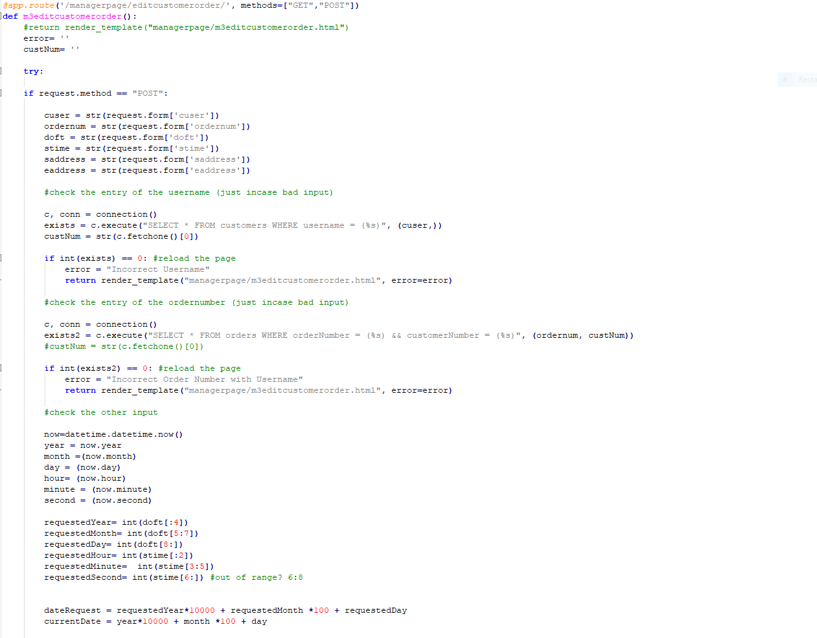](http://teamnovaproject.us/managerpage/viewbuses/)

[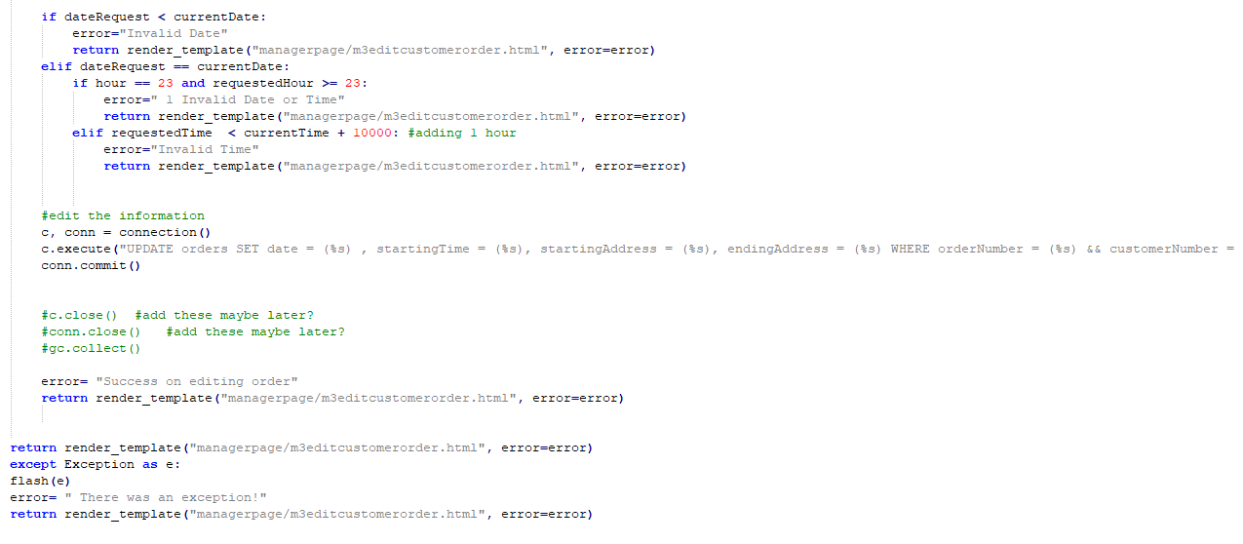](http://teamnovaproject.us/managerpage/viewbuses/)

[Individual Test Cases](http://teamnovaproject.us/managerpage/viewbuses/)

* [McCabe’s Path Testing Technique:](http://teamnovaproject.us/managerpage/viewbuses/)

[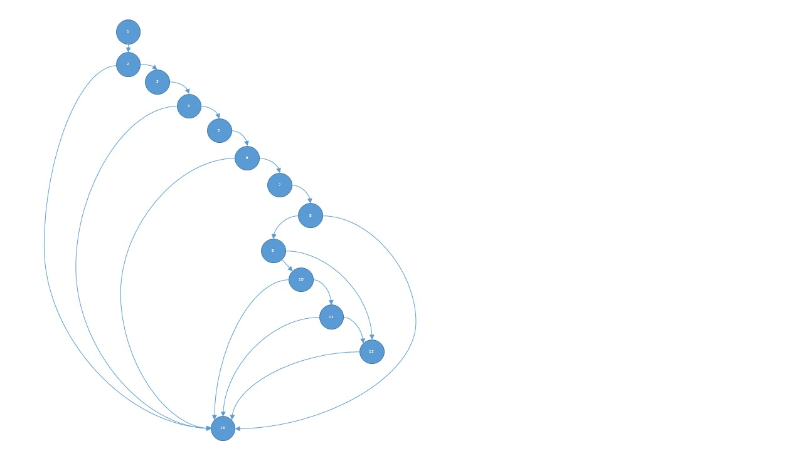](http://teamnovaproject.us/managerpage/viewbuses/)

[Nodes = 13](http://teamnovaproject.us/managerpage/viewbuses/)

[Edges = 19](http://teamnovaproject.us/managerpage/viewbuses/)

[Predicates = 7](http://teamnovaproject.us/managerpage/viewbuses/)

[V(G): 20-14+2=8](http://teamnovaproject.us/managerpage/viewbuses/)

[V(G): 7+1=8](http://teamnovaproject.us/managerpage/viewbuses/)

[Independent Paths](http://teamnovaproject.us/managerpage/viewbuses/)

**[1)](http://teamnovaproject.us/managerpage/viewbuses/)**[1-2-3-4-5-6-7-8-9-10-11-12-13](http://teamnovaproject.us/managerpage/viewbuses/)

**[2)](http://teamnovaproject.us/managerpage/viewbuses/)**[1-2-13](http://teamnovaproject.us/managerpage/viewbuses/)

**[3)](http://teamnovaproject.us/managerpage/viewbuses/)**[1-2-3-4-13](http://teamnovaproject.us/managerpage/viewbuses/)

**[4)](http://teamnovaproject.us/managerpage/viewbuses/)**[1-2-3-4-5-6-13](http://teamnovaproject.us/managerpage/viewbuses/)

**[5)](http://teamnovaproject.us/managerpage/viewbuses/)**[1-2-3-4-5-6-7-8-13](http://teamnovaproject.us/managerpage/viewbuses/)

**[6)](http://teamnovaproject.us/managerpage/viewbuses/)**[1-2-3-4-5-6-7-8-9-12-13](http://teamnovaproject.us/managerpage/viewbuses/)

**[7)](http://teamnovaproject.us/managerpage/viewbuses/)**[1-2-3-4-5-6-7-8-9-10-11-13](http://teamnovaproject.us/managerpage/viewbuses/)

**[8)](http://teamnovaproject.us/managerpage/viewbuses/)**[1-2-3-4-5-6-7-8-9-10-13](http://teamnovaproject.us/managerpage/viewbuses/)

|  |  |  |  |  |
| --- | --- | --- | --- | --- |
| **[Test Cases for McCabe](http://teamnovaproject.us/managerpage/viewbuses/)** | | | | |
| **[Test Case](http://teamnovaproject.us/managerpage/viewbuses/)** | **[Description](http://teamnovaproject.us/managerpage/viewbuses/)** | **[Start at](http://teamnovaproject.us/managerpage/viewbuses/)** | **[Input](http://teamnovaproject.us/managerpage/viewbuses/)** | **[Output](http://teamnovaproject.us/managerpage/viewbuses/)** |
| [UT.2.1.1](http://teamnovaproject.us/managerpage/viewbuses/) | [Test of path 1.](http://teamnovaproject.us/managerpage/viewbuses/) | [[http://teamnovaproject.us/managerpage/editcustomerorder/](http://teamnovaproject.us/managerpage/viewbuses/)](http://teamnovaproject.us/managerpage/editcustomerorder/) | **[Customer Username:](http://teamnovaproject.us/managerpage/viewbuses/)**  [customer](http://teamnovaproject.us/managerpage/viewbuses/)  **[Customer Order](http://teamnovaproject.us/managerpage/viewbuses/)**  **[Number:](http://teamnovaproject.us/managerpage/viewbuses/)**  [1](http://teamnovaproject.us/managerpage/viewbuses/)  **[Date:](http://teamnovaproject.us/managerpage/viewbuses/)**  *[current date](http://teamnovaproject.us/managerpage/viewbuses/)*  **[Starting Time:](http://teamnovaproject.us/managerpage/viewbuses/)**  *[current time + 2 hours](http://teamnovaproject.us/managerpage/viewbuses/)*  **[Starting Address:](http://teamnovaproject.us/managerpage/viewbuses/)**  [123 start st.](http://teamnovaproject.us/managerpage/viewbuses/)  **[Ending Address:](http://teamnovaproject.us/managerpage/viewbuses/)**  [123 end st.](http://teamnovaproject.us/managerpage/viewbuses/)  **[Click Enter](http://teamnovaproject.us/managerpage/viewbuses/)** | [[http://teamnovaproject.us/managerpage/editcustomerorder/](http://teamnovaproject.us/managerpage/viewbuses/)](http://teamnovaproject.us/managerpage/editcustomerorder/)  [Message: Success on editing Order](http://teamnovaproject.us/managerpage/viewbuses/) |
| [UT.2.1.2](http://teamnovaproject.us/managerpage/viewbuses/) | [Test of path 2. Original load of page without Enter clicked.](http://teamnovaproject.us/managerpage/viewbuses/) | [[http://teamnovaproject.us/managerpage/editcustomerorder/](http://teamnovaproject.us/managerpage/viewbuses/)](http://teamnovaproject.us/managerpage/editcustomerorder/) | **[None](http://teamnovaproject.us/managerpage/viewbuses/)** | [[http://teamnovaproject.us/managerpage/editcustomerorder/](http://teamnovaproject.us/managerpage/viewbuses/)](http://teamnovaproject.us/managerpage/editcustomerorder/) |
| [UT.2.1.3](http://teamnovaproject.us/managerpage/viewbuses/) | [Test of path 3. Invalid customer username.](http://teamnovaproject.us/managerpage/viewbuses/) | [[http://teamnovaproject.us/managerpage/editcustomerorder/](http://teamnovaproject.us/managerpage/viewbuses/)](http://teamnovaproject.us/managerpage/editcustomerorder/) | **[Customer Username:](http://teamnovaproject.us/managerpage/viewbuses/)**  [invalidcustomer](http://teamnovaproject.us/managerpage/viewbuses/)  **[Customer Order Number:](http://teamnovaproject.us/managerpage/viewbuses/)**  [1](http://teamnovaproject.us/managerpage/viewbuses/)  **[Date:](http://teamnovaproject.us/managerpage/viewbuses/)**  [2020-12-01](http://teamnovaproject.us/managerpage/viewbuses/)  **[Starting Time:](http://teamnovaproject.us/managerpage/viewbuses/)**  [12:01:01](http://teamnovaproject.us/managerpage/viewbuses/)  **[Starting Address:](http://teamnovaproject.us/managerpage/viewbuses/)**  [123 start st.](http://teamnovaproject.us/managerpage/viewbuses/)  **[Ending Address:](http://teamnovaproject.us/managerpage/viewbuses/)**  [123 end st.](http://teamnovaproject.us/managerpage/viewbuses/)  **[Click Enter](http://teamnovaproject.us/managerpage/viewbuses/)** | [[http://teamnovaproject.us/managerpage/editcustomerorder/](http://teamnovaproject.us/managerpage/viewbuses/)](http://teamnovaproject.us/managerpage/editcustomerorder/) |
| [UT.2.1.4](http://teamnovaproject.us/managerpage/viewbuses/) | [Test of path 4. Invalid customer order number.](http://teamnovaproject.us/managerpage/viewbuses/) | [[http://teamnovaproject.us/managerpage/editcustomerorder/](http://teamnovaproject.us/managerpage/viewbuses/)](http://teamnovaproject.us/managerpage/editcustomerorder/) | **[Customer Username:](http://teamnovaproject.us/managerpage/viewbuses/)**  [customer](http://teamnovaproject.us/managerpage/viewbuses/)  **[Customer Order Number:](http://teamnovaproject.us/managerpage/viewbuses/)**  [29000](http://teamnovaproject.us/managerpage/viewbuses/)  **[Date:](http://teamnovaproject.us/managerpage/viewbuses/)**  [2020-12-01](http://teamnovaproject.us/managerpage/viewbuses/)  **[Starting Time:](http://teamnovaproject.us/managerpage/viewbuses/)**  [12:01:01](http://teamnovaproject.us/managerpage/viewbuses/)  **[Starting Address:](http://teamnovaproject.us/managerpage/viewbuses/)**  [123 start st.](http://teamnovaproject.us/managerpage/viewbuses/)  **[Ending Address:](http://teamnovaproject.us/managerpage/viewbuses/)**  [123 end st.](http://teamnovaproject.us/managerpage/viewbuses/)  **[Click Enter](http://teamnovaproject.us/managerpage/viewbuses/)** | [[http://teamnovaproject.us/managerpage/editcustomerorder/](http://teamnovaproject.us/managerpage/viewbuses/)](http://teamnovaproject.us/managerpage/editcustomerorder/) |
| [UT.2.1.5](http://teamnovaproject.us/managerpage/viewbuses/) | [Test of path 5. Invalid date.](http://teamnovaproject.us/managerpage/viewbuses/) | [[http://teamnovaproject.us/managerpage/editcustomerorder/](http://teamnovaproject.us/managerpage/viewbuses/)](http://teamnovaproject.us/managerpage/editcustomerorder/) | **[Customer Username:](http://teamnovaproject.us/managerpage/viewbuses/)**  [customer](http://teamnovaproject.us/managerpage/viewbuses/)  **[Customer Order Number:](http://teamnovaproject.us/managerpage/viewbuses/)**  [1](http://teamnovaproject.us/managerpage/viewbuses/)  **[Date:](http://teamnovaproject.us/managerpage/viewbuses/)**  [1900-09-01](http://teamnovaproject.us/managerpage/viewbuses/)  **[Starting Time:](http://teamnovaproject.us/managerpage/viewbuses/)**  [12:01:01](http://teamnovaproject.us/managerpage/viewbuses/)  **[Starting Address:](http://teamnovaproject.us/managerpage/viewbuses/)**  [123 start st.](http://teamnovaproject.us/managerpage/viewbuses/)  **[Ending Address:](http://teamnovaproject.us/managerpage/viewbuses/)**  [123 end st.](http://teamnovaproject.us/managerpage/viewbuses/)  **[Click Enter](http://teamnovaproject.us/managerpage/viewbuses/)** | [[http://teamnovaproject.us/managerpage/editcustomerorder/](http://teamnovaproject.us/managerpage/viewbuses/)](http://teamnovaproject.us/managerpage/editcustomerorder/) |
| [UT.2.1.6](http://teamnovaproject.us/managerpage/viewbuses/) | [Test of path 6. Invalid date .](http://teamnovaproject.us/managerpage/viewbuses/) | [[http://teamnovaproject.us/managerpage/editcustomerorder/](http://teamnovaproject.us/managerpage/viewbuses/)](http://teamnovaproject.us/managerpage/editcustomerorder/) | **[Customer Username:](http://teamnovaproject.us/managerpage/viewbuses/)**  [customer](http://teamnovaproject.us/managerpage/viewbuses/)  **[Customer Order Number:](http://teamnovaproject.us/managerpage/viewbuses/)**  [1](http://teamnovaproject.us/managerpage/viewbuses/)  **[Date:](http://teamnovaproject.us/managerpage/viewbuses/)**  [2020-01-01](http://teamnovaproject.us/managerpage/viewbuses/)  **[Starting Time:](http://teamnovaproject.us/managerpage/viewbuses/)**  [12:01:01](http://teamnovaproject.us/managerpage/viewbuses/)  **[Starting Address:](http://teamnovaproject.us/managerpage/viewbuses/)**  [123 start st.](http://teamnovaproject.us/managerpage/viewbuses/)  **[Ending Address:](http://teamnovaproject.us/managerpage/viewbuses/)**  [123 end st.](http://teamnovaproject.us/managerpage/viewbuses/)  **[Click Enter](http://teamnovaproject.us/managerpage/viewbuses/)** | [[http://teamnovaproject.us/managerpage/editcustomerorder/](http://teamnovaproject.us/managerpage/viewbuses/)](http://teamnovaproject.us/managerpage/editcustomerorder/) |
| [UT.2.1.7](http://teamnovaproject.us/managerpage/viewbuses/) | [Test of path 7. Invalid date .](http://teamnovaproject.us/managerpage/viewbuses/) | [[http://teamnovaproject.us/managerpage/editcustomerorder/](http://teamnovaproject.us/managerpage/viewbuses/)](http://teamnovaproject.us/managerpage/editcustomerorder/) | **[Customer Username:](http://teamnovaproject.us/managerpage/viewbuses/)**  [customer](http://teamnovaproject.us/managerpage/viewbuses/)  **[Customer Order Number:](http://teamnovaproject.us/managerpage/viewbuses/)**  [1](http://teamnovaproject.us/managerpage/viewbuses/)  **[Date:](http://teamnovaproject.us/managerpage/viewbuses/)**  *[current date](http://teamnovaproject.us/managerpage/viewbuses/)*  **[Starting Time:](http://teamnovaproject.us/managerpage/viewbuses/)**  *[current time](http://teamnovaproject.us/managerpage/viewbuses/)*  **[Starting Address:](http://teamnovaproject.us/managerpage/viewbuses/)**  [123 start st.](http://teamnovaproject.us/managerpage/viewbuses/)  **[Ending Address:](http://teamnovaproject.us/managerpage/viewbuses/)**  [123 end st.](http://teamnovaproject.us/managerpage/viewbuses/)  **[Click Enter](http://teamnovaproject.us/managerpage/viewbuses/)** | [[http://teamnovaproject.us/managerpage/editcustomerorder/](http://teamnovaproject.us/managerpage/viewbuses/)](http://teamnovaproject.us/managerpage/editcustomerorder/) |
| [UT.2.1.8](http://teamnovaproject.us/managerpage/viewbuses/) | [Test of path 8. Invalid time and must be tested between 11:00 and 11:59 pm.](http://teamnovaproject.us/managerpage/viewbuses/) | [[http://teamnovaproject.us/managerpage/editcustomerorder/](http://teamnovaproject.us/managerpage/viewbuses/)](http://teamnovaproject.us/managerpage/editcustomerorder/) | **[Customer Username:](http://teamnovaproject.us/managerpage/viewbuses/)**  [customer](http://teamnovaproject.us/managerpage/viewbuses/)  **[Customer Order Number:](http://teamnovaproject.us/managerpage/viewbuses/)**  [1](http://teamnovaproject.us/managerpage/viewbuses/)  **[Date:](http://teamnovaproject.us/managerpage/viewbuses/)**  *[current date](http://teamnovaproject.us/managerpage/viewbuses/)*  **[Starting Time:](http://teamnovaproject.us/managerpage/viewbuses/)**  [11:58:01](http://teamnovaproject.us/managerpage/viewbuses/)  **[Starting Address:](http://teamnovaproject.us/managerpage/viewbuses/)**  [123 start st.](http://teamnovaproject.us/managerpage/viewbuses/)  **[Ending Address:](http://teamnovaproject.us/managerpage/viewbuses/)**  [123 end st.](http://teamnovaproject.us/managerpage/viewbuses/)  **[Click Enter](http://teamnovaproject.us/managerpage/viewbuses/)** | [[http://teamnovaproject.us/managerpage/editcustomerorder/](http://teamnovaproject.us/managerpage/viewbuses/)](http://teamnovaproject.us/managerpage/editcustomerorder/) |

* [Principal Path Testing Technique:](http://teamnovaproject.us/managerpage/viewbuses/)

[A principal path is defined as the “usual” path to occur under the typical scenario with no errors.](http://teamnovaproject.us/managerpage/viewbuses/)

[Path 1: Variable “exists” is equal to 0](http://teamnovaproject.us/managerpage/viewbuses/)

[Path 2: Variable “exists” is equal to 1](http://teamnovaproject.us/managerpage/viewbuses/)

[Path 3: Variable “exists2” is equal to 1](http://teamnovaproject.us/managerpage/viewbuses/)

[Path 4: Variable “exists2” is equal to 0](http://teamnovaproject.us/managerpage/viewbuses/)

[Path 5: Variable “dateRequest” is less than variable “currentDate”](http://teamnovaproject.us/managerpage/viewbuses/)

[Path 6: Variable “dateRequest” is greater than variable “currentDate”](http://teamnovaproject.us/managerpage/viewbuses/)

|  |  |  |  |  |
| --- | --- | --- | --- | --- |
| **[Test Cases for Principal Path](http://teamnovaproject.us/managerpage/viewbuses/)** | | | | |
| **[Test Case](http://teamnovaproject.us/managerpage/viewbuses/)** | **[Description](http://teamnovaproject.us/managerpage/viewbuses/)** | **[Start at](http://teamnovaproject.us/managerpage/viewbuses/)** | **[Input](http://teamnovaproject.us/managerpage/viewbuses/)** | **[Output](http://teamnovaproject.us/managerpage/viewbuses/)** |
| [UT.2.2.1](http://teamnovaproject.us/managerpage/viewbuses/) | [Test of path 1. Customer does not exist in database.](http://teamnovaproject.us/managerpage/viewbuses/) | [[http://teamnovaproject.us/managerpage/editcustomerorder/](http://teamnovaproject.us/managerpage/viewbuses/)](http://teamnovaproject.us/managerpage/editcustomerorder/) | **[Customer Username:](http://teamnovaproject.us/managerpage/viewbuses/)**  [invalidcustomer](http://teamnovaproject.us/managerpage/viewbuses/)  **[Customer Order](http://teamnovaproject.us/managerpage/viewbuses/)**  **[Number:](http://teamnovaproject.us/managerpage/viewbuses/)**  [1](http://teamnovaproject.us/managerpage/viewbuses/)  **[Date:](http://teamnovaproject.us/managerpage/viewbuses/)**  *[current date](http://teamnovaproject.us/managerpage/viewbuses/)*  **[Starting Time:](http://teamnovaproject.us/managerpage/viewbuses/)**  *[current time + 2 hours](http://teamnovaproject.us/managerpage/viewbuses/)*  **[Starting Address:](http://teamnovaproject.us/managerpage/viewbuses/)**  [123 start st.](http://teamnovaproject.us/managerpage/viewbuses/)  **[Ending Address:](http://teamnovaproject.us/managerpage/viewbuses/)**  [123 end st.](http://teamnovaproject.us/managerpage/viewbuses/)  **[Click Enter](http://teamnovaproject.us/managerpage/viewbuses/)** | [[http://teamnovaproject.us/managerpage/editcustomerorder/](http://teamnovaproject.us/managerpage/viewbuses/)](http://teamnovaproject.us/managerpage/editcustomerorder/) |
| [UT.2.2.2](http://teamnovaproject.us/managerpage/viewbuses/) | [Test of path 2. Customer does exist in database.](http://teamnovaproject.us/managerpage/viewbuses/) | [[http://teamnovaproject.us/managerpage/editcustomerorder/](http://teamnovaproject.us/managerpage/viewbuses/)](http://teamnovaproject.us/managerpage/editcustomerorder/) | **[Customer Username:](http://teamnovaproject.us/managerpage/viewbuses/)**  [customer](http://teamnovaproject.us/managerpage/viewbuses/)  **[Customer Order](http://teamnovaproject.us/managerpage/viewbuses/)**  **[Number:](http://teamnovaproject.us/managerpage/viewbuses/)**  [1](http://teamnovaproject.us/managerpage/viewbuses/)  **[Date:](http://teamnovaproject.us/managerpage/viewbuses/)**  *[current date](http://teamnovaproject.us/managerpage/viewbuses/)*  **[Starting Time:](http://teamnovaproject.us/managerpage/viewbuses/)**  *[current time + 2 hours](http://teamnovaproject.us/managerpage/viewbuses/)*  **[Starting Address:](http://teamnovaproject.us/managerpage/viewbuses/)**  [123 start st.](http://teamnovaproject.us/managerpage/viewbuses/)  **[Ending Address:](http://teamnovaproject.us/managerpage/viewbuses/)**  [123 end st.](http://teamnovaproject.us/managerpage/viewbuses/)  **[Click Enter](http://teamnovaproject.us/managerpage/viewbuses/)** | [[http://teamnovaproject.us/managerpage/editcustomerorder/](http://teamnovaproject.us/managerpage/viewbuses/)](http://teamnovaproject.us/managerpage/editcustomerorder/) |
| [UT.2.2.3](http://teamnovaproject.us/managerpage/viewbuses/) | [Test of path 3. Order number exists for customer.](http://teamnovaproject.us/managerpage/viewbuses/) | [[http://teamnovaproject.us/managerpage/editcustomerorder/](http://teamnovaproject.us/managerpage/viewbuses/)](http://teamnovaproject.us/managerpage/editcustomerorder/) | **[Customer Username:](http://teamnovaproject.us/managerpage/viewbuses/)**  [customer](http://teamnovaproject.us/managerpage/viewbuses/)  **[Customer Order Number:](http://teamnovaproject.us/managerpage/viewbuses/)**  [1](http://teamnovaproject.us/managerpage/viewbuses/)  **[Date:](http://teamnovaproject.us/managerpage/viewbuses/)**  [2020-12-01](http://teamnovaproject.us/managerpage/viewbuses/)  **[Starting Time:](http://teamnovaproject.us/managerpage/viewbuses/)**  [12:01:01](http://teamnovaproject.us/managerpage/viewbuses/)  **[Starting Address:](http://teamnovaproject.us/managerpage/viewbuses/)**  [123 start st.](http://teamnovaproject.us/managerpage/viewbuses/)  **[Ending Address:](http://teamnovaproject.us/managerpage/viewbuses/)**  [123 end st.](http://teamnovaproject.us/managerpage/viewbuses/)  **[Click Enter](http://teamnovaproject.us/managerpage/viewbuses/)** | [[http://teamnovaproject.us/managerpage/editcustomerorder/](http://teamnovaproject.us/managerpage/viewbuses/)](http://teamnovaproject.us/managerpage/editcustomerorder/) |
| [UT.2.2.4](http://teamnovaproject.us/managerpage/viewbuses/) | [Test of path 4. Invalid customer order number.](http://teamnovaproject.us/managerpage/viewbuses/) | [[http://teamnovaproject.us/managerpage/editcustomerorder/](http://teamnovaproject.us/managerpage/viewbuses/)](http://teamnovaproject.us/managerpage/editcustomerorder/) | **[Customer Username:](http://teamnovaproject.us/managerpage/viewbuses/)**  [customer](http://teamnovaproject.us/managerpage/viewbuses/)  **[Customer Order Number:](http://teamnovaproject.us/managerpage/viewbuses/)**  [29000](http://teamnovaproject.us/managerpage/viewbuses/)  **[Date:](http://teamnovaproject.us/managerpage/viewbuses/)**  [2020-12-01](http://teamnovaproject.us/managerpage/viewbuses/)  **[Starting Time:](http://teamnovaproject.us/managerpage/viewbuses/)**  [12:01:01](http://teamnovaproject.us/managerpage/viewbuses/)  **[Starting Address:](http://teamnovaproject.us/managerpage/viewbuses/)**  [123 start st.](http://teamnovaproject.us/managerpage/viewbuses/)  **[Ending Address:](http://teamnovaproject.us/managerpage/viewbuses/)**  [123 end st.](http://teamnovaproject.us/managerpage/viewbuses/)  **[Click Enter](http://teamnovaproject.us/managerpage/viewbuses/)** | [[http://teamnovaproject.us/managerpage/editcustomerorder/](http://teamnovaproject.us/managerpage/viewbuses/)](http://teamnovaproject.us/managerpage/editcustomerorder/) |
| [UT.2.2.5](http://teamnovaproject.us/managerpage/viewbuses/) | [Test of path 5. Date is less than current date.](http://teamnovaproject.us/managerpage/viewbuses/) | [[http://teamnovaproject.us/managerpage/editcustomerorder/](http://teamnovaproject.us/managerpage/viewbuses/)](http://teamnovaproject.us/managerpage/editcustomerorder/) | **[Customer Username:](http://teamnovaproject.us/managerpage/viewbuses/)**  [customer](http://teamnovaproject.us/managerpage/viewbuses/)  **[Customer Order Number:](http://teamnovaproject.us/managerpage/viewbuses/)**  [1](http://teamnovaproject.us/managerpage/viewbuses/)  **[Date:](http://teamnovaproject.us/managerpage/viewbuses/)**  [1900-09-01](http://teamnovaproject.us/managerpage/viewbuses/)  **[Starting Time:](http://teamnovaproject.us/managerpage/viewbuses/)**  [12:01:01](http://teamnovaproject.us/managerpage/viewbuses/)  **[Starting Address:](http://teamnovaproject.us/managerpage/viewbuses/)**  [123 start st.](http://teamnovaproject.us/managerpage/viewbuses/)  **[Ending Address:](http://teamnovaproject.us/managerpage/viewbuses/)**  [123 end st.](http://teamnovaproject.us/managerpage/viewbuses/)  **[Click Enter](http://teamnovaproject.us/managerpage/viewbuses/)** | [[http://teamnovaproject.us/managerpage/editcustomerorder/](http://teamnovaproject.us/managerpage/viewbuses/)](http://teamnovaproject.us/managerpage/editcustomerorder/) |
| [UT.2.2.6](http://teamnovaproject.us/managerpage/viewbuses/) | [Test of path 6. Date is greater than current date.](http://teamnovaproject.us/managerpage/viewbuses/) | [[http://teamnovaproject.us/managerpage/editcustomerorder/](http://teamnovaproject.us/managerpage/viewbuses/)](http://teamnovaproject.us/managerpage/editcustomerorder/) | **[Customer Username:](http://teamnovaproject.us/managerpage/viewbuses/)**  [customer](http://teamnovaproject.us/managerpage/viewbuses/)  **[Customer Order Number:](http://teamnovaproject.us/managerpage/viewbuses/)**  [1](http://teamnovaproject.us/managerpage/viewbuses/)  **[Date:](http://teamnovaproject.us/managerpage/viewbuses/)**  [2020-01-01](http://teamnovaproject.us/managerpage/viewbuses/)  **[Starting Time:](http://teamnovaproject.us/managerpage/viewbuses/)**  [12:01:01](http://teamnovaproject.us/managerpage/viewbuses/)  **[Starting Address:](http://teamnovaproject.us/managerpage/viewbuses/)**  [123 start st.](http://teamnovaproject.us/managerpage/viewbuses/)  **[Ending Address:](http://teamnovaproject.us/managerpage/viewbuses/)**  [123 end st.](http://teamnovaproject.us/managerpage/viewbuses/)  **[Click Enter](http://teamnovaproject.us/managerpage/viewbuses/)** | [[http://teamnovaproject.us/managerpage/editcustomerorder/](http://teamnovaproject.us/managerpage/viewbuses/)](http://teamnovaproject.us/managerpage/editcustomerorder/) |

* [Compound Conditions Testing Technique:](http://teamnovaproject.us/managerpage/viewbuses/)

[Statement: ‘hour == 23 and requestedHour > = 23:’](http://teamnovaproject.us/managerpage/viewbuses/)

|  |  |  |
| --- | --- | --- |
| [Test Cases](http://teamnovaproject.us/managerpage/viewbuses/) | [hour == 23](http://teamnovaproject.us/managerpage/viewbuses/) | [requestedHour >= 23](http://teamnovaproject.us/managerpage/viewbuses/) |
| [1](http://teamnovaproject.us/managerpage/viewbuses/) | [T](http://teamnovaproject.us/managerpage/viewbuses/) | [T](http://teamnovaproject.us/managerpage/viewbuses/) |
| [2](http://teamnovaproject.us/managerpage/viewbuses/) | [T](http://teamnovaproject.us/managerpage/viewbuses/) | [F](http://teamnovaproject.us/managerpage/viewbuses/) |
| [3](http://teamnovaproject.us/managerpage/viewbuses/) | [F](http://teamnovaproject.us/managerpage/viewbuses/) | [T](http://teamnovaproject.us/managerpage/viewbuses/) |
| [4](http://teamnovaproject.us/managerpage/viewbuses/) | [F](http://teamnovaproject.us/managerpage/viewbuses/) | [F](http://teamnovaproject.us/managerpage/viewbuses/) |

[Test case 1 is unnecessary to test since both sides of the compound statement are already being tested when TRUE. Therefore, cases 2, 3, and 4 are the only pairs required to be tested.](http://teamnovaproject.us/managerpage/viewbuses/)

[Sub test cases:](http://teamnovaproject.us/managerpage/viewbuses/)

[T F -> (=, <)](http://teamnovaproject.us/managerpage/viewbuses/)

[F T -> (>, >), (>, =), (<, >), (<, =)](http://teamnovaproject.us/managerpage/viewbuses/)

[F F -> (>, <), (<, <)](http://teamnovaproject.us/managerpage/viewbuses/)

[Therefore, a total of 7 test cases.](http://teamnovaproject.us/managerpage/viewbuses/)

|  |  |  |  |  |
| --- | --- | --- | --- | --- |
| **[Test Cases for Compound Conditions](http://teamnovaproject.us/managerpage/viewbuses/)** | | | | |
| **[Test Case](http://teamnovaproject.us/managerpage/viewbuses/)** | **[Description](http://teamnovaproject.us/managerpage/viewbuses/)** | **[Start at](http://teamnovaproject.us/managerpage/viewbuses/)** | **[Input](http://teamnovaproject.us/managerpage/viewbuses/)** | **[Output](http://teamnovaproject.us/managerpage/viewbuses/)** |
| [UT.2.3.1](http://teamnovaproject.us/managerpage/viewbuses/) | [Test of path 1. Current time must be 11pm.](http://teamnovaproject.us/managerpage/viewbuses/) | [[http://teamnovaproject.us/managerpage/editcustomerorder/](http://teamnovaproject.us/managerpage/viewbuses/)](http://teamnovaproject.us/managerpage/editcustomerorder/) | **[Customer Username:](http://teamnovaproject.us/managerpage/viewbuses/)**  [invalidcustomer](http://teamnovaproject.us/managerpage/viewbuses/)  **[Customer Order](http://teamnovaproject.us/managerpage/viewbuses/)**  **[Number:](http://teamnovaproject.us/managerpage/viewbuses/)**  [1](http://teamnovaproject.us/managerpage/viewbuses/)  **[Date:](http://teamnovaproject.us/managerpage/viewbuses/)**  *[current date](http://teamnovaproject.us/managerpage/viewbuses/)*  **[Starting Time:](http://teamnovaproject.us/managerpage/viewbuses/)**  [22:00:01](http://teamnovaproject.us/managerpage/viewbuses/)  **[Starting Address:](http://teamnovaproject.us/managerpage/viewbuses/)**  [123 start st.](http://teamnovaproject.us/managerpage/viewbuses/)  **[Ending Address:](http://teamnovaproject.us/managerpage/viewbuses/)**  [123 end st.](http://teamnovaproject.us/managerpage/viewbuses/)  **[Click Enter](http://teamnovaproject.us/managerpage/viewbuses/)** | [[http://teamnovaproject.us/managerpage/editcustomerorder/](http://teamnovaproject.us/managerpage/viewbuses/)](http://teamnovaproject.us/managerpage/editcustomerorder/) |
| [UT.2.3.2](http://teamnovaproject.us/managerpage/viewbuses/) | [Test of path 2. Current time must be 24. This is not feasible.](http://teamnovaproject.us/managerpage/viewbuses/) | [[http://teamnovaproject.us/managerpage/editcustomerorder/](http://teamnovaproject.us/managerpage/viewbuses/)](http://teamnovaproject.us/managerpage/editcustomerorder/) | **[Customer Username:](http://teamnovaproject.us/managerpage/viewbuses/)**  [customer](http://teamnovaproject.us/managerpage/viewbuses/)  **[Customer Order](http://teamnovaproject.us/managerpage/viewbuses/)**  **[Number:](http://teamnovaproject.us/managerpage/viewbuses/)**  [1](http://teamnovaproject.us/managerpage/viewbuses/)  **[Date:](http://teamnovaproject.us/managerpage/viewbuses/)**  *[current date](http://teamnovaproject.us/managerpage/viewbuses/)*  **[Starting Time:](http://teamnovaproject.us/managerpage/viewbuses/)**  [24:00:00](http://teamnovaproject.us/managerpage/viewbuses/)  **[Starting Address:](http://teamnovaproject.us/managerpage/viewbuses/)**  [123 start st.](http://teamnovaproject.us/managerpage/viewbuses/)  **[Ending Address:](http://teamnovaproject.us/managerpage/viewbuses/)**  [123 end st.](http://teamnovaproject.us/managerpage/viewbuses/)  **[Click Enter](http://teamnovaproject.us/managerpage/viewbuses/)** | [[http://teamnovaproject.us/managerpage/editcustomerorder/](http://teamnovaproject.us/managerpage/viewbuses/)](http://teamnovaproject.us/managerpage/editcustomerorder/) |
| [UT.2.3.3](http://teamnovaproject.us/managerpage/viewbuses/) | [Test of path 3. Current time must be 24. This is not feasible.](http://teamnovaproject.us/managerpage/viewbuses/) | [[http://teamnovaproject.us/managerpage/editcustomerorder/](http://teamnovaproject.us/managerpage/viewbuses/)](http://teamnovaproject.us/managerpage/editcustomerorder/) | **[Customer Username:](http://teamnovaproject.us/managerpage/viewbuses/)**  [customer](http://teamnovaproject.us/managerpage/viewbuses/)  **[Customer Order Number:](http://teamnovaproject.us/managerpage/viewbuses/)**  [1](http://teamnovaproject.us/managerpage/viewbuses/)  **[Date:](http://teamnovaproject.us/managerpage/viewbuses/)**  *[current date](http://teamnovaproject.us/managerpage/viewbuses/)*  **[Starting Time:](http://teamnovaproject.us/managerpage/viewbuses/)**  [23:00:00](http://teamnovaproject.us/managerpage/viewbuses/)  **[Starting Address:](http://teamnovaproject.us/managerpage/viewbuses/)**  [123 start st.](http://teamnovaproject.us/managerpage/viewbuses/)  **[Ending Address:](http://teamnovaproject.us/managerpage/viewbuses/)**  [123 end st.](http://teamnovaproject.us/managerpage/viewbuses/)  **[Click Enter](http://teamnovaproject.us/managerpage/viewbuses/)** | [[http://teamnovaproject.us/managerpage/editcustomerorder/](http://teamnovaproject.us/managerpage/viewbuses/)](http://teamnovaproject.us/managerpage/editcustomerorder/) |
| [UT.2.3.4](http://teamnovaproject.us/managerpage/viewbuses/) | [Test of path 4. Current time must be before 11pm.](http://teamnovaproject.us/managerpage/viewbuses/) | [[http://teamnovaproject.us/managerpage/editcustomerorder/](http://teamnovaproject.us/managerpage/viewbuses/)](http://teamnovaproject.us/managerpage/editcustomerorder/) | **[Customer Username:](http://teamnovaproject.us/managerpage/viewbuses/)**  [customer](http://teamnovaproject.us/managerpage/viewbuses/)  **[Customer Order Number:](http://teamnovaproject.us/managerpage/viewbuses/)**  [29000](http://teamnovaproject.us/managerpage/viewbuses/)  **[Date:](http://teamnovaproject.us/managerpage/viewbuses/)**  *[current date](http://teamnovaproject.us/managerpage/viewbuses/)*  **[Starting Time:](http://teamnovaproject.us/managerpage/viewbuses/)**  [24:00:00](http://teamnovaproject.us/managerpage/viewbuses/)  **[Starting Address:](http://teamnovaproject.us/managerpage/viewbuses/)**  [123 start st.](http://teamnovaproject.us/managerpage/viewbuses/)  **[Ending Address:](http://teamnovaproject.us/managerpage/viewbuses/)**  [123 end st.](http://teamnovaproject.us/managerpage/viewbuses/)  **[Click Enter](http://teamnovaproject.us/managerpage/viewbuses/)** | [[http://teamnovaproject.us/managerpage/editcustomerorder/](http://teamnovaproject.us/managerpage/viewbuses/)](http://teamnovaproject.us/managerpage/editcustomerorder/) |
| [UT.2.3.5](http://teamnovaproject.us/managerpage/viewbuses/) | [Test of path 5. Current time must be before 11pm..](http://teamnovaproject.us/managerpage/viewbuses/) | [[http://teamnovaproject.us/managerpage/editcustomerorder/](http://teamnovaproject.us/managerpage/viewbuses/)](http://teamnovaproject.us/managerpage/editcustomerorder/) | **[Customer Username:](http://teamnovaproject.us/managerpage/viewbuses/)**  [customer](http://teamnovaproject.us/managerpage/viewbuses/)  **[Customer Order Number:](http://teamnovaproject.us/managerpage/viewbuses/)**  [1](http://teamnovaproject.us/managerpage/viewbuses/)  **[Date:](http://teamnovaproject.us/managerpage/viewbuses/)**  *[current date](http://teamnovaproject.us/managerpage/viewbuses/)*  **[Starting Time:](http://teamnovaproject.us/managerpage/viewbuses/)**  [23:00:00](http://teamnovaproject.us/managerpage/viewbuses/)  **[Starting Address:](http://teamnovaproject.us/managerpage/viewbuses/)**  [123 start st.](http://teamnovaproject.us/managerpage/viewbuses/)  **[Ending Address:](http://teamnovaproject.us/managerpage/viewbuses/)**  [123 end st.](http://teamnovaproject.us/managerpage/viewbuses/)  **[Click Enter](http://teamnovaproject.us/managerpage/viewbuses/)** | [[http://teamnovaproject.us/managerpage/editcustomerorder/](http://teamnovaproject.us/managerpage/viewbuses/)](http://teamnovaproject.us/managerpage/editcustomerorder/) |
| [UT.2.3.6](http://teamnovaproject.us/managerpage/viewbuses/) | [Test of path 6. Current time must be 24. This is not feasible.](http://teamnovaproject.us/managerpage/viewbuses/) | [[http://teamnovaproject.us/managerpage/editcustomerorder/](http://teamnovaproject.us/managerpage/viewbuses/)](http://teamnovaproject.us/managerpage/editcustomerorder/) | **[Customer Username:](http://teamnovaproject.us/managerpage/viewbuses/)**  [customer](http://teamnovaproject.us/managerpage/viewbuses/)  **[Customer Order Number:](http://teamnovaproject.us/managerpage/viewbuses/)**  [1](http://teamnovaproject.us/managerpage/viewbuses/)  **[Date:](http://teamnovaproject.us/managerpage/viewbuses/)**  *[current date](http://teamnovaproject.us/managerpage/viewbuses/)*  **[Starting Time:](http://teamnovaproject.us/managerpage/viewbuses/)**  [22:00:01](http://teamnovaproject.us/managerpage/viewbuses/)  **[Starting Address:](http://teamnovaproject.us/managerpage/viewbuses/)**  [123 start st.](http://teamnovaproject.us/managerpage/viewbuses/)  **[Ending Address:](http://teamnovaproject.us/managerpage/viewbuses/)**  [123 end st.](http://teamnovaproject.us/managerpage/viewbuses/)  **[Click Enter](http://teamnovaproject.us/managerpage/viewbuses/)** | [[http://teamnovaproject.us/managerpage/editcustomerorder/](http://teamnovaproject.us/managerpage/viewbuses/)](http://teamnovaproject.us/managerpage/editcustomerorder/) |
| [UT.2.3.7](http://teamnovaproject.us/managerpage/viewbuses/) | [Test of path 7. Current time must be before 11pm.](http://teamnovaproject.us/managerpage/viewbuses/) | [[http://teamnovaproject.us/managerpage/editcustomerorder/](http://teamnovaproject.us/managerpage/viewbuses/)](http://teamnovaproject.us/managerpage/editcustomerorder/) | **[Customer Username:](http://teamnovaproject.us/managerpage/viewbuses/)**  [customer](http://teamnovaproject.us/managerpage/viewbuses/)  **[Customer Order Number:](http://teamnovaproject.us/managerpage/viewbuses/)**  [1](http://teamnovaproject.us/managerpage/viewbuses/)  **[Date:](http://teamnovaproject.us/managerpage/viewbuses/)**  *[current date](http://teamnovaproject.us/managerpage/viewbuses/)*  **[Starting Time:](http://teamnovaproject.us/managerpage/viewbuses/)**  [22:00:01](http://teamnovaproject.us/managerpage/viewbuses/)  **[Starting Address:](http://teamnovaproject.us/managerpage/viewbuses/)**  [123 start st.](http://teamnovaproject.us/managerpage/viewbuses/)  **[Ending Address:](http://teamnovaproject.us/managerpage/viewbuses/)**  [123 end st.](http://teamnovaproject.us/managerpage/viewbuses/)  **[Click Enter](http://teamnovaproject.us/managerpage/viewbuses/)** | [[http://teamnovaproject.us/managerpage/editcustomerorder/](http://teamnovaproject.us/managerpage/viewbuses/)](http://teamnovaproject.us/managerpage/editcustomerorder/) |

[Final (merged test cases)](http://teamnovaproject.us/managerpage/viewbuses/)

|  |  |  |
| --- | --- | --- |
| [Test Case](http://teamnovaproject.us/managerpage/viewbuses/) | [Expected Output](http://teamnovaproject.us/managerpage/viewbuses/) | [Actual Output](http://teamnovaproject.us/managerpage/viewbuses/) |
| [UT.2.1.1](http://teamnovaproject.us/managerpage/viewbuses/) | [[http://teamnovaproject.us/managerpage/editcustomerorder/](http://teamnovaproject.us/managerpage/viewbuses/)](http://teamnovaproject.us/managerpage/editcustomerorder/)  [Message: Success on editing Order](http://teamnovaproject.us/managerpage/viewbuses/) |  |
| [UT.2.1.2](http://teamnovaproject.us/managerpage/viewbuses/) | [[http://teamnovaproject.us/managerpage/editcustomerorder/](http://teamnovaproject.us/managerpage/viewbuses/)](http://teamnovaproject.us/managerpage/editcustomerorder/) |  |
| [UT.2.1.3](http://teamnovaproject.us/managerpage/viewbuses/) | [[http://teamnovaproject.us/managerpage/editcustomerorder/](http://teamnovaproject.us/managerpage/viewbuses/)](http://teamnovaproject.us/managerpage/editcustomerorder/) |  |
| [UT.2.1.4](http://teamnovaproject.us/managerpage/viewbuses/) | [[http://teamnovaproject.us/managerpage/editcustomerorder/](http://teamnovaproject.us/managerpage/viewbuses/)](http://teamnovaproject.us/managerpage/editcustomerorder/) |  |
| [UT.2.1.5](http://teamnovaproject.us/managerpage/viewbuses/) | [[http://teamnovaproject.us/managerpage/editcustomerorder/](http://teamnovaproject.us/managerpage/viewbuses/)](http://teamnovaproject.us/managerpage/editcustomerorder/) |  |
| [UT.2.1.6](http://teamnovaproject.us/managerpage/viewbuses/) | [[http://teamnovaproject.us/managerpage/editcustomerorder/](http://teamnovaproject.us/managerpage/viewbuses/)](http://teamnovaproject.us/managerpage/editcustomerorder/) |  |
| [UT.2.1.7](http://teamnovaproject.us/managerpage/viewbuses/) | [[http://teamnovaproject.us/managerpage/editcustomerorder/](http://teamnovaproject.us/managerpage/viewbuses/)](http://teamnovaproject.us/managerpage/editcustomerorder/) |  |
| [UT.2.1.8](http://teamnovaproject.us/managerpage/viewbuses/) | [[http://teamnovaproject.us/managerpage/editcustomerorder/](http://teamnovaproject.us/managerpage/viewbuses/)](http://teamnovaproject.us/managerpage/editcustomerorder/) |  |

**[Integration Test](http://teamnovaproject.us/managerpage/viewbuses/)**

[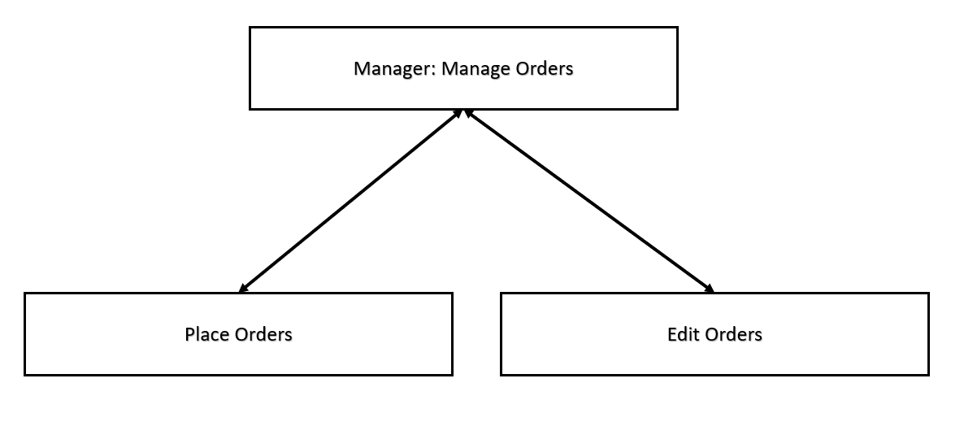](http://teamnovaproject.us/managerpage/viewbuses/)

|  |  |  |
| --- | --- | --- |
| [Bottom Up Integration](http://teamnovaproject.us/managerpage/viewbuses/) | | |
| [Step](http://teamnovaproject.us/managerpage/viewbuses/) | [Interface Tested](http://teamnovaproject.us/managerpage/viewbuses/) | [Test Cases](http://teamnovaproject.us/managerpage/viewbuses/) |
| [1](http://teamnovaproject.us/managerpage/viewbuses/) | [Place Orders](http://teamnovaproject.us/managerpage/viewbuses/) | [IT.1.1.1 - IT.1.1.5](http://teamnovaproject.us/managerpage/viewbuses/) |
| [2](http://teamnovaproject.us/managerpage/viewbuses/) | [Edit Orders](http://teamnovaproject.us/managerpage/viewbuses/) | [IT.1.1.6 - IT.1.1.13](http://teamnovaproject.us/managerpage/viewbuses/) |
| [3](http://teamnovaproject.us/managerpage/viewbuses/) | [Manager: Manage Orders](http://teamnovaproject.us/managerpage/viewbuses/) | [IT.1.1.14 - IT.1.16](http://teamnovaproject.us/managerpage/viewbuses/) |

|  |  |  |  |  |
| --- | --- | --- | --- | --- |
| **[Integration tests for Manager Manage Orders](http://teamnovaproject.us/managerpage/viewbuses/)** | | | | |
| **[Test Case](http://teamnovaproject.us/managerpage/viewbuses/)** | **[Description](http://teamnovaproject.us/managerpage/viewbuses/)** | **[Start at](http://teamnovaproject.us/managerpage/viewbuses/)** | **[Input](http://teamnovaproject.us/managerpage/viewbuses/)** | **[Output](http://teamnovaproject.us/managerpage/viewbuses/)** |
| [IT.1.1.1](http://teamnovaproject.us/managerpage/viewbuses/) | [Test of path 1. Invalid Username.](http://teamnovaproject.us/managerpage/viewbuses/) | [[http://teamnovaproject.us/managerpage/placecustomerorderbilling/](http://teamnovaproject.us/managerpage/viewbuses/)](http://teamnovaproject.us/managerpage/placecustomerorderbilling/) | **[Username:](http://teamnovaproject.us/managerpage/viewbuses/)**  [Invalidcustomer](http://teamnovaproject.us/managerpage/viewbuses/)  **[Credit Card Number:](http://teamnovaproject.us/managerpage/viewbuses/)**  [1234567891011121](http://teamnovaproject.us/managerpage/viewbuses/)  **[CVV Number:](http://teamnovaproject.us/managerpage/viewbuses/)**  [123](http://teamnovaproject.us/managerpage/viewbuses/)  **[Address:](http://teamnovaproject.us/managerpage/viewbuses/)**  [123 Something Rd.](http://teamnovaproject.us/managerpage/viewbuses/)  **[City:](http://teamnovaproject.us/managerpage/viewbuses/)**  [Brookings](http://teamnovaproject.us/managerpage/viewbuses/)  **[State:](http://teamnovaproject.us/managerpage/viewbuses/)**  [SD](http://teamnovaproject.us/managerpage/viewbuses/)  **[Zipcode:](http://teamnovaproject.us/managerpage/viewbuses/)**  [57006](http://teamnovaproject.us/managerpage/viewbuses/)  **[Bill Home:](http://teamnovaproject.us/managerpage/viewbuses/)**  [yes](http://teamnovaproject.us/managerpage/viewbuses/)  **[Click Enter](http://teamnovaproject.us/managerpage/viewbuses/)** | [[http://teamnovaproject.us/managerpage/placecustomerorderbilling/](http://teamnovaproject.us/managerpage/viewbuses/)](http://teamnovaproject.us/managerpage/placecustomerorderbilling/) |
| [IT.1.1.2](http://teamnovaproject.us/managerpage/viewbuses/) | [Test of path 2. Original load of page without Enter clicked.](http://teamnovaproject.us/managerpage/viewbuses/) | [[http://teamnovaproject.us/managerpage/placecustomerorderbilling/](http://teamnovaproject.us/managerpage/viewbuses/)](http://teamnovaproject.us/managerpage/placecustomerorderbilling/) | **[None](http://teamnovaproject.us/managerpage/viewbuses/)** | [[http://teamnovaproject.us/managerpage/placecustomerorderbilling/](http://teamnovaproject.us/managerpage/viewbuses/)](http://teamnovaproject.us/managerpage/placecustomerorderbilling/) |
| [IT.1.1.3](http://teamnovaproject.us/managerpage/viewbuses/) | [Test of path 3. Invalid Username. Bill Home not yes.](http://teamnovaproject.us/managerpage/viewbuses/) | [[http://teamnovaproject.us/managerpage/placecustomerorderbilling/](http://teamnovaproject.us/managerpage/viewbuses/)](http://teamnovaproject.us/managerpage/placecustomerorderbilling/) | **[Username:](http://teamnovaproject.us/managerpage/viewbuses/)**  [Invalidcustomer](http://teamnovaproject.us/managerpage/viewbuses/)  **[Credit Card Number:](http://teamnovaproject.us/managerpage/viewbuses/)**  [1234567891011121](http://teamnovaproject.us/managerpage/viewbuses/)  **[CVV Number:](http://teamnovaproject.us/managerpage/viewbuses/)**  [123](http://teamnovaproject.us/managerpage/viewbuses/)  **[Address:](http://teamnovaproject.us/managerpage/viewbuses/)**  [123 Something Rd.](http://teamnovaproject.us/managerpage/viewbuses/)  **[City:](http://teamnovaproject.us/managerpage/viewbuses/)**  [Brookings](http://teamnovaproject.us/managerpage/viewbuses/)  **[State:](http://teamnovaproject.us/managerpage/viewbuses/)**  [SD](http://teamnovaproject.us/managerpage/viewbuses/)  **[Zipcode:](http://teamnovaproject.us/managerpage/viewbuses/)**  [57006](http://teamnovaproject.us/managerpage/viewbuses/)  **[Bill Home:](http://teamnovaproject.us/managerpage/viewbuses/)**  [no](http://teamnovaproject.us/managerpage/viewbuses/)  **[Click Enter](http://teamnovaproject.us/managerpage/viewbuses/)** | [[http://teamnovaproject.us/managerpage/placecustomerorderbilling/](http://teamnovaproject.us/managerpage/viewbuses/)](http://teamnovaproject.us/managerpage/placecustomerorderbilling/) |
| [IT.1.1.4](http://teamnovaproject.us/managerpage/viewbuses/) | [Test of path 4.](http://teamnovaproject.us/managerpage/viewbuses/) | [[http://teamnovaproject.us/managerpage/placecustomerorderbilling/](http://teamnovaproject.us/managerpage/viewbuses/)](http://teamnovaproject.us/managerpage/placecustomerorderbilling/) | **[Username:](http://teamnovaproject.us/managerpage/viewbuses/)**  [customer](http://teamnovaproject.us/managerpage/viewbuses/)  **[Credit Card Number:](http://teamnovaproject.us/managerpage/viewbuses/)**  [1234567891011121](http://teamnovaproject.us/managerpage/viewbuses/)  **[CVV Number:](http://teamnovaproject.us/managerpage/viewbuses/)**  [123](http://teamnovaproject.us/managerpage/viewbuses/)  **[Address:](http://teamnovaproject.us/managerpage/viewbuses/)**  [123 Something Rd.](http://teamnovaproject.us/managerpage/viewbuses/)  **[City:](http://teamnovaproject.us/managerpage/viewbuses/)**  [Brookings](http://teamnovaproject.us/managerpage/viewbuses/)  **[State:](http://teamnovaproject.us/managerpage/viewbuses/)**  [SD](http://teamnovaproject.us/managerpage/viewbuses/)  **[Zipcode:](http://teamnovaproject.us/managerpage/viewbuses/)**  [57006](http://teamnovaproject.us/managerpage/viewbuses/)  **[Bill Home:](http://teamnovaproject.us/managerpage/viewbuses/)**  [yes](http://teamnovaproject.us/managerpage/viewbuses/)  **[Click Enter](http://teamnovaproject.us/managerpage/viewbuses/)** | [[http://teamnovaproject.us/managerpage/placecustomerorder/](http://teamnovaproject.us/managerpage/viewbuses/)](http://teamnovaproject.us/managerpage/placecustomerorder/) |
| [IT.1.1.5](http://teamnovaproject.us/managerpage/viewbuses/) | [Test of path 5.](http://teamnovaproject.us/managerpage/viewbuses/) | [[http://teamnovaproject.us/managerpage/placecustomerorderbilling/](http://teamnovaproject.us/managerpage/viewbuses/)](http://teamnovaproject.us/managerpage/placecustomerorderbilling/) | **[Username:](http://teamnovaproject.us/managerpage/viewbuses/)**  [Invalidcustomer](http://teamnovaproject.us/managerpage/viewbuses/)  **[Credit Card Number:](http://teamnovaproject.us/managerpage/viewbuses/)**  [1234567891011121](http://teamnovaproject.us/managerpage/viewbuses/)  **[CVV Number:](http://teamnovaproject.us/managerpage/viewbuses/)**  [123](http://teamnovaproject.us/managerpage/viewbuses/)  **[Address:](http://teamnovaproject.us/managerpage/viewbuses/)**  [123 Something Rd.](http://teamnovaproject.us/managerpage/viewbuses/)  **[City:](http://teamnovaproject.us/managerpage/viewbuses/)**  [Brookings](http://teamnovaproject.us/managerpage/viewbuses/)  **[State:](http://teamnovaproject.us/managerpage/viewbuses/)**  [SD](http://teamnovaproject.us/managerpage/viewbuses/)  **[Zipcode:](http://teamnovaproject.us/managerpage/viewbuses/)**  [57006](http://teamnovaproject.us/managerpage/viewbuses/)  **[Bill Home:](http://teamnovaproject.us/managerpage/viewbuses/)**  [no](http://teamnovaproject.us/managerpage/viewbuses/)  **[Click Enter](http://teamnovaproject.us/managerpage/viewbuses/)** | [[http://teamnovaproject.us/managerpage/placecustomerorder/](http://teamnovaproject.us/managerpage/viewbuses/)](http://teamnovaproject.us/managerpage/placecustomerorder/) |
| [IT.1.1.6](http://teamnovaproject.us/managerpage/viewbuses/) | [Test of path 1.](http://teamnovaproject.us/managerpage/viewbuses/) | [[http://teamnovaproject.us/managerpage/editcustomerorder/](http://teamnovaproject.us/managerpage/viewbuses/)](http://teamnovaproject.us/managerpage/editcustomerorder/) | **[Customer Username:](http://teamnovaproject.us/managerpage/viewbuses/)**  [customer](http://teamnovaproject.us/managerpage/viewbuses/)  **[Customer Order](http://teamnovaproject.us/managerpage/viewbuses/)**  **[Number:](http://teamnovaproject.us/managerpage/viewbuses/)**  [1](http://teamnovaproject.us/managerpage/viewbuses/)  **[Date:](http://teamnovaproject.us/managerpage/viewbuses/)**  *[current date](http://teamnovaproject.us/managerpage/viewbuses/)*  **[Starting Time:](http://teamnovaproject.us/managerpage/viewbuses/)**  *[current time + 2 hours](http://teamnovaproject.us/managerpage/viewbuses/)*  **[Starting Address:](http://teamnovaproject.us/managerpage/viewbuses/)**  [123 start st.](http://teamnovaproject.us/managerpage/viewbuses/)  **[Ending Address:](http://teamnovaproject.us/managerpage/viewbuses/)**  [123 end st.](http://teamnovaproject.us/managerpage/viewbuses/)  **[Click Enter](http://teamnovaproject.us/managerpage/viewbuses/)** | [[http://teamnovaproject.us/managerpage/editcustomerorder/](http://teamnovaproject.us/managerpage/viewbuses/)](http://teamnovaproject.us/managerpage/editcustomerorder/)  [Message: Success on editing Order](http://teamnovaproject.us/managerpage/viewbuses/) |
| [IT.1.1.7](http://teamnovaproject.us/managerpage/viewbuses/) | [Test of path 2. Original load of page without Enter clicked.](http://teamnovaproject.us/managerpage/viewbuses/) | [[http://teamnovaproject.us/managerpage/editcustomerorder/](http://teamnovaproject.us/managerpage/viewbuses/)](http://teamnovaproject.us/managerpage/editcustomerorder/) | **[None](http://teamnovaproject.us/managerpage/viewbuses/)** | [[http://teamnovaproject.us/managerpage/editcustomerorder/](http://teamnovaproject.us/managerpage/viewbuses/)](http://teamnovaproject.us/managerpage/editcustomerorder/) |
| [IT.1.1.8](http://teamnovaproject.us/managerpage/viewbuses/) | [Test of path 3. Invalid customer username.](http://teamnovaproject.us/managerpage/viewbuses/) | [[http://teamnovaproject.us/managerpage/editcustomerorder/](http://teamnovaproject.us/managerpage/viewbuses/)](http://teamnovaproject.us/managerpage/editcustomerorder/) | **[Customer Username:](http://teamnovaproject.us/managerpage/viewbuses/)**  [invalidcustomer](http://teamnovaproject.us/managerpage/viewbuses/)  **[Customer Order Number:](http://teamnovaproject.us/managerpage/viewbuses/)**  [1](http://teamnovaproject.us/managerpage/viewbuses/)  **[Date:](http://teamnovaproject.us/managerpage/viewbuses/)**  [2020-12-01](http://teamnovaproject.us/managerpage/viewbuses/)  **[Starting Time:](http://teamnovaproject.us/managerpage/viewbuses/)**  [12:01:01](http://teamnovaproject.us/managerpage/viewbuses/)  **[Starting Address:](http://teamnovaproject.us/managerpage/viewbuses/)**  [123 start st.](http://teamnovaproject.us/managerpage/viewbuses/)  **[Ending Address:](http://teamnovaproject.us/managerpage/viewbuses/)**  [123 end st.](http://teamnovaproject.us/managerpage/viewbuses/)  **[Click Enter](http://teamnovaproject.us/managerpage/viewbuses/)** | [[http://teamnovaproject.us/managerpage/editcustomerorder/](http://teamnovaproject.us/managerpage/viewbuses/)](http://teamnovaproject.us/managerpage/editcustomerorder/) |
| [IT.1.1.9](http://teamnovaproject.us/managerpage/viewbuses/) | [Test of path 4. Invalid customer order number.](http://teamnovaproject.us/managerpage/viewbuses/) | [[http://teamnovaproject.us/managerpage/editcustomerorder/](http://teamnovaproject.us/managerpage/viewbuses/)](http://teamnovaproject.us/managerpage/editcustomerorder/) | **[Customer Username:](http://teamnovaproject.us/managerpage/viewbuses/)**  [customer](http://teamnovaproject.us/managerpage/viewbuses/)  **[Customer Order Number:](http://teamnovaproject.us/managerpage/viewbuses/)**  [29000](http://teamnovaproject.us/managerpage/viewbuses/)  **[Date:](http://teamnovaproject.us/managerpage/viewbuses/)**  [2020-12-01](http://teamnovaproject.us/managerpage/viewbuses/)  **[Starting Time:](http://teamnovaproject.us/managerpage/viewbuses/)**  [12:01:01](http://teamnovaproject.us/managerpage/viewbuses/)  **[Starting Address:](http://teamnovaproject.us/managerpage/viewbuses/)**  [123 start st.](http://teamnovaproject.us/managerpage/viewbuses/)  **[Ending Address:](http://teamnovaproject.us/managerpage/viewbuses/)**  [123 end st.](http://teamnovaproject.us/managerpage/viewbuses/)  **[Click Enter](http://teamnovaproject.us/managerpage/viewbuses/)** | [[http://teamnovaproject.us/managerpage/editcustomerorder/](http://teamnovaproject.us/managerpage/viewbuses/)](http://teamnovaproject.us/managerpage/editcustomerorder/) |
| [IT.1.1.10](http://teamnovaproject.us/managerpage/viewbuses/) | [Test of path 5. Invalid date.](http://teamnovaproject.us/managerpage/viewbuses/) | [[http://teamnovaproject.us/managerpage/editcustomerorder/](http://teamnovaproject.us/managerpage/viewbuses/)](http://teamnovaproject.us/managerpage/editcustomerorder/) | **[Customer Username:](http://teamnovaproject.us/managerpage/viewbuses/)**  [customer](http://teamnovaproject.us/managerpage/viewbuses/)  **[Customer Order Number:](http://teamnovaproject.us/managerpage/viewbuses/)**  [1](http://teamnovaproject.us/managerpage/viewbuses/)  **[Date:](http://teamnovaproject.us/managerpage/viewbuses/)**  [1900-09-01](http://teamnovaproject.us/managerpage/viewbuses/)  **[Starting Time:](http://teamnovaproject.us/managerpage/viewbuses/)**  [12:01:01](http://teamnovaproject.us/managerpage/viewbuses/)  **[Starting Address:](http://teamnovaproject.us/managerpage/viewbuses/)**  [123 start st.](http://teamnovaproject.us/managerpage/viewbuses/)  **[Ending Address:](http://teamnovaproject.us/managerpage/viewbuses/)**  [123 end st.](http://teamnovaproject.us/managerpage/viewbuses/)  **[Click Enter](http://teamnovaproject.us/managerpage/viewbuses/)** | [[http://teamnovaproject.us/managerpage/editcustomerorder/](http://teamnovaproject.us/managerpage/viewbuses/)](http://teamnovaproject.us/managerpage/editcustomerorder/) |
| [IT.1.1.11](http://teamnovaproject.us/managerpage/viewbuses/) | [Test of path 6. Invalid date .](http://teamnovaproject.us/managerpage/viewbuses/) | [[http://teamnovaproject.us/managerpage/editcustomerorder/](http://teamnovaproject.us/managerpage/viewbuses/)](http://teamnovaproject.us/managerpage/editcustomerorder/) | **[Customer Username:](http://teamnovaproject.us/managerpage/viewbuses/)**  [customer](http://teamnovaproject.us/managerpage/viewbuses/)  **[Customer Order Number:](http://teamnovaproject.us/managerpage/viewbuses/)**  [1](http://teamnovaproject.us/managerpage/viewbuses/)  **[Date:](http://teamnovaproject.us/managerpage/viewbuses/)**  [2020-01-01](http://teamnovaproject.us/managerpage/viewbuses/)  **[Starting Time:](http://teamnovaproject.us/managerpage/viewbuses/)**  [12:01:01](http://teamnovaproject.us/managerpage/viewbuses/)  **[Starting Address:](http://teamnovaproject.us/managerpage/viewbuses/)**  [123 start st.](http://teamnovaproject.us/managerpage/viewbuses/)  **[Ending Address:](http://teamnovaproject.us/managerpage/viewbuses/)**  [123 end st.](http://teamnovaproject.us/managerpage/viewbuses/)  **[Click Enter](http://teamnovaproject.us/managerpage/viewbuses/)** | [[http://teamnovaproject.us/managerpage/editcustomerorder/](http://teamnovaproject.us/managerpage/viewbuses/)](http://teamnovaproject.us/managerpage/editcustomerorder/) |
| [IT.1.1.12](http://teamnovaproject.us/managerpage/viewbuses/) | [Test of path 7. Invalid date .](http://teamnovaproject.us/managerpage/viewbuses/) | [[http://teamnovaproject.us/managerpage/editcustomerorder/](http://teamnovaproject.us/managerpage/viewbuses/)](http://teamnovaproject.us/managerpage/editcustomerorder/) | **[Customer Username:](http://teamnovaproject.us/managerpage/viewbuses/)**  [customer](http://teamnovaproject.us/managerpage/viewbuses/)  **[Customer Order Number:](http://teamnovaproject.us/managerpage/viewbuses/)**  [1](http://teamnovaproject.us/managerpage/viewbuses/)  **[Date:](http://teamnovaproject.us/managerpage/viewbuses/)**  *[current date](http://teamnovaproject.us/managerpage/viewbuses/)*  **[Starting Time:](http://teamnovaproject.us/managerpage/viewbuses/)**  *[current time](http://teamnovaproject.us/managerpage/viewbuses/)*  **[Starting Address:](http://teamnovaproject.us/managerpage/viewbuses/)**  [123 start st.](http://teamnovaproject.us/managerpage/viewbuses/)  **[Ending Address:](http://teamnovaproject.us/managerpage/viewbuses/)**  [123 end st.](http://teamnovaproject.us/managerpage/viewbuses/)  **[Click Enter](http://teamnovaproject.us/managerpage/viewbuses/)** | [[http://teamnovaproject.us/managerpage/editcustomerorder/](http://teamnovaproject.us/managerpage/viewbuses/)](http://teamnovaproject.us/managerpage/editcustomerorder/) |
| [IT.1.1.13](http://teamnovaproject.us/managerpage/viewbuses/) | [Test of path 8. Invalid time and must be tested between 11:00 and 11:59 pm.](http://teamnovaproject.us/managerpage/viewbuses/) | [[http://teamnovaproject.us/managerpage/editcustomerorder/](http://teamnovaproject.us/managerpage/viewbuses/)](http://teamnovaproject.us/managerpage/editcustomerorder/) | **[Customer Username:](http://teamnovaproject.us/managerpage/viewbuses/)**  [customer](http://teamnovaproject.us/managerpage/viewbuses/)  **[Customer Order Number:](http://teamnovaproject.us/managerpage/viewbuses/)**  [1](http://teamnovaproject.us/managerpage/viewbuses/)  **[Date:](http://teamnovaproject.us/managerpage/viewbuses/)**  *[current date](http://teamnovaproject.us/managerpage/viewbuses/)*  **[Starting Time:](http://teamnovaproject.us/managerpage/viewbuses/)**  [11:58:01](http://teamnovaproject.us/managerpage/viewbuses/)  **[Starting Address:](http://teamnovaproject.us/managerpage/viewbuses/)**  [123 start st.](http://teamnovaproject.us/managerpage/viewbuses/)  **[Ending Address:](http://teamnovaproject.us/managerpage/viewbuses/)**  [123 end st.](http://teamnovaproject.us/managerpage/viewbuses/)  **[Click Enter](http://teamnovaproject.us/managerpage/viewbuses/)** | [[http://teamnovaproject.us/managerpage/editcustomerorder/](http://teamnovaproject.us/managerpage/viewbuses/)](http://teamnovaproject.us/managerpage/editcustomerorder/) |
| [IT.1.1.14](http://teamnovaproject.us/managerpage/viewbuses/) | [Test that tab to reach lower component tabs works.](http://teamnovaproject.us/managerpage/viewbuses/) | [http://teamnovaproject.us/managerpage/](http://teamnovaproject.us/managerpage/viewbuses/) | [Click Manage Orders tab.](http://teamnovaproject.us/managerpage/viewbuses/) | [Place Customer Order and Edit Customer Order tabs displayed](http://teamnovaproject.us/managerpage/viewbuses/) |
| [IT.1.1.15](http://teamnovaproject.us/managerpage/viewbuses/) | [Test that tab for Place Order component works](http://teamnovaproject.us/managerpage/viewbuses/) | [http://teamnovaproject.us/managerpage/](http://teamnovaproject.us/managerpage/viewbuses/) | [Click Manage Orders tab.](http://teamnovaproject.us/managerpage/viewbuses/)  [Click Place Customer Order tab.](http://teamnovaproject.us/managerpage/viewbuses/) | [http://teamnovaproject.us/managerpage/placecustomerorder/](http://teamnovaproject.us/managerpage/viewbuses/) |
| [IT.1.1.16](http://teamnovaproject.us/managerpage/viewbuses/) | [Test that tab for Edit Order component works](http://teamnovaproject.us/managerpage/viewbuses/) | [http://teamnovaproject.us/managerpage/](http://teamnovaproject.us/managerpage/viewbuses/) | [Click Manage Orders tab.](http://teamnovaproject.us/managerpage/viewbuses/)  [Click Edit Customer Order tab.](http://teamnovaproject.us/managerpage/viewbuses/) | [http://teamnovaproject.us/managerpage/editcustomerorder/](http://teamnovaproject.us/managerpage/viewbuses/) |

**[Testing Schedule](http://teamnovaproject.us/managerpage/viewbuses/)**

|  |  |  |  |  |
| --- | --- | --- | --- | --- |
| **[White Box Tests](http://teamnovaproject.us/managerpage/viewbuses/)** | | | | |
| **[Test Case Number](http://teamnovaproject.us/managerpage/viewbuses/)** | **[Date Tested](http://teamnovaproject.us/managerpage/viewbuses/)** | **[Team Nova Team Member Testing](http://teamnovaproject.us/managerpage/viewbuses/)** | **[Reference](http://teamnovaproject.us/managerpage/viewbuses/)** | **[Success](http://teamnovaproject.us/managerpage/viewbuses/)** |
| [UT.1.1.1](http://teamnovaproject.us/managerpage/viewbuses/) | [4/12/2018](http://teamnovaproject.us/managerpage/viewbuses/) | [Jacob Gordon](http://teamnovaproject.us/managerpage/viewbuses/) | [Unit Testing 1.1](http://teamnovaproject.us/managerpage/viewbuses/) |  |
| [UT.1.1.2](http://teamnovaproject.us/managerpage/viewbuses/) | [4/12/2018](http://teamnovaproject.us/managerpage/viewbuses/) | [Jacob Gordon](http://teamnovaproject.us/managerpage/viewbuses/) |  |
| [UT.1.1.3](http://teamnovaproject.us/managerpage/viewbuses/) | [4/12/2018](http://teamnovaproject.us/managerpage/viewbuses/) | [Jacob Gordon](http://teamnovaproject.us/managerpage/viewbuses/) |  |
| [UT.1.1.4](http://teamnovaproject.us/managerpage/viewbuses/) | [4/12/2018](http://teamnovaproject.us/managerpage/viewbuses/) | [Jacob Gordon](http://teamnovaproject.us/managerpage/viewbuses/) |  |
| [UT.1.1.5](http://teamnovaproject.us/managerpage/viewbuses/) | [4/12/2018](http://teamnovaproject.us/managerpage/viewbuses/) | [Jacob Gordon](http://teamnovaproject.us/managerpage/viewbuses/) |  |
| [UT.2.1.1](http://teamnovaproject.us/managerpage/viewbuses/) | [4/13/2018](http://teamnovaproject.us/managerpage/viewbuses/) | [John Hedman](http://teamnovaproject.us/managerpage/viewbuses/) | [Unit Testing 1.2](http://teamnovaproject.us/managerpage/viewbuses/) |  |
| [UT.2.1.2](http://teamnovaproject.us/managerpage/viewbuses/) | [4/13/2018](http://teamnovaproject.us/managerpage/viewbuses/) | [John Hedman](http://teamnovaproject.us/managerpage/viewbuses/) |  |
| [UT.2.1.3](http://teamnovaproject.us/managerpage/viewbuses/) | [4/13/2018](http://teamnovaproject.us/managerpage/viewbuses/) | [John Hedman](http://teamnovaproject.us/managerpage/viewbuses/) |  |
| [UT.2.1.4](http://teamnovaproject.us/managerpage/viewbuses/) | [4/13/2018](http://teamnovaproject.us/managerpage/viewbuses/) | [John Hedman](http://teamnovaproject.us/managerpage/viewbuses/) |  |
| [UT.2.1.5](http://teamnovaproject.us/managerpage/viewbuses/) | [4/13/2018](http://teamnovaproject.us/managerpage/viewbuses/) | [John Hedman](http://teamnovaproject.us/managerpage/viewbuses/) |  |
| [UT.2.1.6](http://teamnovaproject.us/managerpage/viewbuses/) | [4/13/2018](http://teamnovaproject.us/managerpage/viewbuses/) | [John Hedman](http://teamnovaproject.us/managerpage/viewbuses/) |  |
| [UT.2.1.7](http://teamnovaproject.us/managerpage/viewbuses/) | [4/13/2018](http://teamnovaproject.us/managerpage/viewbuses/) | [John Hedman](http://teamnovaproject.us/managerpage/viewbuses/) |  |
| [UT.2.1.8](http://teamnovaproject.us/managerpage/viewbuses/) | [4/14/2018](http://teamnovaproject.us/managerpage/viewbuses/) | [Nate Fleet](http://teamnovaproject.us/managerpage/viewbuses/) |  |
| [IT.1.1.1](http://teamnovaproject.us/managerpage/viewbuses/) | [4/14/2018](http://teamnovaproject.us/managerpage/viewbuses/) | [Nate Fleet](http://teamnovaproject.us/managerpage/viewbuses/) | [Integration Test](http://teamnovaproject.us/managerpage/viewbuses/) |  |
| [IT.1.1.2](http://teamnovaproject.us/managerpage/viewbuses/) | [4/14/2018](http://teamnovaproject.us/managerpage/viewbuses/) | [Nate Fleet](http://teamnovaproject.us/managerpage/viewbuses/) |  |
| [IT.1.1.3](http://teamnovaproject.us/managerpage/viewbuses/) | [4/14/2018](http://teamnovaproject.us/managerpage/viewbuses/) | [Nate Fleet](http://teamnovaproject.us/managerpage/viewbuses/) |  |
| [IT.1.1.4](http://teamnovaproject.us/managerpage/viewbuses/) | [4/14/2018](http://teamnovaproject.us/managerpage/viewbuses/) | [Nate Fleet](http://teamnovaproject.us/managerpage/viewbuses/) |  |
| [IT.1.1.5](http://teamnovaproject.us/managerpage/viewbuses/) | [4/14/2018](http://teamnovaproject.us/managerpage/viewbuses/) | [Nate Fleet](http://teamnovaproject.us/managerpage/viewbuses/) |  |
| [IT.1.1.6](http://teamnovaproject.us/managerpage/viewbuses/) | [4/14/2018](http://teamnovaproject.us/managerpage/viewbuses/) | [Nate Fleet](http://teamnovaproject.us/managerpage/viewbuses/) |  |
| [IT.1.1.7](http://teamnovaproject.us/managerpage/viewbuses/) | [4/14/2018](http://teamnovaproject.us/managerpage/viewbuses/) | [Nate Fleet](http://teamnovaproject.us/managerpage/viewbuses/) |  |
| [IT.1.1.8](http://teamnovaproject.us/managerpage/viewbuses/) | [4/15/2018](http://teamnovaproject.us/managerpage/viewbuses/) | [Mark Kirschenman](http://teamnovaproject.us/managerpage/viewbuses/) |  |
| [IT.1.1.9](http://teamnovaproject.us/managerpage/viewbuses/) | [4/15/2018](http://teamnovaproject.us/managerpage/viewbuses/) | [Mark Kirschenman](http://teamnovaproject.us/managerpage/viewbuses/) |  |
| [IT.1.1.10](http://teamnovaproject.us/managerpage/viewbuses/) | [4/15/2018](http://teamnovaproject.us/managerpage/viewbuses/) | [Mark Kirschenman](http://teamnovaproject.us/managerpage/viewbuses/) |  |
| [IT.1.1.11](http://teamnovaproject.us/managerpage/viewbuses/) | [4/15/2018](http://teamnovaproject.us/managerpage/viewbuses/) | [Mark Kirschenman](http://teamnovaproject.us/managerpage/viewbuses/) |  |
| [IT.1.1.12](http://teamnovaproject.us/managerpage/viewbuses/) | [4/15/2018](http://teamnovaproject.us/managerpage/viewbuses/) | [Mark Kirschenman](http://teamnovaproject.us/managerpage/viewbuses/) |  |
| [IT.1.1.13](http://teamnovaproject.us/managerpage/viewbuses/) | [4/15/2018](http://teamnovaproject.us/managerpage/viewbuses/) | [Mark Kirschenman](http://teamnovaproject.us/managerpage/viewbuses/) |  |