# Indiana University Signage Case Study | PRIME Sign ProgramIndiana Revenue Forecasting, LLC

1315 10th St, Room A203  
Bloomington, IN 47401

## To: Indiana State Budget Committee

## From: Jacob Alder, Revenue Analyst

## Date: January 26, 2021

## Re: 2022-2023 Indiana Quarterly Budget Forecast

Ahead of the Indiana state legislative session, and in coordination with IHS Global Insight, whose 2022/23 reports provided an outline for this memorandum, I prepared the following revenue forecast. The state has effectively managed the COVID-19 pandemic and consumer spending has returned to pre-pandemic levels. The Omnicron variant has caused some business and consumer uncertainty, and future coronavirus variants may emerge. After nearly two years of Hoosier response and flexibility, however, I am confident our state will continue to manage the uncertainty. The following revenue estimates reflect this confidence in the collective state resiliency and learned ability over the past two years.

Table . indiana Revenue Forecasts



Table 1 illustrates the revenue forecast for 2022-2023. State revenue from personal income taxes (PIT) will increase through the end of 2022 with a slight dip in Q4 but a substantial rebound in 2023 Q1. This performance is associated with historically strong end-of-year performance throughout the past twenty years. PIT revenues will taper slightly, declining by approximately 7% from the peak of Q1. State revenue from sales taxes (RST) will be highest in 2023 Q1 and remain relatively stable, but taper slightly through 2023, declining by only 0.1% over the year, as consumer spending remains strong.

## Method

I employed a linear spline regression to the third-degree on PIT and RST data covering 2000-2021, all published on the Indiana State Budget Authority (SBA) website.[1] These years take into account three recessions (dot.com, Great Recessions, COVID-19). The plots are included in the appendix; the blue line in Figure 1 shows the fitted PIT estimation against a box and whiskers plot grouped by fiscal year; the red line in Figure 2 shows the RST estimation against a similar boxplot of the corresponding RST data. The attentive observer will notice greater variation in the PIT (blue) graph in more recent years. This has a straightforward answer in the pandemic. I chose to include 2020 and 2021 PIT years for two reasons: first, consistency with the RST estimation; second, though these years report a wider variance, the expected value is on an estimable trajectory consistent with the previous years.

The third-degree polynomial estimation technique follows the format:

$$Y_{i}=Qtr+FY_{i}+F{Y_{i}}^{2}+F{Y_{i}}^{3}+ϵ_{i}$$

Where $Y_{i}$ is the tax (PIT or RST), $Qtr$ is the quarter of the fiscal year, and $FY_{i}$ is the Indiana fiscal year (squared and cubed). Using R, an open-source free statistical program, and the fixest package, I determined that the tightest forecast includes the previous recessions, especially the pandemic-induced recession. Finally, I report HC1 robust standard errors in the appendix, Table 2.

At this point, the state is cognizant that unpredictable natural disasters and acts of God do not fit neatly in budget forecasts. Thus, I make the following recommendations.

1. Effective budget forecasts must acknowledge forecasting *limitations*
2. Methodology trumps accuracy and *political agreement* to revisit and revise the forecast

## Recommendations

1. *Limitations:* The SBA will easily recall the quick unraveling of budget forecasts in 2020, and again in 2021. My forecast, while robust, contains assumptions about continued economic rebound, as evidenced by the previous strong quarters. Yet, estimation science is imprecise and the future will look different than the exact numbers provided here. Granted, I have designed my estimation model with a narrow error tolerance, and I submit the estimated revenues with confidence.
2. *Political agreement:* Unlike many other states in the U.S., Indiana’s budget building process is politically balanced, which may contribute to its accuracy.[2] This advantageous agreement enables the cohesive budget forecasts that gain general consensus. The process, however, is not part of statutory law. I recommend enshrining it in the Indiana constitution to protect the politically inclusive process for the years ahead.

## Conclusion

On behalf of Indiana Revenue Forecasting LLC, I submit this revenue forecast to the Governor with the confidence that Indiana’s continued recovery from the coronavirus pandemic will enable strong quarters and economic growth. I advise the SBA to keep watch on the personal income tax revenues, which have demonstrated wide variability in the recent past. Moving too quickly to finance large programs could set Indiana on an unstable trajectory. For now, the state’s strong recovery

## Appendix

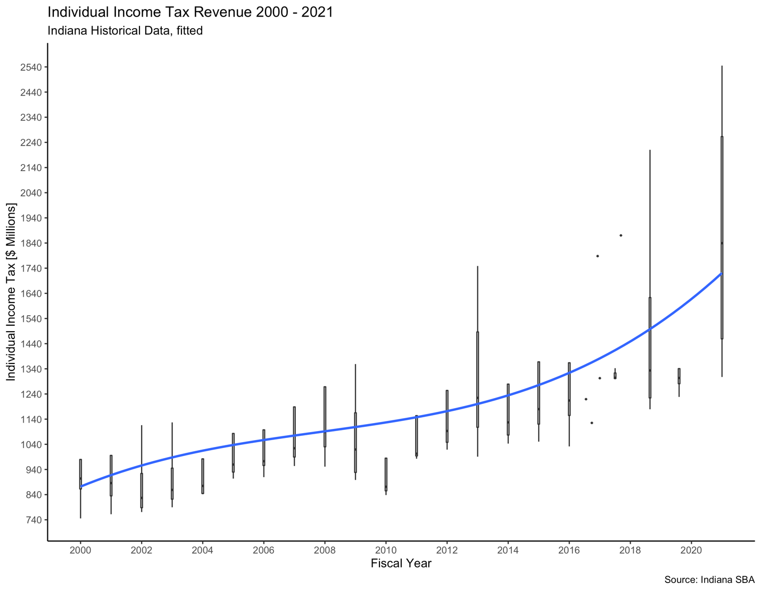

Figure Individual income tax Revenue

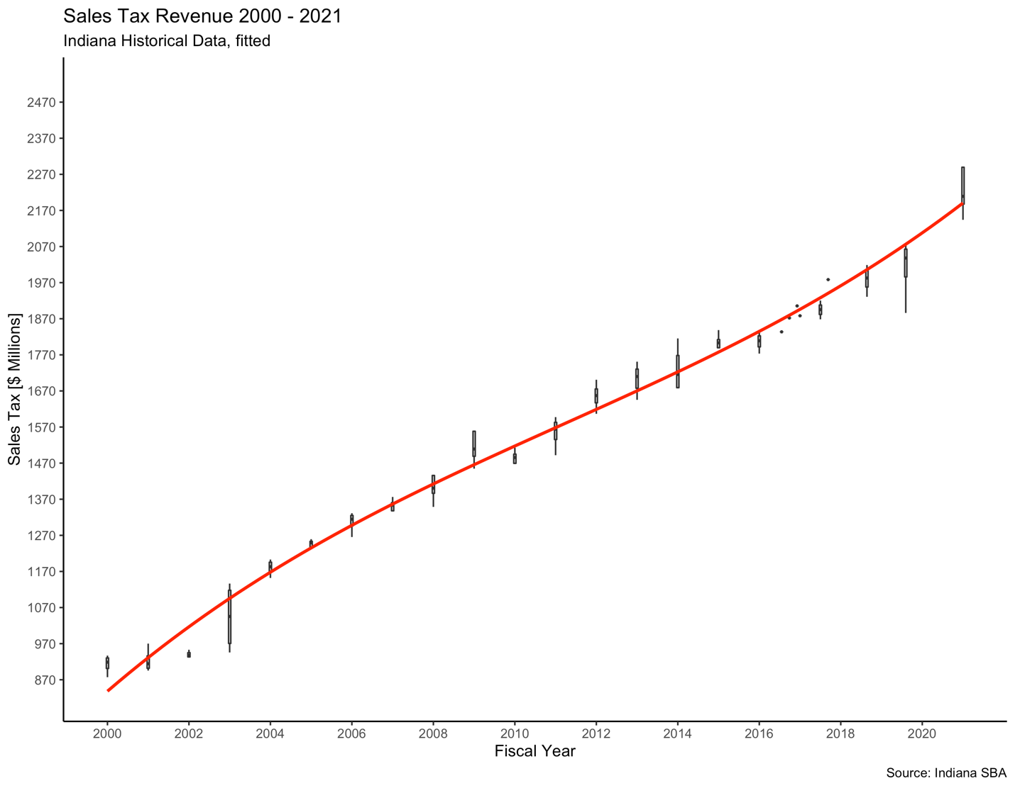

Figure Sales Tax Revenue

Table Model estimation results

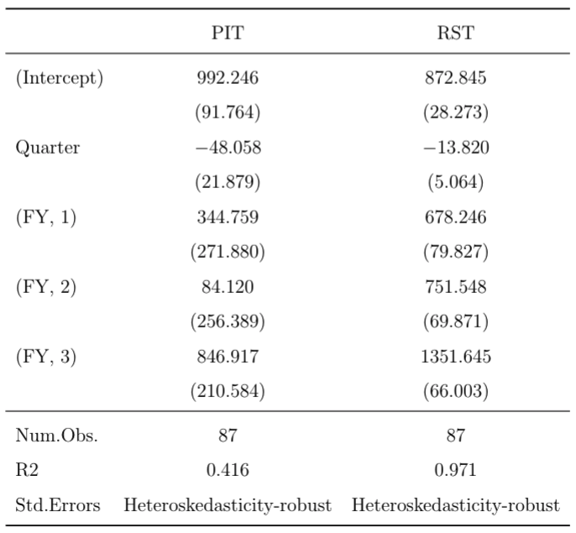

1. IN SBA, “Revenue Data”. Web. Accessed 26 Jan 2022. https://www.in.gov/sba/budget-information/revenue-data/fy2021-monthly-revenue-reports/
2. Mikesell J., and Ross J., 2013. “State Revenue Forecasts and Political Acceptance: The Value of Consensus Forecasting In The Budget Process” Indiana University Research Paper No. 2013-04-01.