**Project 1**

**<Executioner>**

CIS-5 (40137)

Jacob A. Velasquez

February 3, 2019

**Introduction**

“Executioner” has many names, more specifically it is commonly known has “Hangman,” growing up however, “Executioner” was our simplistic game. The rules are simple, the player must guess letters to create a word without guessing incorrectly and costing lives. The player is given a total of six lives, indicated by one body part per life and must retry when guessing the letter incorrectly. The player can be given a vague hint to what each word depicts with the number of letters as well indicated by blank spaces. A menu was setup to show different levels and how they can be accessed.

**Summary**

Project size: about 250 lines

The number of variables: about 20

The number of methods: 5

The project has a variety of concepts learned from Gaddis as well as Savitch. A menu was sufficient enough to engage the word being chosen, the only problem was once the word was guessed correctly then the player was not indicated whether they won but rather only if the player guesses incorrectly. A strong barrier that needs to be fixing would have to be engaging the player so that each letter guessed incorrectly would then be indicated as a body part being placed on the post. Rather as of right now the player can guess the right words but the program would continue to run despite winning.

**Flowchart**

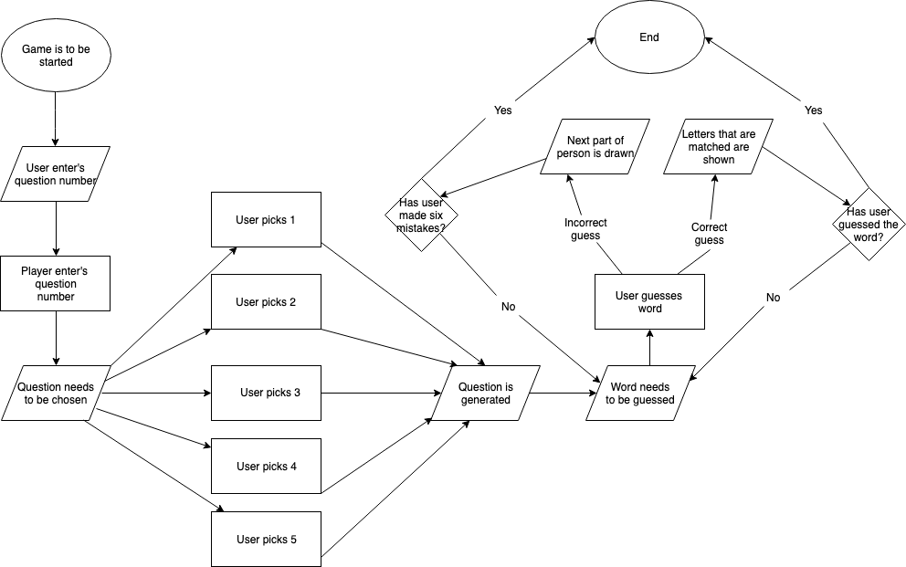

**Code:**

//System Libraries Here

#include <iostream>

#include <cstdlib>

#include <string>

#include <iomanip>

using namespace std;

//Program Execution Begins Here

int main(int argc, char** argv) {

//Declare all Variables Here

char choice;

//Show menu and loop

do{

//Display menu

cout<<endl<<endl<<"Type 0 to Exit"<<endl;

cout<<"Executioner Time!! Are you ready to save yourself?!"<<endl;

cout<<"Type 1 for Question 1!"<<endl;

cout<<"Type 2 for Question 2!"<<endl;

cout<<"Type 3 for Question 3!"<<endl;

cout<<"Type 4 for Question 4!"<<endl;

cout<<"Type 5 for Question 5!"<<endl<<endl;

//Input choice

cin>>choice;

//Place solutions to problems in switch statements

switch(choice){

case '1':{

//Declare all Variables Here

int chance = 0 ; //Amount of tries taken

char letter; //Letter input

int lives = 6; //Amount of lives

char num1 = '_', num2 = '_', num3 = '_', num4 = '_', num5 = '_';

char nu1 = 'J', nu2 = 'A', nu3 = 'C', nu4 = 'O', nu5 = 'B';

//Input data

cout<<"Executioner Time, use all caps please!"<<endl;

cout<<"What is my name (Jacob)?"<<endl;

do{

cout<<num1<<" "<<num2<<" "<<num3<<" "<<num4<<" "<<num5<<endl;

cout<<" _______ "<<endl;

cout<<" | | "<<endl;

cout<<" | O "<<endl;

cout<<" | /|/ "<<endl;

cout<<" | | "<<endl;

cout<<" | / / "<<endl;

cout<<"_|_ "<<endl;

cout<<"YOU HAVE "<<lives<<" CHANCES LEFT"<<endl;

cin>>letter;

cout<<endl;

cout<<endl;

//Process/Calculations Here

if (letter=='J'){

num1 = nu1;

cout<<"I guess you are winning, keep it up!"<<endl;

}

if (letter=='A'){

num2 = nu2;

cout<<"I guess you are winning, keep it up!"<<endl;

}

if (letter=='C'){

num3 = nu3;

cout<<"I guess you are winning, keep it up!"<<endl;

}

if (letter=='O'){

num4 = nu4;

cout<<"I guess you are winning, keep it up!"<<endl;

}

if (letter=='B'){

num5 = nu5;

cout<<"I guess you are winning, keep it up!"<<endl;

}

if (!(letter=='J'||letter=='A'||letter=='C'||letter=='O'||letter=='B')){

cout<<"Come on now that ain't one of the letters"<<endl;

chance=0+1;

}

lives=lives-chance;

}

while (lives>=1);{

cout<<"You got executed! The word was "<<nu1<<nu2<<nu3<<nu4<<nu5<<", let's go back to the menu to try again"<<endl;

exit(0);

}

break;

}

case '2':{

//Declare all Variables Here

int chance = 0 ; //Amount of tries taken

char letter; //Letter input

int lives = 6; //Amount of lives

char num1 = '_', num2 = '_', num3 = '_', num4 = '_', num5 = '_', num6 = '_';

char nu1 = 'J', nu2 = 'I', nu3 = 'G', nu4 = 'S', nu5 = 'A', nu6 = 'W';

//Input data

cout<<"Executioner Time, use all caps please!"<<endl;

cout<<"What is my favorite hobby growing up (Jigsaw)?"<<endl;

do{

cout<<num1<<" "<<num2<<" "<<num3<<" "<<num4<<" "<<num5<<" "<<num6<<endl;

cout<<" _______ "<<endl;

cout<<" | | "<<endl;

cout<<" | O "<<endl;

cout<<" | /|/ "<<endl;

cout<<" | | "<<endl;

cout<<" | / / "<<endl;

cout<<"_|_ "<<endl;

cout<<"YOU HAVE "<<lives<<" CHANCES LEFT"<<endl;

cin>>letter;

cout<<endl;

cout<<endl;

//Process/Calculations Here

if (letter=='J'){

num1 = nu1;

cout<<"I guess you are winning, keep it up!"<<endl;

}

if (letter=='I'){

num2 = nu2;

cout<<"I guess you are winning, keep it up!"<<endl;

}

if (letter=='G'){

num3 = nu3;

cout<<"I guess you are winning, keep it up!"<<endl;

}

if (letter=='S'){

num4 = nu4;

cout<<"I guess you are winning, keep it up!"<<endl;

}

if (letter=='A'){

num5 = nu5;

cout<<"I guess you are winning, keep it up!"<<endl;

}

if (letter=='W'){

num6 = nu6;

cout<<"I guess you are winning, keep it up!"<<endl;

}

if (!(letter=='J'||letter=='I'||letter=='G'||letter=='S'||letter=='A'||letter=='W')){

cout<<"Come on now that ain't one of the letters"<<endl;

chance=0+1;

}

lives=lives-chance;

}

while (lives>=1);{

cout<<"You got executed! The word was "<<nu1<<nu2<<nu3<<nu4<<nu5<<nu6<<", let's go back to the menu to try again"<<endl;

exit(0);

}

break;

}

case '3':{

//Declare all Variables Here

int chance = 0 ; //Amount of tries taken

char letter; //Letter input

int lives = 6; //Amount of lives

char num1 = '_', num2 = '_', num3 = '_', num4 = '_';

char nu1 = 'L', nu2 = 'O', nu3 = 'V', nu4 = 'E';

//Input data

cout<<"Executioner Time!! Are you ready to save yourself?!"<<endl;

cout<<"What emotion is prevalent in this month of February(Love)?"<<endl;

do{

cout<<num1<<" "<<num2<<" "<<num3<<" "<<num4<<endl;

cout<<" _______ "<<endl;

cout<<" | | "<<endl;

cout<<" | O "<<endl;

cout<<" | /|/ "<<endl;

cout<<" | | "<<endl;

cout<<" | / / "<<endl;

cout<<"_|_ "<<endl;

cout<<"YOU HAVE "<<lives<<" CHANCES LEFT"<<endl;

cin>>letter;

cout<<endl;

cout<<endl;

//Process/Calculations Here

if (letter=='L'){

num1 = nu1;

cout<<"I guess you are winning, keep it up!"<<endl;

}

if (letter=='O'){

num2 = nu2;

cout<<"I guess you are winning, keep it up!"<<endl;

}

if (letter=='V'){

num3 = nu3;

cout<<"I guess you are winning, keep it up!"<<endl;

}

if (letter=='E'){

num4 = nu4;

cout<<"I guess you are winning, keep it up!"<<endl;

}

if (!(letter=='L'||letter=='O'||letter=='V'||letter=='E')){

cout<<"Come on now that ain't one of the letters"<<endl;

chance=0+1;

}

lives=lives-chance;

}

while (lives>=1);{

cout<<"You got executed! The word was "<<nu1<<nu2<<nu3<<nu4<<", let's go back to the menu to try again"<<endl;

exit(0);

}

break;

}

case '4':{

//Declare all Variables Here

int chance = 0 ; //Amount of tries taken

char letter; //Letter input

int lives = 6; //Amount of lives

char num1 = '_', num2 = '_', num3 = '_', num4 = '_';

char nu1 = 'H', nu2 = 'A', nu3 = 'T', nu4 = 'E';

//Input data

cout<<"Executioner Time!! Are you ready to save yourself?!"<<endl;

cout<<"What is actually the emotion that fills up to those without love in this month(Hate)?"<<endl;

do{

cout<<num1<<" "<<num2<<" "<<num3<<" "<<num4<<endl;

cout<<" _______ "<<endl;

cout<<" | | "<<endl;

cout<<" | O "<<endl;

cout<<" | /|/ "<<endl;

cout<<" | | "<<endl;

cout<<" | / / "<<endl;

cout<<"_|_ "<<endl;

cout<<"YOU HAVE "<<lives<<" CHANCES LEFT"<<endl;

cin>>letter;

cout<<endl;

cout<<endl;

//Process/Calculations Here

if (letter=='H'){

num1 = nu1;

cout<<"I guess you are winning, keep it up!"<<endl;

}

if (letter=='A'){

num2 = nu2;

cout<<"I guess you are winning, keep it up!"<<endl;

}

if (letter=='T'){

num3 = nu3;

cout<<"I guess you are winning, keep it up!"<<endl;

}

if (letter=='E'){

num4 = nu4;

cout<<"I guess you are winning, keep it up!"<<endl;

}

if (!(letter=='H'||letter=='A'||letter=='T'||letter=='E')){

cout<<"Come on now that ain't one of the letters"<<endl;

chance=0+1;

}

lives=lives-chance;

}

while (lives>=1);{

cout<<"You got executed! The word was "<<nu1<<nu2<<nu3<<nu4<<", let's go back to the menu to try again"<<endl;

exit(0);

}

break;

}

case '5':{

//Declare all Variables Here

int chance = 0 ; //Amount of tries taken

char letter; //Letter input

int lives = 6; //Amount of lives

char num1 = '_', num2 = '_', num3 = '_', num4 = '_', num5 = '_';

char nu1 = 'P', nu2 = 'I', nu3 = 'A', nu4 = 'N',nu5 = 'O';

//Input data

cout<<"Executioner Time!! Are you ready to save yourself?!"<<endl;

cout<<"What has many keys, but can't even open a single door(Piano)?"<<endl;

do{

cout<<num1<<" "<<num2<<" "<<num3<<" "<<num4<<" "<<num5<<endl;

cout<<" _______ "<<endl;

cout<<" | | "<<endl;

cout<<" | O "<<endl;

cout<<" | /|/ "<<endl;

cout<<" | | "<<endl;

cout<<" | / / "<<endl;

cout<<"_|_ "<<endl;

cout<<"YOU HAVE "<<lives<<" CHANCES LEFT"<<endl;

cin>>letter;

cout<<endl;

cout<<endl;

//Process/Calculations Here

if (letter=='P'){

num1 = nu1;

cout<<"I guess you are winning, keep it up!"<<endl;

}

if (letter=='I'){

num2 = nu2;

cout<<"I guess you are winning, keep it up!"<<endl;

}

if (letter=='A'){

num3 = nu3;

cout<<"I guess you are winning, keep it up!"<<endl;

}

if (letter=='N'){

num4 = nu4;

cout<<"I guess you are winning, keep it up!"<<endl;

}

if (letter=='O'){

num5 = nu5;

cout<<"I guess you are winning, keep it up!"<<endl;

}

if (!(letter=='P'||letter=='I'||letter=='A'||letter=='N'||letter=='O')){

cout<<"Come on now that ain't one of the letters"<<endl;

chance=0+1;

}

lives=lives-chance;

}

while (lives>=1);{

cout<<"You got executed! The word was "<<nu1<<nu2<<nu3<<nu4<<nu5<<", let's go back to the menu to try again"<<endl;

exit(0);

}

break;

}

default:{

cout<<"Exit the Program"<<endl;

exit(0);

}

}

}while(choice>='1'&&choice<='5');

//Exit

return 0;

}

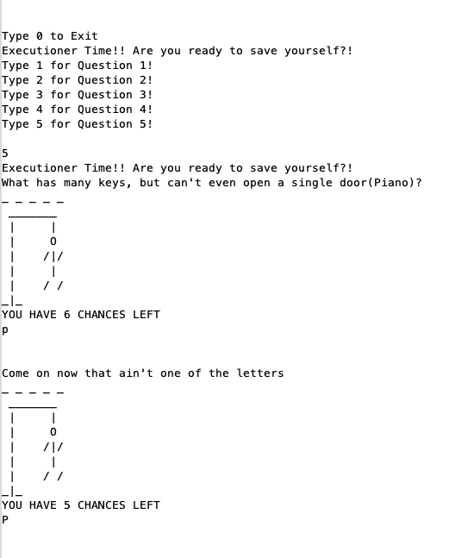**Screenshot of Input / Output**

