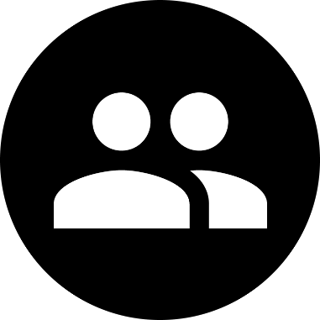

Friendly

Job Board Spin-Off

Jacob Brokaw | Full Stack Web Developer | Dec 13th, 2019

fsdp.jacobbrokaw.com

Welcome to the Docs

Good afternoon, presentation attendee! Welcome to my project documentation, the place where I explain the magic. Before we get into that though, let me take a moment to introduce myself.

Who am I?

Simply put, I’m a creator. Building computer applications, whether it be native or web, has always been exciting to me. I enjoy learning, and I strive to become a better developer by exposing myself to many different technologies. When building an application, the most rewarding experience to me is typing the backend, middle-tier, and front end together to create a seamless user-experience.

The “Friendship” Board

For my final project, I chose to work on the Job Board. But rather than focusing on jobs, I took the concept and applied it to friendships in the workplace.

Reflection

During the creation of Friendly, I focused on improving my project management skills and the way I build an application. This time, I finished every piece of functionality, before touching the UI. When looking back, I can confidently say that the quality and efficiency of my work benefitted tremendously. Of course, there’s always room for improvement though. In my future projects, I will continue to refine my workflow.

Project Overview

Friendly’s primary features:

* Easy application review process
* Ability to manage cliques (groups) and openings
* Apply to an opening with a single click
* Material Design compliant UI
* Seamless workflow between three types of users, Admin, Superior, and Friend

Database Diagram

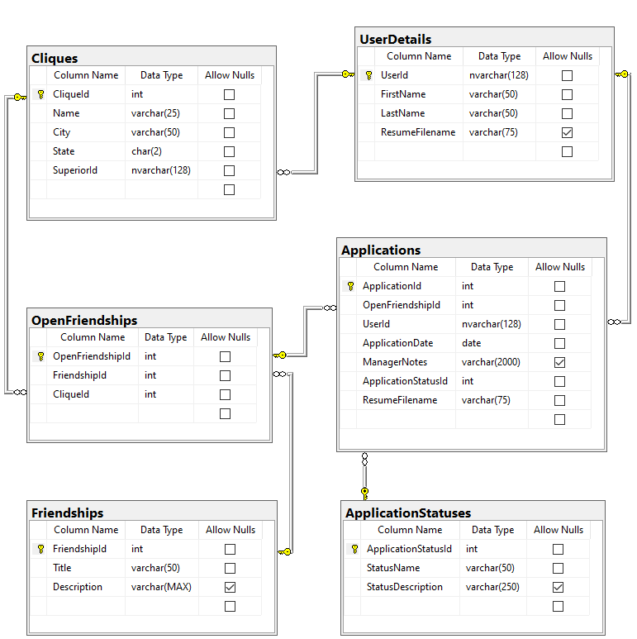

Permissions Overview

|  |  |  |  |  |
| --- | --- | --- | --- | --- |
| **Home** | Index | Support |  |  |
| Admin | X | X |  |  |
| ***Cliques*** | Index | Create | Edit | Delete |
| Admin | X | X | X | X |
| ***Friendships*** | Index | Create | Edit | Delete |
| Admin | X | X | X | X |
| Superior | X |  |  |  |
| ***Openings*** | Index | Create | Edit | Delete |
| Admin | X |  |  |  |
| Superior | X | X | X | X |
| Friend | X |  |  |  |
| ***Applications*** | Index | Details | Apply | Review |
| Admin | X | X |  |  |
| Superior | X | X |  | X |
| Friend | X | X | X |  |

User Interface Highlights

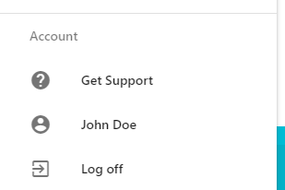

A dynamic account menu sits at the  
bottom of Friendly’s side nav

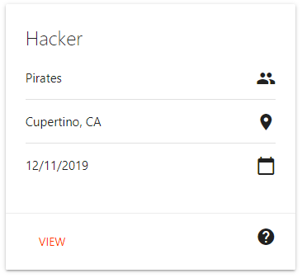Applications are tiled out into custom, responsive cards 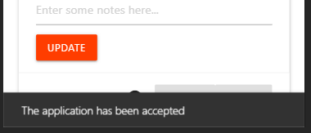

Using Materialize, I implemented toasts (unobtrusive notifications) to display dynamic information

Code Highlights

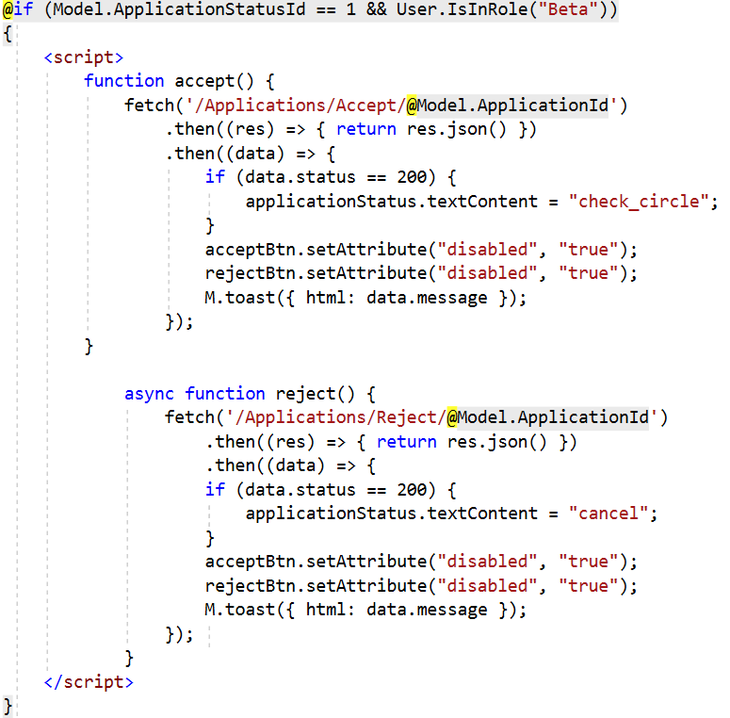

Rather than changing the status of an application through a form post, users can click a button and asynchronously call to the server.

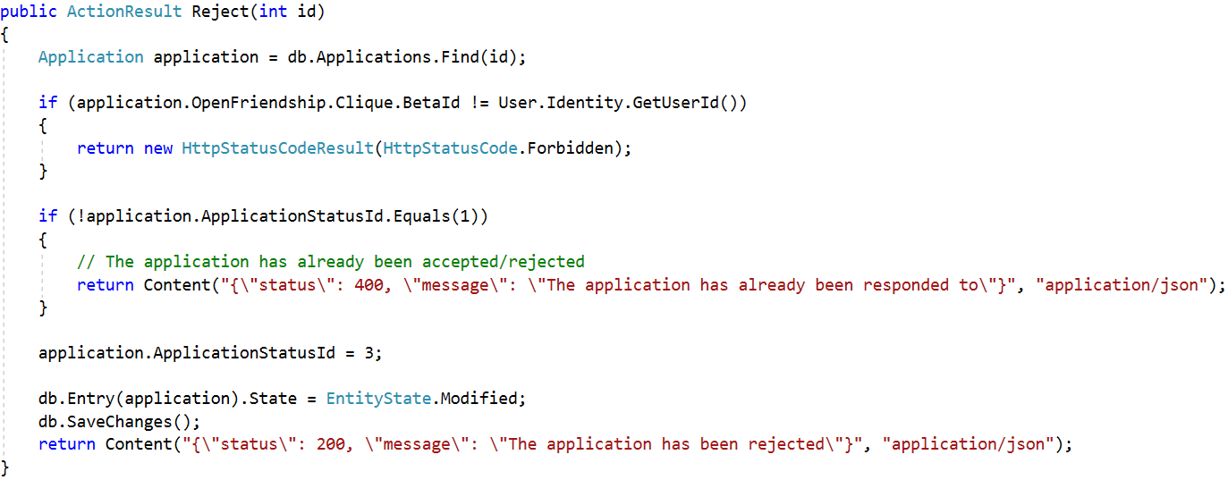

To update the status of an application, the server listens for a get request with an application ID. Instead of sending a View, the server sends a JSON response, allowing for an uninterrupted user experience.

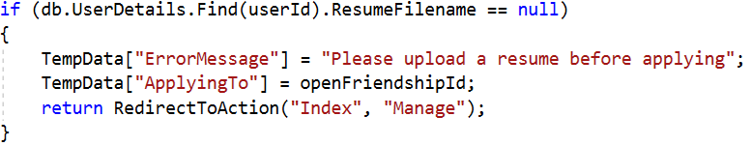

When applying to an open friendship, a user must have a resume. To ensure this, a simple if statement sends the user to their account management page, passing the ID of the open friendship they’re applying to. Once they save their resume, it will continue the application.