**Personal Portfolio Template**

(Group number)

(Nick Pettigrew – n9654488)

(Scrumbois)

**Artefact 1** – (**Final User Stories reposit**ory)

**(Description about what the artefact is in general)**

The Final User Story Repository (in the form of a power-point pack) combined all user stories collected in a single google docs page and collated them in a single document. These user stories were then categorised, and presented in a meaningful order in the required template.

Multiple versions of this document were formulated based on feedback received from the group members, to ensure consistency and that the final submission was reflective of what the group believed was a representation of the final product.

**(Brief description of how it was used/contribution to the project)**

The user stories formed the foundation of what the project is to become during both sprints. In referring to these stories, the group is able to ensure that what is being developed is in line with the functionality and acceptance criteria as depicted in each story.

In addition to this, the user stories also provided a sense of how much effort is to be spent to achieve the acceptance criteria for each story.

**(Screen capture of where it’s used)**

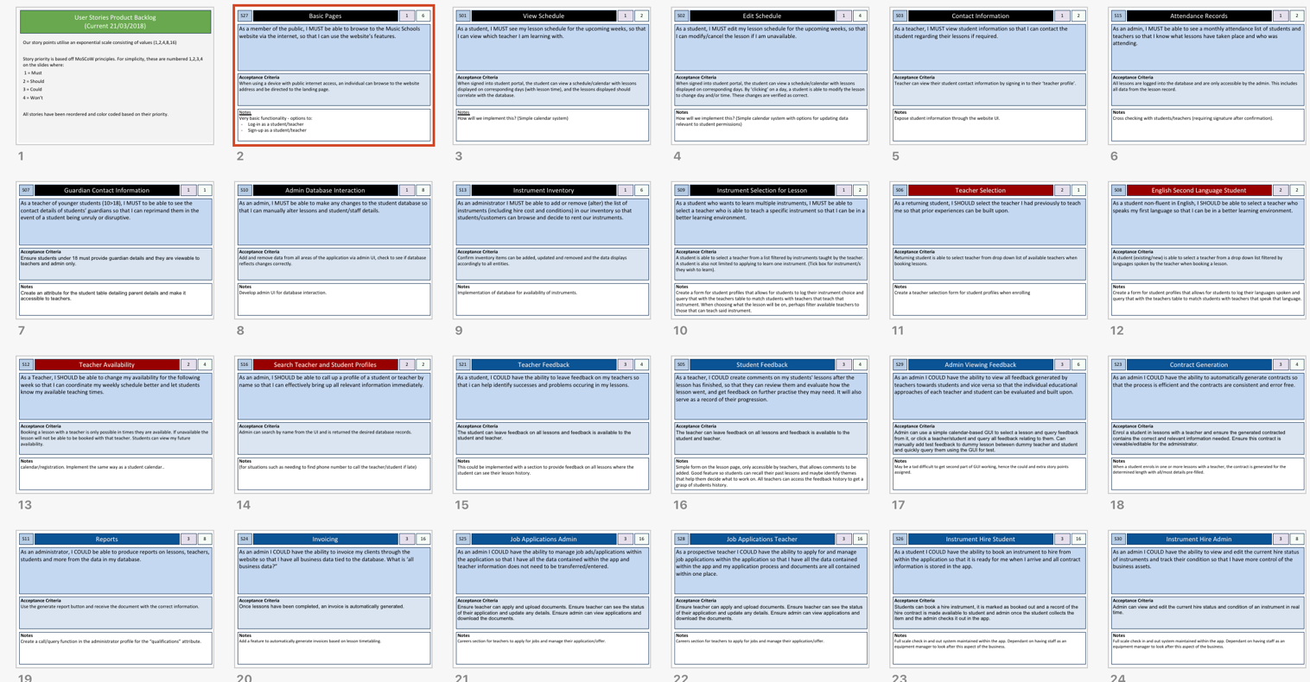

**Artefact 2** – **(User Interface Design)**

**(Description about what the artefact is in general)**

The User Interface Design artefact was created as a template (and early iteration mock-up) which incorporated each user requirement as described in the User Stories repository.

(Brief description of how it was used/contribution to the project)

In creating both a template page, and subsequent mock-up UI pages (based on this template) creation of the actual html Django template (and pages based on this template) were able to be coded in html5 and css3 with ease.

With the non-functional template and mock-up’s created, the draft UI was presented to the design team for feedback, at which point slight modifications were made to further improve upon.

**(Screen capture of where it’s used)**

|  |  |  |
| --- | --- | --- |
|  |  |  |
|  |  |  |
|  | |  |

**Artefact 3** – (**Django Project App/Page Template**)

**(Description about what the artefact is in general)**

The Django project app/page template allows any subsequent pages that are required to deliver the functional requirements of the Music School page to be created with minimal additional html5 code. Additionally, it means that each page created within the Django project is guaranteed to have the same ‘look and feel’ as each page.

**(Brief description of how it was used/contribution to the project)**

After creating the application (schedule) within the Django Project (v3, mma_3) which acts as the front-end (user facing) of the web-app a html template was created. To assist in simplicity within the template file, a static external ccs3 style sheet was also created to provide the html template with consistent styling and a basic yet functional structure (through floating divs). After combining these two files to formulate the basic template file, an index page was created which doubles as the landing/login page. For improved usability, this page was hard-coded as the default redirected landing page within the root ulrs.py file.

**(Screen capture of where it’s used)**

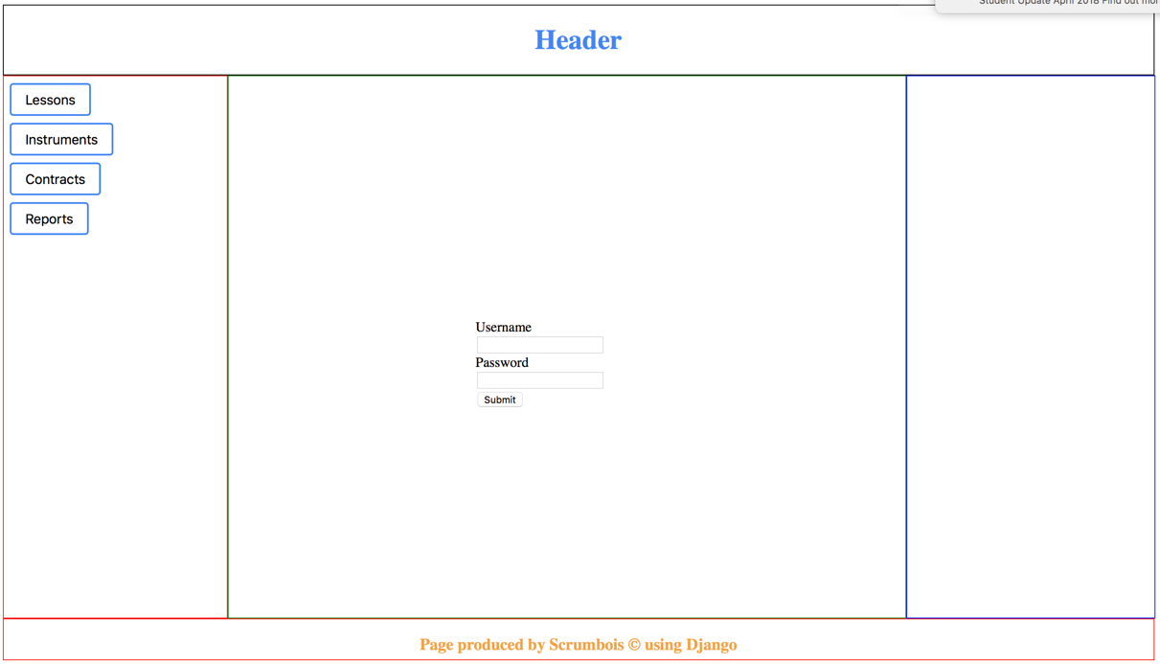

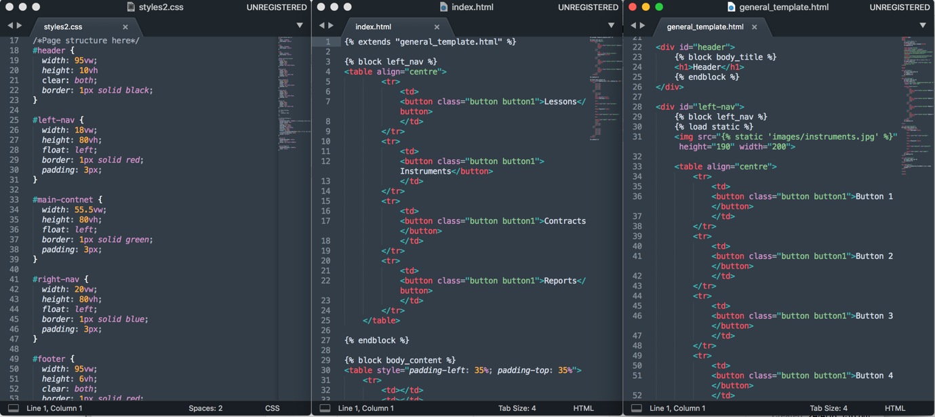

**Artefact 4** – **(Sprint & Release Planning spreadsheet)**

**(Description about what the artefact is in general)**

The Sprint & Release Planning Spreadsheet was formulated as a means to outline which stories would be assigned to each sprint, and detail how much effort would be required (in terms of story points) to deliver each.

**(Brief description of how it was used/contribution to the project)**

The spreadsheet was largely used as a planning tool to ensure the group had distributed the required user stories throughout the duration of both sprints in a way that would align with the teams likely velocity.

The spreadsheet was broken down into the number of stories in each sprint, for each release.

**(Screen capture of where it’s used)**

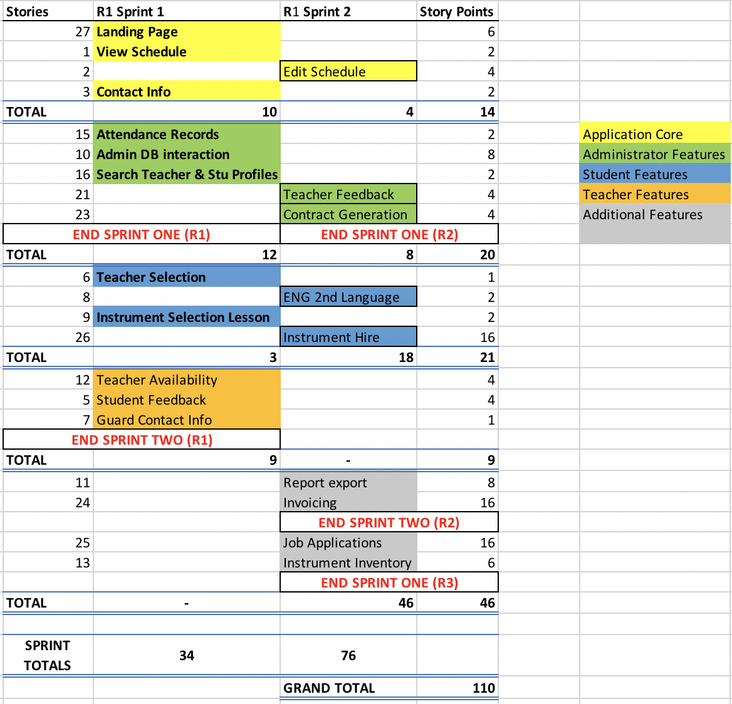

**Artefact 5** – (Name of Artefact)

(Description about what the artefact is in general)

…

(Brief description of how it was used/contribution to the project)

…

(Screen capture of where it’s used)

...

…