Are Archived NBA Consensus Moneylines Calibrated? A Pre-Specified Test of Favorite Pricing Across 15,351 Games
Jacob Burdier
The Scholars' Academy
August 2026
A pre-specified look at whether favorites in an archived NBA moneyline series were priced fairly, using a verified public archive
Abstract
Tests for bias in sports-betting prices often rely on small groups of games. That creates a power problem: a significant result can be fragile, while a non-significant result may simply be too weak to detect a meaningful effect. This study set its analysis strategy before looking at outcomes, defined the smallest effect worth detecting as the margin a bettor would need to overcome at the quoted prices, and then ran one primary test on 15,351 NBA regular-season games from 2007-08 through 2019-20.
Favorites with a vig-free implied probability above .70 (6,840 games) won 80.83 percent of the time, compared with an implied 80.26 percent. That is a 0.58 percentage-point gap (z = 1.22, p = .223). The estimate is stable across six variance estimators that allow correlation within seasons and within teams, none of which rejects calibration. At the quoted prices a bettor needed favorites to outperform their vig-free probability by 3.01 percentage points to break even, against a design able to detect 1.33 points, so the observed gap is well inside the region the test was built to rule out.
Two qualifications are reported rather than buried. A logistic calibration regression does not reject perfect calibration under most variance estimators, but does under two-way clustering on season and team (p = .037), an estimator that is unreliable at 13 clusters. And of five vig-removal rules, four leave the gap below its own break-even threshold while one, power normalization, produces a gap of -1.31 points against a 1.24-point threshold.
The study also quantifies a methodological issue: comparing outcomes with raw implied probabilities, without removing the vig, manufactures an apparent favorite bias of 2.5 percentage points that is the bookmaker margin rather than evidence about bettors.
Keywords: sports betting, market calibration, favorite-longshot bias, pre-specified analysis, vig removal, statistical power, NBA
1. Introduction
Legal sports betting is now a large consumer market in the United States. State-regulated sportsbooks accepted roughly $149.9 billion in wagers during 2024 (American Gaming Association, 2025). That scale makes it worth asking how well prices work, but it does not make every statistical finding about those prices convincing. A dataset can include thousands of games and still leave only a few dozen observations in the odds range that builds a conclusion.
A short power calculation makes the issue clear. A 74-game group of favorites priced near .85, the kind of narrow bucket often used in these studies, has only about 7 percent power to detect a 1.7 percentage-point pricing deviation. Even samples of several hundred games often miss moderate deviations. That creates two risks: a significant result from a small group can turn on one or two outcomes, and a null result can be uninformative because the test was never able to detect the effect in the first place.
This study is built to avoid that trap, and it asks one question:
Do the archived consensus moneylines in this series systematically misstate the win probability of favorites by an amount large enough to be both statistically detectable and economically exploitable?
The population is NBA regular-season games from 2007-08 through 2019-20. The primary estimand is the calibration gap among favorites whose vig-free implied probability exceeds .70. The threshold, the analysis plan, and the smallest effect worth detecting were all fixed before outcomes were examined. With 6,840 games in that group the design detects a deviation of 1.33 percentage points at 80 percent power, comfortably below the 3.01-point break-even requirement a bettor actually faces. Whatever the outcome, the result is informative.
1.1 Three questions that are easy to conflate
This literature moves quickly between three claims that are related but not equivalent, and this paper is careful about which one it makes.
Calibration asks whether stated probabilities match realized frequencies. Profitability asks whether a betting rule earns a positive return after paying the quoted price. Market efficiency asks whether available information is impounded in prices so thoroughly that no systematic strategy can exploit it.
A market can be well calibrated on average and still contain predictable conditional patterns. It can also carry small calibration errors that no bettor could monetize once the margin is paid. This paper's primary estimand is calibration, with a secondary and direct test of flat-stake profitability. It is not a test of general informational efficiency, and no such claim is made.
2. Background
Fama (1970) frames market efficiency as a question about what information prices absorb. Betting markets offer a clean version of that test because every price settles against a known outcome. Early point-spread work on professional football generally found that simple public betting rules did not produce stable profits (Zuber, Gandar, & Bowers, 1985; Sauer, Brajer, Ferris, & Marr, 1988), although profitability, calibration, and price efficiency are connected but distinct questions.
Four strands of that literature bear on this study, and they disagree with one another in ways worth naming.
The first is behavioral. Longshot bias means longshots are overpriced and return less than favorites, the classic result in horse racing (Griffith, 1949; Thaler & Ziemba, 1988). Favorite bias is the reverse. Because the labels are used inconsistently, this paper follows Newall and Cortis (2021). Woodland and Woodland (2001) report favorite bias in NHL money lines.
The second concerns how bookmakers set prices. Levitt (2004) argues that a book can shade prices toward bettor demand rather than balancing every position. That is a candidate mechanism for mispricing, not evidence that mispricing exists. Paul and Weinbach (2008) find that NBA favorites attract a disproportionate share of tickets but do not find that betting against them beats the market.
The third asks whether any of it survives costs. Moskowitz (2021) finds that behavioral patterns in betting prices are too small to clear transaction costs. Angelini and De Angelis (2019) test odds across many books and find most markets efficient at the best available price.
The fourth is methodological, and it is where this paper sits. Winkelmann, Otting, Deutscher, and Makarewicz (2024) benchmark inefficiency tests against simulated and real odds and ask whether the tests themselves are up to the job. What is still missing is an NBA moneyline calibration analysis with a pre-specified comparison and an explicit power justification. This paper is not trying to rediscover favorite bias. It asks whether an adequately powered, economically anchored test can separate real favorite mispricing from the artifact created by the bookmaker's margin.
3. Data
The data are consensus moneylines and final scores for 15,490 NBA regular-season games from 2007-08 through 2019-20, originally published by the sportsbookreviewsonline.com archive and redistributed in the public repository accompanying Dotan's UCLA master's thesis (Dotan, 2020). Files were retrieved unmodified on 20 July 2026.
The archive reports one moneyline for each side of a game, but it does not say whether the line is an opening or closing quote, and it does not identify the originating sportsbook. This paper therefore calls the object an archived consensus moneyline and avoids treating it as a closing line. That distinction is not cosmetic: a price recorded in the morning and a price recorded seconds before tip-off are different economic objects, and nothing in this dataset distinguishes them. One further sign that the series is a composite rather than a single book's quote is that one game is recorded with a booksum below one, which no single book would offer.
3.1 Verification
Because the data passed through two intermediaries, they were audited before analysis began. A stratified sample of 260 games, 20 from each of the 13 seasons, was checked directly against the live primary archive. All 260 moneylines matched exactly on both sides, including extreme prices such as -1300 against +800, and all 260 outcomes matched the final scores.
That sample was drawn by hand rather than by a seeded random procedure, so it should be read as a stratified spot check that found no errors, not as a probabilistic guarantee about the remaining games. The stronger claim rests on an automated check that covers the whole file. The same source repository ships a separate team-game-level extraction with its own moneyline and outcome columns, and every value in the analysis file is compared against it: 30,978 prices and 15,490 outcomes, with no discrepancy. Season game counts match the true NBA schedule in every year, including the 990-game 2011-12 lockout season, the 1,229-game 2012-13 season after one cancellation, and the 971 games played before the March 2020 suspension. One game is missing a moneyline in the source, matching the source thesis's own description. The verification script and its full output are published with the replication materials.
3.2 Exclusions and profile
The analysis excludes one game with a missing moneyline and 138 pick'em games, where neither side is a favorite. That leaves 15,351 games. The source thesis's processing pipeline had already removed 986 playoff games, so the analysis covers the regular season only. The mean overround on the analysis sample is 3.77 percent, and favorite vig-free implied probabilities range from .502 to .985.
The series ends in March 2020 because that is where the source archive ends. It therefore predates the subsequent expansion of legal sports betting in the United States. No claim is made here about whether that expansion changed market behavior; it is simply outside the sample.
4. Methods
The analysis plan was written and frozen before any outcome data were examined, and it is published in full with the replication materials. The record of that freeze is internal to the author's files rather than lodged with an outside registry, so the work is described throughout as pre-specified rather than pre-registered. The limitations section explains why that distinction matters.
4.1 Probabilities and the favorite
American odds convert to a raw implied probability. For negative odds q equals the absolute value of the odds divided by that value plus 100; for positive odds q equals 100 divided by the odds plus 100. The two raw probabilities of a game sum to more than one, and the excess is the bookmaker's margin.
Writing the two raw probabilities as q1 and q2, and their sum as P, the primary analysis removes the margin proportionally:
p1 = q1 / P and p2 = q2 / P
This assumes the margin is taken in proportion to price, so that in absolute terms the favorite absorbs more of it than the underdog. That is one assumption among several, and because the entire distinction between an apparent favorite bias and a calibration gap depends on it, four alternatives are tested in section 5.4. The favorite is the side with the higher vig-free probability. Raw probabilities are retained for the sensitivity analysis.
4.2 The primary test
The single confirmatory hypothesis concerns favorites whose vig-free implied probability exceeds .70. Under the null each game is a Bernoulli trial with its own probability, so the number of favorite wins follows a Poisson-binomial distribution with mean equal to the sum of the game-level probabilities and variance equal to the sum of p(1 - p). The test compares actual wins with that expected sum and uses the corresponding game-level null variance. It is two-sided at alpha = .05. Because implied probabilities vary game by game, this construction replaces the fixed-probability bucket tests common in the literature, which treat every game in a bucket as carrying the same probability.
4.3 Dependence
The Poisson-binomial framework treats games as independent conditional on their own prices. That is standard for a calibration test, but these observations are not obviously independent, and the assumption deserves to be named rather than assumed.
Dependence within a game is not an issue, because only one favorite outcome is analyzed per game and the two sides are collinear by construction. Four other channels are plausible. Each team appears in roughly a thousand games, so a team the market persistently misjudges would correlate its own residuals across the sample. Roster rules, pace, officiating and market structure are common within a season. Injuries and news propagate across nearby games. And a consensus price aggregates books that share information, so pricing errors need not be idiosyncratic.
None of this changes the point estimate; all of it can change the standard error. Section 5.4 therefore re-estimates the gap under cluster-robust variance at the season level, the favorite-team level, the underdog-team level, and two-way, and adds a team-blocked bootstrap alongside the season-blocked one. The confirmatory test is retained in its pre-specified form; the question asked of these alternatives is only whether the conclusion survives them.
4.4 Power
The null result matters only if the design could have caught a deviation worth caring about, so the calculation is stated in full. Let p be the vig-free implied probability of each game in the primary group and n the number of games. The standard error of the gap is the square root of the sum of p(1 - p), divided by n. For a two-sided test at alpha, power against a true gap is the probability that the standardized estimate exceeds the critical value in either tail, and the minimum detectable effect at target power is the sum of the two critical values multiplied by the standard error. The variance is the heterogeneous per-game one rather than a single pooled value, so the calculation reflects the actual distribution of prices.

Parameter | Value
Primary group n | 6,840
Significance level (two-sided) | α = .05
Target power | .80
Null model | Poisson-binomial, per-game variance
Standard error of the gap | 0.474 pp
Critical values z(α/2), z(power) | 1.960, 0.842
Minimum detectable effect | 1.33 pp
Break-even requirement | 3.01 pp
Observed gap | +0.58 pp
Table 1. Power parameters for the primary test. The minimum detectable effect is the sum of the two critical values multiplied by the standard error. Figure 3 plots the full power curve behind these numbers.
4.5 The economic bar
A calibration gap matters to a bettor only when it is larger than the share of the margin carried by the favorite side of the price. That share equals the raw implied probability minus the vig-free probability, computed game by game. In the primary group it averages 3.01 percentage points, with a 10th-to-90th-percentile range of 2.35 to 3.72. Across all favorites it averages 2.61 points, and in the extreme tail 3.02 points. Because the design's minimum detectable effect is 1.33 points, the test can detect favorite mispricing well below the level a bettor could actually exploit.
4.6 Confirmatory and exploratory analyses
The distinction is kept explicit throughout, because it governs how much weight each result can carry.

Confirmatory, fixed in advance | Exploratory, added at review
Primary Poisson-binomial test above .70 | Season-by-season gaps and Cochran Q
Logistic calibration regression | Extreme tail above .90
Five fixed probability buckets, Holm corrected | Season-blocked and team-blocked bootstrap
Flat-stake returns | Cluster-robust variance estimators
Raw-probability sensitivity check | Alternative vig-removal rules
Table 2. Only the left column was pre-specified. Results in the right column are reported as exploratory and are not corrected for multiplicity across the family.
5. Results
5.1 Primary result
The primary group contains 6,840 games, 44.6 percent of the sample. Favorites won 5,529 games against an expected 5,489.45, an observed rate of 80.83 percent against an implied 80.26 percent. The gap is +0.58 percentage points, with z = 1.22 and p = .223. The test does not reject calibration. The direction of the gap runs toward favorites winning slightly more often than their price implies, which is the opposite of the favorite bias the study was designed to detect.
5.2 Continuous calibration
The logistic regression gives an intercept of -0.047 (95% CI: -0.107 to 0.013) and a slope of 1.049 (95% CI: 0.982 to 1.116). Under classical standard errors the joint Wald test of perfect calibration gives chi-squared = 2.45 with p = .293. Section 5.4 reports how that test behaves under clustered variance, where it is less stable than the primary test. Figure 1 shows the decile calibration plot.
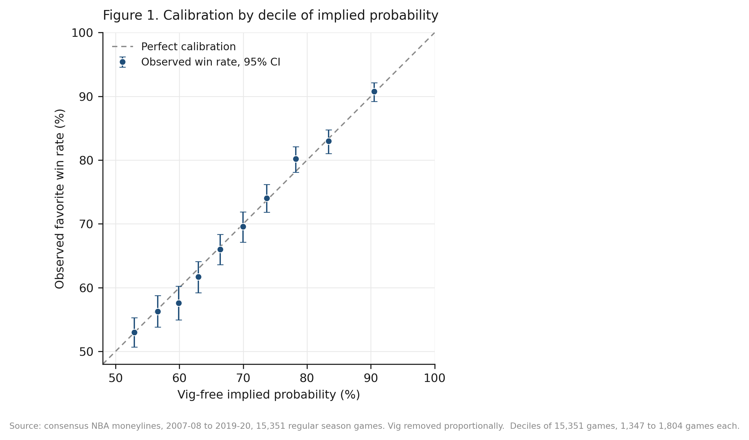
Figure 1. Observed favorite win rates against vig-free implied probability, by decile of implied probability, with 95 percent Wilson intervals, against the line of perfect calibration. Deciles of 15,351 games, 1,347 to 1,804 games each. Each game is weighted equally. Archived consensus moneylines, 2007-08 to 2019-20, vig removed proportionally.
5.3 Bucket results
None of the pre-specified buckets reject after the Holm correction. The largest deviation is +1.73 points in the .75 to .80 range, with a raw p of .091 and a Holm-adjusted p of .457.

Bucket | n | Observed | Implied | Expected wins | Gap (pp) | z | p | Holm p
(.50, .60] | 4,064 | 54.45% | 55.44% | 2,253.1 | -0.99 | -1.27 | .204 | .817
(.60, .70] | 4,447 | 64.11% | 64.85% | 2,883.9 | -0.74 | -1.04 | .300 | .899
(.70, .75] | 1,933 | 73.10% | 72.39% | 1,399.3 | +0.71 | 0.70 | .485 | .970
(.75, .80] | 1,661 | 79.11% | 77.38% | 1,285.3 | +1.73 | 1.69 | .091 | .457
(.80, 1.00] | 3,246 | 86.32% | 86.41% | 2,804.9 | -0.09 | -0.15 | .880 | .970
Table 3. Pre-specified probability buckets, Poisson-binomial test in each, Holm correction across the five. Expected wins is the sum of the game-level vig-free probabilities in the bucket.
5.4 Robustness
Three families of check are reported: across seasons, across dependence structures, and across vig-removal rules. The first two leave the primary conclusion intact. The third leaves it intact under four of five rules and qualifies it under the fifth.
Across seasons, no individual season rejects the null. The 13 season-level gaps range from -2.82 to +2.52 percentage points and every p value is above .10. Heterogeneity is assessed with the Cochran Q statistic in its meta-analytic form, which is a test of whether the season gaps differ from one another by more than sampling noise, not a test that the pooled gap is zero. Writing y for the season gap and w for the inverse of its Poisson-binomial null variance, Q is the sum of w times the squared deviation of y from the inverse-variance-weighted mean, referred to a chi-squared distribution on twelve degrees of freedom. Constructed that way, Q = 8.37 with p = .756 and I-squared at 0 percent, so there is no detectable variation across seasons. In the extreme tail above .90 implied probability, 756 games produce a +0.63-point gap with p = .506; its minimum detectable effect of 2.66 points sits just below its 3.02-point break-even requirement, so even the thinnest pre-specified slice is adequately powered for economically relevant bias.
Dependence is the more serious concern, and the primary estimate is unmoved by it. Table 4 re-estimates the same gap under variance estimators that allow correlation within seasons and within teams. The point estimate is +0.58 points in every specification by construction; what changes is the standard error, which ranges from 0.39 to 0.53 points against the Poisson-binomial value of 0.47. No estimator rejects calibration. A team-blocked bootstrap over 32 favorite teams gives a 95 percent interval of -0.52 to +1.57 points, wider than the season-blocked interval of -0.19 to +1.26 and still containing zero.

Variance estimator | Clusters | SE (pp) | z | p | 95% CI (pp)
Poisson-binomial (primary test) | — | 0.47 | 1.22 | .223 | -0.35 to +1.51
Independent, classical | — | 0.47 | 1.23 | .218 | -0.34 to +1.50
Clustered by season | 13 | 0.39 | 1.50 | .134 | -0.18 to +1.33
Clustered by favorite team | 32 | 0.53 | 1.09 | .276 | -0.46 to +1.62
Clustered by underdog team | 33 | 0.50 | 1.16 | .246 | -0.40 to +1.56
Two-way, season and favorite team | 13 | 0.48 | 1.22 | .224 | -0.35 to +1.51
Table 4. The primary calibration gap under six variance estimators. The gap is +0.58 pp throughout; only its standard error changes. None rejects calibration at .05.
The logistic calibration regression is less stable than the primary test under the same treatment. Its joint Wald p is .293 with classical errors, .221 clustering on favorite team, .181 on underdog team, .085 on season, and .037 two-way on season and team. The last of those would reject perfect calibration at .05. It is reported rather than omitted, with the caveat that cluster-robust variance is unreliable when the number of clusters is small, and thirteen seasons is small enough that the estimator is known to understate variance and overstate significance. The reading this paper takes is that the confirmatory result is robust, the secondary regression is sensitive to how dependence is modeled, and a reader who prefers the two-way estimate should treat the calibration slope as unresolved rather than confirmed.
Vig removal is the assumption the whole analysis rests on, so four alternatives to proportional normalization were run. Under additive normalization each side gives up the same number of probability points. Under power normalization each raw probability is raised to a common exponent. Shin (1993) prices against a share of insider money, which loads more margin onto longshots; for a two-outcome book Shin's solution turns out to coincide exactly with the additive rule, which was verified symbolically to forty decimal digits and numerically across the whole sample. Under the constant-odds-ratio rule the quoted and fair odds differ by a common factor.

Vig-removal rule | n | Gap (pp) | z | p | Break-even (pp) | Verdict
None, raw probabilities | 8,014 | -2.50 | -5.90 | <.001 | — | artifact
Proportional (primary) | 6,840 | +0.58 | 1.22 | .223 | 3.01 | below
Additive, equal margin | 7,120 | -0.60 | -1.32 | .186 | 1.88 | below
Shin (1993) | 7,120 | -0.60 | -1.32 | .186 | 1.88 | below
Constant odds ratio | 7,202 | -0.74 | -1.63 | .104 | 1.79 | below
Power | 7,211 | -1.31 | -2.91 | .004 | 1.24 | exceeds
Table 5. The primary test under five vig-removal rules, plus the no-normalization case. Verdict compares the absolute gap with that rule's own break-even requirement. Shin and additive coincide exactly for a two-outcome book.
The headline reading survives, with one qualification stated plainly. Four of the five rules leave the gap below its own break-even threshold and none of those four is significant at .05. The fifth, power normalization, produces a gap of -1.31 points against a 1.24-point threshold, and it is significant at p = .004. Under that rule alone the sample would show a small, statistically detectable favorite bias marginally above the level a bettor would need to overcome, in the direction of betting underdogs, with a margin over break-even of seven hundredths of a percentage point. Power normalization is also the rule that behaves least plausibly at extreme prices, pushing heavy favorites toward implied probabilities above what any of the other rules produce. The honest summary is that the conclusion is robust to the normalization choice under four of five rules and is not universal across all of them.
5.5 Returns
The dollar-return results tell the same story. Flat one-dollar bets at the quoted prices lose money in every direction: -4.06 percent per bet on all favorites (95% CI: -5.13 to -3.00), -3.91 percent on all underdogs (-6.57 to -1.25), and -2.90 percent on favorites above .70 (-4.04 to -1.76). Those losses are consistent with the 3.77 percent mean overround. Figure 2 shows that observed returns in every bucket are within the confidence interval around the return expected when prices are calibrated. Put directly against the economic hurdle, the observed +0.58-point calibration gap, and even its +1.26-point upper bound, fall well short of the +3.01 points a favorite bettor needed at these prices.
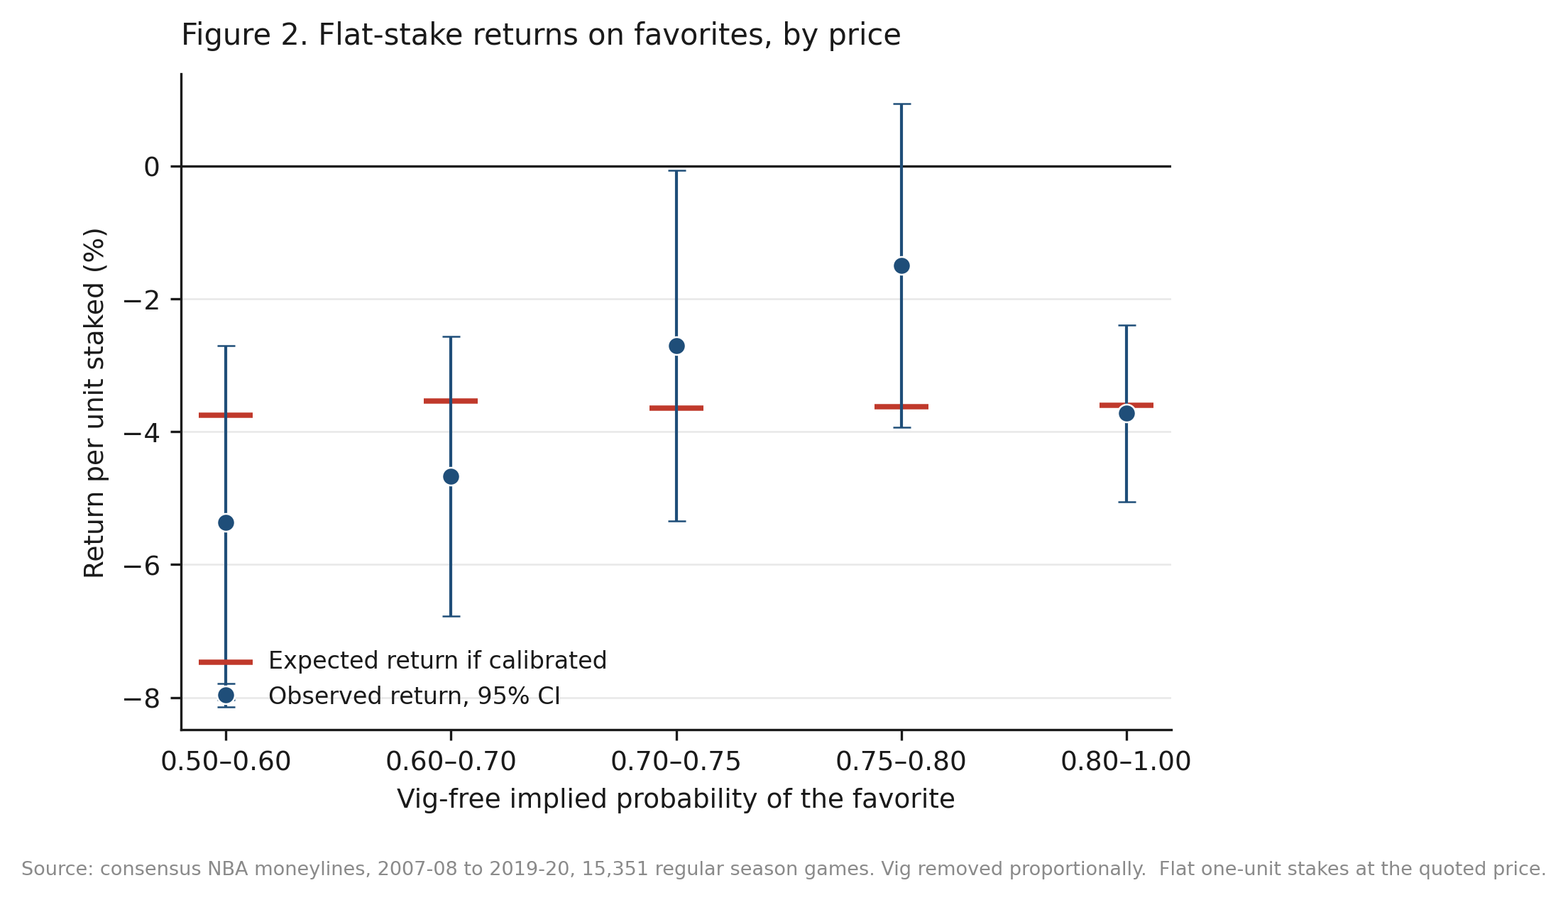
Figure 2. Flat one-dollar stakes on the favorite at the quoted price, by bucket of vig-free implied probability, with 95 percent intervals. The expected-return marker in each bucket is computed from the actual quoted odds in that bucket under the assumption that the vig-free probabilities are correct; it differs across buckets because the payout structure differs. Archived consensus moneylines, 2007-08 to 2019-20.
5.6 A methodological caution
Testing observed win rates against raw implied probabilities, without removing the vig, produces an apparent favorite bias of -2.50 percentage points with z = -5.90. Under proportional vig removal that gap is the bookmaker's margin rather than anything about bettor behavior. The artifact reading is conditional on the normalization being approximately correct, and both raw and normalized results are reported so a reader can see exactly what the assumption is doing. The point matters because several bucket-test designs in circulation skip vig removal entirely, and Table 5 shows that the sign of the headline finding flips with that single step.
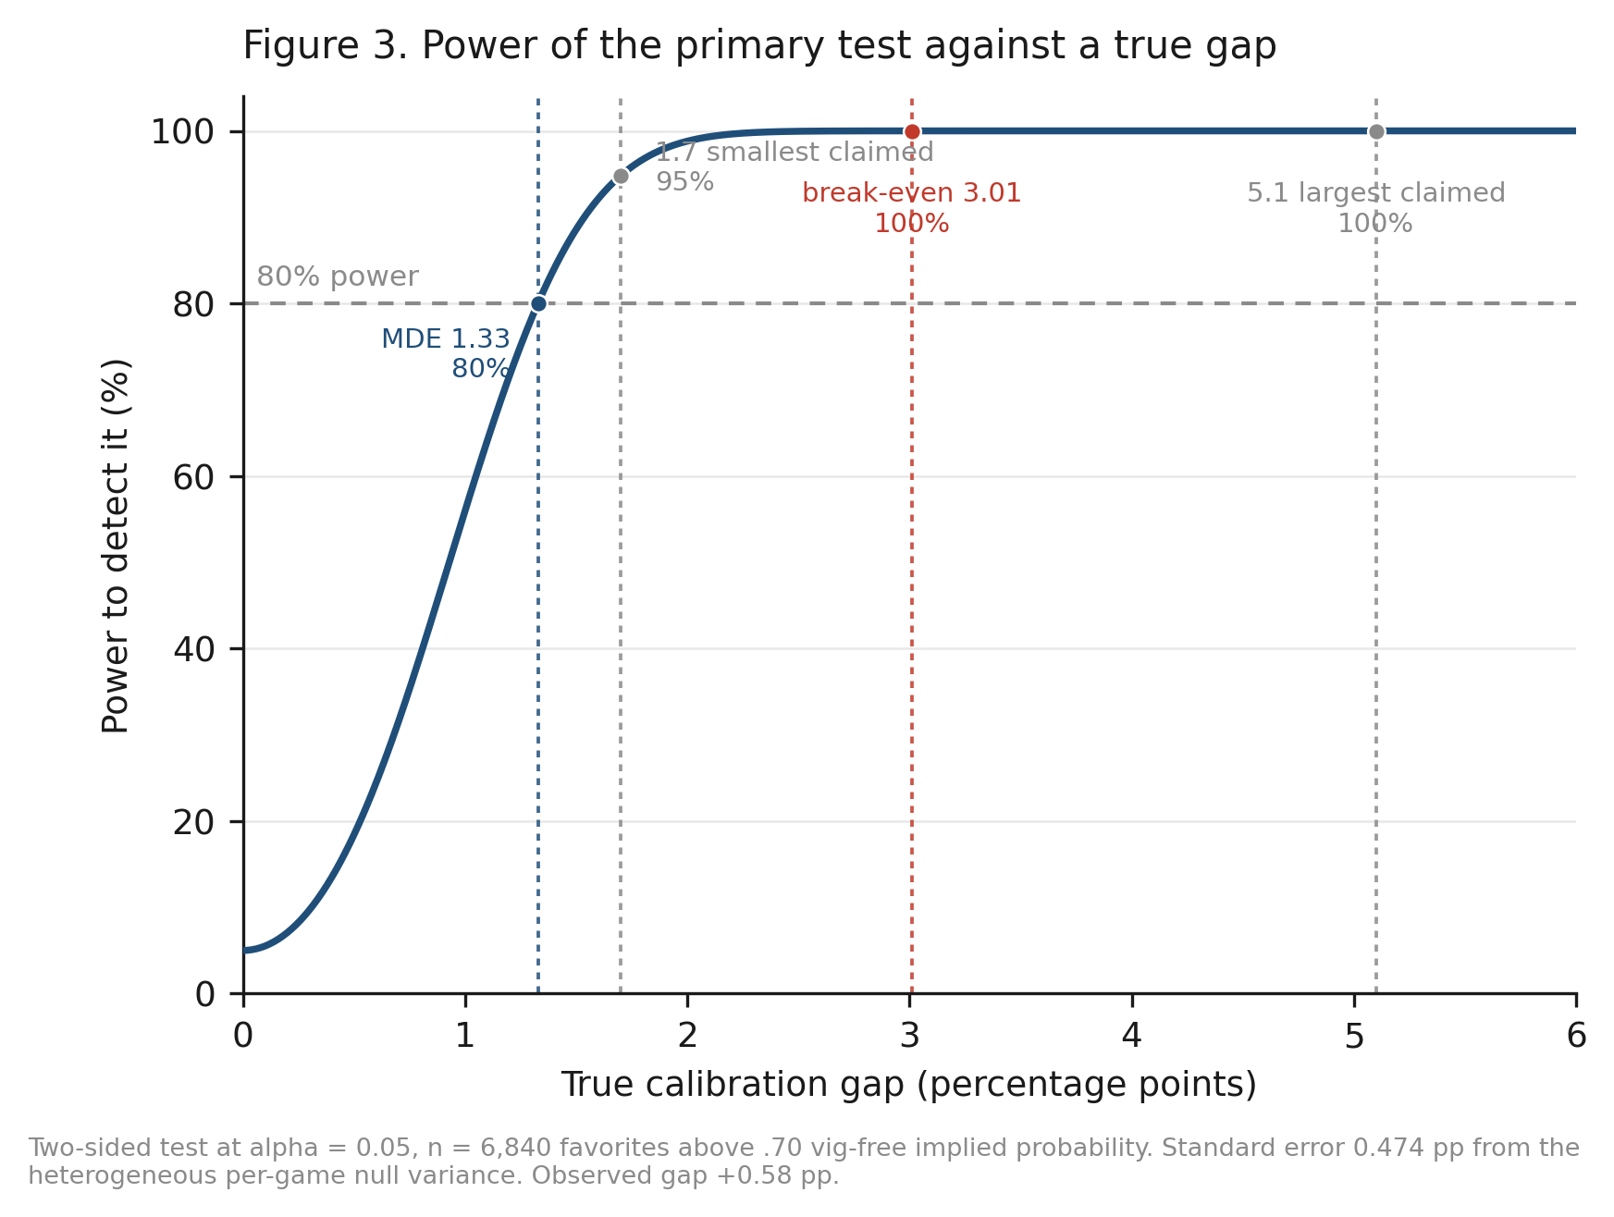
Figure 3. Power of the primary test against a true calibration gap, two-sided at alpha = .05, n = 6,840, standard error 0.474 pp from the heterogeneous per-game null variance. Marked: the 1.33-point minimum detectable effect, the 1.7 and 5.1-point ends of the range claimed in prior work, and the 3.01-point break-even requirement.
6. Discussion
The null result needs to be read narrowly. In these archived consensus moneylines, pooled across 2007 to 2020 and within every season and pre-specified odds range examined, the aggregate favorite calibration gap was smaller than the design's 1.33-point minimum detectable effect and well below the 3.01-point break-even requirement. The estimate holds up under variance estimators that allow correlation within seasons and within teams.
What the result does not establish is broader. It does not rule out localized situational biases outside the pre-specified slices, mispricing at individual books, inefficiency in opening lines, or edges available by shopping for the best price across books. It says nothing about informational efficiency in general, and nothing about the post-2020 market. Because the timing of each quote is undocumented, it also cannot speak to closing-line efficiency, and this paper deliberately makes no claim about how professional bettors benchmark themselves.
The finding is consistent with the broader literature. Moskowitz (2021) reaches a similar conclusion for betting markets generally: whatever behavioral patterns exist in prices are too small to survive costs. The contribution here is the form of the test rather than the surprise of the answer. One pre-specified comparison, a power justification fixed in advance, an economic anchor computed from the actual quoted prices, a data layer verified against an independent extraction, and a robustness program that reports the one specification which does not agree.
The design's power is what makes the null meaningful. A narrow bucket of a few dozen games could not have detected the biases commonly claimed in this literature; this design could have. Figure 3 makes the claim exact rather than rhetorical: power is 95 percent against a 1.7-point gap, the smallest commonly claimed, and effectively certain against gaps of three points or more.
Read together with Table 5, the more durable contribution is methodological. An analyst who compares outcomes with raw implied probabilities in this sample finds a 2.5-point favorite bias at z = -5.90 and would reasonably report it as a behavioral result. It is the margin. A pre-specified, adequately powered, economically anchored calibration test can tell those two things apart, and that is the part of this design worth reusing.
7. Limitations
Several limits define the reach of these findings. The sample includes regular-season games only and ends in March 2020, where the source archive ends, so the conclusions describe that period. The archive provides one consensus line per game, which means the data cannot speak to line shopping, best-price execution, or the identity of the sportsbook, and the timing of each quote is undocumented at the source.
Proportional vig removal is one of several possible normalizations. Four alternatives are reported in section 5.4; four of five leave the conclusion unchanged and power normalization does not, which is stated rather than set aside. The archive has no ticket-share data, so claims about public betting cannot be tested here. The 260-game primary-source audit was drawn by hand rather than by a seeded random procedure and should be read accordingly; the full-sample cross-validation is the stronger evidence.
The primary test assumes games are independent conditional on their prices. Cluster-robust estimators and block bootstraps relax that assumption and leave the primary result unchanged, but the season-level estimators rest on only thirteen clusters, which is too few for cluster-robust variance to be reliable, and the two-way estimate of the calibration regression should be treated with corresponding caution in both directions. Equal-weight calibration is also a different question from dollar-weighted profitability, which is why the flat-stake return analysis is reported directly.
Finally, the analysis plan was fixed before outcome data were examined, but the record of that freeze is internal to the author's files rather than lodged with an outside registry, so its timing is not independently verifiable and the work is described as pre-specified rather than pre-registered. The plan itself is published in full with the replication materials, and the design leaves little room for undisclosed flexibility: there is one named primary comparison, a threshold and an effect-size floor both set from stated reasoning rather than from the outcome data, and exploratory analyses reported separately and labeled as such. Readers who wish to check the stronger claim can re-run the confirmatory pipeline, which reproduces every reported statistic from the raw archive.
8. Conclusion
A pre-specified, adequately powered, economically anchored test on verified data finds the archived NBA consensus moneylines in this series calibrated: over 15,351 games, favorites were priced correctly to within a fraction of the bookmaker's own margin, and the estimate holds under variance estimators that allow correlation within seasons and within teams.
For bettors, the practical lesson is that in the archived consensus prices examined here, simply choosing favorites or underdogs did not offer an exploitable edge. That statement is deliberately confined to this series and this period; it is not a claim about the NBA betting market in general, and the one normalization rule that disagrees is reported in section 5.4.
For researchers, the design points a way past a recurring problem in the literature, where underpowered bucket tests produce results, in either direction, that cannot support the conclusions drawn from them, and where a step as ordinary as removing the vig determines the sign of the headline finding.
Data and Code Availability
Data. The underlying historical odds archive is publicly available from sportsbookreviewsonline.com and is redistributed in the repository accompanying Dotan (2020) at https://github.com/guydotan/ucla-thesis. The derived analysis dataset is published with the replication materials, together with a script that re-downloads the complete upstream files, prints their SHA-256 hashes, and confirms that every retained column matches the original row for row.
Code. All scripts required to reproduce the reported results, tables and figures are available at https://github.com/jacobburdier05/nba-moneyline-calibration. A single command runs verification, dataset construction, the confirmatory analyses, the robustness analyses and the figures in about one minute.
Analysis plan. The pre-specified analysis plan is published in the same repository under preregistration/analysis_plan.md, with a provenance note stating when it was transcribed into the repository and what evidence does and does not exist for the date it was frozen.
References
American Gaming Association. (2025). State of the states 2025: The AGA survey of the commercial casino industry. https://www.americangaming.org/resources/state-of-the-states-2025/
Angelini, G., & De Angelis, L. (2019). Efficiency of online football betting markets. International Journal of Forecasting, 35(2), 712-721. https://doi.org/10.1016/j.ijforecast.2018.07.008
Burdier, J. (2026). Replication materials for “Are archived NBA consensus moneylines calibrated? A pre-specified test of favorite pricing across 15,351 games” [Computer software]. GitHub. https://github.com/jacobburdier05/nba-moneyline-calibration
Cheung, K. C. (2015). Fixed-odds betting and traditional odds. Sports Trading Network.
Dotan, G. (2020). Beating the book: A machine learning approach to identifying an edge in NBA betting markets (Master's thesis, UCLA). Data repository: https://github.com/guydotan/ucla-thesis
Fama, E. F. (1970). Efficient capital markets: A review of theory and empirical work. The Journal of Finance, 25(2), 383-417. https://doi.org/10.2307/2325486
Griffith, R. M. (1949). Odds adjustments by American horse-race bettors. The American Journal of Psychology, 62(2), 290-294. https://doi.org/10.2307/1418469
Holm, S. (1979). A simple sequentially rejective multiple test procedure. Scandinavian Journal of Statistics, 6(2), 65-70.
Kahneman, D., & Tversky, A. (1979). Prospect theory: An analysis of decision under risk. Econometrica, 47(2), 263-291. https://doi.org/10.2307/1914185
Levitt, S. D. (2004). Why are gambling markets organised so differently from financial markets? The Economic Journal, 114(495), 223-246. https://doi.org/10.1111/j.1468-0297.2004.00207.x
Moskowitz, T. J. (2021). Asset pricing and sports betting. The Journal of Finance, 76(6), 3153-3209. https://doi.org/10.1111/jofi.13082
Newall, P. W. S., & Cortis, D. (2021). Are sports bettors biased toward longshots, favorites, or both? A literature review. Risks, 9(1), Article 22. https://doi.org/10.3390/risks9010022
Paul, R. J., & Weinbach, A. P. (2008). Price setting in the NBA gambling market: Tests of the Levitt model of sportsbook behavior. International Journal of Sport Finance, 3(3), 137-145.
Sauer, R. D., Brajer, V., Ferris, S. P., & Marr, M. W. (1988). Hold your bets: Another look at the efficiency of the gambling market for National Football League games. Journal of Political Economy, 96(1), 206-213. https://doi.org/10.1086/261532
Shin, H. S. (1993). Measuring the incidence of insider trading in a market for state-contingent claims. The Economic Journal, 103(420), 1141-1153. https://doi.org/10.2307/2234240
Sportsbook Reviews Online. (n.d.). NBA scores and odds archives. https://www.sportsbookreviewsonline.com/scoresoddsarchives/nba/nbaoddsarchives.htm
Thaler, R. H., & Ziemba, W. T. (1988). Anomalies: Parimutuel betting markets. Journal of Economic Perspectives, 2(2), 161-174. https://doi.org/10.1257/jep.2.2.161
Winkelmann, D., Otting, M., Deutscher, C., & Makarewicz, T. (2024). Are betting markets inefficient? Evidence from simulations and real data. Journal of Sports Economics, 25(1). https://doi.org/10.1177/15270025231204997
Woodland, L. M., & Woodland, B. M. (2001). Market efficiency and profitable wagering in the National Hockey League: Can bettors score on longshots? Southern Economic Journal, 67(4), 983-995.
Zuber, R. A., Gandar, J. M., & Bowers, B. D. (1985). Beating the spread: Testing the efficiency of the gambling market for National Football League games. Journal of Political Economy, 93(4), 800-806. https://doi.org/10.1086/261332
Reproducibility and AI Disclosure
This paper is designed to be reproducible. The replication materials include the frozen analysis plan, the primary and robustness analysis scripts, the data verification script and its full output, the figure-generating scripts, and machine-readable result tables, so every number and figure can be regenerated from the raw archive. The headline statistics were reproduced independently from the raw files, including the exact test size and power, the Poisson-binomial test statistic, the break-even algebra, the Cochran Q construction, and the alternative normalizations.
AI tools assisted with code generation, statistical checking, data verification, and copy-editing. The research question, study design, assumptions, interpretation, and final claims are the author's. No AI-generated source or statistic is cited as evidence, and every reference in this paper was located and read directly.

