Vig Removal Changes the Answer: A Pre-Specified Calibration Test of 15,351 Archived NBA Moneylines
Jacob Burdier
The Scholars' Academy · ORCID 0009-0004-9468-6513
August 2026
Abstract
Studies of bias in sports-betting prices almost always remove the bookmaker's margin first, then ask whether favorites win as often as their prices imply. That removal step is a modeling choice, and I ask how much the answer depends on it. The analysis plan was fixed before I looked at any outcome. The smallest effect worth detecting was set at the margin a bettor must overcome at the quoted prices. One primary test was then run on 15,351 NBA regular-season games from 2007-08 through 2019-20.
Under the pre-specified proportional rule, favorites above .70 vig-free implied probability (6,840 games) won 80.83 percent of the time against an implied 80.26 percent. The gap is 0.58 percentage points (z = 1.22, p = .223, 95 percent CI -0.35 to +1.51). A bettor needed 2.99 points to break even. Two one-sided tests reject a true gap that big in either direction at p < .001. So the gap is smaller than what a bettor could have used. The estimate holds across six variance estimators allowing correlation within seasons and within teams. The continuous calibration regression is less stable. Its joint test gives p = .037 under two-way clustering on thirteen seasons. The calibration slope is better read as unresolved than as confirmed.
That answer changes with the rule. Holding the same 6,840 games fixed and changing only how the margin is removed, the gap runs from -1.21 to +0.58 points and the sign flips. Power normalization is significant at p = .008 where proportional normalization is not, though on a like-for-like sample neither reaches the level a bettor would need. Removing no margin at all gives -2.43 points at p < .001, which measures the margin, not anything about bettors. Whether favorite bias appears in this market, how large it is, and which way it points all turn on a modeling step most papers settle in one sentence. The finding is that dependence, not the null result itself, and a design fixed in advance and tied to an economic threshold is what makes it visible.
Keywords: sports betting, market calibration, favorite-longshot bias, pre-specified analysis, vig removal, statistical power, NBA
1. Introduction
State-regulated sportsbooks accepted roughly $149.9 billion in wagers during 2024 (American Gaming Association, 2025). That scale makes it worth asking how well the prices work, but it does not make every finding about them convincing. A dataset can hold thousands of games and still leave only a few dozen in the range that carries the conclusion. Take a 74-game bucket of favorites priced near .85, the kind of slice these studies often report. Ask whether it could detect a deviation the size of the break-even margin computed later from these very prices, 3.01 percentage points. It has about 11 percent power. A significant result from such a test can turn on one or two outcomes, and a null result says almost nothing.
I built this study to avoid that trap. It asks one question:
Do these archived moneylines get the favorite's win probability wrong by enough to both show up in a test and be worth betting on?
The population is NBA regular-season games from 2007-08 through 2019-20. The quantity being estimated is the calibration gap among favorites whose vig-free implied probability is above .70. The threshold, the analysis plan, and the smallest effect worth detecting were all fixed before I looked at any outcome.
Three claims are easy to mix up, and I am careful about which one I make. Calibration asks whether stated probabilities match how often those outcomes actually happen. Profitability asks whether a betting rule earns a positive return after paying the quoted price. Market efficiency asks whether prices absorb information so completely that no systematic strategy can beat them. A market can be well calibrated on average and still contain predictable patterns in particular situations. It can also carry calibration errors too small for any bettor to turn into profit once the margin is paid. I estimate calibration, with a secondary direct test of flat-stake profitability. No claim is made about how well the market uses information.
2. Background
Fama (1970) frames efficiency as a question about what information prices absorb. Betting markets test that cleanly, because every price settles against a known outcome. Early point-spread work on professional football found that simple public rules did not produce stable profits (Zuber, Gandar, & Bowers, 1985; Sauer, Brajer, Ferris, & Marr, 1988). Four strands of the later literature bear on this work, and they disagree.
The behavioral strand concerns direction. Longshot bias means longshots are overpriced, the classic horse-racing result (Griffith, 1949; Thaler & Ziemba, 1988); favorite bias is the reverse. Because the labels are used inconsistently, I follow Newall and Cortis (2021). Woodland and Woodland (2001) report favorite bias in NHL money lines. Berkowitz, Depken and Gandar (2018) later questioned their conversion method, and the authors themselves reported in 2011 that the effect disappears in later seasons. A second strand concerns pricing. Levitt (2004) argues a book can shade prices toward what bettors want instead of balancing every position. That is a possible explanation, not evidence of mispricing. Paul and Weinbach (2008) find NBA favorites attract more than their share of tickets, but find no profit in betting against them. A third asks whether any edge survives costs, and mostly finds that none does (Moskowitz, 2021; Angelini & De Angelis, 2019).
The fourth strand is methodological, and that is where I sit. Winkelmann, Otting, Deutscher, and Makarewicz (2024) ask whether the inefficiency tests themselves are up to the job. What is missing is an NBA moneyline calibration analysis with a comparison chosen in advance and a stated power justification. I am not trying to rediscover favorite bias. I am asking a narrower question. Can a properly powered test tell real mispricing apart from gaps that only appear because of how the bookmaker’s margin was removed? The comparison has to be chosen in advance and tied to an economic threshold.
3. Data
The data are consensus moneylines and final scores for 15,490 NBA regular-season games from 2007-08 through 2019-20. The archive at sportsbookreviewsonline.com published them first. Dotan (2020) reposted them in the repository that accompanies his thesis. Files were retrieved unmodified on 20 July 2026.
The archive reports one moneyline per side but does not say whether it is an opening or closing quote, and does not identify the book. So I call the object an archived consensus moneyline, and I do not treat it as a closing line. The distinction matters: a morning price and a price seconds before tip-off are economically different things, and nothing in the archive tells them apart. One further sign that the series is a blend of several books: a single game is recorded with a booksum below one. No individual book would offer that.
The data passed through two other hands before reaching me, so I audited them before any analysis. A stratified sample of 260 games, 20 per season, was checked against the live original archive. All 260 moneylines matched on both sides, including prices as extreme as -1300 against +800, and all 260 outcomes matched. That sample was drawn by hand, not by a seeded random procedure. It is a spot check that found no errors, not a guarantee backed by random sampling. The stronger evidence is automated and covers the whole file. The same source repository ships a separate team-game-level extraction with its own moneyline and outcome columns. Every value in the analysis file was compared against it: 30,978 prices and 15,490 outcomes, with no discrepancy. Season counts match the real NBA schedule in every year. That includes the 990-game 2011-12 lockout, the 1,229-game 2012-13 season after one cancellation, and the 971 games played before the March 2020 shutdown.
One game with a missing moneyline and 138 pick'em games are excluded, leaving 15,351. The source pipeline had already removed 986 playoff games, so the sample is regular season only. Mean overround is 3.77 percent and favorite vig-free probabilities range from .502 to .985. The series ends in March 2020 because that is where the archive ends. It comes before most of the US legal betting expansion. I make no claim about that period.
4. Methods
The analysis plan was written and frozen before any outcome data were examined and is published in full with the replication materials. The record of that freeze sits in my own files, not with an outside registry. I therefore describe the work as pre-specified, not pre-registered.
4.1 Probabilities, and why proportional normalization is primary
American odds convert to a raw implied probability: for negative odds, the absolute value divided by itself plus 100; for positive odds, 100 divided by the odds plus 100. The two raw probabilities sum to more than one, and the excess is the margin. Writing them q1 and q2 with sum P, the primary analysis removes the margin proportionally:
p1 = q1 / P and p2 = q2 / P
Dividing both sides by the same constant leaves the ratio q1/q2 unchanged, so the two sides keep their relative pricing exactly and only the overall level shifts. The additive rule keeps the difference q1 - q2 unchanged instead. Neither rule follows from theory alone.
Three reasons make proportional the primary rule, and the choice determines the headline number. It was fixed in the analysis plan before I looked at any outcome, so it was not chosen after seeing which rule gave which answer. It is the prevailing convention in this literature, which keeps the estimate comparable. And keeping relative pricing fixed is the natural default for a calibration question. What I will not claim is that it has better theory behind it than the others. It does not. Of the rules tested, the only one with a real model of behavior behind it is Shin (1993). For a two-outcome book it reduces exactly to the additive rule (Clarke, Kovalchik, & Ingram, 2017), and it puts the gap at -0.60 rather than +0.58. That estimate is not significant and sits well below the bar that rule sets for itself, so the main conclusion is unchanged, but the sign is not. Section 5.4 reports all five rules; the Shin derivation and its numerical verification are in supplementary section S1.
The favorite is the side with the higher vig-free probability. Raw prices are kept for the sensitivity analysis.
4.2 The primary test, dependence, and power
The one main hypothesis is about favorites whose vig-free probability is above .70. Under the null each game is a Bernoulli trial with its own probability. Favorite wins therefore follow a Poisson-binomial distribution. Its mean is the sum of the game-level probabilities and its variance is the sum of p(1 - p). The test compares actual wins with that expected sum, two-sided at alpha = .05. Implied probabilities change from game to game. Bucket tests common in this literature treat every game in a bucket as having the same chance. This replaces them.
That framework treats games as independent conditional on their prices, which is standard for a calibration test but is an assumption. Dependence within a game is not an issue, since only one favorite outcome is analyzed and the two sides are mirror images of each other. Four other routes are plausible. Each team appears in roughly a thousand games, so a team the market keeps misjudging would correlate its own errors. Roster rules, pace and market structure are shared within a season. Injuries and news carry over into nearby games. And a consensus price blends books that share information. None of this changes the point estimate, and all of it can change the standard error. Section 5.4 therefore re-estimates the gap under cluster-robust variance at the season, favorite-team, underdog-team and two-way levels, and adds a team-blocked bootstrap. The confirmatory test is retained in its pre-specified form.
The null result matters only if the design could catch a deviation worth caring about. The standard error of the gap is the square root of the sum of p(1 - p), divided by n. It gives each game its own variance instead of a single pooled value. Under the normal approximation, the standard two-sided minimum detectable effect at 80 percent power is the sum of the two critical values multiplied by that standard error. That formula approximates the Poisson-binomial power function instead of inverting it exactly, so the exact version was computed as a check. The two agree to four thousandths of a percentage point. Details are in supplementary section S2.

Parameter | Value
Primary group n | 6,840
Significance level, two-sided | alpha = .05
Target power | .80
Null model | Poisson-binomial, per-game variance
Standard error of the gap | 0.474 pp
MDE, normal approximation | 1.3281 pp
MDE, exact Poisson-binomial | 1.3242 pp
Break-even requirement | 3.01 pp
Observed gap | +0.58 pp
Table 1. Power parameters for the primary test. Figure 3 plots the full curve.
4.3 The economic bar, and what was pre-specified
A gap only matters to a bettor if it beats the share of the margin sitting on the favorite side. That share equals the raw implied probability minus the vig-free probability, computed game by game. In the primary group it averages 3.01 percentage points (10th to 90th percentile 2.35 to 3.72), across all favorites 2.61, and in the extreme tail 3.02.
That equally weighted average is a shortcut. Expected return on a one-unit stake is p/r minus one, where p is the true probability and r is the raw implied price. Because r sits in the denominator, the portfolio breaks even on a gap weighted by 1/r, not on a plain average. Solving for the exact uniform shift gives 2.99 points against the 3.01 quoted above. That is about two hundredths of a point, so the two are interchangeable at these prices. The derived 2.99 is used wherever the number carries a test, and the derivation is in supplementary section S5.1.

Confirmatory, fixed in advance | Exploratory, added at review
Primary Poisson-binomial test above .70 | Season gaps and Cochran Q
Logistic calibration regression | Extreme tail above .90
Five probability buckets, Holm corrected | Season- and team-blocked bootstrap
Flat-stake returns | Cluster-robust variance estimators
Raw-probability sensitivity check | Alternative vig-removal rules
Table 2. Only the left column was pre-specified. Right-column results are exploratory and are not corrected for multiplicity across the family.
5. Results
5.1 Primary result and continuous calibration
The primary group contains 6,840 games, 44.6 percent of the sample. Favorites won 5,529 against an expected 5,489.45, an observed rate of 80.83 percent against an implied 80.26. The gap is +0.58 percentage points, z = 1.22, p = .223, with a 95 percent interval of -0.35 to +1.51. The test does not reject calibration. Favorites win slightly more often than their price implies. That is the opposite of the bias I built the test to catch.
Failing to reject zero is not the same as showing the gap is small, so that claim is tested directly. Two one-sided tests run exactly on the Poisson-binomial, against the 2.99-point break-even margin. They reject a true gap of +2.99 at p = 4.7e-08, and one of -2.99 at p = 2.4e-13. The gap is smaller in absolute value than the amount a bettor would need. The intervals say the same thing on their own: the upper bound is +1.51 points and the team-blocked bootstrap gives +1.57, both well under 2.99. The 1.33-point minimum detectable effect describes what the design could catch. It is not a claim that smaller effects were ruled out, and it is not used as one.
The logistic calibration regression gives an intercept of -0.047 (95 percent CI: -0.107 to 0.013) and a slope of 1.049 (0.982 to 1.116). Under classical standard errors the joint Wald test of perfect calibration gives chi-squared = 2.45, p = .293. Section 5.3 reports how that test behaves under clustered variance, where it is less stable than the primary test.
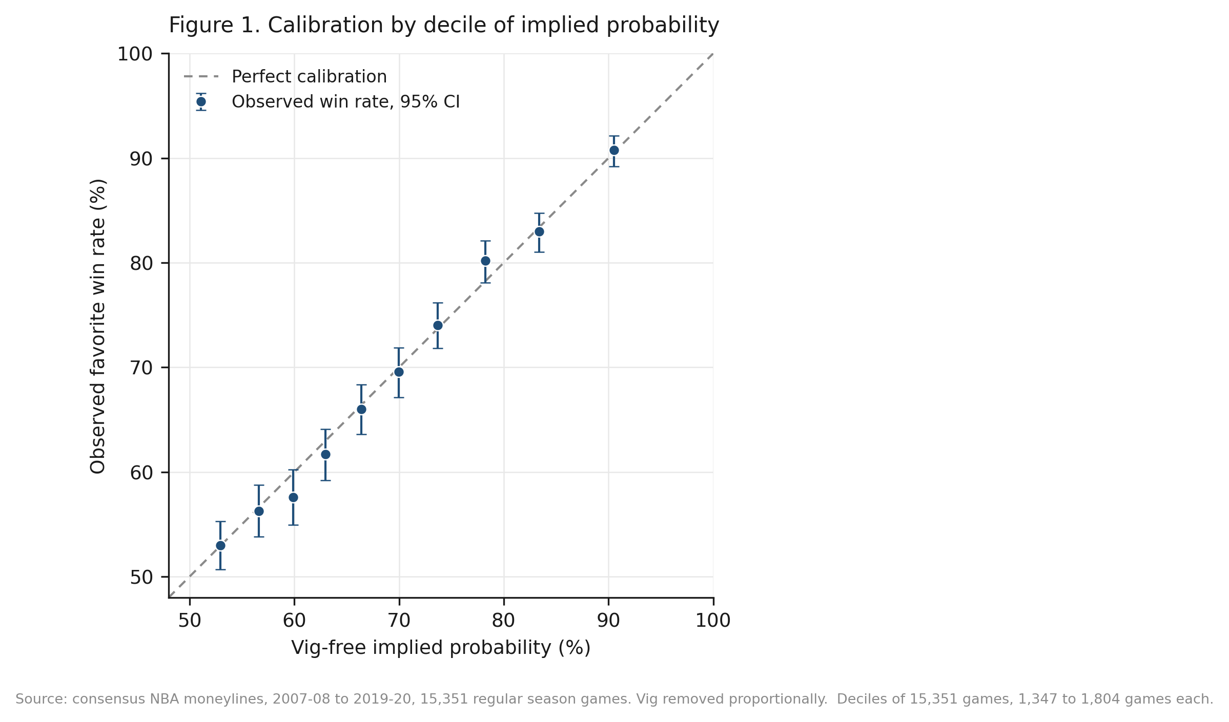
Figure 1. Observed favorite win rates against vig-free implied probability, by decile, with 95 percent Wilson intervals, against the line of perfect calibration. Deciles of 15,351 games, 1,347 to 1,804 games each, equally weighted.
5.2 Buckets
No pre-specified bucket rejects after Holm correction. The largest deviation is +1.73 points in the .75 to .80 range, raw p .091, Holm-adjusted .457.

Bucket | n | Observed | Implied | Expected wins | Gap (pp) | z | p | Holm p
(.50, .60] | 4,064 | 54.45 percent | 55.44 percent | 2,253.1 | -0.99 | -1.27 | .204 | .817
(.60, .70] | 4,447 | 64.11 percent | 64.85 percent | 2,883.9 | -0.74 | -1.04 | .300 | .899
(.70, .75] | 1,933 | 73.10 percent | 72.39 percent | 1,399.3 | +0.71 | 0.70 | .485 | .970
(.75, .80] | 1,661 | 79.11 percent | 77.38 percent | 1,285.3 | +1.73 | 1.69 | .091 | .457
(.80, 1.00] | 3,246 | 86.32 percent | 86.41 percent | 2,804.9 | -0.09 | -0.15 | .880 | .970
Table 3. Pre-specified buckets, Poisson-binomial test in each, Holm correction across the five. Expected wins is the sum of game-level vig-free probabilities.
5.3 Seasons and dependence
No individual season rejects. The 13 season gaps range from -2.82 to +2.52 points with every p above .10. Differences among the seasons are measured with the Cochran Q statistic. Meta-analysis calls this heterogeneity. It asks whether the season gaps differ from one another by more than sampling noise, not whether the pooled gap is zero. Write y for a season's gap and w for the inverse of its Poisson-binomial null variance. Q is then the sum of w times the squared deviation of y from the inverse-variance-weighted mean, on twelve degrees of freedom. Built that way, Q = 8.37, p = .756, I-squared 0 percent. In the extreme tail above .90, 756 games give +0.63 points at p = .506. Its minimum detectable effect of 2.66 sits just below its 3.02-point break-even requirement. Even the thinnest pre-specified slice has enough power to catch bias large enough to matter there.
A particularly informative dependence check is the team-blocked bootstrap. The team bootstrap resamples 32 favorite teams instead of 13 seasons, so it does not lean on approximations that fail when clusters are few. Whether team membership is the right grouping is itself an assumption, so it is reported alongside the others, not in place of them. It gives a 95 percent interval of -0.52 to +1.57 points, wider than the season-blocked -0.19 to +1.26, and containing zero. Table 4 adds the cluster-robust estimators; the point estimate is +0.58 throughout and only the standard error moves, from 0.39 to 0.53 against the Poisson-binomial 0.47. None rejects calibration. The rows resting on 13 season clusters are sensitivity checks, not reliable inference. Cluster-robust variance needs many clusters to be accurate, and at 13 it is known to come out too small. The season-clustered p of .134 is therefore, if anything, too low.

Variance estimator | Clusters | SE (pp) | z | p | 95 percent CI (pp)
Poisson-binomial (primary test) | — | 0.47 | 1.22 | .223 | -0.35 to +1.51
Independent, classical | — | 0.47 | 1.23 | .218 | -0.34 to +1.50
Clustered by season (unreliable, 13) | 13 | 0.39 | 1.50 | .134 | -0.18 to +1.33
Clustered by favorite team | 32 | 0.53 | 1.09 | .276 | -0.46 to +1.62
Clustered by underdog team | 33 | 0.50 | 1.16 | .246 | -0.40 to +1.56
Two-way, season and team (unreliable, 13) | 13 | 0.48 | 1.22 | .224 | -0.35 to +1.51
Table 4. The primary gap under six variance estimators. The gap is +0.58 pp throughout; only the standard error changes, and none rejects calibration.
The logistic calibration regression is less stable under the same treatment. Its joint Wald p is .293 classical, .221 clustering on favorite team, .181 on underdog team, .085 on season and .037 two-way. The last of these would reject at .05, but it rests on the same thirteen clusters. The reading taken here is that the confirmatory result is robust and the secondary regression is sensitive to how dependence is modeled. A reader who prefers the two-way estimate should treat the calibration slope as unresolved, not confirmed.
5.4 Vig removal
Vig removal is the assumption the whole analysis rests on, so four alternatives were run. Additive normalization takes the same number of probability points off each side. Power normalization raises each raw probability to a common exponent. The constant-odds-ratio rule separates quoted and fair odds by a common factor, and Shin (1993) prices against a share of insider money. Shin turns out to add nothing new here. For a two-outcome book it matches the additive rule exactly, which Clarke, Kovalchik, and Ingram (2017) proved for races with two competitors. Requiring the two probabilities to sum to one, while Shin keeps their difference fixed, leaves only one possible pair. Whelan (2025) gives the closed form for Shin's insider share in that case. So in a two-way market Shin's story carries no information the mechanical rule does not already carry, and the two should not be counted as separate checks. The supplement carries the derivation, the check at machine precision, and the recovered insider share of 0.4 to 7.2 percent.

Vig-removal rule | n | Gap (pp) | z | p | Break-even (pp) | Verdict
None, raw probabilities | 8,014 | -2.50 | -5.90 | <.001 | — | margin artifact
Proportional (primary) | 6,840 | +0.58 | 1.22 | .223 | 3.01 | below
Additive, equal margin | 7,120 | -0.60 | -1.32 | .186 | 1.88 | below
Shin (1993) | 7,120 | -0.60 | -1.32 | .186 | 1.88 | below
Constant odds ratio | 7,202 | -0.74 | -1.63 | .104 | 1.79 | below
Power | 7,211 | -1.31 | -2.91 | .004 | 1.24 | exceeds
Table 5. The primary test under five vig-removal rules plus the no-normalization case. Verdict compares the absolute gap with that rule's own break-even requirement. Note that n differs by row: each rule produces its own probabilities and so selects its own set of games above .70. Supplementary section S5 repeats this with the sample held fixed.
Table 5 changes two things at once, and they have to be separated. Each rule produces its own probabilities, so each also selects its own set of games above the .70 threshold, from 6,840 under proportional up to 7,211 under power. Holding the sample fixed at the 6,840 games the pre-specified rule selects, and changing only the rule, narrows the spread a little, to -1.21 through +0.58. The sign still flips and power normalization is still significant, at p = .008. But it no longer clears the bar it sets for itself: -1.21 against 1.22, short by a hundredth of a point instead of clear by seven hundredths.
Those two numbers are indistinguishable. Power normalization puts the gap essentially exactly at the amount a bettor would need. Which side of that line it falls on depends partly on which games the rule admits. What survives is that the sign and the significance of estimated favorite bias move with the rule. What does not survive is the narrower claim that some rule here produced a gap a bettor could have used. The full fixed-sample table is Table S7, in supplementary section S5.
Proportional normalization is primary because it was fixed in the plan before I looked at outcomes, and for no other reason. Two things can be said about power normalization, and neither is that it gave an inconvenient answer. Raising probabilities to a common exponent is a flexible adjustment with no story about bookmakers or bettors behind it. And it differs most from the other rules exactly where the sample is thinnest. Neither point settles anything: it is a materially different sensitivity result, not one that can be set aside.
The first row of Table 5 is the sharpest single result in the paper. Testing observed win rates against raw prices, with no vig removed at all, shows an apparent favorite bias. It is -2.50 points at z = -5.90 in that table's own sample, and -2.43 on the fixed sample used above. Under proportional normalization that gap is the bookmaker's margin, not anything about bettors. Several bucket-test designs in use skip vig removal entirely, and the table shows that the sign of the headline finding turns on that one step.
5.5 Returns and power
Flat one-dollar bets at the quoted prices lose money every way you cut them: -4.06 percent on all favorites (95 percent CI: -5.13 to -3.00), -3.91 on all underdogs (-6.57 to -1.25), and -2.90 on favorites above .70 (-4.04 to -1.75). That is consistent with the 3.77 percent mean overround. Those intervals apply a normal approximation to a skewed quantity. Losak and Kalamvokis (2025) argue this makes profitability tests in this literature reject too often. Simulating their null here moves no bound by more than 0.09 points, and the test holds its nominal size, so the intervals stand. The failure they describe does reproduce in these prices at smaller sample sizes; see supplementary section S4. Against the economic hurdle directly, the observed +0.58-point gap and even its +1.26-point upper bound fall well short of the +3.01 points a favorite bettor needed.
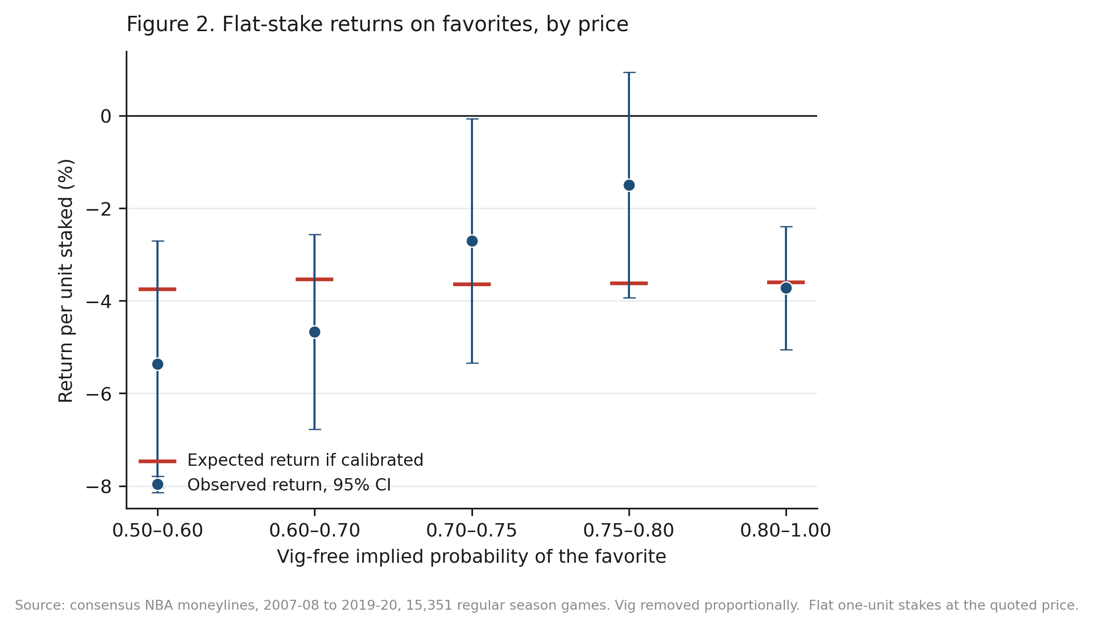
Figure 2. Flat one-dollar stakes on the favorite at the quoted price, by bucket, with 95 percent intervals. The expected-return marker in each bucket comes from the odds actually quoted there, assuming the vig-free probabilities are right. The markers differ across buckets because the payouts do.
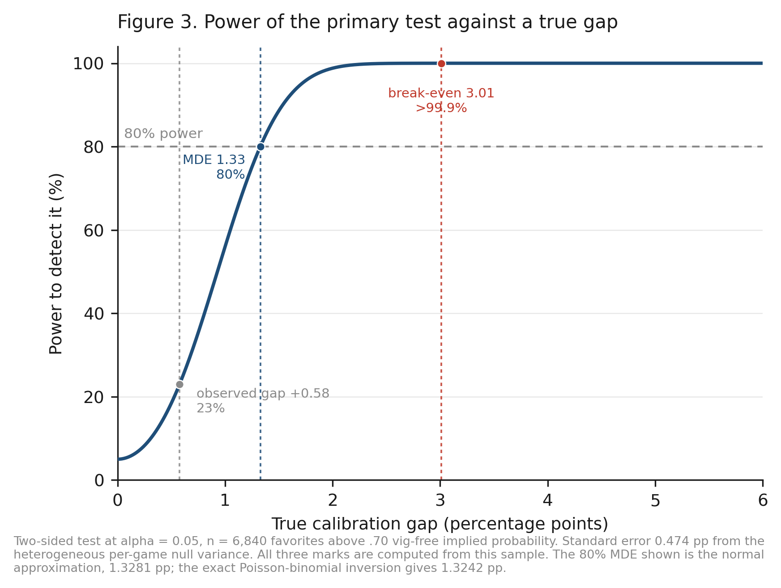
Figure 3. Power of the primary test against a true calibration gap, two-sided at alpha = .05, n = 6,840, standard error 0.474 pp. Every mark is computed from this sample: the observed +0.58-point gap, the 1.33-point minimum detectable effect, and the break-even requirement. The break-even mark is the quantity that carries the economic claim; the minimum detectable effect describes only what the design could catch. No mark is taken from prior work; supplementary section S3 explains why.
6. Discussion
The null should be read narrowly, and it is conditional on a rule. Under proportional normalization the overall favorite calibration gap runs from -0.35 to +1.51 points at 95 percent confidence. An equivalence test rules out anything as large as the 2.99-point break-even margin. That holds pooled across 2007 to 2020, and within every season and odds range set in advance. It also holds under variance estimators that allow correlation within seasons and within teams. Biases in situations outside the slices set in advance are not ruled out. Nothing here speaks to mispricing at a single book, to opening lines, or to edges from shopping for the best price across books. Because the timing of each quote is unrecorded it says nothing about closing-line efficiency, and no claim is made about how professional bettors measure themselves.
The more lasting contribution is about method, and it is bigger than the margin effect alone. Three treatments of the same 6,840 games give three different answers. Raw probabilities give an estimated favorite bias of -2.43 points at p < .001. Proportional normalization gives +0.58 at p = .223, and power normalization gives -1.21 at p = .008. Whether the bias exists, how big it is, and which way it points all move with one modeling choice. Most papers in this literature make that choice in a single sentence and never return to it. A design fixed in advance, tied to an economic threshold and backed by a power calculation, does not make that choice for the analyst. What it does is make the consequences visible. Figure 3 states the power claim in the only units I can defend: above 99.9 percent at the 3.01-point break-even, 80 percent at 1.33 points, against roughly 11 percent for a 74-game bucket.
7. Limitations
The headline result is conditional on the vig-removal rule, and the paper is written that way throughout. The sample is regular season only and ends where the source archive ends, in March 2020. The archive gives one consensus line per game, so the data cannot speak to line shopping or book identity, and the timing of each quote is undocumented. Proportional vig removal is one of several normalizations. Section 5.4 reports four alternatives. On a fixed sample all five leave the gap below the level a bettor would need. Power normalization is the closest: it is significant and sits right at that level. There is no ticket-share data, so claims about public betting cannot be tested. The 260-game audit was hand-drawn, not seeded; it is a sanity check, and the full-sample cross-validation is the real audit.
The primary test assumes games are independent conditional on their prices. Cluster-robust estimators and block bootstraps relax that assumption and leave the result unchanged. But the season-level estimators rest on only thirteen clusters. That is too few for cluster-robust variance to be reliable, so the two-way estimate of the calibration regression deserves matching caution in both directions. Weighting every game equally also answers a different question from weighting by dollars wagered, which is why the flat-stake analysis is reported directly. Finally, the analysis plan was fixed before outcome data were examined. But the record of that freeze is internal, and was never filed with a registry. Its timing cannot be checked independently, which is why the work is described as pre-specified rather than pre-registered. The plan is published in full, and the design leaves little room for hidden flexibility. There is one named main comparison. The threshold and the effect-size floor were set from stated reasoning, not from looking at outcomes. Exploratory analyses are reported separately. Readers can re-run the confirmatory pipeline, which reproduces every reported statistic from the raw archive.
8. Conclusion
Under the vig-removal rule fixed in advance, this test finds no evidence of favorite miscalibration large enough to matter. Over 6,840 games the gap is +0.58 percentage points, and its interval runs from -0.35 to +1.51. An equivalence test rules out anything as large as the 2.99-point break-even margin. That holds under variance estimators allowing correlation within seasons and teams. For bettors, in the archived consensus prices examined here, simply choosing favorites or underdogs offered no exploitable edge. That statement is confined to this series, this period, and that rule.
The last clause is the point. On the same 6,840 games, changing only the vig-removal rule moves the estimate from -1.21 to +0.58 points. It flips the sign and turns a null into a significant result. So the defensible headline is not that these moneylines are calibrated. It is that the evidence for favorite miscalibration is not robust to the choice of vig-removal model. That dependence is invisible to single-rule bucket tests, which are common in prior work. Reporting how the answer moves across rules is not a caveat attached to the result. On this evidence it is the result.
Data and Code Availability
The odds archive is public, from sportsbookreviewsonline.com. It is also posted at https://github.com/guydotan/ucla-thesis. The repository holds all analysis scripts, the derived dataset, the frozen analysis plan, and the supplement. A script there re-downloads the original files and checks every column kept here against them. The address is https://github.com/jacobburdier05/nba-moneyline-calibration. A single command reproduces every reported statistic, table and figure from the raw archive in about six minutes.
References
American Gaming Association. (2025). State of the states 2025: The AGA survey of the commercial casino industry. https://www.americangaming.org/resources/state-of-the-states-2025/
Angelini, G., & De Angelis, L. (2019). Efficiency of online football betting markets. International Journal of Forecasting, 35(2), 712-721. https://doi.org/10.1016/j.ijforecast.2018.07.008
Berkowitz, J. P., Depken, C. A., & Gandar, J. M. (2018). The conversion of money lines into win probabilities: Reconciliations and simplifications. Journal of Sports Economics, 19(1).
Burdier, J. (2026). Replication materials for “Vig removal changes the answer” [Computer software]. GitHub. https://github.com/jacobburdier05/nba-moneyline-calibration
Cheung, K. C. (2015). Fixed-odds betting and traditional odds. Sports Trading Network.
Clarke, S., Kovalchik, S., & Ingram, M. (2017). Adjusting bookmaker's odds to allow for overround. American Journal of Sports Science, 5(6), 45-49. https://doi.org/10.11648/j.ajss.20170506.12
Dotan, G. (2020). Beating the book: A machine learning approach to identifying an edge in NBA betting markets (Master's thesis, UCLA). https://github.com/guydotan/ucla-thesis
Fama, E. F. (1970). Efficient capital markets: A review of theory and empirical work. The Journal of Finance, 25(2), 383-417. https://doi.org/10.2307/2325486
Griffith, R. M. (1949). Odds adjustments by American horse-race bettors. The American Journal of Psychology, 62(2), 290-294. https://doi.org/10.2307/1418469
Holm, S. (1979). A simple sequentially rejective multiple test procedure. Scandinavian Journal of Statistics, 6(2), 65-70.
Levitt, S. D. (2004). Why are gambling markets organised so differently from financial markets? The Economic Journal, 114(495), 223-246. https://doi.org/10.1111/j.1468-0297.2004.00207.x
Losak, J. M., & Kalamvokis, J. (2025). Simulation for the win: A better way to test for betting strategy profitability [Conference presentation]. International Association of Sports Economists. Unpublished; slides provided by the author.
Moskowitz, T. J. (2021). Asset pricing and sports betting. The Journal of Finance, 76(6), 3153-3209. https://doi.org/10.1111/jofi.13082
Newall, P. W. S., & Cortis, D. (2021). Are sports bettors biased toward longshots, favorites, or both? A literature review. Risks, 9(1), Article 22. https://doi.org/10.3390/risks9010022
Paul, R. J., & Weinbach, A. P. (2008). Price setting in the NBA gambling market: Tests of the Levitt model of sportsbook behavior. International Journal of Sport Finance, 3(3), 137-145.
Sauer, R. D., Brajer, V., Ferris, S. P., & Marr, M. W. (1988). Hold your bets: Another look at the efficiency of the gambling market for National Football League games. Journal of Political Economy, 96(1), 206-213. https://doi.org/10.1086/261532
Shin, H. S. (1993). Measuring the incidence of insider trading in a market for state-contingent claims. The Economic Journal, 103(420), 1141-1153. https://doi.org/10.2307/2234240
Sportsbook Reviews Online. (n.d.). NBA scores and odds archives. https://www.sportsbookreviewsonline.com/scoresoddsarchives/nba/nbaoddsarchives.htm
Thaler, R. H., & Ziemba, W. T. (1988). Anomalies: Parimutuel betting markets. Journal of Economic Perspectives, 2(2), 161-174. https://doi.org/10.1257/jep.2.2.161
Whelan, K. (2025). On estimates of insider trading in sports betting. The Manchester School, 93(3), 217-229. https://doi.org/10.1111/manc.12505
Winkelmann, D., Otting, M., Deutscher, C., & Makarewicz, T. (2024). Are betting markets inefficient? Evidence from simulations and real data. Journal of Sports Economics, 25(1). https://doi.org/10.1177/15270025231204997
Woodland, L. M., & Woodland, B. M. (2001). Market efficiency and profitable wagering in the National Hockey League: Can bettors score on longshots? Southern Economic Journal, 67(4), 983-995.
Woodland, L. M., & Woodland, B. M. (2011). The reverse favourite-longshot bias in the National Hockey League: Do bettors still score on longshots? Journal of Sports Economics, 12(1), 106-117.
Zuber, R. A., Gandar, J. M., & Bowers, B. D. (1985). Beating the spread: Testing the efficiency of the gambling market for National Football League games. Journal of Political Economy, 93(4), 800-806. https://doi.org/10.1086/261332
Reproducibility
Every headline number was reproduced a second time from the raw files, independently. That check covered the test size and power, the Poisson-binomial statistic, the break-even algebra, the Cochran Q, the equivalence test, and the four alternative vig-removal rules.
Every reference was located and read directly. No statistic here is quoted from a secondary source; each is computed by the published pipeline and can be re-derived by anyone from the raw archive.

