## Planetary Investigation Lander (PIL) Design and Integration

### PIL and Ground Station

Ground Control will consist of a computer connected to an Arduino, which will be integrated with a radio transceiver. The ground control radio will communicate with the PIL radio, so we can send and receive commands and data. The data will be plotted live using custom written ground control software.

electronics_diagram_PDR.emf

Figure 34: Diagram of Ground Control Payload Commination Hardware

## Planetary Investigation Lander (PIL) Electronics & Description

The electronics for the PIL will provide data and data transmission about the current atmospheric conditions to the Ground Control. Data will be collected by several sensors, and transmitted to ground control in real time via radio communication. An Arduino board will be the microcontroller used to interface the atmospheric sensors and radio. The Arduino program will constantly loop, collecting raw data from the sensors and transforming it into meaningful data (example - transforming the voltage generated from a pyranometer into solar irradiance using a known equation, relating voltage to solar irradiance). The meaningful data will be put into a JSON string and sent to ground control using the serial stream radio. When a photo is taken, a flag will be sent to the ground informing ground control that part of a JPEG image file is being sent. Part of the JPEG binary will then be sent. And end binary flag will be sent to ground when that part of the JPEG binary is ending, and the ground control will go back to parsing JSON data. We are sending only parts of a JPEG file at a time to continue measuring and sending atmospheric data, without spending too much time transmitting a whole JPEG file. The same data will also be written to a micro SD card on board the PIL as backup, in case of radio failure. The PIL will also scan for incoming radio signals from ground control. These radio signals, if existent, will contain actions for the PIL. These actions will include radio power adjustment and measurement frequency to conserve battery.

### PIL Electronics Components

* Arduino Mega 2650 - Microcontroller that interfaces with all sensors and the radio. The Arduino will collect the data from the sensors, create a JSON string from the data, and send the JSON string over serial to the radio. Binary data will be intermittently sent to the radio which corresponds to parts of a jpeg image when a photo is taken.
* XTEND-900 - Radio transceiver that receives and transmits an asynchronous serial stream.
* SparkFun Venus GPS - GPS Module that outputs GPS Coordinates over a serial connection.
* RHT03 - Temperature and Humidity Sensor. After testing, we discovered only one is needed. Data is able to be captured at a frequency of at least 3HZ. Data is sent over a single wire interface.
* BMP180 - Barometer sensor. Sends barometric pressure over an I2C connection. The barometric pressure can be used to report altitude as well.
* ML8511 - Ultraviolet light sensor. This sensor continuously streams a voltage between 0V and 3.3V that represents the amount of UV light.
* Apogee Instruments SP-215 - Pyranometer. The pyranometer continuously streams a voltage between 0V and 5V that represents solar irradiance.
* ADXL345 - Accelerometer sensor. Sends acceleration data over an I2C connection.
* LS-Y201-2MP - JPEG Color camera that outputs JPEG data over a serial connection.
* SparkFun microSD Transflash - microSD Breakout board to write data to microSD. Backup data storage in case of radio failure.
* Custom PCB – This PCB will hold the SparkFun Venus GPS, RHT03, BMP180, ADXL345 and SparkFun microSD Transflash. This will allow a neat organization of wires, and reduce risk of connection failures.

### PIL Electronics Testing

* Arduino Mega 2650 – Verify the Arduino can communicate with all sensors
* XTEND-900 – Test radio connection between PIL and Ground Control
* SparkFun Venus GPS – Test GPS and verify location outputted with current location.
* RHT03 – Test and verify temperature and humidity are within expected range.
* BMP180 – Test pressure on ground and verify it is within expected range.
* ML8511 – Test sensor by covering the sensor to prevent any light from entering, then uncover in sunlight. Verify UV intensity increased with sunlight.
* Apogee Instruments SP-215 – Test sensor by covering the sensor to prevent any light from entering, then uncover in sunlight. Verify solar irradiance increases with sunlight.
* ADXL345 – Test data outputted from accelerometer by standing the sensor upright. Verify acceleration of gravity (z axis) is close to 9.81 M/S2. Verify x and y axis is close to 0 M/S2 (no gravity on x and y axis when upright).
* LS-Y201-2MP – Test photo capture and transmission. Verify JPEG data is fully transmitted and can be displayed on a computer.
* SparkFun microSD Transflash – Test file creation and writing abilities.
* Custom PCB – Test trace continuity to verify all connections are made.

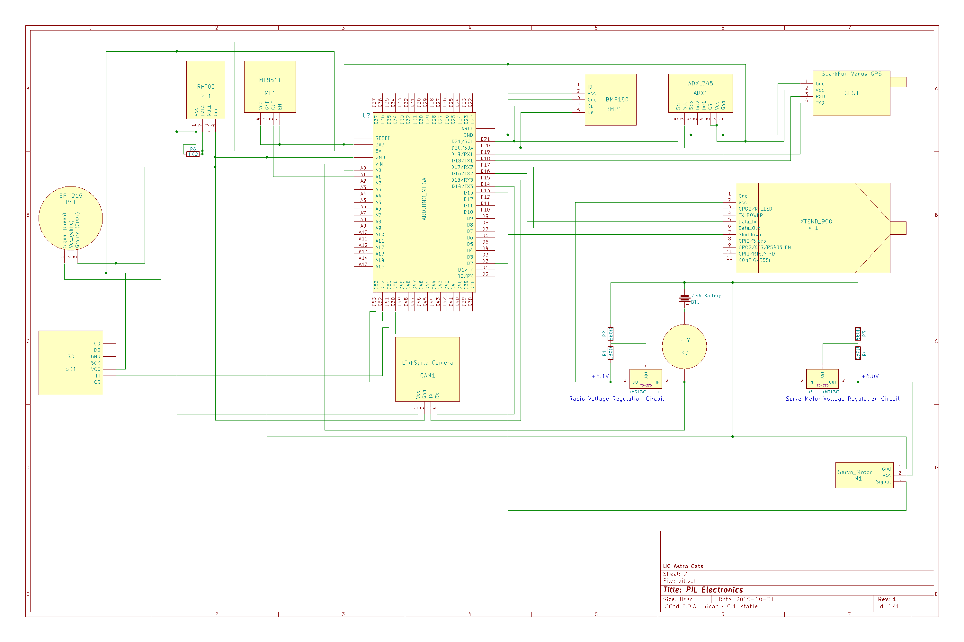

Figure 35: PIL Electrical Schematic

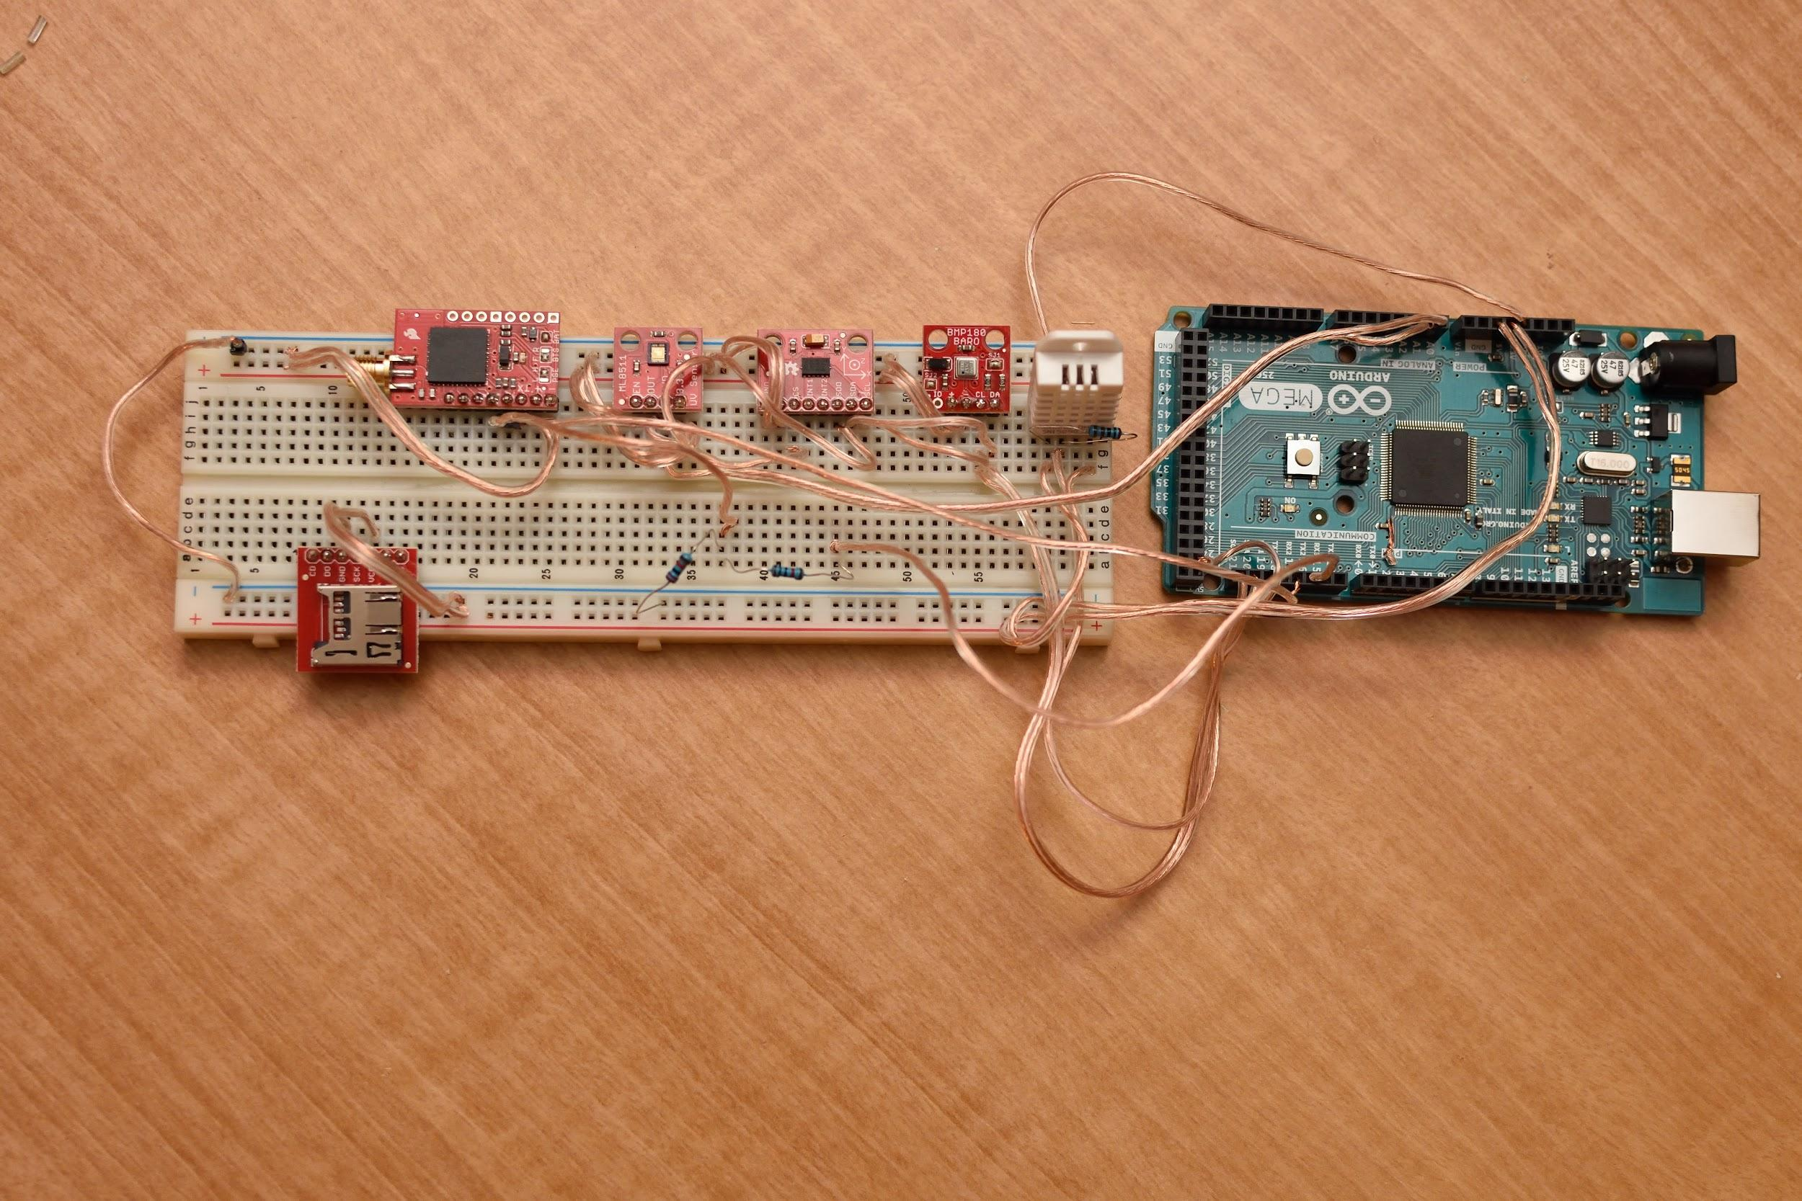

Figure 36: PIL Electronics Prototype on Breadboard

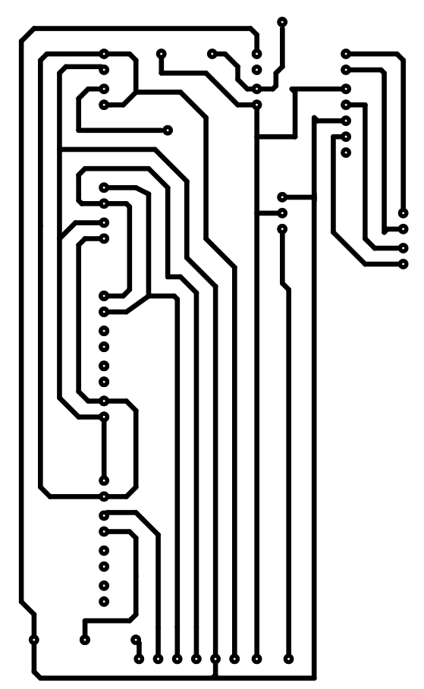

## Ground Support Electronics & Description

The ground control will receive and display data obtained from the PIL and Rocket tracking bay on a PC. Incoming data will be either JSON data or binary data. JSON data will be parsed and the user interface will be updated based on the new values that were received. Binary data that is parts of a JPEG file will be collected and when the end of JPEG file is detected, ground control will put together all parts of the JPEG file, decompress and display the image. The ground control will also be capable of sending commands to the PIL. These commands will include radio power adjustment and measurement frequency to conserve PIL battery. The ground control will consist of a PC, an Arduino board and a radio transceiver. Custom software will be developed that displays the data obtained from the PIL and Rocket Tracking Bay graphically and numerically. The data will be written to disk as it is collected for further analysis.

### Ground Control Electronics Components

* Arduino Mega 2650 – Microcontroller that interfaces the radio transceiver with the PC. Sends incoming radio data from the PIL and Tracking Bay to the PC, and sends outgoing commands to the radio, to transmit to the PIL.
* XTEND-900 – Radio transceiver that receives and transmits an asynchronous serial stream.
* PC – A laptop used to interface with the Arduino to display gathered data using custom software. The ground control software will parse the incoming JSON data or binary data, and update the user interface to display the new values received. The intermittently collected binary data will be put together once the end of a JPEG is detected, and the JPEG image will be decompressed and displayed on the ground control user interface.

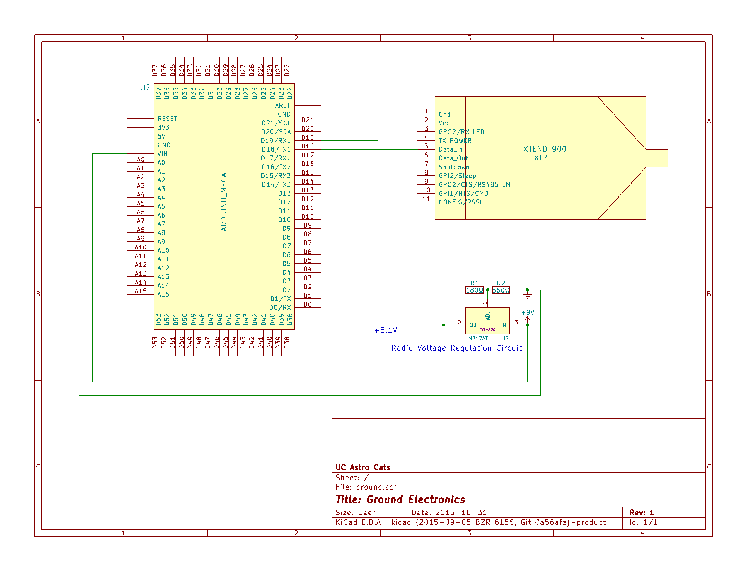

Figure 36: Ground Station Wiring Schematic

### Ground Control Software

The ground control software development has been started. The ground control software is being written in C++, using wxWidgets for the GUI library. A serial port reading thread is able to read the data from the Arduino, and a user interface update thread parses the data from the serial port, and updates the display. The following displays development have been started: radio signal strength from PIL and rocket, temperature, humidity, UV intensity, solar irradiance, air pressure and altitude, and pitch and roll display.

The ground control software can also record and playback data. This will be our main point of data collection, with the SD card on the PIL as a backup. The data collected will be analyzed later, and can be played back with the GUI for visual analysis and testing.

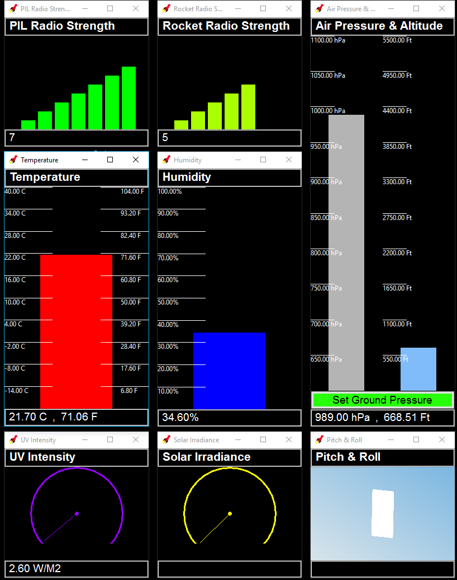

Ground Control Gauges

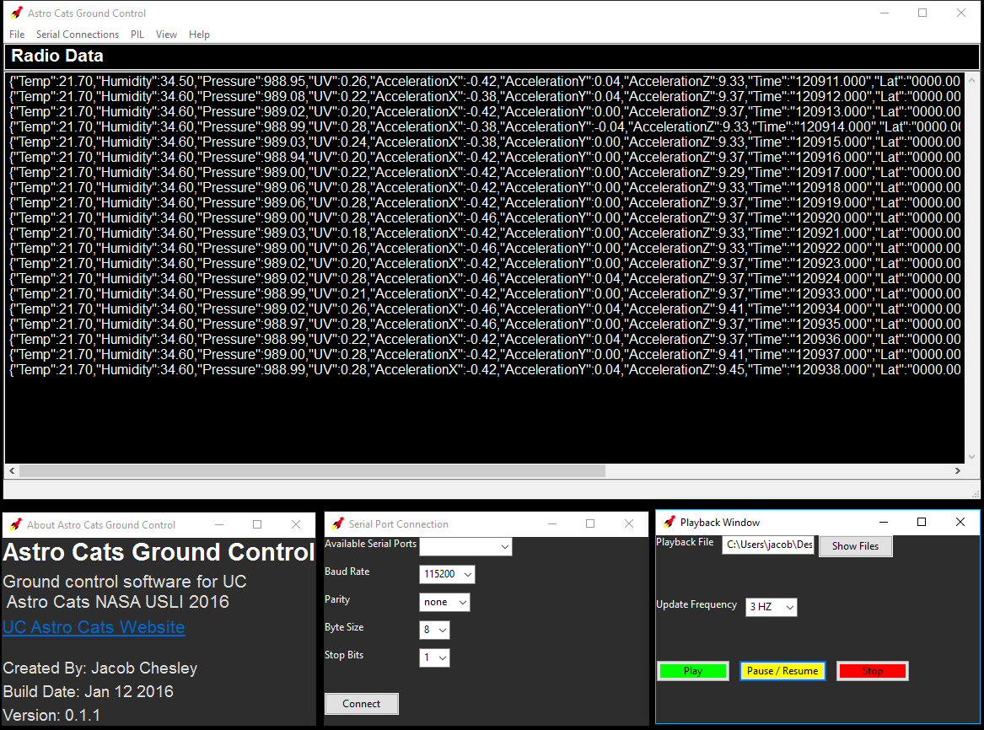

Ground Control Main Window (top), About Window (bottom left), Serial Port Connection Window (bottom middle), and Playback Window (bottom right).