# **HW1.UseCases and Story Board**

## Use Case #1: Choose Configuration

**Participating Actor:** Initiated by user

**Entry Condition:** None

**Exit Criteria:** Configuration is selected

**Flow of Events:**

1. User requests to choose a configuration
2. SyllablastApp chooses configuration and refreshes display

## Use Case #2:Swap Syllables

**Participating Actor:** Initiated by user

**Entry Condition:** User selects 2 syllables

**Exit Criteria:** Syllables are swapped, score increments/decrements, number of swaps incremented

**Flow of Events:**

1. User requests to swap syllables
2. SyllablastApp swaps syllables and refreshes display

## Use Case #3:Reset Puzzle

**Participating Actor:** Initiated by user

**Entry Condition:** None

**Exit Criteria:** Puzzle is reset to initial state, both score and number of swaps is reset to 0

**Flow of Events:**

1. User requests to reset puzzle
2. SyllablastApp resets puzzle and refreshes display

## Use Case #4:Undo Swap

**Participating Actor:** Initiated by user

**Entry Condition:** A swap has been made

**Exit Criteria:** Syllables return to previous location, score incremented/decremented, number of swaps decreases by 1

**Flow of Events:**

1. User requests to undo a swap
2. SyllablastApp undoes swap and refreshes display

## Use Case #5:Complete Puzzle

**Participating Actor:** Initiated by User

**Entry Condition:** Swap occurs?

**Exit Criteria:** Congratulatory message appears, puzzle becomes inactive

**Flow of Events:**

1. User makes a successful final swap
2. SyllablastApp congratulates user, refreshes display

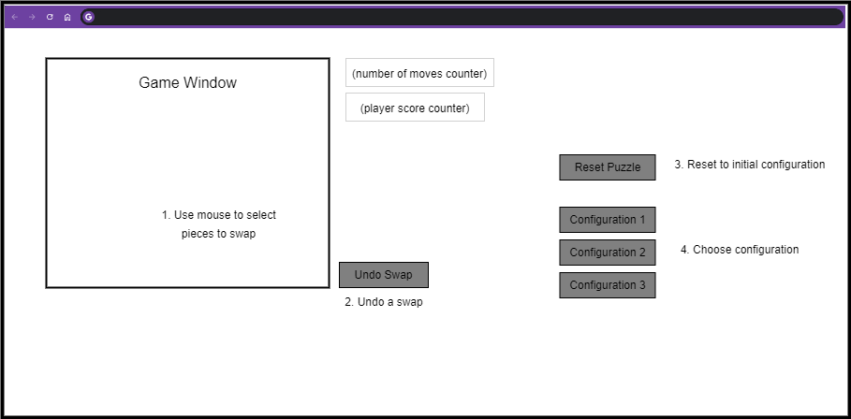**Story Board**