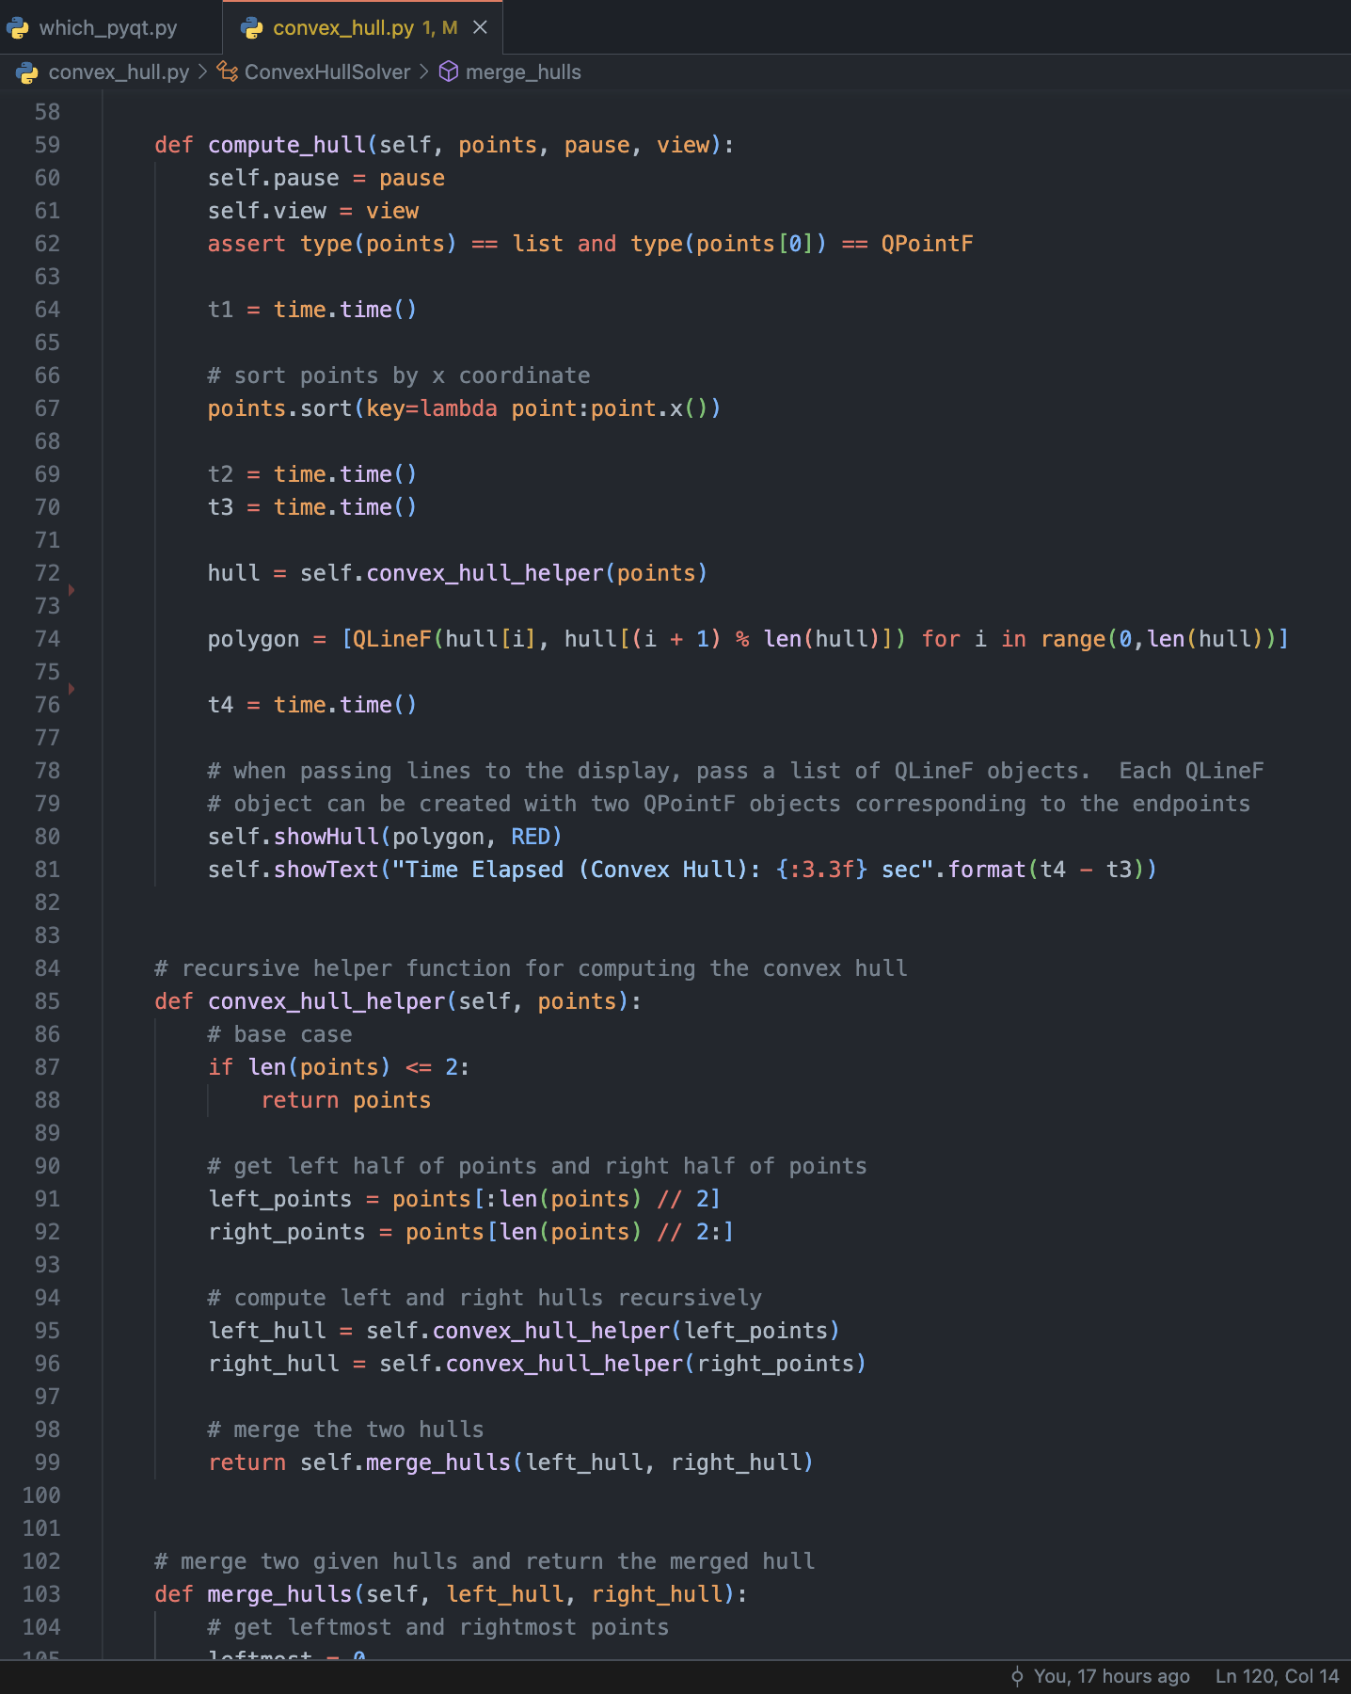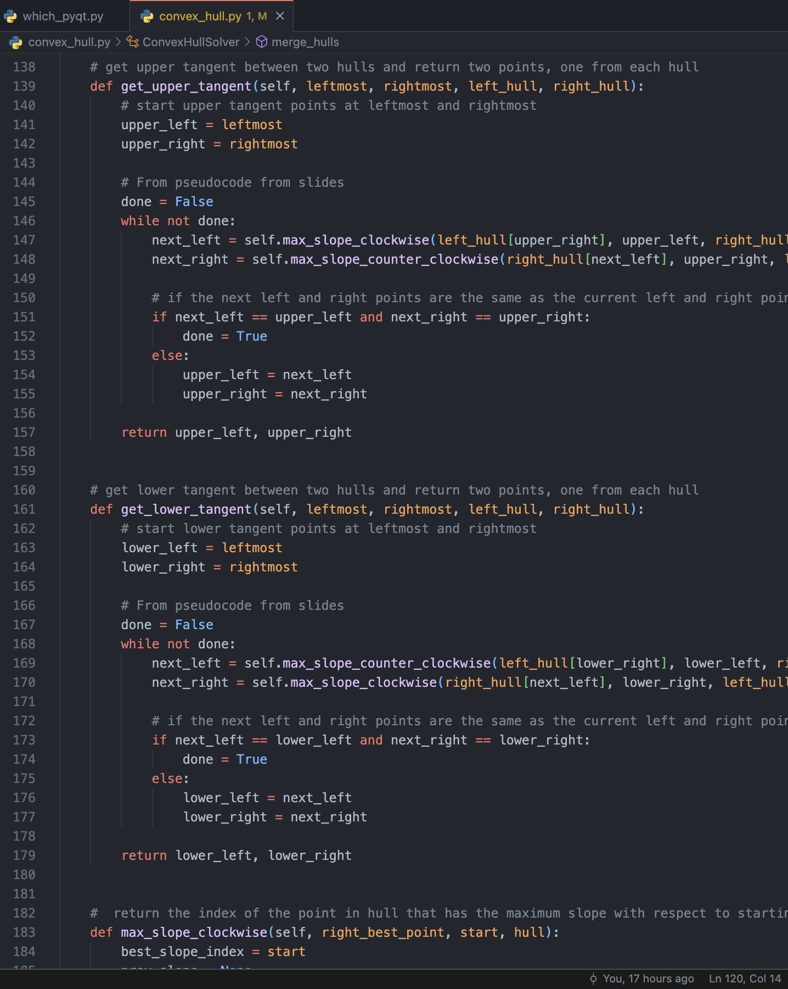

2. My solution for convex hull can be broken into the following pieces:

* convex_hull_helper: recursive function call to compute hull
  + Constant time, runs log(n) times
    - Calls merge_hulls
  + O(Log(n)) time complexity
* merge_hulls
  + Calls get_upper_tangent & get_lower_tangent
  + Worst case, iterates over n points in left & right hulls to add to convex hull
  + O(n) time complexity
* get_upper_tangent and get_lower_tangent
  + iterates over points in left and right hull and finds upper/lower tangent respectively
  + calls max_slope
    - gets max/best slope from given starting point for the tangent line
  + Worst case, iterates over N points in left or right hull and calls max_slope each iteration
  + Runs O(n) times and calls max_slope which at worst case has a time complexity of O(n)
  + Thus, get_upper_tangent and get_lower_tangent run in O(n^2) worst case (very very rare).
* Max_slope (clockwise and counter clockwise)
  + Iterates over points in given hull and finds best slope (highest or lowest) for respective tangent using a given point
  + Absolute worst case, runs in O(N) time complexity if it iterated over every single point in the hull. (however, since we are using the divide and conquer algorithm we end up iterating over just a few nodes, making it much less than O(n) in practice.

Overall, using the D&C algorithm, we get O(nlog(n)), however, using the smaller numbers we are using (7 digits and less), we can expect nearly linear times. And It uses O(nlog(n)) space for the recursive calls and the space to hold the new hull.

3.

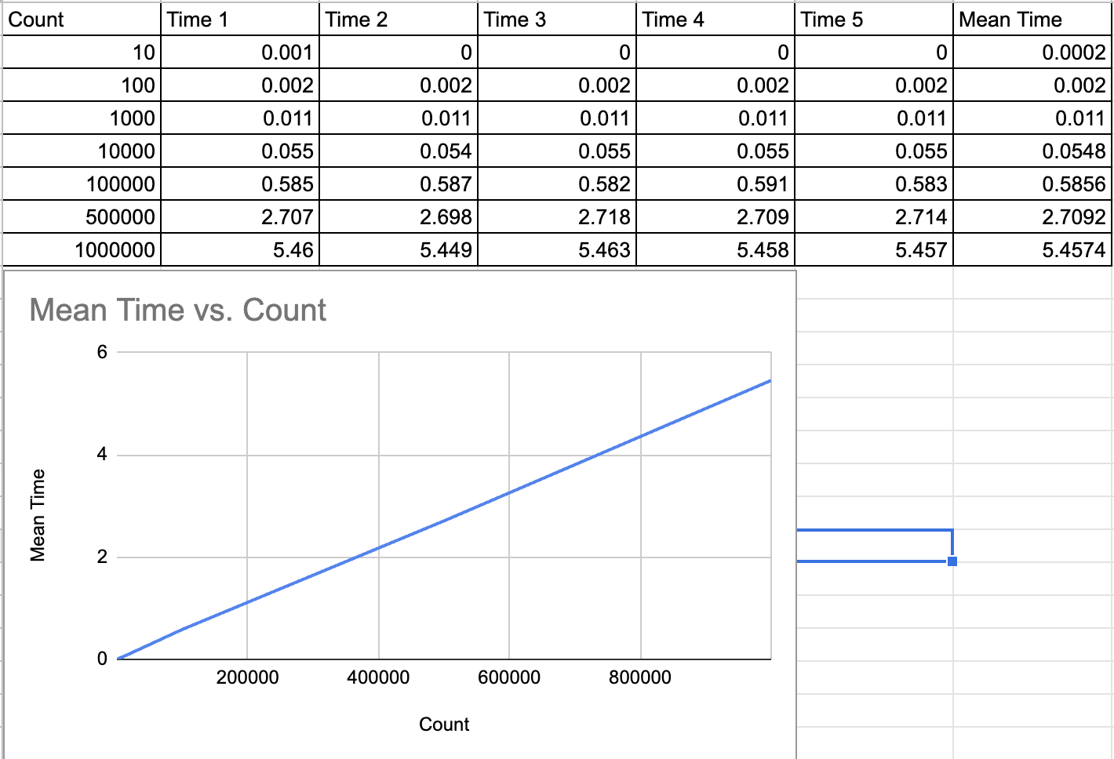

I did not use a logarithmic graph, but if I did then it would make the linear relationship look like a logarithmic relationship. However, the best relationship is linear. This can be seen by inspection, and also calculated the ratio from 500,000 -> 100,000 = 2.7s -> 5.4s (both growth 2x).

4. As mentioned above, there are some discrepancies from the theoretical and empirical analysis. Theoretically, it should be O(nlog(n)), however, in practice, with numbers 7 digits and less, it is essentially linear.

5. (Green dots cause it’s a lot easier to see than blue LOL)