Terr-Out

High Concept Pitch

# Game Overview

### Genre

Terr-Out is a First-Person Co-operative Survival Horror.

### Platform

The Platform for Terr-Out is currently a PC only title.

# Target Audience

Terr-Out’s Target audience is for Teens/Young Adults.

# Rating

ESRB rating for Terr-Out is M: for Mature

# Technology

The Technology used for Terr-Out is the development software called Unity. Using Unity’s C# language scripting, plus the modelling program Blender, our game is quickly taking the shape with a chilling atmosphere that only such modern technologies could deliver.

# Competitor Analysis

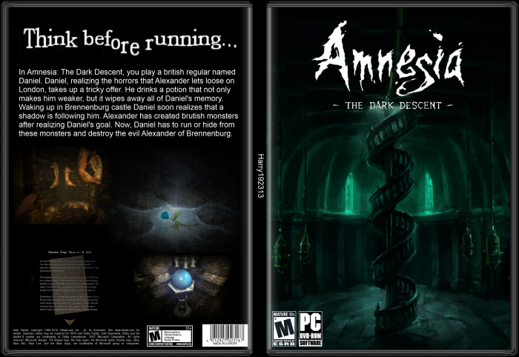Games like Amnesia, Slender, and Outlast are similar to Terr-Out in that the primary game mechanics focus on finding ways to escape the entity giving chase without any form of combat mechanics.

We feel this will be very important in order to maintain a dark & looming ambiance, which all of these games have pulled off extremely well.

### 

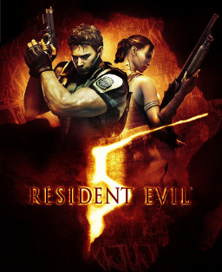Left 4 Dead & Resident Evil 5 are very different from Terr-Out when looking at their heavy focus on action, though a significant part of what makes these games appealing is their multiplayer component, which is going to be a significant part of Terr-Out. Gamers have been increasingly drawn to games that provide and in-depth co-operative survival experience, ourselves included. So we are looking forward providing the same experience with some unique twists in Terr-Out.

While Terr-out shares certain features found in the previously mentioned titles, it will certainly differentiate itself with some unique environment interactions, a very detailed multiplayer communication system, randomly generated maps, and other features brought together to bring players a stand-out experience!

# Player and Objectives

Survival of the fittest. You and another player are placed in a maze. You both must find the exit together by using your intuition and intelligence to avoid traps and outwit the monster chasing you. Players must be quiet in order to avoid hinting to the monster where their location is.

# Story

The story revolves around a hidden labyrinth deep within Stone Ridge jail, the player (a prisoner) has a chance to get out of jail free, but with a twist. The player has to go through a winding labyrinth to get out, but they’re not alone, another has been picked out to help them. He is another who has the chance to be free. The 2 of them must find their way out, any way they can. The labyrinth has a secret no one knows about. A monster within its maze, hell-bent to eat you alive!

# Characters

The Monster – Chases the players to no end, no matter what, you cannot kill him, only stop him for a set time with traps. If the monster gets close enough to any player, the player dies.

The Prisoner(s) – 2 people who have the chance to be free from jail, no names only numbers as they are represented by.

# Core Mechanics

### Basic FPS Controls

Basic Mouse Movement for moving the camera or what the player sees and W, A, S, and D to traverse the world that is created. Right mouse button is used to sprint for a couple of seconds, while the left mouse button is used to activate and deactivate traps. The space key is used for jumping.

### Randomly Generated Maps

Randomly generated maps allow a different play through each time. One play through of a game will have a different map from another play through. This gives the game more replay value. The map will be a maze made out of different types of tiles. The map generator randomly chooses which tile will be placed next, unless that place is needed for a specific tile to make part of the main path. The main path is the correct way to go in order to find the exit. The main path is first a fairly simple path but is then distorted randomly a couple times to make it harder for the player to find their way.

### Online Multiplayer with Random Players

Playing by yourself is fun, but why not add someone to make the game better? This maybe and issue within the current genre, but innovation never hurt anybody , so this game contains multiplayer mode to connect other players to help or hurt other players playing the game online, give the game more replayability when it comes to this sort of genre.

### Traps and Triggers System

To make the game harder for players to get away from the monster, a trap and trigger system has been added within maze. Step on the panel, and have a brick fall on your head, or a set of walls crush you on either side. Traps can be activated and deactivated by the players, as well as the monster itself. When any player activates or deactivates a trap, another trap is randomly deactivated or activated accordingly.

### Distance Based Chat System

Communication is crucial for a multiplayer game, so to really emphasize this point, we’ve added a distance-based, sonar-like auditory feature, on top of a standard text chat system.

The auditory feature has a few uses in gameplay:

1. Ambient sounds will have their point of origin indicated my visual highlighting that surrounds the player’s field of view. This will simulate the realistic ability to detect the direction of a noise, thus allowing players to shout out to find one another.
2. The monster is also making sounds as he gives chase, thus allowing players to know which way to run, even if they can’t look back!
3. The monster might be deadly, but it’s also a mindless brute, meaning it’s easily distracted by whatever tempts its bloodlust. Feel like being bait to save your partner’s skin? Get in close, raise your voice (full in-game voice volume control), and shout out loud to lure the beast away!
4. When players are together they can lower their voices to a dull roar, and hopefully not get any more attention than they want.

Once players are within a certain close-enough range of each other, they’ll have full text chat functionality to convey complex messages needed to navigate their way out of the nightmare they’ve found themselves in as a team.

### Constant Chasing Enemy

The monster of Terr-Out is always chasing you or the other player. The monster using its sense of hearing to locate the players. Players can activate traps and use them against the monster.

# Level Progression

The Maze progresses and gets tougher every level, once you complete a level, you get another generated map to run around in.

### Enemy difficulty increase

Every level, the monster gets faster and thus reducing your chances of survival.

### Altered Maze Generation

The levels change every time you reset a level or finish and pass on to the next one, the map also gets slightly bigger to lessen the chances of survival every level.

### Traps get Harder

With the maze getting larger and tougher every level, so do the traps that can stop you or aid you at times. Traps also become more abundant with larger levels.

# MAEJOR GAMES Team Members

* Matt Joncas
* Adam Merkel
* Eric Roodzant
* Jacob Deichert
* Odin Von Doom
* Ryan A.J Holubeshen