Terr-Out

High Pitch Concept

Developed by: MAEJOR Games Feb 1st 2014 Terr-out

## Game Overview

### Genre

Terr-Out is a First-Person Survival Horror

### Platform

The Platform for Terr-Out is currently a PC only title.

# Target Audience

Terr-Outs Target audience is for Teens/Young Adults.

# Rating

ESRB rating for Terr-Out is M : for Mature

# Technology

The Technology used for Terr-Out is the Development Software Called Unity ,

Using unity’s c# scripting plus Blender made Models for easy import and export or Unity and Blender

Model Files.

Developed by MEAJOR Games feb 1st 2014 Terr-out

# Competitor Analysis

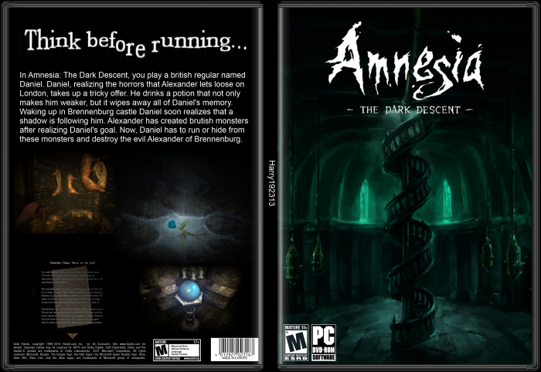Games like Amnesia, Slender, and Outlast are similar to (Game name) in

that the primary game mechanics focus on finding ways to escape the

entity giving chase without any form of combat mechanics.

We feel this will be very important in order to maintain a dark

& looming ambiance, which all of these games have pulled off

extremely well.



### 

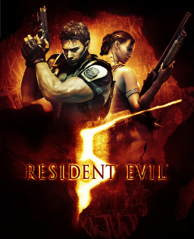Left 4 Dead & Resident Evil 5 are very different from Terr-out

when looking at their heavy focus on action, though a

significant part of what makes these games appealing is their

multiplayer component, which is going to be a significant part

of Terr-out. Gamers have been increasingly drawn to games

that provide and in-depth cooperative survival experience,

ourselves included. So we are looking forward providing the

same experience with some unique twists in Terr-out

While Terr-out shares certain features found in the previously mentioned titles, it will certainly

differentiate itself with some unique environment interactions, a very detailed multiplayer

communication system, randomly generated maps, and other features brought together to bring players

a stand-out experience!

Developed by MAEJOR games feb 1st 2014 Terr-out

## Player and Objectives

Survival of the Fittest. Use your intuition and intelligence to complete mazes and outwit the monster

chasing you. As well as sabotaging other players you are currently playing with, and be the last person to

survive the levels.

# Story

The story revolves around a hidden labyrinth deep within Stone Ridge jail , the player (The

prisoner(s)) have a chance to get out of jail free , but with a twist . The player (prisoner) has to go

through a winding labyrinth to get out , but your not alone, another has been picked out to help you.

He is another who has the chance to be free. The 2 of them must find their way out , any way they can ,

from helping each other , to pushing each one over. The Labyrinth has a secret no one knows about . A

monster within its maze , hellbent to eat you alive!

# Characters

The Monster – Chases the players to no end, no matter what , you cant kill him , only

stop him for a set time with traps. If the monster gets close enough to any player the player dies.

The Prisoner(s) – 2 people who have the chance to be free from jail no names only

numbers as they are represented by numbers.

Developed by: MAEJOR Games feb 1st 2014 Terr-out

## Core Mechanics

### Basic FPS Controls

Basic Mouse Movement for moving the camera or what the player sees and W , A , S ,D to

traverse the world that is created. As well the space button is used to sprint for a couple seconds to try

to out run the Monster

### Randomly Generated Maps

### 

Randomly Generated Maps , Allows no matter what a different play through . One play

through of a game will have a different map from another play through of Terr-out. This gives the

game more replay value . The Map will be a maze made out of different types of tiles. The map

generator randomly chooses which tile will be placed next, unless that place is needed for a

specific tile to make part of the main path. The main path is the correct way to go in order to

find the exit. The main path is first a fairly simple path but is then distorted randomly a couple

times to make it harder for the player to find their way.

### Online Multiplayer with Random Players

Playing by yourself is fun , but why not add someone to make the game better? This

maybe and issue within the current genre , but innovation never hurt anybody , so this game contains

multiplayer mode to connect other players to help or hurt other players playing the game online, give

the game more replayability when it comes to this sort of genre

Developed by MAEJOR Games feb 1st 2014 Terr-out

### Traps and Triggers System

### 

To make the game harder for players to get away from the monster , Traps and trigger

system has been added to be the mechanic of “Booby traps” with in maze. Step on the panel , and have

a brick fall on your head , or a set of walls crush you on either side.

### 

### Distance Based Chat System

Chat is crucial for a multiplayer game , but it takes away from the scariness of (Game Name) so

we added a distant Based Chat System , the closer you are the higher chance you have to seeing

someone chating or adding text to the chatbox, giving a almost realistic ambiance to the multiplayer

aspect of the game.

### Constant Chasing Enemy

## 

The Monster of (Game Name) is always chasing you or the other player , no matter what

happens , more walls on the map , or more pitfalls on the map , he will be chasing you down using

waypoints set on the randomly generated map, 2 to 3 red nodes on the map , the monster can find his

way from one end of the map to the other.

## Level Progression

The Maze progresses and gets tougher every level , once you complete a Level , you get another generated map to run around in .

Developed by MAEJOR Games Feb 1st 2014 Terr-out

## Enemy becomes Faster

Every so levels the monster gets faster and faster reducing your chances of survival .

## Altered Maze Generation.

The Levels change every time you reset a level or finish and pass on to the next one , the

map also gets slightly bigger to lessen the chances of survival every level.

## Traps get Harder.

With the maze getting bigger and crazier every level , so do the traps that can stop you

or aid you at times. And the traps become more abundant with bigger levels.

MAEJOR GAMES team Members :

Matt Jonas

Adam Merkel

Eric Roozant

Jacob Deichart

Odin Von Doom

Ryan A.J Holubeshen