HW 8

(MATH/CS 375)

Jacob Hurst

05/03/18

**Problem 1:**Plotting the errors in approximating the function 1/(1+x^2) on interval [-1, 1] with   
 h = [1/2, 1/4, 1/8, 1/16, 1/32, 1/64] by the Trapezoidal, Midpoint, & Simpson rules.

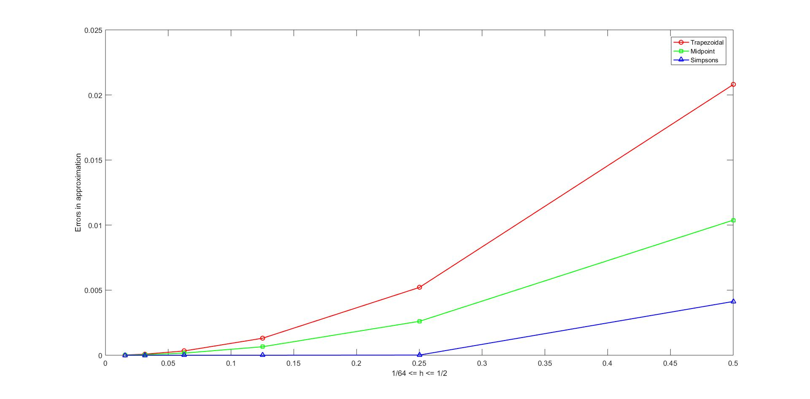

**Problem 2:** Plotting the errors in approximating the function exp(sin(4*pi*x)) on interval [-1, 1] with   
 h = [1/2, 1/4, 1/8, 1/16, 1/32, 1/64] by the Trapezoidal, Midpoint, & Simpson rules.

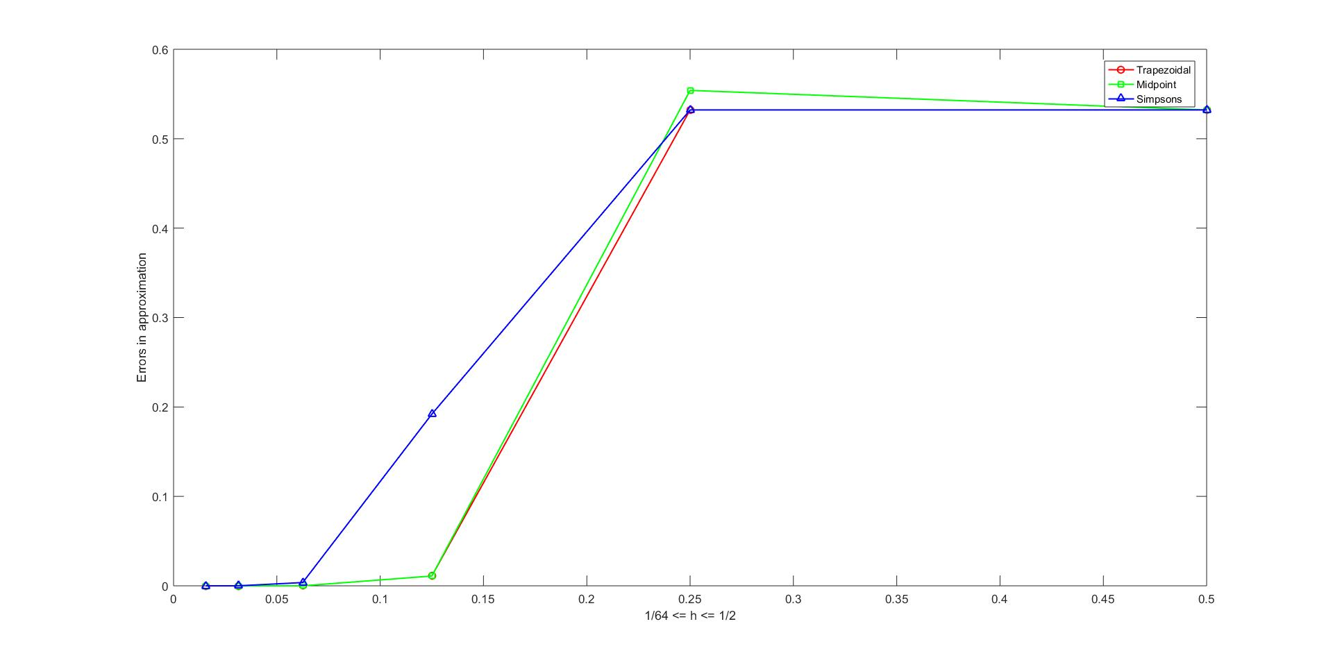

**Problem 3a:** Plotting the errors in approximating the function 1/(1+x^2) on interval [-1, 1] with   
 h = [1/2, 1/4, 1/8, 1/16, 1/32, 1/64] by Gauss-Legendre quadrature.

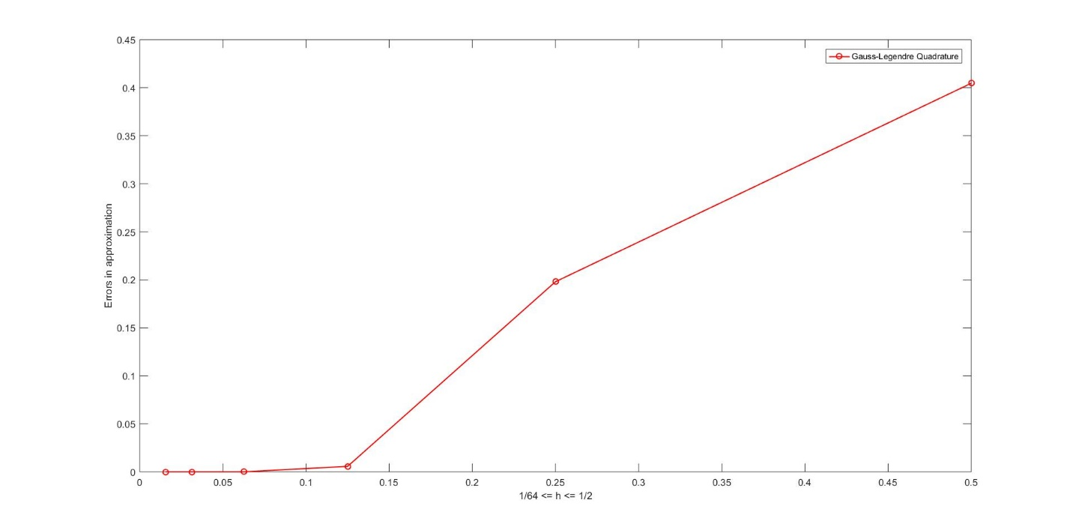

**Problem 3b:** Plotting the errors in approximating the function exp(sin(4*pi*x)) on interval [-1, 1] with   
 h = [1/2, 1/4, 1/8, 1/16, 1/32, 1/64] by Gauss-Legendre quadrature.

