Jacob Dichter

Professor Ausif Mahmood

CPSC 552

4/2/23

Assignment 9

*Linear and Non-Linear Classification, Logistic Regression,*

*SVM, Decision Trees, Random Forests*

**Linear Decision Boundary – Logistic Regression**

Unable to resolve issue of undefined variable Labels

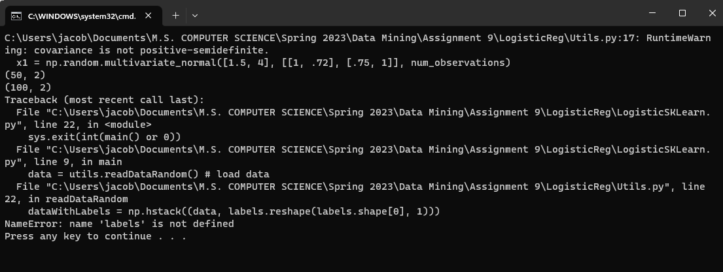

**Support Vector Machine (SVM)**

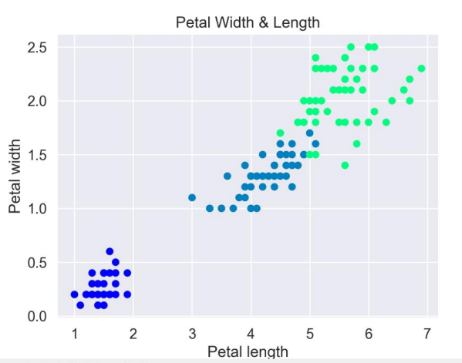

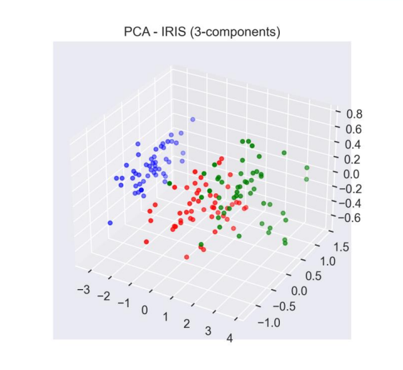

**Decision Trees and Random Forests**

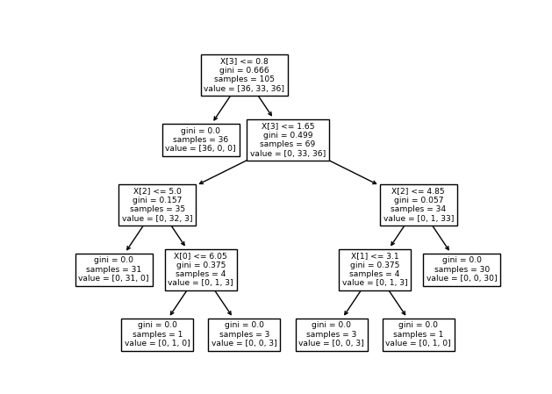

*Decision Tree boundaries*

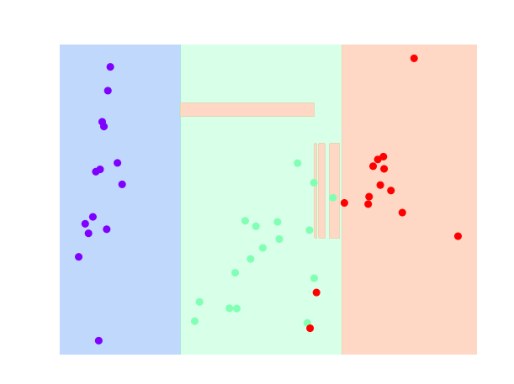

*Random Forest boundaries*

