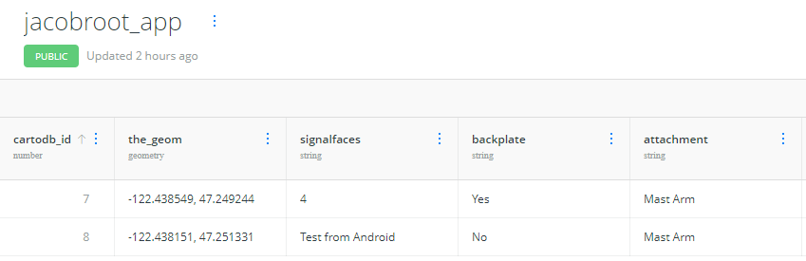

Desc:

This application was created to map the location of left-side “yield on green” signals in the state of Washington. Users create a point on the map, enter in the form details, and submit it to an online CARTO form. Inputs from all users are available and visible at all times.

Screenshots:

