Feb 11:

* <https://docs.google.com/drawings/d/1VBBzBdQgDy7lpbvTuUm47qbzNlIUubNYjX3K3KBkTV4/edit>
* Traditional Code Search Module: <https://github.com/microsoft/CodeBERT/tree/master/UniXcoder>
* <https://github.com/microsoft/CodeBERT/blob/master/UniXcoder/downstream-tasks/code-search/run.py> ‘
* Next two weeks MVP for diagram implemented

| Timeline | Task | Description |
| --- | --- | --- |
| Week 4 - Hung, | Set up a code search module using UniXcoder   * Fine-tuning UniXcoder. * Perform Vector Comparison. * Create a terminal application with Natural Language Query as input | Develop a library that have:   * Input: Natural Language. * Output: List of relevant code.   Existing library and data:   * UniXcoder: <https://github.com/microsoft/CodeBERT/blob/master/UniXcoder/downstream-tasks/code-search/run.py> |
| Week 4 - | Prompt Engineering Creation | Design a prompt for reranking the candidate codes from traditional code search. |
| Week 5 - | LLM’s integration | Write a script to get the output from prompts you made in previous steps. |
| Week 4, 5 | Documentation | Create reports for class |
| After demo | Develop a GUI for traditional code search | Allow users to input query and output list of code. |
| After demo | Dataset selection and curation | * Be familiar with using CodeSearchNet dataset. * Next round: collect your favourite code repositories and perform the code search on it. |

Feb 4

Fxing the HumanSignal login:

* [https://app.heartex.com/user/trial?attr=guide-signup&ref=click-here&__hstc=90244869.cad8cd6284ac7e2200059bd5375c3534.1734536536863.1734632954643.1738707210614.7&__hssc=90244869.7.1738707210614&__hsfp=598159989&_gl=1*nhmj5j*_gcl_au*OTMxMjM5MjQ1LjE3MzQ1MzY1MzY.*_ga*MzE2NTk0NzM2LjE3MzQ1MzY1MzY.*_ga_NQELN45JRH*MTczODcwNzIwOS44LjEuMTczODcwNzMyNC4xNS4wLjA](https://app.heartex.com/user/trial?attr=guide-signup&ref=click-here&__hstc=90244869.cad8cd6284ac7e2200059bd5375c3534.1734536536863.1734632954643.1738707210614.7&__hssc=90244869.7.1738707210614&__hsfp=598159989&_gl=1*nhmj5j*_gcl_au*OTMxMjM5MjQ1LjE3MzQ1MzY1MzY.*_ga*MzE2NTk0NzM2LjE3MzQ1MzY1MzY.*_ga_NQELN45JRH*MTczODcwNzIwOS44LjEuMTczODcwNzMyNC4xNS4wLjA).
* Waiting for HumanSignals
* Draft Nova email
* Judge 90 total principals

January 28

1. Setup an openLLM and try to use API for question-answering:

* <https://github.com/vllm-project/vllm>

1. Check this system:

* <https://app.heartex.com/projects/105085/data?tab=166938>

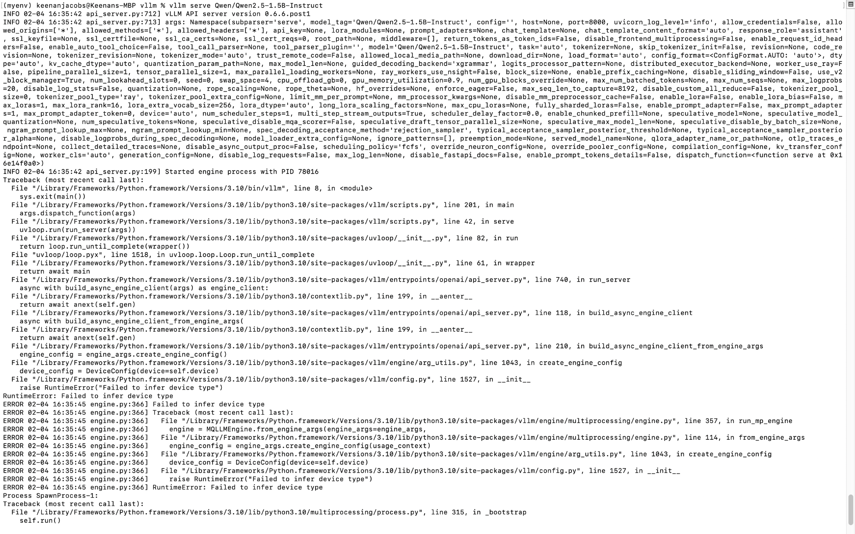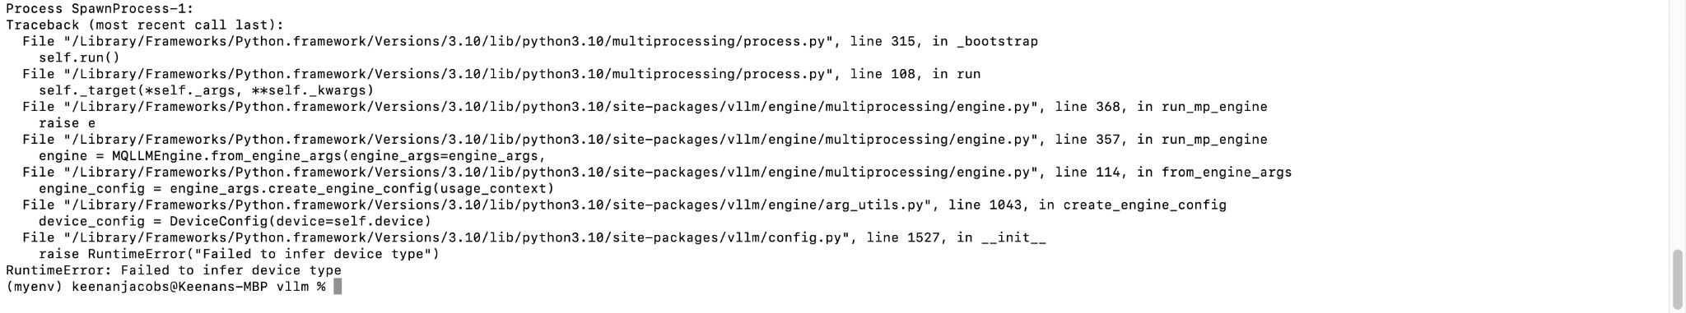  
Context: I have done every step in the [website](https://docs.vllm.ai/en/latest/getting_started/installation/cpu/index.html). I installed every requirement and it is still not working. I have a Mac with a CPU processor and I think that is this issue.