\begin{table}[]

\begin{tabular}{lrrrr}

\hline

Model & AIC \\ \hline

Base: RE for Brand and Material & 2548 \\

Gender x Size & 2556 \\

Gender x Year & 2483 \\

Both Interactions & 2486 \\

FE for Brand | Gender x Year & 2520 \\

FE for Material | gender x Year & 2551 \\ \hline

\end{tabular}

\end{table}

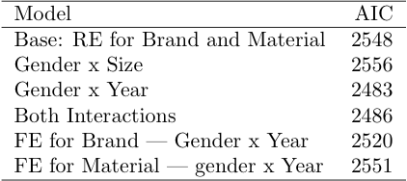

$Best\ Model: \\ \\log(Price) \sim (1|Material) + (1|Brand) + Condition + Year \* Gender$

