**Team ToBeDetermined**

**Iteration 1**

**Jacob Fenger, Joshua Crockett, Whittney Ford, Sharmistha Maity, Sateendra Dey, Shantanu Mandal**

**Pivotal Tracker:** https://www.pivotaltracker.com/n/projects/2319205

**Github Repo:** https://github.com/jacobfenger/TAMU_Polo_Assignment_Maker

**Heroku Deployment:** https://stark-bastion-56965.herokuapp.com/

**Customer Meeting:** Sunday 3/31 @ 7:00 PM

**User Stories:**

1. Separate login for officers
2. Officers can add a horse to the database
3. Anyone can view horses in database

**Design Diagram:**

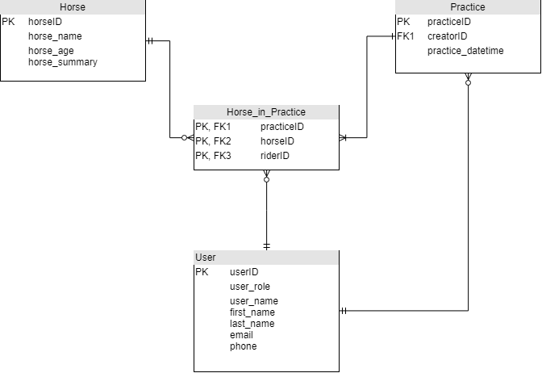

**Test Output: (1 unit test is still currently failing)**

Rspec:

*Finished in 0.06911 seconds (files took 1.61 seconds to load)*

*7 examples, 1 failure*

*Failed examples:*

*rspec ./spec/controllers/horses_controller_spec.rb:11 # HorsesController test_create should display error for invalid horse*

*Cucumber:*

*2 scenarios (2 failed)*

*12 steps (2 failed, 10 passed)*

*0m0.343s*

*Coverage report generated for Cucumber Features to /home/ec2-user/environment/TAMU_Polo_Assignment_Maker/coverage. 47 / 62 LOC (75.81%) covered.*

*Failed examples:*

*expected to find text "Horse was saved successfully" in "Texas A&M Polo Assignment Maker Home Horses Logout Name Age Summary Add a horse"*

*Display error for valid name of horse*

*expected to find text "Horse was not saved successfully" in "Texas A&M Polo Assignment Maker Home Horses Logout Name Age Summary Add a horse"*

*Display error for invalid name of horse*