**Team ToBeDetermined**

**Iteration 3**

**Jacob Fenger, Joshua Crockett, Whittney Ford, Sharmistha Maity, Sateendra Dey, Shantanu Mandal**

**Pivotal Tracker:** https://www.pivotaltracker.com/n/projects/2319205

**Github Repo:** https://github.com/jacobfenger/TAMU_Polo_Assignment_Maker

**Heroku Deployment:** https://stark-bastion-56965.herokuapp.com/

**Customer Meeting:** Sunday 4/21 @ 7:00 PM

**User Stories:**

1. Officers can create and edit a practice
2. Members are able to sign up for a practice and enter what horses they want to ride
3. Having two separate tables by member or officer role on the member’s list page
4. Promote/demote button implemented on member’s list page

Due to the upcoming deadline for iteration 4, we determined that we would not have the assignment making feature done in time. This is a more complicated user story that would require a good amount of front and back-end design to make it as seamless as possible. This was moved to the icebox for future iterations.

Our next goals in terms of implementing user stories for iteration 4 is to improve the design and core functionality of the website to make it as usable as possible. This was one of the main focuses in the initial development of this project.

**Design Diagram:**

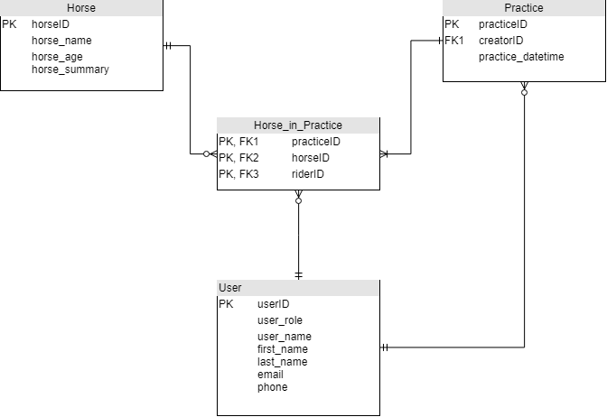

**Test Output:**

Rspec:

*Coverage report generated for Cucumber Features, RSpec to:  
/TAMU_Polo_Assignment_Maker/coverage. 148 / 221 LOC (66.97%) covered.*

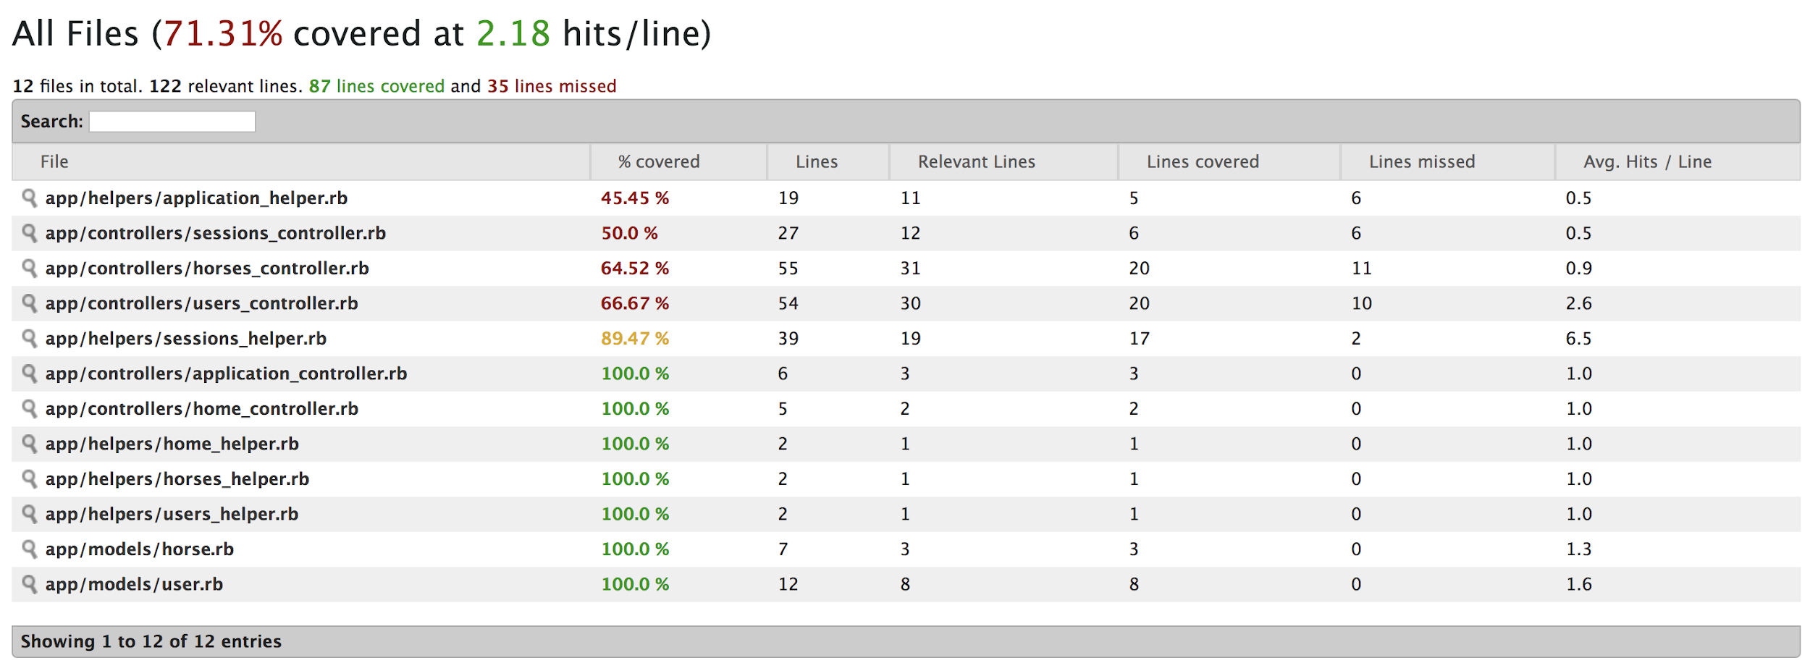

*Cucumber:*

13 scenarios (13 passed)

84 steps (84 passed)

0m11.369s

Coverage report generated for Cucumber Features to /mnt/c/Projects/TAMU_Polo_Assignment_Maker/coverage. 187 / 242 LOC (77.27%) covered.