Project - prj
prj -mode script -file SemiDetached_2F.cfg

RESULTS - res

res -mode script -file annual.res

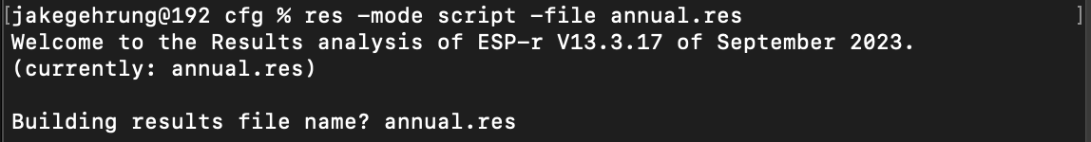

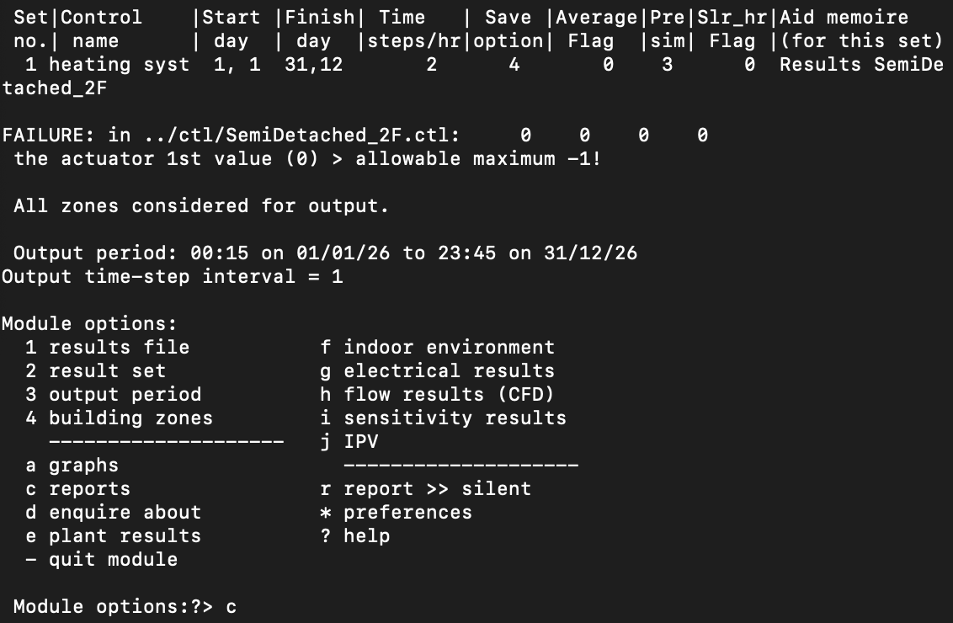

REPORTS - c

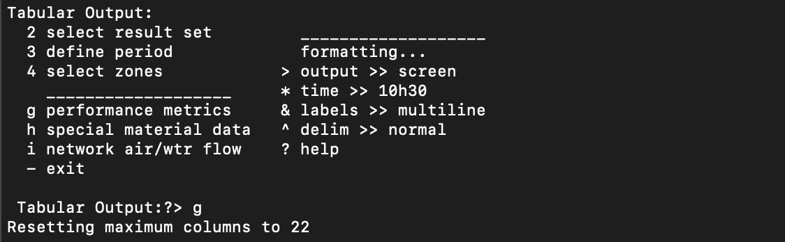

Performance Metrics - g

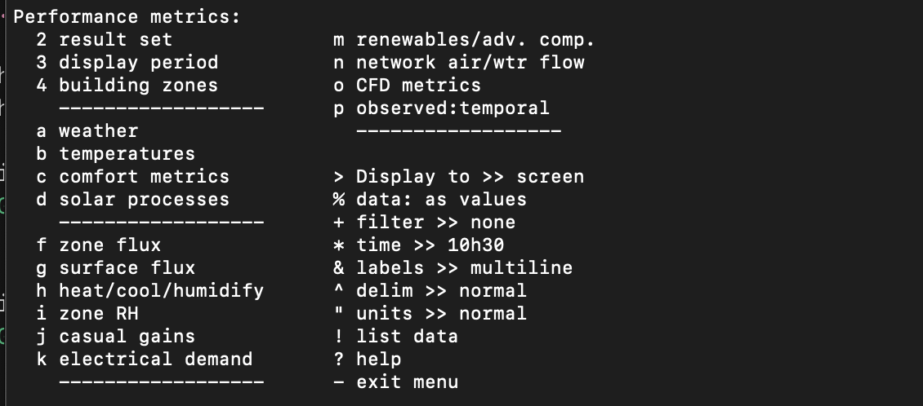

Heat/cool/humidify – h
