**Decision Tree**

REPTree

============

x_std < 0.68

| x_std < 0.43

| | y_std < 0.37

| | | x_std < 0.15 : not-hand-wash (39/0) [24/0]

| | | x_std >= 0.15

| | | | x_avg < 2.39 : not-hand-wash (16/1) [8/1]

| | | | x_avg >= 2.39 : hand-wash (3/1) [2/0]

| | y_std >= 0.37 : not-hand-wash (91/0) [33/1]

| x_std >= 0.43

| | y_std < 0.28 : hand-wash (2/0) [0/0]

| | y_std >= 0.28

| | | x_avg < -1.46

| | | | x_avg < -7.89 : not-hand-wash (11/0) [15/0]

| | | | x_avg >= -7.89

| | | | | y_std < 0.96 : hand-wash (5/0) [2/1]

| | | | | y_std >= 0.96

| | | | | | x_avg < -6.23 : hand-wash (2/0) [1/0]

| | | | | | x_avg >= -6.23 : not-hand-wash (2/0) [1/0]

| | | x_avg >= -1.46 : not-hand-wash (30/0) [12/1]

x_std >= 0.68

| x_avg < -7.6 : not-hand-wash (50/0) [23/2]

| x_avg >= -7.6

| | y_std < 2.03

| | | x_avg < 6.98

| | | | y_avg < -9.33 : not-hand-wash (9/0) [9/0]

| | | | y_avg >= -9.33

| | | | | z_avg < 0.79 : hand-wash (20/1) [17/2]

| | | | | z_avg >= 0.79

| | | | | | x_avg < 4.5

| | | | | | | x_std < 1.44 : not-hand-wash (19/3) [9/2]

| | | | | | | x_std >= 1.44 : hand-wash (15/6) [6/1]

| | | | | | x_avg >= 4.5 : hand-wash (6/0) [3/1]

| | | x_avg >= 6.98 : not-hand-wash (17/0) [8/0]

| | y_std >= 2.03

| | | x_std < 2.64

| | | | x_avg < -1

| | | | | z_avg < 0.21 : hand-wash (18/0) [4/0]

| | | | | z_avg >= 0.21

| | | | | | y_std < 4.23

| | | | | | | y_std < 3.66

| | | | | | | | y_std < 2.99 : not-hand-wash (12/4) [5/1]

| | | | | | | | y_std >= 2.99 : hand-wash (5/0) [3/1]

| | | | | | | y_std >= 3.66 : not-hand-wash (5/0) [3/1]

| | | | | | y_std >= 4.23 : hand-wash (15/0) [2/0]

| | | | x_avg >= -1

| | | | | z_avg < 9.15 : hand-wash (269/2) [134/6]

| | | | | z_avg >= 9.15 : not-hand-wash (2/0) [2/0]

| | | x_std >= 2.64

| | | | y_std < 10.13 : hand-wash (27/11) [20/4]

| | | | y_std >= 10.13 : not-hand-wash (6/0) [3/0]

Size of the tree : 51

**Accuracy of Classification**

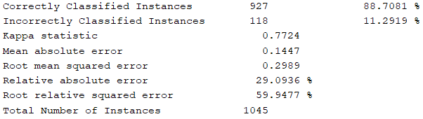

**Confusion Matrix**

