Super Mario Maker and Difficulty Preferences

Written by:

Jacob Hogrefe

Junior Computer Science Major

Quinnipiac University

Revision Date April 30, 2023

Purpose of Document:

This document is intended to provide an exploration into what kinds of levels players decide to play in Super Mario Maker, based on data contained within each level. More specifically, it will try to find if there is a preference for easier more casual levels. This will be determined by the number likes (also known as stars) and the total number of unique players. It will then dive into what the proportions of all the levels of a certain theme are a certain difficulty. Lastly, it will determine which level themes contain the most levels of a certain difficulty.

Outline of Document:

Executive Summary………………………………………………………………………………3

Section One – Overall Data………………………………………………………………………5

Section Two – Data Over Time ………………………………………………………………….6

Section Three – Difficulty and Level Theme…………………………………………………….8

Appendix…………………………………………………………………………………………11

Stored Procedures…………………………………………………………………..……11

difficultyOverall…………………………………………………………………11

difficultyMakeUpOfAllLevels ………………………………………………………………11

difficultyAndLevelTheme………………………………………………...……..11

themeEngagement

User Privileges…………………………………………………………………………..12

Executive Summary

For as long as platformers have been around, there have always been people who have wanted to create their own levels and publish them to the world. In 2015, Nintendo granted this ability with the release of their new game Super Mario Maker. In it, there is an entire course editor with the different physics engines and features from their most popular 2D Mario releases. Given that the ability to make any level has nearly endless possibilities, especially when you consider the differences between the different games, there is a wide range of difficulty for the levels, leading to Nintendo to include the feature to sort levels by the difficulty of them.

For this report, I want to explore and prove that most players are looking for a more casual/laidback level to play, rather than a super difficult “test your skills” kind of level to play. In addition, I want to prove that the game style of Super Mario World contains the most difficult levels compared to the rest of the themes. This report will attempt to explore how different statistics tracked within the game relate to the difficulty of the level. In this case, we will be looking at the number of likes, unique players, and the total number of attempts that are on each level. In addition, I will explore the difficulty trends over the period in which the data was captured. Provided data was captured over a 6-month period between November 2017 and April 2018. Lastly, I will look at whether there is a correlation between the difficulty of a level and which theme contains the greatest number of difficult levels.

After examining the data, it was unsurprising to see that there was a clear preference for normal levels. However, this was only a slight lead ahead of the more difficult levels, but easy levels were some of the least popular levels out of the entire dataset. My prediction on the popularity of the difficult levels was correct; however, I didn’t expect the data to be so close. Another interesting aspect was the data showing that there was an increase in playing difficult levels through the months of November 2017 and January 2018. All these months saw an increase in stars and unique players for super expert and exper levels. Comparing the level themes to each other, the Super Mario Bros. theme was the most popular for difficult levels, with Super Mario World, New Super Mario Bros. U, and Super Mario Bros. 3 following. Each game’s theme followed the trend of the entire dataset, with the only real outlier being the popularity for the easy difficulty for the New Super Mario Bros. U was much more popular than all the other easy levels, and even more popular than some theme’s normal difficulty. Overall, the data was surprising, proving me wrong that Super Mario World would have more people playing difficult levels.

Section One – Overall Data:

Figure 1.1: Data for the entire dataset

After looking at the overall data for the whole dataset, and we already notice something interesting when looking at the unique player and number of stars for each difficulty. As shown in the image above, both the expert and superExpert difficulties have more unique players compared to the easy levels, but less than the normal levels. In addition, this data also holds true for the number of stars for each difficulty. However, as expected, there is a clear correlation between the difficulty and the number of attempts. It’s clear from this image that normal levels are preferred over super difficult levels, but easy levels are the least popular as these levels are typically designed by small children and don’t have much thought or care put into them compared to the other difficulties.

Section Two – Data Over Time:

Figure 2.1: Difficulty statistics for November 2017

Figure 2.2: Difficulty statistics for December 2017

Figure 2.3: Difficulty statistics for January 2018

After looking at the data for all 6 months individually, one of the most shocking things was for a 3-month period, super expert and expert difficulty levels were way more popular than the other difficulty levels by a longshot. As for a reason for this outcome, the only thing that makes some sort of sense is this is that this is typically when college students come home from school. While this may or may not be the exact reason, it’s still interesting to see such a large difference between the harder difficulties and the more casual difficulties.

Section Three – Difficulty and Level Theme:

Figure 3.1: Difficulty statistics for Super Mario Bros.

Figure 3.2: Difficulty statistics for Super Mario World

Something I wasn’t expecting after seeing this data was that Super Mario Bros would have not only more stars, but more unique players than all the other game themes, with Super Mario World falling closely behind. I was expecting Super Mario World to have a more popular super expert difficulty community as it’s one of the most popular games to modify with kaizo levels. These results were also the same for the expert difficulty.

Figure 3.3: Difficulty statistics for New Super Mario Bros. U

Figure 3.4: Difficulty statistics for Mario Bros. 3

Another interesting thing after looking at these results is that the Mario Bros 3. And New Super Mario Bros. U theme were the least popular overall, having less stars and unique players. What’s interesting about these graphs and numbers, is that they follow a very similar trend to the statistics for the entire dataset.

In conclusion, there is a good amount of data showing that most players of Super Mario Maker aren’t looking for super difficult levels. While this does ignore the outliers such as YouTubers, it still shows that most people want a casual experience playing Mario. However, there is a difference between all the level themes, making Super Mario Bros. a theme that has a community around it for super difficult levels, while New Super Mario Bros. U has a community for easier and more

Appendix:

Stored Procedures

difficultyOverall: Returns the difficulty statistics for the entire dataset.

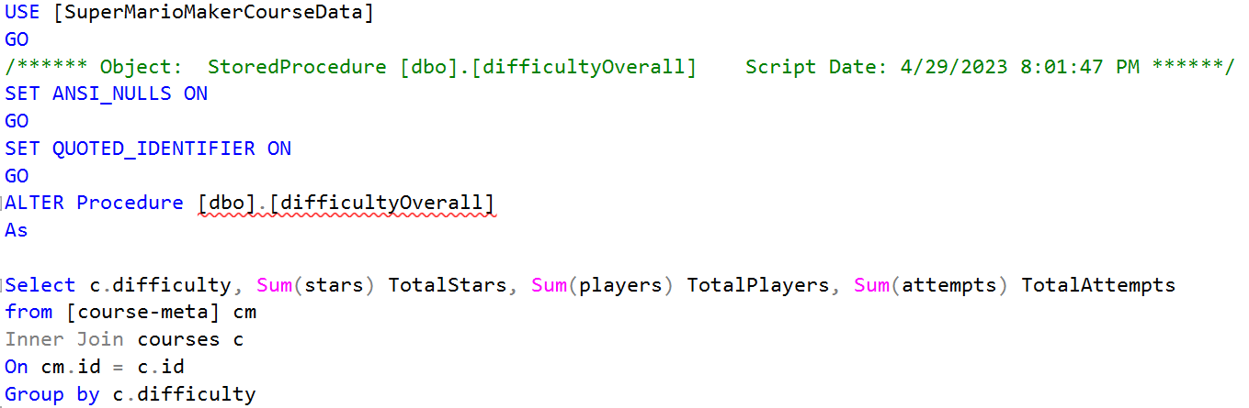

difficultyMakeUpOfAllLevels: Returns the number of levels per difficulty for every level theme.

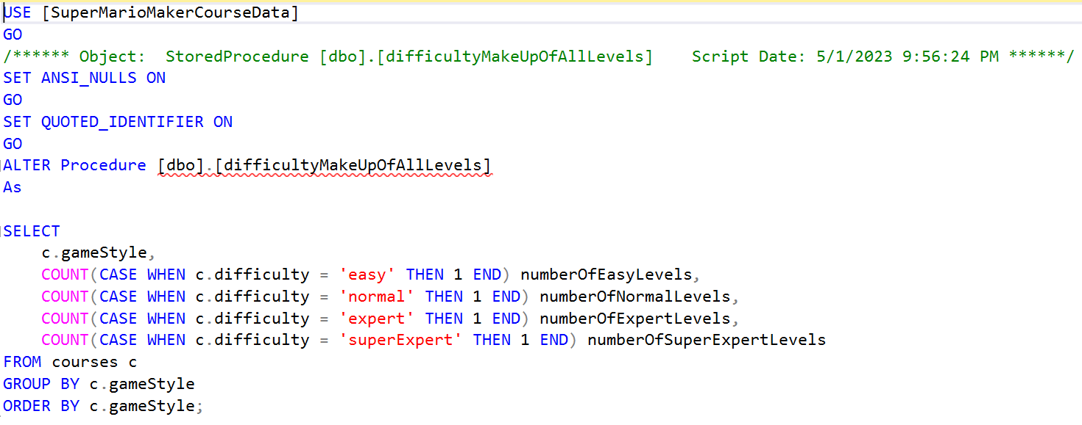

difficultyAndLevelTheme: Takes in a parameter for the difficulty and returns the total number of levels for each level theme.

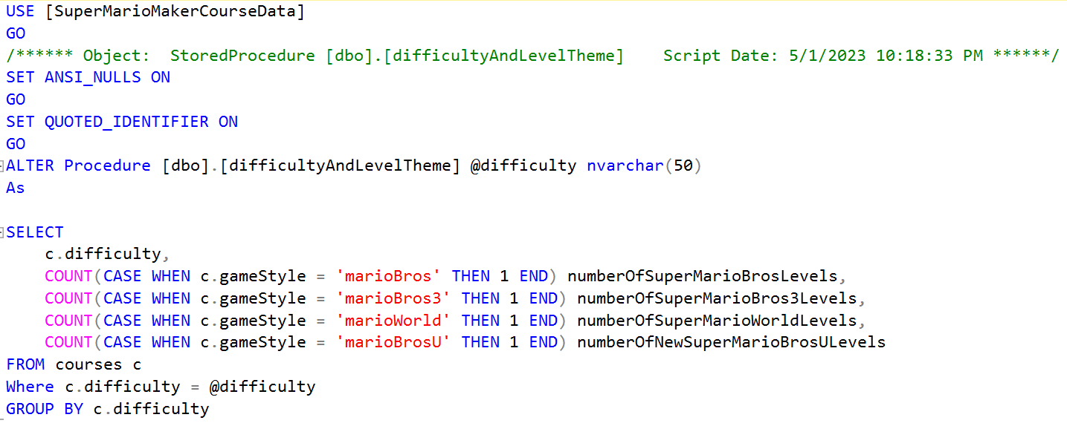

themeEngagement: Takes in a parameter for the difficulty and returns the total amount of stars and unique players per level theme for each difficulty.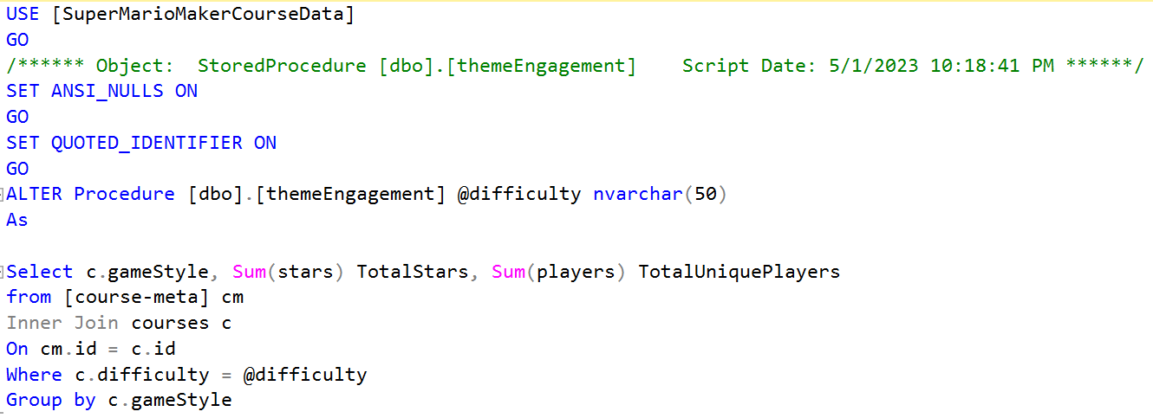

User Privileges

There are a total of 3 users that have their own roles and privileges. The first user is an Admin, who can perform any action needed on the entire database. The second user is a DataAnalyst, who can view and make queries on all the data but cannot add or remove data. The last user is a DataManager, who can add and remove data to the database, but cannot perform the DROP command. All three users can execute the stored procedures.

