Jacob Morse

Mr Davis

Computer Science Pre-AP

October 21 2015

**Methods Madness Essay**

My project methods madness project creates a group of the borders of squares and circles in random places on a black rectangle acting as a canvas. My program does this by first, creating a black rectangle in a predetermined place, with a predetermined size with the method *drawRectangle*. Then I use two For Loops, one in *drawSomeCircle* and another in drawSomething, to draw the shapes, in which the number it draws is determined by what the user inputs. These shapes are then placed in random places with the imported class Random. I believe that my art project is a great example of what you can do with JavaFX, using many different elements such as ovals, rectangles, fills, and strokes.

My program shows encapsulation by having all my methods being called in another method, and that method being called in my public method: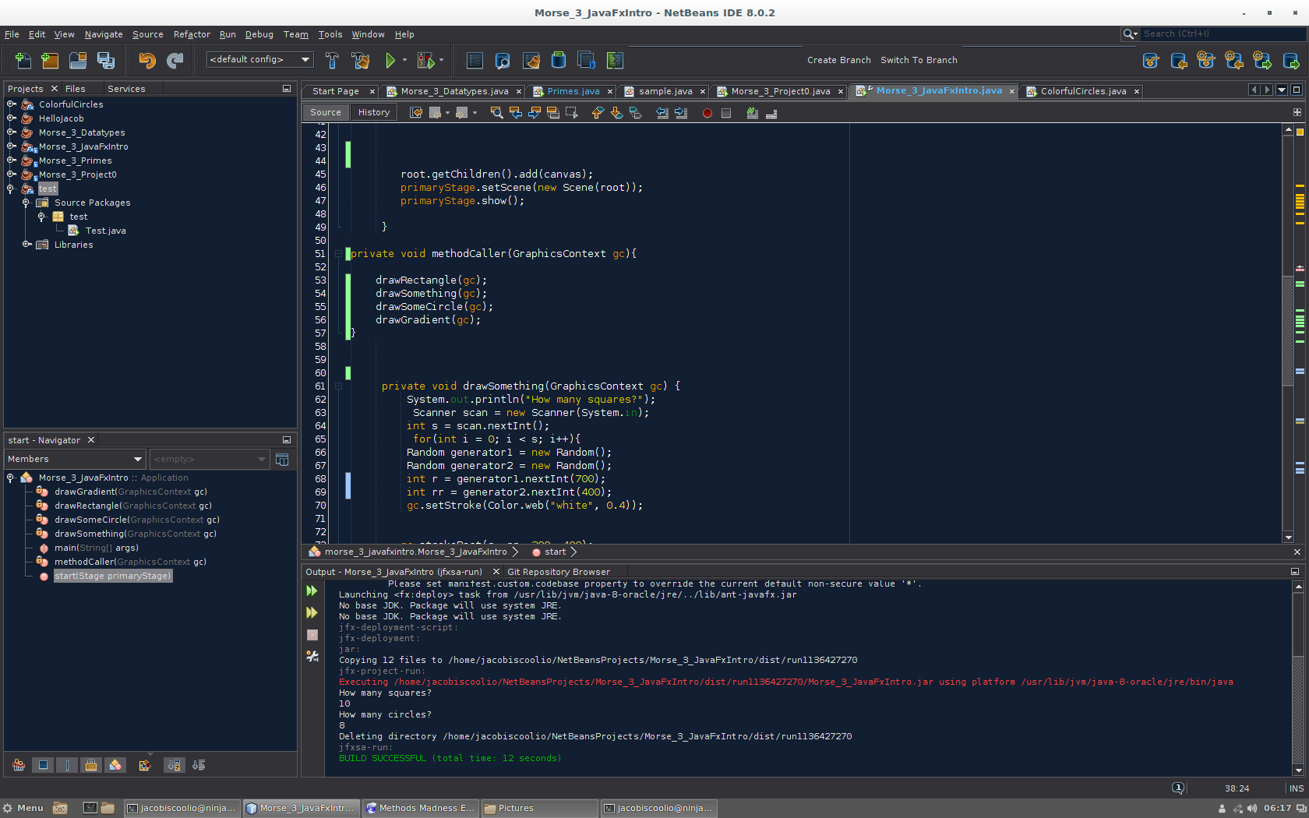

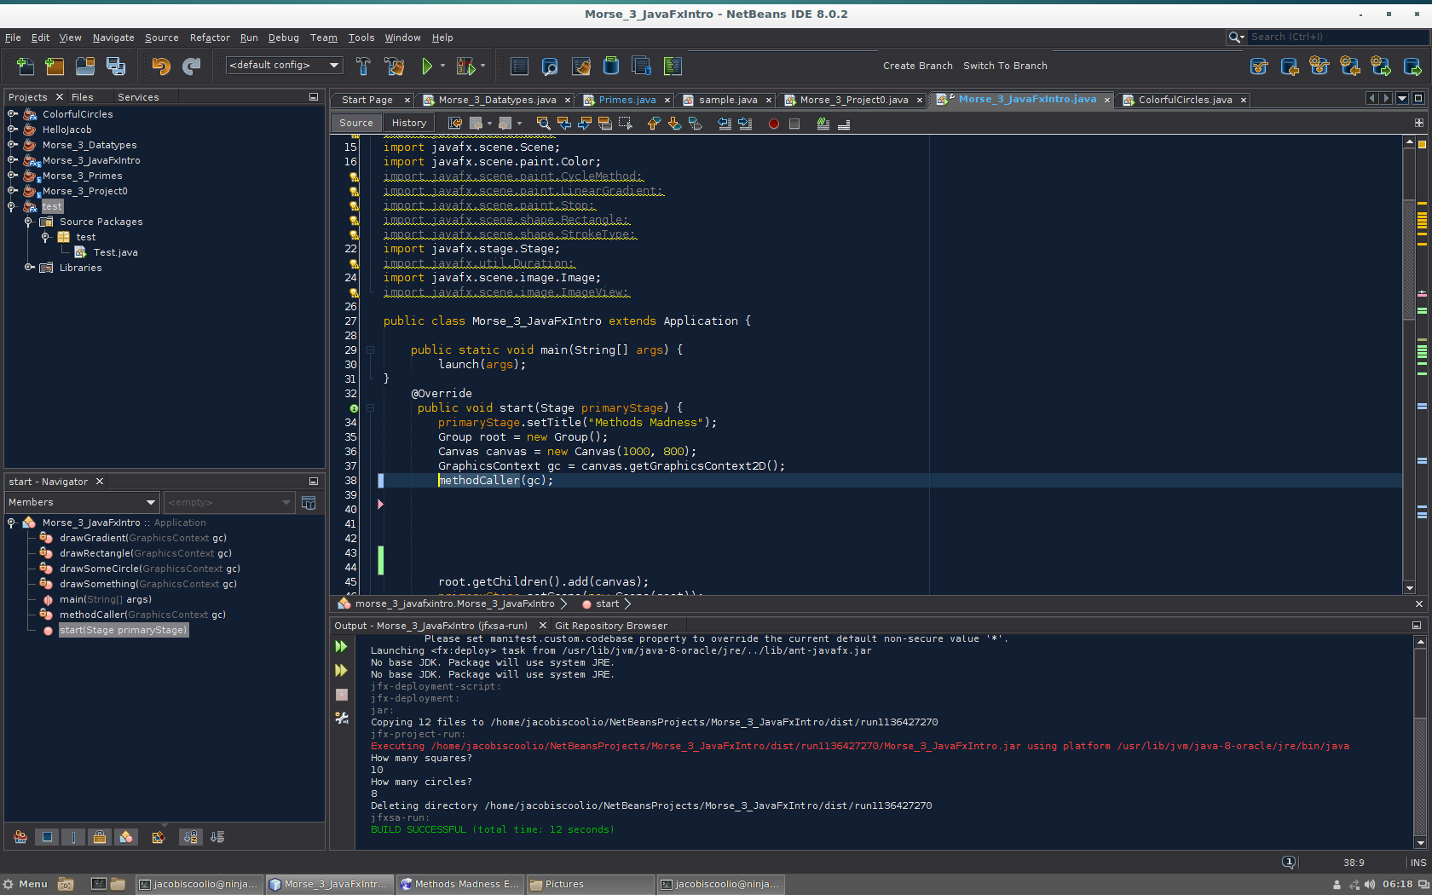

I have many different methods in my program. The drawSomething method creates a number of slightly translucent white rectangles based on the number the user inputs. The drawSomeCircle method does the same exact thing but with small circles. The drawRectangle method creates a black rectangle as big as my canvas. The drawGradient method creates an image of a gradient I created and puts it on the canvas. Finally the methodCaller method calls all the methods so that I only have to call one method at the beginning of my code.

My program uses many different imported classes that are essential to my program, These are the following classes: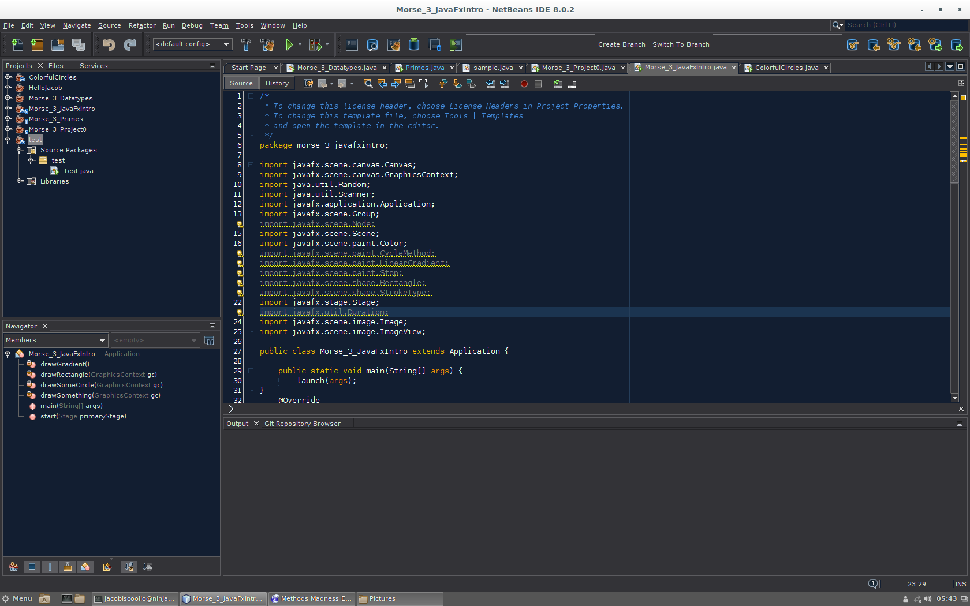

The way my program asks for input is the Scanner class, which asks for an input for a certain variable by the user. The way my shapes are placed in random sections of the canvas is the Random class. One of the most important classes is the Canvas class, which create the plain that my things are drawn, and Graphics Context, which draws the shapes and graphics.

All of my methods in my program passes the variable gc, and returns the value gc, which draws the graphics in which I tell the program as seen here: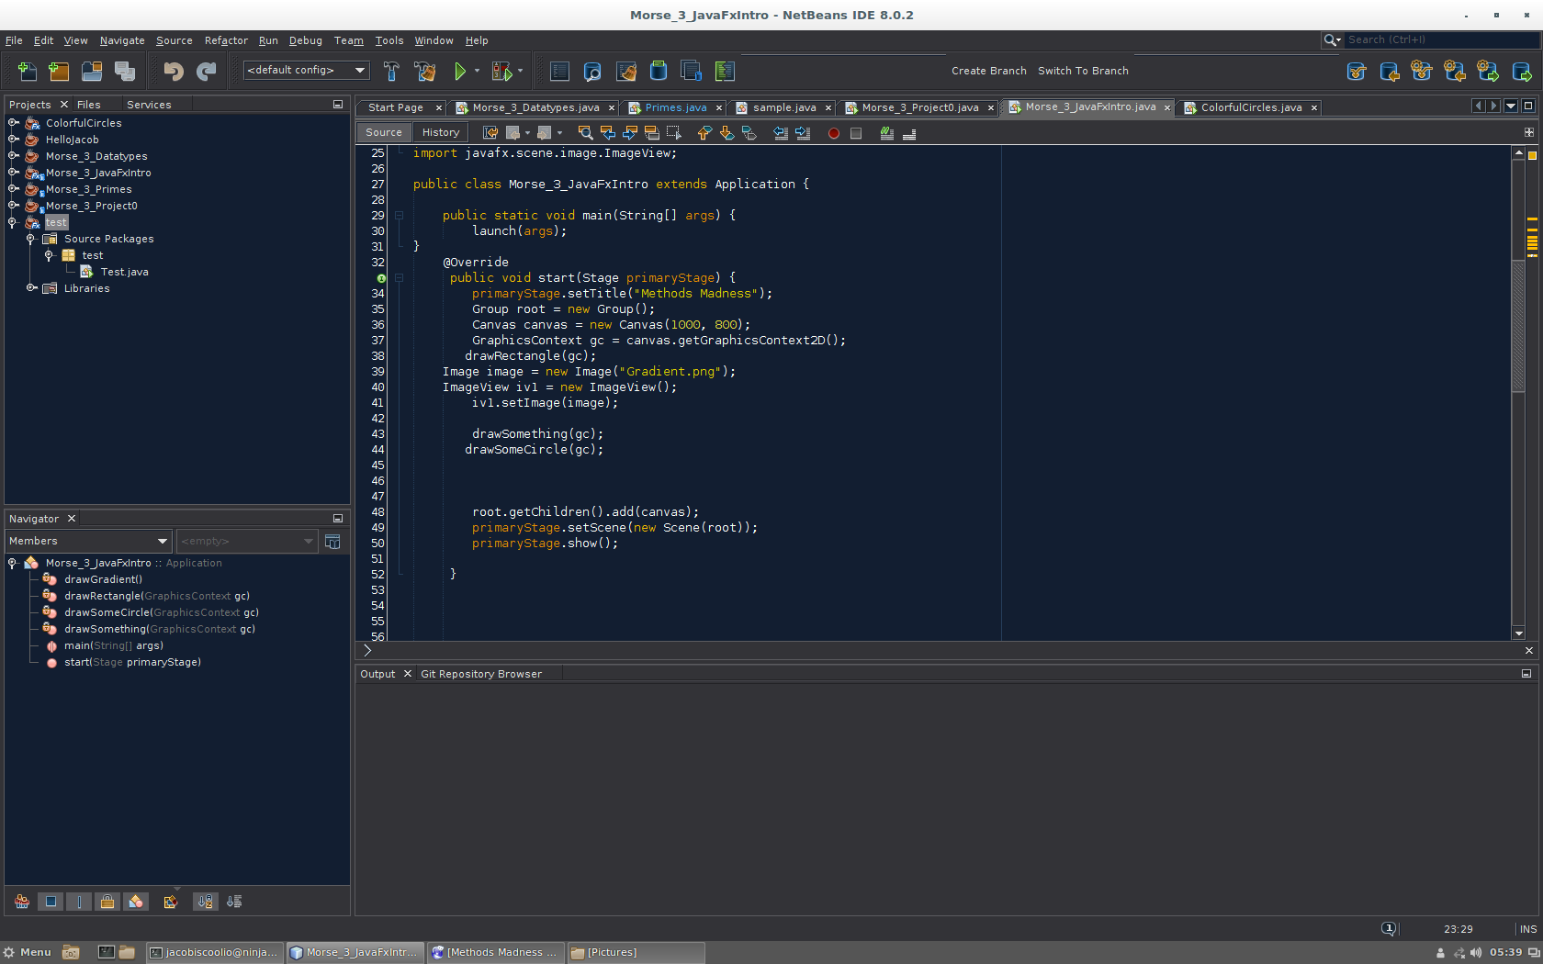

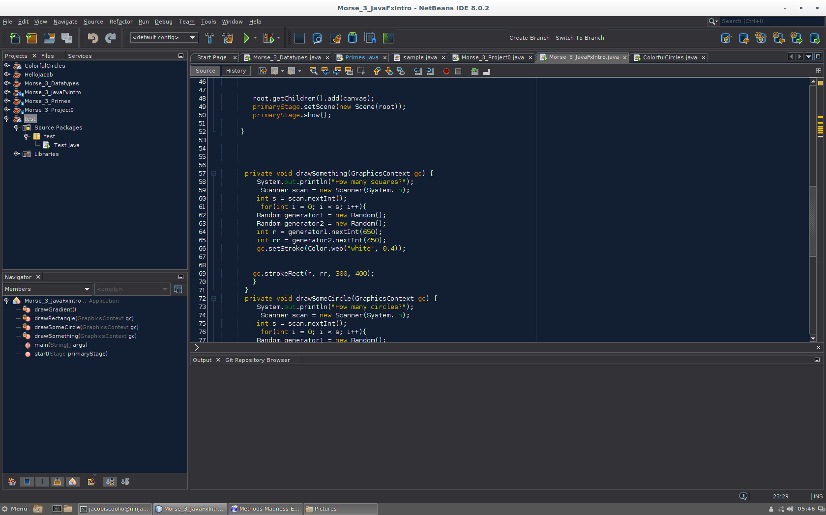

This allows my program do draw graphics without being in the main method. In other words it’s so I can have multiple methods.

The access modifiers in my program are my private values used in my program, and the one public value in the main method:



My class constructor is the main method that does everything in the project. It calls the methods, it make the canvas, and call the Graphics Context: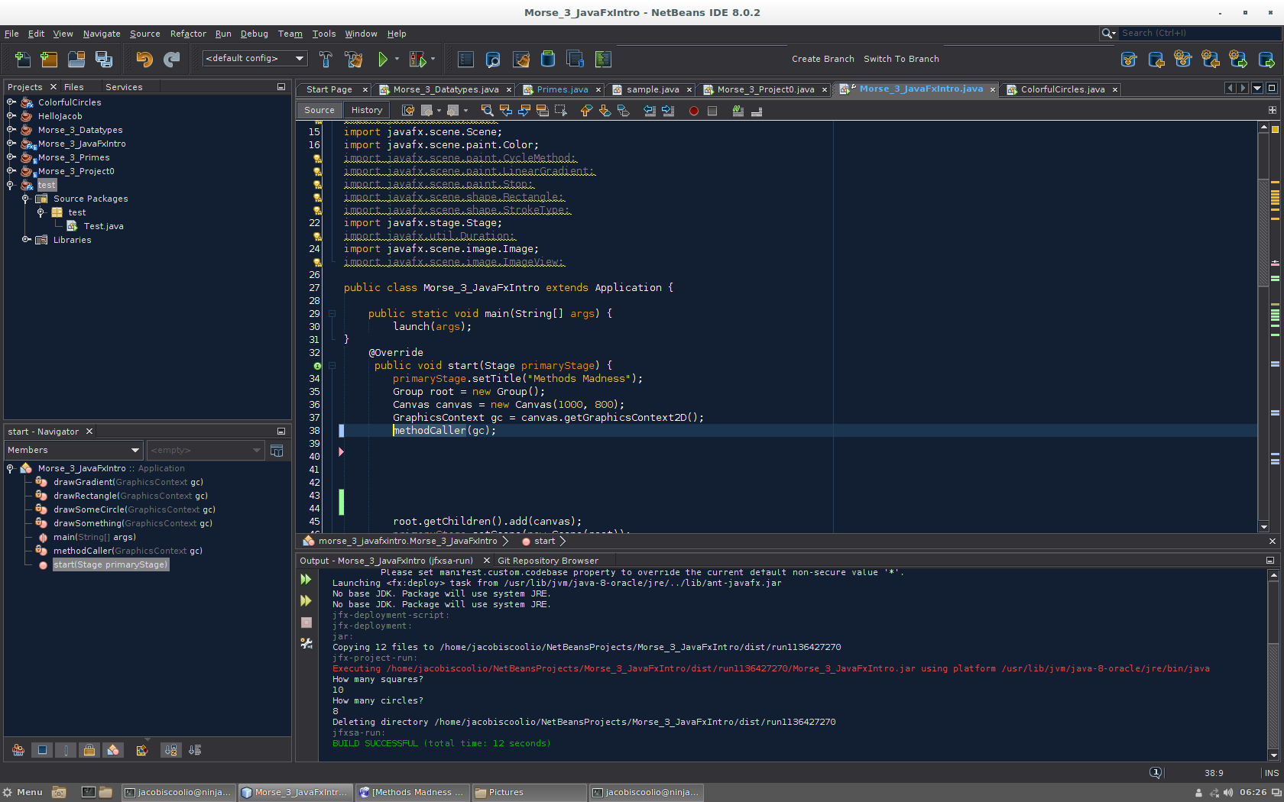

Overall, my program turned out how I wanted it to turn out. I made all of the element that I wanted for my program. I may continue this program in the future just to keep making it better, but other than that, I’m happy that I was able to add these different features to my program. It was challenging to make, but very useful in a sense that it reminded me of different things I can do in future programs.

