EFFECTIVE SWITCHING SYSTEM(EFS)

by

V.JACOB JEBARAJ 18BEC1107

P.GOPALAKRISHNA 18BEC1109

ASTRO JES 18BLC1065

ASHISHKUMAR 18BLC1119

A project report submitted to

**DR.MANOJ KUMAR R**

**SCHOOL OF ELECTRONICS ENGINEERING**

in partial fulfilment of the requirements for the course of

# ECE-3003 MICROCONTROLLER AND ITS APPLICATION

# in

**B.Tech. ELECTRONICS AND COMMUNICATION ENGINEERING**



**Vandalur – Kelambakkam Road**

**Chennai – 600127**

**JUNE 2020**

**BONAFIDE CERTIFICATE**

Certified that this project report entitled “EFFECTIVE SWITCHING SYSTEM(EFS)**”**is a bonafide work of **V.JACOB JEBARAJ - 18BE1107,P.GOPALAKRISHNA:18BEC1109,ASTROJES 18BLC1065, ASHISHKUMAR 18BLC1119 and** who carried out the Project work under my supervision and guidance for**ECE3003-MICROCONTROLLER AND ITS APPLICATION**

**DR.MANOJ KUMAR R**

Professor

School of Electronics Engineering (SENSE),

VIT University, Chennai

Chennai – 600 127.

**ACKNOWLEDGEMENT**

We wish to express our sincere thanks and deep sense of gratitude to our project guide,**Dr.MANOJ KUMAR R,**Professor, School of Electronics Engineering, for his consistent encouragement and valuable guidance offered to us in a pleasant manner throughout the course of the project work.

We are extremely grateful to **Dr.Sivasubramanian. A,**Dean of School of Electronics Engineering, VIT Chennai, for extending the facilities of the School towards our project and for her unstinting support.

We express our thanks to our Head of the Department**Dr.Vetrivelan. P**forhis support throughout the course of this project.

We also take this opportunity to thank all the faculty of the School for their support and their wisdom imparted to us throughout the course.

We thank our parents, family, and friends for bearing with us throughout the course of our project and for the opportunity they provided us in undergoing this course in such a prestigious institution.

**JACOB ASHISH GOPAL ASTRO**

# ABSTRACT

Automaticcontol for smart swithing system projects main idea is to develop a application where fans and light will be controlled automatically using microcontroller system. Implementing this system can save lot of efficiency in controlling swithces. This application uses 8051 microcontroller and bluetooth transmitters and receivers.In present system swithches are maintained manually, but there are many cases where human errors which had caused huge damages. In order to develop this application accuracy is most important so there is need to be a quality check before implementing in reality.In this project two powerful transmitters and receivers are used, among them one transmitter and one receiver is used at the upside at the human level and other pair is fixed at downside.

**TABLE OF CONTENTS**

|  |  |  |
| --- | --- | --- |
| **SI.NO** | **CONTENT** | **Page No** |
| 1 | INTRODUCTION  LITERACY REVIEW | **6**  **6** |
| 2 | ATCHITUCTURE  COMPONENTS DESCRIPTION  SOFTWARE REQUIREMENT  ALGORITM | **7**  **7** |
| 3 | DESIGN | **8** |
| 4 | WORKING | **9** |
| 5 | stimulation | **10** |
| 6 | code | **17** |
| 7 | APPLICATIONS  conclusion | **18** |
| 8 | REFERENCES | **19** |

**INTRODUCTION**

In, today’s day and age, we have developed so much that there are a lot of industries and buildings that use multiple switches to handle the huge number of equipment and even the basic devices such as lights and fans.Therefore, our aim by this switching system is to make this process more efficient.So, what our system is expected to do is:If an appropriate code is entered, the custom preset devices such as fans and lights will turn On.The Status of those devices will be displayed on the LCDThis is particularly useful when a set devices need to be turned On, where manually turning on each one of those can be highly inefficient.

**LITERATURE REVIEW**

The 8051 is one of the most popular microcontrollers in use today. Thus, the ability to program in microcontroller 8051 is an important thing. A microcontroller has a CPU in addition to a fixed amount of RAM, ROM, I/O ports and a timer all on a single chip. It ideal for many applications in which cost and space are critical. It also save space of the applications takes, the power it consumes and the price per unit are much more critical consideration than the computing power. Computers transfer data in two way, parallel and serial. To transfer to a device located many meters away, the serial method is used. In serial communication, data is sent 5 one bit at a time, in contrast to parallel communication. The 8051 has serial communication capability built into it. The fact that in serial communication a single data line is used instead of the 8-bit data line of parallel communication makes it not only much cheaper. There is three ways of transfer : simplex, half duplex and full duplex. Half duplex happened when data is transmitted one way at a time.

**INTEL’S 8051 Architecture**

The generic 8051 architecture sports a Harvard architecture, which contains two separate buses for both program and data. So, it has two distinctive memory spaces of 64K X 8 size for both program and data. It is based on an 8 bit central processing unit with an 8 bit Accumulator and another 8 bit B register as main processing blocks. Other portions of the architecture include few 8 bit and 16 bit registers and 8 bit memory locations. Each 8031 device has some amount of data RAM built in the device for internal processing. This area is used for stack operations and temporary storage of data. This base architecture is supported with on chip peripheral functions like I/O ports, timers/counters, versatile serial communication port. So it is clear that this 8051 architecture was designed to cater many real time embedded needs. FIG 3: 8051 ARCHITECTURE 4.2 Timers/Counters 8031 has two 16 bit Timers/Counters capable of working in different modes. Each consists of a `High' byte and a `Low' byte which can be accessed under software. There is a mode control register and a control register to configure these timers/counters in number of ways. These timers can be used to measure time intervals, determine pulse widths or initiate events with one microsecond resolution up to a maximum of 65 millisecond (corresponding to 65, 536 counts). Use software to get longer delays. Working as counter, they can accumulate occurrences of external events (from DC to 500 KHz) with 16 bit precision. In our project we are using 8 bit microcontroller AT89C2051, it is the advanced 8 bit microcontroller from ATMEL, which incorporates Flash Rom, and Timer etc.

**COMPONENTS DESCRIPTION**

•8051 Microcontroller

•8051 Development Board

•8051 Programmer

•4×4 Matrix Keypad

•16×2 LCD

•L293D Motor Driver Board

•DC Motor

•10KΩ Potentiometer

•Connecting wires

•Power Supply

•If 8051 Development Board is not used, then the following components are needed.

–11.0592 MHz Quartz Crystal

–2 x 33pF Ceramic Capacitors

–2 x 10 KΩ Resistor (1/4 Watt)

–10 µF Capacitor (Polarized)

–Push Button

–2 x 1 KΩ Resistors (for pull up)

# SOFTWARE REQUIREMENT

# 1)Keil compiler

# 2)Flash magic

# 3)Proteus

**5. ALGORITM**

1. START

2. initialise lcd , keypad

3. clear lcd

4. print “Enter code” on lcd

5. get 5 char long password using matrix key pad

6. if input = “12345” then

6.1 print “Enter master code ”

6.2 get 10 char long password using matrix key pad

6.3 if input = masterlock then 6.3.1 change CODE

6.3.2 go to step 4

6.4 else

6.4.1 print “ fan code” on lcd

6.4.2 go to step 4 7. else

7.1 if input = userlock or input = default lock then

7.1.1 unlock the lock

7.1.2 retry count = 3

7.1.3 print “ „ #‟ to lock ” on lcd

7.1.4 accept input using matrix key pad

7.1.5 if input = “ # ” then lock

7.1.6 goto step 4

7.2 else

7.2.1 decrement retry count

7.2.2 print “ wrong code ” on lcd

7.2.3 if retry count = 0 then sound alarm on

7.2.4 go to step 4

8. STOP

# DESIGN

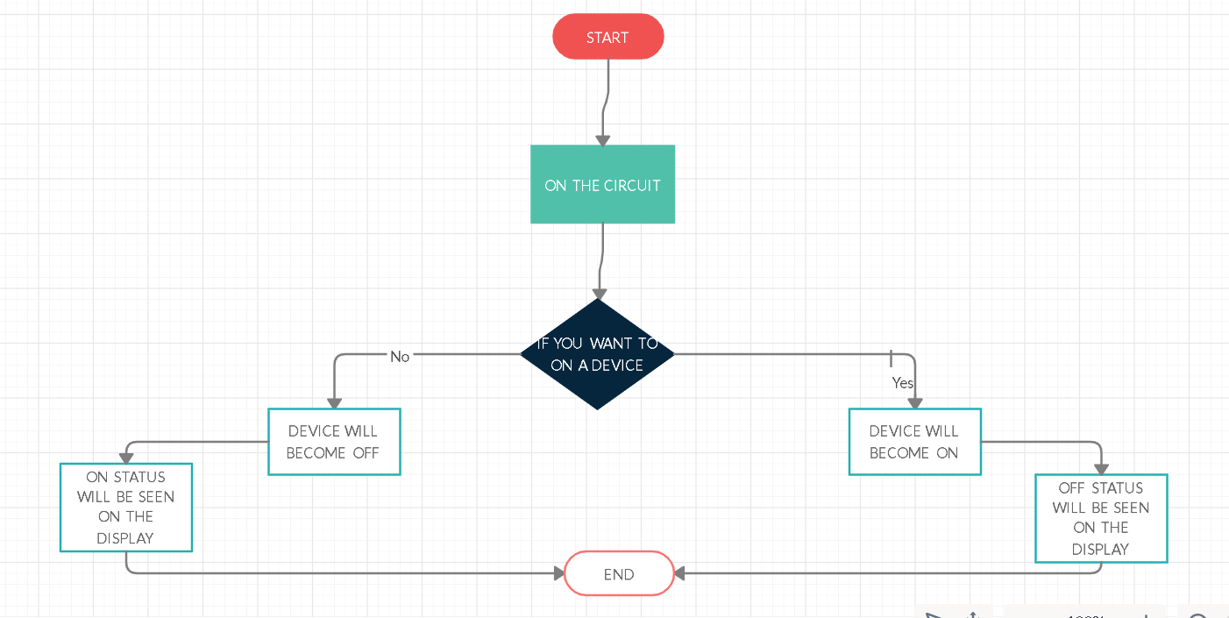

**WORKING**

Initially, declare the PORT1 to LCD data pins and control pins (RS and E) to P3.0 and P3.2. Also, declare PORT2 to keypad. Also use P0.0 and P0.1 for motor driver.Then, display the message “enter the code to turn on the respective devices” on LCD.Now read the five-digit code from the user.Compare the entered code with the stored set of codes for each of the custom presets.

If code is appropriate, then make P0.0 pin HIGH and P0.1 pin LOW to turn on the preset devices. During this time, display *“Turning On the said Devices”* on LCD.If the code is wrong, then display *“Preset Does Not Exist”* on LCD.

After some delay again ask to enter code.

**PROTEUS STIMULATION:**

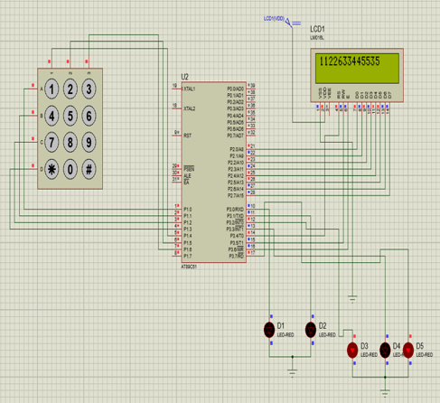

**FIG:PROTEUS STIMULATION**

**CODE:**

sbit R0=P1^0;

sbit R1=P1^1;

sbit R2=P1^2;

sbit R3=P1^3;

sbit C0=P1^4;

sbit C1=P1^5;

sbit C2=P1^6;

sbitrs=P3^4;

sbitrw=P3^5;

sbit e=P3^6;

sbit f=P3^0;

sbit g=P3^1;

sbit h=P3^2;

sbit i1=P3^3;

sbit j=P3^7;

void delay();

void cmd(unsigned int);

void dat(unsigned int);

void main(void)

{ cmd(0x38);

cmd(0x01);

cmd(0x0c);

cmd(0x80);

cmd(0x06);

f=0;

g=0;

h=0;

i1=0;

j=0;

while(1)

{ R0=R1=R2=R3=1;

R0=0;

if(C0==0)

{ dat('1');

if(f==0)

{f=1;

}

else

{

f=0;

}

while(C0==0);

}

R0=R1=R2=R3=1;

R0=0;

if(C1==0)

{

dat('2');

if(g==0)

{

g=1;

}

else

{

g=0;}

while(C1==0);

}

R0=R1=R2=R3=1;

R0=0;

if(C2==0)

{dat('3');

if(h==0)

{

h=1;

}

else

{

h=0;}

while(C2==0);

}

R0=R1=R2=R3=1;

R1=0;

if(C0==0)

{

dat('4');

if(i1==0)

{

i1=1;

}

else

{

i1=0;}

while(C0==0);

}

R0=R1=R2=R3=1;

R1=0;

if(C1==0)

{

dat('5');

if(j==0)

{

j=1;

}

else

{j=0;}

while(C1==0);

}

R0=R1=R2=R3=0;

R1=0;

if(C2==0)

{dat('6');

while(C2==0);}

R0=R1=R2=R3=1;

R2=0;

if(C0==0){

dat('7');

while(C0==0);}

R0=R1=R2=R3=1;

R2=0;

if(C1==0)

{dat('8');

while(C1==0);}

R0=R1=R2=R3=1;

R2=0;

if(C2==0)

{dat('9');

while(C2==0);}

R0=R1=R2=R3=1;

R3=0;

if(C1==0)

{

dat('0');

while(C1==0);}}}

void delay()

{int i;

e=1;

for(i=0;i<30000;i++);

e=0;

}void cmd(unsigned int ch)

{

rs=0;

rw=0;

P2=0x00;

P2=ch;

delay();}

void dat(unsigned char ch)

{

rs=1;

rw=0;

P2=0x00;

P2=ch;

delay();

**APPLICATIONS**

There are multiple versatile use case scenarios for our Effective Switching System (EFS).

•With the increasing number of devices in our home only and people moving towards home automation, this simple device can go a long way in helping our users by reducing the hassle of turning On and Off multiple electronic appliances.

•It's use case in industries is even more obvious. When multiple set of equipment’s need to be turned on and off munually the process can get highly inefficient and time consuming.

•This does not only reduce labor costs but also reduces the points of failures in the industry by reducing the number of switches and thereby increasing the overall reliability of the entire system.

**CONCLUSION**

This project is meant for switching systems whose access is only for respected authorities. Using a microcontroller the password entered is checked with the stored password and then does the corresponding operations. Here we use a 5 digit password for better secrecy.

### REFERENCES

<https://www.tutorialspoint.com/microprocessor/microcontrollers_8051_architecture.htm>

<https://www.edgefx.in/keypad-interfacing-with-8051-microcontroller/>

<http://www.circuitstoday.com/proteus-software-introduction>

<http://www.circuitstoday.com/interfacing-16x2-lcd-with-8051>

http://web.mit.edu/6.115/www/document/8051.pdf