README file for Atlantis AMLS and Data Processing
Data processing required for generation of BGM files for Atlantis Models

ArcInfo AMLs
processshapefile.aml
Used to generate an ArcInfo coverage from the input shapefile used to initially create boxes.
Converts shapefile to ArcInfo coverage;
Process coverage to generate individual arc segments from each vertex
Generate node, arc and polygon topology required for BGM file
Performs initial calculations on BGM-ID field (initialises all values to -2 prior to manual calculation of BGM-ID’s in ArcView)

TAG_COV.aml
Arcs:
Requires pre-tagging of BGM-BND for ARCS. Tagging follows convention:
-3 Untagged – Initialised stage – Set by processshapefile.aml, or requires resetting by user.
-2 Non-dynamic arcs for oceanic polygons – Final tagging is BGM-ID = -3
-1 Coastal Arcs - For tagging
0: BGM-ID=0 – Predefined starting boundary face. Has to face onto polygon BGM-ID=0.
Polygons:

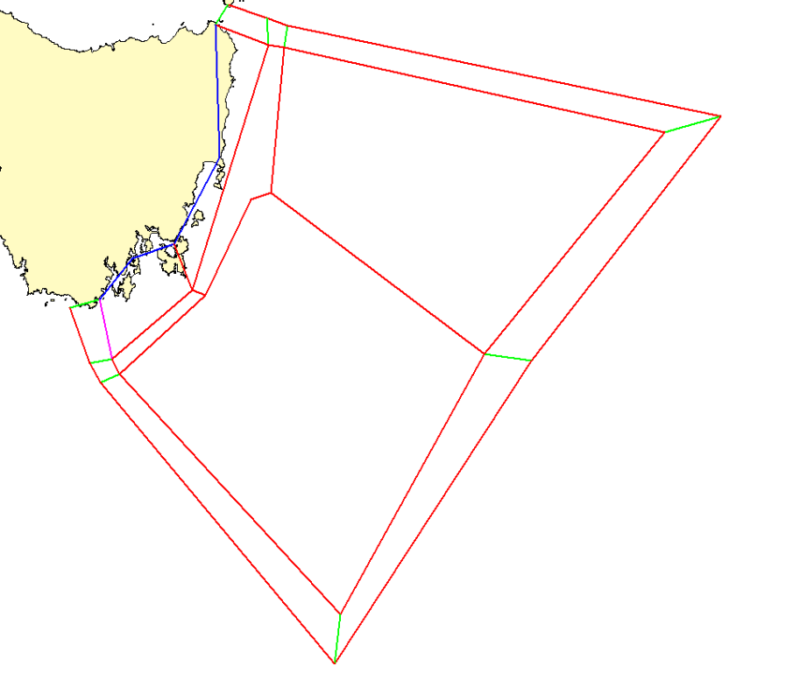
Tagging for BGM-BND. Red -3 – Internal faces will have an ID, External faces untagged, Green -2 – Untagged boundary faces, Blue -1 – Tagged coastal faces.
AML uses boundary polygon (global polygon) to identify non-coastal arcs which do not require tagging.

BGM_POLY.aml
Generates BGM output for polygons

iFace and iBox only contain dynamic faces. i.e Faces between boundary and internal boxes, and between internal boxes - does not include coastal faces.
The two lists should match ID’s. i.e the iFace list ID’s should be in order with the iBox list and the corresponding adjacent box ID.

BGM_ARCS.aml
Generates BGM output for Arcs

Only contain dynamic faces. i.e Faces between boundary and internal boxes, and between internal boxes - does not include coastal faces

BGM_BOUNDARY.aml
Generates BGM output for the model domain boundary.

The boundary is defined by all external dynamic arcs. This includes the coastal arcs, and dynamic faces between the oceanic boundaries and the internal boxes. Removal of the boundary boxes and all internal arcs creates the domain boundary.

ArcInfo coverage Processing
Once the initial boxe boundaries have been generated as an ArcView shapefile, the dataset is converted to an ArcInfo coverage. This data format contains the necessary topology required for generation of the BGM file.
Arc and Polygon attributes must be tagged manually to generate the numbering required. The information is stored in the arc and polygon attribute tables under BGM-ID. This field is created and initialised to -2 in processshapefile.aml.
Polygon tagging:
- All Polygons are tagged.
- Polygon 0 (zero) must be a boundary polygon
- Polygon 1 must be adjacent to 0 and must be a dynamic polygon
- The rest are numbered sequentially approximately clockwise.
Arc tagging:
- Only dynamic arcs are tagged. i.e. those which have flows between adjacent polygons.
- Arc 0 is an arc forming a boundary between polygons 0 and 1.
- Arcs between boundary boxes are not tagged, except for coastal boundary boxes, which have flows between them.
- Arcs on the outer boundary are not tagged
- Boundary arcs are flagged as -1. This allows identification of arcs that have not been tagged, which should remain as -2. These can then be easily identified, and are normally small arcs which should be removed. Non dynamic arcs between boundary boxes are tagged as -3. The tagging scheme allows for the arcs defining the model domain to be selected out based on their BGM ID’s. The remaning arcs are tagged 1 to n following approximately clockwise around the dataset.
Polygon and Arc tagging can be performed in ArcView or ArcInfo/ArcMap. Sample tagging script is in BGM.SetID.ave.

Info from Beth
Basically the rules we're running with are
1. Vertices of boundary (start with edge box 0 and go clockwise) - include any land edge and the edge of boundary boxes touching dynamic polygons
2. Number every box (beginning with box 0, and its best if box 0 is a boundary box)
3. For vertices of each box (start with upper left and go clockwise)
4. Number all faces (i) between dynamic polygons (i.e. polygons completely within the boundary) and (ii) between dynamic polygons and boundary boxes (don't stat faces between boundary boxes)
5. For each face left-right is determined starting at p1 looking to p2
And:
A boundary box must be 0
First dynamic box must be 1

Automatic Tagging – Pre tagging requirements:
Field BGM-BND
- All arcs initially tagged -3
- Coastal boundary faces tagged -1
- Interior non-dynamic faces tagged -2 (oceanic adjacent box boundaries)
- The remaining exterior arcs (adjacent to global polygon) tagged -3
  - First dynamic arc tagged 0. Should be the first dynamic arc from Box BGM-ID = 0.

Active Boundary:
Active boundary consists of removing all arcs tagged as -1, building coverage and reselecting all arcs with LPOLY# or RPLOY# = 1 (global polygon)

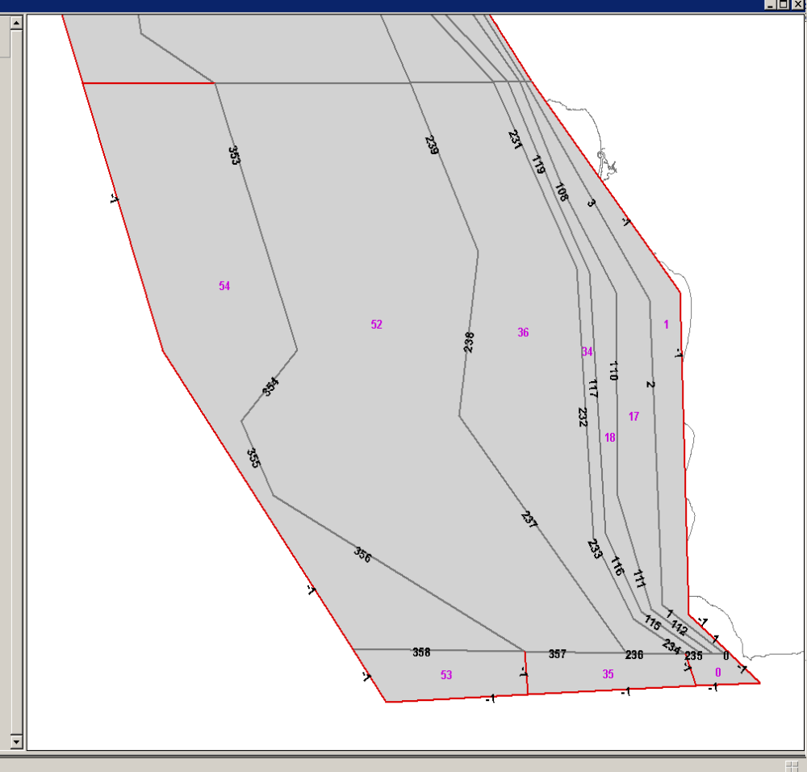
Figure 1 Sample BGM labelling for EMOCC_31. Red arcs are non-dynamic boundary box arcs and not tagged.

REM ******************************************
REM ***** Batch file for running AMLS
REM runbgms.bat <inputcov> <date yyyymmdd>
echo on
if "%1" == "" goto inerror
if "%2" == "" goto inerror
if not exist %1 goto nocov
goto runamls

:runamls
echo Input Coverage: %1
arc "&r ../../amls/bgm_boundary %1" > %1_%2.bgm.0
arc "&r ../../amls/bgm_poly %1" > %1_%2.bgm.1
arc "&r ../../amls/bgm_arcs %1" > %1_%2.bgm.2
goto end

:nocov
echo No Input Coverage Directory - Exiting
goto end

:inerror
echo No Input Coverage Name - Exiting
echo OR No Input Date - Exiting
echo Enter date as yyyymmdd
goto end

:end
REM ******************************************

' Avenue Script: BGM.SetID
' Calc incremental ID's for BGM-ID field

theVTab = av.FindDoc("Attributes of Boxes_v2").GetVtab
fldBGM_ID = theVtab.FindField("BGM-id")

' Get the last ID
lstID = {}
for each aRec in theVtab
lstID.Add(theVtab.ReturnValueNumber(fldBGM_ID,aRec))
end
lstID.Sort(FALSE)
_numBGMID = lstID.Get(0)
' MsgBox.Info(_numBGMID.AsString,"")
_numBGMID = _numBGMID + 1

if (System.IsShiftKeyDown = TRUE) then
_numBGMID = MsgBox.Input("Enter Start BGM-ID","Start BGM-ID",_numBGMID.AsString)
_numBGMID = _numBGMID.AsNumber
end

if (theVtab.GetSelection.Count <> 1) then
MsgBox.Info("More Than One Record Selected","Bailing")
Return NIL
else
for each aRec in theVtab.GetSelection
' MsgBox.Info(_numBGMID.AsString,"")
if (theVtab.ReturnValueNumber(fldBGM_ID,aRec) > 0) then
if (System.IsShiftKeyDown = TRUE) then
MsgBox.Info("Re Numbering Feature","Bailing")
else
MsgBox.Info("Already has ID","Bailing")
Return NIL
end
end
theVTab.SetEditable(TRUE)
theVTab.SetValueNumber(fldBGM_ID,aRec,_numBGMID)
theVTab.SetEditable(FALSE)
end
end

av.Run("View.ZoomToSelected",{})
av.FindDoc("View1").GetDisplay.ZoomToScale(40000)

