Integrating climate and ecosystem models
Hobart, September 2008

Summary and publication outline
9th September 2008

Attending the workshop were:
Alistair Hobday, Anthony Richardson, Christopher Brown, Cathy Bulman, Villy Christensen, Beth Fulton, Peter Gehrke, Shane Griffiths, Hector Lozano-Montes, Richard Matear, Julie Martin, Sarah Metcalf, Tom Okey, Reg Watson

Other contributors:
Neil Klaer, Neil Gribble, Hugh Possingham

Project timeline, September onwards
September/October: Predictive models for coastal production
October/November: Downscaled Bluelink production scenarios (Matear)
November/December: Climate impact on ecological, economic and social indices
January: Adaptation to climate change using fishery management
February-April: Writing up and submission of manuscript ‘Toward managing marine ecosystems in a changing world’

Potential future work
1. Envelope for temperature response and equations (using new Ecopath implementation)
2. Effects of multiple climate drivers on marine ecosystems (temperature, productivity, sea level)
3. A comparison of the effect of trend vs inter-annual variability in productivity projections. Examples of inter-annual variability include decadal changes in ocean circulation and stochastic events such as cyclones.
4. Importance of different trophic controls in marine ecosystems (bottom-up, top-down, wasp-waist)
Publication outline and workshop summary
Toward managing marine ecosystems in a changing world
Brown et al.

Introduction
Climate change is likely to have widespread and significant impacts on Australian marine systems.
- Australian systems are generally oligotrophic, and such systems may be sensitive to relatively small changes in nutrient enrichment
- Australia is isolated, with unique biodiversity
- 80% of Australians live within 50 km of the coast and fisheries are economically and socially important
- The magnitude of predicted physical changes is large. For example, temperature in SE Australia is projected to warm by more than 3°C this century, more than anywhere else in the Southern Hemisphere
- To understand climate change impacts in Australia via empirical field-based studies alone will take decades and require considerable financial resources
- Early implementation is key to flexible adaptation measures

Aims
- Assess potential impacts of changes in primary productivity due to climate change on Australia’s marine ecosystems
- Highlight how climate adaptation in Australian marine systems may differ to Australian terrestrial systems
- Develop generalisations in the response of marine ecosystems to climate change by using the comparative approach
- Focus on effects on fishery yields and associated economic, social and ecological consequences of climate change

Background
- A quality EwE model for a single ecosystem takes >2 person years to construct and refine, so we will build on >36 person years of development
- Australian marine EwE models cover a large latitudinal range and diversity of ecosystems
- Australian marine EwE models have been built for different purposes (e.g. investigate fishing impacts or eutrophication)

Last paragraph
- Here we use nutrient-phytoplankton-zooplankton (NPZ) and benthic production models, forced by GCMs, to project changes in primary production in Australian waters
- We consider the A1B1 (low) and A1F1 (high) emission scenarios. However, the A2 scenario is now considered “middle of the road”
- We investigate potential future changes in primary productivity to estimate a minimum response of ecosystems and to limit the number of variables. Climate impacts on primary production are likely to have a large impact on marine ecosystems.

Methods

Approach
- Use output from CSIRO Mk3.5 GCM to force BlueLink and then NPZD (forcing of primary production by NPZ and rainfall) in the 2060s. Predict phytoplankton production in trend from present day to 2060s.
- Simple models for benthic production (microphytobenthos, seagrass, macroalgae) forced with CSIRO Mk3.5 global climate model (GCM) to project changes in benthic production.
- Use production trends to force existing EwE models and variations of these models that represent alternative ecological hypotheses (for instance, phytoplankton shading of seagrass).
- Explore differences in ecosystem response between 2060s and the present, under low (B1) and high (A2) emission scenarios (Note: the B1 scenario is not likely to be available with the fine-scale Bluelink simulations for some time).
- A subset of key ecosystem indicators are used to summarise the response of the Ecopath models. These include biological (ecosystem diversity and maturity), economic (fishery value) and social (employment opportunities, job stability, charismatic species) indices.
- Identify optimal solutions for each Ecosim model, based on optimising economic, social or ecological objectives and combinations of these objectives.

Descriptive summary of Ecopath with Ecosim models.
Table 1. Description of Australian Ecopath with Ecosim models included that will be used for analysis. Listed are the model’s name, abbreviation, key reference and the main purpose for which it was built. Also included are some key model variables: the area they cover, the number of living groups, what type of time-series data the model has been fitted to and primary producer groups in each model with the percentage each contributes to system primary productivity (estimated from the model). Note: some of the models listed in this table may be unavailable for use at the time of publication.

Model | Abbrevi-ation | Reference | Model was developed to investigate: | Area (km²) | No. living groups | Fitting to time-series data | Primary producer groups | Percentage of primary  production
Great Barrier Reef coast | GBRCst | (Gehrke 2007) | Effect of reducing nutrient content of river outflow on coastal fisheries | 987 | 18 | Y (16 years, 7 groups) | Phytoplankton  Seagrass  Microphytobenthos  Macro-algae  Mangroves | 73  20  5.8  0.88  0.25
Great Barrier Reef | GBR | (Gribble 2003) | Impact of prawn trawl on bi-catch species and food-webs, trophic links between coastal and reef ecosystems |  | 25 | Not yet | Benthic autotrophs  Phytoplankton | 82  19
Gulf of Carpentaria, Benthic | GCBnth | Unpublished | Ecological effects of prawn trawl fishery | 3.7x10⁴ | 51 | Y (36 years, 1 group) | Microphytobenthos  Phytoplankton  Macroalgae Seagrass | 51  45  3.4  0.12
Gulf of Carpentaria, IUU | GCIUU | (Okey et al. 2007), not released | Impacts of illegal, unreported and unregulated catch on Gulf ecosystems, legal fishery catch and the economy | 3.7x10⁴ | 79 | N | Phytoplankton  Microphytobenthos  Macro-algae  Seagrass  Mangroves | 57  40  3.1  0.10  0.05
Albatross Bay (Gulf of Carpenteria) | GCAlb | Unpublished | The decline in banana prawn trawl catch | 5788 | 92 | Under-way | Marine phytoplankton  Microphytobenthos  Estuarine phytoplankton  Marine macro-algae  Estuarine macro-algae  Mangroves | 76  11  7.6  5.1  0.28  0.01
Darwin harbour | Dar | (Martin 2005) | Predicting consequences of mangrove habitat loss to fish species in Darwin Harbour | 200 | 20 | N | Mangroves  Phytoplankton  Benthic producers | 60  34  6.8
Port Phillip Bay | PPB |  | Comparison of models of different complexity ,impact of nutrient input on the ecosystem and fisheries |  | 33 | Y | Phytoplankton  Microphytobenthos  Macro-algae Seagrass | 62  26  12  0.20
Jurien Bay | Jur | Unpublished | Ecological and fishery implications of new marine protected regions in the region | 823 | 72 | Under-way | Ecklonia  Sargassum  Low algae  Turfs  Corraline algae  Ephemeral seagrasses  Perenial seagrasses  Seagrass epiphytes  Microphytobenthos  Small phytoplankton  Large phytoplankton
Eastern tuna and billfish fishery | ETBF | Unpublished | Past ecosystem effects of fishing and future effects of new management policy | 2.6x10⁶ | 43 | Y (3 groups, 55 years) | Phytoplankton | 100
North-West shelf | NWS | (Bulman 2006) | Define trophic structure of the system | 7x10⁴ | 43 | N | Phytoplankton  Benthic producers  Microphytobenthos | 86  8.2  5.9
South-east shelf | SEF | (Bulman et al. 2006) | Assess impact of variability in primary production on fisheries, potential impact of, increasing seals on fisheries and ecosystem effects of fishery discards | 3x10⁴ | 55 | Y ( 10 years, 42 groups) | Phytoplankton | 100
Tasmania | Tas | Unpublished | Suitability of new quotas on the banded morwong fishery, trophic cascades caused by introduced species and compare qualitative and quantitative ecosystem models | 350 | 27 | N | Phytoplankton  Red algae  Brown algae  Green algae  Crustose algae | 70  17  7.6  2.0  3.1
Southern Tasmanian seamounts | STSM |  | Linkage between pelagic fishery and deep sea benthic marine protected area |  | 24 | N | Phytoplankton | 100

Caveats
Table 2. Caveats and how each was addressed.

Caveats | How addressed
Structure of Ecopath models dependent upon user aims, expertise, and philosophy | Used a suite of Ecopath models  Performed comparative analysis of Ecopath models
Not all Ecosim models have been calibrated to time-series data | Investigate how predictions change for different settings of the key Ecosim interaction parameters.
Spatial resolution of NPZ output too coarse | Used the finest scale future productivity available (NPZ coupled to BlueLink forced by CSIRO Mk3.5 GCM, 15 km grids)
Uncertainty in future emissions | A high (A2) and low emission (B1) future used
NPZD output only relevant to phytoplankton | Nutrient supply from offshore important for supplying nutrients in Australia. (Exceptions: Darwin Harbour, Port Phillip Bay?). More dependent on rainfall?
Phytoplankton productivity constitutes a relatively small proportion of productivity in near-shore environments | Phytoplankton is the only primary producer in all models. Percentage of primary production by phytoplankton is given in Table 1.
No existing projections for macro-algae and seagrass production under different climate scenarios | (A) Can implement impact on other autotrophic functional groups  1. Algae (brown, red, green) – productivity positively correlated with phytoplankton and rainfall (nutrient input)  2. Benthic microalgae – productivity positively correlated with phytoplankton but there is a negative mediation effect at high phytoplankton densities  Seagrass – positively correlated to rainfall around estuaries  Key question is do the different primary producers scale with nutrients in the water column (e.g. from NPZD) or with nutrients from runoff (from GCM rainfall)?
(B) Mechanistic models:
Use existing simple mechanistic models for these benthic producers and force with GCM output.
Prediction ability of macro-algae and seagrass production models untested | See if production hind-cast anomalies improve the fit of Ecosim models to time-series data
Temperature ignored | Implementation is completely different and will be addressed in subsequent work  Keep it more straightforward here
Impacts of cyclones on primary productivity ignored | Not well captured by current GCMs  Could be focus of other work on how important stochastic forcing is – do we get same ecosystem trajectory?
How robust are the findings from the NPZ? | Exact magnitude dependent on assumptions but sign around most of Australia unlikely to change  Latest GCMs resolves Southern Annual Mode better than previous models and its variability ultimately responsible for projected productivity changes in Australian waters
Rainfall difficult to predict | Can use average of GCM ensembles for rainfall or best models for Australia
Coupling of primary production to the ecosystem uni-directional (ie changes in the ecosystem will not feed-back to the primary producers in the future simulations) | Feed-backs probably weak in pelagic and open ecosystems (references). Possibly important in enclosed bay ecosystems. Can test with Beth’s Atlantis simulations?
No changes in distribution of species | Will investigate impacts of changes in productivity first  Will investigate changes in temperature in next paper  Because functional groups (and not generally species) are incorporated in the models, changes in species distribution are taken into account if range changes substitute ecologically equivalent species.

Table 3: Anthropogenic and climate driven impacts on Australian marine ecosystems

Region | Anthropogenic drivers of change | Climate impacts | Climate impacts simulations | Adaptation measures
Great Barrier Reef coast | Eutrophication  Fishing  Pollution | River nutrient input  Temperature  Ocean currents | Hydrographic/statistical models linked to GCM rainfall river nutrient input, NPZ for phytoplankton | Regulation of nutrient inputs  Fishery harvest strategies
Great Barrier Reef | Fishing  Eutrophication  Pollution | Coral bleaching  Temperature  Ocean currents | NPZ for phytoplankton and temperature projections for coral bleaching | Regulation of nutrient inputs  Fishery harvest strategies  Transplant tolerant corals
Gulf of Carpentaria | Fishing  Illegal fishing | River nutrient input  Temperature  Ocean currents | Hydrographic/statistical models linked to GCM rainfall river nutrient input, NPZ for phytoplankton | Fishery harvest strategies  Policing of illegal fishing
Darwin harbour | Recreational fishing  Coastal development | River nutrient input  Temperature | Hydrographic/statistical models linked to GCM rainfall river nutrient input | Fishery harvest strategies  Restrict loss of mangroves
Port Phillip Bay | Eutrophication Fishing  Coastal development  Pollution | River nutrient input  Temperature  Ocean currents | Hydrographic/statistical models linked to GCM rainfall river nutrient input, NPZ for phytoplankton | Regulation of nutrient inputs  Fishery harvest strategies
Jurien Bay | Fishing | Temperature  Ocean currents | NPZ for phytoplankton  GCM linked seagrass-macroalgal models | Fishery harvest strategies
Eastern tuna and billfish fishery | Fishing | Temperature  Ocean currents | NPZ for phytoplankton | Fishery harvest strategies
North-West shelf | Fishing | Temperature  Ocean currents | NPZ for phytoplankton | Fishery harvest strategies
NSW shelf | Fishing | Temperature  Ocean currents | NPZ for phytoplankton | Fishery harvest strategies
South-east shelf | Fishing | Temperature  Ocean currents | NPZ for phytoplankton | Fishery harvest strategies
Tasmania | Fishing | Temperature  Ocean currents | NPZ for phytoplankton  Seagrass-macroalgal model | Fishery harvest strategies
Southern Tasmanian seamounts | Fishing | Temperature  Ocean currents | NPZ for phytoplankton | Fishery harvest strategies

Results

Summarise responses of changes in phytoplankton primary productivity (from NPZD in GCM/BlueLink)
- Comparison of models using current conditions/configurations
- Describe and summarise output from Ecopath models forced by changes in primary productivity of all autotrophs under low and high emission scenarios
- Which functional groups go up and which ones go down? Why?
- Optimisation of management results – what solutions do we get and what generalisations can be made

Discussion
First cut approach - taken one realisation of productivity
Less capacity for environmental management in oceanic systems, whereas more management opportunities inshore

Performance of models/limitations of Ecopath models
- Mediation (non-tropic interactions) not implemented in all Ecopath models (probably more important coastally than oceanically)
- Does not include trophic mis-match
- Invasive species not included
- Changes in species ranges not considered

Figures

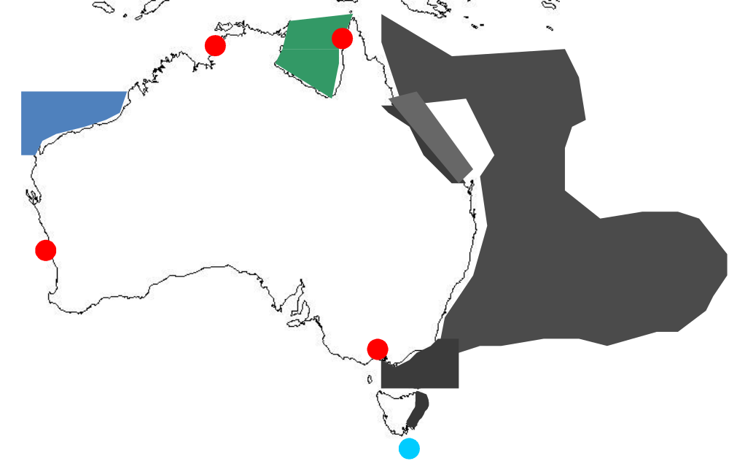
Figure 1. Approximate domains of the Australian Ecopath models. Dark blue is for shelf models, light blue pelagic models, red bay models and green coastal models.

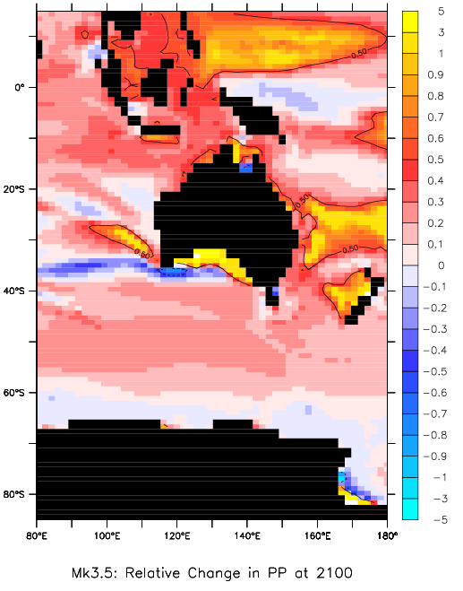
Figure 2. Relative change in primary production at 2100 (Matear)

Table 4. Example of an investigation of climate impact adaptation. Change in fishery value (summed over 100 years) and ecosystem diversity from a comparison of two climate scenarios with (1) no change in production and (2) increasing phytoplankton production as per the A1 emissions scenario. Also shown are the changes in value and diversity if fishing effort is adjusted to optimise value.
Region | Change in fishery value | Change in ecosystem diversity | Improvement in value if management adapts | Change in diversity if management adapts
Eastern tuna and billfish fishery | 14.5% | -0.25% | 1 % | 0.62%
Great Barrier Reef coast | 22% | 8.3% | 312% | -58%

References

Bulman C (2006) Trophic webs and modelling of Australia's North West Shelf, CSIRO
Bulman C, Condie S, Furlani M, Cahill M, Klaer N, Goldsworthy S, Knuckley I (2006) Trophic dynamics of the eastern shelf and slope of the South East Fishery: impacts of and on the fishery, Final Report for Fisheries Research & Developement Corporation
Gehrke C (2007) A comparative analysis of coastal fishery food webs in the Great Barrier Reef region, CSIRO: Water for a Healthy Country National Research Flagship
Gribble NA Ecosystem modelling of the Great Barrier Reef: an ECOPATH EwE balanced trophic biomass approach, QDPI&F, James Cook University
Gribble NA (2003) GBR-prawn: modelling ecosystem impacts of changes in fisheries management of the commercial prawn (shrimp) trawl fishery in the far northern Great Barrier Reef. Fisheries Research 65:493-506
Martin JM (2005) The distribution, abundance and trophic ecology of the fishes of Darwin harbour mangrove habitats. Charles Darwin University
Okey TA, Griffiths S, Pascoe S, Kenyon R, Miller M, Dell Q, Pillans R, Buckworth R, Gribble NA, Engstrom N, Bishop J, Milton D, Salini J, Stevens J (2007) The effect of illegal foreign fishing on the ecosystem in the Gulf of Carpentaria: management options and downstream effects on other fisheries, Australian Fisheries Management Authority Project 2006/825 Final Report. CSIRO Marine and Atmospheric Research, Cleveland, Australia

