How to Build an Atlantis Model:
A living document

Isaac Kaplan
NMFS NWFSC
Isaac.Kaplan@noaa.gov
3/2/05 and 4/2/07

with many bits written by Beth Fulton
CSIRO
Beth.Fulton@csiro.au

Table of Contents
Page
Introduction……………………………………………2
Model Structure……………………………………….3
Atlantis Code Structure…………………………........7
Run Files (parameter files)…………………………...8
Parameterizing Atlantis Ecology……………………11
Parameterizing other Bits of Atlantis……………....15
Running Atlantis………………………………….....15
Viewing Standard Output…………………………..15
Viewing Additional Output…………………………19
Calibrating the Model………………………………19
Appendix A: BGM Box Geometry File Format…...23
Appendix B: Timeseries (TS) File Format…………25
Appendix C: NetCDF (.CDF) File Format…………26

** Filenames for the California Current model are in GREEN**

INTRODUCTION

This document attempts to describe setup and parameterization of Atlantis models in general, and the California Current Atlantis model in particular. Atlantis is the brainchild of Beth Fulton (beth.fulton@csiro.au), and it evolved from her BM2 ecosystem model for Port Philip Bay, Australia.

Atlantis includes modules that simulate oceanography, ecology, fleet dynamics, economics, assessments, and management decisions. The simulations involve a three dimensional ocean area. Here we primarily focus on setting up the ecological module of Atlantis, which will probably always be the first step in model building.

The ecological module of Atlantis simulates the dynamics of up to about 60 functional groups in the food web, using nitrogen as a common currency between groups. Silica is also handled dynamically, as is oxygen, though in a very rudimentary fashion. Functional groups include habitat-forming species like kelp, corals and sponges, as well as additional benthic invertebrates, vertebrates, phytoplankton, zooplankton, refractory and labile detritus, and carrion.
Atlantis is a collection of C++ routines, currently compiled in Microsoft Visual C++ 6.0 . The differential equations for the system dynamics are solved using an adaptive forward difference method, with an overall time step of 12 or 24 hours.
Below, I elaborate on the details of the equations, and later in the document I describe how to parameterize, run, and calibrate the model.

Understanding the core equations:
Key documentation for Atlantis core equations is: appendices C-F of Beth Fulton’s thesis (ftp://ftp.marine.csiro.au/pub/fulton ), and appendices B-D of Fulton, Parslow, Smith, and Johnson (Biogeochemical Marine Ecosystem Models II: The Effect of Physiological Detail on Model Performance ) (fulton_bms_ecol_model.doc).

Atlantis tracks the abundance of biological groups within 3-dimensional polygons. For instance, a vertical view of the California Current model (West Coast of the US) looks like this:

Figure 1. California Current Model region. Each polygon is colored proportional to the abundance of a creature of interest.

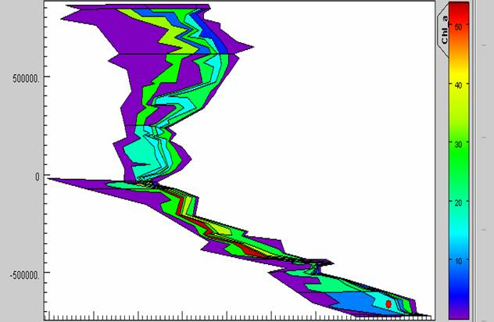

where each colored shape is a polygon. Each of these polygons has up to 7 depth zones (the nearshore polygon has 1 depth zone, the next polygon offshore has 2, and so on out to the 7th polygon offshore which has 7 depth zones).

Model Structure

Primary Production
Primary producer abundance is modeled as an aggregated biomass pool in each spatial box. The model tracks abundance (mg N/m³) per box. Biomass growth is limited by nutrient, light and space availability. Biomass is lost to predation, lysis, and linear and quadratic mortality. Linear mortality represents additional density-independent mortality not explicitly modeled. Quadratic mortality represents density dependent mortality (for instance, self shading).

Rate of change for standard water column (w) primary producer (PX) is
(1)
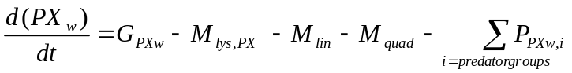

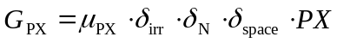 (2)
Where G_{PX} stands for the growth of PX, M_{lys},_{PX} is the loss of PX due to lysis, M_{lin} and M_{quad} are loss due to linear and quadratic mortality, P_{PX,I} are the losses of PX due to predation, μ_{PX} is the maximum growth rate, and δ_{irr} is light limitation, δ_{N} is nutrient limitation , and δ_{space} is space limitation.

Invertebrates
Invertebrates are also modeled simply as aggregated biomass pools in each spatial box. The model tracks abundance (mg N/m³) per box, based on growth, predation, and linear and quadratic mortality. Quadratic mortality in this case represents density dependent effects (predation, disease) that are not explicitly modeled; the ultimate effect is to impose a reasonable carrying capacity. In general, I (IK) attempt to set linear and quadratic mortality to 0 when possible. Linear and quadratic mortality represent ecological components not treated explicitly in the model.

Rate of change for a standard invertebrate consumer (CX) is

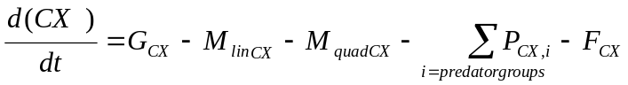 (3)
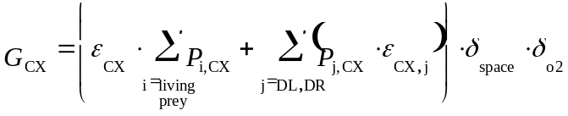 (4)
where G_{CX} is growth, M_{linCX} and M_{quadCX} are linear and quadratic mortality, P_{i,j} is predation by group j and group i, and F_{CX} is fishing on this group (this is set to zero for the unfished scenario here). ε_{CX} is the growth efficiency of CX when feeding on live prey, ε_{CX,j} the efficiency when feeding on detritus (DL treated separately to DR), δ_{space} is space limitation, and δ_{O2} is oxygen limitation.

Vertebrates
Vertebrates have 10 age classes. These classes need not be a single year long, but represent different phases in the lifecycle, so that for some groups it may be one year while for other (long lived) groups it could represent a decade or more. This is the most computationally efficient way of representing vertebrates with drastically different longevities within a common model framework. The duration of each age class is always 10% of the total longevity of the creature.
For each age class and each spatial cell, the model tracks the number of individuals and their average structural weight (bones and hard parts, in mg N/m³) and reserve weight (soft tissue, in mg N/m³). Growth and abundance are functions of recruitment, predation, consumption, and linear and quadratic mortality. Atlantis tracks abundance, biomass, weight-at-age, and condition (reserve weight/structural weight) of each group through time, in each box and for the entire model domain. Some crude metrics of model performance can include: 1) comparing model-predicted values for structural and reserve weight relative to expected values, with expected values from von Bertalanffy growth parameters (for weight at age), or 2) stock assessments (for unfished abundance)
The rate of change for a vertebrate group (FX) is:
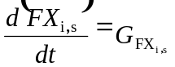 (5)
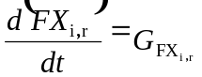 (6)
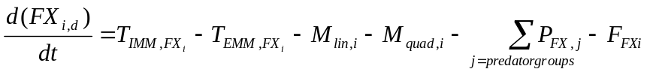 (7)
where the subscript i represents age group i (there is one equation for each age class included), s stands for structural weight, r for reserve weight , and d for density. The T terms represent the movement of fish in to (T_{IMM,Fxi}) and out of (T_{EM,Fxi}) the cell. In addition there are short-term spawning and recruitment events which affect the various FX pools. Other notation is as described above. The growth for each fish group is calculated by equations of the same form as (4), but per age group of each fish. The result is then apportioned to structural and reserve weight, favoring replenishment of reserves when the animal is underweight.

Nutrients
Water column nitrogen (ammonia and nitrate) concentrations are governed by uptake by autotrophs, excretion by consumers, nitrification, and denitrification.

Rates of change for ammonia (NH) and nitrate (NO) in the water column are:
(8)
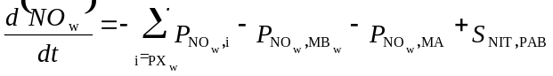 (9)

where P_{N,XX} is the uptake of NH or NO by the autrophs (either generic, microphytobenthos MB, or macroalgae MA) , E_{CX} is the production of NH by the consumer CX, S_{NIT,XB} is the amount of NH converted to NO during nitrification by the bacteria XB, R_{NET} is the amount of NH produced by denitrification.
Full descriptions of the dynamics of other forms of nitrogen, silica, bacteria, detritus, and sediment chemistry, as well as specifialized parameterizations for dinoflagellates and macrophytes, are contained in Fulton (2004).

Process Assumptions: Predation and Recruitment
Growth of vertebrates is based on von Bertalanffy growth parameters, but varies with consumption. For the California Current model, we chose a Holling type II functional response for predation, as previous work by Fulton et al (2004) suggests that this is simple to parameterize, yet is as effective as other representations given the nature of questions to be asked of strategic models. Alternative feeding functional responses exist within Atlantis , including Holling type I and III, and Ecosim-type functional response.

Our implementation of the Holling type II functional response is:
(10)
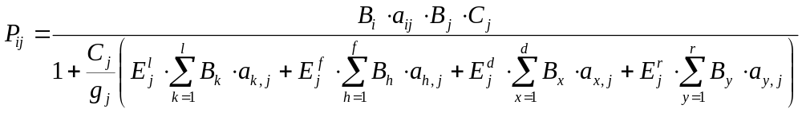

where P_{ij} is the proportion of prey i in the diet of predator j, B_{i} is the biomass of prey i and B_{j} is the biomass of predator j; a_{ij} is the availability of prey i to predator j; C_{j} is the maximum ingestion rate of predator j; g_{j} is the maximum growth rate of predator j; E^{l}_{j} is the efficiency of predator j on live food (the l superscript), E^{l}_{j} is the efficiency of predator j on seagrass, macroalgae or phytoplankt, E^{d}_{j} is the efficiency of predator j on labile detritus, and E^{r}_{j} is the efficiency of predator j on refractory detritus. The sums in the denominator are simply the sums of each of the available food biomasses (one for live food, one for seagrass, and one each for labile and refractory detritus).

Recruitment can be based on Beverton-Holt, Ricker, or several other relationships. For the California Current, we used the standard form of the Beverton Holt model:
R= α*S / (β +S) (11)
where α represents the maximum number of recruits produced (number of indivuals), and β represents the spawning stock biomass at which recruitment is ½ maximum (measured in mg N). Here we use the ecological definition of recruits: fish that are approximately 60-180 days old and have settled out of the plankton and begun feeding. Atlantis does not explicitly model larvae or larval dispersal. Recruits are distributed evenly in all areas where juveniles can exist.

For the movement of ecological groups we allowed density-dependent movement of vertebrates, as well as advection of plankton. The equations that govern density-dependent movement are described in Fulton (2004), but overall movement serves to transfer abundance towards neighboring cells with higher potential growth rates. We can also force large seasonal migrations for species such as whales.

Oceanography
The model is forced with circulation, salinity, and temperature outputs from a Regional Ocean Modeling System (ROMS), or similar oceanographic model. Oceanographic output becomes input to Atlantis. In some cases where oceanographic models are not available, fields of salinity, temperature, and circulation can be pieced together from observations or literature.

ATLANTIS CODE STRUCTURE

The C++ code libraries are structured by topic and have the same major divisions as can be seen in the parameter and output files:

Physics
physics = atphysics.lib

Ecology
ecological = atecology.lib

Assessment
assessment = atassess.lib

Fisheries and management
fisheries and management = atmanage.lib

Economics
socioeconomics = atecon.lib

Main loop
main loop = atlantismain.exe

RUN FILES (PARAMETER FILES)

The examples below assume that you have a compiled atlantis .exe executable. This involves using Microsoft Visual C++ 6.0 to compile the following workspaces: atecology, atmanage, atecon, atphysics, and assess, as discussed in “Atlantis Code Structure” above. Compiling atlantismain will bundle these together, creating an atlantis.exe file that can be used together with the input parameter files described below.

On Apr.2, 2007 these files and workspaces are in: C:\Atlantis\EMOCC_AtlantisWorkingCopy\code_Apr28\atlantis_code_2

Basic Atlantis run files:

On Apr. 2, 2007, all run files and the most recent .exe are in:
C:\Atlantis\EMOCC_AtlantisWorkingCopy\run_emocc

The most important file is the .bat file. It specifies most of the parameter files to be read and included for this run. For instance, if you open testEMOCCFeb2FishImmed.bat with Textpad, it looks like this:

atlantisemocc -i Emocc_bio_Dec21StartApril2005.nc 0 -o EmoccOut.nc -r at_run_LessFPS.prm -f at_force_nuts_CoastBoxUpwell_CatchHist.prm -p at_physics_nutsB.prm -b Emocc_BiolFeb2.prm -h emocc_catches_BeginDay1.prm -a ams_assess.prm -e at_economics.prm

Here are the details on these files. Bold file names are for the California Current model (as of Apr 2, 2007). Bold italicized names are generic Atlantis names.

atlantisemocc
Atlantis is the generic name of the exe.
This is the name of the .exe executable file, compiled in C++.

Emocc_bio_Dec21StartApril2005.nc
Biology.nc
Biology initial conditions file, specifying initial biomass and size. This is created as a text .cdf file, then packed into a .nc file. See below for instructions on packing. The biology .cdf file also specifies the box geometry file to use, such as emocc62April182006.bgm. See Appendix A for more description of the .bgm format, and Appendix C for description of the generic format for .cdf files.

EmoccOut.nc
Out.nc
Name of file to which output is written (in netCDF .nc format)

at_run_LessFPS.prm
Run.prm
Run file, which specifies length of run, timestep (12 or 24hr), flags for debugging and verbosity, number of total groups in the model, number of fisheries, which modules to turn off (e.g. assessments and economics)etc.

at_force_nuts_CoastBoxUpwell_CatchHist.prm
force.prm
This file specifies the forcing time series that are read in from .ts-files text. The forcing files are for hydrodynamics, point sources, climate time series (precipitation, irradiance, temperature and salinity), historical catch (e.g. box1catch.ts, box2catch.ts, etc), fuel prices, GDP and complex spatial zonation. Example forcing files can include the output from ROMS models (such as EMOCChydroA.nc, EMOCCtemp.nc and Emoccsalt.nc), nutrient input forcing files from sewage or upwelling (Box1.ts, Box2.ts, etc.), and light (solar.ts). See Appendix B for description of .ts format.

at_physics_nutsB.prm
Physics.prm
physics parameters (coefficients) stored in physics.prm. Apart from setting some flags (e.g. turning resuspension on/off), point-source scaling and quarterly eddy strength distribution these parameters are not typically changed.

Emocc_BiolFeb2.prm
Ecology and biology prm

Biology parameter files (growth rates, reproductive rates, diets, quarterly spatial distributions, etc.) All flags are at the top of the file, with parameters in the lower half. The model checks parameters are in the correct form when read-in (i.e. checks if integer read-in for switches, binaries for flags etc)

emocc_catches_BeginDay1.prm
harvest prm
Fisheries and management parameters and submodel definitions are given in harvest.prm. This includes fisheries, target species, catch history, discards, changes in selectivity over time, etc. As in the biol.prm file flags are defined first and then the parameters are group by topic in the lower half of the file. Note that if you are forcing with time series of catch or fishing mortality, those forcing files must be specified in the forcing prm described above (e.g. at_force_nuts_CoastBoxUpwell_CatchHist. ).

ams_assess.prm
Assessment prm
Assessment parameters. The sample design, sampling error structures and basic assessment model parameters are given in assess.prm. Not currently used for the California Current model (but the file must be specified and present in the directory).

at_economics.prm
Economics prm
Economics parameters for fleet dynamics etc. Includes the socio-economics parameters (for the market model, trading model, and black-book based effort allocation model). Not currently used for the California Current model (but the file must be specified and present in the directory).

Notes on packing/unpacking CDF and .NC files:

Once you have created a flat ascii text .cdf version of a file (e.g. biology.nc), it must be packed into a .nc file using pack.bat or the dos command. You will need the netcdf library to do this.

Using pack.bat:
C:\atlantis\emocc_atlantisworkingcopy\run_emocc> pack

Using the dos command
C:\netcdf\bin\ncgen -o init_npz.nc init_npz.cdf
The intended output filename is indicated by the switch –o

There are two other netcdf files that Atlantis automatically loads: fstatistic_blank.nc and diagnostic_blank.nc. To create these files take the cdf versions of these files from an existing run and modify them so that for each variable in the data section of the file there is one _ entry for each box in the new model. If cdf versions do not exist already use the unpack.bat (after opening it and changing the file names) or the following dos command to create an ascii .cdf file:

c:\netcdf\bin\ncdump fstatistic_blank.nc > fstatistic_blank.cdf
c:\netcdf\bin\ncdump diagnostic_blank.nc > diagnostic_blank.cdf

PARAMETERIZING ATLANTIS ECOLOGY

Parameterizing the biology and ecology mainly involves setting up the biology prm file (e.g. Emocc_BiolFeb2.prm) and the biology .nc file (e.g. Emocc_bio_Dec21StartApril2005). The nc file is derived by ‘packing’ a .cdf file.

Parameterizing the biology .cdf file (initial conditions):
At the top, the biology .cdf file contains headers. The headers specify default fill values for abundance of all groups. These are generally left at 0, because we will usually have data on abundance per area, so these default fill values will go unused. For instance, for age class 0 planktivorous fish:
Planktiv_O_Fish1_Nums:_FillValue = 0. ;

For vertebrates, initial reserve nitrogen and structural nitrogen are specified in the header. For instance, for age class 0 planktivorous fish:

Planktiv_O_Fish10_StructN:_FillValue = 8203.985119 ;
Planktiv_O_Fish1_ResN:_FillValue = 3925.659316 ;

For the California Current model, these values come from weight-at-age from von Bertalanffy growth parameters, converted to nitrogen-weight-at-age (see “Biological Parameter Conversions” below).

Below the headers are the following entries for vertebrates, specified per spatial box: initial abundance, reserve nitrogen, and structural nitrogen, and total nitrogen. Invertebrates only have total nitrogen entries.

Vertebrates’ reserve nitrogen and structural nitrogen have been specified in the header and are left at that default. For instance:

Shark_R2_ResN =
_, _, _, _, _, _, _, _,
_, _, _, _, _, _, _, _,
_, _, _, _, _, _, _, _,
etc.

Abundance per area is derived from surveys or assessments. The format for it is as follows, for example for age class 1 of planktivorous fish:

Planktiv_O_Fish1_Nums =
0,0,0,0,0,0,0,0,
0,0,0,0,0,0,0,0,
18904,0,0,0,0,0,0,0,
250395,0,0,0,0,0,0,0,
7860,0,0,0,0,0,0,0,
etc., with 1 row for eachl 2D box.
Then repeat the whole matrix a 2nd time
;
The matrix has # of columns equal to maximum # of depth layers + 1 (sediment). The 1st entry in each row is the surface, and the last entry is the sediment. Each row corresponds to a 2 dimensional ‘box’, for instance the colored boxes in Figure 1. The whole matrix is repeated before the final “;”. The resulting matrix therefore has 2 x # of boxes in figure 1. The boxes follow the same numbering as in the .bgm box geometry file.

For vertebrates, total Nitrogen can be left blank, because Atlantis will calculate it based on the numbers and reserve N and structural N that you’ve specified. For instance:

Demersal_O_Fish_N =
_, _, _, _, _, _, _, _,
_, _, _, _, _, _, _, _,
_, _, _, _, _, _, _, _,
etc.

For invertebrates, you must specify total nitrogen per box. For 3D invertebrates, the matrix entries have the same dimensions as shown above for vertebrate numbers-per-box

Two dimensional benthos have only one entry per 2 dimensional box. An example is for shallow filter feeders’ total nitrogen (mg N/m^3), for the California Current model with 62 boxes:

Filter_Shallow_N =
0.00, 0.5 , 0.5 , 0.5 , 0.5 , 0.5 , 0.5 , 0.5 , 0.00, 0.05, 0.05, 0.05, 0.05, 0.05, 0.05, 0.05, 0.05, 0.05, 0.05, 0.05, 0.05, 0.05, 0.05, 0.00, 0.05, 0.05, 0.05,
0.05, 0.05, 0.05, 0.05, 0.00, 0.05, 0.05, 0.05, 0.05, 0.05, 0.05, 0.05, 0.0, 0.05, 0.05, 0.05, 0.05, 0.05, 0.05, 0.05, 0.00, 0.00, 0.00, 0.00, 0.00, 0.00, 0.00, 0.00, 0.5 , 0.05, 0.05, 0.05, 0.05, 0.05, 0.00,
0.00, 0.5 , 0.5 , 0.5 , 0.5 , 0.5 , 0.5 , 0.5 , 0.00, 0.05, 0.05, 0.05, 0.05, 0.05, 0.05, 0.05, 0.05, 0.05, 0.05, 0.05, 0.05, 0.05, 0.05, 0.00, 0.05, 0.05, 0.05,
0.05, 0.05, 0.05, 0.05, 0.00, 0.05, 0.05, 0.05, 0.05, 0.05, 0.05, 0.05, 0.0, 0.05, 0.05, 0.05, 0.05, 0.05, 0.05, 0.05, 0.00, 0.00, 0.00, 0.00, 0.00, 0.00, 0.00, 0.00, 0.5 , 0.05, 0.05, 0.05, 0.05, 0.05, 0.00;

There is one entry for each of the 62 boxes, and then the whole matrix is repeated again for a total of 124 entries.

Parameterizing the biology .prm file:

Here I focus on a few key parameters from the biology prm file. GroupName means any species code (like FPL, FPS, etc.), VertName means any vertebrate, InvertName means any invertebrate.

flagGroupName – turns groups on or off.

GroupName_ddepend_move 0 flag to specify whether you want density dependent movement

mum_XX maximum growth rates. Invertebrates have 1 entry, while vertebrates have 10 (1 per age class). Invertebrates must use units of mg N/m^3/day.
For vertebrates, there are two options for units: A) consumption per day, relative to biomass, or B) consumption in terms of mg N/day/individual. Flagfishrates toggles between the two choices of units.

Growth rate per day, relative to biomass, can be derived from Ecopath PB parameters, converting to a daily rate and multiplying by a factor like 1.2 to account for the fact that Atlantis uses this as a maximum. However, it is more common to use option B, consumption in terms of mg N/day/individual. For the California Current model, we estimated this by calculating daily growth (in mg N/day/individual) from the von Bertalanffy and length-weight equations.

c_GroupName -- maximum consumption rates. Invertebrates have 1 entry, while vertebrates have 10 (1 per age class). Invertebrates must use units of mg N/m^3/day.
For vertebrates, there are two options for units: A) consumption per day, relative to biomass, or B) consumption in terms of mg N/day/individual. Flagfishrates toggles between the two choices of units.

For option A, consumption per day relative to biomass can be derived from Ecopath QB parameters, converting to a daily rate and multiplying by a factor like 1.2 to account for the fact that Atlantis uses this as a maximum. However, it is more common to use option B, consumption in terms of mg N/day/individual. For the California Current model, we estimated this by calculating daily growth (in mg N/day/individual) from the von Bertalanffy and length-weight equations. We then assumed that consumption up till the age-at-maturity was 10x growth (i.e. the conversion efficiency was 0.10). After the age-at-maturity we assumed that consumption scaled to the 3/4 power of body weight, as body weight increased above weight-at-maturity.

mL_GroupName ‘unexplained’ linear mortality. A tuning parameter.

mQ_XX ‘unexplained’ quadratic mortality (density dependent). A tuning parameter.

pPREY1GroupName1 diet or predator-prey interaction terms, for juvenile consumption of juveniles. It’s easiest to change these in the diets.xls spreadsheet, then paste them in to the biology prm. Values of 0 mean no consumption of that prey by that predator. We generally start with 0.01 for a strong interaction and 0.001 for a weak interaction, and calibrate from there. However, Jason Link and Robert Gamble have a new tool for estimating these from diet data.

pPREY2GroupName1 – same as above, but for juvenile consumption of adults

pPREY1GroupName2 - same as above, but for adult consumption of juveniles

pPREY2GroupName2 - same as above, but for adult consumption of adults

p_InvertNameVertName interaction (diet) parameters for vertebrate predation on invertebrates. Per age class of vertebrates. These generally must be low, near 0.0001, because there is no gape limitation in these cases.

BHalphaVertName and BHbetaVertName --
Beverton Holt alpha and beta parameters in recruitment. Alpha represents the maximum number of recruits produced (number of indivuals), and Beta represents the spawning stock biomass at which recruitment is ½ maximum (measured in mg N). Here we use the ecological definition of recruits: fish that are approximately 30-180 days old and have settled out of the plankton and begun feeding. Alpha can generally be taken from stock assessments, which report Ro. Beta can be calculated if you know alpha and assume a steepness appropriate for that group. To convert between steepness and beta, see for example: http://www.fish.washington.edu/research/coleraine/coleraine.pdf → page 4.

Flagfishrates specifies whether vertebrate mum_ and c_ are relative rates (growth rate per day, as a proportion of weight) , or absolute (mg N/day).

Biological Parameter Conversions:
Atlantis uses nitrogen as a currency for all biological groups. In setting up the initial conditions for the simulation, we assume the following for all living groups:
Wet weight(mg)/20 = carbon weight
Carbon weight./5.7 = Ash Free Dry Weight
AFDW/3.65 = Structural Weight
(S.W.)(2.65) = Reserve Weight

PARAMETERIZING OTHER BITS OF ATLANTIS

Add something here about parameterization of fisheries, econ, assessment, management.

RUNNING ATLANTIS

Open a command window (Start→Run→cmd)

Change directories to the location of the exe and input files
Cd /d c:\atlantis\emocc_atlantisworkingcopy\run_emocc

Then type:
testEMOCCFeb2FishImmed
or whatever the name of the .bat file is.

The parameter input files will be read in by the C code when the program is run. Currently all files are in \run_emocc subdirectory.

Run time is currently 2-12 hrs, depending upon the run length and the complexity (i.e. # of boxes, species, or modules turned on/off).

VIEWING STANDARD MODEL OUTPUT

In the .bat file (e.g. testEMOCCFEb2FishImmed.bat) , you specified an output file name (e.g. EMOCCOut.nc). Double clicking on this will produce open the net cdf output in the viewer, OLIVE. The output file contains 3D time series of both physical and ecological variables. Sometime OLIVE will not read the .nc file if you ended the run prematurely. However, if the run crashed on its own, you can usually still open the .nc file and view the output with OLIVE. To download OLIVE: ftp://ftp.marine.csiro.au/pub/fulton →OliveSetup.exe .

You can also view the text output file, log.txt. The flags in the run file (e.g. at_run_LessFPS.prm) control the frequency at which the log.txt output is written, and whether you want detailed output checking certain nutrients, fisheries, species, diets, etc.
Beth recommends viewing with Textpad, http://www.textpad.com/ .

The output file (EMOCCOut.nc) can also be handled and visualized using the R package ncdf or various Matlab netcdf packages (http://www.marine.csiro.au/sw/matlab-netcdf.html or http://mexcdf.sourceforge.net/ or http://www.odyle.net/mma/NCDView/ncdview.php)

I (IK) have an R script available called PlotOutNC_NandR.r that takes the .nc file and plots biomass over time for all species, and reserve and structural nitrogen over time for all species. Example:

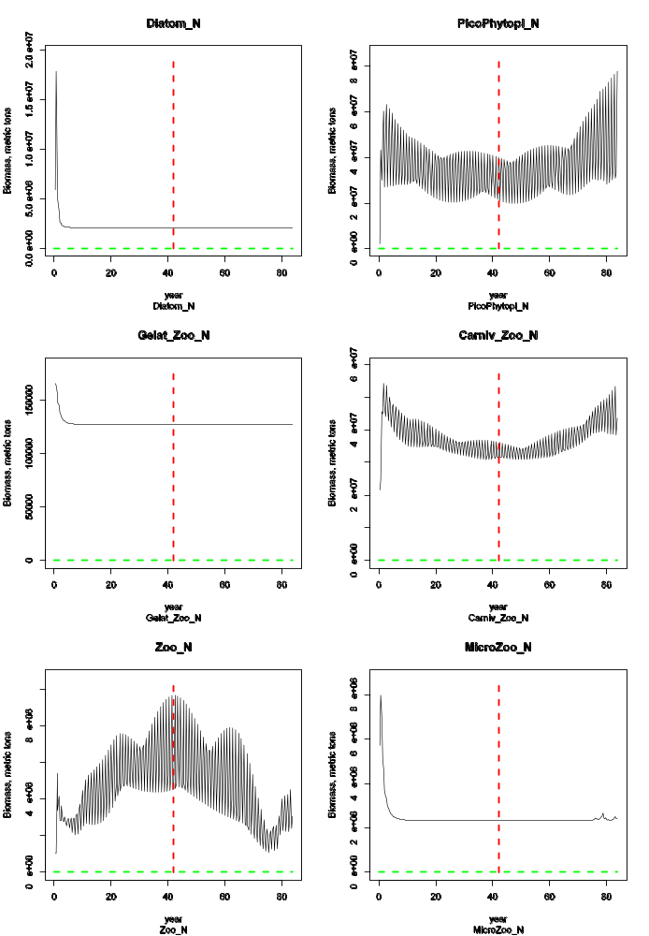

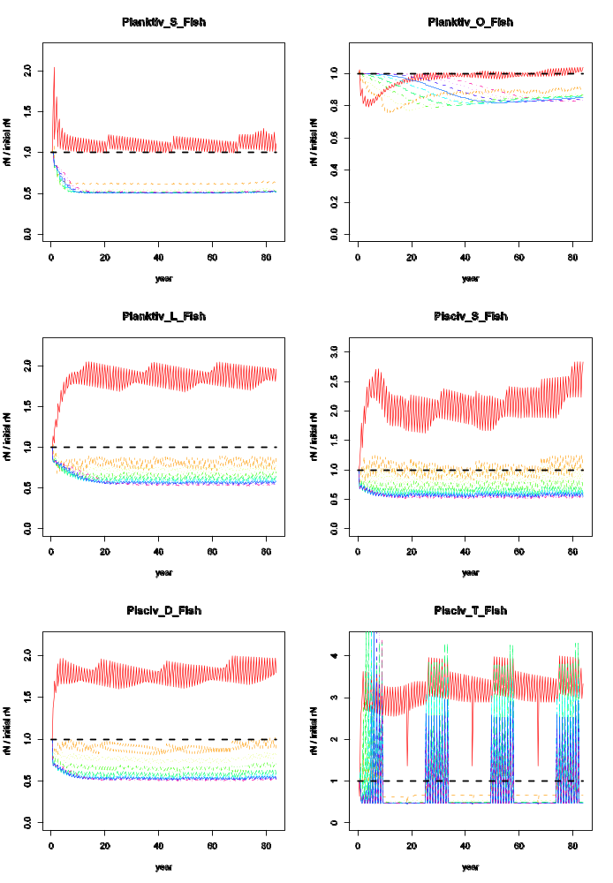
The use of the supporting xls files (biomass_trajectories.xls, diets.xls etc) is recommended as they do facilitate the calibration process. Biomass_trajectories compares the observed biomass trend to historical data, while diets.xls allows you to easily modify the pPreyXX diet interaction terms (see below), and to compare parameterization between runs.

VIEWING ADDITIONAL OUTPUT FILES

Additional ecological output is contained in outTOT.nc, outPROD.nc, and YOY.txt.
These files represent additional aggregated or diagnostic output. Assessment and indicator values are given in topic specific indicator files (i.e. a long list of files grouped by indicator type). The fisheries and management output is given in outF.nc, outFTOT.nc, catch.txt, effort.txt, catch_per_fishery.txt. The socioeconomics are also given in a short list of aggregated files.

CALIBRATING THE MODEL

The main software tools used to calibrate the model are OLIVE, textpad, and Excel files that use lookup tables to compare model output with observations and assessments (as appropriate). Use OLIVE to view the out.nc file, and use textpad to view the log.txt file.

The general goals of calibration are, in this order:
1. Prevent most species from going extinct
2. Have vertebrates grow such that size-at-age is reasonable
3. For species with historical data are available, have the model recreate observations of abundance from surveys or assessments
4. For species with no historical data, the model should yield reasonable time series of abundance
5. Capturing observed spatial distributions

The relative values reported in log.txt are key to successfully calibrating the model, particularly for vertebrates.

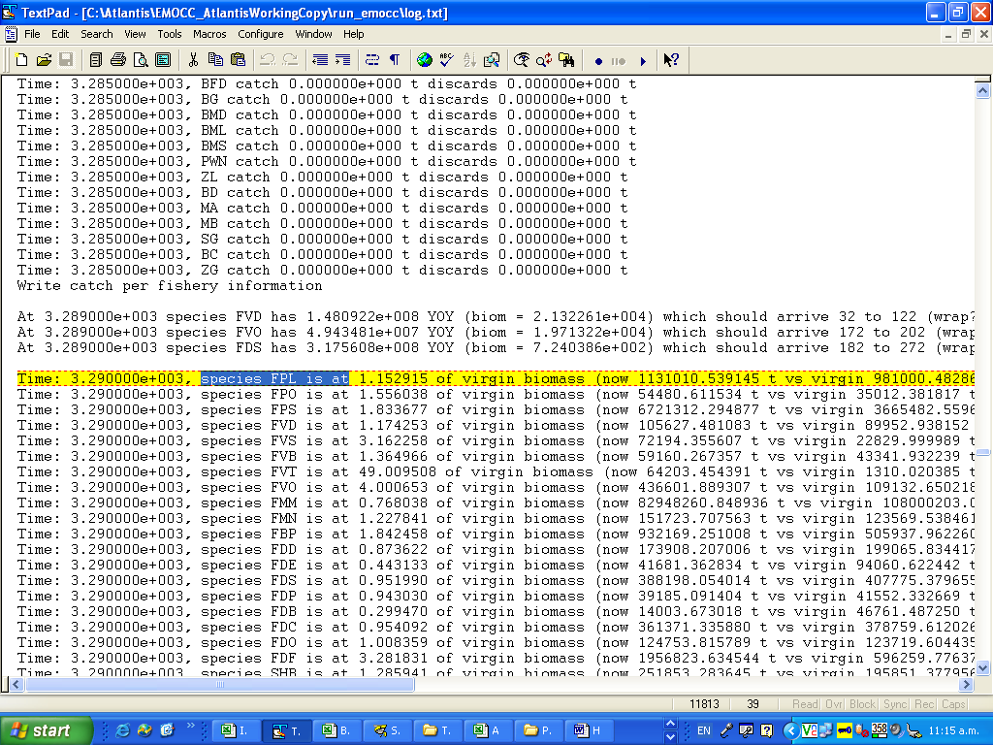

The screenshot above shows log.txt output for day 3290. In yellow, we can see that species FPL is at 1.152915 x its initial biomass. This sums across all boxes (i.e. disregards space in the model). The text says “virgin biomass ”, but this is a misnomer, and should really say “initial biomass”.

Output frequency is dictated by toutinc in the run.prm file (e.g. at_run_LessFPS.prm).

Using Textpad’s F5 (Search) key allows you to rapidly scan through species abundance over time, for both vertebrates and invertebrates. For invertebrates, this information in log.txt is the main diagnostic tool.

For vertebrates, log.txt give you an additional diagnostic: it allows for tracking of growth relative to initial conditions:
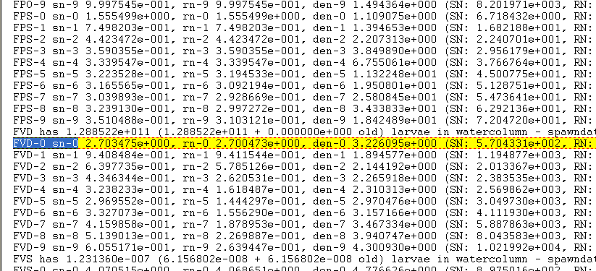

The yellow highlighted area in the screenshot shows us that at this timestep, age class 0 FVD (piscivorous demersal fish) have a structural weight (sn) = 2.7 x initial, reserve weight (rn) also 2.7x initial, and density (numbers) =3.2 x initial.

Once size-at-age is within 20% of the von Bertalanffy curve expected from the literature, then growth is generally acceptable. When calibrating vertebrates, attempt to get relative SN and RN values reasonable before worrying about numbers (den results). Note though that if numbers are too high (by an order of magnitude or more) the group maybe starving itself so you may need to reduce recruitment or increase predation to get numbers under control before you will make any headway with the growth of the group.

The use of the supporting xls files (biomass_trajectories.xls, diets.xls etc) is recommended as they do facilitate the calibration process.

During calibration, tuning typically focuses primarily on changing growth rates, consumption rates, linear and quadratic mortality, and Beverton Holt parameters. These variables are in the biology.prm file (e.g. Emocc_BiolFeb2.prm). Below, XX could be any species code (e.g. FVD, FPL, etc.):

c_XX consumption rates. These are C in equation 10, the predator-prey functional response.

mum_XX maximum growth rates. These are g in equation 10 above, and they place a upper limit on G in equations 5 and 6.

mL_XX ‘unexplained’ linear mortality (Isaac usually tries to leave this at 0). See M_{lin} in equations 1,3, and 7 above.

mQ_XX quadratic mortality (‘unexplained’ density dependence) (Isaac usually tries to leave this at 0). See M_{quad} in equations 1,3, and 7 above.

pPREYXX diet or predator-prey interaction terms. It’s easiest to change these in the diets.xls spreadsheet, then paste them in to the biology prm. These interaction terms are a in equation 10 above.

BHalphaXX Beverton Holt alpha parameters in recruitment. See alpha in equation 11 above.

MSE EVALUATION

When evaluating an MSE, the biomass values as well as the diagnostics reported in the txt and TOT.nc files are typically used, as these match the performance measures typically used to judge MSEs.

APPENDIX A: BGM File Format
The .bgm file defines the geography used in the Atlantis model to define the bathymetry of the model system, but also used by OLIVE for display of the model. The model is cast in x-y terms (rather than latitude-longitude), typically created using an Albers projection. The structure of the bgm file is as follows

# box model geometry comment
# number of boxes in horizontal plane
nbox nb

# number of faces in horizontal plane
nface nf

# Maximum bottom depth (m) if botz > this reset botz
# to be this as far as model is concerned
maxwcbotz -20

# vertices of polygon defining the boundary of the dynamic model spaces, polygons outside this are treated as boundary boxes
bnd_vert 4846663.054 2672181.026
bnd_vert 4846577.624 2671694.641
bnd_vert 4846769.65 2671316.256
bnd_vert 4846620.269 2670658.417
bnd_vert 4846647.232 2670053.268
bnd_vert 4846896.231 2669701.554
bnd_vert 4846895.551 2668853.126
bnd_vert 4846480.926 2668328.515
bnd_vert 4846068.874 2668006.796
bnd_vert 4846040.837 2667847.55

# Data for box number 0
box0.label box0
box0.inside 4850502.794 2660539.214 // midpoint of polygon
box0.nconn 1 // number of neighbouring dynamic boxes
box0.iface 0 // face numbers connecting box with dynamic neighbouring boxes
box0.ibox 1 // box-id numbers of dynamic neighbouring boxes
box0.botz -7.58 // depth of the box
box0.area 4.96E+05 // area of the box
box0.vertmix 0.000001 // vertical mixing scalar for the polygon
box0.horizmix 1 // horizontal transport scalar for the polygon
box0.vert 4850016.494 2660989.963 // vertices of polygon
box0.vert 4850411.21 2660812.231
box0.vert 4851009.235 2660650.395
box0.vert 4850843.256 2660162.581
box0.vert 4850087.844 2660321.401
box0.vert 4850016.494 2660989.963

AND SO ON FOR nb BOXES

# Data for face number 0
face0.p1 4850016.494 2660989.963 // one endpoint of face
face0.p2 4850087.844 2660321.401 // other endpoint of face
face0.length 672.3586014 // length of face
face0.cs -0.106119971 0.994353333 // cosine and sine of this vs (0,0)
face0.lr 0 1 // box to left and right of face standing at p1 looking at p2

AND SO ON FOR nf faces

APPENDIX B: Time-series file format
Time series files include temperature, salinity, solar intensity, historical catch forcing, etc.
The time series files used to force the model follow the standard CMAR ts format, which is as follows for a time series files with N data columns and a reference year of 1951

# Comments
#
## COLUMNS N
##
## COLUMN1.name Time
## COLUMN1.long_name Time
## COLUMN1.units days since 1951-01-08 0:00:00 +10
## COLUMN1.missing_value -999
##
## COLUMN2.name variable_name
## COLUMN2.long_name Variable
## COLUMN2.units mg/s
## COLUMN2.missing_value -999
##
## And so on until all N columns defined
1 0.045292995 0.226464977 and so on upto N columns

APPENDIX C: Netcdf file format
The initial conditions file for the biology (biology.nc) is generated by ‘packing’ a biology .cdf file. This biology .cdf file contains initial biomass and size values, and is just an ascii text file.

Netcdf files are laid out in the following fashion

filename {
dimensions
t = UNLIMITED ; // (x currently)
b =
z =
variables:
double t(t) ;
t:units = "seconds since 1951-01-01 00:00:00 +10" ;
double variable_name(t, b, z) ;
variable_name:characteristic =

// global attributes:
:title = "npz" ;
:global parameters
data:
t = 0;

variable_name =
_, _ ;
}

where 1951 is the reference year and the data array for variable name is laid out so that there are z entries per line, with b lines. This is then repeated for each of the t steps.

