Atlantis model

Geography
The geography of the region is represented by 71 polygonal boxes (Figure 2.1) based on physical and ecological properties and distributions captured in the demersal bioregionalisation by Lyne et al ref and an independent pelagic analysis using the CSIRO’s CARS (Climatological Atlas of Regional Seas) data set and the same general Bioregionalisation approach. Within each box there are up to five layers, depending on the total depth of the box – shallower boxes have fewer layers. The nominal potential layer depths are shown in Figure 2.1. In the open ocean boxes (darkest blue boxes in Figure 2.1) the maximum depth represented was 1800m; waters below this depth were omitted and the bottom explicit layer was treated as having an open lower boundary with regard to exchanges.
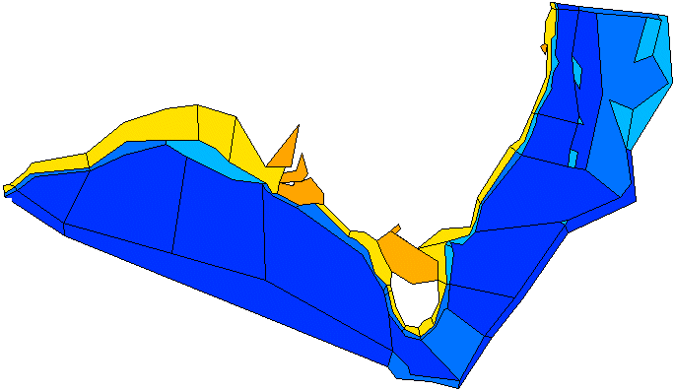
Max Oceanic
Sediment
Epibenthic
Watercolumn

Figure 2-1: Map of model domain for south east Australian Atlantis model, depth key shown in metres. The vertical layers are grouped into those in the water column (depths below the maximum oceanic are omitted, see text), epibenthic (a 2D layer between the water column and the sediments) and the sediment layer(s).

Canyons
While the spatial resolution in Atlantis does not allow explicit representation of individual canyons, the proportional cover of each box that is canyon can be represented. This is not an independent habitat type itself, but for those species known to aggregate in canyons the canyons in a cell act to enhance the biomass a habitat type in a cell can support. They can also (optionally) be used to condition production or vertical exchanges. The proportional cover of canyons (estimated from GIS bathymetry databases) in each box of the southeast Australian Atlantis model is given in Figure 2.2.
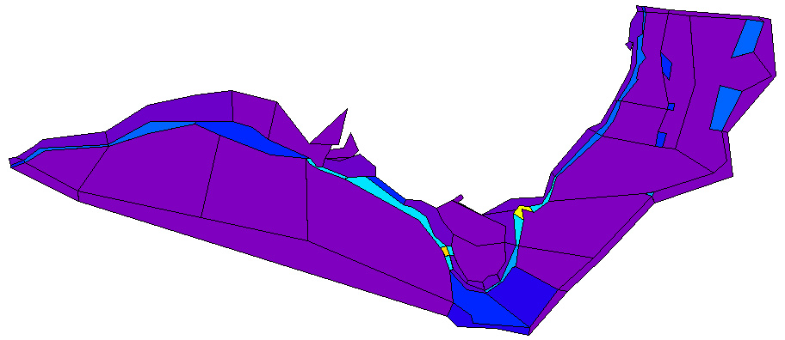
Figure 2-2: Proportional coverage of canyons per box in the southeast Atlantis model (taken from GIS analysis of bathymetry data)

Biophysical Environment

Physical Environment

Currents – Horizontal and Vertical Advection-Diffusion
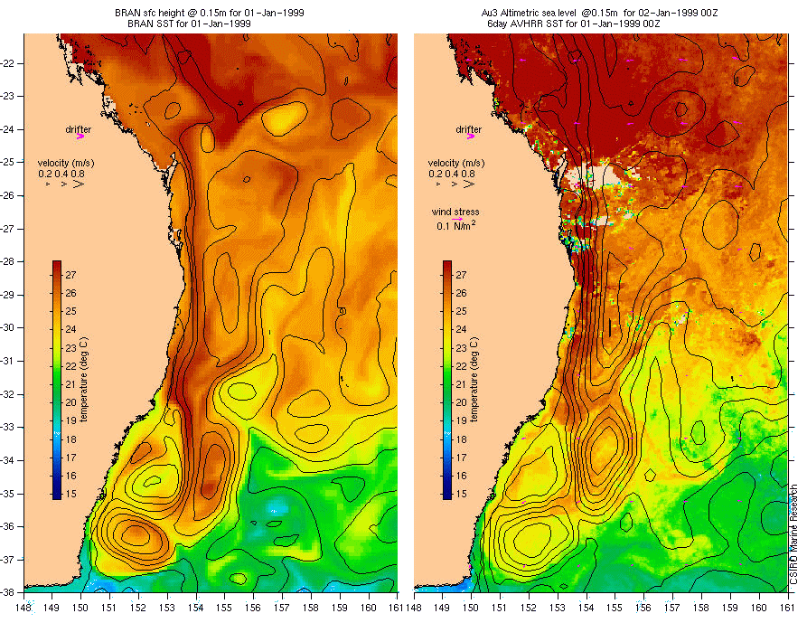
Water exchanges both vertically and horizontally were calculated from the SPINUP5 output of the BlueLink ocean simulation model. Give BlueLink explanation and description of how flows were calculated and hyperdiffusion corrected. As an example, a comparison between observed altimetric sea height and the sea height predicted by BlueLink for January 1st 1999 is given in Figure 2.3. The quality of the match is good and is typical of the quality of the BlueLink model output versus real current flow. Unfortunately the BlueLink products are not available long-term and so for the model runs used in this study the flows were repeated without modification in a decadal loop. While this did not allow for long-term (>10 year) trends or cycles in properties such as current strength or water temperature it did produce seasonal and interannual variation, leading to a wide enough range of environmental forcing to capture the main conditions experienced in the southeast Australian marine region.
Figure 2-3: Comparison of observed altimetric sea height (on right) and sea height as predicted by BlueLink (on left).
The transport model was executed once per 12 hour time-step. There is variation in the strength of exchange between cells at this temporal resolution and from year to year. As a demonstration of the extent of this variability, the gross seasonal pattern of flows and upwelling strength is shown in Figure 2.4; and an example twenty year time series of net exchange from a single cell, both vertically and horizontally, is given in Figure 2.5.
Current plot here
Figure 2-4: Gross seasonal currents from BlueLink as applied in the transport model used in Atlantis (a) Summer, (b) Autumn, (c) Winter and (d) Spring

Time series plot here
Figure 2-5: An example twenty year time series of net horizontal and vertical exchange at the surface of box XX in the southeast Atlantis model

Eddies
The spatial scale of the southeast Atlantis model (hereafter Atlantis SE) is not suitable for explicitly capturing oceanic eddies. These features have a strong influence on productivity however, and to better capture the cycles and distribution of production, eddies need to be represented in some form. The approach used here is to use an energy strength index (calculated from the variance of sea surface height) and condition primary production on that index using the following relationship:
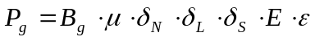 (1)
where P_{g} is the growth in the population of primary producers, B_{g} is the biomass of the primary producer, μ is the growth rate of the primary producer, δ_{N} is the limitation scalar due to ambient nutrient levels, δ_{L} is the limitation scalar due to ambient light levels, δ_{S} is the limitation scalar due to space limitation (for attached macrophytes only), E the local strength of the energy index and ε is the energy coefficient (which is the key term for predicting the impact of eddies on primary productivity).
The energy fields were taken from a quarterly analysis completed as part of the pelagic bioregionalisation (ref). As the model runs through the course of a year it interpolates from one quarterly field to the next to get a smooth transition in eddy values at any one location through the year. The four quarterly distributions in Atlantis SE are shown in Figure 2.6.

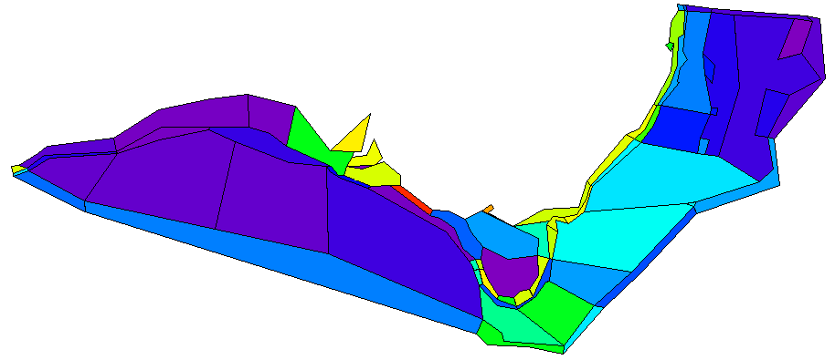
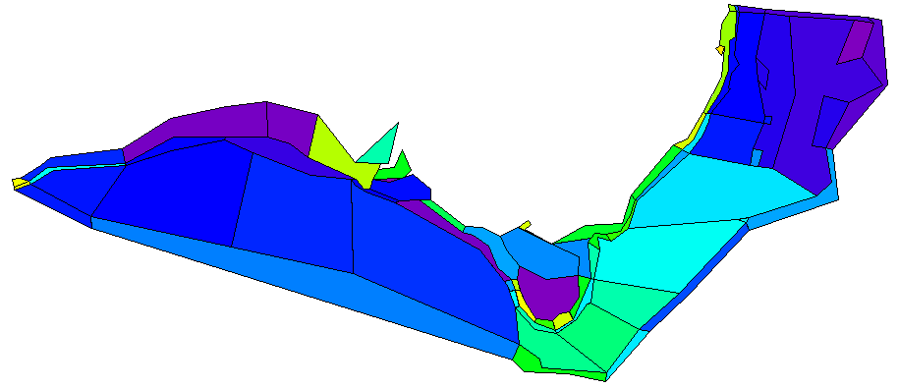
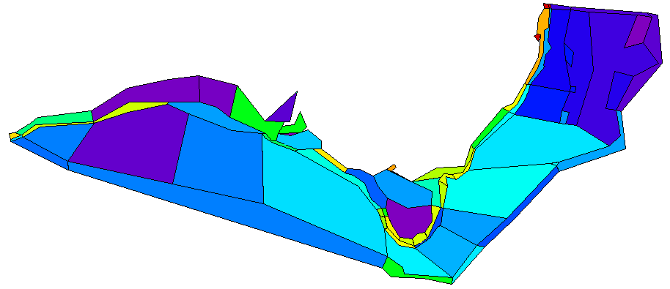
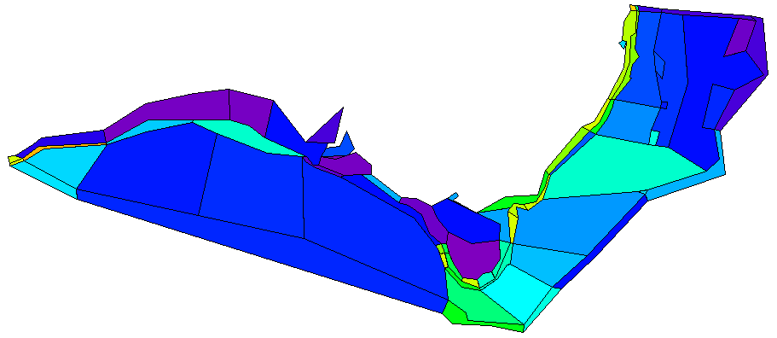
Summer
Autumn
Winter
Spring

Figure 2-6: Quarterly energy fields used to represent eddy strength in the southeast Atlantis model.

Temperature and Salinity
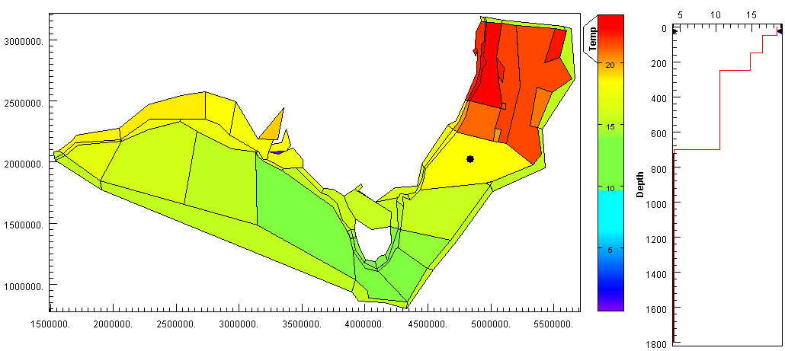
The same BlueLink model outputs used to provide advection and diffusion for Atlantis SE were also used to provide time series of temperature and salinity in every cell of the model. In the same way the currents were recycled through time (as only limited length time series were available) the time series of temperature and salinity were also recycled through the course of any individual Atlantis run. An example of the resulting time series (in this case for temperature) is given in Figure 2.7.
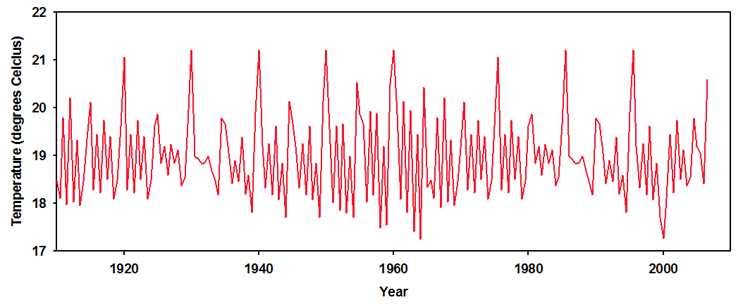
Figure 2-7: Example (a) temperature map and static depth profile and (b) time series (from box marked with black dot in the map) from Atlantis SE, based on BlueLink model output

Sediments
As Atlantis SE is a shelf and deep water model there is no call for fine scale sediment dynamics (as the bottom layers are too thick for resuspension to be a sensible mechanism to include). Therefore the sediment environment has been characterised as the proportion of each cell that is rough, flat and soft ground (see Figure 2.8 – 2.10). The sediment data used to parameterise this in the southeast model were taken from a data set that is now part of the draft Sediment Type (Folk classification) of the Australian EEZ (National Geoscience Dataset) – reachable via the Neptune data directory reference (http://neptune.oceans.gov.au/index.html) and from data on the auSEABED data repository (http://instaar.colorado.edu/~jenkinsc/dbseabed/auseabed/auseabed.html). Habitat degradation scenarios can be used to modify these values, but typically they are constant throughout a single Atlantis run.
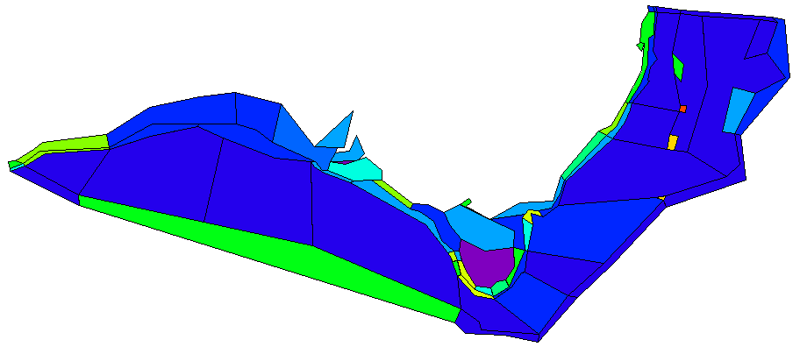
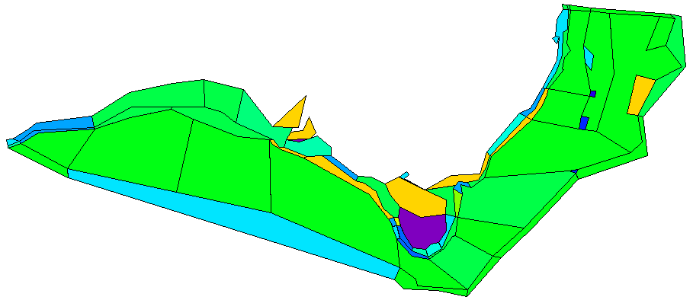
Figure 2-8: Proportional cover of rough ground per box, used to dictate sediment properties in the southeast Atlantis model.

Figure 2-9: Proportional cover of flat ground per box, used to dictate sediment properties in the southeast Atlantis model.

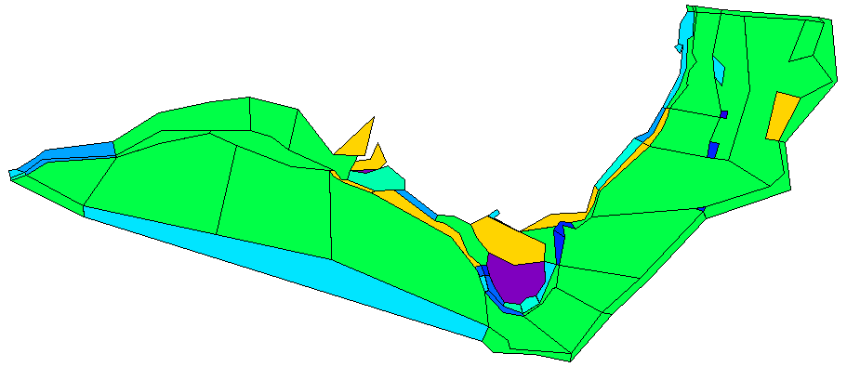
Figure 2-10: Proportional cover of soft ground per box, used to dictate sediment properties in Atlantis SE.

Ecological Components

Functional Groups
The biological groups included in Atlantis SE (listed in Tables 2.1 and 2.2) were made up of functional groups (aggregate groups of species with similar size, diet, predators, habitat preferences, migratory patterns and life history strategy) and dominant target species in the SESSF. The list of groups and species broadly matches the list identified in the trophic analysis and Ecosim model by Bulman (ref) and an independent grouping of the entire trophic web using regular colouration (Dambacher ref or pers. com.). The invertebrate groups are represented using biomass pools, while the cephalopods, prawns and vertebrates are presented as age structured stocks.
In addition to these living biological groups, pools of ammonia, nitrate, silica, carrion, labile and refractory detritus are also represented dynamically.
A “simple” network diagram of the complete food web is given in Figure 2. 11 and the complete biological parameterisation is given in Appendix A. The complete bibliography used to source the parameters, initial conditions and distributions is given in Appendix B.

Stock Structure
Atlantis SE allows for the vertebrate groups to have multiple stocks, though this feature is not used for all vertebrate groups. For some groups, these stocks represent reproductive stocks (as defined for stock assessment purposes or experts on the species – in particular Ross Daley advised on all the shark distributions), for others they denote that different species are being represented in different parts of the model domain (e.g. tiger flathead in the SET and deepwater flathead in the GABT fisheries). Those groups with multiple stocks and the distribution of those stocks are given in Figure 2.12. All other vertebrate species and groups are considered to have a single stock which stretches across their entire range within the model.

Table 2-1: List of invertebrate functional groups included in Atlantis SE.
Model Component | Group Composition |  | Model Component | Group Composition
Pelagic invertebrates |  |  | Benthic invertebrates
Large phytoplankton | Diatoms |  | Sediment bacteria | Aerobic and anaerobic bacteria
Small phytoplankton | Picophytoplankton |  | Carnivorous infauna | Polychaetes
Small zooplankton | Heterotrophic flagellates |  | Deposit feeders | Holothurians, echinoderms, burrowing bivalves
Mesozooplankton | Copepods |  | Deep water filter feeders | Sponges, corals, crinoids, bivalves
Large zooplankton | Krill and chaetognaths |  | Shallow water filter feeders | Mussels, oysters, sponges, corals
Gelatinous zooplankton | Salps (pryosomes), coelenterates |  | Scallops | Pecten fumatus
Pelagic bacteria | Pelagic attached and free-living bacteria |  | Herbivorous grazers | Urchins, Haliotis laevigata, Haliotis rubra, gastropods
Squid | Sepioteuthis australis, Notodarus gouldi |  | Deep water megazoobenthos | Crustacea, asteroids, molluscs
 |  |  | Shallow water megazoobenthos | Stomatopods, octopus, seastar, gastropod, and non-commercial crustaceans
 |  |  | Rock lobster | Jasus edwardsii, Jasus verreauxi
 |  |  | Meiobenthos | Meiobenthos
 |  |  | Macroalgae | Kelp
 |  |  | Seagrass | Seagrass
 |  |  | Prawns | Haliporoides sibogae
 |  |  | Giant crab | Pseudocarcinus gigas

Table 2-2: List of vertebrate groups and species in Atlantis SE.
Model Component | Group Composition
Fin-fish
Small pelagics | Engraulis, Sardinops, sprat
Red Bait | Emmelichthyidae (Emmelichthys nitidus)
Mackerel | Trachurus declivis, Scomber australisicus
Migratory mesopelagics | Myctophids
Non-migratory mesopelagics | Sternophychids, cyclothene (lightfish)
School whiting | Sillago
Shallow water piscivores | Arripis, Thyrsites atu, Seriola, leatherjackets
Blue warehou | Seriolella brama
Spotted warehou | Seriolella punctata
Tuna and billfish | Thunnus, Makaira, Tetrapturus, Xiphias
Gemfish | Rexea solandri
Shallow water demersal fish | Flounder, Pagrus auratus, Labridae, Chelidonichthys kumu, Pterygotrigla, Sillaginoides punctata, Zeus faber
Flathead | Neoplatycephalus richardsoni, Platycephalus
Redfish | Centroberyx
Morwong | Nemadactylus
Ling | Genypterus blacodes
Blue Grenadier | Macruronus novaezelandiae
Blue-eye trevalla | Hyperoglyphe Antarctica
Ribaldo | Mora moro
Orange Roughy | Hoplostethus atlanticus
Dories and Oreos | Oreosomatidae, Macrouridae, Zenopsis
Cardinalfish | Cardinalfish
Sharks
Gummy Shark | Mustelus antarcticus
School Shark | Galeorhinus galeus
Demersal Sharks | Heterodontus portusjacksoni, Scyliorhinidae, Orectolobidae
Pelagic Sharks | Prionace glauca, Isurus oxyrunchus, Carcharodon carcharias, Carcharhinus
Dogfish | Squalidae
Gulper Sharks | Centrophorus
Skates and Rays | Rajidae, Dasyatidae
Top predators
Seabirds | Albatross, shearwater, gulls, terns, gannets, penguins
Seals | Arctocephalus pusillus doriferus, Arctocephalus forsteri
Sealion | Neophoca cinerea
Dolphins | Delphinidae
Orcas | Orcinus orca
Baleen Whales | Megaptera novaeangliae, Balaenoptera, Eubalaena australis

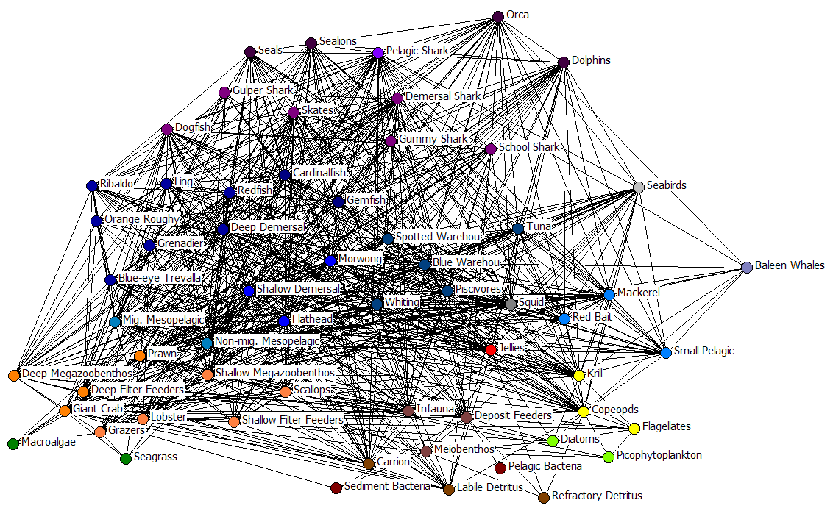

Figure 2-11: Food web used in Atlantis SE – as an interpretation aid, groups with similar trophic levels, habitat and depth preferences are coloured similarly.

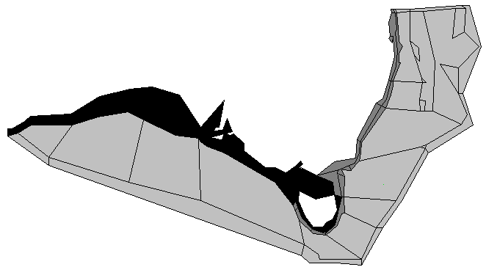  Mackerel | 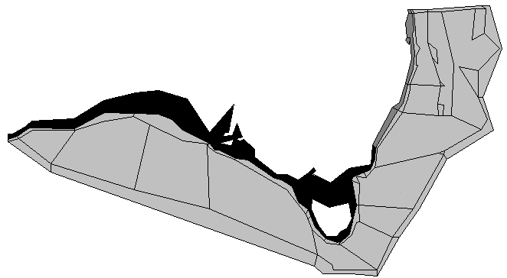  Small pelagics | 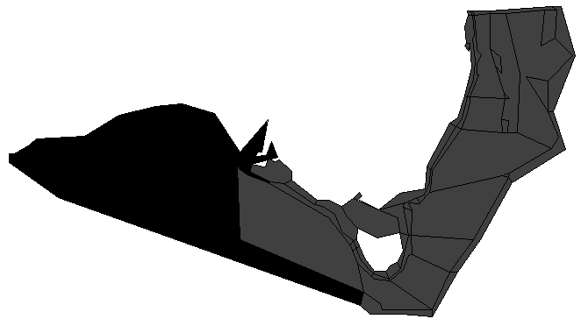  School whiting | 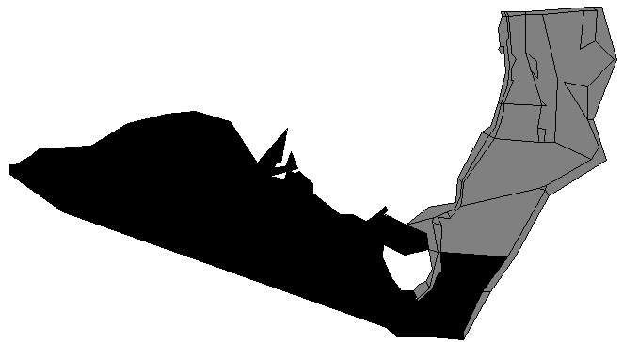  Tuna and Billfish
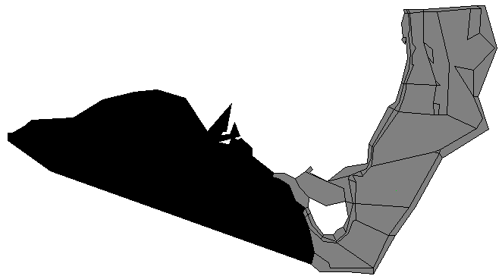  Flathead | 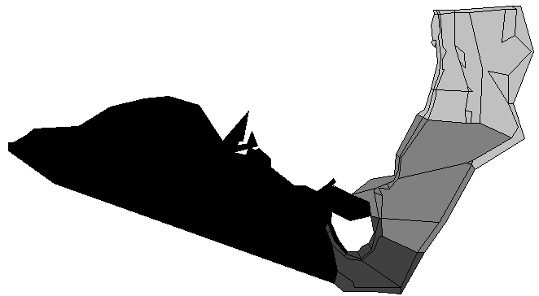  Deep demersal fish | 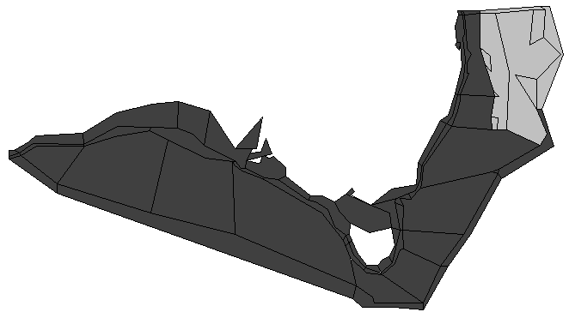  Blue-eye Trevalla | 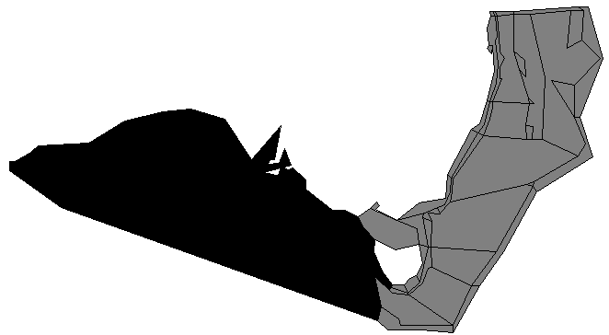  Redfish
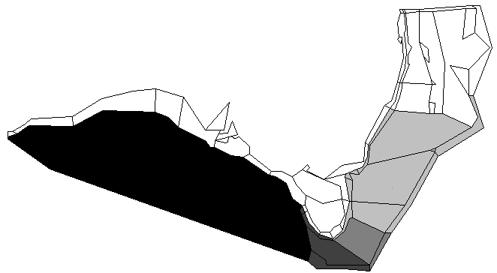  Orange Roughy | 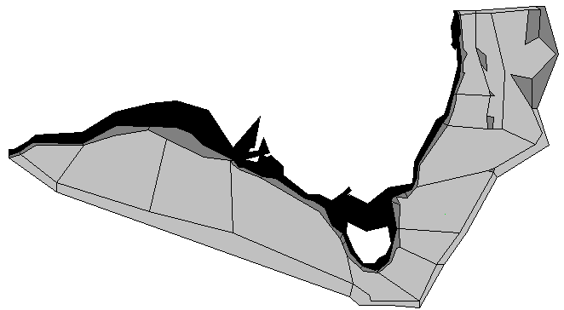  Demersal sharks | 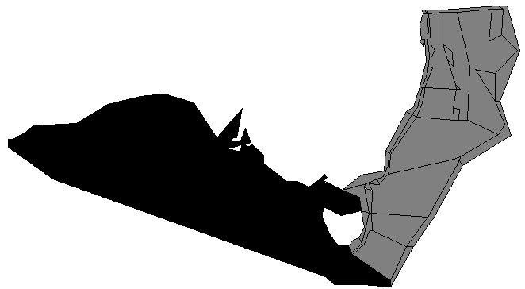  Morwong  Ling  Gemfish  Shallow Demersal fish  Blue Warehou

Figure 2-12: Stock structure patterns for the vertebrate groups in Atlantis SE that have multiple stocks. Note that for Flathead, Redfish and demersal sharks the stocks actually represent different species rather than genetic stocks.

Trophic Connections
The potential trophic connections between groups are given in Tables 2.3-2.6. These trophic connections are broken up based on maturity; represented as a juvenile-juvenile connection matrix, a juvenile-adult matrix, and adult-juvenile and adult-adult matrices. There is further differentiation by age for some of the vertebrate predatory interactions with invertebrates – as the strength and rapidity of ontogenetic diet shifts can vary quite considerably group to group (details of this further age-structuring of the trophic connections is provided in Appendix A). The values in these matrices are the maximum available proportion of the prey population available to that predator at any one location at any one time. The effective proportion of available food taken is then calculated based on overlap of predator and prey, habitat preferences and habitat state, the amount of forage available, and for vertebrates the relative size of predator and prey (as this determines whether gape limitation is occurring).
Unlike other ecosystem models the existence of a connection does not guarantee that predation will always occur. First both predator and prey must be present in the cell for an interaction to take place (so if they are in different boxes or layers the interaction is impossible). Second, for vertebrate prey the predator must have a suitable gape to capture the prey, so the prey must either be smaller than the gape or the predator must be identified as a group that can bite chunks out of prey that are too large to fit in their mouth whole. This last stage means that as fish grow they can pass through various predation refuges and windows.
The connections defined in Table 2.3 are based on diet information from data collected in the area (Bulman et al ref), from consultation with experts on species in the area (Ross Daley, John Stevens, Cathy Bulman, Jock Young) and from the literature (refs – from the BRS Bible and elsewhere). The final values used were the result of estimates from these sources modified through model calibration so that the resultant realised diet composition matched the available data and the biomass dynamics predicted by the model matched the best understanding of the changes in system state (from assessments and surveys) through the period 1910 to 2005, though the calibration was based primarily on the period 1910 to 2000 (and that is what is presented in chapter 3).

Habitat Dependencies
To represent the fact that in reality the large areas covered by single Atlantis boxes would not be homogeneous, a sub-grid scale model is used to capture the effects of finer scale habitat patchiness. To date this is only done for benthic and biogenic habitat usage and dependencies. The parameterisation of this usage and dependency (given in Table 2.7) was based on information in Williams and Bax ref.
Usage simply reflects whether a group can access an area containing a habitat type. If it can’t, then it is not possible for it to access any prey biomass associated with that habitat type. A simple on-off usage is needed to establish this non-trophic connection; there is no relative strength of the term as in the trophic connections. During trophic interactions the habitat usages of predator and prey are compared to see if the two groups can be in the same small scale patches and thus able to interact directly. During a fishing event a similar comparison is made between the habitat preferences (and thus fine scale distribution) of fish and the types of habitat a fishery can access.
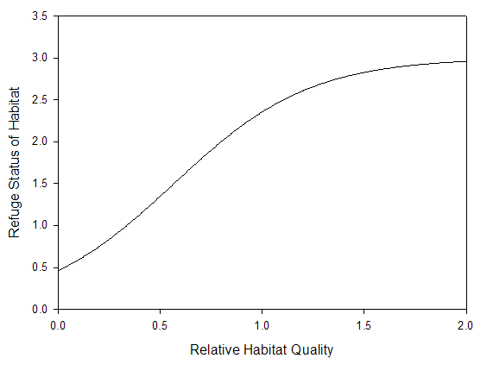
Habitat dependency is a group characteristic that is in addition to its habitat usage (it is quite feasible for a group to use habitat, but not be dependent upon it). Habitat dependency can also modify the trophic interactions. A simple non-linear curve (Figure 2.13) relates the quality of the habitat to the amount of structural refuge it could supply to a species dependent upon it. The trophic interaction terms for prey dependent on that habitat are then scaled by the value from this curve during any feeding interactions in that box – this means that good quality habitat provides more cover for prey groups dependent upon it, whereas degraded habitat allows predators to access more of their prey. This representation is an optional feature in Atlantis SE and may be omitted as it is open to criticism on three fronts. First the curve does not have a final inflection that would match the case where even good quality habitat has become saturated and fails to provide any refuge for a larger proportion of the total population. Second the curve is deterministic and time invariant so there is no explicit dynamic trade-off between predation risk and hunger-driven searching in open ground as there is in Ecosim (Walters et al ref). Third it ignores the use of cover by predators, where improved cover can actually lead to more successful predation interactions (e.g. Lynx using grass to hide from Snow-shoe hares in Canada). These are all valid criticisms, but for the purposes of Atlantis SE they were put to the side and the habitat dependency weighting of trophic interactions was used as it allowed for a wider range of system dynamics that better matched collective scientific understanding of the fine scale dynamics in the southeast of Australia (Alan Williams and Cathy Bulman pers. com.).
Figure 2-13: Relationship between relative habitat quality and refuge status proffered used to condition habitat dependent trophic interactions in Atlantis SE.

Fishing Fleets
Based on targeting and gear use, all fisheries (including State fisheries) were grouped into fleets and further divided into “fleet components” (using essentially the same approach as was used to determine the ecological groups). As the focus of the model is on Commonwealth fisheries, these were handled dynamically and were resolved in more detail - including the representation of sectors which were active historically, but have declined more recently, so that the past fisheries activities could be represented explicitly. In contrast State fleets were aggregated more heavily and their distribution and effort levels were set as finxed scenarios in all runs. Recreational fishing was also represented with a simple tithe (flat rate per person fishing recreationally) rather than using a detailed dynamic effort allocation model. A list of all fleets and fleet components used in the model and their gear, target and effort allocation details are given in Table 2.8 and their potential connections with the ecological groups in the model is shown in Figure 2.14.
The Commonwealth fisheries fleet definitions were drawn from previous work on the topic by Klaer (refs) and an independent analysis of AFMA’s logbook data. In the logbook analysis, boats were sorted based on size, areas fished, gear and reported landings. This analysis was performed using the year 2000 as a reference year (as that was to be the first year of the management strategy evaluation runs) and also across all years (1985 – 2004), so that (i) it could be judged how representative the year 2000 was of the general patterns and (ii) to see if there were any other large scale events or trends that needed to be kept in mind when using the logbook data to calibrate the dynamic fisheries model. This last point is particularly important as the model was calibrated (or trained) using the data from the mid-late 1990s so that it was not using the same 2000 onwards data that would ultimately be used as a check of the model against reality in the early years of the period covered by the management strategy evaluation projections. However, substantial changes in the fleet dynamics either side of 2000 would be problematic as the model would not have been trained using current effort allocation behaviours. While changes did occur during the late 1990s through the early 2000s, these were not considered large enough to jeopardise the model’s performance given that it contained the explicit kinds of behaviours (gear switching and effort shifts) that were seen in the data.
For those familiar with the commonwealth fisheries the division of the fleets into fleet components may seem disconcerting, but it is necessary for capturing the correct overall fleet dynamics given the effort allocation models available in Atlantis. The various fleet components, that represent what would be considered a single fleet in reality, can still hold quota and fish the target groups beyond the primary target that differentiates their behaviour in the logbook data. The division into fleet components is simply a characterisation division based on their behaviour as reported in the logbooks. This is the best way of capturing the range of behaviour shown by these large multi-behavioural fleets. When reporting results in the following chapters, to reduce confusion for those considering the results these fleet components have been recombined to form the overall trawl fleets traditionally reported.

Table 2-3: Fisheries (fleets and fleet components) represented in Atlantis SE - recreational fishing includes fishing from charter boats. Depths represents potential depths fished, fisheries did not automatically fish all potential depths at any one time or even during the course of an entire run. Note that fisheries could target many more groups than just the primary target and that the primary target group is for the start of the dynamic runs, within a run the identity of the primary target group could change as a result of decisions made by the dynamic fisheries.
Fishery (Fleet) | Fleet Component | Gear | Depths (m) | Primary target group(s) | Effort model | Subfleets
Dive | - | Dive | < 35 | Grazers, Lobster, Deposit Feeders | Forced | All size boats together
Fin-fish auto-longline | - | Auto-longline | < 600 | Ling, Blue grenadier | Dynamic | All size boats together
Fin-fish drop line | - | Drop lines | < 650 | Blue-eye trevalla | Dynamic | All size boats together
Fin-fish mesh net | - | Mesh nets | < 250 | Warehou | Dynamic | All size boats together
Fin-fish trap | - | Traps | < 550 | Ling and demersals | Forced | All size boats together
Inshore line | - | Drop and hand lines | < 200 | Shallow piscivores | Forced | All size boats together
Pots | - | Traps | < 250 | Lobster, Shallow Megazoobenthos | Forced | All size boats together
Recreational (represented as a tithe) | - | Multiple | < 200 | Multiple | Dynamic | Individuals  Charter boats
Scallop dredge | - | Dredge | < 150 | Scallops | Forced | All size boats together
Shark net | - | Mesh nets | < 150 | Gummy shark | Dynamic | < 30m  30 – 40m  > 40m
Shark longline | - | Longline | < 150 | Gummy shark | Dynamic | All size boats together
Small pelagic state fisheries | - | Net, seine | < 250 | Small Pelagics, Mackerel | Forced | All size boats together
Small pelagic commonwealth fishery | - | Midwater trawl | < 300 | Mackerel, Red Bait | Dynamic | All size boats together
Small pelagic purse seine | - | Purse seine | < 250 | Small Pelagics, Mackerel | Forced | All size boats together
Squid jig | - | Jig | < 200 | Squid | Forced | All size boats together
Tuna longline | - | Pelagic longline | > 50 | Tuna and Billfish | Forced | All size boats together
Tuna purse seine | - | Purse seine | > 50 | Tuna and Billfish | Forced | All size boats together
Trawl (with state, SET and GABT divisions) ¹ | Cephalopod trawl | Bottom trawl | < 300 | Squid | Dynamic | All size boats together
Trawl (with state, SET and GABT divisions) ¹ | Crustacean trawl | Bottom trawl | 50 – 250 | Crustaceans ² | Forced | All size boats together
Trawl (with state, SET and GABT divisions) ¹ | Prawn trawl | Bottom trawl | 300 - 500 | Royal Red Prawns | Dynamic | All size boats together
 | Fin-fish midwater trawl | Midwater trawl | 50-400 | Demersals | Dynamic | All size boats together
 | Squid midwater trawl | Midwater trawl | < 500 | Squid | Dynamic | All size boats together
 | Danish seine | Danish seine | < 200 | Flathead | Dynamic | < 30m  > 30m
 | General demersal trawl | Bottom trawl | < 650 | Ling, Blue Grenadier | Dynamic | < 30m  30 – 40m  40 – 50m  > 50 m
 | Shelf demersal trawl | Bottom trawl | < 250 | Flathead | Dynamic | < 30m  30 – 40m  > 40m
 | Orange Roughy trawl | Bottom trawl | < 1250 | Orange Roughy | Dynamic | < 30m  30 – 40m  > 40m
1. The state fishery components were really only active for Crustacean trawl and Shelf demersal trawl copmponents.
2. For state fisheries the primary target groups are prawns and Giant Crab, while for the commonwealth fisheries the target group is “non prawn crustaceans”,

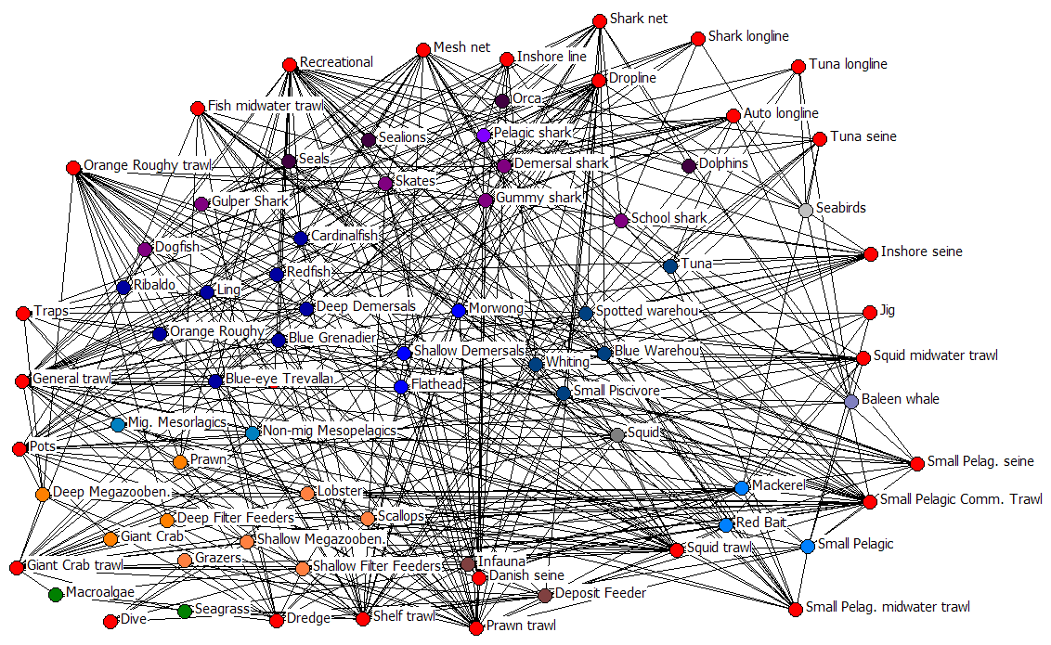
Figure 2-14: Fisheries connections in Atlantis SE, colouring of ecological groups shown here is as of Figure 2.11; all fisheries are coloured red here.

Socio-economics
Previous implementations of Atlantis used simple aggregate fleet models to represent the fisheries and their effort allocation (Fulton et al 2004 AFMA report and other refs). This kind of model was not sufficiently resolved to capture the processes and dynamics of interest in this study, where system state and proposed management methods could have differential impacts not only across gears, but also across vessel classes with different cost structures and vessel characteristics. Consequently a new socio-economics model was implemented that saw the larger fleets subdivided based on size and operational behaviours (subfleet divisions for each fleet are provided in Table 2.8).
A detailed description of the socio-economics model is given in Appendix C, but a brief description is provided here. There are four main parts to the current socio-economic model in Atlantis:
- Calculation of economic indicators (some of which are then used within the rest of the economic model, while others are reported as performance statistics)
- Fleet tracking (including investment, disinvestment and switching between fleets and gear types), and resulting port activity status
- Effort allocation (spatial and temporal) by fleet based on socio-economic factors
- Quota trading
A flow diagram of the steps in the socio-economic model is given in Figure 2.15 and details of the different components described briefly below are more fully described in the appropriate sections of Appendix C.

Economic indicators
The economic indicators calculated and reported in Atlantis SE are drawn from two sources. The first is the list of economic indicators in the final report of the qualitative phase (Stage 1) of the project (ref). The second was those economic variables that were needed as part of the broader economic model (e.g. variable costs, prices and rents).
For those indicators taken from the Stage 1 report, the form of the relationship used to calculate the indicator in Stage 2 was based on the descriptions given in the narrative explanation of the economic indicators (ref). The simplest curve that matched this shape was used for the quantitative relationship. It is possible to use additive, average and multiplicative combinations of these values across subfleets to give overall values per fleet. In the case of the results reported here, additive combinations are used.

* If quota limiting
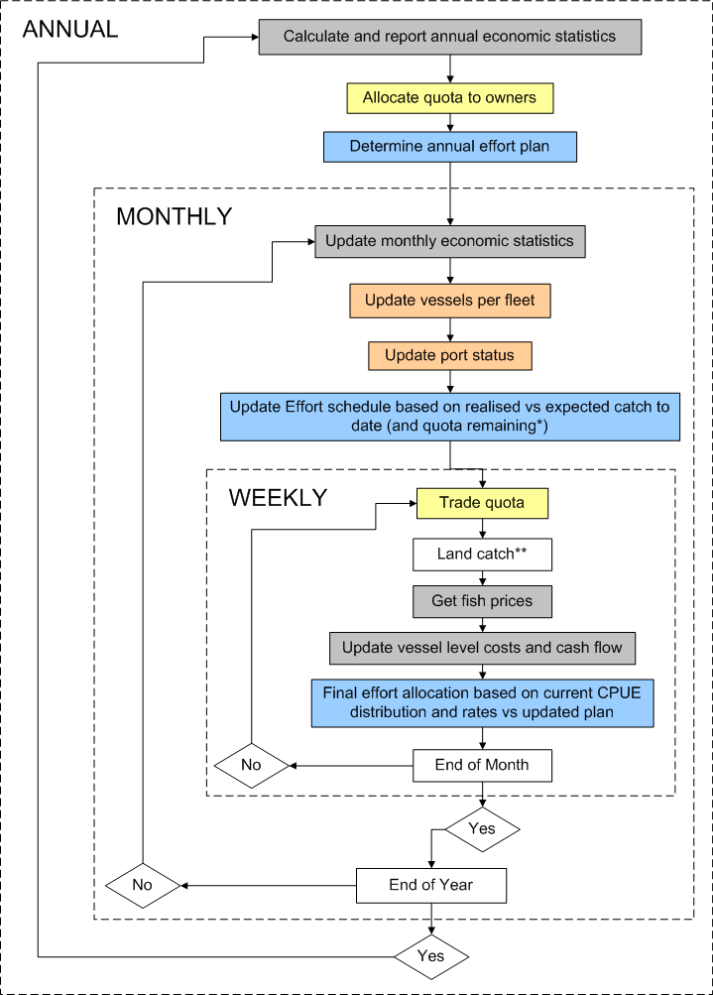
** If trip complete, multi-week trips are possible and catch will not be ended until the trip is complete.

Figure 2-15: Schematic diagram of the flow of the economics model in Atlantis SE. Blue indicates effort allocation steps, grey indicates economic indicator or value calculation and reporting steps, yellow indicates quota allocation and trading, and orange indicates steps dealing with fleet and port status determination.
The indicators calculated per fleet are:
- number of boats switching between fleets or gears
- average boat size
- total marginal rent (or profit)
- gross value of the catch
- value of leased quota
- extent of quota trading extent
- cash flow per boat
- return on investment
- revenue per tonne
- revenue per effort
The indicators calculated per subfleet (either for later aggregation to fleet or for use directly in the economics model) are:
- overall catch per unit effort
- total discards
- average size of the catch
- composition of the catch
- gross value of the catch
- costs per day (including fuel, capital, gear, unloading and fixed costs)
- costs per ton
- revenue per day
- revenue per ton landed
- revenue on investment
- index of average marginal profit (cash flow index)
- operator marginal rent (takes crew share into account)
- capital utilisation
- extent of spatial management effecting the subfleet
- number of within gear changes (including selectivity, swept area, discarding, access and escapement) per year
- management and research costs associated with the subfleet
- trading extent
- total quota held (either owned or leased permanently or temporarily) by the subfleet
- sale value of quota

Fleet and port status
This section of the socio-economic model tracks fleet and port status. The membership of each subfleet is checked monthly, with the number of vessels in the subfleet updated based on whether any existing vessels in the subfleet have been decommissioned, forced from the fishery by debt, sold in a buyback scheme, or switched to alternative fisheries. If spare licences exist, new vessels may also enter a fishery.
Investment, disinvestment and switching between fleets are based on the model by Thébaud et al. (2006). This constructs a probability of leaving a fishery (or buying into a fishery if spare licences are available) based on long-term net returns vs short term payouts. A random number draw is then compared against this probability to determine how many (if any) boats take up this option. The switching between fleets is dealt with in the same manner – with boats shifting to the fishery that had the best trade-off of potential returns vs cost of boat modification. Boats joining a fishery in this way would enter the subfleet matching their vessel size, if available licences existed. If there are no available licences then the boats can not switch and remain in their original fleet.
Boats forced from a fishery due to debt could number beyond those that purposefully choose a decommission payout (or participate in a buyback scheme). Boats will leave a fishery if their total debt is beyond the maximum acceptable threshold (based on banking industry business fore-closure policies (ref) and the costs of maintaining a shore-based household for a year (treasury ref)) or the vessel has opted to tie up rather than fish (due to expected marginal rents being less than the acceptable level, typically a substantial loss) for x months of the previous year. In the results presented here x was set to 12 (i.e. an entire year of not fishing) as this presented a plausible maximum based on a current fisher’s ability to accept debt loading and subsidise fishing activities with other sources of income.
Port activity is based on the number of vessels that considered a port to be their home port and the amount of landings channelled through a port. This port activity index is then used to calculate the dynamic (human) population of the port, which can also be scaled based on prescribed overall population changes (which capture population shifts due to activities other than fishing). In turn this population influences recreational fishing pressure and can also contribute to coastal habitat degradation and pollution (though these latter two features can also be forced independent of population if desired).

Effort allocation

Black-books
In reality fishers build up knowledge of the system, both through personal experience and by sharing information (potentially dis-information) with others. The concept of “Black-books” is used in Atlantis SE to capture this knowledge. These are subfleet-level arrays of CPUE and effort per area per month. The model is initialised with arrays created by averaging over the more recent historical catch and effort data (particularly the logbook data 1995 – 2000). As the model runs these historical data is updated with the model generated CPUE and effort data. A weighting parameter dictates the subfleet’s willingness to weight the most recent catch and effort data over longer term patterns, which captures the degree to which the fishers in the subfleet are “risk takers” or “traditionalists”.
Infortmation sharing is not dealt with explicitly in Atlantis SE, though as the model acts at the fleet and subfleet levels some of this sharing is implicitly incorporated into the model. The related issue of disinformation is not dealt with in this model at all, though others have looked into the topic (refs). Into the future it may be possible to include consideration of the topic as the model contains a simple friendship network representation,

Effort Allocation Tiers
After consultation with industry members it was clear that a hierarchical effort allocation and planning scheme is used to decide effort distributions and magnitude in the SESSF. A three tiered dynamic effort allocation sub-model is included in the economics model at the level of the subfleet to capture this hierarchical process. The three tiers are:
- Annual – Changes in targeting are made based on expected returns per species that the fishery can access; using annually updated expected returns per month, the available quota per target group (if quota is constraining), and the knowledge stored in the subfleet level monthly Black-books (see above), a plan is made for effort per box per month.
- Monthly – The existing expected plan (originally defined annually) is updated based on realised catch vs expected catch and the available quota (if quota is constraining) per species; required down time for maintenance and profitability (or losses) of the operations constrain the maximum planned effort per month (e.g. if losses are higher than can be tolerated the boat will tie up rather than fish)
- Weekly – Check to see whether available quota (if constraining) or planned effort for the month is already used up; if permissible effort remains, allocate it based on planned distribution of effort and the current realised spatial distribution of CPUE weighted by costs of reaching these boxes and the preference of the subfleet for using pre-determined plans rather than the current CPUE distribution.
If catch rates in the boxes fished fall below a threshold level, then exploratory fishing is undertaken in boxes adjacent to cells fished in the previous year. An alternative formulation had return of effort to historically fished boxes that had not recently been fished as well as exploratory fishing in boxes adjacent to the boxes in the Black-Books with recorded historical effort. While this alternative exploration model is appropriate in well-established or widely distributed fisheries, which the SET would appear to be, the changes in targeting and effort distributions through the last 15 years of the fishery mean that the effort distribution and shifts of the current fishery more closely matches that of a fishery which hasn’t thoroughly exploited all spatial areas it overlaps. This means that the former exploration model out performs the alternative in this case and so was used in Atlantis SE. It was also the exploration model that best fits the nature of the GAB fisheries.

Quota trading
Atlantis SE can model quota trading in fisheries with individual transferable quotas (ITQs). However because the model represents fleets and sub-fleets rather than individual vessels, quota trading is limited to trade between fleets and sub-fleets. Quota trading is typically only active when quota is constraining. Other quota trading models are dealt with species-by-species (e.g. Little ref), but as quota packages are traded in the SESSF a dynamic quota trading model had to be developed for the SESSF. This model involves both a price model and an actual trading model. The price model is a reparameterised version of the quota price model developed by Newell et al. (2005) for New Zealand (see Appendix C for formulation and parameterisation used). The steps in the quota trading model are given in Figure 2.16.

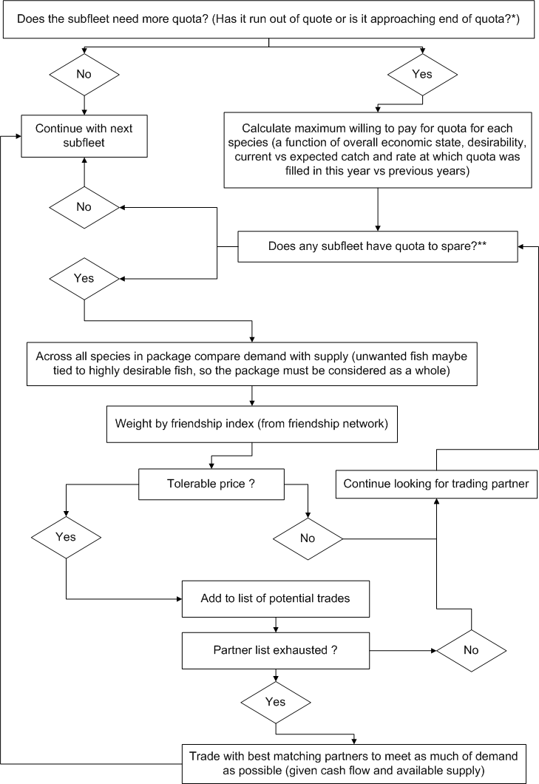

* This occurs when the catch has come within a threshold % of filling the subfleet’s quota for a species. The base % is 10% but this reduces as the year progresses, so that there is not excessive overrun or undercatch due to quota availability.
** A subfleet will put up quota for sale if they have caught less than a threshold % of the subfleet’s quota for a species. The base % is 10% but it increases substantially as the year progresses so that the subfleet is not left with a lot of unused quota at year end (and does not forgo the income gained from trading it).

Figure 2-16: Flow diagram of steps in the quota trading model used in Atlantis SE.

Assessment
A wide range of sampling and assessment models are available as part of the harvest strategy component in Atlantis. The sampling models include representations of fisheries dependent, observer-based and fisheries independent data collection methods and data handling procedures. The assessment models span the range of most commonly used fisheries assessment models, including: the most common variants of the Schaefer production model (Haddon ref); Virtual Population Assessment (ADAPT VPA ref); Multi-Species VPA (MSVPA); and integrated assessment models such as CAB and Stock Synthesis (Punt ref, Methot 1980). The first two types of assessment model have been directly incorporated into Atlantis, while the latter two sit outside the Atlantis modelling framework and are called as needed (usually annually) from within the Atlantis assessment module. In these cases, the data files needed to run the assessment models are ouputs from the Atlantis monitoring sub-model (within the fisheries sub-model).
Early versions of Atlantis SE used data generated by the fisheries sub-model and the CAB model to assess the target species and groups represented in the model and to recommend quotas. It quickly became obvious however that this approach was computationally prohibitive, particularly in combination with the already high demands of the Atlantis model itself. The alternative approach adopted was to use a “pseudo-assessment” to derive the estimates of biomass, fishing and natural mortality that are subsequently used in the harvest control rule to determine the quotas. This was done by taking the actual (Atlantis model) available biomasses and numbers lost to predation and fishing, and adding error to represent the uncertainties in the assessment process. These values were then used in the final harvest control rule calculations which determined the RBCs (recommended biological catches). A series of trials were run comparing the assessments and resulting quotas from the full integrated assessment and the pseudo-assessments. There were differences in the estimates (by as much as 15%), but more importantly the differences in the recommended RBCs were less than 10%. Given the buffering in rate of TAC change (TACs were not allowed to increase by more than 20%, or decrease by more than 50% in one step) and the other sources of error and variation in the model, this level of divergence in the RBC was considered acceptable – especially as the resulting effort dynamics produced in the fisheries and economics model were not markedly different under TACs produced by the full and pseudo-assessments.
Beyond the harvest strategies, which focus on management of quota species, Atlantis SE includes the ability to assess and manage other ecological impacts of fishing, including on bycatch species, on threatened, endangered and protected species, and on benthic habitats. The assessment models for these ecological components are not yet well developed, and mostly rely on the use of “triggers” associated with key species and habitat indicators to identify the need for management action.

Management
The Management sub-model in Atlantis adjusts the settings of all the management levers based on the results from various assessment models. The principal assessments are those for target and quota species, but as noted in section 2.5, impacts on other components of the ecosystem are also considered. In the results presented in this report, the management levers that were explicitly considered were:
- gear size (which impacts selectivity, accessibility and escapement)
- discarding
- spatial management (zoning, spawning, TEP-based and total closures)
- seasonal closures
- quotas (including basket, companion and regional TACs)
- trip limits
Of these, quotas and spatial management were the most frequently used measures.

Harvest strategies and RBCs
The way in which the RBC was set depended on the decision making method employed in each scenario. In runs where quotas were not a management lever (i.e. the NGO specified scenario) the method of RBC setting was irrelevant. Of more interest are the two main RBC setting methods used in those cases where quotas did form a major part of the management regulations. The first attempted to replicate the “negotiated” method of setting TAC’s during the period of the late 1990s and early 2000s. If the catch rates had been increasing for more than five years then the TAC was raised by 20%. If on the other hand, catch rates had been decreasing for five years and the current rates were below a critical level (set at 5% peak levels) then the TAC was decreased by 50%.
The second method of RBC setting uses the harvest strategy framework (HSF) recently introduced to the SESSF (ref). The HSF assigns each quota species to one of four tiers depending on the amount of information available for that species. Tiers 1 and 2 have the most information (a quantitative stock assessment). Tier 3 has information on the age or size structure of the catch. Tier 4 uses catch per unit effort data only. Each tier has a harvest control rule that takes information from the assessment to determine the RBC for each species.
Tier 1 – The recommended biological catch (RBC) is calculated by applying the allowable fishing mortality (F_{ADJ}) the current estimated biomass (B_{CUR}) using the agreed base case assessment model. The allowable fishing mortality is calculated using:
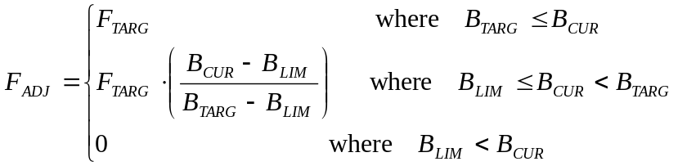 (2)
with F_{x} the fishing mortality rate that would cause the spawning biomass (not absolute biomass) to decline to x% of its unfished levels; B_{x} is the biomass at x% of unfished levels. In this case F_{TARG} is set to F₄₈, B_{TARG} is B₄₀ and B_{LIM} is B₂₀.
Tier 2 – as for Tier 1, but with F_{TARG} is set to F₆₀, B_{TARG} is B₅₀ and B_{LIM} is B₂₀.
Tier 3 – this is a catch based tier where the RBC is set at some defined fraction of recent average catches. The fraction is based on the ratio of current fishing mortality to natural mortality rates as follows:

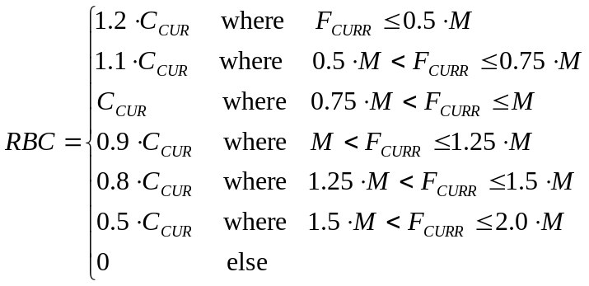 (3)
Tier 4 – this is also a catch based tier where the RBC is set based on recent trends in catch rate using:
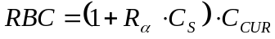 (4)
where R_{α} is the scaling coefficient (set to 1.0 in this case); C_{S} is the trend in catch rates over the last five years; and C_{CUR} is the average catch over the last five years.
When these tier rules were in use, the majority of quota groups were treated as tier one or two for the results reported here.
The final TAC is the set based on the calculated RBC after (potentially) taking a number of other considerations into account. This means the final TAC need not be as high as the RBC, but it is never allowed to exceed it.

For the case where the “negotiated” method of setting TAC’s was being used these extra considerations where not included and so the TAC matched the RBC. For the tiered RBC calculations the following other considerations were taken into account when setting the final TAC:
- Level of companion TACs (see below)
- Discards are taken into account (the F rate is calculated including discards and expected discards are subtracted from the RBC to give the new TAC)
- Is spatial management being traded off against any TAC reduction (see the description under the “Integrated Management” scenario in section 2.8.6)
- Need to transition from last TAC to new TAC that would be set under the harvest strategy, where the two are very different. In this case the following rule was used:
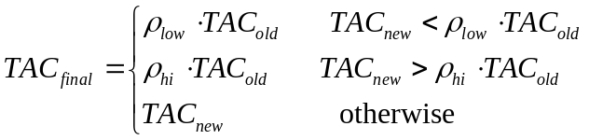
I
Where TAC_{new} is the new TAC set using the RBC and other considerations (like companion status and discards); ρ_{low} is the proportional decrease in TAC that would be likely to be implemented in any one step (set to 0.5 here); and ρ_{hi} is the proportional increase in TAC that would be likely to be implemented in any one step (set to 1.2 here).
It has been acknowledged that in reality other considerations when setting a TAC are: whether multi-year TACs are in place; and that there may be justification in setting TACs slightly above RBCs in a multi-species fishery if there is only a very small probability that the resulting TAC would ever be fully taken. As rules on how to do treat either of these cases were not available during the development of the Atlantis SE model they were not considered explicitly here. The later issue was instead subsumed into the handling of companion TACs within Atlantis SE. While the impact of the former issue was considered only post hoc, by examining how often it would have lead to an alternative regime of TACs under the methods used here.

Regional, Companion and Basket TACs
Some scenarios included regional, companion and basket TACs. Regional TACs used the same methods outlined above, but were based on the status of the stock in each region rather than the total overall biomass. Companion TACs were also initially set separately for each species using the standard methods, but were then revised (rescaled) based on the ratio of the catches of the companion species. Whether TACs were scaled up or down depended on whether weak or strong link companions were identified. If a species pair was marked as a strong link companion, then the lower TAC was scaled up so the ratio of the TACs matched the catch ratio. If a weak link TAC had been set then the higher TAC was scaled down so the resulting TAC ratio matched the catch ratio.
Most of the basket TACs currently used in the SESSF were best represented in Atlantis SE by a more standard TAC on a single group, as the group membership included all species in the basket. Other deepwater demersal sharks and the gulper shark group needed to be represented by a combined (basket) TAC in the runs discussed here. In that case the TAC was not substantially modified during the course of the run and the catches of both groups were combined when checking if the basket had been exceeded. If the basket quota had been exceeded, it was marked as tripped and no more of those groups could be retained for the remainder of the fishing year regardless of the make-up of the catch that originally filled the basket quota (i.e. all of the catch could come from one of the groups and still cause the quota to be filled; it was not necessary to have catch from both groups).

Spatial management
Spatial management was one of the main management levers used in several of the scenarios. In some cases, fixed zoning was applied (so the proportion of each box accessible by the fishery remained constant throughout the course of the run), but in others rolling and dynamically applied spatial zoning and closures were used (the specific zonings for each scenario are given in detail with the scenario descriptions below). When rolling or seasonal closures were used a time series of proportional access per box per fishery was read-in from a pre-generated file. However, in the case of seasonal spawning closures and trade-offs between spatial management and TAC reductions, the zoning was dynamically set from within the management model. In both of these cases the proportional box access was adjusted for particular specified boxes, but smaller spatial closures on the scale of aggregations were represented by temporarily resetting the catchability of the aggregating group to much lower levels. This solution has its drawbacks, but given the spatial resolution of the aggregations compared with the box sizes it was the most computationally efficient means of addressing the problem. Targeted trials using a more complex agent-based model (InVitro) indicated that the end result of explicit small scale closures and the catchability adjustment were very similar at the population level. Therefore this approach was deemed acceptable for use in the runs considered here.

Performance Measures
The performance measures used to evaluate the performance of each management scenario were the same as those adopted in the final report of the qualitative phase (Stage 1) of this study (ref). Several additional performance measures to describe system state were also included based on recommendations from the work of Fulton et al (2005) on robust indicators of the ecological effects of fishing. A complete list of all performance measures and their definitions is given in Table 2.9. It was not possible to tease out some of the social or management measures as much as in the qualitative report. Similarly it was not possible to generate innovation or sector confidence measures dynamically from within Atlantis so they were omitted here.
Table 2-4: Performance measures used to evaluate the various management strategies and scenarios
Indicator | Definition
Fishery measures
Catch of fished groups | Catch time series (tonnes per year) for each fished group (target or byproduct)
Catch of bycatch groups | Catch time series (tonnes per year) for each bycatch group
Size of catch | Average size of the fish caught per fishery
Total landed catch | Catch time series across all landings
Catch composition | Make-up (by identity and number of groups) of the catch per fishery
Effort per fishery | Effort time series (days fished per year) per fishery (or subfleet)
Fleet size | Number of vessels per fishery (or subfleet)
Average size of vessel | Average size of the vessel in the fishery (fishing power index)
Area fished | Total square kilometres fished through the year – want simple total footprint or scaled by effort per box?
Distance travelled | Kilometres steamed during the year (sum of distances from home port to midpoint of boxes fished)
Catch per unit effort | Total catch / Total effort per fishery
Discards per group | Time series of discards (tonnes per year) for each group impacted by fishing
Total discards | Time series of total discards
Management measures
Management costs | Compliance costs (spatial management, gear and TAC monitoring/enforcement/administration) plus costs of assessments plus data management/collection/collation costs
Research costs | Costs of fisheries independent surveys and science in support of assessments
Management access | Access to fishing sites per fishery
Management stability | Number of changes to management per year per fishery
Gear conflict | Overlap of effort distributions of conflicting gears
TEP interactions | Interactions with TEP groups per fishery
Economic measures
Trades | Number of quota trades per fishery
Proportion of quota traded | Proportion of quota held by fishery that was traded
Total quota holdings | Total quota held by a fishery across all groups
Value of quota traded | Total value of quota sold and leased
Gross value of product | Sum of catch * market value across all groups fished
Revenue per tonne landed | Total revenue per tonne landed per fishery (across all groups caught)
Costs per tonne landed | Total costs (fuel, capital, gear, unloading and fixed) per tonne landed per fishery (across all groups caught)
Costs per day fished | Total costs (fuel, capital, gear, unloading and fixed) per day fished per fishery
Boat cash income | Marginal profit per fishery (or subfleet)
Return on investment | Revenue per dollar invested (spent on costs, new boats and new gears if switch fisheries) in the fishery
Capital ultilisation | Revenue per dollar invested in new boats and new gears if switch fisheries
Operator’s marginal rent | Operator’s marginal rent – overall marginal rent minus crew’s share
Number of vessels switching | Number of vessels from this fishery that switched fisheries or gears
Ecological measures
Biomass of each group | Biomass¹ (or relative biomass) of each group (or stock)
Habitat cover | Proportional cover by biogenic habitat forming groups
Pelagic:Demersal biomass ratio | Ratio of total pelagic : demersal biomass (index of system structure)
Piscivore:Planktivore biomass ratio | Ratio of total piscivore : planktivore biomass (index of food web structure and integrity)
Infauna:Epifauna biomass ratio | Ratio of total infauna:epifauna biomass per box (index of benthic fauna integrity)
Diversity | Count of groups (and age stages) present
Biomass size spectra slope | Slope of biomass size spectra (index of system state change)
Social (and Port) measures
Community perception
Port status | Index of activity (catch) flowing through port (which is an index of the employment generated by fishing in the port due to unloading, processing, transport and services/infrastructure)
1. For the age structured groups both total biomass and the spawner biomass were considered.

Integrated Measures
It is always difficult to present comparisons across multiple performance measures. Integrated Indices and multivariate methods (such as PCA) have been used in the past to try and simplify this potentially dauting task. In this instance kite plots were used to present results based around topical groupings of the performance measures listed above. Instead of aggregating all the performance measures into a single index the measures were grouped in broad topic areas. The performance measures were then converted into relative measures versus the “best” value for that indicator across all years in all scenarios. These relative measures were then summed and the final values normalised so that they could all be compared on kite diagrams. In cases where a high value for a performance measure indicated poor performance the measure was inverted during the calculation of the integrated topical indicator. The following equations outline the calculation of each of the integrated indicators:
EXAMPLE OUTPUT THAT MAY ALSO BE OF INTEREST GIVEN DISCUSSION OF CHANGES THROUGH TIME AND SPACE AND REGIONALISATION

Changes in community structure
One use for Atlantis is to consider the change in community structure through time as the system state changes. Rather than defining and constraingin assbelgaes within Atlantis, the model predicts assemblages and resource partitioning based on habitat preferences, trophic connections and the results of the physical, ecological and biogeochemical processes included in the model. There is variation through time and from cell-to-cell, but distinct regions that contain similar ratios of groups can be seen through the finer details. While these patterns can be discerned directly from maps of spatial distributions of biomass generated by Atlantis, a more rigorous method is that described in Fulton et al. (2004b) – where assemblages are determined by (1) considering the fourth root transform of the average biomasses of all groups in each box on a two-dimensional non-metric Multidimensional Scaling (MDS) plot derived from a Bray Curtis similarity matrix; and then (2) examining the average values of the physical variables and the biomass per group (using the SIMPER routine of the Primer software package (Clark and Warwick 1994)) to ascertain which groups determine the clustering seen in the MDS. This analysis identifies areas (groups of boxes) in the model output that share biological and physical characteristics.
In the 1910 state of the system there are five general types of assemblages and 15 individually identifable assemblages in the modelled area. The different gerneal types are largely related to the depth and nutrient levels (and mixing) found in the boxes:
- bay assemblages (at A, B and C in Figure 3.70) are shallow water, high nutrient and high light assemblages that are supported mostly by benthic primary producers and detritus and dominated by shallow living fish (or juvenile age stages of groups that live at depth when older)
- shelf assemblages (the grey-blue, purple, royal blue, light blue, pink, cyan and yellow areas in Figure 3.70) are similar to the bay assemblages, but have a few more groups (or age stages) that are oceanic or live at depth when older; the differences between the shelf assemblages are due to differences in local productivity (areas fed by upwellings, like the aqua zone in Figure 3.70, support more groups at higher biomasses than the less productive shelf areas, like the purple area)
- slope assemblages (cream, maroon and dark blue areas in Figure 3.70) have no shallow water groups and no photosynthetic producers (though the detritus and zooplankton supporting the webs may be sourced from the photic zone), but are dominated by the deep water groups (e.g. ling and orange roughy); the most productive of these assemblages is the maroon area, which includes the slope and adjoining underwater plateau
- seamount assemblage (the orange areas in Figure 3.70) are intermediate in content between the shelf and slope assemblages (it does not contain all of the shelf groups, but does have the planktivores, tunas and higher order predators that are attracted to these locations); it contains many more groups than the slope assemblages
- pelagic (open ocean) assemblage (the grey area in Figure 3.70), which contains no demersal or benthic groups and is dominated by the smaller plankton groups, gelatinous zooplankton and vertebrates with planktivorous or piscivorous diets; seasonally there are differences east and west of the maroon area.
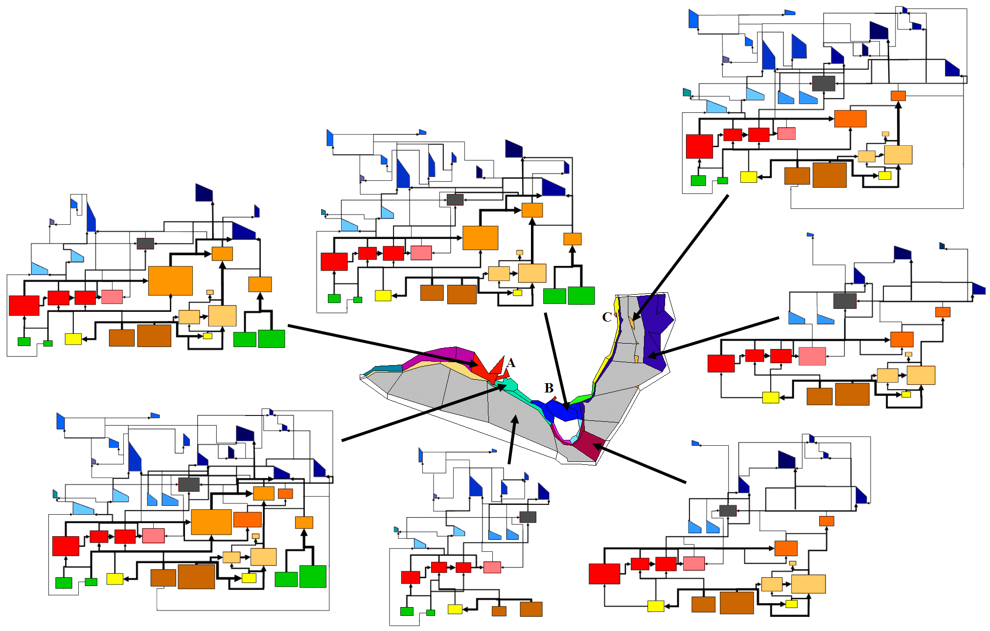
Figure 3-17: Assemblages predicted by for the 1910 system state of the southeast Atlantis model. Boxes of the same colour contain the same assemblage. Simplified foodwebs (some groups omitted for clarity) for a subset of the assemblages are shown (not all assemblages are shown for clarity). The foodwebs for the yellow, light green, light green, light blue, pink, purple and grey-blue areas are similar to that for the royal blue area (in Bass Strait); the foodweb for the cream (slope) areas is similar to that for the deep blue area.

3.4.1 Perturbed states
Through time, particularly when changing pressures (like fishing or other anthropogenic pressures) is applied to the systems there are shifts in the assemblages. The relative compositions and even membership can change. Different groups can dominate and the differences between regions can decrease (or increase) substantially. As an example of these changes in the assemblages and their foodwebs a series of snapshots from the time series on the shelf and in the canyons off eastern Victoria are shown in Figures 3.71 and 3.72.
Figure 3.71 shows the evolution in the modelled east Victorian shelf assemblage over 80 years of increasingly intensive exploitation. While minor changes in biomass (polygon size) does occur prior to 1980, mainly to do with flathead and morwong; it is not until the 1980s that striking changes can be seen. At this point seals have begun to make some recovery and the small pelagic (light blue polygons), zooplankton (in red) and squid (grey boxes) have begun to increase, but the bulk of the rest of the changes are to do with declines: baleen whales have been all but lost; the oldest age phases of many of the exploited fish groups have been depleted (the irregular polygins taking on a much more triangular appearance); and the biomass of some of the chrondrithyans has fallen. By 2000 picture has become more extreme. All of the exploited and bycatch vertebrates groups have triangular polygons, showing the loss of older larger fish; large bodied fish groups have also been severely depleted; seals and now whales have begun a recovery, but squid and small pelagics continue to have elevated biomasses (in comparison to unfished levels); carrion from discards, jellyfish and some of the small-bodied benthic invertebrates have also increased in abundance at this point. In total this has lead to a restructuring of the pathways in the web too, with the strong demersal flows switching to more pelagic routes.
The patterns that took 60 or more years to develop on the shelf are evident within 10 years at depth (Figure 3.72). By the 1990s the exploited groups had lost the older age phases and seen large biomass reductions, particularly amongst some of the chrondricthyans; the mesopelagics biomas had increased moderately, as had the biomass of some of the scavenging and smaller bodied invertebrate groups. The trend continued through so that by the time of the 2000 snap shot most of the fish groups are tiny and skewed remnants of the original populations and flows are dominated by pelagic and invertebrate groups.

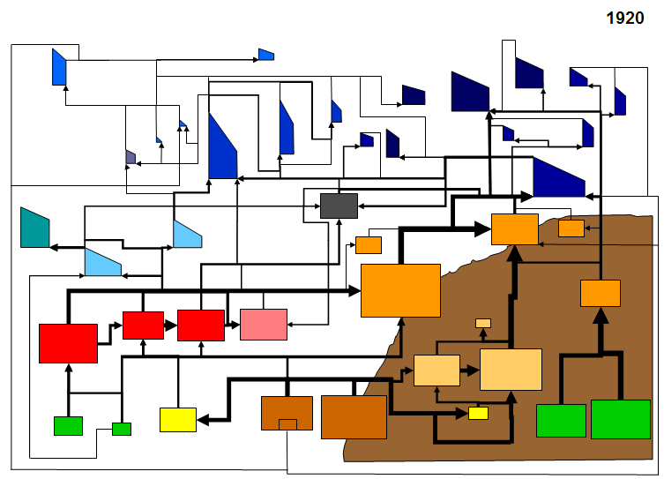
Figure 3-18: Snap shots from the time series of biomasses and food web structure in the box off eastern Victoria on the shelf above the Horeshoe Canyon (this area has been a focus for fishing pressure for over 80 years). The size of the polygons and flow arrows are scaled based on the log(group biomass), a rectangle indicates an invertebrate biomass pool and the irregular polygons represent the age structure of the vertebrate groups (youngest to the left, oldest to the right). Years the snapshots represent are (a) 1920, (b) 1940, (c) 1960, (d) 1980 and (e) 2000. Key to the colours is presented at the end of the figure (after e).
(a)

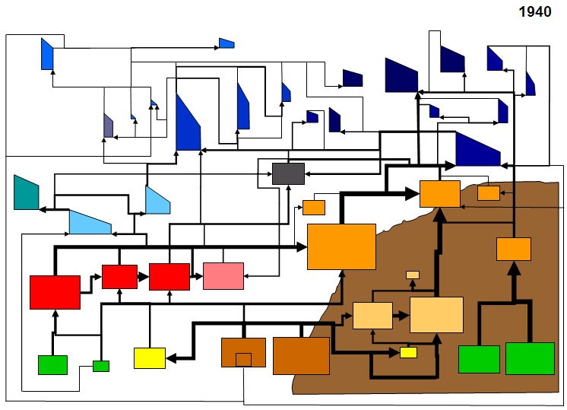
(b)

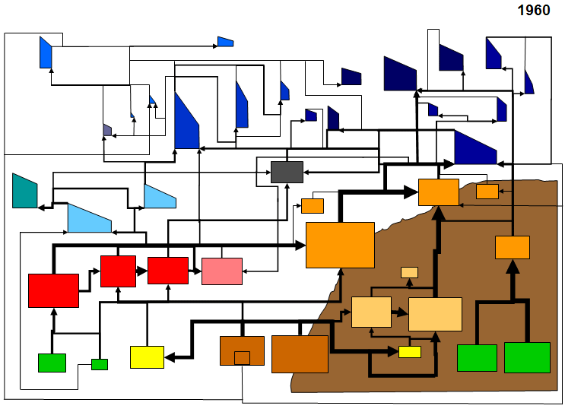
(c)

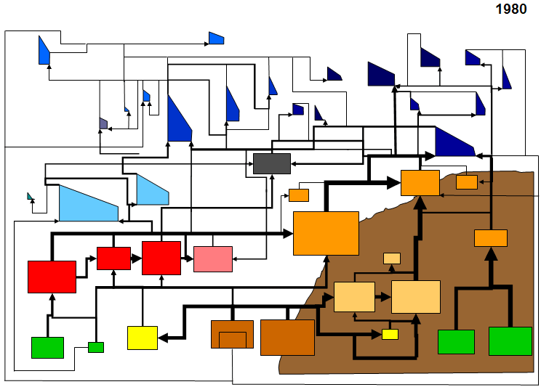
(d)

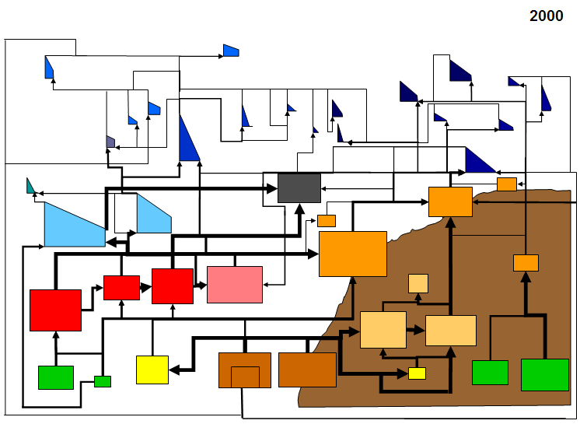
(e)

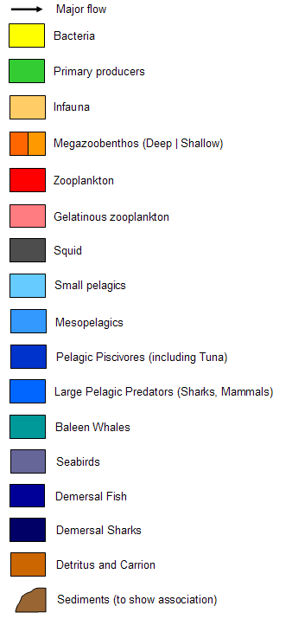

Figure 3-19: Snap shots from the time series of biomasses and food web structure in the slope and canyon box off eastern Tasmania (where fishing was concentrated during the peak periods of the 1980s-2000s). The size of the polygons and flow arrows are scaled based on the log(group biomass), a rectangle indicates an invertebrate biomass pool and the irregular polygons represent the age structure of the vertebrate groups (youngest to the left, oldest to the right). Years the snapshots represent are (a) 1980, (b) 1990, and (c) 2000. Key is the same as given above for Figure 3.70
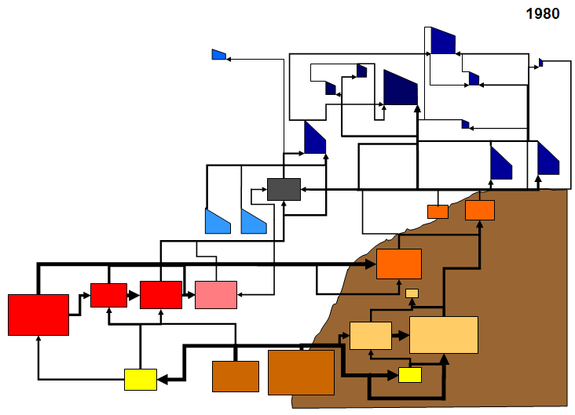
(a)
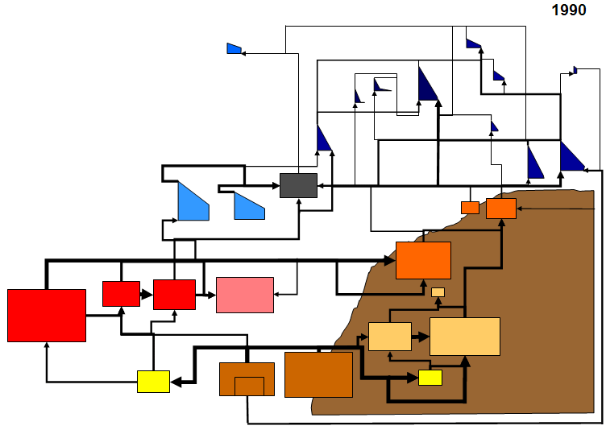
(b)

This buffering was used to reflect the mediating effects of the AFMA TAC setting process.

