Short Summary of the Atlantis Modelling Package

Developer: Beth Fulton (Beth.Fulton@csiro.au)

Atlantis (Fulton et al., 2004a) is an ecosystem box-model intended for use in management strategy evaluation (as described in de la Mare 1996, Cochrane et al 1998, Butterworth and Punt 1999, Sainsbury et al. 2000). It has been applied to multiple marine systems (from single bays to millions of square kilometres) in Australia and the United States (Figure 1).

The overall structure of Atlantis is based around having multiple alternative submodels to represent each step in the management strategy and adaptive management cycles (Figure 2) – though some steps are more elaborated than others (the biophysical and fisheries submodels being the most extensive). At the core of Atlantis is a deterministic biophysical submodel that is spatially-resolved in three dimensions using a map made up of boxes and slab-like layers. This model tracks the nutrient (usually nitrogen and silica) flows through the main biological groups found in the marine ecosystem of interest. The primary ecological processes considered in the model are consumption, production, waste production and cycling, migration, predation, recruitment, habitat dependency, and mortality. Atlantis treats lower (invertebrate) trophic levels as biomass pools (though cephalopods and prawns may have some age structure), while the vertebrates are represented using an age- and stock-structured formulation (which tracks the condition of average individuals). The physical environment is also represented explicitly - via a set of polygons matched to the major geographical and bioregional features of the simulated marine system. Polygonal maps are used as they allow for the model to focus the spatial attention where needed, capturing the critical dynamics while still achieving computational efficiency (Nihoul and Djenidi, 1998, Fulton et al 2004b). The biological components are replicated in each layer of each of these polygons. Movement between the polygons is by advective transfer or directed movements (depending on the variable in question).

Atlantis also features a detailed exploitation model. This model deals with the impact of pollution, coastal development and broad-scale environmental change, but is focused on the detailed dynamics of fishing fleets. It allows for multiple fleets, each with its own characteristics (regarding gear selectivity, habitat association, targeting, effort allocation and management
structures). At its most complex it includes explicit handling of economic drivers, compliance decisions, exploratory fishing and other complicated real world concerns (such as quota trading).

The exploitation model interacts with the ecosystem, but also supplies ‘simulated data’ to a sampling and assessment submodel. As Atlantis is primarily used in Management Strategy Evaluation it includes both operating (biophysical and fisheries submodels) and assessment submodels (so that the effacy of monitoring and assessment models can be considered hand-in-hand with any management strategies). The sampling and assessment submodel in Atlantis therefore is designed to generate sector dependent and independent data with realistic levels of measurement uncertainty (bias and variance). This ‘simulated data’ is based on the outputs from the biophysical and exploitation submodels, given a user specified monitoring scheme. By handling the monitoring of the system in this way, a wide range of combinations of fisheries and survey information can be mimicked (from landings data only through to on board catch composition monitoring by observers and intensive independent surveys). The ‘data’ is then fed into the same assessment models used in reality (including Surplus Production, Adapt VPA and Bayesian integrated assessments). In addition to these traditional assessment methods, a range of ecological indicators can be calculated (with an eye to their potential role in future ecosystem-based management schemes).

The output of the assessment models are fed to the management model (typically a set of decision rules and management levers) for action. The management model in Atlantis is currently only detailed for the fisheries sector. For this sector it includes an extensive list of potential management levers (including gear restrictions, days at sea, quotas, spatial and temporal zoning, discarding restrictions, size limits, bycatch mitigation, and dynamic reference points). It is also possible to track a crude index of the costs of management (mainly monitoring and enforcement costs).

Atlantis’ greatest strength is its modular construction. A wide range of alternative assumptions and model implementations are provided. This means the user has a greater freedom to set the complexity at the desired level – from a few groups with simple trophic interactions and a simple catch equation through to extensive models, with complicated stock structure, multiple fleets, detailed economics and multiple management levers (input, output and spatial). A lot of developmental attention has also been given to is its ability to capture age-size dependencies, temporal and spatial variation, with the result that it does produce realistic ecosystem dynamics both temporally and spatially (Fulton et al., 2004c). From a user’s point of view, this flexibility and mechanistic basis does, unfortunately, make the model process- and parameter-intensive. This can make validation time consuming and can also lead to large uncertainties. This is much less of a problem within the strategic setting of an MSE than it would be in a tactical assessment. It must be stressed that Atlantis was never intended to replace traditional assessments, rather it is a policy assessment tool to aid in the assessment of situations or strategies that are beyond single species models.

REFERENCES
Butterworth, D.S., and A.E. Punt. 1999. Experiences in the evaluation and implementation of management procedures. ICES Journal of Marine Science 56: 985–998.
Cochrane, K. L., D.S.Butterworth, J.A.A. De Oliveria and B.A. Roel. 1998. Management procedures in a fishery based on highly variable stocks and with conflicting objectives: experiences in the South African pelagic fishery. Reviews in Fish Biology and Fisheries 8: 177–214.
de la Mare, W.K. 1996. Some recent developments in the management of marine living resources. In Frontiers of Population Ecology, pp. 599–616. Ed. by R. B. Floyd, A. W. Shepherd, and P. J. De Barro. CSIRO Publishing, Melbourne, Australia.
Fulton, E.A., M. Fuller, A.D.M. Smith, and A.E. Punt. 2004a. Ecological Indicators of the Ecosystem Effects of Fishing: Final Report. Australian Fisheries Management Authority Report, R99/1546.
Fulton, E.A., A.D.M. Smith and C.R. Johnson. 2004b. Effects of spatial resolution on the performance and interpretation of marine ecosystem models. Ecological Modelling 176: 27 – 42.
Fulton E.A,. J.S. Parslow, A.D.M. Smith and C.R. Johnson. 2004c. Biogeochemical Marine Ecosystem Models II: The Effect of Physiological Detail on Model Performance. Ecological Modelling, 173: 371-406.
Morato, T., E.A. Fulton and T. Pitcher. In press. Approaches to the modelling of seamounts and their fisheries. In, Seamounts, Ecology, Fisheries and Conservation. Fish and Aquatic Resources Series (FAR), Blackwell Publishing, Oxford.
Nihoul, J.C.J. and S. Djenidi, 1998. Chapter 18: Coupled physical, chemical and biological models. In: K.H. Brink and A.R. Robinson (eds), The Sea. John Wiley & Sons Inc: New York, London.
Sainsbury, K.J., A.E. Punt A.E. and A.D.M. Smith. 2000. Design of operational management strategies for achieving fishery ecosystem objectives. ICES Journal of Marine Science, 57: 731–741

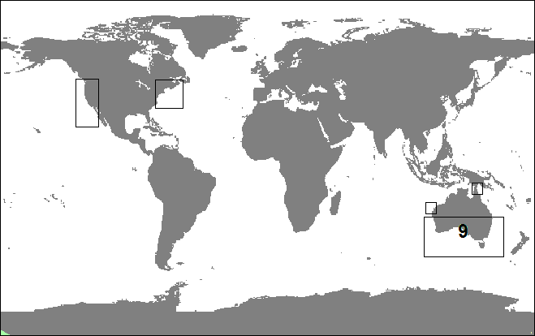

Figure 1: Map of the location and extent of existing Atlantis models. Note that for the southeast of Australia there are 9 models within the marked area, two of these cover substantial parts of this large area, while the others are restricted to small parts of (e.g. single bays).

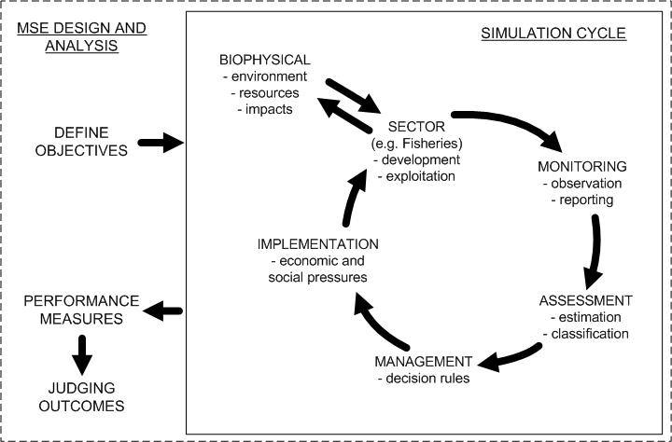

Figure 2: Management Strategy Evaluation (MSE) cycle. The steps in the simulation cycle match those in the adaptive management cycle; within an MSE model (such as Atlantis), each of these steps is represented by a submodel.

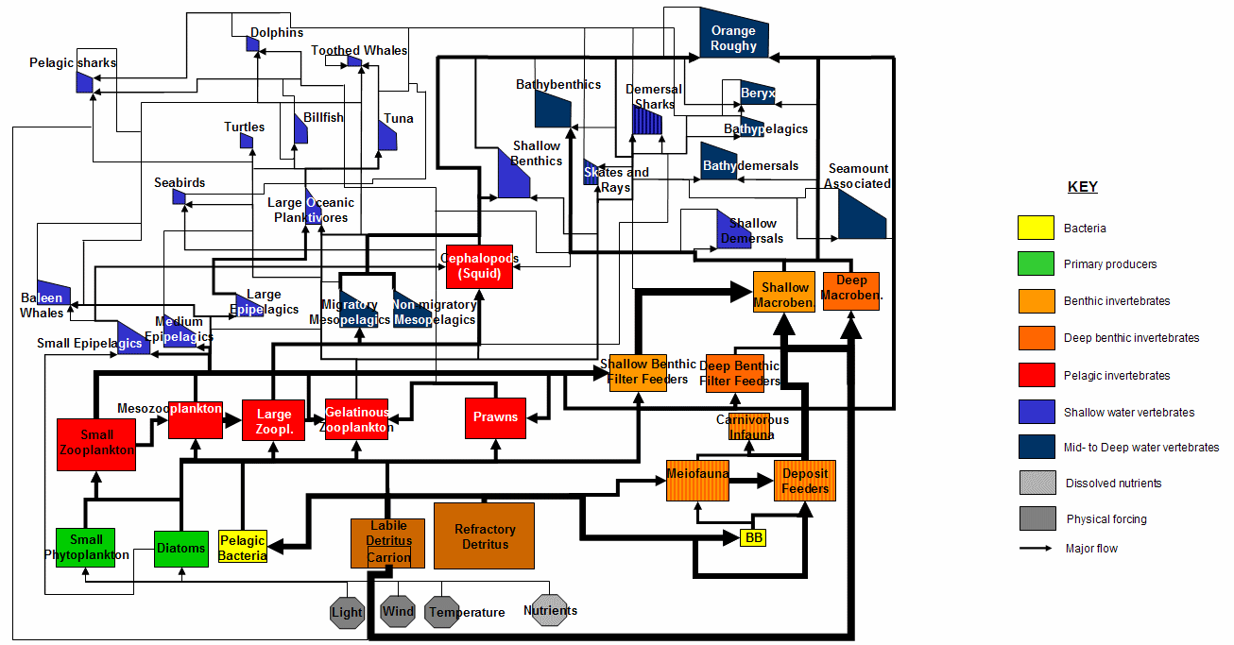

Figure 3: Example Atlantis biological model structure (from Morato et al., in press), with model groups and major flows (size of the arrow is proportional to path strength). For the boxes representing the biological groups, rectangles represent biomass pools and trapezoids are for age-structed vertebrate groups (with the shape proportional to the size structure in the population – left side showing contribution of small fish and right side the large fish in each population). Octagons represent physical and chemical components of the biophysical model

