Diets in Atlantis and Using diets.xls

Diets in Atlantis
Diet connections in Atlantis represent the maximum proportion of the prey population available to the predator population at any one instance. The realised availability of prey to predator is dependent on this value, conditioned on whether predator and prey are both in the same cell (i.e. spatially available), habitat dependency (the predator and prey must use the same habitat types to interact), the state of the habitat (if there is habitat dependent) and gape limitation (the prey must fit within the specified “gape” slot of the predator – defined vs structural N, as a measure of size).
The diet connection matrix in the Atlantis biology.prm is actually made up of 4 matrices:
- Juvenile prey eaten by juvenile predators (pPREY1FXX1)
- Adult prey eaten by juvenile predators (pPREY2FXX1)
- Juvenile prey eaten by adult predators (pPREY1FXX2)
- Adult prey eaten by adult predators (pPREY2FXX2)
This matrix assumes that prey groups (the columns of the matrix) match the “Index” from the functionalGroups.csv file.
While many methods exist for obtaining initial estimates of the availability parameters (e.g. availability calculator), these availability values can not be measured directly in the field (at least not feasibly). From experience rules of thumb on their values include:
- When consuming an age-structured group (i.e. the gape limitation terms are in play) values for a>0.6 are considered high (not impossible, but be wary)
- When consuming biomass pools (including age structured biomass pools – like for CEP or PWN under the old code) then a>0.01 is considered high
- If consuming detritus keep a low (e.g. <0.001), though consumption of carrion (discards) can be set higher

Using diets.xls
One useful tool for considering the diets is diets.xls. This consists of the following worksheets
Diets
This is the main sheet of the file and the most helpful (in my opinion).
The body of the left hand end of the sheet is the diet matrix (all formatted ready to copy and paste to/from the Atlantis biology.prm file). Likewise immediately underneath (starting about cell B494) are the ontogenetic diets (also pre-formatted to be pasted straight into Atlantis – DO NOT paste from Atlantis on to these ontogenetic values, they are calculated from the main array above the block in combination with initial distributions entered below this block, see below for more explanation).
To initially set up the main diet matrix and the ontogenetic sections of the sheet you must:
- either enter your diet matrix straight into this spreadsheet or if you have one from a pre-existing biology.prm file copy it in here, making sure the order of the vectors pPREY1FPL1 through to pPREYPWN2 match the expected order given in the sheet.
- for the ontogenetic diets enter your values in the slots beginning at B1095 (again you could copy in from an existing file being careful that the order of vectors in the prm file matches the expected order in the excel file). Note then when changing values in the main diet connection array at the top left of the page any changes relating to the ontogenetic diets will be reflected in the recalculated values (starting B494) using the shape of the original distribution of values given in the block of parameters at B1095 (i.e. changing values for FVD eating ZG will scale the original values up/down not make them more or less skewed to a particular age class).
Now to see the level of pressure coming from each predator you must enter biomasses for each group. To do this, starting in cell B2 paste biomass values for each group in the model in the order they come out in the log.txt. The easiest way to do this is to got to log.txt and find a section which reads like
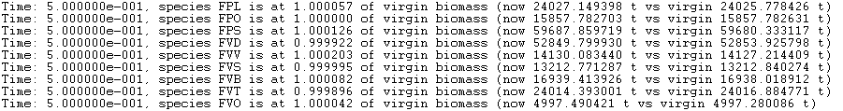
If you want starting biomasses pick Time close to zero (e.g. 0.5 as above), if you want it later in the run pick a larger time. Then select this block of text and copy it to a blank excel spreadsheet - using “text to columns” to move it from a single string per line to having columns of values – so your sheet looks like:
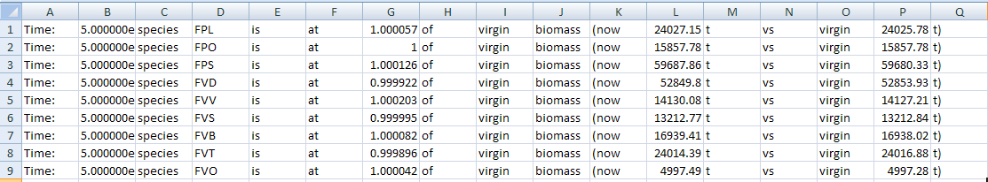
Then copy the column of biomasses that represents the “now” biomass value (so in the example above this column would be column L which starts with the value 24027.149398). Using “paste special” and choosing “values” and “transpose” as the options paste this list of values into the row starting at cell B2 in the diets worksheet.
The next step is to make sure that the values in row 3 are mapping biomasses from row 2 correctly. This will depend on how many of the groups you have turned on in the model. The easiest way to check which groups are on is to go back to the excel spread sheet where you pasted log.txt and simply copy the list of species codes (column D, starting with FPL in the example above) and using paste special paste this column into the row starting at B1 in the diets sheet. This way you can see which group goes with which biomass and compare it to the order expected by the rest of the sheet (the codes in row 4) and use this to guide how you set the values in row 3. If you know how to use the excel function HLOOKUP then it is very useful for doing this biomass match-up step. To use this approach in B3 enter the formula: =IF(ISERROR(HLOOKUP(B4,$B$1:$BL$2,2,FALSE)),0,HLOOKUP(B4,$B$1:$BL$2,2,FALSE))
Then fill across the row to cell BK3 (leave BL3 onwards alone) and this should do the biomass match-ups automatically. This is the way it is in the diets.xls file I hand out as the default starting point.
If you prefer to step through the process for yourself then use the following logic. If all groups are turned on in the model then rows 1 and 4 should be identical upto the DC entries (after that row 1 will list DIN and row 4 will go into DLsed etc, ignore this for now as the spreadsheet automatically deals with this). In this case there is an exact match and the biomass values used in row 3 should be set = to the value immediately above it. The simplest way to do this is to go to cell B3 and type =B2. Then if you put your cursor over the bottom right corner of B3 you can drag this formula along the entire row (so now each cell in the row equals the value immediately above it).
If you are not using all potential groups in the model the codes in row 1 will not line up with the codes in row 4. In this case use the headings to show you how to set up row 3. For instance if you are missing FPO in your model your row 1 you would use the following logic to fill in row 3 of the spreadsheet:
Row 4 vs Row 1 | Formula for mapping values in row 2 to cells in row 3 (examples given as if working on column D)
Row 4 and row 1 match | Cell value in row3 = value in row 2 of the same column: e.g. set D3 =D2
Row 4 and row 1 mismatch, because the group is off (so missing from row 1) | Cell value in row 3 = 0: e.g. set D3 =0
Row 4 and row 1 mismatch, because an earlier group is off (so code in row 1 out of step with code in row 4) | Cell value in row 3 set =value in row 2 of the column where the group is listed in row 1: e.g. if FPO is off (so FPS is listed in column C of row 1 instead of column D) then set D3 =C2
An example is shown below.
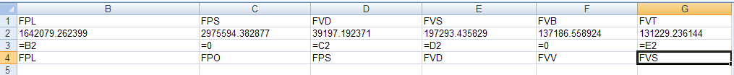
It is also necessary to set-up gape limitation parameters (so size-based diet results shown in spreadsheet). To do this go to cell EQ978 (a block of parameters under the right hand side of the spreadsheet) and enter the sizes (in terms of structural N) for each ageclass of each group, as well as the lower and upper gape parameters (KLP and KUP in the biology.prm file) and the last juvenile ageclass (the ageclass of maturity in biology.prm).
With all this complete the top right side of the spreadsheet (which has a light blue bar across the top) will show you the level of pressure on the prey from each predator. This is a crude measure which multiples predator biomass by prey biomass and whether the prey fits into the gape:
P*H*g
where
P = total predator biomass
H = total prey biomass
g = gape coefficient (=1 if fit in predator gape, 0 if don’t fit)
This value is indicative of the “available prey biomass” that will be used in the Eat() routine in Atlantis and is a good index of relative pressure on that group. The spreadsheet has been conditionally formatted (colour coded) to give you some sense of how much pressure is on the prey group.
Cell Colour | P*H*g | Qualitative measure of pressure on prey from predator
 | < 10 | Minimal
 | 10-1000 | Light
 | 1000-10000 | Moderate
 | > 10000 | Heavy
This colour coding should be used to identify sources of heavy pressure and to compare pressure across groups. The absolute values are not particularly informative however. For instance, note very high biomasses of predators and prey will end up red even if the actual prey biomass is so large it could support that level of pressure… the colour coding is simply there as a guide!.
matrix_diff
This compares two diet matrices and gets their differences and average values.
“Matrix A” is loaded straight from the “diets” worksheet. Paste in “Matrix B” from another source starting at cell A484 (e.g. from an old prm file so you can see the difference between the current diet and some past diet). The difference (A - B) is shown starting at cell A964 – so you can see what’s changed and by how much using the key:
Cell Colour | Indicates
 | A = B
 | A < B
 | A > B
An average of A and B is also given at the bottom of the page (starting about A1444) in case a value midway between A and B is useful in the next iteration of the diet (so past wasn’t quite there but new one went to far so looking for something in between).
maxtrix_comparison
This compares two presence/absence diet matrixes.
Paste in values (0 for no connection >0 for connection) and this will give a presence/absence plot vs the matrix stored in dietmatrix. The key to the results is:
Cell Colour | Dietmatrix value | Matrix_comparison value
 | 0 | 0
 | Any | 1
 | >0 | 0

dietmatrix
Produces a presence/absence colour coded matrix. Paste in values (0 for no connection >0 for connection) and that will bring up colour coded matrix showing presence (white) and absence (grey) of links.
TS_diets
This shows the difference between to presence/absence diet connection matrices. Typically these matrixes are generated by setting flagdietcheck to 1 in run.prm. Take one presence/absence diet matrix and paste it at the top of the page (top corner of the values is in cell B3), I usually put in the matrix from day 1 or soon after start. Then page down to paste in the next matrix (top corner of the values is in cell B73), I usually use one from later in the run (or the end of the run). Then page down to see the comparison using the following key:
Cell Colour | Indicates
 | Connection is the same in both matrices (either 1 in both matrices, or 0 in both)
 | Connection present in the first matrix (i.e. value of 1) is lost in the second matrix (i.e. at 0)
 | Connection not present in the first matrix (i.e. value of 0) is gained in the second matrix (i.e. at 0)
The loss or addition of a trophic connection would be due to the gape limitation vs changing size of the group (so the prey or predator has grown/shrunk vs initial state and so gape limitation has meant that a food pathway has opened/closed as a result).

Note that the middle section of the spreadsheet (without the light blue bar) does a similar calculation and colour coding of pressure but without the gape consideration and so can be misleading. I would not generally use it.

