How to Build an Atlantis Model:
A living document

Isaac Kaplan
NMFS NWFSC
Isaac.Kaplan@noaa.gov
3/2/05 and 4/2/07

with bits written by Beth Fulton,
CSIRO
Beth.Fulton@csiro.au

Ivonne Ortiz,
NMFS AFSC
Ivonne.Ortiz@noaa.gov

and Cameron Ainsworth
Cameron.Ainsworth@noaa.gov

Table of Contents
Table of Contents 2
Introduction 3
Understanding the core equations: 3
Model structure 4
Primary Production 4
Invertebrates 5
Vertebrates 5
Nutrients 6
Process Assumptions: Predation and Recruitment 7
Oceanography 8
Atlantis code structure 8
Run files (parameter files) 9
Basic Atlantis run files: 9
Parameterizing Atlantis ecology 11
Parameterizing the biology .cdf file (initial conditions): 12
Parameterizing the biology .prm file: 14
Biological Parameter Conversions: 17
Parameterizing other bits of Atlantis 18
Fisheries with Catch Forcing (no fleet dynamics): 18
Fisheries with Fleet dynamics: 19
Fisheries PRM 20
Building the Econ.prm 23
Running Atlantis 24
Viewing standard model output 25
Viewing additional output files 29
Calibrating the model 29
Calibrating with fishing: 32
MSE evaluation 33
Appendix A: BGM File Format 34
BGM design considerations 34
BGM structure 34
Boundary vertices 36
Box specific information 37
Face specific information. 39
Building the BGM file 40
Running processshapefile.aml: 41
Tagging the coverage file: 41
Appendix B: Time-series file format 44
Appendix C: Netcdf file format 45
Appendix D: Building Hydro Files: 46

** Filenames for the California Current model are in GREEN**

Introduction

This document attempts to describe setup and parameterization of Atlantis models in general, and the California Current Atlantis model in particular. Atlantis is the brainchild of Beth Fulton (beth.fulton@csiro.au), and it evolved from her BM2 ecosystem model for Port Philip Bay, Australia.

Atlantis includes modules that simulate oceanography, ecology, fleet dynamics, economics, assessments, and management decisions. The simulations involve a three dimensional ocean area. Here we primarily focus on setting up the ecological module of Atlantis, which will probably always be the first step in model building.

The ecological module of Atlantis simulates the dynamics of up to about 60 functional groups in the food web, using nitrogen as a common currency between groups. Silica is also handled dynamically, as is oxygen, though in a very rudimentary fashion. Functional groups include habitat-forming species like kelp, corals and sponges, as well as additional benthic invertebrates, vertebrates, phytoplankton, zooplankton, refractory and labile detritus, and carrion.
Atlantis is a collection of C routines, currently compiled in Microsoft Visual C++ 6.0 . The differential equations for the system dynamics are solved using an adaptive forward difference method, with an overall time step of 12 or 24 hours.
Below, I elaborate on the details of the equations, and later in the document I describe how to parameterize, run, and calibrate the model.

Understanding the core equations:
Key documentation for Atlantis core equations is: appendices C-F of Beth Fulton’s thesis (ftp://ftp.marine.csiro.au/pub/fulton ), and appendices B-D of Fulton, Parslow, Smith, and Johnson (Biogeochemical Marine Ecosystem Models II: The Effect of Physiological Detail on Model Performance) (fulton_bms_ecol_model.doc).

Atlantis tracks the abundance of biological groups within 3-dimensional polygons. For instance, a vertical view of the California Current model (West Coast of the US) looks like this:

Figure 1. California Current Model region. Each polygon is colored proportional to the abundance of a creature of interest.

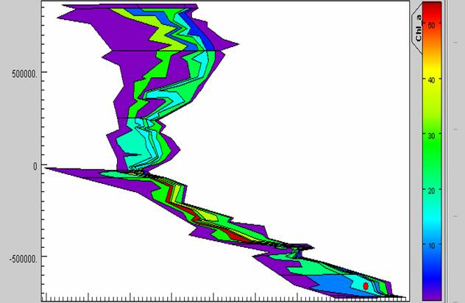

where each colored shape is a polygon. Each of these polygons has up to 7 depth zones (the nearshore polygon has 1 depth zone, the next polygon offshore has 2, and so on out to the 7th polygon offshore which has 7 depth zones).

Model structure

Functional group considerations
After you have assembled a species list, you will aggregate these species into functional groups. The groups (and the equations that govern them) are hard-wired into the code, so there is little flexibility. Here are the rules you must follow:

Per-area invertebrates
There will be 10 invertebrate groups whose biomass is measured on a per-area basis – these are best used with epibenthic species that occur only on top of the substrate. Of these, 2 must be primary producers (such as macro algae or sea grass).

Per-volume invertebrates
There will be 19 invertebrate groups whose biomass is measured on a per-volume basis – these are best used for planktonic species in the water column or infaunal species (occurring within the substrate) – and will normally include your zooplankton groups. Of these, 3 must be primary producers (e.g., small/med/large phytoplankton) and 3 must be detritus groups. There is no flexibility with the 3 detritus groups, one must be labile detritus (easily disassociated), one must be refractory detritus (cohesive particles) and one must be carrion (dead animals). Invertebrates are not age structured in the model (as opposed to vertebrates which always are) – each group is treated as a single pool. However, you have the option to assign juvenile groups to 2 out of the 19 invertebrate groups. Note: this is only a juvenile/adult split pool, as opposed to the fully age-structured vertebrates.

In other words, you have 3 options for the invertebrate groups:
Option 1) 2 adult groups + 2 juvenile groups + 15 non age-structured = 19 total
Option 2) 1 adult group + 1 juvenile group + 17 non age-structured = 19 total
Option 3) 19 non age-structured = 19 total

Vertebrates
There will be 35 vertebrate groups. Atlantis treats all of these groups the same. From these, you may chose any combination of fish, bird, mammal or reptile groups. These are measured as ‘number of individuals’ in the model. Each of the groups will be structured into 10 age categories (regardless of how long they live). The age classes for long-lived animals will therefore span more time.

*NOTE: you can always have fewer functional groups. E.g., fewer than 10 per-area invertebrates, fewer than 19 per-volume invertebrates, or fewer than 35 vertebrates.

Primary Production
Primary producer abundance is modeled as an aggregated biomass pool in each spatial box (where box refers to a single depth layer of a polygon). The model tracks density (mg N/m³) per box. Biomass growth is limited by nutrient, light and space availability. Biomass is lost to predation, lysis, and linear and quadratic mortality. Linear mortality represents additional density-independent mortality not explicitly modeled. Quadratic mortality represents density-dependent mortality (for instance, self shading).
Rate of change for standard water column (w) primary producer (PX) is
(1)
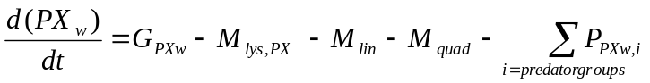
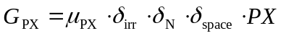 (2)
Where G_{PX} stands for the growth of PX, M_{lys},_{PX} is the loss of PX due to lysis, M_{lin} and M_{quad} are loss due to linear and quadratic mortality, P_{PX,I} are the losses of PX due to predation by i species, μ_{PX} is the maximum growth rate, δ_{irr} is light limitation, δ_{N} is nutrient limitation , and δ_{space} is space limitation.

Invertebrates
Invertebrates are also modeled simply as aggregated biomass pools in each spatial box. The model tracks density (mg N/m³) per box, based on growth, predation, and linear and quadratic mortality. Quadratic mortality in this case represents density dependent effects (predation, disease) that are not explicitly modeled; the ultimate effect is to impose a reasonable carrying capacity. In general, I (IK) attempt to set linear and quadratic mortality to 0 when possible. Linear and quadratic mortality represent ecological components not treated explicitly in the model.
Rate of change for a standard invertebrate consumer (CX) is
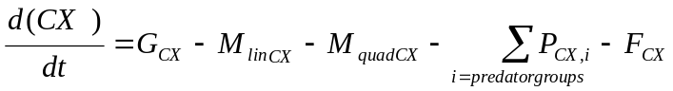 (3)
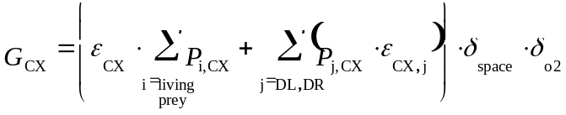 (4)
where G_{CX} is growth, M_{linCX} and M_{quadCX} are linear and quadratic mortality, P_{i,j} is predation by group j and group i, and F_{CX} is fishing on this group (this is set to zero for the unfished scenario here). ε_{CX} is the growth efficiency of CX when feeding on live prey, ε_{CX,j} the efficiency when feeding on detritus (DL treated separately to DR), δ_{space} is space limitation, and δ_{O2} is oxygen limitation.

Vertebrates
For vertebrates, Atlantis tracks abundance, biomass, weight-at-age, and condition (reserve weight/structural weight) of each group through time, in each 3-d box and for the entire model domain. Age structure is captured in Atlantis using the most computationally efficient approach for species with drastically different longevities; by assigning each a common number of age classes. In Atlantis, vertebrates have 10 age classes. These classes need not be a single year long, but represent different phases in the lifecycle, so that for some groups it may be one year while for other (long lived) groups it could represent a decade or more. The duration of each age class is always 10% of the total longevity of the creature.
For each age class and each spatial box, the model tracks the number of individuals and their average structural weight (bones and hard parts, in mg N/m³) and reserve weight (soft tissue, in mg N/m³). Growth and abundance are functions of recruitment, predation, consumption, and linear and quadratic mortality. Using the characteristics of vertebrates, some crude metrics of model performance can include: 1) comparing model-predicted values for structural and reserve weight relative to expected values, with expected values from von Bertalanffy growth parameters (for weight at age), or 2) stock assessments (for unfished abundance).
The rate of change for a vertebrate group (FX) is:
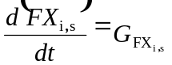 (5)
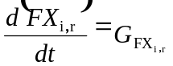 (6)
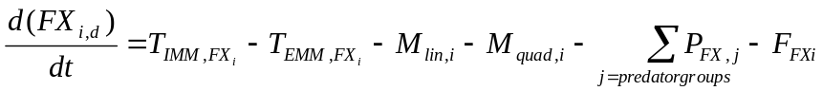 (7)
where the subscript i represents age group i (there is one equation for each age class included), s stands for structural weight, r for reserve weight , and d for density. The T terms represent the movement of fish in to (T_{IMM,Fxi}) and out of (T_{EM,Fxi}) the cell. In addition there are short-term spawning and recruitment events which affect the various FX pools. Other notation is as described above. The growth for each fish group is calculated by equations of the same form as (4), but per age group of each fish. The result is then apportioned to structural and reserve weight, favoring replenishment of reserves when the animal is underweight.

Nutrients
Water column nitrogen (ammonia and nitrate) concentrations are governed by uptake by autotrophs, excretion by consumers, nitrification, and denitrification.
Rates of change for ammonia (NH) and nitrate (NO) in the water column are:
(8)
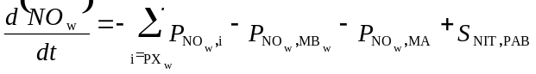 (9)

where P_{N,XX} is the uptake of NH or NO by the autotrophs (either generic, microphytobenthos MB, or macroalgae MA) , E_{CX} is the production of NH by the consumer CX, S_{NIT,XB} is the amount of NH converted to NO during nitrification by the bacteria XB, R_{NET} is the amount of NH produced by denitrification.
Full descriptions of the dynamics of other forms of nitrogen, silica, bacteria, detritus, and sediment chemistry, as well as specifialized parameterizations for dinoflagellates and macrophytes, are contained in Fulton (2004).

Process Assumptions: Predation and Recruitment
Growth of vertebrates is based on von Bertalanffy growth parameters, but varies with consumption. For the California Current model, we chose a Holling type II functional response for predation, as previous work by Fulton et al (2004) suggests that this is simple to parameterize, yet is as effective as other representations given the nature of questions to be asked of strategic models. Alternative feeding functional responses exist within Atlantis, including Holling type I and III, and Ecosim-type functional response.

Our implementation of the Holling type II functional response is:
(10)
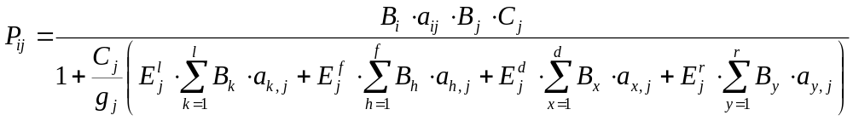

where P_{ij} is the consumption of prey i by predator j, B_{i} is the biomass of prey i and B_{j} is the biomass of predator j; a_{ij} is the availability of prey i to predator j; C_{j} is the maximum ingestion rate of predator j; g_{j} is the maximum growth rate of predator j; E^{l}_{j} is the efficiency of predator j on live food (the l superscript), E^{l}_{j} is the efficiency of predator j on seagrass, macroalgae or phytoplankton, E^{d}_{j} is the efficiency of predator j on labile detritus, and E^{r}_{j} is the efficiency of predator j on refractory detritus. The sums in the denominator are simply the sums of each of the available food biomasses (one for live food, one for seagrass, and one each for labile and refractory detritus).

Recruitment can be based on Beverton-Holt, Ricker, or several other relationships. For the California Current, we used the standard form of the Beverton Holt model:
R= α*S / (β +S) (11)
where α represents the maximum number of recruits produced (number of indivuals), and β represents the spawning stock biomass at which recruitment is ½ maximum (measured in mg N). Here we use the ecological definition of recruits: fish that are approximately 60-180 days old and have settled out of the plankton and begun feeding. Atlantis does not explicitly model larvae or larval dispersal. Recruits are distributed evenly in all areas where juveniles can exist.
For the movement of ecological groups we allowed density-dependent movement of vertebrates, as well as advection of plankton. The equations that govern density-dependent movement are described in Fulton (2004), but overall movement serves to transfer abundance towards neighboring cells with higher potential growth rates. We can also force large seasonal migrations for species such as whales.

Oceanography
The model is forced with circulation, salinity, and temperature outputs from a Regional Ocean Modeling System (ROMS), or similar oceanographic model. Oceanographic output becomes input to Atlantis. In some cases where oceanographic models are not available, fields of salinity, temperature, and circulation can be pieced together from observations or literature.

Atlantis code structure

The C++ code libraries are structured by topic and have the same major divisions as can be seen in the parameter and output files:

Physics
physics = atphysics.lib

Ecology
ecological = atecology.lib

Assessment
assessment = atassess.lib

Fisheries and management
fisheries and management = atmanage.lib

Economics
socioeconomics = atecon.lib

Main loop
main loop = atlantismain.exe

You will need two additional C++ libraries that accompany Atlantis: the netcdf library and the sjwlib library. If you’re at NOAA NWFSC you can copy them from ecosystem\EMOCC_Atlantis.

Run files (parameter files)

The examples below assume that you have a compiled atlantis.exe executable. This involves using Microsoft Visual C++ 6.0 to compile the following workspaces: atecology, atmanage, atecon, atphysics, and assess, as discussed in “Atlantis Code Structure” above. Compiling atlantismain will bundle these together, creating an atlantis.exe file that can be used together with the input parameter files described below.

On Apr.2, 2007 these files and workspaces are in: C:\Atlantis\EMOCC_AtlantisWorkingCopy\code_Apr28\atlantis_code_2

Basic Atlantis run files:

On Apr. 2, 2007, all run files and the most recent .exe are in:
EMOCC_AtlantisWorkingCopy\run_emocc\runfilesApr82007

The most important file is the .bat file. It specifies most of the parameter files to be read and included for this run. For instance, if you open testEMOCCFeb2FishImmed.bat with Textpad, it looks like this:

atlantisemocc -i Emocc_bio_Dec21StartApril2005.nc 0 -o EmoccOut.nc -r at_run_LessFPS.prm -f at_force_nuts_CoastBoxUpwell_CatchHist.prm -p at_physics_nutsB.prm -b Emocc_BiolFeb2.prm -h emocc_catches_BeginDay1.prm -a ams_assess.prm -e at_economics.prm

Here are the details on these files. Bold file names are for the California Current model (as of Apr 2, 2007). Bold italicized names are generic Atlantis names.

atlantisemocc
Atlantis is the generic name of the exe.
This is the name of the .exe executable file, compiled in C++.

Emocc_bio_Dec21StartApril2005.nc
Biology.nc
Biology initial conditions file, specifying initial biomass and size. This is created as a text .cdf file, then packed into a .nc file. See below for instructions on packing. The biology .cdf file also specifies the box geometry file to use, such as emocc62April182006.bgm. See Appendix A for more description of the .bgm format, and Appendix C for description of the generic format for .cdf files.

EmoccOut.nc
Out.nc
Name of file to which output is written (in netCDF .nc format)

at_run_LessFPS.prm
Run.prm
Run file, which specifies length of run, timestep (12 or 24hr), flags for debugging and verbosity, number of total groups in the model, number of fisheries, which modules to turn off (e.g. assessments and economics)etc.

at_force_nuts_CoastBoxUpwell_CatchHist.prm
force.prm
This file specifies the forcing time series that are read in from .ts-files text. The forcing files are for hydrodynamics, point sources, climate time series (precipitation, irradiance, temperature and salinity), historical catch (e.g. box1catch.ts, box2catch.ts, etc), fuel prices, GDP and complex spatial zonation. Example forcing files can include the output from ROMS models (such as EMOCChydroA.nc, EMOCCtemp.nc and Emoccsalt.nc), nutrient input forcing files from sewage or upwelling (Box1.ts, Box2.ts, etc.), and light (solar.ts). See Appendix B for description of .ts format.

at_physics_nutsB.prm
Physics.prm
physics parameters (coefficients) stored in physics.prm. Apart from setting some flags (e.g. turning resuspension on/off), point-source scaling and quarterly eddy strength distribution, these parameters are not typically changed.

Emocc_BiolFeb2.prm
Ecology and biology prm

Biology parameter files (growth rates, reproductive rates, diets, quarterly spatial distributions, etc.) All flags are at the top of the file, with parameters in the lower half. The model checks if parameters are in the correct form when read-in (i.e. checks if integer read-in for switches, binaries for flags etc)

emocc_catches_BeginDay1.prm
harvest prm
Fisheries and management parameters and submodel definitions are given in harvest.prm. This includes fisheries, target species, catch history, discards, changes in selectivity over time, etc. As in the biol.prm file flags are defined first and then the parameters are grouped by topic in the lower half of the file. Note that if you are forcing with time series of catch or fishing mortality, those forcing files must be specified in the forcing prm described above (e.g. at_force_nuts_CoastBoxUpwell_CatchHist.prm ).

ams_assess.prm
Assessment prm
Assessment parameters. The sample design, sampling error structures and basic assessment model parameters are given in assess.prm. Not currently used for the California Current model (but the file must be specified and present in the directory).

at_economics.prm
Economics prm
Economics parameters for fleet dynamics etc. Includes the socio-economics parameters (for the market model, trading model, and black-book based effort allocation model). Not currently used for the California Current model (but the file must be specified and present in the directory).

Notes on packing/unpacking CDF and .NC files:

Once you have created a flat ascii text .cdf version of a file (e.g. biology.cdf), it must be packed into a .nc file using pack.bat or the dos command. You will need the netcdf library to do this and a pack.bat file. If you’re at NOAA NWFSC you can copy it from ecosystem\EMOCC_Atlantis\netcdf to c:\netcdf .

Pack.bat looks like this (modify the file names as needed):
C:\netcdf\bin\ncgen -o init_npz.nc init_npz.cdf
The intended output filename is indicated by the switch –o
You can also run this from the dos command line by just typing in the previous italicized line.

Using pack.bat:
C:\atlantis\emocc_atlantisworkingcopy\run_emocc> pack

There are two other netcdf files that Atlantis automatically loads: fstatistic_blank.nc and diagnostic_blank.nc. To create these files take the cdf versions of these files from an existing run and modify them so that for each variable in the data section of the file there is one _ entry for each box in the new model. If cdf versions do not exist already use the unpack.bat (after opening it and changing the file names) or the following DOS command to create an ascii .cdf file:

c:\netcdf\bin\ncdump fstatistic_blank.nc > fstatistic_blank.cdf
c:\netcdf\bin\ncdump diagnostic_blank.nc > diagnostic_blank.cdf

Parameterizing Atlantis ecology

Parameterizing biology and ecology files
Parameterizing the biology and ecology mainly involves setting up the biology prm file (e.g. Emocc_BiolFeb2.prm) and the biology .nc file (e.g. Emocc_bio_Dec21StartApril2005.nc). The nc file is derived by ‘packing’ a .cdf file.

Parameterizing the biology .cdf file (initial conditions):

See Appendix C for a generic description of .cdf file format.

The CDF format (and its packed version, the .NC file) are inherited from oceanographers.
In general, the files contain 3-dimensional variables that are structured (t,b,z), meaning (time, numberOfBoxes, numberOfDepthLayers). For initial conditions files (like a biology.cdf file), we only have one time step, so the matrices simplify to just (b,z).

It is useful to remember that Atlantis has age structured vertebrates that have time-varying weight-at-age, but just biomass pools of invertebrates. Therefore the biology.cdf file must specify these things:
- Concentration (mg N/m^3) of invertebrates and nutrients
- Numbers-at-age for vertebrates (# individuals per age class per box)
- Reserve (meat+gonad) weight-at-age for vertebrates (mg N/individual)
- Structural (bone) weight-at-age for vertebrates (mg N/individual)

At the top, the biology .cdf file contains headers, where you declare the variable. For instance, to declare Diatom concentration:

double Diatom_N(t, b, z) ;
Diatom_N:bmtype = "tracer" ;
Diatom_N:units = "mg N m-3" ;
Diatom_N:long_name = "Diatom Nitrogen" ;
Diatom_N:dtype = 0 ;
Diatom_N:sumtype = 1 ;
Diatom_N:inwc = 1 ;
Diatom_N:insed = 1 ;
Diatom_N:dissol = 0 ;
Diatom_N:decay = 0. ;
Diatom_N:partic = 1 ;
Diatom_N:passive = 1 ;
Diatom_N:svel = -1.0e-007 ;
Diatom_N:xvel = 0. ;
Diatom_N:psize = 1.e-005 ;
Diatom_N:b_dens = 1000000000. ;
Diatom_N:i_conc = 200000000. ;
Diatom_N:f_conc = 200000000. ;
Diatom_N:_FillValue = 0.05 ;

Much farther down in the file, there is the data associated with this variable:

Diatom_N =
0.028, 0.107, 0.549, 17.216, _, _, _, 0,
10.388, _, _, _, _, _, _, 0,
2.625, _, _, _, _, _, _, 0,
3.045, _, _, _, _, _, _, 0,
… total matrix has dimension (b,z)

The headers specify a default FillValue for each variable, which will be applied any place in the data matrix where there is an underscore ( _ ).

Generally it is easiest to handle each of the key components in this way:
- Concentration of invertebrates and nutrients → Specify values in data matrix
- Numbers-at-age for vertebrates → Specify values in data matrix
- Reserve weight-at-age for vertebrates → Specify as fill value in header; leave as _ in data matrix.
- Structural weight-at-age for vertebrates→ Specify as fill value in header; leave as _ in data matrix.

Examples of #3 and #4 from the headers are:

Planktiv_O_Fish10_StructN:_FillValue = 8203.985119 ;

Planktiv_O_Fish10_ResN:_FillValue = 3925.659316 ;

For the California Current model, these values come from weight-at-age from von Bertalanffy growth parameters, converted to nitrogen-weight-at-age (see “Biological Parameter Conversions” below).

If you have specified FillValues for StructN and ResN in the header, you can leave them blank in the data, to accept these fill values. For example:
Planktiv_O_Fish10_ResN =
_, _, _, _, _, _, _, _,
_, _, _, _, _, _, _, _,
_, _, _, _, _, _, _, _,
etc.

Abundance per area (# 2 above) is derived from surveys or assessments. The format for it is as follows, for example for age class 1 of planktivorous fish:

Planktiv_O_Fish1_Nums =
0,0,0,0,0,0,0,0,
0,0,0,0,0,0,0,0,
18904,0,0,0,0,0,0,0,
250395,0,0,0,0,0,0,0,
7860,0,0,0,0,0,0,0,
etc., with 1 row for each 2D box.

;
The matrix has # of columns equal to maximum # of depth layers + 1 (sediment). The 1st entry in each row is the deepest water column layer, with subsequent entries moving up through the water column. Nearshore boxes will have some entries (in the middle of a row) that will necessarily be 0, since the full number of depth layers don’t exist nearshore. The last entry is always the sediment. Each row corresponds to a 2 dimensional ‘box’, for instance the colored boxes in Figure 1. The resulting matrix therefore has as many rows as the # of boxes in figure 1. The boxes follow the same numbering as in the .bgm box geometry file.

For vertebrates, total Nitrogen can be left blank, because Atlantis will calculate it based on the numbers and reserve N and structural N that you’ve specified. For instance:

Planktiv_O_Fish_N =
_, _, _, _, _, _, _, _,
_, _, _, _, _, _, _, _,
_, _, _, _, _, _, _, _,
etc.

For invertebrates, you must specify total nitrogen per box. For 3D invertebrates, the matrix entries have the same dimensions as shown above for vertebrate numbers-per-box.

One weird quirk: Two dimensional benthos have only one entry per 2 dimensional box. An example is for shallow filter feeders’ total nitrogen (mg N/m^2), for the California Current model with 62 boxes:

Filter_Shallow_N =
0.00, 0.5 , 0.5 , 0.5 , 0.5 , 0.5 , 0.5 , 0.5 , 0.00, 0.05, 0.05, 0.05, 0.05, 0.05, 0.05, 0.05, 0.05, 0.05, 0.05, 0.05, 0.05, 0.05, 0.05, 0.00, 0.05, 0.05, 0.05,
0.05, 0.05, 0.05, 0.05, 0.00, 0.05, 0.05, 0.05, 0.05, 0.05, 0.05, 0.05, 0.0, 0.05, 0.05, 0.05, 0.05, 0.05, 0.05, 0.05, 0.00, 0.00, 0.00, 0.00, 0.00, 0.00, 0.00, 0.00, 0.5 , 0.05, 0.05, 0.05, 0.05, 0.05, 0.00;

There is one entry for each of the 62 boxes.

Parameterizing the biology .prm file:

Here I focus on a few key parameters from the biology prm file. GroupName means any species code (like FPL, FPS, etc.), VertName means any vertebrate, InvertName means any invertebrate. There are many, many parameter entries in the prm file, but typically you can ignore many of them because they are for unused options (such as Holling type III, while we use Holling type II functional response). Below are the most important parameters to get the biology running. In general, these are dynamics parameters that you would expect to enter into any ecosystem model: growth rates, consumption rate, diet composition, ‘additional’ mortality, recruitment, and migration parameters.

flagGroupName – turns groups on or off.

GroupName_ddepend_move 0 flag to specify whether you want density dependent movement

mum_XX maximum growth rates. Invertebrates have 1 entry, while vertebrates have 10 (1 per age class). Invertebrates must use units of mg N/m^3/day.
For vertebrates, there are two options for units: A) consumption per day, relative to biomass, or B) consumption in terms of mg N/day/individual. Flagfishrates toggles between the two choices of units.

Growth rate per day, relative to biomass, can be derived from Ecopath PB parameters, converting to a daily rate and multiplying by a factor like 1.2 to account for the fact that Atlantis uses this as a maximum. However, it is more common to use option B, consumption in terms of mg N/day/individual. For the California Current model, we estimated this by calculating daily growth (in mg N/day/individual) from the von Bertalanffy and length-weight equations.

c_GroupName -- maximum consumption rates. Invertebrates have 1 entry, while vertebrates have 10 (1 per age class). Invertebrates must use units of mg N/m^3/day.
For vertebrates, there are two options for units: A) consumption per day, relative to biomass, or B) consumption in terms of mg N/day/individual. Flagfishrates toggles between the two choices of units.

For option A, consumption per day relative to biomass can be derived from Ecopath QB parameters, converting to a daily rate and multiplying by a factor like 1.2 to account for the fact that Atlantis uses this as a maximum. However, it is more common to use option B, consumption in terms of mg N/day/individual. For the California Current model, we estimated this by calculating daily growth (in mg N/day/individual) from the von Bertalanffy and length-weight equations. We then assumed that consumption up till the age-at-maturity was 10x growth (i.e. the conversion efficiency was 0.10). After the age-at-maturity we assumed that consumption scaled to the 3/4 power of body weight, as body weight increased above weight-at-maturity.

mL_GroupName ‘unexplained’ linear mortality. A tuning parameter.

mQ_XX ‘unexplained’ quadratic mortality (density dependent). A tuning parameter.

pPREY1GroupName1 diet or predator-prey interaction terms, for juvenile consumption of juveniles. It’s easiest to change these in the diets.xls spreadsheet, then paste them in to the biology prm. Values of 0 mean no consumption of that prey by that predator. We generally start with 0.01 for a strong interaction and 0.001 for a weak interaction, and calibrate from there. However, Jason Link and Robert Gamble have a new tool for estimating these from diet data.
Each of these variables is vector that is 1 row x NumberOfGroupsInModel.

pPREY2GroupName1 – same as above, but for juvenile consumption of adults

pPREY1GroupName2 - same as above, but for adult consumption of juveniles

pPREY2GroupName2 - same as above, but for adult consumption of adults

p_InvertNameVertName interaction (diet) parameters for vertebrate predation on invertebrates. Per age class of vertebrates. These generally must be low, near 0.0001, because there is no gape limitation in these cases.

BHalphaVertName and BHbetaVertName --
Beverton Holt alpha and beta parameters in recruitment. Alpha represents the maximum number of recruits produced (number of indivuals), and Beta represents the spawning stock biomass at which recruitment is ½ maximum (measured in mg N). Here we use the ecological definition of recruits: fish that are approximately 30-180 days old and have settled out of the plankton and begun feeding. Alpha can generally be taken from stock assessments, which report Ro. Beta can be calculated if you know alpha and assume a steepness appropriate for that group. To convert between steepness and beta, see for example: http://www.fish.washington.edu/research/coleraine/coleraine.pdf → page 4.

Flagfishrates specifies whether vertebrate mum_ and c_ are relative rates (growth rate per day, as a proportion of weight) , or absolute (mg N/day).

FGroupName_S1 , FGroupName_S2, _S3, _S4 : These are the spatial distribution of each species, per season (season 1-4). Values in the vectors represent proportion of the population in each box. Typically this comes from trawl survey data, or some knowledge of the areas (2D boxes) where the creatures spend their time. By using different values for each season you can simulate seasonal movement patterns *within* the model region.
Dimensions: 1 row x numberOfBoxesInModel. (e.g. 1x 62 for EMOCC).

Vertday , vertnight : these are the vertical distribution of the species, in terms of proportion in each of the depth layers. You specify this here as if the creature lived in the areas farthest offshore, where you have the maximum number of depth layers present. The flag flagdemGroupname denotes whether this species is a demersal or pelagic species, and adjusts the vertical distribution accordingly in cases where there are less than the maximum number of depth layers present (in other words, when you are close to shore).
Dimensions: 1 row x numberOf WaterColumnDepthLayers.

GroupName_habdepend – a flag stating whether presence of any species is linked to presence of a geologic or biogenic habitat type.

Habitat_GroupName – specifies which geologic or biogenic habitat type each species is dependent on.
Dimensions: 1 x numberOfPossibleHabTypes

Migrate_Time - day on which species leave the model if they migrate. Enter multiple values if the species does multiple migrations per year.

Migrate_Return -- day on which species re-enters the model if they migrate. Enter multiple values if the species does multiple migrations per year.

Migrate_Period – length of time over which the species leave and enter the system. This just allows the migrations to occur over a couple weeks or month, instead of happending instantaneously.

FSMG- proportional growth in weight of individuals while they are outside the model region, if they migrate

KMiga_GroupName, KMiga_GroupNamern, KMiga_GroupNamesn : The numbers at age, reserve N at age, and structural N of age of each functional group that begins the model run (day 0) outside the model domain.

KWRR, KWSR: The weight of individual recruits of each functional group. Units are mg structural nitrogen (SR) and mg reserve nitrogen (RR).

Biological Parameter Conversions:
Atlantis uses nitrogen as a currency for all biological groups. In setting up the initial conditions for the simulation, we assume the following for all living groups:
Wet weight(mg)/20 = carbon weight
Carbon weight./5.7 = Ash Free Dry Weight
AFDW/3.65 = Structural Weight
(S.W.)(2.65) = Reserve Weight

Parameterizing other bits of Atlantis

There are multiple ways to simulate fleet dynamics in Atlantis. Below I describe how to set up simple forcing with fishing mortality, simple catch forcing (e.g. from total landings database, disregarding fleets), and then how to set up fleet dynamics

Fisheries forced with Fishing Mortality Rates (F); no fleet dynamics

In the Harvest.PRM:
- Set flagfishFPL, flagfishFPO etc. to 1 for all harvested species
- Set flagF_FPS, flagF_FPO, etc. to 1 0 0 0 0 0 ...
This makes the first (and only) fleet impose F on each species.
- Set mFC_FPS, mFC_FVD, etc. to Daily fishing mortality rates for fleet 1 on that species. This looks like the following…

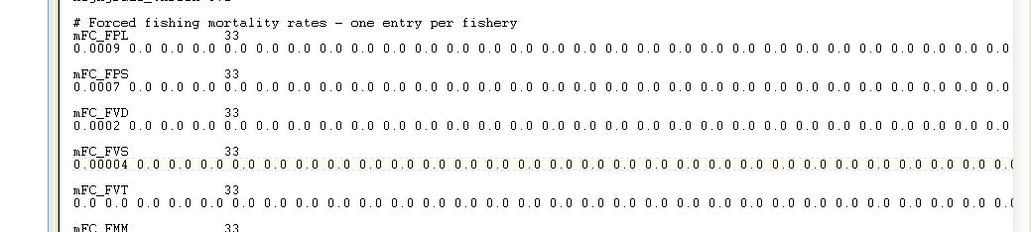

Converting from annual to daily:
(1-annualMortalityRate) = exp( - 365* dailyMortalityRate)
i.e. dailyMortalityRate = - [ln (1-anualMortalityRate) ]/ 365

- Make sure FPL_mFC_startage etc. are 0 0 0 0 …

Less important things:
- If you want F to vary during the simulation, see FPL_mFC_changes, mFCchange_start_FPS, mFCchange_period_FPS, mFCchange_mult, etc.
- Set FFCDR_FPL etc. to 0 (unless you want some proportion of catch to go into discard, which is probably unnecessary for basic calibration)
- Set flageffortmodel to 13 (though this probably doesn’t matter)
- Set midwcCEP_flagmpa etc. to 0 (for no MPAs)
- Ignore everything with catchability, selectivity, discards, etc.
- Set habitat_midwcCEP etc. to 1 1 1 1 … (probably doesn’t matter)
- Set imposecatchstart and imposecatch end to day 0 and end-of-simulation, respectively.
- Make sure TAC_FPL, TAC_FPO, etc. are very large (larger than the the amount you want harvested)

In forcing.PRM: make sure nCatchts is 0; or if you do have catch.ts files listed, make sure they don’t begin imposing catch until well after your simulation is over.

Check output: See OutCatch.txt and OutCatchPerFishery.txt to compare catches with your expectations.

Fisheries with Catch Forcing (no fleet dynamics):
Example: Y:\ecosystem\EMOCC_Atlantis\ForageFishAtlantis\LowRecStatQuoKrill5kMT\WhackZL_LowRecVeryHiDiet.bat

Four steps:

1. Check the .cdf specified in the .bat file (and then pack it back to .nc format, if necessary), to see when the model will start. For instance, in Emocc_bio_StartJan2005.cdf :
t:units = "seconds since 2005-01-01 00:00:00 +10" ;
flagimposeglobal 3

# The vectors indicate whether a catch time
# series is used for catch rather than fleet dynamics model (0=no, 1=yes)
# Assumes fisheries in order
# midwcCEP_id jigCEP_id midwcFP_id dredgeBFS_id netFD_id netSH_id plineFVO_id pseineFVO_id
# pseineFP_id trapBMS_id trapFD_id dtrawlBMS_id dtrawlCEP_id dtrawlFD_id dtrawlFDB_id
# dtrawlFDO_id midwcFD_id dseineFDB_id dlineFD_id dlineFVS_id dlineSH_id diveBG_id
# pseineFVS_id cullPIN_id recfish_id ptrawlPWN_id dtrawlFBP_id midwcZL_id trapFDE_id
# dlineFDE_id netFDE_id midwcPWN_id mowMA_id

flagimposecatch_FPS 33
3 0 0 0 0 0 0 0 0 0 0 0 0 0 0 0 0 0 0 0 0 0 0 0 0 0 0 0 0 0 0 0 0

2. Check the catch.prm file (e.g. emocc_catches_BeginYear1.prm) to see “imposecatchstart” and “imposecatchend”. These are the days of the model run, relative to the start day specified in the .cdf, for which Atlantis will look for the .ts catch forcing files. For days outside this range, no catch forcing is applied.

3. In the forcing file (at_force_nuts_CoastBoxUpwell_CatchHist.prm ), specify the .ts forcing files of catch per box. Also there will be a section for discard, MPAs, etc.

########
#Historical Catches
# Historical catch lists. typeCatchts 1 means use previous record; 0 means interpolate
nCatchts 62
typeCatchts 1

Catchts0.name box0catch
Catchts0.location 370889.3287 -717418.8373 0
Catchts0.data box0catch.ts
Catchts0.rewind 0

Catchts1.name box1catch
Catchts1.location 359593.9774 -660401.4815 1
Catchts1.data box1catch.ts
Catchts1.rewind 0

…

Catchts61.name box61catch
Catchts61.location 220100.1 -460000.1 61
Catchts61.data box61catch.ts
Catchts61.rewind 0

4. Create the .ts catch forcing files for each box of the model. These specify catch ( in mgN/sec) in each box, for each functional group. Note that there’s a line in the catch forcing .ts file that says:
COLUMN1.units days since 1981-01-01 00:00:00 +10
Make sure this makes sense in the context of imposecatchstart in the catch.prm file , and the netcdf file’s t:units = "seconds since…

If you’re at NOAA NWFSC, you can create the catch.ts files using the Instructions sheet in Y:\ecosystem\EMOCC_Atlantis\ForageFishAtlantis\CatchForcingTemplate_Atlantis.xls. You will also need the directory, including matlab scripts, Y:\ecosystem\EMOCC_Atlantis\ForageFishAtlantis\LogBook

In general, you need to create box0catch.ts, box1catch.ts etc. (as specified in the catch.prm file), with catch units of mg N/s per 2-dimensional box. The header must follow a standard format, (and ## is NOT a comment! ). If catch data is available quarterly, each row can begin a new quarter (day 0, day 91, day 182, etc.)

You should be able to force the model with fishing mortality (F), just as with catch. In the harvest.prm (e.g. emocc_catches_BeginYear1.prm), see
flagF_FPS

Fisheries with Fleet dynamics:
An Emocc example is Y:\ecosystem\EMOCC_Atlantis\Isaac\Sept2007EMOCC\EMOCCSept29aEcon
And the bat file (testEMOCCEcon.bat)

Step 1: Check the run.prm (e.g. at_run_econ.prm) to make sure that
flagecon_on 1

Step 2: Check the biology PRM, make sure you have the proper groups turned on (for instance, for EMOCC I have turned on SHC, FVV, FDM, FDE, WHS, in part to account for species important for fisheries, such as Pacific Ocean Perch (SHC), Chilipepper rockfish (FVV), Bocaccio (FDM), Widow rockfish (WHS), English sole (FDP)).

Step 3: Check the forcing prm (e.g. at_force_nuts_CoastboxUpwell.prm). If catch forcing .ts files are specified (like box0catch.ts), make sure these are correct.

Step 4: Build the fisheries and harvest.prm ( e.g. at_harvest_emocc.prm). See details below.

Step 5: Check the econ.prm (e.g. Emocc_econ.prm) . See details below.

Fisheries PRM
( e.g. at_harvest_emocc.prm)

Starting from the top of the file, you may see a list of fleets (commented out). Note that some ‘fleets’ can be only from one port, and not all fleets need to have fleet dynamics (some can be forced with catch timeseries as described above).

Main parts of this file are:
- Define fisheries: effort, demersal/pelagic, which fleet dyn model to use, target spp, what habitats the gear can access
- Select and parameterize selectivity and catchability
- Select and parameterize discarding
- Define fleets’ seasonal and vertical (water column) effort distribution.
- Define ports (location, human population, etc. )
- Establish trip limits (if using Dan Holland econ model).

Here are some key details (taken from EMOCC, using Dan Holland Econ model):

XX_Effort : These are in units of vessel days fished per day.

flaghabitat_ to 0 (“standard”)

Set the flag for whether fisheries are benthic (1) or pelagic (0):
midwcFP_flagdempelfishery 0
dredgeBFS_flagdempelfishery 1

Effort model be set to 1 for fleets with simple catch forcing scenarios, or to some other value for dynamic fleets. 11 is for the trawl fleets using Dan Holland ITQ model.
dtrawlBMS_effortmodel 11
dtrawlCEP_effortmodel 1

Turn exploratory fishing on for dynamic fleets:
midwcCEP_explore 1

# Flag indicating whether total effort can drop dynamically (without management) as stocks are depleted. 0=No, 1=Yes
midwcCEP_effortdrop 0 0

Selectivity: many options can be used; cohort specific was chosen for EMOCC:
midwcCEP_selcurve 1

Discarding: many options available. For EMOCC we chose a constant %
flagdiscard_FPS 0

Flagimposecatch_ set to 0 for dynamic fleets, but fleets with simple catch forcing from .ts files may need =1.

target_midwcCEP : Set the target species for each fleet (to determine effort dynamics that respond to cpue of target species)

Fisheries habitat association indicates which habitats each fishery can operate in.
habitat_midwcCEP 10

For non-dynamic fleets which are just forced with .ts files:
imposecatchstart and imposecatchend

Set some reasonable age distribution of the catch, though the model will depart from this if those age classes aren’t available.
CatchTS_agedistrib

Catchability per group per fishery. There are up to 13 fisheries associated with each group. Equation is Catch(mt per day)= q*sel*effort(vesseldays per day)*swept area (m3 per day)*biomass(mt) . See atharvest.c. For EMOCC, I started off with a rough guess of q, then adjusted it to try to get total catch to match the expected total catch.

q_FPL

Constant selectivity per age class (juv and adult).
Effort*selectivity*catchability should give the expected total catches.

sel_CEPad
sel_CEPjuv

Swept area per fleet:
midwcCEP_sweptarea 10000.0

You can use co-catch to handle bycatch, but I prefer to use effort, catchability, and selectivity, so the variable below is left at 0.
FCcocatchFPL

Set seasonal distribution of effort (per quarter)
mEff_midwcCEP 4
0.25 0.25 0.25 0.25

A tuning parameter:
midwcCEP_mFCscale 1

Prescribed effort distributions (proportion of total effort per box per in each #quarter), for static fisheries.
Effort_hdistribmidwc

Vertical effort distributions (proportion of effort for the box applied in each water column layer)
Effort_vdistribmidwcCEP 7

Fishery port association
ports_midwcCEP 17

Port location and timing parameters - there must be as many entries as there are ports (K_num_ports). X coordinate (in metres as in model space).

ports_x 17
ports_y 17

Population of each port , mostly to calculate recfish effort:
ports_pop 17

Bimonthly trip limits (like in the US) - if you want to use these (currently only with Dan Holland economic model) then to enter them, fill in TAC above for entire year and then enter the proportion in each bimonthly
# period in the vectors below
BiTAC_FPL 6
0.166666667 0.166666667 0.166666667 0.166666667 0.166666667 0.166666667

A useful option for MSE is “Rule based stock management. Population thresholds when populations fall below threshold values”. See the part of the PRM that involves:

FC_thresh_FPL
FC_high_thresh_FPL

Changes in fishing mortality (F) through time can be parameterized here, but also in forcing .ts files. I’m not sure which is better. See parameters such as:

FPL_mFC_changes 33
mFCchange_start_FPL 1

Building the Econ.prm
(emocc_econ.prm)
(To see how EMOCC econ was setup for Dan Holland economic model, search for “Emocc” and the associated comments.)

As always, there are many options and unused parameters. For the Dan Holland Econ model , the main work involves
- defining the fleets (# of vessels, trip length, downtime, etc)
- Establishing each fleet’s ‘black book’; the expected catch, effort, and CPUE that each fleet expects in each box in each month. This dictates initial effort distribution at the start of the model, as if it were fishermen’s notebook of recent years’ catches.
- Price per functional group per box (doesn’t vary by fleet)

Key parameters are:
Number of boats per subfleet (if only 1 subfleet per fleet, then only first entry filled in)
midwcCEP_nboat 5
4 0 0 0 0

Home port per subfleet (if only 1 subfleet per fleet, then only first entry filled in)
midwcCEP_home_port 5
1 0 0 0 0

# Trip length per subfleet
midwcCEP_triplength 5
3 0 0 0 0

# Down time per month - minimum proportion of month for maintenance
midwcCEP_minDownTime 5
0.2 0 0 0 0

# Debt tolerated in $ per day
midwcCEP_TolDebt 5
500 0 0 0 0

# Catch and cpue is in lbs
flaglbs 1

## Temporal black books - catch per month (in kg) per species for each fleet and subfleet
JanCatchFPL_sub1 33

# Effort in days at sea
JanmidwcCEPEffort_sub1 62

## Spatial black books - CPUE per box per month per subfleet per fishery
JanmidwcCEPCPUE_sub1 62

# Params for Dan Hollands model only
# betarev is a parameter to concentrate effort set equal to 1 initially
netSH_betarev 5
1 1 1 1 1

#Towtime per trip, in hrs. For EMOCC, this is 72hrs/trip*0.5*0.8= towhours*towtriprate*(1-steam)=29hrs
TowTimemidwcCEP 62

# Price per kg, varies by each of the 62 regions. From Dans .txt file.
ECONexpriceFDF 62

Add more here about parameterization of management.

Running Atlantis

Open a command window (Start→Run→cmd)

Change directories to the location of the exe and input files
Cd /d c:\atlantis\emocc_atlantisworkingcopy\run_emocc

Then type:
testEMOCCFeb2FishImmed
or whatever the name of the .bat file is.

The parameter input files will be read in by the C code when the program is run. Currently all files are in \run_emocc subdirectory.

Run time is currently 2-12 hrs, depending upon the run length and the complexity (i.e. # of boxes, species, or modules turned on/off).

Viewing standard model output

In the .bat file (e.g. testEMOCCFEb2FishImmed.bat), you specified an output file name (e.g. EMOCCOut.nc). Double clicking on this will produce open the net cdf output in the viewer, OLIVE. The output file contains 3D time series of both physical and ecological variables. Sometime OLIVE will not read the .nc file if you ended the run prematurely. However, if the run crashed on its own, you can usually still open the .nc file and view the output with OLIVE. To download OLIVE: ftp://ftp.marine.csiro.au/pub/fulton →OliveSetup.exe .

Below is a typical OLIVE output, showing Mesopelagic_N_Fish Nitrogen concentration, for a box off Oregon, in Depth Layer 4. The plot on the bottom shows the time series of abundance in this box (red dot on map):

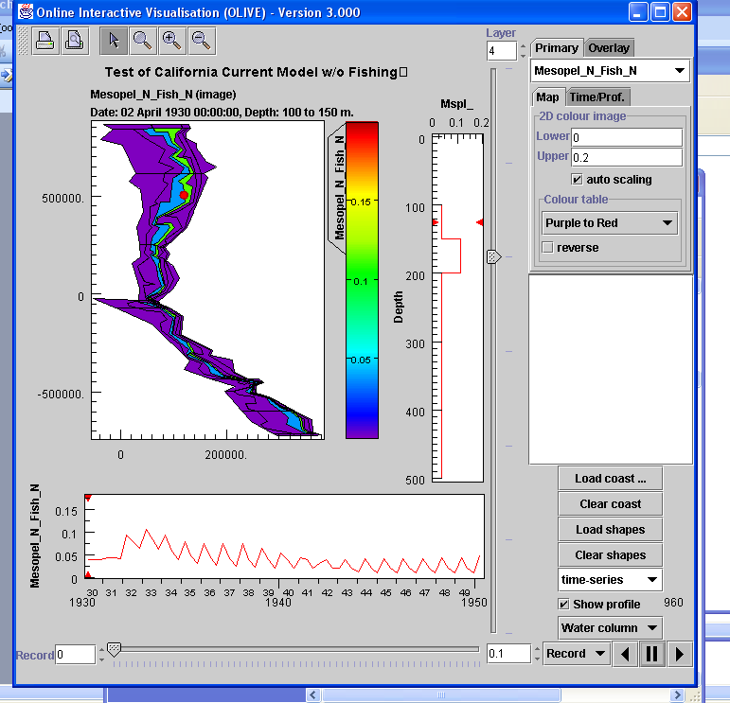

You can also view the text output file, log.txt. The flags in the run file (e.g. at_run_LessFPS.prm) control the frequency at which the log.txt output is written, and whether you want detailed output checking certain nutrients, fisheries, species, diets, etc.
Beth recommends viewing with Textpad, http://www.textpad.com/ .

The output file (EMOCCOut.nc) can also be handled and visualized using the R package ncdf or various Matlab netcdf packages (http://www.marine.csiro.au/sw/matlab-netcdf.html or http://mexcdf.sourceforge.net/ or http://www.odyle.net/mma/NCDView/ncdview.php)

I (IK) have an R script available called PlotOutNC_NandR.r that takes the .nc file and plots biomass over time for all species, and reserve and structural nitrogen over time for all species. Example:

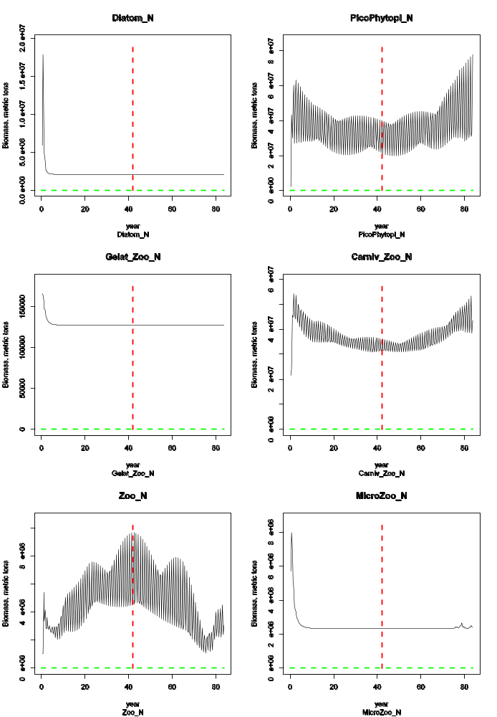

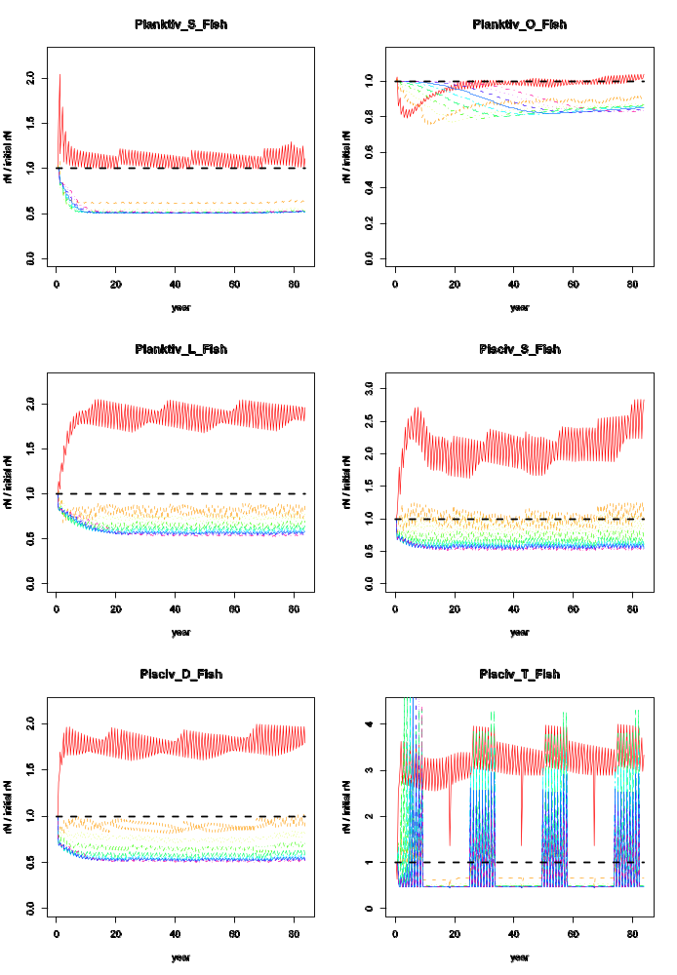

Viewing additional output files

Additional ecological output is contained in outTOT.nc, outPROD.nc, and YOY.txt.
These files represent additional aggregated or diagnostic output. Assessment and indicator values are given in topic specific indicator files (i.e. a long list of files grouped by indicator type). The fisheries and management output is given in outF.nc, outFTOT.nc, catch.txt, effort.txt, catch_per_fishery.txt. The socioeconomics are also given in a short list of aggregated files.

Calibrating the model

The main software tools used to calibrate the model are OLIVE, textpad, and Excel files that use lookup tables to compare model output with observations and assessments (as appropriate). Use OLIVE to view the out.nc file, and use textpad to view the log.txt file.

The general goals of calibration are, in this order:
1. Prevent most species from going extinct
2. Have vertebrates grow such that size-at-age is reasonable
3. For species with historical data are available, have the model recreate observations of abundance from surveys or assessments
4. For species with no historical data, the model should yield reasonable time series of abundance
5. Capturing observed spatial distributions

The relative values reported in log.txt are key to successfully calibrating the model, particularly for vertebrates.

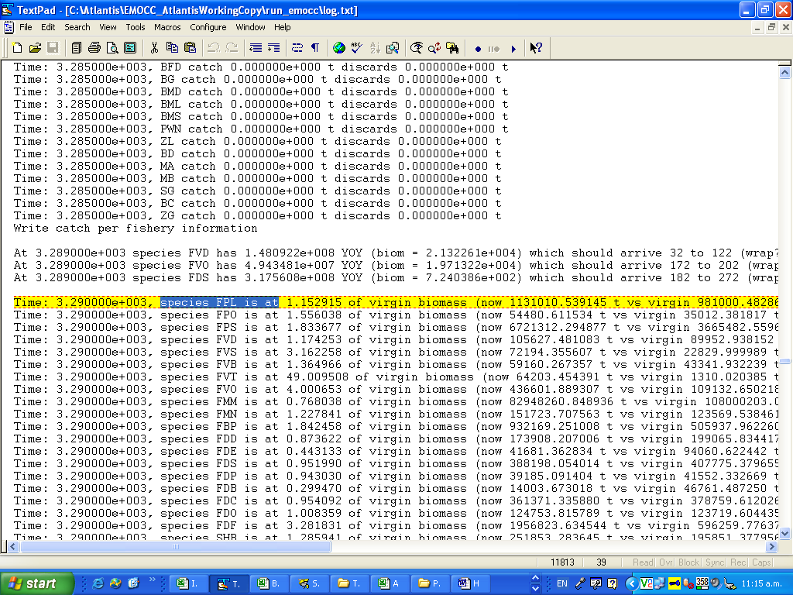

The screenshot above shows log.txt output for day 3290. In yellow, we can see that species FPL is at 1.152915 x its initial biomass. This sums across all boxes (i.e. disregards space in the model). The text says “virgin biomass ”, but this is a misnomer, and should really say “initial biomass”.

Output frequency is dictated by toutinc in the run.prm file (e.g. at_run_LessFPS.prm).

Using Textpad’s F5 (Search) key allows you to rapidly scan through species abundance over time, for both vertebrates and invertebrates. For invertebrates, this information in log.txt is the main diagnostic tool.

For vertebrates, log.txt gives you an additional diagnostic: it allows for tracking of growth relative to initial conditions:
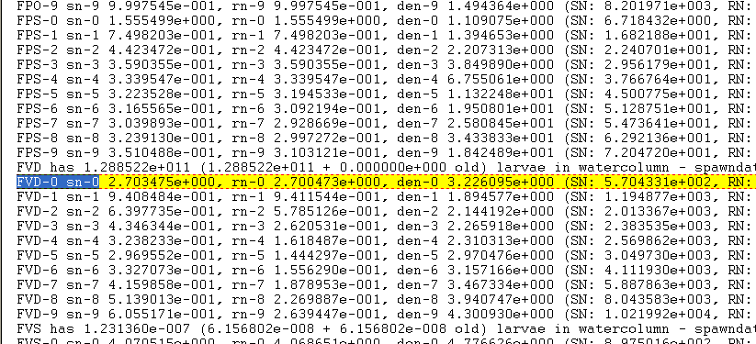

The yellow highlighted area in the screenshot shows us that at this timestep, age class 0 FVD (piscivorous demersal fish) have a structural weight (sn) = 2.7 x initial, reserve weight (rn) also 2.7x initial, and density (numbers) =3.2x initial.

Once size-at-age is within 20% of the von Bertalanffy curve expected from the literature, then growth is generally acceptable. When calibrating vertebrates, attempt to get relative SN and RN values reasonable before worrying about numbers (den results). Note though that if numbers are too high (by an order of magnitude or more) the group maybe starving itself so you may need to reduce recruitment or increase predation to get numbers under control before you will make any headway with the growth of the group.

The use of the supporting xls files (biomass_trajectories.xls, diets.xls etc) is recommended as they do facilitate the calibration process. Biomass_trajectories.xls compares the observed biomass trend to historical data, while diets.xls allows you to easily modify the pPreyXX diet interaction terms (see below), and to compare parameterization between runs.

For NOAA NWFSC, supporting xls files are in ecosystem\EMOCC_Atlantis\SupportingXLS_files

During calibration, tuning typically focuses primarily on changing growth rates, consumption rates, linear and quadratic mortality, and Beverton Holt parameters. These variables are in the biology.prm file (e.g. Emocc_BiolFeb2.prm). Below, XX could be any species code (e.g. FVD, FPL, etc.):

c_XX consumption rates. These are C in equation 10, the predator-prey functional response.

mum_XX maximum growth rates. These are g in equation 10 above, and they place a upper limit on G in equations 5 and 6.

mL_XX ‘unexplained’ linear mortality (Isaac usually tries to leave this at 0). See M_{lin} in equations 1,3, and 7 above.

mQ_XX quadratic mortality (‘unexplained’ density dependence) (Isaac usually tries to leave this at 0). See M_{quad} in equations 1,3, and 7 above.

pPREYXX diet or predator-prey interaction terms. It’s easiest to change these in the diets.xls spreadsheet, then paste them in to the biology prm. These interaction terms are a in equation 10 above.

BHalphaXX Beverton Holt alpha parameters in recruitment. See alpha in equation 11 above.

Calibrating with fishing:

A major part of calibrating the model is comparing how it performs when faced with various levels of fishing intensity, both real historical values and hypothetical values. This sort of qualitative exploration can reveal underlying problems, such as parameterizations that involve too little recruitment (and therefore inevitable decline of a stock) or too much recruitment (and therefore unreasonable resilience to fishing). For heavily fished target species, we roughly expect Atlantis to behave like a single species model. For lightly fished, nontarget or forage species, we expect ecosystem dynamics to matter a lot more, and Atlantis may (reasonably) diverge from a single species assessment prediction.

Beth’s suggestions on fishing scenarios to run:

1. Unfished - Atlantis spinup estimate of the unexploited system (where
possible from virgin, but also what system would it head to from current
state if unfished)

2. Historical removals - can the Atlantis state support historically
recorded catches (and suspected misreported catches); does the
trajectory match assessment/survey data? (preferably survey data over assessment as the
later can be dodgy itself)

3. Fish the target(s) at current levels (and do so constantly through
time)

4. Fish the target(s) at assessment estimate of RBC (Recommended Biological Catch, which may differ from MSY)

5. Fish the target(s) at 5xassessment estimate of RBC

6. Fish the target(s) at 0.2xassessment estimate of RBC

7. Fish the target(s) at 0.2current levels

8. Fish the target(s) at 20xcurrent levels (or more depending on current F)

9. Shock the system in some other way (e.g. nutrient pollution, habitat
degradation etc)

10. Combinations of shocks (typically high fishing + a non-fishing
shock)

For the California Current model, we conducted something similar to #3-8 by simply running scenarios across a range of fishing mortalities, ranging from F = 0.0 to F = 1.0.

MSE evaluation

When evaluating an MSE, the biomass values as well as the diagnostics reported in the txt and TOT.nc files are typically used, as these match the performance measures typically used to judge MSEs.

Appendix A: BGM File Format

The .bgm file defines the geography used in the Atlantis model to define the bathymetry of the model system, but also used by OLIVE for display of the model. The input of this file specifies in detail the geometry of the model with polygons, and faces of each polygon, individually identified. The model is cast in x-y terms (rather than latitude-longitude), typically created using an Albers projection.

The following section is broken into three parts. They will discuss 1.) general BGM design considerations 2.) structure of the BGM file, and 3.) the use of ArcGIS tools and scripts to actually generate the BGM file.

BGM design considerations
The BGM input file is derived from a shapefile with the following requirements:
- The least number of boxes (polygons) possible (usually, less than 90*)
- The least number of vertices possible (less than 500*).
- Keep the number of dynamic faces (those corresponding to non-boundary boxes) to less than 400* if possible.
- Must have perfect topology (no gaps, no overlaps between polygons)

*These are maximum values for guideline purposes only. (A face is a line of a polygon or an arc in coverage files; a vertex is a point or a node; a box is a polygon).

Both the number of boxes and number of vertices determine the number of calculations performed: biological parameters, fisheries and vertical mixing (in oceanography) are box-specific, while horizontal fluxes (oceanography) are face-specific. The time step in Atlantis can be set at either 12 hours (preferable for areas with strong tidal cycles) or 1 day. The higher the number of boxes/faces the higher the number of computations required, increasing the running time of simulations.

BGM structure
The bgm file shows the number of boxes and dynamic faces at the top of the file along with the maximum depth in the model (including boundary boxes): Then it describes the geometry of the model in three main sections:

- boundary vertices
- individual box (polygons) description
- individual dynamic face (lines) description

The structure of the bgm file is as follows:
-------------------------------------------------------------------
# box model geometry comment
# number of boxes in horizontal plane
nbox nb

# number of faces in horizontal plane
nface nf

# Maximum bottom depth (m) if botz > this reset botz
# to be this as far as model is concerned
maxwcbotz -20

# vertices of polygon defining the boundary of the dynamic model spaces, polygons outside this are treated as boundary boxes
bnd_vert 4846663.054 2672181.026
bnd_vert 4846577.624 2671694.641
bnd_vert 4846769.65 2671316.256
bnd_vert 4846620.269 2670658.417
bnd_vert 4846647.232 2670053.268
bnd_vert 4846896.231 2669701.554
bnd_vert 4846895.551 2668853.126
bnd_vert 4846480.926 2668328.515
bnd_vert 4846068.874 2668006.796
bnd_vert 4846040.837 2667847.55

# Data for box number 0
box0.label box0
box0.inside 4850502.794 2660539.214 // midpoint of polygon
box0.nconn 1 // number of neighbouring dynamic boxes
box0.iface 0 // face numbers connecting box with dynamic neighbouring boxes
box0.ibox 1 // box-id numbers of dynamic neighbouring boxes
box0.botz -7.58 // depth of the box
box0.area 4.96E+05 // area of the box
box0.vertmix 0.000001 // vertical mixing scalar for the polygon
box0.horizmix 1 // horizontal transport scalar for the polygon
box0.vert 4850016.494 2660989.963 // vertices of polygon
box0.vert 4850411.21 2660812.231
box0.vert 4851009.235 2660650.395
box0.vert 4850843.256 2660162.581
box0.vert 4850087.844 2660321.401
box0.vert 4850016.494 2660989.963

AND SO ON FOR nb BOXES

# Data for face number 0
face0.p1 4850016.494 2660989.963 // one endpoint of face
face0.p2 4850087.844 2660321.401 // other endpoint of face
face0.length 672.3586014 // length of face
face0.cs -0.106119971 0.994353333 // cosine and sine of this vs (0,0)
face0.lr 0 1 // box to left and right of face standing at p1 looking at p2

AND SO ON FOR nf faces
-------------------------------------------------------------------

Boundary vertices
The boundary vertices section is the list of the vertices in the boxes that form the perimeter of the dynamic boxes throughout the total geographical extent of the model, creating one big polygon. They appear listed as shown below in (x,y) format, where x,y is in projected (that is as a linear transformation of) longitude and latitude (see Fig. 2).

bnd_vert 114808.53116241223 -198659.07516970747
bnd_vert 111900.78818530716 -198343.95031504458
bnd_vert 111471.43038234783 -208869.7219088128
bnd_vert 162668.94072214147 -279486.97754990094

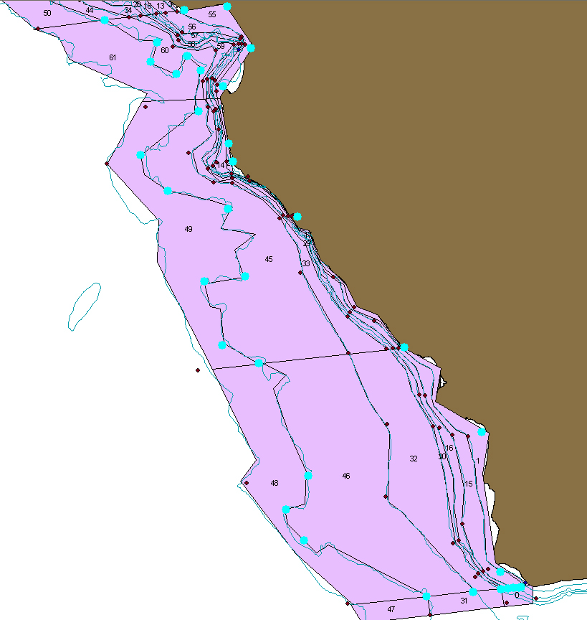

Fig 2. Boundary vertices shown partially for EMOCC. In light blue dots. Note the boundary vertices are NOT the outline of the geographical extent of the model, but the outline of the dynamic boxes within the model. As one large polygon, vertices are ordered sequentially in either clockwise or anticlockwise direction. Direction must always be the same for all ordered sequences (boxes, faces, vertices, etc.). Note also that the highlighted boundary vertices are those of the simplified box model, not the vertices of the working shapefile. This is apparent because not all the segments between two boundary vertices are one straight line; rather some segments are composed by several straight lines.

Box specific information

The section for Box specific information describes the full geometry of each box (polygon) individually:

# Box number 0 Box number identifier, is the user defined number assigned to the box for spatial calculations such as biomass allocation, quantifying habitats, etc.
box0.label box0 Box label is the number of the box as used for BGM scripts and is generated by ArcMap / ArcInfo. Ideally this identifier is the same as the Box number, but not always and not necessarily. Both box numbers and box labels are unique.

box0.inside 45503.28021 727529.5392 Centroid of polygon
box0.nconn 7 Number of faces shared with other polygons
box0.iface 0 1 2 4 5 6 7 Number id of each shared face. Each individual face has a unique number assigned to it.
box0.ibox 77 34 1 1 1 1 1 Box to which each shared face corresponds to
box0.botz -2400 Average maximum depth of water column
box0.area 1.52E+10 Area of polygon
box0.vertmix 0.000001 Default value for vertical mixing**
box0.horizmix 1 Default value for horizontal mixing**
box0.vert 23492.63556 842456.6404 List of vertices (x,y) in clockwise or
box0.vert -13847.19353 841270.2606 counterclockwise sequence (see below).
box0.vert -37486.38732 789424.1104
box0.vert 2855.36963 759840.1553
box0.vert 28806.20743 611920.3798
box0.vert 81977.33123 611920.3798
box0.vert 99452.69802 644315.4042
box0.vert 71564.11803 671189.854
box0.vert 84240.7453 736601.2508
box0.vert 44182.60312 794913.7362
box0.vert 23492.63556 842456.6404

Direction of ordered sequences:
The sequential order ifaces, ibox and box vertices must have the same direction the same for all the polygons and boundary vertices. Either clockwise or counterclockwise will work (see Fig 3). In order to ensure that your vertices are ordered consistently in a clockwise or counterclockwise direction, use CHECKWINDING.EXE available from Cameron.ainsworth@noaa.gov. It is time consuming to check the winding order manually, and easy to make a mistake.
**Default mixing values are only used if something goes wrong with the oceanography data provided for the model and specified in the hydro file.
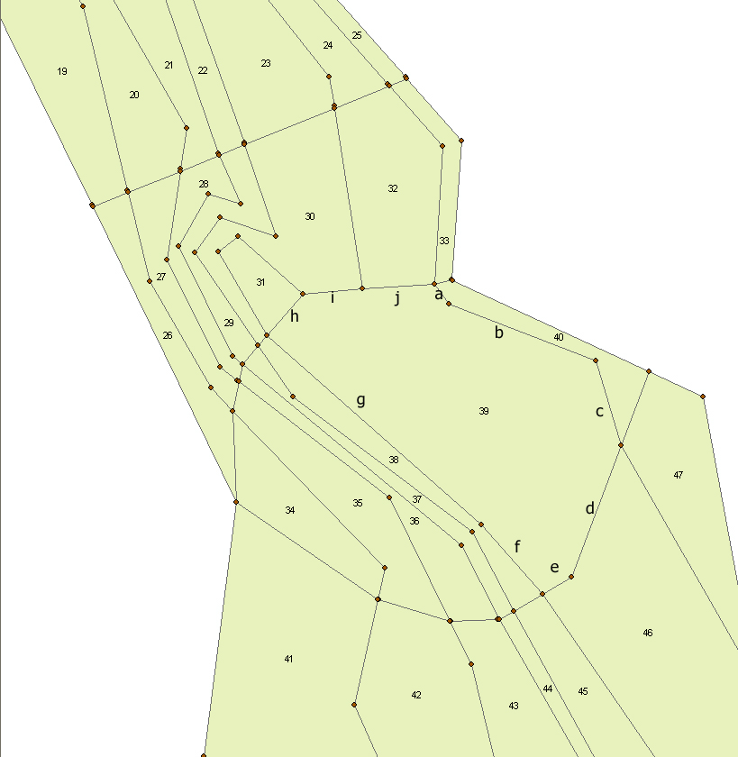

Figure 3. Box 39 has 10 nconn (10 shared faces, a,b,c,d,e,f,g,h,i,j), with boxes 40, 40, 40,46,46,38,38,31,30,32. In clockwise order.

Face specific information.
This section describes each dynamic face (faces of all non-boundary boxes) geometrically by providing it’s starting and ending points, length, sine and cosine for the angle, and orientation by specifying the boxes to the left and to the right.

# Data for face number 0 Unique identifier number for individual face
face0.p1 23492.63556 842456.6404 First point (x1,y1)
face0.p2 -13847.19353 841270.2606 Second point (x2,y2)
face0.length 37358.67146 Length
face0.cs 0.999495636 0.031756476 Cosine and sine of face for angle or slope
(slope = sine/cosine = y2-y1/x2-x1 = rise/run)
face0.lr 0 77 Number of the box to the left and to the right as you look from point 1 to point 2. This orientation is crucial as it is later used in the hydrography and if it is wrong it turns the flows the WRONG direction (use CHECKWINDING.EXE) to test this in addition to the winding direction of polygons.

Trigonometry refresher:

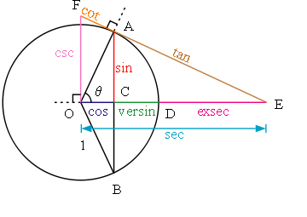

Figure 4 shows the orientation and proper way to designate boxes to the left and right of a face. Use CHECKWINDING.EXE available from Cameron.ainsworth@noaa.gov to also test whether your left/right configurations are correct.

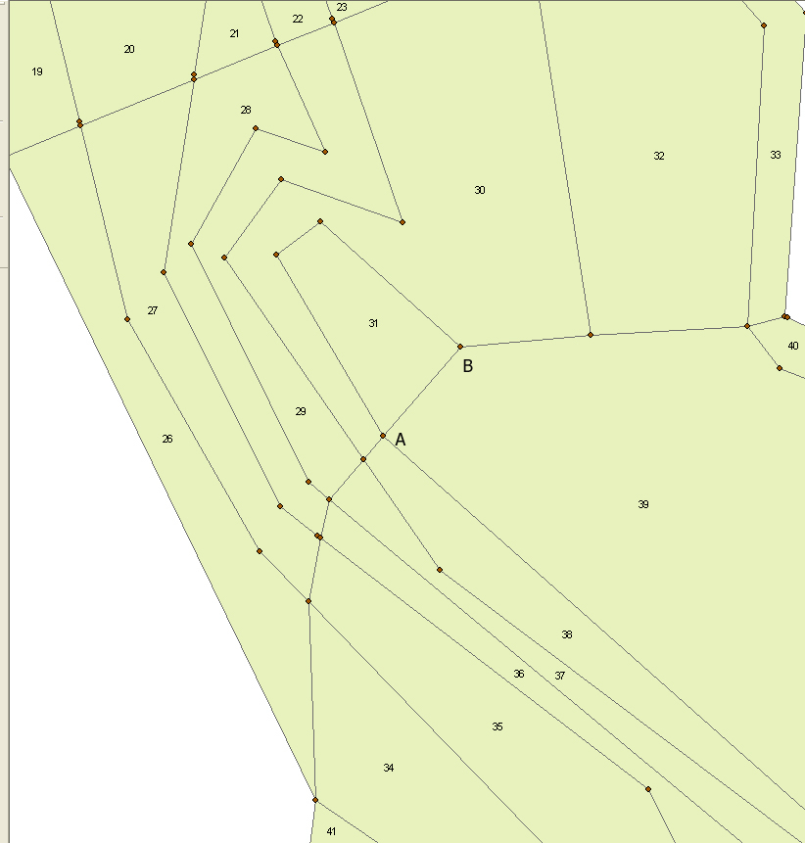

Figure 4. Points A and B of face shared by box 31 and box 39. Left and right boxes are designated as you look from point 1 to point 2. If A is point 1 and B is point 2, then box 31 would be on the left and box 39 on the right. Conversely, if B is point 1 and A is point 2, then box 31 would be on the right and box 39 on the left. Setting the direction incorrectly inverts the direction of the flow in the hydro file, hence it is a critical detail in the bgm file.

Building the BGM file
The old way of building the BGM file (prior to Jan 2008) involved running 6 AML scripts. AML is the programming language for ArcGIS. The 6 are: processshapefile.aml, tag_cov.aml, bgm_arcs.aml, bhm_boundary.aml, bgm_poly.aml, and bgm_poly_ungenerate.aml. In the new way, you still run the first two, processshapefile.aml and tag_cov.aml, but then use a JAVA application called “BGM Editor” under development by Beth’s group, which replaces the last 4 AMLs. All AML scripts are available from Beth Fulton; the JAVA program is operational as of Feb 2008 but not ready for release (contact Beth for details).

The following instructions refer to the new method, using processshapefile.aml, tag_cov.aml, and the JAVA application, “BGM Editor”:

Running processshapefile.aml:
- AML are text files, so they can be viewed
- See comments in AML file
- Create a new directory on the hard drive with no spaces in the path name (e.g., c:\NoSpaces\BGM\)
- Unzip all AML files into the folder
- Make sure you have GIS workstation installed so that you have access to ArcInfo.
- Under ArcInfo (in startup menu) run Arc – a DOS-like command box will appear
- Change the active path using the following command:
&workspace c:\NoSpaces\BGM\
- Copy ArcGIS shapefile (e.g., shapefilename) into that folder (including all 6 shapefile components: .dbf, .prj, .sbn, .sbx, .shp, .shx.) – this shapefile will be turned into a coverage file by the first AML script, processshapefile.aml
- Run processshapefile.aml using the following command:
&run processshapefile shapefilename
- This creates a coverage file with the same name as the shape file (except no caps)
- Open ArcCatalog and browse to the new coverage file – double click the coverage to reveal the subcomponents: arc, label, node, polygon and tic.
- Open ArcMap (new project)
- Drag the ‘arc’ feature class of the new coverage file from ArcCatalog into the layers pane of ArcMap – the arcs (i.e., line segments only, not polygons or vertices) will be displayed
- Open attribute table of the ‘arc’ feature class and examine the lengths of all the line segments. If any of the lengths are tiny (orders of magnitude less than average) then you probably have an accidental segment that may or may not require you to redraw the map.

Tagging the coverage file:
- Open attribute table of the ‘arc’ feature class layer. There will be a column with no data in it called BGM-BND. This is data that categorizes each line segment into one of four categories: 0,-1,-2 or -3. Only one segment will be assigned 0 (unique) and it must be assigned to a segment separating a nondynamic (boundary) box from a dynamic (non-boundary) box. -1 is assigned to all coastal line segments (bordering land). -2 is assigned to all segments separating a non-dynamic boundary box from another non-dynamic boundary box. -3 is assigned to the rest of the segments – these will include all segments separating dynamic (non-boundary) boxes from other dynamic (non-boundary) boxes and all segments separating dynamic (non-boundary) boxes from non-dynamic (boundary) boxes except for the one unique “0” segment. Note: -3 will also include the outside faces of boundary boxes (i.e., adjacent to nothing – no land or polygon).
- The code 0, -1, -2, or -3 will be entered into the BGM-BND column, but since this is a coverage file rather than a shape file, you cannot edit the attribute table directly. You must instead right-click the BGM-BND column and select ‘Field Calculator’
- To turn all values to -3 (which will be the value for the majority of faces) select the whole BGM-BND column, activate the field calculator, enter “-3” into the argument box and press OK. To enter the 0, -1 and -2 values, select the rows representing the line segments of interest and activate field calculator (make sure “Calculate selected records only” check box is checked) and enter 0, -1 or -2 into the argument box and press OK.

After tagging open the command line window in Arc catalog

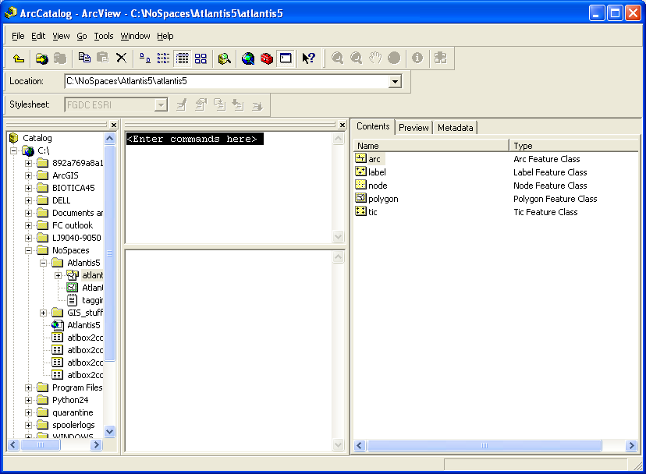

Type this or something like it. (note, you have to start with ArcInfo license):

export_arc COVER c:\NoSpaces\BGM\mycoverage c:\NoSpaces\mycoverage.e00 NONE

The .e00 file is then generated in the ‘mycoverage’ folder. This .e00 file is an input for the BGM editor – the output of the BGM editor is the final BGM file. At the time of this writing (June 2008), no user outside of CSIRO has successfully generated the BGM file using the Beta-release BGM editor (or the previous 6 AML scripts for that matter), so it may be necessary at this point to get Beth Fulton’s help (or Michael Fuller’s help – Michael.fuller@csiro.au).

If the alpha-release BGM editor is available, it may be possible to create the BGM file with it, but be aware that as of July 2008, the BGM editor did not put the necessary sin/cosine information into the resulting BGM file. However, Beth Fulton does have an excel file that generates the necessary sin/cosine information (cos_sin_calcxls.xls). After using the excel file you can manually input the sin/cosine information into the BGM file.

You’re done.

Appendix B: Time-series file format
Time series files include temperature, salinity, solar intensity, historical catch forcing, etc.
The time series files used to force the model follow the standard CMAR ts format, which is as follows for a time series files with N data columns and a reference year of 1951

# Comments
#
## COLUMNS N
##
## COLUMN1.name Time
## COLUMN1.long_name Time
## COLUMN1.units days since 1951-01-08 0:00:00 +10
## COLUMN1.missing_value -999
##
## COLUMN2.name variable_name
## COLUMN2.long_name Variable
## COLUMN2.units mg/s
## COLUMN2.missing_value -999
##
## And so on until all N columns defined
1 0.045292995 0.226464977 and so on upto N columns

Appendix C: Netcdf file format
The initial conditions file for the biology (biology.nc) is generated by ‘packing’ a biology .cdf file. This biology .cdf file contains initial biomass and size values, and is just an ascii text file.

Netcdf files are laid out in the following fashion

filename {
dimensions
t = UNLIMITED ; // (x currently)
b =
z =
variables:
double t(t) ;
t:units = "seconds since 1951-01-01 00:00:00 +10" ;
double variable_name(t, b, z) ;
variable_name:characteristic =

// global attributes:
:title = "npz" ;
:global parameters
data:
t = 0;

variable_name =
_, _ ;
}

where 1951 is the reference year and the data array for variable name is laid out so that there are z entries per line, with b lines. This is then repeated for each of the t steps.

Appendix D: Building Hydro Files:
[Mostly written by Albert.J.Hermann@noaa.gov]

To run Atlantis, you generally need:

- one salinity.nc file,
- one temperature.nc file, and
- at least one waterflux.nc file.

These filenames are specified in the forcing file listed in the .bat file. For instance, -at_force_nuts_CoastBoxUpwell_CatchHist.prm lists these filenames. The salinity file lists parts per thousand, and the temperature file lists degrees C.

In Atlantis, you only want flows for faces between:

(i) boundary and dynamic boxes (for system inflow/outflow)
(ii) dynamic boxes (for advection/diffusion within the model domain)

Oceanography data such as temperature and salinity is specific for each face (line segment) of a box (polygon). You then need to provide the starting and ending points that define each face of a polygon. In contrast the vertical flux is box specific and includes data through the water column, so maximum depth of the water column under each box is needed as well as depth layers. Since the oceanography is face specific, it is vital that the geographic information given to the oceanographer matches the final geography detailed in geometrical form in the box geometry model (bgm) file. In other words, make sure that whatever the oceanographer is calling face 1 *is the same* line segment you are referring to as face 1, otherwise the program will assign the oceanography to what is labeled face 1 but in reality could be face 23. You laugh, but it has happened. The same applies to the boxes.

Data for the oceanographer includes two tables, and a map. You also need to let them know the starting date (day/month), number of years and timestep (12 hr) for which you want data. The map of the model is a courtesy, but it really helps to have a visual image of the spatial arrangement of the model -preferably with the boxes numbered for reference. You will typically want the starting date to extend as far back in time as possible. Previous Atlantis models have used 7-15 years of data from ROMS, the longest is 50 years. Depending on the data available to the oceanographers, you may wish to start the hydrodynamics from 1970, for example.

Tables 1 and 2 show the information needed by oceanographers in order to run the oceanographic model (e.g., ROMS, HAMSOM) and provide the information needed to construct the hydro file. Table 1 contains the data for each face, ordered by polygon; table 2 contains the depth information of each polygon. Note in table 1 the direction in which the faces are listed for each polygon (clockwise or counterclockwise) must be specified when you give them your models information. The direction does not matter so long as it is consistent throughout the entire file. That is ALL vertices must be listed in clockwise or anticlockwise sequence.
Table D1. Face specific information
Line segments (faces) in Clockwise sequence |  | Point 1 (x1,y1) |  | Point 2 (x2,y2)
Polygon (box number)* | Face identifier  (a unique number for each face)*** | Starting longitude DD | Starting latitude | ending longitude | Ending latitude
0 | 0 | -140.00000 | 35.00** | -135.00000 | 35.00
0 | 1 | -135.00000 | 35.00 | -135.0000 | 30.00
0 | 2 | -135.0000 | 30.00 | -140.0000 | 30.00
0 | 3 | -140.0000 | 30.00 | -140.00000 | 35.00**
 You must specify the direction in which the faces (and points are listed. Either Clockwise or Anticlockwise will work but it has to be consistent throughout the file.
* Polygon number: the order of the boxes does not matter but the faces for any one given polygon must be consecutive.
** Make sure to close the polygon by making the ending point of the last face be the same as the starting point of the first face (see bold numbers in table above).
***Faces included are only the dynamic faces. These are the faces of the non-boundary boxes. Since the boundary boxes are not used for any active calculation in the model, no oceanographic data is needed for the boundary boxes (or non-dynamic boxes).
****Optionally, you may include a column with segment lengths

Table D2. Box specific information
Polygon (box number) | Maximum depth* | No. of layers | Area of box  (optional)** | Depth layers throughout model***
0 | 1000 | 4 | 50,000 | Layer 1 | 250m
1 | 750 | 3 | 20,000 | Layer 2 | 500
2 | 500 | 2 | 40,000 | Layer 3 | 750
3 | 250 | 2 | 25,000 | Layer 4 | 1000
4 | 1000 | 4 | 10,000
5 | 750 | 3 | 15,000
* maximum of water column in that box
** Not necessary unless you require some other format/data. Ask the oceanographer or just include it. If it is not used it doesn’t matter.
***These are just specified once, not for each polygon. For each polygon only the number of layers is specified.

The ROMS model categorizes oceanography at points along a regular grid. From this, they interpolate the Atlantis face and polygon data. The grid size they may use to produce the hydrodynamic data is flexible; it can be between 3 x 3 km to 10 x 10 km. Atlantis modelers should generally prefer a longer time series of data, rather than high spatial resolution, so go to 10 x 10 km if necessary. The longer time series is preferable for fitting the Atlantis model to data. If possible, it is useful to have one low resolution data set for fitting and broad-scale applications, and one high resolution data set for specific fine-scale investigations with Atlantis.

Oceanographers generally can provide data in a textfile.dat format, with separate files for horizontal flux across faces and vertical flux:
The flux-facexxxx.dat files have the format
Face # | Time step (12h) | Depth category | Water flux across face  (m^3 / s)
1 | 1 | 1 | W1,1,1
1 | 1 | 2 | W1,1,2
1 | 1 | 3 | W1,1,3
1 | 2 | 1 | W1,2,1
1 | 2 | 2 | W1,2,2
1 | 2 | 3 | W1,2,3
… |  | … | …
2 | 1 | 1 | W2,1,1
2 | 1 | 2 | W2,1,2
2 | 1 | 3 | W2,1,3
… | … | … | …

Note: oceanographers often use Sverdrups (10⁶ m³/s) to express water flux. You may need to convert this data to (m³/s) before constructing the hydrofile.
The fluxes are positive inward - positive values indicate flux *into* the polygon.
Note that the face# has the value of the first vertex used by that face (there are two for each face, i.e. face#1 spans vertex#1 and vertex#2. A face# of 999 refers to a bogus face, that is, one which doesn't correspond to any polygon (they correspond to faces defined by the last vertex of, say, polygon 1, connected to the first vertex of polygon 2). The value "-0.100e+35" is a missing value flag - it indicates that this face/depthrange is over land or below the ocean bottom. These were set to zero in the calculations for w.
Other .dat files (such as wxxx.dat) are for vertical flux, and have the following format:

Polygon # | Depth layer | Vertical upwelling velocity  (m/s) | Average temperature (degrees Celsius) | Average salinity  (parts per thousand)
0 | 1 (25 m) | Water velocity (0,1) | Temp (0,1) | Sal (0,1)
0 | 2 (80 m) | Water velocity (0,2) | Temp (0,2) | Sal (0,2)
0 | 3 (150 m) | Water velocity (0,3) | Temp (0,3) | Sal (0,3)
0 | 4 (500 m) | Water velocity (0,4) | Temp (0,4) | Sal (0,4)
0 | 5 (1000 m) | Water velocity (0,5) | Temp (0,5) | Sal (0,5)
1 | 1 (25 m) | Water velocity (1,1) | Temp (1,1) | Sal (1,1)
1 | 2 (80 m) | Water velocity (1,2) | Temp (1,2) | Sal (1,2)
1 | 3 (150 m) | Water velocity (1,3) | Temp (1,3) | Sal (1,3)
2 | 1 (25 m) | Water velocity (2,1) | Temp (2,1) | Sal (2,1)
2 | 2 (80 m) | Water velocity (2,2) | Temp (2,2) | Sal (2,2)
… | … | … | … | …

Only the deepest polygons will have all of the depth layers; a shallow polygon may include only 1 depth layer.

Given these .dat files, Beth has scripts (hydroconstruct.exe) to create the .nc files that represent water flux, temp, and salinity.

As it requires a large amount of effort for the oceanographers to generate the final face and vertical fluxes for the entire time series (e.g., 30 years), it may be useful to ask for a dummy file. The dummy file can contain a single day’s worth of data (i.e., a typical day). This file can be created sooner and with less effort. It will allow the Atlantis modeler to begin the process of tuning while they are waiting for the final oceanographic data.

In addition, the Atlantis modeler can create a very simple dummy file that essentially removes oceanography from the computations. The structure of that CDF file is as follows:

--------------------------------------------------------------------
netcdf Hydro_goc_dummy {
dimensions:
t = UNLIMITED ; // (1 currently)
b = 51 ; ***change to number of polygons
z = 7 ; ***change to number of depth layers
dest = 1 ;
variables:
double t(t) ;
t:units = "seconds since 1980-01-01 00:00:00 +10" ;
t:dt = 86400. ;
double exchange(t, b, z, dest) ;
exchange:_FillValue = 0. ;
int dest_b(t, b, z, dest) ;
dest_b:_FillValue = -1 ;
int dest_k(t, b, z, dest) ;
dest_k:_FillValue = -1 ;

// global attributes:
:title = "trivial" ;
:geometry = "goc51.bgm" ; ***rename to your BGM file
:parameters = "" ;
data:

t = 86400 ;

exchange =
_, _, _, _, _, _, _, ***add additional rows for each polygon, add additional columns for each depth layer
_, _, _, _, _, _, _,
_, _, _, _, _, _, _ ;

dest_b =
_, _, _, _, _, _, _, ***as above
_, _, _, _, _, _, _,
_, _, _, _, _, _, _ ;

dest_k =
_, _, _, _, _, _, _, ***as above
_, _, _, _, _, _, _,
_, _, _, _, _, _, _ ;
}
--------------------------------------------------------------------

Annoying things about the the PRM:

- _S1, _S2, etc. seasonal distributions need to sum to 1.

2. Anything to the right of 5 or 6 decimal points will be ignored, including scientific notation like 3.2945822935E-02

- For MigIOBox, adults and juveniles, you need to add “dummy” values for a second migration, for the following groups:
FVT, FVB, SHP, REP, PIN, WHT, WHB
For example, for an 18 box model, to the biology prm add:
MigIOBox_FVB2juv 18
0 0 0 0 0 0 0 0 0 0 0 0 0 0 0 0 0 0

And FVO needs 3 migrations specified in MigIOBox.

Biology PRM
C_PB_T15 0.1
C_BB_T15 0.1
flagBOlim , BDlim, BGlim, BFlim, SiLim all set to 1.
P_BFDsplit 0
P_BMDsplit 0
Recruit_time needs to be less than 365

Assess.prm
Zones should be dimensioned to your number of boxes.

Infinite values for growth can be caused by wrong layer thicknesses.
This is due to botz > sum of dz or sum of nominaldz . It needs to be <=

