CONTENTS
CONTENTS i
4 Simulation Testing – Atlantis Framework 3
4.1 Operating Model 3
4.1.1 Atlantis 3
4.1.2 Biological submodels 3
Case study 1 - Shallow Bay 4
Case study 2 – Coast-to-open-ocean 4
4.1.3 Physical submodels 14
Case study 1 - Shallow Bay 14
Case study 2 – Coast-to-open-ocean 14
4.1.4 Fisheries submodels 15
Case study 1 - Shallow Bay 15
Case study 2 – Coast-to-open-ocean 15
Alternative Fisheries Submodels 17
Effort Allocation 17
Selectivity Curves 18
Discarding submodels 18
Bycatch submodels 18
4.1.5 Management submodels 19
4.2 Scenarios 19
Fisheries Scenarios 22
Ecological Scenarios 23
Environmental Scenarios 25
4.3 Model behaviour 25
4.3.1 Regional assemblages 25
Case study 1 - Shallow Bay 26
Case study 2 – Coast-to-open-ocean 26
4.3.2 Perturbed states 29
Case study 1 - Shallow Bay 29
Case study 2 – Coast-to-open-ocean 29
4.3.3 Scenario differences 36
Case study 1 - Shallow Bay 36
Case study 2 – Coast-to-open-ocean 39
4.4 Sampling Model 44
APPENDIX C – ATLANTIS OPERATING MODEL EQUATIONS 47
C.1 Rate of change equations 47
C.1.1 Autotrophs 47
C.1.2 Bacteria 48
C.1.3 Invertebrate Consumers 48
C.1.4 Vertebrate Consumers 48
C.1.5 Inanimate Pools 50
C.2 Process equations 52
C.2.1 Growth of primary producers 52
C.2.2 Growth of mixotrophic primary producers 53
C.2.3 Growth of bacteria 54
C.2.4 Growth of consumers 55
C.2.5 Mortality and loss functions 57
C.2.6 Waste processes 58
C.2.7 Physical processes 59
C.2.8 Equations for Sediment Chemistry 60
C.2.9 Equations for Vertebrate Movement 62
D FISHERIES AND MANAGEMENT MODEL EQUATIONS 64
D.1 Fishing mortality and management 64
D.2 Effort 64
D.3 Selectivity 65
D.4 Management 66
D.5 Discarding 67
APPENDIX E – SAMPLING MODEL PARAMETERS 68
APPENDIX F – SAMPLING MODEL EQUATIONS 71
F.1 Invertebrates 71
F.2 Physical characteristics 71
F.3 Vertebrates 71
F.3.1 Charismatic vertebrates 71
F.4 Fisheries data 72
F.5 Fisheries independent sampling (fished vertebrates) 72
F.6 Diet composition 73

4 Simulation Testing – Atlantis Framework
4.1 Operating Model
As mentioned in Chapter 3, to allow the modelled ecosystems (and hence the outcomes of the study) to be more representative, the modelled systems were based on the corresponding real systems, but did not match the systems exactly. Similarly, the fisheries (and other human sectors) represented in the modelled systems are not exact reproductions of their real world counterparts. The modelled fisheries and the trends in fishing effort were selected to produce the maximum amount of contrast in the ecological impacts in the generated data set. This contrast was necessary to properly test the flexibility and robustness of the potential indicators. This approach may result in overestimation of the performance of some indicators, but it will more quickly identify indicators with little potential utility (if an indicator does not perform well under these circumstances it will generally be of little practical use) and so screen poor indicators from further consideration.
In contrast to the biology and anthropogenic model components, the physical aspects of the operating models replicate the hydrographic conditions found in the real ecosystems as closely as possible. This was done to ensure that realistic rates of water movement and transfer were retained, even when other forcing conditions (e.g. temperature or nutrient levels) were modified to represent the impacts of anthropogenic pressures.
4.1.1 Atlantis
The Atlantis framework was used for the operating models in this study. Atlantis consists of two models: a biogeochemical ecosystem model (which produces deterministic time-series for each component in the modelled ecosystem) and a sampling model (which “collects” the data from the ecosystem model and calculates the indicators). The sampling model takes the data time-series from the ecosystem model output and adds sampling error and other stochastic elements so that the final data sets resemble as closely as possible those collected by scientific surveys and commercial fisheries. Further details of these models are given below and the equations are given in the appendices.
4.1.2 Biological submodels
Atlantis is a revised version of Bay Model 2 (BM2) (Fulton 2001, Fulton et al. 2004b). The original version of BM2 was built as part of a modelling study investigating model complexity, and has proven to be a useful tool for simulating temperate marine bays (Fulton 2001). Atlantis is a deterministic model that tracks the nutrient (nitrogen and silica) flow through the main biological groups found in temperate marine ecosystems, and three detritus groups (labile detritus, refractory detritus and carrion). The invertebrate and primary producer groups are simulated using aggregate biomass pools, while the vertebrates are represented using age-structured models. The primary processes considered in Atlantis are consumption, production, waste production, migration, predation, recruitment, habitat dependency, and natural and fishing mortality. A summary of the chief assumptions is given in Table 4.1, and the general mathematical formulations for the phototrophic, invertebrate consumer, bacterial, and vertebrate groups are provided in Appendix C.
In a few cases (particularly for the shallow bay ecosystem) the literature suggests that aspects of the real ecosystems the operating models are based on are not representative of the majority of that kind of ecosystem globally. In those cases, alternative ecological scenarios are run with different parameter sets (one for the default starting ecosystem structure and another that is more general) – see Ecological Scenarios under section 4.2 below.
Case study 1 - Shallow Bay
The food web modelled in the shallow bay operating model contains 21 invertebrate groups (including microfauna) and 8 vertebrate groups (listed in Table 4.2). These groups represent the main functional groups in temperate bays and are defined using size, rates of turnover and shared predators and prey. The resulting foodweb is given in Figure 4.1.
To consider the implications of structural uncertainty two of the key ecological assumptions are varied. The first is the connectivity of the foodweb. In one case the strength of the linkages is very high, while in the other case the majority of the links are weak to moderate in strength. Two other major assumption which was varied was the degree of closure of the ecosystem. The main variation in model formulations between open and closed systems was the form of the vertebrate stock structure. This was varied by using two vertebrate submodels, which cover the spatial structure scenarios typically seen in large temperate bays:
1) A Beverton-Holt stock-recruitment relationship is used to determine the number of young-of-the-year added to each population in each year (see Appendix C.1.4 for details of the equations used). Using this submodel means the ecosystem is closed, as the vertebrate species is fully contained within the modelled system with little if any feed in from outside the system.
2) Constant levels of young-of-the-year are maintained regardless of the size of the population within the bay. In this case the modelled ecosystem is open, as the vertebrate stocks are fed by recruits from a breeding population that is external to the Bay. Only post-recruitment factors (e.g. mortality once in the population) are important in this submodel, whereas pre- and post- recruitment factors impact the population dynamics in the first vertebrate submodel.
The only vertebrate group whose reproduction was not varied between the two cases was the wading bird group. Due to their biology, wading birds, which breed elsewhere, and only spend part of their year around the bay, are considered to have an external breeding population regardless of the recruitment function used for the other vertebrates.
Case study 2 – Coast-to-open-ocean
The food web modelled in the coast-to-open-ocean operating model contains 19 invertebrate
Table 4.1: The assumptions and formulations of Atlantis.
Feature | Assumptions and/or formulation notes
General features
biomass units | mg N/m3
input forcing | nutrients, temperature and physics on interannual, seasonal, tidal frequencies
level of group detail | functional group (with a small number of individual species)
resolution of the formulation used for the invertebrate groups | follow the dynamics of the entire biomass pool of the functional group (or species) in the cell
resolution of the formulation used for the vertebrate groups | follow the biomass dynamics (structural and reserve weight) of the ‘average individual’ for the functional group (or species) in the cell and the number of individuals in the cell
time step | adaptive* daily or diurnal time step
Process related
bioturbation and bioirrigation | yes, simple exchange between layers
consumption formulation | type II (asymptotic), with an availability parameter which can be habitat dependent
equations | five general sets of rate of change equations used (autrophs, invertebrate consumer, vertebrate consumer, bacteria, inanimate)
formulation detail | general: only growth, mortality and excretion explicit
light limitation | optimal irradiance fixed
mixotrophy | yes, for dinoflagellates (if present)
nutrient limitation | external nutrients determine uptake
nutrient ratio | Redfield
oxygen limitation | yes
sediment burial | very low background rate included
sediment chemistry | dynamic, with sediment bacteria
shading of primary producers | yes
spatial (or habitat) limitation | yes (for benthic or demersal groups (and species))
spatial structure | flexible with the potential for multiple vertical and horizontal cells
temperature dependency | yes
transport model used for hydrodynamics flows | yes
Model closure
top predators represented by static loss terms | some top predators are included explicitly, but predators not explicitly included in the foodweb are represented using quadratic mortality terms
mortality terms | linear and quadratic
Vertebrate and fisheries related
age structure for the vertebrate groups | multiple age classes (or stages, which equate to life phases), with final age class of each group a “plus group”
fishery discards | target and bycatch groups (and species)
incidental mortality due to fishing | yes
invertebrate fisheries | yes
management | variable, may be via effort limitations, gear limitations, minimum legal size, area or temporal closures and may be based on target or endangered stocks
stock-recruit relationship | Beverton-Holt, productivity-based or constant recruitment
stock structure | depends on recruitment function chosen – may be internal (all the stock within the bay and self-seeds) or external (the reproductive stock outside the bay produces the recruits and the oldest age classes migrate out of the bay to join this stock)
* Time steps at this scale (daily or diurnal) may cause instability in variables with fast dynamics (e.g. phytoplankton groups). These groups (all at the base of the foodweb) use smaller time-steps (adaptive in the sense that to optimise computational efficiency they are as large as they can be without causing instability) which are repeated until full model level time step has been completed. In contrast the higher trophic level groups (and the physical submodels) employ only model level time-steps.
Table 4.2: The components included in the shallow bay Atlantis operating model and their code names. An asterisk (*) indicates that the component also has an internal silicon pool

Components | Code name |  | Components | Code name |  | Components | Code name
Pelagic invertebrate groups |  |  | Benthic invertebrate groups (cont.) |  |  | Nutrients
diatoms* | PL |  | infaunal carnivores | BC |  | dissolved organic nitrogen | DON
autotrophic flagellates | AF |  | benthic deposit feeders | BD |  | ammonia | NH
picophytoplankton | PS |  | meiobenthos | OB |  | nitrate | NO
dinoflagellates | DF |  | aerobic bacteria | AEB |  | dissolved silicate | Si
free-living pelagic bacteria | PFB |  | anaerobic bacteria | ANB
pelagic attached bacteria | PAB |  |  |  |  | Physical
heterotrophic flagellates | HF |  | Vertebrate groups |  |  | light | IRR
microzooplankton | ZS |  | planktivorous fish | FPS |  | salinity | SAL
large omnivorous zooplankton | ZL |  | piscivorous fish | FVS |  | sediment grain types | PHI
large carnivorous zooplankton | ZLC |  | demersal fish | FD |  | bottom stress | STRESS
cephalopods | CEP |  | demersal herbivorous fish | FG |  | porosity | POR
 |  |  | wading birds | WAD |  | volume | VOL
Benthic invertebrate groups |  |  | seabirds | SB
seagrass | SG |  | large sharks | SH |  | Fishery fleet types
macroalgae | MA |  | marine mammals | MAM |  | purse seine | PUR
microphytobenthos* | MB |  |  |  |  | line fishery for piscivores | LIN
macrozoobenthos | MZ |  | Dead |  |  | line fishery for sharks | LL
(epifaunal carnivores) |  |  | labile detritus | DL |  | pot | POT
benthic (epifaunal) grazers | BG |  | refractory detritus* | DR |  | dredge | DGE
benthic suspension feeders | BF |  |  |  |  | dive | DIV
 |  |  | Gaseous |  |  | jig | JIG
 |  |  | dissolved oxygen | O2 |  | trawl | TWL

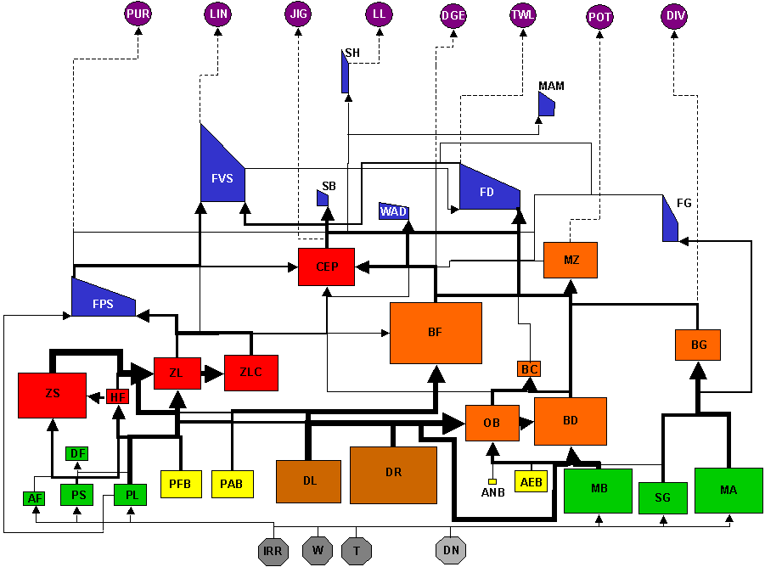
Figure 4.1: Foodweb structure for the biological and fisheries components of the shallow bay Atlantis operating model. Only direct feeding, waste production, nutrient uptake, and environmental links are shown. The codes are listed in Table 4.2, except for Temperature (T) and Wind (W) which have impacts in the model, but are not explicitly modelled. Dissolved Nutrients (ammonia (NH), nitrate (NO) and dissolved organic nitrogen (DON)) are shown here as a single pool (DN) for convenience and clarity. Bycatch groups for each fishery are listed in Table 4.3.

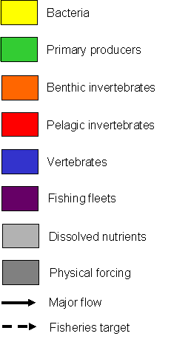
Table 4.3: Target and bycatch groups for the fleets represented in the shallow bay operating model

Fleet | Target groups | Bycatch groups
purse seine | planktivorous fish | marine mammals
Long fishery for piscivores | piscivorous fish | seabirds  large sharks
line fishery for sharks | large sharks | seabirds
pot¹ | macrozoobenthos | benthic suspension feeders  benthic (epifaunal) grazers  infaunal carnivores  benthic deposit feeders  demersal fish  demersal herbivorous fish
dredge | benthic suspension feeders | macrozoobenthos  benthic (epifaunal) grazers  infaunal carnivores  benthic deposit feeders  demersal fish  demersal herbivorous fish
dive | benthic (epifaunal) grazers | -
jig | cephalopods | -
trawl | demersal fish  demersal herbivorous fish | macrozoobenthos  benthic suspension feeders  benthic (epifaunal) grazers  infaunal carnivores  benthic deposit feeders

1. See text under fisheries submodels for explanation for the number of bycatch groups included for this fishery.

Table 4.4: The components included in the coast-to-open-ocean Atlantis operating model and their codenames. An asterisk (*) indicates that the component also has an internal silicon pool and the number in parentheses after each fleet type is the number of fleets of that type, differentiated based on what they target.

Components | Codename |  | Components | Codename |  | Components | Codename
Pelagic invertebrate groups |  |  | Vertebrate groups (continued) |  |  | Nutrients
large phytoplankton | PL |  | migratory mesopelagic fish | FMM |  | dissolved organic nitrogen | DON
small phytoplankton | PS |  | non-migratory mesopelagics | FMN |  | ammonia | NH
small zooplankton | ZS |  | shallow demersal fish | FDS |  | nitrate | NO
mesozooplankton | ZM |  | deep demersal fish | FDD |  | dissolved silicate | Si
large carnivorous zooplankton | ZL |  | demersal sharks | SHD
gelatinous zooplankton | ZG |  | pelagic sharks | SHP |  | Physical
cephalopods | CEP |  | seabirds | SB |  | Light | IRR
 |  |  | pinnipeds | PIN |  | Salinity | SAL
Benthic invertebrate groups |  |  | baleen whales | WHB |  | sediment grain types | PHI
seagrass | SG |  | toothed whales | WHT |  | bottom stress | STRESS
macroalgae | MA |  |  |  |  | Porosity | POR
pelagic bacteria | PB |  | Vertebrate species |  |  | Volume | VOL
sedimentary bacteria | SB |  | flathead (Neoplatycephalus spp) | FSF
meiobenthos | BO |  | ling (Gentyperus blacodes) | FSL |  | Fishery fleet types
deposit feeders | BD |  | orange roughy | FSO |  | purse seine (3) | PUR
carnivorous infauna | BC |  | (Hoplostethus atlanticus) |  |  | demersal line (3) | DLN
benthic grazers | BG |  | southern bluefin tuna | FST |  | pelagic line (1) | PLN
deep filter feeders | BFD |  | (Thunnus maccoyii) |  |  | dredge (1) | DGE
shallow filter feeders | BFS |  | gummy shark | FSG |  | dive (1) | DIV
deep macrozoobenthos | BMD |  | (Mustelus antarcticus) |  |  | jig (1) | JIG
shallow macrozoobenthos | BMS |  |  |  |  | demersal trawl (5) | BTW
 |  |  | Dead |  |  | midwater trawl (3) | MTW
Vertebrate groups |  |  | labile detritus | DL |  | trap (2) | TRP
small planktivorous fish | FPS |  | Refractory detritus* | DR |  | recreational (1) | REC
large planktivorous fish | FPL |  | carrion | DC |  | gillnet (2) | NET
shallow piscivorous fish | FVS |  |  |  |  | danish seine (1) | DSN
deep piscivorous fish | FVD |  | Gaseous |  |  | cull (1) | CUL
tropical piscivorous fish (tunas) | FVT |  | dissolved oxygen | O2

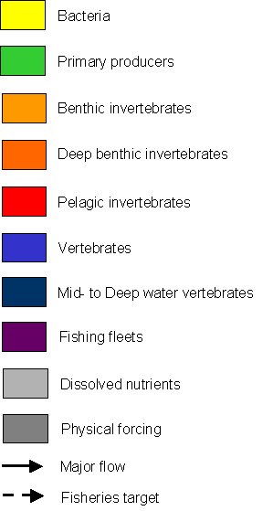
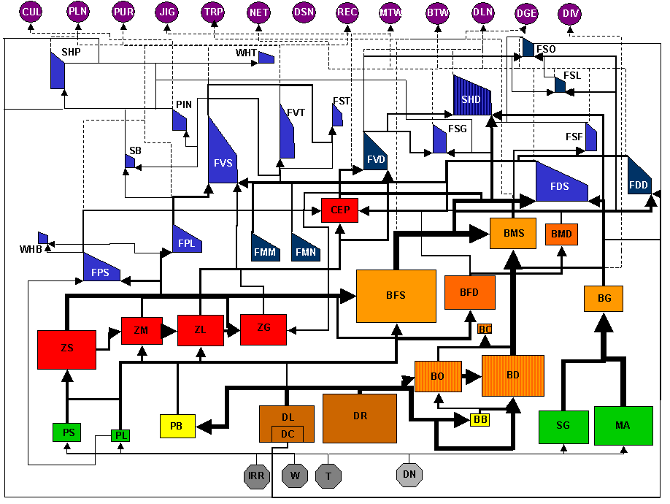
Figure 4.2: Foodweb structure for the biological and fisheries components of the coast-to-open-ocean Atlantis operating model. Only direct feeding, waste production, nutrient uptake, and environmental links are shown. The codes are listed in Table 4.4, except for Temperature (T) and Wind (W) which have impacts in the model, but are not explicitly modelled. Dissolved Nutrients (ammonia (NH), nitrate (NO) and dissolved organic nitrogen (DON)) are shown here as a single pool (DN) for convenience and clarity. Bycatch groups for each fishery are listed in Table 4.5.

Table 4.5: Target, by-product and bycatch groups for the fleets represented in the coast-to-open-ocean operating model.
Fleet | Target group | By-product groups | Bycatch groups
purse seine for tunas | southern bluefin tuna  tropical piscivorous fish |  | toothed whales
purse seine for planktivores | small planktivorous fish  large planktivorous fish |  | toothed whales
purse seine for piscivores | shallow piscivorous fish
demersal line deep demersal fish | deep demersal fish  ling  deep piscivorous fish
demersal line for piscivores | shallow piscivorous fish
demersal line for demersal sharks | gummy shark  demersal sharks
pelagic line | southern bluefin tuna  tropical piscivorous fish  pelagic sharks |  | seabirds
dredge | shallow filter feeders |  | macroalgae  seagrass
dive | benthic grazers
jig | cephalopods
demersal trawl for macrozoobenthos | shallow macrozoobenthos | shallow demersal fish | small planktivorous fish  demersal sharks  carnivorous infauna  macroalgae  seagrass  deposit feeders  gelatinous zooplankton
demersal trawl for cephalopods | cephalopods

Fleet | Target group | By-product groups | Bycatch groups
demersal trawl for deep demersal fish | deep demersal fish  deep piscivorous fish  ling | gummy shark  shallow macrozoobenthos | migratory mesopelagic fish  non-migratory mesopelagic fish  demersal sharks  deep filter feeders  deep macrozoobenthos  carnivorous infauna  deposit feeders  gelatinous zooplankton
demersal trawl for flathead | flathead  shallow demersal fish | large planktivorous fish  shallow piscivorous fish cephalopods  shallow filter feeders | gummy shark  demersal sharks  pinnipeds  shallow macrozoobenthos  carnivorous infauna  macroalgae  seagrass  deposit feeders  gelatinous zooplankton
demersal trawl for orange roughy | orange roughy |  | deep filter feeders  carnivorous infauna  deposit feeders
midwater trawl for cephalopods | cephalopods
midwater trawl for planktivores | small planktivorous fish  large planktivorous fish |  | pinnipeds
midwater trawl for deep demersal fish | deep demersal fish  deep piscivorous fish |  | migratory mesopelagic fish  non-migratory mesopelagic fish
trap for macrozoobenthos | shallow macrozoobenthos
trap for deep demersal fish | ling  deep demersal fish
gillnet for demersal fish | deep demersal fish  shallow demersal fish  ling |  | pinnipeds  baleen whales  toothed whales

Fleet | Target group | By-product groups | Bycatch groups
gillnet for demersal sharks | gummy shark  demersal sharks | pelagic sharks | baleen whales
danish seine | flathead  shallow demersal fish | large planktivorous fish  shallow piscivorous fish | gummy shark
cull | pinnipeds
recreational | shallow piscivorous fish  flathead  shallow macrozoobenthos  shallow demersal fish  cephalopods  shallow filter feeders | large planktivorous fish  small planktivorous fish  tropical piscivorous fish  demersal sharks  pelagic sharks  benthic grazers

groups (including microfauna), and 20 vertebrate groups (listed in Table 4.2). These groups represent the main functional groups, and 5 species of interest, in coastal and open waters around southern and eastern Australia. As in the shallow bay case, the functional groups are defined using size, rates of turnover and shared predators and prey. The species of interest selected for inclusion in the operating model are all species of particular commercial significance that have been (or are expected to be) particularly vulnerable to intensive fishing pressure. The resulting foodweb is given in Figure 4.2.
4.1.3 Physical submodels
The hydrographic submodel included in Atlantis (and BM2 before it) is a transport model, modified from that developed for the Port Phillip Bay Integrated Model by Murray and Parslow (1999) and Walker (1999). Horizontally, it resolves the modelled area into discrete polygons (Figures 4.3 and 4.4). The size of each polygon reflects the extent of spatial homogeneity in the physical variables represented in the model (depth, seabed type (reef or flat), canyon coverage, porosity, bottom stress, erosion rate, salinity, light and temperature). Atlantis is also vertically structured and is comprised of multiple layers (up to five water column layers, an epibenthic layer, and a sediment layer (Figures 4.3 and 4.4)). The fluxes driving the transport model are either derived from a spatially and temporally finely resolved three-dimensional non-linear, variable density hydrodynamic model (Walker 1999) or from satellite data. The model is also driven by seasonal variation in irradiance and temperature, as well as by nutrient inputs from point sources, atmospheric deposition of dissolved inorganic Nitrogen (DIN), and exchanges with an oceanic boundary boxes. If the deepest water column box contacts the sediments, a sediment chemistry submodel deals with nutrient remineralisation and oxygen exchange. Otherwise, the bottom of the deepest water column box is also treated as an open boundary.
Case study 1 - Shallow Bay
The modelled shallow temperate bay ecosystem, based on Port Phillip Bay, is represented using 59 polygons and 3 layers (Figure 4.3). In any polygons shallower than 25m the water column layer was truncated appropriately (e.g. a polygon 8m deep would have a single 8m water column layer). The transport model is driven by files containing only four years of flows, light levels, evaporation, precipitation and point source inputs (of nutrients, freshwater etc) that were taken from a full three dimensional hydrodynamics model of Port Phillip Bay, or timeseries of data collected in Port Phillip Bay during the mid 1990s. Once the model reaches the end of a four-year period it rewinds and repeats the four years of physical forcing. In addition to allowing model scenarios to span long time periods, this also allowed for some regular long-term environmental cycles (analogous to ENSO) in the environmental forcing functions.
The standard scenarios run for the first case study span 90 years (after model burn in), with output of data values every 28 days.
Case study 2 – Coast-to-open-ocean
The modelled coast-to-open-ocean ecosystem, based on the southeast region of Australia, is represented using 59 polygons and up to 7 layers (Figure 4.4). If the depth of a polygon is less than 1800 m, the water column layer(s) are truncated to match (e.g. a box in that is 100m deep would have 2x50m water column layers). Any open ocean cells that are deeper than 1800m have no epibenthic or sediment layers, and are treated as having an open boundary under the deepest water column layer. The transport model is driven by files containing a single year of flows (estimated from satellite data, Dunn unpublished), light levels, evaporation, precipitation and point source inputs generated artificially, but based on real time series collected from the Southeast of Australia from the mid to late 1990s. As described in the first case study the forcing files a repeated through time (the flows annually, the other files every four years).
The standard scenarios run for this case span 120 years (after model burn in), with output of data values every 90 days. These times do not match those for the first case study. The length of the run was extended to accommodate the long-term dynamics of some of the long-lived vertebrate groups and the possible trajectories of fisheries development over such a large area. The lower temporal resolution in the output data was necessary due to data storage limitations. It does omit some fine scale variation in the groups with fast turnover dynamics, but it is still sufficient to capture seasonal patterns, variability and the dominant patterns in the output (Fulton 2001), especially given that the forcing is estimated from running averages of satellite data and the large volume of the model cells (Fulton unpublished).
4.1.4 Fisheries submodels
The Atlantis operating models include the main types of fleets typical of those kinds of ecosystem. Each fleet is characterised by its target, byproduct and bycatch groups, gear type (and associated selectivity curve and habitat impacts), habitat dependency, discarding, and effort allocation submodels. The alternative fisheries submodels are detailed below after the fleets in each operating model are described.
Case study 1 - Shallow Bay
Eight fisheries are included in the bay ecosystem operating model (Table 4.2): purse seine, longline, pot, dive, dredge, trawl, jig and shark line fisheries. These fisheries are differentiated by their primary targets, but may share bycatch groups (Table 4.3). These fisheries represent the primary fisheries operated in temperate bays. The recreational fisheries are not explicitly represented, but are lumped with the commercial fisheries using the same gear. Also the “pot”, fishery actually represents all the fisheries targeting the macrozoobenthos (e.g. crabs). These include fisheries using drop nets, set nets, pots, trawls, haul nets, beach seines, beam tide trawls, fish traps, and wading. Consequently, the range of non-target groups affected by the ‘pot fishery’, as implemented in the bay ecosystem operating model, extends beyond those usually associated with a pot fishery.
Case study 2 – Coast-to-open-ocean
Thirteen types of fisheries are included in the coast-to-open-ocean operating model (Table 4.3): purse seine, demersal line, pelagic line, dredge, dive, jig, demersal (bottom) trawl, midwater trawl, trap, gillnet, Danish seine, recreational and pinniped cull fisheries. There are multiple fleets from some of the types of fisheries, which represent fleets with different target or byproduct groups (Table 4.5). There is overlap in the groups taken (either as targeted catch, byproduct or bycatch) by the various fisheries.
Figure 4.3: Horizontal and vertical spatial geometries used to define the temperate bay ecosystem based on Port Phillip Bay. The fine black lines indicate the boundaries of model polygons, thick black lines mark the edges of management zones, and sampling locations are indicated by black dots.

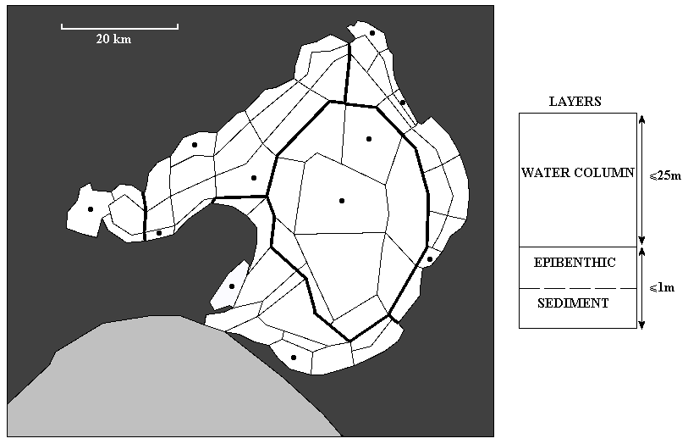

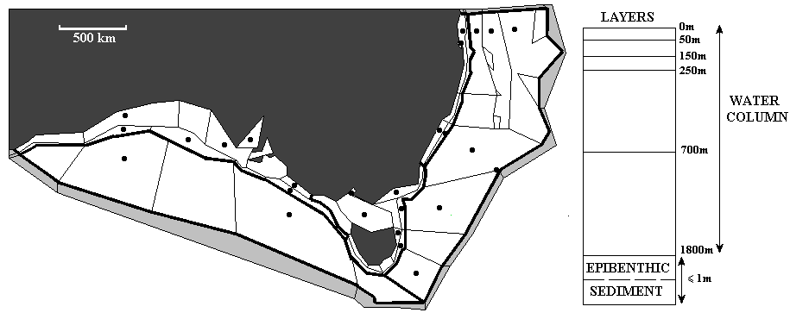
Figure 4.4: Horizontal and vertical spatial geometries used to define the coast-to-open-ocean-ocean ecosystem based on the southeast region of Australia. The fine black lines indicate the boundaries of model polygons, thick black lines mark the edges of management zones, and sampling locations are indicated by black dots.

Alternative Fisheries Submodels
Several alternative fisheries submodels are included in the operating models. These include alternative bycatch, habitat dependency, selectivity, discarding, and effort allocation models. All of these can change through time - representing changes in fishing practices, advances in gear, alternative management strategies and the like.
For each of these types of submodels (i.e. bycatch or selectivity or discarding or effort allocation etc) each fleet can only use one of the alternative formulations at a time, but the formulation used can change through the course of a run. In addition, different fleets can be using different alternatives for the various submodels. As the different types of submodel are not mutually exclusive, multiple combinations of the various submodels can be activated in any one model scenarios. For instance, in the basic fishing scenarios the dive fishery uses constant selectivity, constant discarding rate, prescribed effort matrices, a TAC, and has no incidental impacts on the environment; while the demersal trawl fishery targeting deep demersal fish uses the dynamic fleet model, a normal selectivity curve, variable discarding, adaptive management, some TACs, has byproduct groups and causes incidental impacts on the biogenic habitats.
Effort Allocation
The wide range of effort allocation submodels available in Atlantis vary from very simplistic constant or prescribed effort through to more dynamic fleet models. While none of the alternative submodels are as sophisticated as fleet dynamics models that model the behaviour of individual vessels (e.g. Little et al. 2004), the more elaborate submodels in Atlantis do represent the dynamics of aggregate fleets and allow for behavioural responses to effects such as effort displacement due to the depletion of local stocks or the creation of Marine Protected Areas. In contrast, the simplest submodels allow for an exploration of fishing effects when there is little information beyond location and magnitude of catch taken. The alternative effort allocation submodels are:
- constant fishing pressure;
- constant effort with the fishing pressure per cell adjusted for area;
- constant effort distributed spatially based on CPUE of previous record period (day, week, season etc);
- prescribed effort distribution (effort per cell per quarter specified by user and model linearly interpolates between them from day-to-day to avoid numerical discontinuties);
- dynamic effort based on distribution of CPUE in previous record period;
- fleet dynamics model incorporating ports (which become operable and developed for fishing at different times), distance (with a fuel penalty function), exploratory fishing and the distribution of CPUE in the previous record period;
- human population based recreational fishing effort (from operating ports);
- effort displacement due to MPA placement or low CPUE; and
- effort which can change through time, and the change can be persistent or pulsed.
The formulations for these submodels are given in Appendix D.
Selectivity Curves
A number of selectivity curves have been included in the Atlantis framework (equations are given in Appendix D). The specific curve used can differ between fleets taking the same group and across groups taken by the same fleet. This allows for a wide range of gear-species interactions and impacts to be modelled. The selectivity curve types included in Atlantis are:
- constant;
- cohort specific constant;
- size based logistic curve;
- size based normal curve;
- size based lognormal curve;
- size based gamma curve;
The selectivity submodel also allows for a vertical mismatch between the group being fished and the gear deployment depth.
Discarding submodels
Each fleet discards a proportion of the catch of each species taken as waste (to represent offal etc). In addition to this there is explicit discarding defined for each group taken by each fishery – to account for high grading or the discarding of undersize individuals. There are three alternative discarding submodels:
- constant;
- cohort specific constant; and
- size based (minimum legal size etc).
The discarding submodel also allows for illegal retention of undersize fish. The formulations for these discarding submodels are given in Appendix D.
Bycatch submodels
The alternative bycatch submodels deal with alternative assumptions regarding the level and distribution of the incidental impacts of fishing on non-target groups (listed in Tables 4.3 and 4.5). Incidental impacts on the ecosystem components due to fishing can either be in the form of groups taken as bycatch (e.g. marine mammal take in purse seines), or in the form of habitat destruction due to the passage of fishing gear (e.g. the crushing of epibenthos). The three alternative submodels are:
- the passage of fishing gear causes no incidental damage to non-target groups (i.e. fishing only impacts the harvested groups);
- the amount of incidental impact on the ecosystem is determined by the simple percentage overlap of the area (habitat types) occupied by the group and the area (habitat types) the fishery can access; or
- the amount of incidental impact on the ecosystem is determined using a variation of the probabilistic model of trawl distribution developed by Ellis and Pantus (2001).
The formulations for these bycatch submodels are given in Appendix D.
4.1.5 Management submodels
The management submodels included in the Atlantis framework form a two-part hierarchy.
At the higher management level, fisheries can be managed using non-adaptive methods, or they can use adaptive methods which respond to reference limit triggers. In the adaptive case, if the estimated stock size of target, vulnerable or endangered groups falls below a reference limit, then a more specific management measure can be activated. The measure can be introduced over a user defined time period (so it can be effective immediately or have a lag of many years in implementation) and it can be reviewed periodically to see if the measures can be relaxed or need to be tightened further. The estimated stock size can be based on fisheries data only, or on scientific research surveys (the latter is more commonly used in the scenarios included in this report). The date taken as the virgin biomass reference point can also be varied, to evaluate the effects of historical ratchets (e.g. Pauly’s ratchet, Pauly 1995) on stock and ecosystem properties (e.g. “health”).
The lower level of the management hierarchy is made up of the range of management measures available in Atlantis. These measures are:
- Total Allowable Catches (TACs) which are set per target or vulnerable group (usually only target group) and which can have multispecies considerations – multispecies fisheries may be allowed to exceed their TACs in a user defined number of species before more stringent management measures (e.g. closures) are imposed;
- gear control (e.g. changes in tow length or mesh size, which are represented respectively via changes in swept area or selectivity curves);
- level of escapement (which may either be a constant, a cohort specific constant, or size based);
- temporal closures that may be temporary or permanent and which may be complete closures for multiple years or only seasonal closures (with the length of the seasonal closure fixed at its initial value or dependent on annual stock estimates); and
- zoning and Marine Protected Areas (so that some areas are open to all fishing, others only accessible by certain gear types, and others defined as completely “no take” zones), which can be of variable sizes, seasonal, in fixed locations or rotating, and have associated rates of infringement and can cause effort displacement to other areas or depths.
The type of management used (e.g. whether a fishery is seasonal and uses TACs) can change through time. Different fleets may also be managed in different ways. For example, an MPA may prevent trawl fishing in a particular area, but purse seining for planktivores may occur anywhere and is only halted if limit reference points for endangered groups are exceeded.
4.2 Scenarios
To investigate the implications for indicator performance of alternative fisheries developments, management actions, environmental and ecological conditions and the simultaneous impacts of other anthropogenic activities, a number of model scenarios were considered for each case study (full list given in Table 4.6). Some of these are based on real events from Australia and elsewhere, while others are simple “what-if” ideas. In some cases the amount of pressure put on the system is beyond that seen in Australian system to date, but it is representative of what has
Table 4.6: Fisheries, ecological and environmental scenarios run in the shallow bay and coast-to-open-ocean operating models. Codes for the scenarios that are used elsewhere in the report (e.g. tables of results) are also given.
Operating Model | Scenario | Code
Shallow Bay
 | Closed system that is unfished (other than research surveys), with fixed levels of nutrient loading¹ | SCN1
 | Closed system with eutrophication – as for unfished, but with fivefold increase in nutrients | SCN2
 | Closed system with sequential fish down and no incidental mortality | SC1
 | Closed system with sequential fish down, no incidental mortality and changing discarding practices | SC2
 | Closed system with sequential fish down and homogeneous incidental mortality | SC3
 | Closed system with sequential fish down and patchy incidental mortality | SC4
 | Closed system with sequential fish down, patchy incidental mortality and changing discarding practices | SC5
 | Closed system with sequential fish down, patchy incidental mortality and effort management based on stock size of target groups | SC6
 | Closed system with sequential fish down, patchy incidental mortality and spatial management (zoning) in place | SC7
 | Closed system with sequential fish down and no trawl Marine Protected Areas (at fixed locations) | SC8
 | Closed system with sequential fish down and no take Marine Protected Areas (at fixed locations) | SC9
 | Closed system with sequential fish down and fivefold increase in nutrients | SC10
 | Open system with sequential fish down and no incidental mortality | SO1
 | Open system with sequential fish down and patchy incidental mortality | SO2
 | Open system with sequential fish down, patchy incidental mortality and effort management based on stock size of marine mammals and seabirds | SO3
 | Open system with sequential fish down and mammals recovering from past large scale harvesting | SO4
Coast-to-open-ocean
 | Unexploited system – no anthropogenic nutrient release, coastal degradation, mean temperature increases or fishing (other than research surveys) | ON1
 | Unfished system with intensive levels of all other anthropogenic pressures – fivefold increase in nutrient loads, habitat degradation or clearing around human settlements and 10% (about 2 degree) increase in average temperature | ON2
 | Sequential fisheries with light fishing pressure | O1
 | Sequential fisheries with intensive fishing pressure (some groups pushed to commercial extinction) | O2
 | Sequential fisheries with light fishing pressure and episodic recruitment pulses | O3
 | Sequential fisheries with intensive fishing pressure (some groups pushed to commercial extinction) and mammals recovering from past large scale harvesting | O4
 | Sequential fisheries with light fishing pressure and mammals recovering from past large scale harvesting | O5
 | Sequential fisheries with intensive fishing pressure and coastal habitat degradation (around human settlements) | O6
 | Sequential fisheries with intensive fishing pressure and changing discarding practices | O7
 | Sequential fisheries with intensive fishing pressure and effort management based on vulnerable groups (particularly marine mammals and seabirds) | O8
 | Sequential fisheries with intensive fishing pressure and gear creep | O9
 | Sequential fisheries with intensive fishing pressure and gear limitation by management | O10
 | Sequential fisheries with intensive fishing pressure and no take Marine Protected Areas (at fixed locations) | O11
 | Sequential fisheries with intensive fishing pressure and no take Marine Protected Areas (at rotating locations) | O12
 | Sequential fisheries with intensive fishing pressure and no trawl Marine Protected Areas (at fixed locations) | O13
 | Sequential fisheries with intensive fishing pressure and no trawl Marine Protected Areas (at rotating locations) | O14
 | Sequential fisheries with intensive fishing pressure and no incidental habitat destruction | O15
 | Sequential fisheries with intensive fishing pressure and episodic recruitment pulses once per decade | O16
 | Sequential fisheries with intensive fishing pressure and episodic recruitment pulses twice per decade | O17
 | Sequential fisheries with intensive fishing pressure and adaptive management based on changing length of fishing season | O18
 | Sequential fisheries with intensive fishing pressure and site attachment for all but those groups/species known to be highly migratory (e.g. tunas) | O19
 | Sequential fisheries with intensive fishing pressure and changing coverage (access) of demersal trawl fleets – to represent improvement in targeting due to GPS and acoustic mappers and also switches to gear that can access rougher ground | O20
 | Sequential fisheries with intensive fishing pressure and management via Total Allowable Catches (TACs) | O21
 | Intensive levels of all anthropogenic pressures – fisheries, fivefold increase in nutrient loads, habitat degradation or clearing around human settlements and 10% (about 2 degree) increase in average temperature | O22

1. Note that the scenario for the unfished open system with fixed levels of nutrient loading was run. As this scenario was tuned to give the same levels of biomass in this unfished state as for the closed system and as the subsequent indicator analysis showed that the results for the unfished open system were no different to those for the unfished closed system it has not been included in the list of scenarios discussed in this report.

occurred elsewhere in the world. It is also what was required to produce good contrast in the data generated for indicator testing.
The most informative scenarios were those where the ecosystem underwent large scale ecological change overall, or where there was a lot of contrast created in at least a few key ecosystem components or attributes. Informative scenarios were given priority in the sensitivity analyses, as it was not feasible (due to the size of the task) to repeat all possible combinations of scenarios and parameterisations. Ideally sensitivity to all process formulations would have been considered, but this was not possible in the time available so previous experience with the Atlantis framework (from Fulton 2001) was used to guide the parameterisations and processes selected for testing.
Fisheries Scenarios
Most of the alternative scenarios dealt with different fisheries assumptions, or parameterisations and alternative fisheries development and effort trajectories. By combining various forms of the many fisheries submodels, over fifty scenarios were run for the shallow bay case study (Fulton et al. 2003). Evaluation of the biomass trajectories of these scenarios indicated that many of them were very similar and only the thirteen most informative were included in the analysis by Fulton et al. 2003. More scenarios from the first case study have been included in the analysis discussed in this report, but it is still only a subset of the full set of scenarios run. The biomass trajectories in those scenarios omitted from the analysis duplicate those from scenarios included in the analysis and so would not add any extra information.
The full set of scenarios run in the shallow bay case study was not run in the coast-to-open-ocean case study. The scenarios run for the second case study consisted of the most informative combinations of submodels from the bay case study as well as a few scenarios which did not make sense at the scale of a single bay, but were important for ecosystems of the scale of the one represented by the coast-to-open-ocean operating model. These latter scenarios are all concerned with details of effort build-up and distribution through time. It made no sense to consider these scenarios in the shallow bay operating model as boats can steam across an ecosystem of that size in much less than a day. In the larger ecosystem though, they are very important as it can take days for a boat to transit to and from potential fishing sites at this scale, which can lead to very different resulting fleet and system dynamics.
Overall, the types of fisheries scenarios run and analysed are:
- no commercial fishing (research surveys only);
- fixed levels of commercial fishing;
- sequential development (described below) of vertebrate and invertebrate fisheries with fixed gears, no incidental impacts of fishing and with/without adaptive management;
- sequential development (described below) of vertebrate and invertebrate fisheries with incidental mortality due to fishing and with/without adaptive management (in the second case study these scenarios were run with a range of parameterisations for the rate of exploration and effort displacement);
- sequential development (described below) of vertebrate and invertebrate fisheries with incidental mortality due to fishing and changing gears, habitat dependencies and discarding practices, and with/without adaptive management;
- sequential development (described below) of vertebrate and invertebrate fisheries with incidental mortality due to fishing and spatial management zoning (multiple scenarios were run with the size of any “no take zones” varying between large (multiple model boxes) to very small (small % of a single model cell), which may be fixed or rotating, and with/without adaptive management; and
- sequential development (described below) of vertebrate and invertebrate fisheries with incidental mortality due to fishing and a background increase in pinniped (marine mammal) population size as it recovers from past large scale harvesting that had reduced the population to a small fraction of its virgin biomass.
Note that when fishing caused incidental mortality due to fishing, multiple scenarios were run using the alternative incidental fishing submodels.
In the scenarios with active commercial fisheries there are usually five phases of development expressed (Figure 4.5). In phase one increasing effort sees the fishery transitions from exploratory (negligible effort levels) to a viable commercial fishery. In phase two there is a gradual but consistent increase in effort until the fishery is putting intense pressure on the stock and low return CPUEs or management measures stall further fleet expansion. In phase three there is continuous intensive fishing pressure and often an expansion into byproduct targeting. In phase four the fishery either collapses or is reduced in size substantially by management actions aimed at restoring stock sizes. In the final phase there is a slight recovery in effort levels as the fishery rebuilds with the recovering stock. Depending on the rate of initial growth and the life history characteristics these phases may take more (or less) time and some fisheries may never reach the final stages, plateauing at relatively constant levels while in phase 2 or 3 (Figure 4.5) – this is more common for fisheries on cephalopods or planktivores). In the sequential fish down scenarios there are staggered starts for the different fleets. The fisheries targeting the higher trophic levels in shallow or easily accessible waters begin first, followed by high value invertebrates. Those fisheries targeting lower trophic levels or stocks in deepwater or harder to access habitats only commence once the CPUE for the easily accessible stocks of higher trophic levels dips (locally or over the entire model domain) (Figure 4.6). These development patterns are representative of those seen in reality (Pauly et al. 1998, Pauly et al. 2003).
Ecological Scenarios
In combination with the fisheries scenarios listed above, alternative ecological scenarios are considered. Given the very different nature and scales of the two ecosystems modelled it makes little sense to use the same ecological scenarios in both cases. In particular the scenarios used in the bay case study occurred in some parts of the coast-to-open-ocean without requiring specific parameterisations. For instance, while it made sense to consider the implications of open and closed forms of the bay, the source-sink dynamics of some geographical regions of the coast-to-open-ocean system meant that different areas of the model were already open (or closed).
In the first case study the fisheries scenarios are run using constant recruitment (i.e. an open system with stocks external to the bay supplying the recruits) and Beverton-Holt-like recruitment (i.e. a closed system where the stocks in the bay supply all the new recruits) (see Appendix C). The other type of ecological scenario considered in the first case study is the number of strong trophic links in the foodweb. The number of strong links is varied across a wide range, but the resulting systems are substantially different only when the number of links
Figure 4.5: Example effort trajectories showing the fisheries phases. P1 = transition from exploratory to viable commercial fishery; P2 = gradual increase in effort until pressure is intense and further expansion stalls; P3 = continuous intensive fishing pressure; P4 = fishery collapse or substantial effort reduction; and P5 = recovery in stock and fishery rebuilding. Dashed lines are bounds on possible levels of effort; red line is an effort trajectory showing eventual overexploitation and stock decline; and blue line is an effort trajectory showing a sustainable fishery. The trajectory used for each fishery can vary with the scenario considered and the exact bounds and length of the phases through time can vary fishery to fishery.
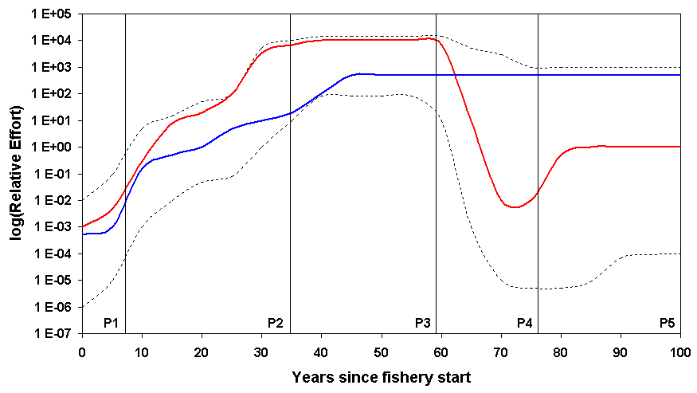
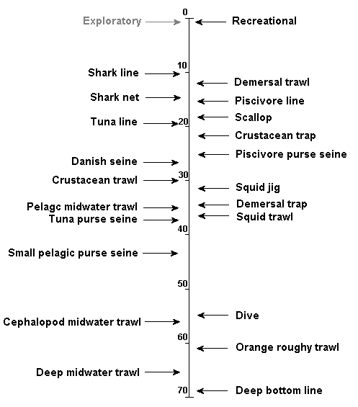
Figure 4.6: Example of staggered starts (fishery in P1 phase in Figure 4.5) of fisheries in sequential fish down scenarios (time axis in years relative to start of first large scale fishery – the recreational fishery). Arrows indicate start time of the fishery. Exact timing can vary depending on scenario definitions, and grey exploratory fishery indicates that exploratory and small scale fisheries exist before the start dates given for the commercial fisheries.

is increased from the default setting of few strong links and many links to an alternative structure where the web links are all much tighter.
In the second case study the ecological scenarios consider issues of dispersal, connectivity and recruitment. The specific ecological scenarios considered are: periodic recruitment of large age classes; variability in recruitment; the degree of larval dispersal (whether local or more widespread); the amount of vertical spread in the distribution of surface dwelling and mid-water fish groups; rates of migration in to or out of the model domain; and the alternative forms of fish movement, whether its fixed seasonally, has a high degree of site fidelity, or is density- and forage-dependent.
Environmental Scenarios
The environmental scenarios all consider anthropogenic changes to the environment due to industries or processes other than fisheries. These were run in combination with the fisheries and ecological scenarios to consider the impacts of simultaneous changes in fishing pressure and other environmental conditions.
The first environmental scenario is a contaminant scenario where point source inputs of nutrients are increased fivefold (a level known to cause eutrophication in coastal boxes). The second environmental scenario is the degradation of shallow benthic habitats due to coastal development and associated activities (e.g. dredging). The last environmental scenario is a general increase in temperature.
In each of the environmental scenarios the change in conditions is produced by multiplying the baseline input files used in the transport model by a scalar (s) that changes linearly with time (t):
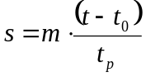 (4.1)
where m is the relative amount by which the value increases over the period; t₀ is the day of the scenario at which the change begins; and t_{p} is the period over which the change comes into effect.
4.3 Model behaviour
Atlantis captures the essential features of temperate marine ecosystems and captures ecological processes, such as resource partitioning and assemblage formation.
4.3.1 Regional assemblages
The physical, ecological and biogeochemical processes included in the operating models lead to the formation of regions within the modelled area which are characterised by specific groups, or assemblages. While there is variation through time and from cell-to-cell, there are general patterns that hold regardless of the finer details. These patterns can be discerned directly from maps of the model generated biomass distributions, but they are quickly and clearly identified using the method described in Fulton et al. (2004b) – where assemblages are determined by (1) considering the fourth root transform of the average biomasses of all groups in each box on a two-dimensional non-metric Multidimensional Scaling (MDS) plot derived from a Bray Curtis similarity matrix; and then (2) examining the average values of the physical variables and the biomass per group (using the SIMPER routine of the Primer software package (Clark and Warwick 1994)) to ascertain which groups determine the clustering seen in the MDS. This analysis identifies areas (groups of boxes) in the model output that share biological and physical characteristics.
Case study 1 - Shallow Bay
The unfished form of the shallow bay operating model predicts two types of assemblages: central and edge (Figure 4.7). There is a single central assemblage that is marked by a distinct plankton community (mainly small phytoplankton and large zooplankton) and while there is some epifauna, it is dominated by infauna, particularly hardy microfauna (meiobenthos, microphytobenthos, and bacteria). The edge assemblages are all of similar form, though details differ. These assemblages are dominated by one of two alternative plankton assemblages, and a rich assemblage of fish, macrophyte and benthic macrofauna.
Case study 2 – Coast-to-open-ocean
The unfished form of the coast-to-open-ocean operating model predicts the presence of at least 15 assemblages in this large area, which fall into five general forms. The form of the assemblages is largely related to depth and nutrient levels (and mixing). The bay assemblages (at A, B and C in Figure 4.8) are shallow water, high nutrient and high light assemblages supported primarily by benthic primary producers and detritus and featuring shallow living fish (or juveniles of groups that move deeper with age). The shelf assemblages (the grey-blue, purple, royal blue, light blue, pink, cyan and yellow areas in Figure 4.8) are similar to the bay assemblages, but with the addition of a few groups (or age stages) that live in slightly deeper (or open) water. The differences between the shelf assemblages are due to changes in local productivity, with those areas fed by upwellings (e.g. the aqua zone in Figure 4.8) including more groups at higher biomasses than the less productive shelf areas (e.g. the purple area). The slope assemblages (cream, maroon and dark blue areas in Figure 4.8) are strikingly different to those on the shelf. They have none of the shallow water groups and no photosynthetic producers (though the detritus and zooplankton supporting the webs there may be sourced from the photic zone), but do include all the deepwater groups (e.g. ling and orange roughy). The maroon area (which includes the slope and adjoining underwater plateau) is the most productive of these areas. The seamount assemblage (the orange areas) are intermediate between the shelf and slope assemblages. The seamount assemblage does not contain all of the shelf groups (e.g. benthic primary producers are missing), but as planktivores, tunas and the higher order predators are attracted to these locations, it contains many more groups than the slope assemblages. The final assemblage is the pelagic (open ocean) assemblage (the grey area in Figure 4.8). This contains no demersal or benthic groups and is dominated by the smaller plankton groups, as well as gelatinous zooplankton and vertebrates with planktivorous or piscivorous diets. As these assemblages were identified using temporally aggregated model output a single pelagic assemblage was identified, but if the data had been considered at a finer temporal resolution (e.g. seasonally) then this large area would have been split - with a
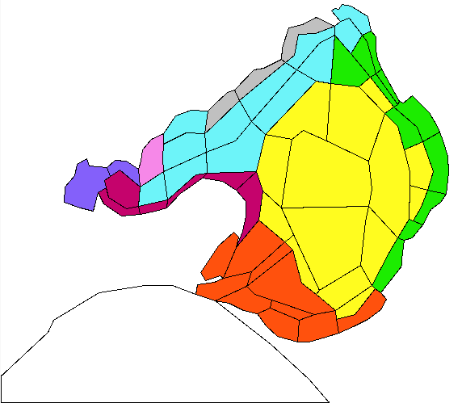
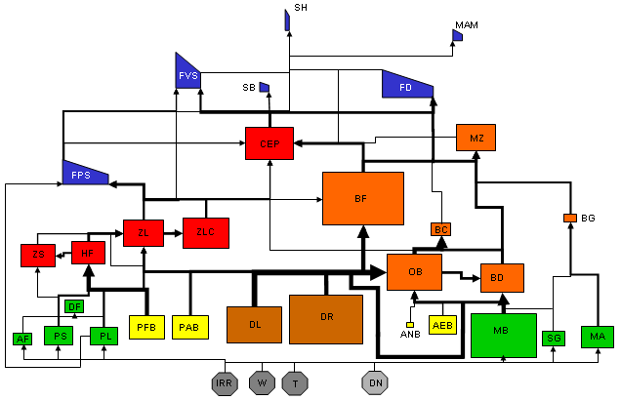
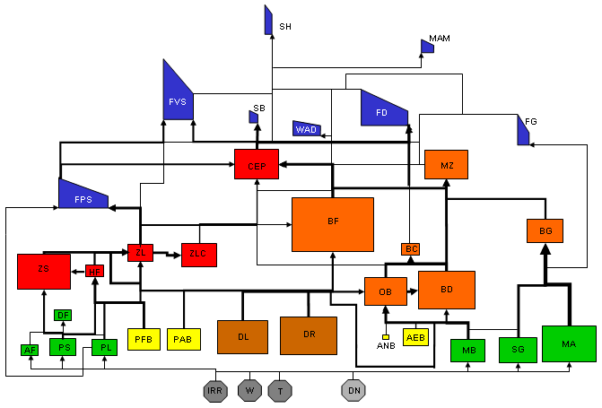
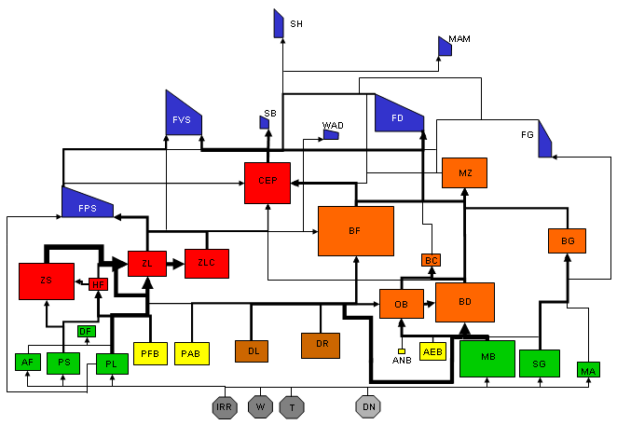
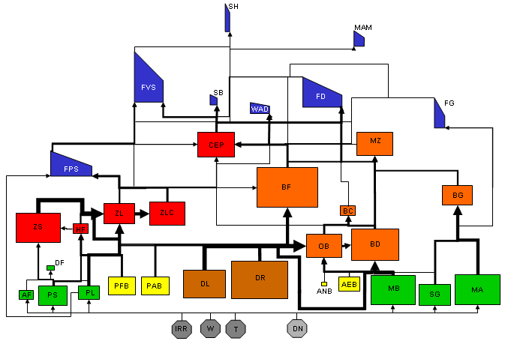
Figure 4.7: Assemblages predicted by unfished shallow bay operating model. Boxes of the same colour contain the same assemblage. Foodwebs for some assemblages are given (not all assemblages are shown for clarity). The foodwebs for the grey, pink and maroon areas are similar to that for the green area, and the assemblage for the dark blue area is similar to that for the light blue area.

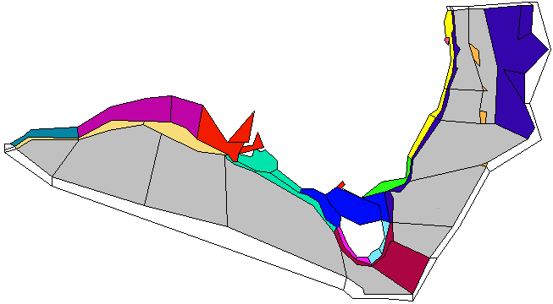
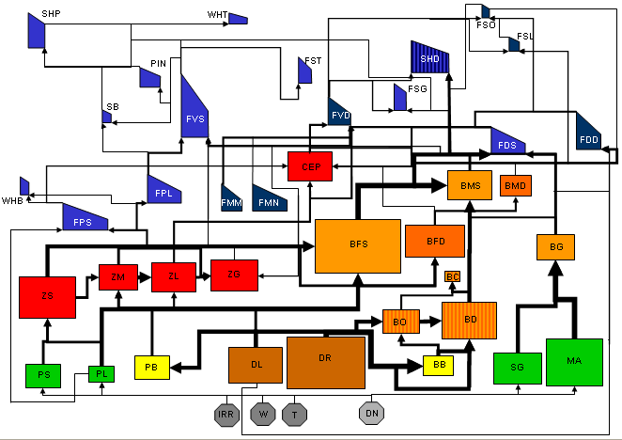
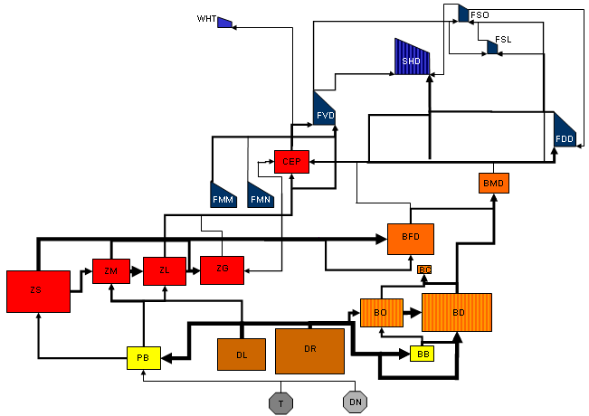
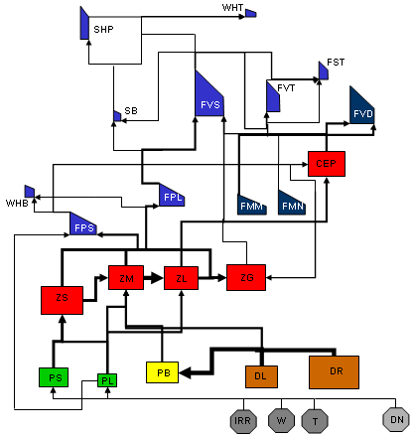
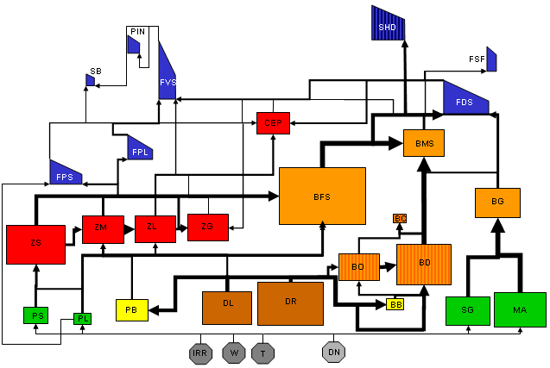
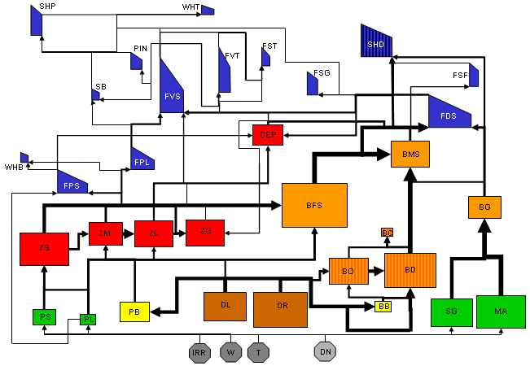
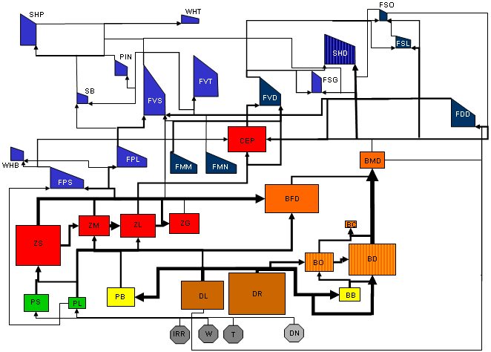
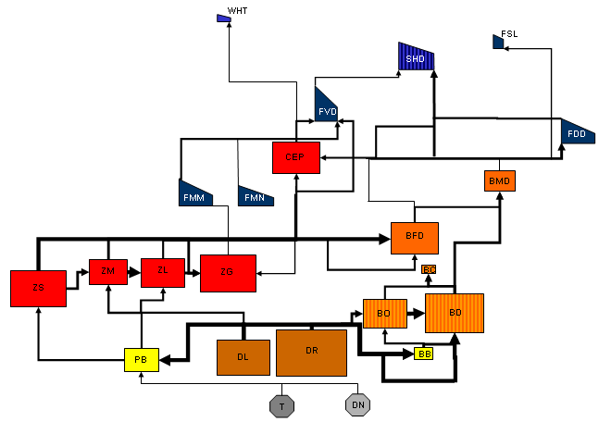
Figure 4.8: Assemblages predicted by unfished coast-to-open-ocean operating model. Boxes of the same colour contain the same assemblage. Foodwebs for some assemblages are given (not all assemblages are shown for clarity). The foodwebs for the yellow, light green, light blue, pink, purple and grey-blue areas are similar to that for the royal blue area (in Bass Strait); the foodweb for the cream (slope) areas is similar to that for the deep blue area.
A
B
C

different assemblage recognised either side of the maroon area (i.e. at least one pelagic assemblage in the open ocean boxes along the bottom of the modelled area and then at least another one in the ocean boxes up the eastern side of the modelled area).
4.3.2 Perturbed states
When fishing (or other anthropogenic pressure) is applied to the modelled ecosystems there are shifts in the assemblages. Different groups can dominate and the differences between regions can drop (or rise) substantially.
Case study 1 - Shallow Bay
The general form of the assemblages remains the same when anthropogenic pressures (e.g. fishing and nutrient pollution) are introduced into the shallow bay operating model. However, there is less differences between the edge assemblages and the area covered by the central assemblage expands, particularly under increased nutrient loads (Figure 4.9). Within assemblages the effect of fishing was largely to reduce those groups directly targeted or taken as bycatch, though groups that could also benefit from fishing due to new food sources (discards) or release from predation or competition (e.g. planktivores, cephalopods and benthic deposit feeders) often increased despite being simultaneously negatively effected by fishing. Examples of the form of assemblages before and after heavy fishing pressure has been applied in the shallow bay operating model are given in Figure 4.10. The assemblages also shifted with changes in nutrient loading, with the epifauna, seagrass and large-bodied fish groups declining and the biomass of small zooplankton and large phytoplankton increasing substantially.
Case study 2 – Coast-to-open-ocean
In contrast to the shallow bay operating model, where the effects of nutrient loading can have the greatest impact on model dynamics (Fulton and Smith in press), the anthropogenic activity with the greatest impacts on the predicted ecological state of the ecosystem state is fishing. Coastal development and nutrient pollution do have some effects, particularly in the bays and in the shelf boxes directly effected by the processes, but fishing had much wider impacts. As with the shallow bay operating model, the change in assemblages with fishing saw many areas become more similar. However, the areas on the edges of the model domain (in particular the blue-gray, purple and cream areas) become more different to the other areas as they do not suffer the same levels of exploitation. While some highly mobile groups are depleted even there (as the movement of individuals into fished areas sees the group “globally” decline) other less mobile groups either do not decrease at all or do not decrease to the same extent as seen in the fished areas.
As in the shallow bay case those groups directly affected by the fisheries often decreased in dominance in the assemblages, particularly the higher trophic level vertebrate groups that are targeted by fishing. While those groups (e.g. baleen whales) that only spent part of their time in the model domain were only relatively lightly impacted (often due to incidental mortality or loss of preferred prey groups); and the lower trophic level groups (e.g. planktivores, Mesopelagics, gelatinous zooplankton and cephalopods) increased dramatically (see the examples in Figure 4.11). The loss of the larger (older) individuals in the target vertebrate
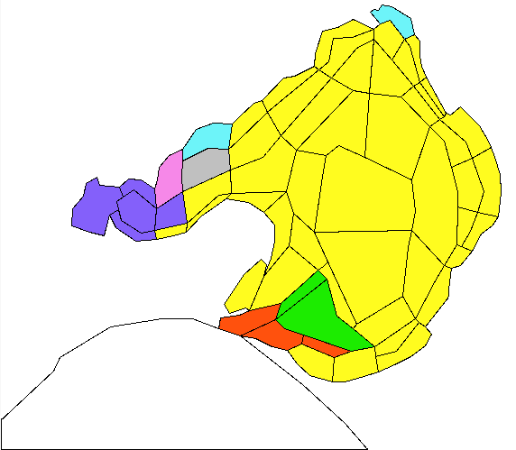
Figure 4.9: Pattern of assemblages predicted when increased (fivefold) nutrient levels are applied in the shallow bay operating model.

Figure 4.10: Examples of assemblages from the shallow bay operating model before and after intensive fishing pressure is applied: (a) central assemblage, (b) edge assemblage (from the light blue area in Figure 4.7)
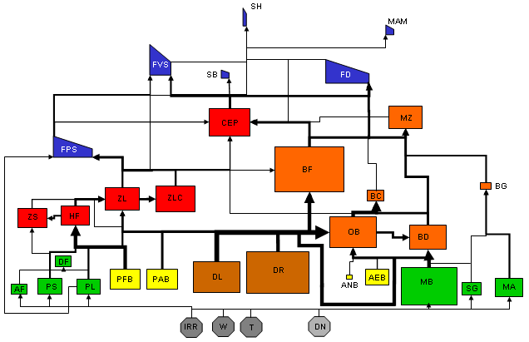
(a) BEFORE

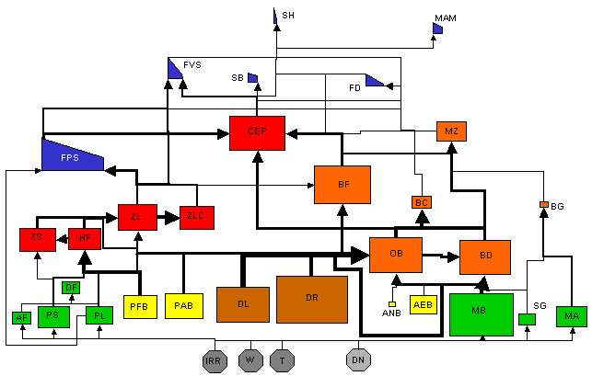
AFTER
Figure 4.10: continued.
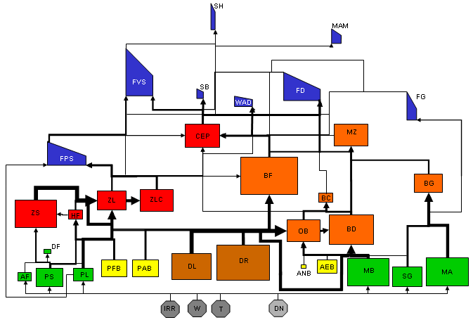
(b) BEFORE

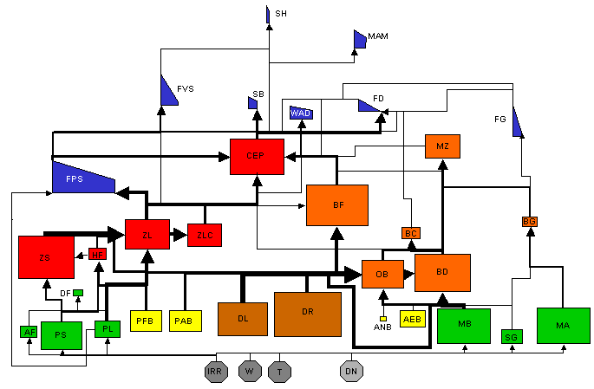
AFTER

Figure 4.11: Examples of assemblages from the coast-to-open-ocean operating model before and after intensive fishing pressure is applied: (a) pelagic assemblage, (b) heavily fished shelf assemblage (from the royal blue area in Figure 4.8), (c) lightly fished shelf assemblage (from the purple area in Figure 4.8) and (d) deepwater assemblage (from the maroon area in Figure 4.8).
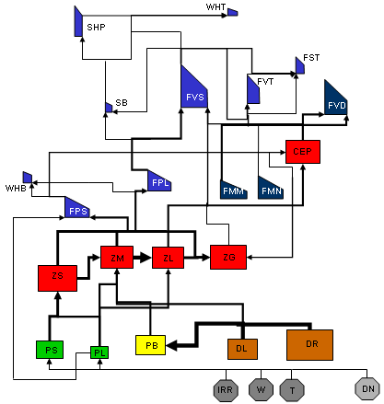
(a) BEFORE

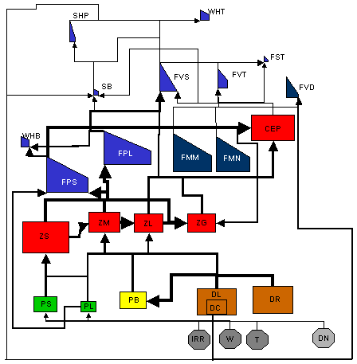
AFTER
Figure 4.11: continued.
(b) BEFORE

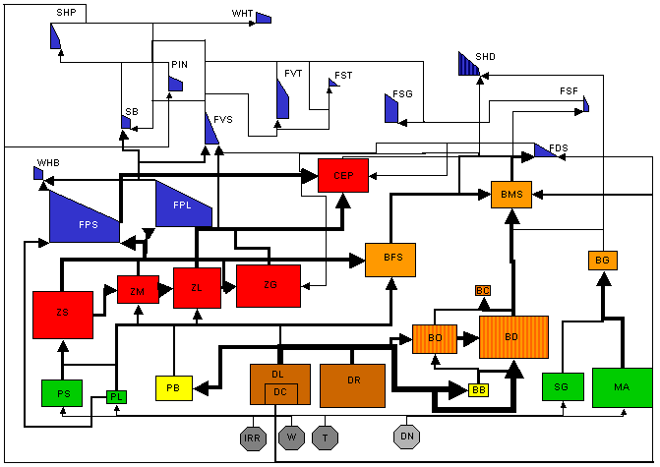
AFTER

Figure 4.11: continued.
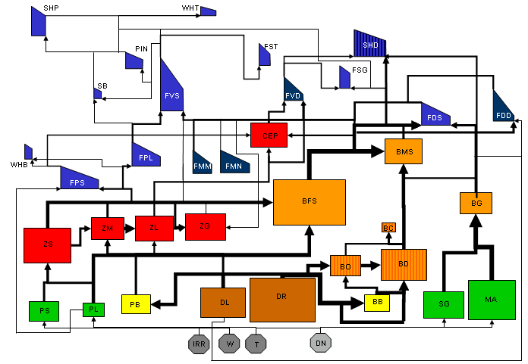
(c) BEFORE

AFTER
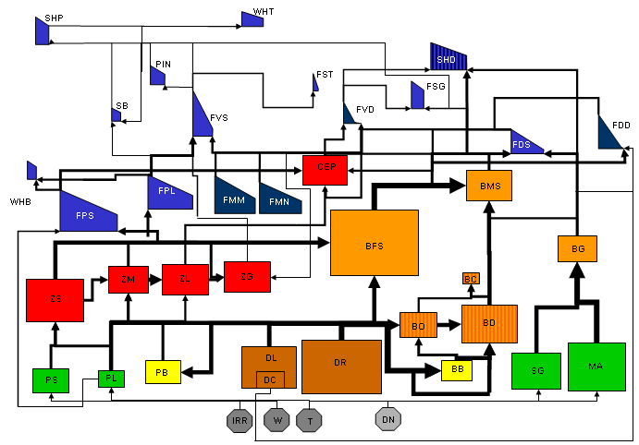

Figure 4.11: continued.
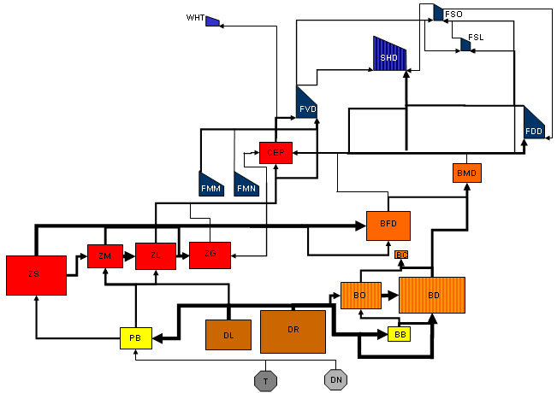
(d) BEFORE

AFTER
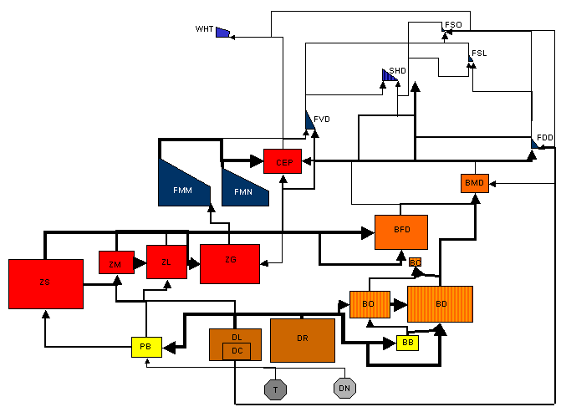
groups is also much more evident in this version of the operating model (see Figure 4.11), though it is obvious in the shallow bay case when it is treated as a closed system.
4.3.3 Scenario differences
The general patterns described above are found in the various scenarios, but there are differences scenario to scenario (which tests the utility if the indicators in the alternative situations) and these are outlined below.
Case study 1 - Shallow Bay
Closed system that is unfished (other than research surveys), with fixed levels of nutrient loading (code: SCN1)
As described above, the unfished system shows distinct central and edge assemblages (shown in Figure 4.7). The central assemblage marked by a plankton community dominated by small phytoplankton and large zooplankton and a benthic community with a large proportion of microfauna (meiobenthos, microphytobenthos, and bacteria) and the edge assemblages dominated by finfish and benthic primary producers and macrofauna.
Closed system with eutrophication – as for unfished, but with fivefold increase in nutrients (code: SCN2)
As outlined above, in the eutrophied system the epifauna, seagrass and large-bodied fish groups decline and the biomass of small zooplankton and large phytoplankton increasing substantially.
Closed system with sequential fish down and no incidental mortality (code: SC1)
While largely similar to the scenario where there is a fish down, incidental mortality and spatial management (described below), there are a few notable differences. The higher trophic level target groups (e.g. piscivorous and demersal fish) are much more heavily impacted (declining to less than 1% of their unfished levels). Amongst the non-target groups many show the same patterns as for the scenario with incidental mortality included (as prey are still released and scavengers can still access discards), though those groups that are not directly fished tend to stay closer to their biomass levels in the unfished scenario. Interestingly, those groups most directly effected by change in nutrient regimes (in particular seagrass) are still impacted by the intensive fishing. This is due to changes in nutrient regimes as a result of discarding and the associated biological processes.
Closed system with sequential fish down, no incidental mortality and changing discarding practices (code: SC2)
The system structure predicted in this scenario differs very little from that in the scenario where there is a fish down, incidental mortality and spatial management (described below). It does however, have a much stronger scavenger subweb. The difference in strength developing after the shift to size-based discarding (“high grading”).
Closed system with sequential fish down and homogeneous incidental mortality (code: SC3)
While similar to scenario where there is a fish down, incidental mortality and spatial management (described below) the target groups in this scenario without spatial management are depressed to less than a tenth of that with zoning in place. Even those target groups that benefit (to some degree) from fishing (e.g. the macrozoobenthos which scavenge discards) are impacted by the fishing, though no where near to the extent of those species which do not directly benefit from fishing (this is particularly the case for the benthic invertebrates).
Closed system with sequential fish down and patchy incidental mortality (code: SC4)
This system predicted by this scenario is similar to that for the case with homogeneous incidental mortality, except that the more site attached (and sessile or sedentary) groups are less effected by fishing – having biomasses between 10% and 100% greater than in the homogeneous case.
Closed system with sequential fish down, patchy incidental mortality and changing discarding practices (code: SC5)
This scenario is largely the same as the scenario for the closed system with sequential fish down, no incidental mortality and changing discarding practices (described above). The differences between these scenarios are that (i) the strength of the scavenger web is not as pronounced in this scenario (as there is less bycatch and so less discarding in total), and (ii) the system is more erratic. The scenario with homogeneous incidental mortality shifts in state toward that of the scenario with all human impacts in place and is sufficiently perturbed to remain in that state year round. Whereas the scenario with patchy incidental mortality fluctuates with the activities of those fisheries with the highest rates of discarding – shifting between a “healthier” state (lower biomasses for “bloom” and scavenger groups), when these fisheries are the least active, and the state permanently present in the case with homogeneous incidental mortality, when these fisheries are most active. It is likely that this fluctuation is symptomatic of a transient event in the ecological structure of the ecosystem that would eventually collapse into one of the two states if the scenario was run for an extended period.
Closed system with sequential fish down, patchy incidental mortality and effort management based on stock size of target groups (code: SC6)
This scenario is very similar to that where there is a fish down, incidental mortality and spatial management (described below), except that the benthic invertebrate groups are more heavily depleted.
Closed system with sequential fish down, patchy incidental mortality and spatial management (zoning) in place (code: SC7)
As described above, in this scenario the target and directly impacted groups generally decline, while any groups that substantially benefit from fishing due to the provision of new food sources (discards) or the release from predation or competition increase.
Closed system with sequential fish down and no trawl Marine Protected Areas (at fixed locations) (code: SC8)
While similar to the scenario fish down, incidental mortality and zoning, this scenario which stops all trawling in all the protected areas has higher levels of the higher trophic level target species (by up to twofold). As a result of increasing fishing pressure in the non-trawl fisheries and the higher biomass of predator groups, groups such as the planktivores have biomass levels lower than in the other fished scenarios.
Closed system with sequential fish down and no take Marine Protected Areas (at fixed locations) (code: SC9)
The ecological structure of the ecosystem predicted in this scenario is closer to the structure seen in the unfished scenario than to any of the fished scenarios. Although localised effects of fishing in those areas open to fishing do cause substantial shifts in biomass (towards the levels seen in the other fished scenarios) in the benthic invertebrate and site associated vertebrate groups.
Closed system with sequential fish down and no take Marine Protected Areas (at fixed locations) (code: SC10)
The system structure predicted in this scenario is a mixture of those seen in the scenario with fishing and zoning and the unfished scenario with a fivefold increase in nutrient loading. While the target groups are depleted, the effects of the nutrient loading on the system are often stronger than the effects of fishing, and where the two impacts overlap rather than cancel out the effects can be substantial. For instance, while small zooplankton and large phytoplankton increase substantially as a result of the eutrophication, the large-bodied fish groups (that are impacted heavily by shifts in the web due to eutrophication as well as targeting by fishing) drop to less than 1% of their virgin levels.
Open system with sequential fish down and no incidental mortality (code: SO1)
While the spatial and biomass patterns for the invertebrate groups in this scenario are largely the same as for the scenario with no incidental mortality and a closed system, the vertebrate groups show a lot less of an impact of fishing (as there is restocking from outside of the model domain).
Open system with sequential fish down and patchy incidental mortality (code: SO2)
In comparison to the analogous scenario in the closed system the target groups do not decline to the same degree (remaining at 60% of virgin biomass or greater rather than dropping to as little as less than 1% of the virgin biomass levels). In addition, as the target species are not as heavily impacted by fishing, fishing continues at very high levels and the benthic and site associated groups that are not replenished from outside stocks are more heavily impacted than is the case in the scenario for the closed system (most have biomass levels less than half of those seen in the closed system case).
Open system with sequential fish down, patchy incidental mortality and effort management based on stock size of marine mammals and seabirds (code: SO3)
There scenario is very similar to that for the scenario where there is an open system with sequential fish down and patchy incidental mortality (described above).
Open system with sequential fish down and mammals recovering from past large scale (code: SO4)
The system state predicted in this scenario is similar to that in the scenario where there is an open system with sequential fish down and patchy incidental mortality (described above). As may be expected given the scenario specifications, the noteworthy differences in this scenario are centred on the marine mammals. The increase in biomass of marine mammals as their stocks recover eventually lead to biomass levels greater than seen in any other scenario – including the unfished scenario. While this increased biomass does lead to a slight drop in the biomass of their prey species (particularly those also targeted by fishing), the biomass of mammals even in this scenario is still not large in absolute terms and so it does not cause large cascading effects on the other groups.
Case study 2 – Coast-to-open-ocean
Unexploited system – no anthropogenic nutrient release, coastal degradation, mean temperature increases or fishing (other than research surveys) (code: ON1)
As described above, the unfished form of the coast-to-open-ocean operating model predicts the presence of five general forms of assemblages: the bay assemblages (supported primarily by benthic primary producers and detritus and featuring shallow living fish); shelf assemblages, which are similar to bay assemblages, but also feature groups (or ages) that live slightly deeper; slope assemblages that lack all the shallow water groups and photosynthetic producers, but do include all the deepwater groups; seamount assemblages, which contain a mix of shelf and slope groups; and the pelagic (open ocean) assemblage that contains no bottom associated groups and is dominated by the smaller plankton groups, gelatinous zooplankton and planktivorous or piscivorous vertebrates.
Unfished system with intensive levels of all other anthropogenic pressures – fivefold increase in nutrient loads, habitat degradation or clearing around human settlements and 10% (about 2 degree) increase in average temperature (code: ON2)
Localised effects of coastal habitat degradation and nutrient pollution. In those impacted areas the epifauna decline and planktonic groups increase (particularly the large phytoplankton and small zooplankton).
Sequential fisheries with light fishing pressure (code: O1)
Similar to the scenario with intensive fishing, but with less depletion of the target groups; and in turn less of an increase in groups released from predation and competition. For example, while the increase in the biomass of planktivores still occurs it is only a 20th of that seen when there is intensive fishing.
Sequential fisheries with intensive fishing pressure (some groups pushed to commercial extinction) and spatial management (zoning) in place (code: O2)
As mentioned above, groups directly effected by the fisheries usually decrease in dominance in the assemblages, particularly any fisheries targeted higher trophic level vertebrate groups (or age stages). In contrast, those groups (e.g. baleen whales) that only spend part of the year (or life cycle) in the model domain are only lightly impacted; and the lower trophic level groups: e.g. planktivores, mesopelagics, gelatinous zooplankton and cephalopods) increase dramatically.
Sequential fisheries with light fishing pressure and episodic recruitment pulses (code: O3)
Similar to that for light fishing without episodic recruitment, but the form of the system remains closer to the unexploited system for longer, particularly in the pelagic. However the bycatch groups on the fishing grounds are more heavily impacted locally as fishing pressure continues longer and these groups do not all benefit from their own episodic recruitment.
Sequential fisheries with intensive fishing pressure (some groups pushed to commercial extinction) and mammals recovering from past large scale harvesting (code: O4)
Similar in overall form to the scenario with intensive fishing and zoning, except that the piscivorous and pelagic groups have slightly lower biomasses and the main shallow water demersal fish groups have higher biomasses (though they are still effectively commercially extinct).
Sequential fisheries with light fishing pressure and mammals recovering from past large scale harvesting (code: O5)
The biomass levels and system structure seen in this scenario is largely similar to the scenario with light fishing but no mammal recovery. Notably, as for the shallow bay operating model, the biomass of marine mammals increases to a point that is higher than that seen in any other scenario, including the unfished system. The effects of this increase are greater in this operating model though as the biomasses attained are much larger in absolute terms and so their prey groups are more heavily impacted. This impact is most obvious in those groups also targeted by fishing. While these groups in no way decline to the extent seen in the scenarios with intensive fishing their biomass does decline to levels lower than in the scenario with light fishing pressure and no large scale mammal recovery.
Sequential fisheries with intensive fishing pressure and coastal habitat degradation (around human settlements) (code: O6)
While similar in overall form to the scenario with intensive fishing the only form of anthropogenic pressure on the ecosystem, the biomass of shallow water benthic and demersal groups in this model are all lower in this scenario. These shifts in the ecological structure of the ecosystem also lead to some impacts on pelagic groups as the top level piscivores switch to more pelagic prey groups as their demersal prey groups decline. These effects are not evident in the west of the model domain (where there is little human habitation), but are particularly evident in the east where human settlements are found in all the shallow water model cells.
Sequential fisheries with intensive fishing pressure and changing discarding practices (code: O7)
While similar to the scenario with intensive fishing pressure and zoning (described above) the shift in discarding practices in this scenario means that groups that consume discards (including the shallow water demersal fish groups) have biomass levels that are higher than in the scenario with zoning despite the continued intensive fishing pressure.
Sequential fisheries with intensive fishing pressure and effort management based on vulnerable groups (particularly marine mammals and seabirds) (code: O8)
While the system predicted in this scenario is largely similar to that in the scenario with intensive fishing pressure and zoning (described above) the higher trophic level target groups (piscivorous and demersal fish) are not quite as depleted (though they are still heavily impacted by fishing). The direct result of this slightly higher biomass level for the predatory groups is that the biomass of their prey species does not increase as much as in the scenario with zoning.
Sequential fisheries with intensive fishing pressure and gear creep (code: O9)
The final biomass levels from this scenario are similar to those for in the scenario with intensive fishing pressure and zoning (described above). The major difference between the scenarios is that the depletions occur more quickly and the final biomass levels (particularly for benthic and demersal groups) are slightly lower than in the scenario with zoning.
Sequential fisheries with intensive fishing pressure and gear limitation by management (code: O10)
The system structure predicted by this scenario is again largely similar to those for in the scenario with intensive fishing pressure and zoning (described above). While there is some increases in biomasses for the target groups, the gear modifications usually lead to changes in size structure of the stocks rather than leading to substantially higher biomasses. The most notable biomass increases in this scenario are actually in those species (e.g. seabirds and marine mammals) which directly benefit from mitigation devices.
Sequential fisheries with intensive fishing pressure and no take Marine Protected Areas (at fixed locations) (code: O11)
The final biomasses predicted in this scenario are similar to those for the scenario with intensive fishing pressure and zoning (described above), but there are notable differences. All of the site associated benthic and demersal groups have much higher biomasses in this scenario (more than 10x higher than those for the scenario with zoning), but the highly mobile pelagic piscivore groups are even more depleted (due to effort displacement and shifts in targeting and the consumption of their juveniles in shallow waters by resident, protected, demersal groups).
Sequential fisheries with intensive fishing pressure and no take Marine Protected Areas (at rotating locations) (code: O12)
While this scenario is very similar to that when the no take MPAs are at fixed locations, the biomass levels of the target groups are all at lower levels in this case.
Sequential fisheries with intensive fishing pressure and no trawl Marine Protected Areas (at fixed locations) (code: O13)
Similar to the system for the scenario with no take MPAs in fixed locations, but with all target groups and non-trawl bycatch groups (e.g. seabirds) at lower biomass levels.
Sequential fisheries with intensive fishing pressure and no trawl Marine Protected Areas (at rotating locations) (code: O14)
While this scenario is very similar to that when the no trawl MPAs are at fixed locations, the biomass levels of the target groups are all at lower levels in this case.
Sequential fisheries with intensive fishing pressure and no incidental habitat destruction (code: O15)
While largely similar to the scenario where there is intensive fishing pressure and zoning, there are some differences. The target groups are generally more heavily impacted in this scenario – in particular those groups which are normally robust to fishing pressure – as predators or competitors normally taken as bycatch remain in the system and so release is not to the same level. The exception to this trend is the demersal shark groups which are usually more heavily affected by incidental than direct fishing mortality, thus with the removal of incidental mortality their overall mortality due to fishing pressure is reduced and the resulting biomass levels are higher. The scavenger web is also weak in this scenario as there are fewer dicards. The final difference is that there is often less difference between the different assemblages identified in the model output, particularly in the shallow waters not directly influenced by upwelling (e.g. east coast boxes).
Sequential fisheries with intensive fishing pressure and episodic recruitment pulses once per decade (code: O16)
This scenario produces dynamics intermediate between those from the scenario with intensive fishing and zoning (outlined above) and the scenario with episodic recruitment twice per decade (described below). The effects described below are not as extreme here as the pulses are not frequent enough to allow intensive fishing to be effective for as long a period and effort reduction begins (for most groups) within about five years of when it would commence without episodic recruitment. As a result overall some bycatch groups are marginally more heavily impacted in this scenario. The target groups receiving the pulses are less impacted (i.e. have higher biomass levels) and there is less web restructuring in the various assemblages directly impacted by the pulses and fishing pressure targeting them.
Sequential fisheries with intensive fishing pressure and episodic recruitment pulses twice per decade (code: O17)
The system predicted by this scenario is of the same general form as the scenario with intensive fishing pressure and zoning. However, all the major bycatch groups and some target groups end up at lower biomass levels. The bycatch groups are more heavily impacted as intensive fishing continues beyond the point it tails off due to low CPUE in the other scenario. While some target groups with episodic recruitment are maintained indefinitely by the episodic recruitment others ultimately end up at lower biomass levels, as they become hyperdepleted so to speak – as fishing continues longer than it would if the periodic strong recruitment pulses did not occur (carried primarily by the strong age class) the age classes that are at average levels are more heavily impacted and when stock sizes become too low to allow for sizeable recruit pulses the overall biomass levels have collapsed to very low levels (as little as <1% of virgin biomasses). These effects of fishing allow for web restructuring due to predation release and shifts in dominance, as in the scenario with intensive fishing and zoning, but these shifts are often more pronounced in this recruitment scenario and so there are also stronger differences between assemblages that receive different levels of fishing pressure. The royal blue, light green, light blue and pink areas in Figure 4.8 are heavily depleted with large scale restructuring of their trophic webs (and all become more similar in form). The aqua and yellow areas become subdivided into those areas heavily impacted by fishing (those cells adjoining the other heavily impacted assemblages) and those areas which are only moderately impacted (as they are either far from port or do not receive a large proportion of the episodic pulse and so are not as intensively fished).
Sequential fisheries with intensive fishing pressure and adaptive management based on changing length of fishing season (code: O18)
This scenario is not substantially different from that with intensive fishing pressure and spatial management via zoning (outlined above), except that while the most heavily targeted groups are substantially depleted (dropping to <5% of virgin biomass in some cases) they do not reach the critically low levels seen in the scenario with zoning (ending up as much as 10x more abundant).
Sequential fisheries with intensive fishing pressure and site attachment for all but those groups/species known to be highly migratory (e.g. tunas) (code: O19)
Overall all biomass levels are higher in this scenario than in the scenario with intensive fishing pressure and zoning, except for those groups which benefit the most from predation release as target species are depleted (e.g. small planktivorous fish, cephalopods and gelatinous zooplankton). In contrast, localised effects of fishing are much higher in this scenario, which means differences between assemblages are more pronounced. Interestingly, the interaction of local effects and generally lower levels of predation release in this scenario leads to higher levels of migratory mesopelagics than seen in the other scenarios. Essentially, the biomass of shallow planktivorous fish is more highly constrained than in the scenario with intensive fishing and the use of zoning for management (due to predation in areas not particularly heavily impacted by fishing), but intensive fishing in specific locations still releases the mesopelagics from predation and the migratory forms have the freedom of movement to capitalise on the “surplus” food left by the smaller stock of small pelagics.
Sequential fisheries with intensive fishing pressure and changing coverage (access) of demersal trawl fleets – to represent improvement in targeting due to GPS and acoustic mappers and also switches to gear that can access rougher ground (code: O20)
The end result of this scenario is almost identical to that for the scenario with zoning and intensive fishing pressure (described above), except that many stocks end up at marginally lower biomass levels and the period of depletion and then the collapse of the most effected fisheries happens more quickly as spatial refuges (and required habitats) are removed and stock reduction is accelerated.
Sequential fisheries with intensive fishing pressure and management via Total Allowable Catches (TACs) (code: O21)
Largely similar to the scenario with intensive fishing pressure and zoning, except that the many target groups are more variable through time and ultimately end up at slightly lower biomass levels (at most 20% lower).
Intensive levels of all anthropogenic pressures – fisheries, fivefold increase in nutrient loads, habitat degradation or clearing around human settlements and 10% (about 2 degree) increase in average temperature (code: O22)
Increased productivity in the photic zone (upper water column) close to settlements locally lead to stronger pelagic webs in this scenario compared to the other scenarios with fishing, while epifauna and associated demersal groups decline. The scavenger subweb is also much stronger in this scenario than in many of the other scenarios, though the effects are again fairly localised. As the effects of the other human impacts (and their interaction with fishing pressure) tend to be localised the differences between assemblages also tends to be stronger.
4.4 Sampling Model
A sampling model processes the output of the operating model and generates data with realistic levels of measurement uncertainty (bias and variance), given specifications for the precision and spatiotemporal coverage of data collection for each data type and source. For example, fisheries data are aggregated spatially and temporally (e.g. total catch for an entire area per quarter), whereas field data are only available infrequently (e.g. annual surveys, or diet data is collected once every ten years) from “snap shots” taken at certain “sampling locations” (marked by dots in Figure 4.3). The distribution of these sampling sites mimics stratified sampling schemes used in real ecosystems (Newell and Harris 1997).
An attempt was made to capture the features of data handling and management practices. To this end, the generated data was pooled across “sampling locations” into user-defined zones for calculation and reporting of indices (marked by bold lines in Figure 4.3). Such zones are commonly used in fisheries management both within Australia and worldwide. In this case, the model zones do not exactly match management zones used in the real systems, but are based on the real zones, as well as bioregions defined by the scientific community (IMCRA Technical Group 1998).
To calculate those indicators that are network or model dependent a network model is required. ECOPATH is used here, due to its popularity and the ready availability of its source code (which is incorporated into the sampling model). At each time step of the sampling model an ECOPATH model is created using the sampled data together with simple decision rules for achieving a balanced model (regarding confidence intervals for input parameters and associated orders of parameter adjustment). The most recent form of each type of data is used to create each ECOPATH model. Given the different sampling frequencies this means that the diet data can be many years older then the biomass, catch, discards and mortality estimates used. The standard parameters required by ECOPATH (detritus inputs, and assimilation efficiency and flows to detritus for each group or fishery) were fixed across all runs (values given in Appendix E). Due to sampling variability in data inputs for bother biomass and data model mis-specification can and does occur in the ECOPATH model (e.g. animals with very low biomasses may be omitted from the model altogether or links may be missing from the diet matrix).
A key element of simulation testing indicators is that the true state of the system is known and so the performance of the indicators can be understood by comparing the indicator values against the true values for the main attributes (system characteristics of interest). The attribute values are also recorded by the sampling model directly from the operating model output.
The sampling model is run repeatedly for each fishing scenario (30 times for the coast-to-open ocean system and 100 times for the bay system) to reflect uncertainties in the observation and monitoring process. The coast-to-open ocean system was not repeated as often as the bay system due to the longer iterative fitting time required for the intermediate mass balance (ECOPATH) model for this larger, more complicated system. As the operating model is deterministic the attributes only need to be calculated once (on the first run of the sampling model for each scenario). A flow diagram outlining all the steps taken in the sampling model is given in Figure 4.12. The frequency of sampling of different data types is listed in Table 4.7 and the equations and parameter setting used are given in Appendices E and F.

Table 4.7: Sampling frequency for the different data types
Data Type | Sampling frequency
fisheries (catch, effort, discards) | (cumulative¹) per month or quarter²
size composition of catch and discards | snapshot every 6 months
diet information (stomach contents) | either annually or once per decade²
physical and chemical system properties | snapshot every 6 months
invertebrate surveys | annually or every 6 months²
bird surveys | annually or every 6 months²
mammal surveys | annually or every 6 months²
fish surveys | annually or every 6 months²
1. Summed over the month or quarter rather than an instantaneous (snapshot) value
2. Alternative parameterisations are used to allow for evaluation of the effects of different sampling designs.
Figure 4.12: Diagram of sampling model steps. Sections in dashed boxes represent submodels with several steps or calculations. Attributes are calculated only once, but the sampling process is repeated (30-100) times.
Start
Operating model parameter values specified
Error added to data collected using fisheries-independent sampling scheme
Invertebrate survey sampling – biomass, production, consumption
Physical sampling – light, oxygen, chlorophyll-a, nutrients, nitrification, denitrification
Bird surveys – numbers in population, average condition, production and consumption for each age stage (YOY, juvenile, mature)
Mammal surveys – age-length key, numbers in population, average condition, production and consumption for each length group (30 length classes)
Fisheries data collated – catch and effort are recorded and discards per fishery are estimated; for vertebrates (including the bycatch - mammals and seabirds) the condition¹ of the catch and the size distribution of catch and discards is estimated
Fish surveys – age-length key, selectivity/catchabilty, condition, stock size, size distribution of stock, production and consumption estimated
Stomach sampling and estimation of the diet matrix
Calculate Indices
Sorted indices (biomass/numbers sorted into size bins) – e.g. ABC curves
Simple indices (little/no manipulation or extra calculations required) – e.g. catch
Calculation of Network and Model Dependent Indices – extra error may be added here*
Summarise network information
Fit ECOSIM-like model
Calculate network indices – e.g. Relative Ascendency
Calculate network dependent and trophic indicators – e.g. SOI and FIB
Record indicator values
Attributes recorded or calculated
APPENDIX C – ATLANTIS OPERATING MODEL EQUATIONS
Table C.1: List of main terms used in the equations in this appendix. All terms, variables, constants and expressions are defined in the relevant sections, but this table may be a useful quick reference for the main terms and conventions.
Term | Meaning
E | Excretion (ammonia produced by a consumer)
F | Fishing (catch)
G | Growth
M | Mortality
P | Uptake
R | Remineralisation
S | Sediment chemistry (nitrification or denitrification, the subscript will denote which on a case-by-case basis)
W | Waste (detritus produced by a consumer)
XX | All doubles (and triples) refer to components of the model (see Tables 4.2 and 4.4 for definitions). They do not represent multiplications at any time and any multiplications will be explicitly denoted by a “.”.

Note that the due to the large number of symbols needed to describe the many equations that make up the operating model, some symbols have had to be reused with sub or superscripts to differentiate between their multiple meanings. Also please consider the symbols here in isolation to those used elsewhere in the report (in the equations or discussion of the sampling model and indicators) as the reuse of symbols does not mean they represent the same thing in the different parts of the report – where this is the case it is specifically stated. I have tried to keep this reuse and potential confusion to a minimum and where it has been necessary to do it as logical as possible, I’m sorry for any inconvenience or confusion this may cause.

C.1 Rate of change equations
C.1.1 Autotrophs
Rate of change for standard water column primary producer (PX):
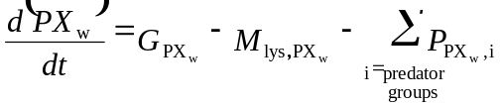 (C.1)
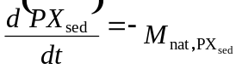 (C.2)
Where G_{PX} stands for the growth of PX, M_{lys,PX} is the loss of PX due to lysis, M_{nat,PX} is the natural mortality losses of PX when in the sediments and P_{PX,I} are the losses of PX due to predation. The equations for the benthic primary producers are slightly different. The rate of change of microphytobenthos is given by:
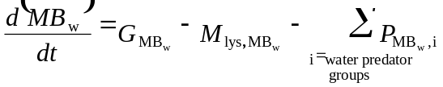 (C.3)
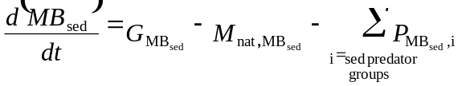 (C.4)
The macrophytes (MX) are restricted to the epibenthic layer and have no water column or sediment pools. The general form of their rate of change is as follows:
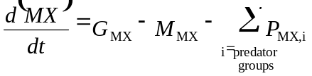 (C.5)
C.1.2 Bacteria
The general formulation for the dynamics of aerobic attached bacteria (where XB stands for Pelagic Attached Bacteria (PAB) or sediment bound Aerobic Bacteria (AEB)) is:
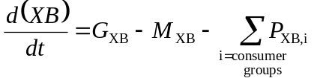 (C.6)
C.1.3 Invertebrate Consumers
Rate of change for a standard invertebrate consumer (CX):
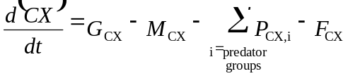 (C.7)
where F_{CX} stands for losses due to fishing on this group. Invertebrate consumers are restricted to having only a water column or epibenthic or sediment pool and can not have pools in multiple layers.
C.1.4 Vertebrate Consumers
The following are the rates of change for a vertebrate group (FX).
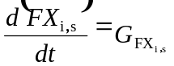 (C.8)
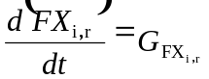 (C.9)
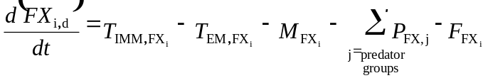 (C.10)
Where the subscript s stands for structural weight (skeletal and other material that can not be reabsorbed), r for reserve weight (fats and other tissues that can be broken down when food is scarce), d for density and i represents age class i (or age class i if life phases not age classes are used – an age class may be a single year class or it may represent a proportion of the total life span of the animal, the terms age class can be used interchangeably with age class for the remainder of the document), there is one equation for each age class included. The T terms represent the movement of vertebrates in to (T_{IMM,Fxi}) and out of (T_{EM,Fxi}) the cell. In addition there are short-term spawning and recruitment events which effect the various FX pools. At the same point each year (the exact day dependent on the vertebrate and with a window of +/- 14 days) the vertebrates reproduce and the materials required to do this is removed from the reserve weight of FX. At this point the proportion of the age class aging into the next age class (if in a scenario with external adult stocks then the oldest age class in the system leaves the system at this time). Sometime later (the exact period dependent on the group) the recruits settle out and their weights and density are assigned to the youngest age class.
The amount of reserve weight (mg N per individual) that is used up during spawning is given by:
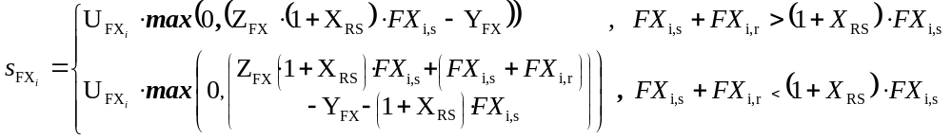 (C.11)
where U_{Fxi} is the proportion of age class i that is reproductively mature, Z_{FX} is the fraction of the weight of FX used in spawning, Y_{FX} is the spawning function constant and X_{RS} is the ratio of structural to reserve weight in well fed vertebrates.
The formulations for recruitment are given by either:
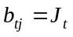 (C.12)
for constant recruitment where J_{t} is element t of the recruitment vector (constant spatially and temporally). More commonly a Beverton and Holt recruitment function was implemented using the following formulation:
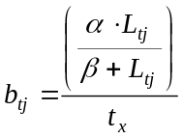 (C.13)
is used, where α is the Beverton-Holt α for the vertebrate group; β is the Beverton-Holt β for the vertebrate group, t_{x} is total length of recruit period; and the biomass of the offspring of vertebrate group FX in cell j at time t (L_{tj}) is determined as follows:
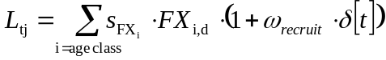 (C.14)
where s_{FXi} is the spawn from age class I of FX, ω_{recrui}t is the scalar for episodic recruiment and δ[t] is an impulse function, which is only non-zero when time t is a multiple of the period of the recruitment pulses.
C.1.5 Inanimate Pools
Rates of change for ammonia (NH) in the water column is:
(C.15)
and in the sediment:
(C.16)
where P_{NH,XX} is the uptake of NH by the autroph XX, E_{CX} is the production of NH by the consumer CX, S_{NIT,XB} is the amount of NH lost due to nitrification by the bacteria XB, R_{NET} is the amount of NH produced by denitrification.
The rates of change for nitrate (NO) in the water column is given by:
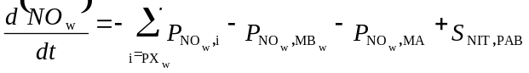 (C.17)
and in the sediment:
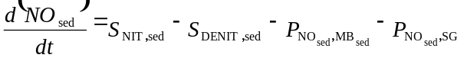 (C.18)
The rates of change of dissolved silicate (Si) in the water column is:
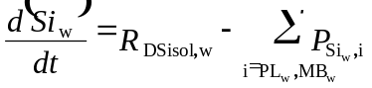 (C.19)
and the rate of change of detrital silica (DSi) in the water column is given by:
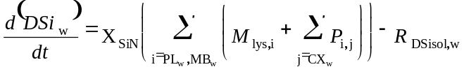 (C.20)
where X_{SiN} is the Redfield ratio of silicon and nitrogen (set at 3.0 (Murray and Parslow 1997)) and R_{DSisol} is the amount of detrital silica remineralised. Note that the equations for Si_{sed} and DSi_{sed} are as for (C.19) and (C.20) except that CX_{sed} is used in the place of CX_{w} and MB is the only PX present in the sediment that uses Si.
The rates of change for dissolved oxygen (O2) in the water column is given by:
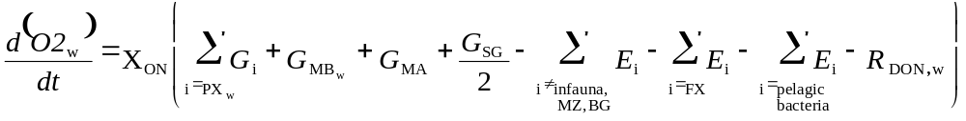
(C.21)
and in the sediment:
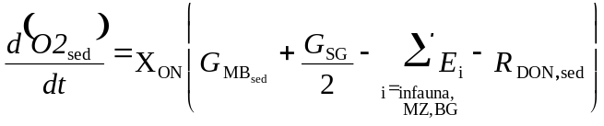 (C.22)
where X_{ON} is the Redfield ratio of oxygen and nitrogen (set at 16.0 (Murray and Parslow 1997)) and R_{DON} is the DON lost due to remineralisation.
The rates of change of dissolved organic nitrogen (DON) in the water column is:
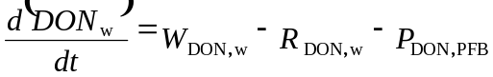 (C.23)
and in the sediment:
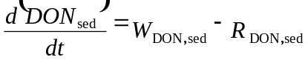 (C.24)
where W_{DON} is the DON produced by bacteria, R_{DON} is the DON lost due to remineralisation and P_{DON,PFB} is the DON taken up by pelagic free bacteria (PFB).
The rates of change of labile detritus (DL) in the water column is:
and in the sediment:
(C.25)
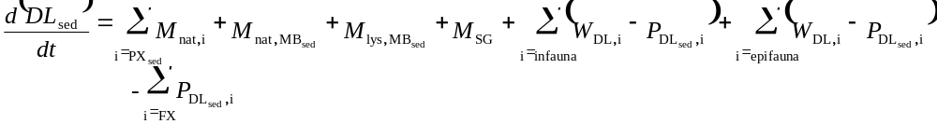where W_{DL,CX} is the amount of DL in the waste products from consumer CX and P_{DL,CX} is the DL consumed by CX.
(C.26)
The rates of change of refractory detritus (DR) in the water column is given by:
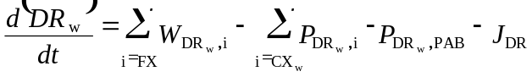 (C.27)
and in the sediment:
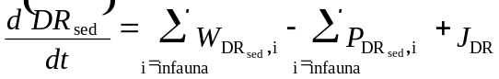 (C.28)
where W_{DR,CX} is the DR in the wastes of consumer CX, P_{DR,CX} is the amount of detritus consumed by CX, infauna includes sediment bacteria and J_{DR} is the amount of DR transferred from the water column to sediment pool due to the feeding activities of the benthic filter feeders.

C.2 Process equations
C.2.1 Growth of primary producers
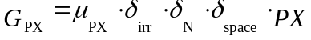 (C.29)
with μ_{PX} is the maximum growth rate, the nutrient limitation factor due to nitrogen is given by:
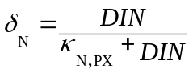 (C.30)
(where DIN=NH+NO) except for those primary producers which are also limited by the availability of Si then nutrient limitation is given by:
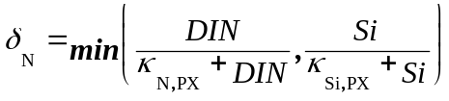 (C.31)
and light limitation is given by:
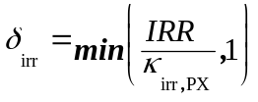 (C.32)
with the κ representing the half saturation constants for the respective processes, and space limitation as follows:
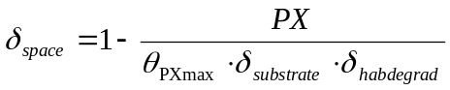 (C.33)
where δ_{substrate} is the proportion of the available space that is of the correct substrate type to support this type of primary producer and δ_{habdegrad} is the scalar for local habitat degradation scenarios (see equation 4.1 in the main text for the equation used). These last two only apply to macrophytes.
Using the above formulations for growth and nutrient limitation the nutrient uptake functions for the primary producer PX are given by:
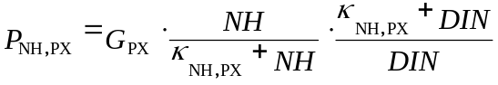 (C.34)
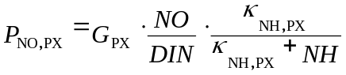 (C.35)
where κ_{NH,PX} is the half saturation constant for the uptake of NH. In addition, for PL and MB there is the uptake of Si as follows:
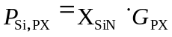 (C.36)
C.2.2 Growth of mixotrophic primary producers
Total growth of mixotrophic primary producers (G_{DF}) is given by
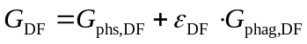 (C.37)
where photosynthetic growth (G_{phs,DF}) is given by
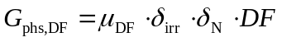 (C.38)
while the phagotrophic contribution (G_{phag,DF}) to total growth is given by
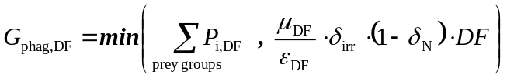 (C.39)
ε_{DF} is the assimilation efficiency of the mixotrophic dinoflagellates (set at 0.6); μ_{DF} is the temperature dependent maximum daily growth rate of the dinoflagellates (set at 0.5 mg N d⁻¹, Murray pers. com.), δ_{irr} is the light limitation factor, δ_{N} the nutrient limitation factor and P_{i,DF} the amount of prey group i grazed by the predator DF, which is calculated in the same way as for all other grazers in Atlantis. The light and nutrient limitation factors were largely calculated as for the pure autotrophs in Atlantis. Since there is strong evidence that dinoflagellates show an increase in efficiency at low light levels (Jeong et al. 1999, Li et al. 1999), there were some modifications made to the formulation of light limitation for this group. The modification is based on general observations that, due to increased efficiency at low light levels, mixotrophic growth rates are two- to three-fold higher than those of strict phototrophic growth under identical (low light) conditions (Skovgaard 1996, Legrand et al. 1998, Li et al. 1999). The final form of the light limitation factor (δ_{irr}) is:
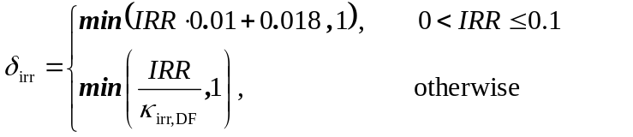 (C.40)
and the nutrient limitation factor as
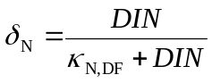 (C.41)
where DIN represents the total inorganic nitrogen pool (made up of ammonia and nitrate).
C.2.3 Growth of bacteria
Growth of the bacteria (G_{XB}) is given by
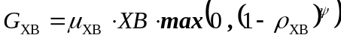 (C.42)
and
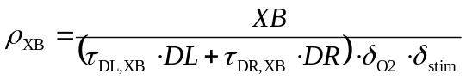 (C.43)
with μ_{XB} representing the maximum temperature-dependent daily growth rate for the group XB. XB is the current pool of bacteria and DL and DR are the labile and refractory detrital pools (all in mg N m⁻³); τ_{DL, XB} and τ_{DR, XB} represent the maximum possible biomass of XB per biomass of that grade of detritus; ψ is the exponent dictating the reduction in growth as the bacterial pool approaches its maximum attainable levels (set to 3) and δ_{O2} is the oxygen limitation factor, which is given by:
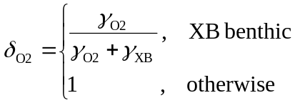 (C.44)
where γ_{XB} is the half oxygen mortality depth for XB, and the oxygen horizon (γ_{O2}) is given by:
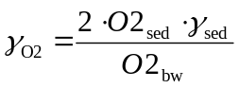 (C.45)
with O2_{sed} the concentration of oxygen in the sediments, O2_{bw} the concentration in the bottom water and γ_{sed} the depth of the sediment layer considered in the model. Finally δ_{stim} indicates the degree of stimulation of the bacteria by bioturbation and it is calculated as follows:
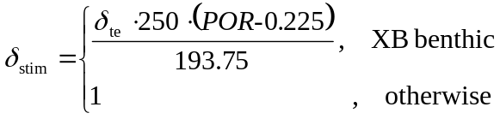 (C.46)
C.2.4 Growth of consumers
The growth of an invertebrate consumer (CX) is given by:
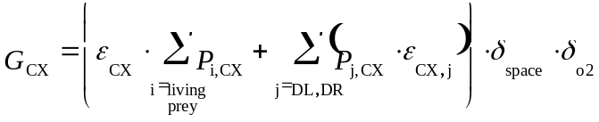 (C.47)
with ε_{CX} the growth efficiency of CX when feeding on live prey, ε_{CX,j} the efficiency when feeding on detritus (DL treated separately to DR), space limitation given by:
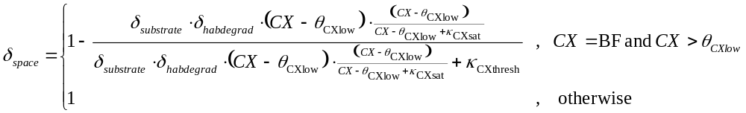 (C.48)
where θ_{CXmax} is the maximum biomass per area allowed for CX, θ_{CXlow} is the crowding lower threshold, κ_{CXsat} is the crowding half saturation level, κ_{CXthresh} is the crowding threshold (this formulation is based on that of the European Regional Seas Ecosystem Model II (ERSEM II) (Blackford 1997)), δ_{substrate} is the proportion of the available space that is of the correct substrate type to support this type of primary producer and δ_{habdegrad} is the scalar for local habitat degradation scenarios (see equation 4.1 in the main text for the equation used).
The oxygen limitation is given by:
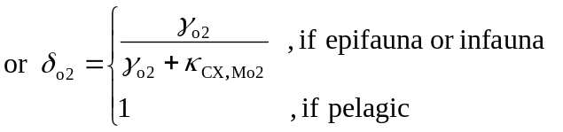 (C.49)
where γ_{o2} is the depth of the oxygen horizon and κ_{CX,Mo2} is the half oxygen mortality depth.
The growth for each vertebrate group, is calculated by equation of the same form as (C.47), but per age class of each vertebrate, the result is then apportioned to structural and reserve weight increases such that:
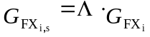 (C.50)
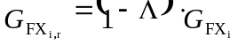 (C.51)
where
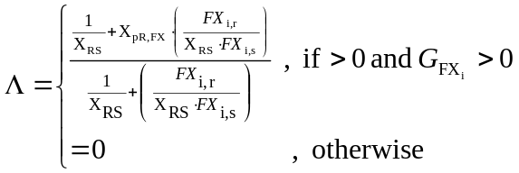 (C.52)
with X_{RS} the maximum ratio of reserve to structural weight FX can have and X_{pR,FX} is the relative degree to which FX concentrates on replenishing reserves rather than undergoing structural growth when underweight.
The grazing term is given by:
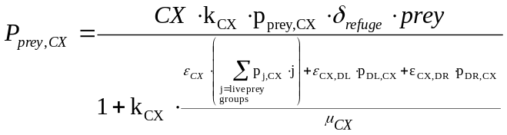 (C.53)
where “prey” is the group being consumed by CX, k_{cx} is the clearance rate of CX and p_{prey,CX} is preference (or availability) of that prey for the predator CX. This last parameter is similar to the “vulnerability” parameters in ECOSIM (Christensen et al. 2000) and represents the fact that the entire prey population will not be available to the predators at any one time (some may be hiding for instance). The availability of the food is further modified by δ_{refuge} if the group is dependent on biogenic habitat refuges, or size refuges (if they are physically outside the gape range of their vertebrate predators) or if the spatial range of the predator and prey do not completely overlap (and so explicit spatial refuges exist). If the group is dependent on biogenic habitat then δ_{refuge} is given by:
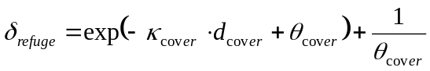 (C.54)
where -κ_{cover} is the refuge magnitude coefficient, θ_{cover} is the habitat steepness coefficient and d_{cover} is the relative cover in the cell for the prey, which is calculated by:
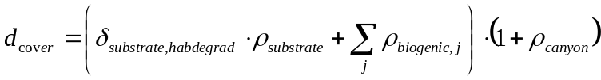 (C.55)
where δ_{substrate,habdegrad} is degradation in the physical habitat due to coastal development (e.g. reefs broken up), ρ_{substrate} is the proportion of the cell covered with suitable substrate types, ρ_{substrate,j} is the proportion of the cell covered by biogenic habitat defining group j and ρ_{canyon} is the proportion of the cell covered by canyons (which is treated as an enhancement factor here as they are known concentrate production but their absence does not prevent the establishment and growth of the groups (Alan Williams pers. com.)).
If the refuges is size-based (only true for vertebrates) then the available prey in cohort i of vertebrate group FX (FX_{i}), for the vertebrate predator (FY_{j}), is given by:
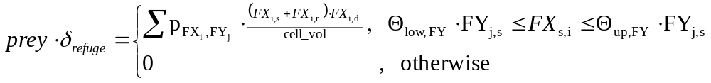 (C.56)
where Θ_{low,FY} is the lower prey selection size limit for FY and Θ_{up,FY} is the upper prey selection size limit. The δ_{refuge} for benthic prey (vertebrate and invertebrate alike) is calculated as follows:
(C.57)
(
)
(
)
⎪
⎪
⎩
⎪
⎪
⎨
⎧
<
<
<
<
<
=
−
−
CX
o2
top
o2
CX
top

top
CX
refuge

,

1

,

,

0

δ
top
2
o
top
CX
γ
γ
γ
γ
γ
γ
γ
γ
γ
γ
γ
γ
and if anaerobic
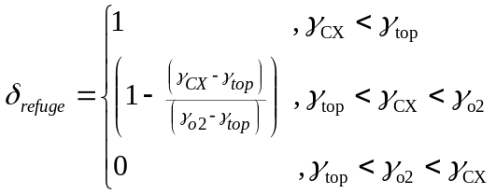 (C.58)
where γ_{CX} is the depth in the sediment that the predator CX can forage down to and γ_{top} is set to zero (as there is only one sediment layer).
C.2.5 Mortality and loss functions
The mortality terms for invertebrate consumers and autotrophs are in terms of lost biomass while those for vertebrates refer to the number of individuals lost. Nevertheless the general form of the equations is the same (but the units of the coefficients obviously differ between the vertebrates and other groups). The natural mortality term for group XX is given by
(C.59)
where m_{lin,XX} is the coefficient of linear mortality for XX, m_{quad,XX} is the coefficient of quadratic mortality for the group XX, m_{O2,XX} is the coefficient of oxygen dependent mortality and m_{special,XX} is the special (additional) loss rate for XX. This rate of “special” mortality is usually set to zero, except in the following cases:

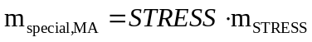 (C.60)
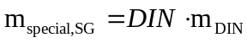 (C.61)
where m_{STRESS} and m_{DIN} are the coefficient of mortality due to mechanical stress and fouling by epiphytes, respectively. Lastly:
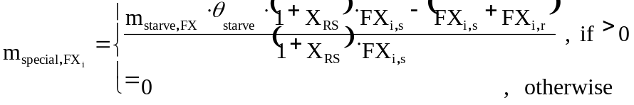 (C.62)
with m_{starve,FX} is the threshold ratio of reserve to structural weight at which death due to starvation is likely. The final term of equation (C.61) was adopted from ERSEM I (Bryant et al. 1995) to represent the impact of seabirds and any other top predators not represented explicitly by the dynamic groups in the model. While all the groups in the model had a linear mortality term, some groups (the vertebrates and higher trophic level zooplankton and benthic groups) suffered mortality described by a quadratic term. Only benthic consumers had oxygen dependent mortality, the macrophyte and vertebrate groups had special mortality as shown above and m_{top} is only applied to the vertebrate groups.
The final loss term is one that is applied to the microscopic primary producers only and it represents lysis. The losses of a primary producer (PX) to lysis is formulated as follows:
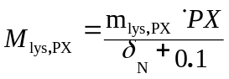 (C.63)
with m_{lys,PX} the rate of lysis.
C.2.6 Waste processes
The production of waste products by invertebrate and vertebrate consumers are handled in the same way, but in the case of vertebrates the mortality term has to be converted from a density to a biomass before being used in the following equations. The production of labile detritus (DL) by consumer group XX is given by:
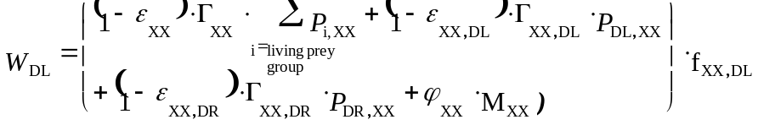 (C.64)
with ϕ_{XX} the proportion of mortality losses assigned to detritus, Γ_{XX} the proportion of the growth inefficiency of XX when feeding on live prey that is sent to detritus, Γ_{XX,DL} the proportion of the growth inefficiency of XX when feeding on DL that is sent to detritus, Γ_{XX,DR} the proportion of the growth inefficiency of XX when feeding on refractory detritus (DR) that is sent to detritus and f_{XX,DL} is the proportion of the total detritus produced that is of the type DL. The same equation is used for the production of DR (W_{DR}), except that the final multiplication of the brackets by f_{XX,DL} is replaced by multiplication by (1-f_{XX,DL}).
The other main waste product is excreted ammonia. The general formulation used for the production of ammonia by a consumer XX (invertebrate or vertebrate) is as follows:
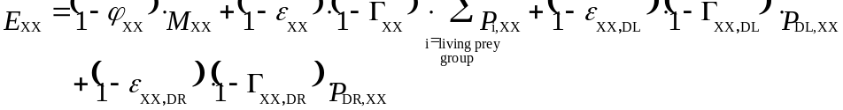 (C.65)
C.2.7 Physical processes
The only physical processes in Atlanits that differ from those in the Port Phillip Bay Integrated Model (PPBIM, detailed in Murray and Parslow 1997, Walker 1997) are bioturbation, bioirrigation and the calculation of the light attenuation coefficient.
The formulation of the light attenuation coefficient is from Fulton (2001) and is given by:
(C.66)
with n_{w} the background extinction coefficient, n_{DON} the contribution due to DON, n_{D} the contribution due to detritus, n_{P} the contribution due to phytoplankton (PX) and n_{susp} the contribution due to suspended sediments (SUSP).
The equations for bioirrigation are as detailed in Walker (1997) for PPBIM, but it is tied to the dynamical sediment fauna via an “enhancement” term similar to that of ERSEM I (Ebenhöh et al. 1995).
As Atlantis uses explicit sediment layers it can approximate particulate diffusion, expulsion (whereby material at depth is moved to the surface) and exchange with the surface by transferring sediment between the appropriate layers of the model. Only those particulate components (tracers) that are allowed in the sediments and are not macrobenthos (sediment grains, settled phytoplankton, microphytobenthos, meiobenthos, detritus and sediment bacteria) can be acted upon by bioturbation. The formulation implemented expresses the tracer concentration in the ith sediment layer (BX_{i}(t)) at the end of a time step as:
(C.67)
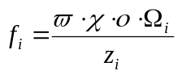 (C.68)
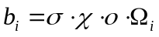 (C.69)
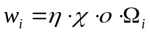 (C.70)
Where k_{i} represents the thickness transferred from i due to particulate diffusion, c_{i} is the thickness moved to the surface from layer i by expulsion and w_{i} is the thickness moved from layer i due to exchange with surface layers and z_{i} is the thickness of layer i. The thicknesses f_{i}, c_{i} and w_{i} only differ in a single parameter. For the parameters they share, χ represents the base density of biological activity; ο represents the modification to the baseline to reflect dynamic sediment fauna activity in the ecological sub-model (calculated in much the same way as that of ERSEM (see Ebenhöh et al. 1995)); and Ω_{i} is the depth dependence of the mixing process (this is a simple functional form, as of PPBIM, and though usually constant it is also possible to implement linear, parabolic and half-Gaussian forms (Walker 1997)). The parameter which does differ in the calculation of f_{i}, c_{i} and w_{i} is the base rate of each process - ϖ is the rate of particle diffusion (m² per Δt per unit biomass of bioturbative benthos per m²), σ is the rate of expulsion (m per Δt per unit biomass of bioturbative benthos per m²) and η is the rate of exchange between the surface and deeper layers (m per Δt per unit biomass of bioturbative benthos per m²). A small amount of burial of sediments and associated detrital particles is also enabled using a similar formulation.
C.2.8 Equations for Sediment Chemistry
Use of a compound effect of enhanced bioturbation (δ_{te}), and porosity (POR) is based on observations by Alongi (1998) and the relationship detailed by Blackburn (1987). Using equations (C.42) to (C.45), the utilisation of labile detritus by aerobic bacteria is given by:
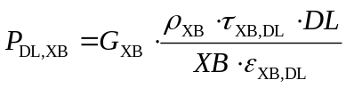 (C.71)
where ε_{XB,DL} is the assimilation efficiency of the bacteria on labile detritus. The uptake of refractory detritus is calculated similarly. The natural mortality term (M_{XB}) is as for the other invertebrates, but the term representing predation losses to predator group i (P_{XB,i}) is given by:
(C.72)
The waste handling equations for bacteria are also different to those for other invertebrates since wastes are channelled into DON not DL. All of the equations for the Anaerobic Bacteria (ANB) are as for XB here, except that any δ_{O2} factors in the equations are replaced by (1-δ_{O2}). Adopting these equations for the attached bacteria made it easier to identify a method of introducing dynamic flexibility to the empirical nitrification-denitrification model proposed by Murray and Parslow (1999a) for PPBIM.
To integrate a more interactive form of the processes governing nitrification and denitrification into Atlantis, the empirical sediment chemistry model used in PPBIM (Murray and Parslow 1999) is linked directly to the activities of sediment bacteria and infauna. The amount of ammonia produced by the remineralisation of DON (R_{DON}) is handled as in PPBIM, that is:
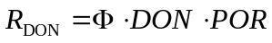 (C.73)
where Φ is the temperature-dependent rate of breakdown for DON (set at 0.00176 d⁻¹, Murray pers. com.). In PPBIM, equations similar to (C.73) were used to calculate the production of ammonia due to the breakdown of DL and DR (Murray and Parslow 1997). This is not the case in Atlantis, where the production of the remainder of the ammonia is dependent upon the activity of sediment dwelling fauna and flora. Thus, the total ammonia available for nitrification and denitrification (R_{NET}) is:
(C.74)
where P_{NH,MB} is the uptake of NH by MB (see equations for autotrophs), E_{XX} is the ammonia released by XX and ξ is the fraction of the excreted NH by infauna that contributes available nitrogen for nitrification and denitrification (set to 0.95). The form of E_{XX} for OB and BD is of the general form given for heterotrophs in Appendix B, but that for AEB and ANB is slightly different and is given by:
(C.75)
where E_{XB} is the release of NH by XB, ε_{XB,DX} is the efficiency of XB on the detritus fraction DX, and the production of DON (W_{DON}) and DR (W_{DR}) are calculated as follows:
(C.76)
(C.77)
where ϕ_{XB} indicates the fraction of the losses of XB due to natural mortality that are not released as NH and f_{XB,DX} is the fraction of the products of growth inefficiency and mortality directed to the detritus fraction DX. Using equation (C.74) the processes of nitrification and denitrification were completed using the form of the empirical model of Murray and Parslow (1999a), giving nitrification (S_{NIT}) as:
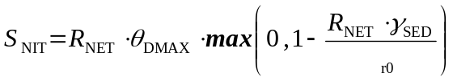 (C.78)
and denitrification (S_{DENIT}) as:
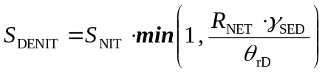 (C.79)
where θ_{DMAX} is the maximum rate of denitrification (set at 0.25, Murray pers. com.), θ_{r0} is the temperature-dependent minimum rate of respiration that supports nitrification (set at 200, Murray and Parslow 1997) and θ_{rD} (set at 10, Murray and Parslow 1997) is the peak of the nitrification-denitrification curve (as defined by Murray and Parslow 1999). This general form is adopted from PPBIM due to its demonstrated performance and robustness (Murray and Parslow 1999, Fulton 2001).
The equations for oxygen are modified from (Walker 1997), due to the more interactive representation of the sediment processes, and oxygen dynamics are now governed by:
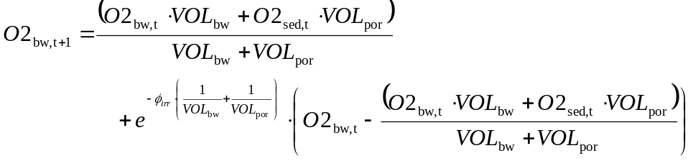
(C.80)
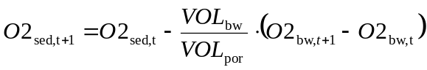 (C.81)
where ϖ_{irr} is the exchange rate due to irrigation, O2_{SED,t} is the concentration of oxygen in the sediment at time t, O2_{bw,t} is the concentration of oxygen in the bottom water at time t, VOL_{bw} is the volume of the bottom water layer and the porewater volume above the oxygen horizon is given by:
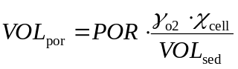 (C.82)
with VOL_{sed} being the volume of the entire sediment layer and χ_{cell} is the area of the cell.
C.2.9 Equations for Vertebrate Movement
The default vertebrate movement (in terms of the density d of vertebrate group FX, age class i, in cell j) is given by:
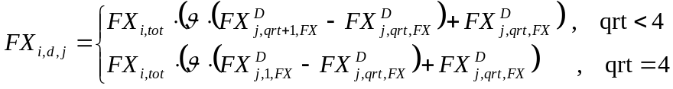 (C.83)
where FX_{i,tot} is the total number of FX in age class i in the entire system (that is the sum over all cells), is the proportion of the current quarter of the year which has already passed, FX^{D}_{j,qrt,FX} is the proportion of the population of FX found in cell j in the qrt quarter of the year.
For the forage and density dependent vertebrate movement scheme, the following formulation is used:
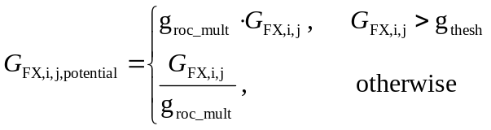 (C.84)
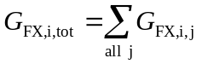 (C.85)
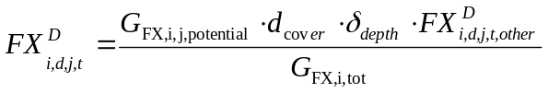 (C.86)
(C.87)
where G_{FX,i,j,potential} is a measure of the potential attractiveness of the cell j based on the available forage, G_{FX,i,j} is calculated as of G_{CX} in equation C.34, g_{roc_mult} is a constant reflecting how much more attractive a site with forage sufficient to support FX_{i} is over a site with poor food resources, g_{thresh} is the potential growth rate (as an index of the quality of the resources) where FX_{i} switch from finding the site desirable to undesirable and d_{cover} is the relative cover in the cell for the group FX_{i} (set to one for all groups that are not habitat-dependent). To take into account other pressures on fish movement (such as seasonal or spawning migration) the calculation of the proportion FX^{D}_{i,d,j,t} is weighted by the ideal distribution for those other migration factors and then the final distribution is determined by interpolating between the current distribution and the ideal distribution (taking the maximum swim speed of the vertebrate into account so that individuals can not move further than they could actually swim in reality). These FX_{i,d,j} values are then normalised so that their sum is one. If a vertebrate group is site attached then it only moves vertically at most, and if the group employs maternal care then the movement scheme is calculated for the mothers and then applied to them and the juvenile age classes.
D FISHERIES AND MANAGEMENT MODEL EQUATIONS
D.1 Fishing mortality and management
Many different fishing mortality equations were used depending on the scenario of fishery of interest. The general form of the amount caught at time t is given by:
(D.1)
where, 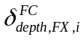is the proportion of FX_{i} at the depth the fishing gear is sweeping, 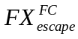 is the proportional escapement (either constant or size-based), the accessibility of FX_{i} for the fishery FC (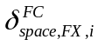) is given by either simple percentage overlap of the habitats occupied by FX_{i} using :
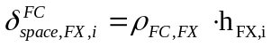
or the distribution model developed by Ellis and Pantus (2001):
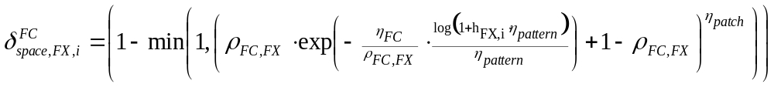 (D.2)
where h_{FXi} is the catchability of the age class i of FX (see equations (D8) to (D12)), ρ_{FC,FX} is the proportional overlap of fishery FC and vertebrate group FX, η_{FC} is the cover of the fishery, η_{pattern} is the distribution of the fishing within the area, η_{patch} is the number of patch types in the area; and finally the effort applied is given by
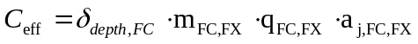 (D.3)
with m_{FC,FX} the current coefficient of fishing mortality for FX by fishery FC (it can change through time as fishing pressure changes) – it is the percentage of total effort (of the FC fishing fleet) concentrated in cell j if the fleet was allowed to act at will; q_{FC,FX} is the selectivity coefficient of the gear used by fishery FC on FX, and a_{,j,FC,FX} is the adjustment to the final rate due to management actions currently applied in cell j (this can also change through time). As indicated by (D.1) and (D.2) the fishing implemented for is a variation on the simple catch equation.
D.2 Effort
The effort coefficient m_{FC,FX} can be calculated in a number of ways, ranging from prescribed effort matrices to dynamic processes (such as basing all effort allocation on past catches or making minor modifications to long term trends of effort distribution based on recent catches in each area) and is given by one of the following equations. If effort is a temporally prescribed constant (i.e. effort per quarter is fixed):
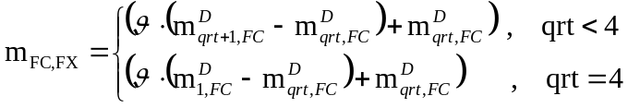 (D.4)
where is the proportion of the current quarter of the year which has already passed, m^{D}_{j,qrt,FX} is the effort of fishery FC in the qrt quarter of the year. This value can be used as is (i.e. homogeneously distributed across all cells) or spatially weighted based on the CPUE from previous time step. If the spatial distribution of the effort is prescribed rather than the temporal component then the equation used is the same as for (D.4) but with m^{D}_{qrt,FX} replaced with m^{D}_{j,qrt,FX} the effort of fishery FC in cell j in quarter qrt.
If the effort distribution is calculated dynamically then m_{FC,FX} in cell j time t is given by:
(D.5)
where the ideal new distribution m_{eff,t,j} given by:
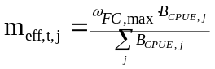 (D.6)
with ω_{FC,max} is maximum allowable effort and B_{CPUE,j} is the CPUE in the cell in the previous time step and the velocity F_{vel} is based on the distance between cells (if CPUE based only) or the distance to the ports if using a fleet dynamics model.
The equations (D4) to (D6) are used for the commercial fleets, but the recreational fishery is represented in a slightly different way:
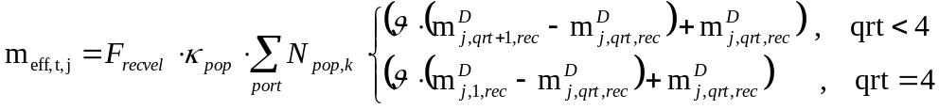 (D.7)
where N_{pop,k} is the population in port k, κ_{pop} is the proportion of the population that fishes recreationally, F_{recvel} is the velocity of recreational vessels based on distances to port, and m^{D}_{j,qrt,FX} the effort of the recreational fishery in cell j in quarter qrt (usually used to constrain recreational and charter-boat effort to coastal cells).
If the effort displacement option is being used then if the total effort for a fishery would drop using any of these dynamic formulations (either due to the imposition of MPAs or declining stocks) then the difference in each area is redistributed to the adjacent cells with the greatest biomass of the target groups.
D.3 Selectivity
The selectivity coefficient q_{FC,FX} may be given by one of five functions depending on the gear used by the fishery. It may be a constant proportion applied to all age classes or it may be size based and calculated based on a normal, logistic, lognormal or gamma distribution. The selectivity of the gear with regard to cohort i of vertebrate group FX (q_{,i,FX}) is given by one of the following equations (depending on the selectivity curve of the gear). If the selectivity curve is a constant
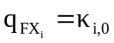 (D.8)
if a logistic selectivity curve is used for the gear then
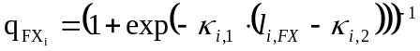 (D.9)
if a normal selectivity curve is used for the gear then
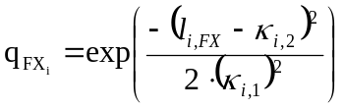 (D.10)
if a lognormal selectivity curve is used for the gear then
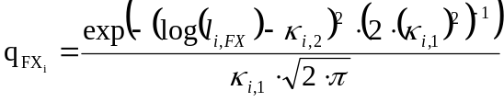 (D.11)
and if a gamma selectivity curve is used for the gear then
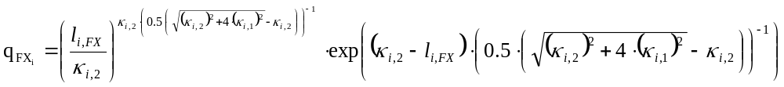
(D.12)
where κ_{ι,0} is the selectivity constant for the fishery on the ith age class of vertebrate group FX, κ_{ι,1} is the selectivity coefficient (spread of the curve) for the fishery on the ith age class of vertebrate group FX, κ_{ι,2} is the selectivity coefficient (length at which 50% of the population is selected) for the fishery on the ith age class of vertebrate group FX and the length (l_{j,FX}) of a vertebrate from cohort i in vertebrate group FX is given by:
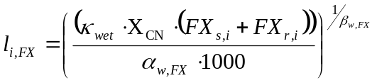 (D.13)
with X_{CN} the redfield ratio of carbon to nitrogen, κ_{wet} is the conversion coefficient from weight to dry weight, α_{w,FX} is a scaling coefficient in the length-weight relationship for FX and β_{w,FX} is the exponent in the length-weight relationship. In practice the logistic or normal selectivity curves are used (unless otherwise specified for that scenario). The parameters used to specify the selectivity curve may be adjusted in response to “management decisions” made under some of the alternative management scenarios (i.e. gear restrictions can translate into changes in selectivity).
D.4 Management
The final coefficient (a_{j,FC,FX}) represents management actions that influence fishing, but not by modifying the gear and its selectivity. This includes effort reduction and spatial and temporal closures or zoning. All of these involve calculating or specifying the proportion of “at will” effort that is allowed under the current management strategy. If a trigger event (such as target or vulnerable stock decline) occurs it initiates a gradual reduction in effort, which can be reversed later if the trigger recovers. The following equation is used to determine the final management coefficient (a_{j,FC,FX}):
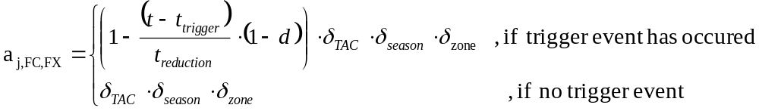 (D.9)
where δ_{TAC} is one normally (set to zero if a TACs are present and has been exceeded), δ_{season} is one if the fishery is not under a temporal closure and δ_{zone} is one if there is no spatial management in the cell (it is zero if the cell is closed and there is no infringement), t is current time, t_{trigger} is the time a trigger event occurred, t_{reduciton} is the time period over which the reduction in effort is to take place and d is the final level of effort allowed relative to the original level when the effort reduction was triggered. Infringement of any of the management conditions is represented by keeping the management scalars at a user defined level above the values they would drop to if there was no infringement. Management actions such as setting TACs or defining fishing seasons year (which are scaled back as stocks decline) occur on the first timestep of each year and are in place for the entire year.
D.5 Discarding
Three forms of discarding were included in the model and the specific one used in any particular case depended on the scenario under consideration. The simplest form of discarding saw a set proportion of the total catch of vertebrate FX by fishery FC discarded – the proportion of each age class actually discarded matched the percentage make-up of the catch. Another form of discarding saw a fixed proportion of all age classes discarded. The final, more realistic formulation used was based on size where the biomass of age class i of FX discarded and is given by
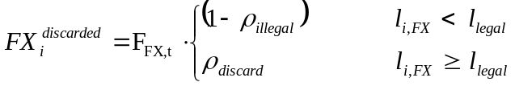 (D.10)
and the length of the vertebrate (l_{i,FX}) is given by (D.8).

APPENDIX E – SAMPLING MODEL PARAMETERS
The following are the default parameters used in the Atlantis sampling models. Alternatives were tried, but these are the default parameter values were used for the majority of runs.
Table E1: The default bias and variance sampling parameters
Parameter | Value |  | Parameter | Value
Proportional bias of sampling mean of |  |  | Error variance (as proportion of the sampling mean) of
salinity | 1.0 |  | salinity | 0.01
physical properties | 1.0 |  | physical properties | 0.25
nutrients | 1.0 |  | nutrients | 0.25
processes (nitrification, denitrification) | 1.0 |  | processes (nitrification, denitrification) | 0.25
large phytoplankton biomass | 1.0 |  | large phytoplankton biomass | 0.36
small phytoplankton biomass | 1.0 |  | small phytoplankton biomass | 0.49
small zooplankton biomass | 0.5 |  | small zooplankton biomass | 1/0
large zooplankton biomass | 1.0 |  | large zooplankton biomass | 0.36
cephalopods biomass | 1.0 |  | cephalopods biomass | 0.36
pelagic bacteria biomass | 0.7 |  | pelagic bacteria biomass | 0.49
sediment bacteria biomass | 0.5 |  | sediment bacteria biomass | 0.49
small infauna biomass | 0.5 |  | small infauna biomass | 2.0
large infauna biomass | 1.0 |  | large infauna biomass | 1.5
sessile epifauna biomass | 1.0 |  | sessile epifauna biomass | 0.36
mobile epifauna biomass | 1.0 |  | mobile epifauna biomass | 0.36
benthic primary producer biomass | 1.0 |  | benthic primary producer biomass | 0.36
refractory detritus biomass | 1.0 |  | refractory detritus biomass | 0.36
labile detritus biomass | 1.0 |  | labile detritus biomass | 0.36
vertebrate biomass | 1.0 |  | vertebrate biomass | 0.36
pelagic primary production | 1.0 |  | pelagic primary production | 0.1
zooplankton production | 1.0 |  | zooplankton production | 0.1
cephalopod production | 1.0 |  | cephalopod production | 0.1
pelagic bacteria production | 1.0 |  | pelagic bacteria production | 0.1
sediment bacteria production | 1.0 |  | sediment bacteria production | 0.2
small infauna production | 1.0 |  | small infauna production | 0.2
large infauna production | 1.0 |  | large infauna production | 0.2
sessile epifauna production | 1.0 |  | sessile epifauna production | 0.2
mobile epifauna production | 1.0 |  | mobile epifauna production | 0.2
benthic primary producer production | 1.0 |  | benthic primary producer production | 0.2
zooplankton consumption | 1.0 |  | zooplankton consumption | 0.1
cephalopod consumption | 1.0 |  | cephalopod consumption | 0.1
pelagic bacteria consumption | 1.0 |  | pelagic bacteria consumption | 0.2
sediment bacteria consumption | 1.0 |  | sediment bacteria consumption | 0.2
small infauna consumption | 1.0 |  | small infauna consumption | 0.2
large infauna consumption | 1.0 |  | large infauna consumption | 0.2
sessile epifauna consumption | 1.0 |  | sessile epifauna consumption | 0.2

Parameter | Value |  | Parameter | Value
mobile epifauna consumption | 1.0 |  | mobile epifauna consumption | 0.2
vertebrate weights | 1.0 |  | vertebrate weights | 0.001
vertebrate production | 1.0 |  | vertebrate production | 0.36
vertebrate consumption | 1.0 |  | vertebrate consumption | 0.36
vertebrate discard rates | 0.7 |  | vertebrate discard rates | 0.25
vertebrate total catch | 0.8 |  | vertebrate total catch | 0.25
vertebrate total effort | 0.9 |  | vertebrate total effort | 0.1
vertebrate total discards | 0.8 |  | vertebrate total discards | 0.36
counts | 1.0 |  | counts | 0.25
numbers observed in the catch | 0.9 |  | numbers observed in the catch | 0.1
selectivity curve fitting¹ | 1.0 |  | selectivity curve fitting¹ | 1.0
parameters of the selectivity curve | 1.0 |  | parameters of the selectivity curve | 0.3
aging | 1.0 |  | aging | 1.0
1. When set to a value other the one incorrect selectivity curves may be selected for fitting and stock estimation.

Table E.2: Default r_{max} parameter settings for the calculation of potential biological removals in the sampling model.

Group | r_{max} |  | Group | r_{max}
small planktivorous fish | 0.6 |  | seabirds | 0.4
large planktivorous fish | 0.6 |  | pinnipeds | 0.35
shallow piscivorous fish | 0.4 |  | baleen whales | 0.4
deep piscivorous fish | 0.4 |  | toothed whales | 0.35
tropical piscivorous fish (tunas) | 0.4 |  | flathead (Neoplatycephalus spp) | 0.35
migratory mesopelagic fish | 0.6 |  | ling (Gentyperus blacodes) | 0.15
non-migratory mesopelagics | 0.6 |  | orange roughy (Hoplostethus atlanticus) | 0.07
shallow demersal fish | 0.4 |  | southern bluefin tuna (Thunnus maccoyii) | 0.07
deep demersal fish | 0.45 |  | gummy shark (Mustelus antarcticus) | 0.07
demersal sharks | 0.45 |  | cephalopds | 0.8
pelagic sharks | 0.35

Table E.3: Constant ECOPATH parameters used in the sampling model. As many groups have the same values for these parameters, rather than repeat the parameters for each group individually, the parameters are given per type-of-group and all groups within that type would use those parameter values.

Type-of-group | Consumer | Assimilation Efficiency | Imports | Proportion that Flows to Detritus  DLpel DRpel DLsed DRsed |  |  |  | Discard Fate  DLpel DRpel DLsed DRsed
large phytoplankton | 0 | - | 0 | 1.0 | 0.0 | 0.0 | 0.0 | 0.8 | 0.0 | 0.0 | 0.2
small phytoplankton | 0 | - | 0 | 1.0 | 0.0 | 0.0 | 0.0 | 0.8 | 0.0 | 0.0 | 0.2
small zooplankton | 1 | 0.4 | 0 | 1.0 | 0.0 | 0.0 | 0.0 | 0.8 | 0.0 | 0.0 | 0.2
large zooplankton | 1 | 0.3 | 0 | 1.0 | 0.0 | 0.0 | 0.0 | 0.8 | 0.0 | 0.0 | 0.2
large pelagic invertebrates | 1 | 0.2 | 0 | 1.0 | 0.0 | 0.0 | 0.0 | 0.8 | 0.0 | 0.0 | 0.2
infauna | 1 | 0.2 | 0 | 0.0 | 0.0 | 0.9 | 0.1 | 0.8 | 0.0 | 0.0 | 0.2
epifauna | 1 | 0.2 | 0 | 0.0 | 0.0 | 0.9 | 0.1 | 0.8 | 0.0 | 0.0 | 0.2
macrophytes | 0 | - | 0 | 0.1 | 0.9 | 0 | 0.0 | 0.8 | 0.0 | 0.0 | 0.2
vertebrates (juvenile and adult) | 1 | 0.2 | 0 | 0.1 | 0.9 | 0 | 0.0 | 0.8 | 0.0 | 0.0 | 0.2
pelagic labile detritus | - | - | 0 | 0.2 | 0.3 | 0.4 | 0.1 | 0.8 | 0.0 | 0.0 | 0.2
pelagic refractory detritus | - | - | 0 | 0.0 | 0.0 | 0.4 | 0.6 | 0.8 | 0.0 | 0.0 | 0.2
benthic labile detritus | - | - | 0 | 0.0 | 0.45 | 0.05 | 0.5 | 0.8 | 0.0 | 0.0 | 0.2
benthic labile detritus | - | - | 0 | 0.0 | 0.05 | 0.05 | 0.9 | 0.8 | 0.0 | 0.0 | 0.2

APPENDIX F – SAMPLING MODEL EQUATIONS
Note that the due to the large number of symbols needed to describe the many equations that make up the sampling model some symbols have had to be reused with sub or superscripts to differentiate between their multiple meanings. Also please consider the symbols here in isolation to those used elsewhere in the report (in the equations or discussion of the operating model and indicators) as the reuse of symbols does not mean they represent the same thing in the different parts of the report – where this is the case it is specifically stated. I have tried to keep this reuse and potential confusion to a minimum and where it has been necessary to do it as logically as possible, I’m sorry for any inconvenience or confusion this may cause.
The following equations describe the formulations implemented at each sampling step to generate “noisy” data from the original deterministic output of the operating model.
F.1 Invertebrates
For each invertebrate group (i) the “sampled” biomass, consumption or production is given by one of the following expressions. If error was assumed to be lognormal (the usual case) the formulation used for :
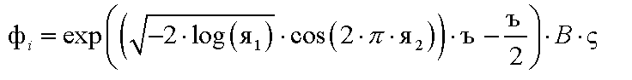
(F.1)
where B is the true biomass, is the (potentially biased) sample mean as a proportion of the true mean and is the variance of the error, Я₁ and Я₂ both ~U(0,1).
F.2 Physical characteristics
Each physical variable sampled had error added in the same way as for the invertebrate pools (F.1). The only major difference to biological pools was that the Ъ for physical variables is usually substantially smaller than for biological variables (see the parameter values in Appendix E).
F.3 Vertebrates
F.3.1 Charismatic vertebrates
The biomass, numbers and condition for all waders and any seabirds are sampled to reflect bird survey data (all sampling spots are included here as they all fall within the usual survey distance from shore restrictions used in reality). The data is lumped into juvenile, fledged and adult groups and error added in the same way as for invertebrates (F.1). The total numbers of seabirds caught (and discarded) are also recorded (with error calculated in the standard way). The average weight and total numbers counted is then used to give a biomass estimate for the waders and seabirds.
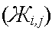
Mammal stock numbers are collected per age class (with error added) to represent aerial and boat surveys of the populations. To determine the mammal size structure the population is sub-sampled (with error as given by (F.1)) twice within the sampling period. This information is binned into size classes and the average condition of the individual in each size class plus the distribution of numbers and age across the size-classes is determined for the stock as a whole and for the animals which have been taken during fishing operations. Normally distributed aging error is included in this sub-sampling process. The distributions are normalized so that they can be used to calculate proportional contributions to network values. The index of condition for the jth size class is calculated using the following formulation
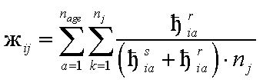
(F.2)
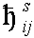
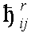
where n_{age} is the number of age classes for group i (in this case there is 20 for mammals), n_{j} is the number of individuals in the sub-sample of the correct size for that age class, is the structural weight of an average individual in cohort a of group i, and is the reserve weight of an average individual in cohort a of group i.
The total production and consumption by mammals, waders and seabirds is calculated by summing the actual values across the age classes. An estimate of this value is then given by adding error in the same way as for invertebrates (F.1).

F.4 Fisheries data
For each fishery the total catch, effort and discards information is aggregated (summed) at the level of the fishing zone (or fishing region) and then error is added in the same way as given in (F.1). The fine scale information is also sub-sampled (with error as given by (F.1)) and binned in the same way as outlined above for the mammals. This data is used to produce an index of condition for the individuals in the catch and to estimate a distribution of the numbers in the catch across the size-classes.
F.5 Fisheries independent sampling (fished vertebrates)
For fish and sharks the population is sampled by “research fishing” (which has associated catchability, selectivity and availability coefficients – see Appendix D for the form of the equations used) twice within the sampling period . This information is binned into size classes and the average condition of the individual in each size class, plus the distribution of numbers and age across the size-classes, is determined for the stock as a whole. Aging error is included in this sub-sampling process. All of these estimates and distributions are then used to produce estimates for the numbers in the stock, catch and discards. Selectivity is then estimated and used to correct the estimates of stock size and numbers in the catch and discards (by dividing the value by the selectivity estimate for that size class). Thus the final estimate of abundance for vertebrate group i in the zone (or region) ( ) is given by
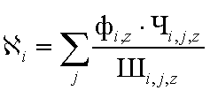
(F.3)
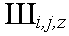
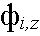
where j is the size class, is the total estimated biomass of group i in zone z, and is the proportion of the population of i in size class j in zone z (from the selectivity corrected size distribution) and is the average weight of the individual in size class j of group i in zone z.
The estimate of the number of fish caught uses the same method, except that the size information used in the calculation of the average weight of the fish comes from catches not fisheries independent samples; and the catch landed rather than the biomass estimate ( ) is used in the calculation of .
F.6 Diet composition
Diet composition is not calculated on time or spatial scales as fine as for the other data types. The temporal resolution is dealt with in section 4.7 of the main report and spatially only an inshore and an offshore diet composition is estimated. This matches the resolution used in the past, though finer scale sampling is beginning to be used in some of the most highly valuable fisheries of the wealthier nations.
The contribution to the diet of group i by group k in area z (Q_{i,k,z}) is calculated using
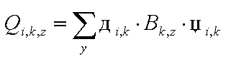
(F.4)
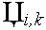
where y is the sampled individuals in that area (inshore or offshore), is the availability of group k to group i, B_{k} is the biomass of group k in that area (for vertebrate group k as the prey, B_{k} is actually the biomass of group k where the individual vertebrate is within the gape limits of the predator group i) and is a random multinomial patchiness scalar. To cope with the fact that very rare groups would hardly ever appear in diet matrices if the multinomial alone was used to mimic patchiness the diet composition was calculated in two steps. The first step (equivalent of sampling 1000 individuals with something identifiable in their stomachs) involved using the Q_{i,k,z} as written with the multinomial determining which actual groups appeared in the stomach of the sampled individuals. The process was then repeated for 10 individuals, but with the rescaled so that all groups with a φ_{i,k}. B_{k} of more than 0.0 but less than 0.01 were set to 0.1, this new set of were normalised and then the multinomial selection of actual prey included in the sample was repeated with this new set of potential contributions. In this way it was possible to represent the under and over-contribution of certain groups to sampled diet composition. This contribution Q_{i,k,z} was then normalized to produce the proportion contribution to the diet of group i by group k (Q’ _{i,k,z}) using
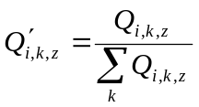 (F.5)
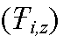
Once this diet composition’s has been determined using (F.4) and (F.5), the trophic level of group i in an area z is the weighted average of its prey’s trophic levels +1, and is given by
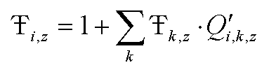
(F.6)
with detritus and primary producers having a trophic level of 1.

