Jacob's Paint - UML Diagrams
CS 250 Paint Project, final release. Jacob Kirby, 11/11/2026.
Repository: https://github.com/jacobkirbyvalpo/CS250-Paint-Project
All diagrams were written in PlantUML

Content
1. Class diagram: every class in the cs250paintprojectjacobkirby package, the JavaFX classes they extend, and how they are connected in the program.
2. Activity diagram: what happens when the user draws a shape, from picking the tool to undo.
3. Sequence diagram: the autosave timer, the desktop notification thread, and the threaded activity logger.
4. State diagram: smart save, warnings, and lossless data

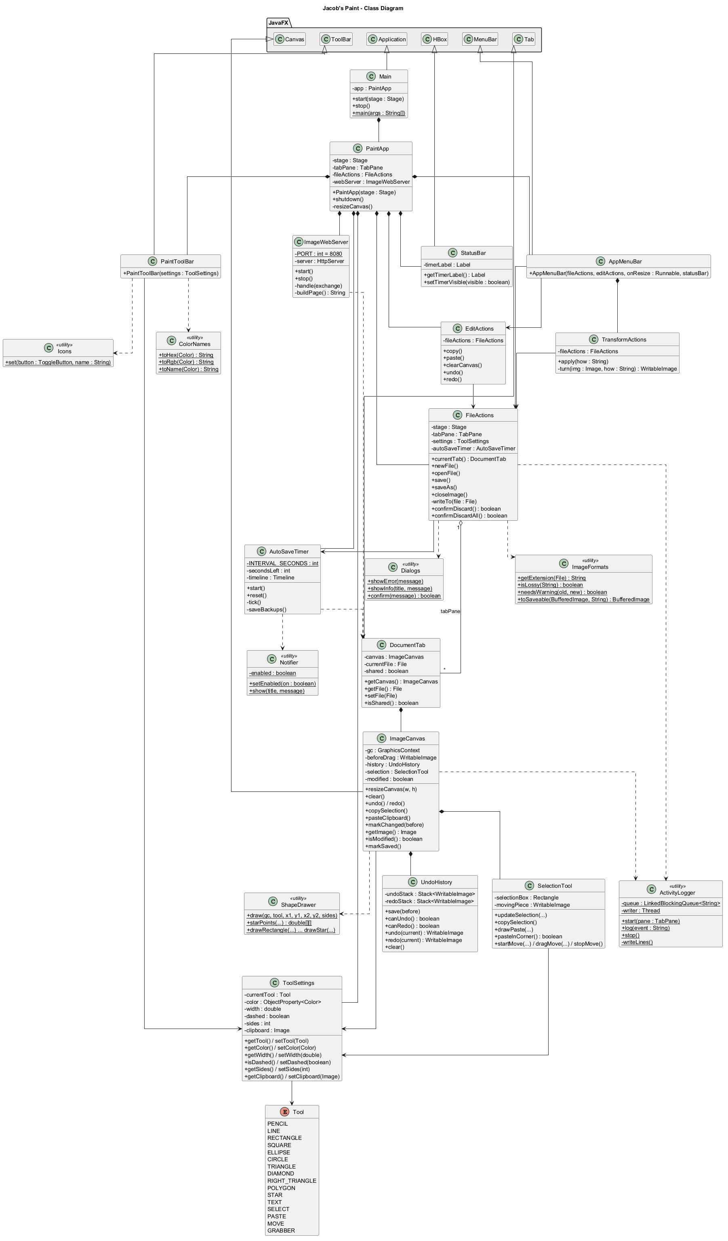
1. Class Diagram
Solid diamonds are ownership (composition) and hollow triangles are inheritance, solid arrows are references and dashed arrows are calls to static helper classes.

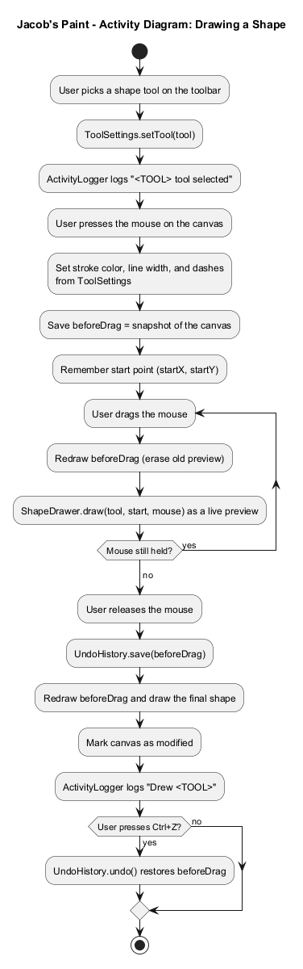
2. Activity Diagram
The canvas is copied before each drag so the preview can be erased and redrawn with every mouse move.
3. Sequence Diagram: Autosave, Notifications and Threaded Logging

The autosave time runs on the JavaFX thread, logs are placed into a queue and written to a log file by a separate logger thread. Each notification runs notify-send (linux) on its own thread too.

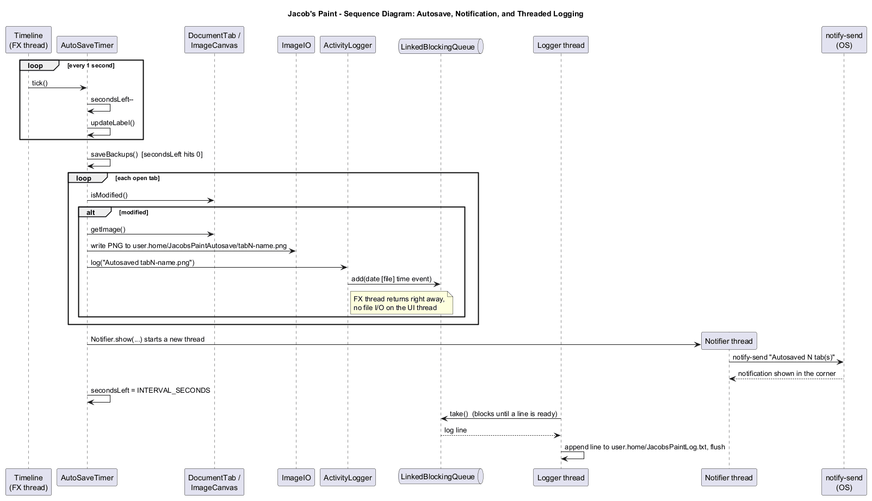
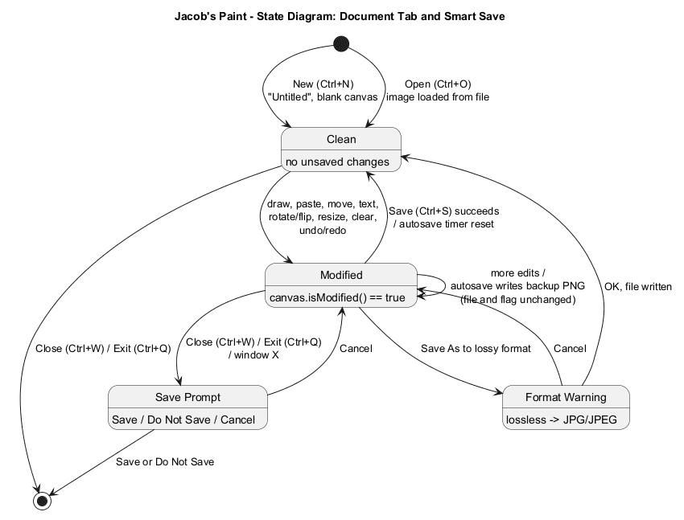
4. State Diagram: Document tab and Smart Save
Every tab tracks whether it has unsaved changes and will warn he user if they try to exit without saving. Saving from a lossless format to JPG will have a warning about loss of data.

