Ground Truth Information for Challenge 1

For a deeper understanding of the subject systems of our challenge case, we provide some details regarding the features identification and dependency analysis performed in a related work [1]. We do not claim that it is a ground-truth, instead the goal is only to make available some basic information to contribute to challenge solution proponents in their studies.

In a manual analysis of the six webshops we identified 14 different features. These features are:

- Frontend: Microservice used as user interface and responsible for calling other microservices.
- User: Manages the customers and user authentication.
- Payment: Manages credit card information and payment tasks with the specified amount and usually returns a transaction ID.
- Catalog: Provides the list of products and the ability to search for products.
- Cart: Stores items in the user's shopping cart.
- Order: Retrieves user cart, prepares order and requests payment, shipment and email notification.
- Product: Provides detailed information about products.
- EmailContact: Sends email to customers/users.
- Shipping: provides shopping cart-based shipping cost estimates.
- Marketing: Shows advertisements based on certain context words.
- Recommendation & Recommends other products based on what is provided in the cart.
- Audit: Allows administrators to audit user data based on property database and external servers.
- Currency: Converts a cash amount into another currency.
- Location: Retrieves user location to support advertisements and currency conversion.

The matrix with the traceability between the six subject systems and their features is presented below:

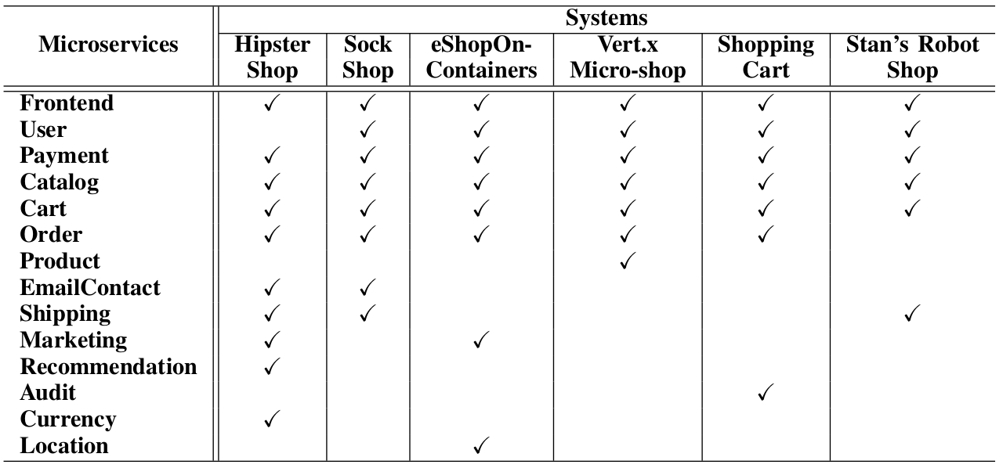
We also collected from the six subject systems the dependencies between features. To identify these dependencies, we firstly analyzed any kind documentation representing the structure of the system (basically images with some microservices names, calling instructions, and infrastructure components). However, not all systems have this artifact, then the source code was used for manual identification of such dependencies. The figure below presents the dependency graph obtained for all systems.

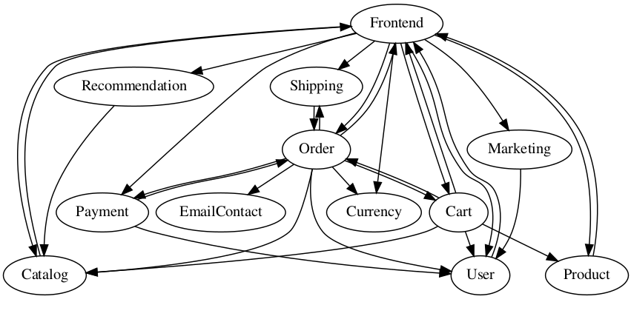
Reference:
[1] Mendonça, W.D.F; Assunção, W.K.G.; Estanislau, L.V.; Vergilio, S.R.; Garcia, A. Towards a Microservices-Based Product Line with Multi-Objective Evolutionary Algorithms. IEEE Conference on Evolutionary Computation (CEC 2020), Glasgow, Scotland-UK, July 2020. (to appear)

